To all Members | Direct Line: (01536) 534398  Email: anneireson@kettering.gov.uk  Our Ref: AI  Your Ref:  Date: 17th September 2013

Dear Councillor

You are summoned to a meeting of Kettering Borough Council to be held in the Council Chamber, Municipal Offices, Bowling Green Road, Kettering on Wednesday, 25th September 2013 at 7.00 pm.

Yours faithfully

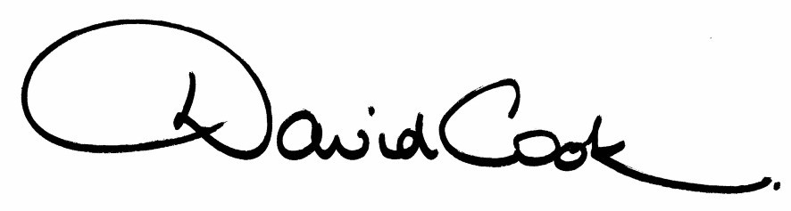

D Cook
Chief Executive

A G E N D A

1. Apologies.

2. Minutes of the meeting of the Council held on 24th April 2013 to be approved as a correct record and signed by the Mayor

3. Declarations of Interest:-

- Disclosable Pecuniary Interests
- Personal Interests

4. To receive any announcements from the Mayor and/or the Leader of the Council.

5. Report of the Chief Executive.

6. The Mayor to ask members of the public present if they want to speak on any item on the agenda.

7. Individual Electoral Registration (presentation)

Reports:

8. Seats on Streets Local Development Order

9. Draft Statement of Community Involvement

10. Community Governance Review

11. To consider motions received in accordance with Council Procedure Rule 16 as follows:-

(a) To be proposed by Councillor Jonathan West and seconded by Councillor Ellie Manns:-

"That Kettering Borough Council welcomes the UK-wide campaign to end 'legal loan sharking' which has included the collection of Borough residents' signatures on a petition in Kettering Town Centre. We believe that the lack of access to affordable credit is socially and economically damaging. Unaffordable credit can cause a myriad of unwanted effects, such as poorer diets, colder homes, rent, council tax and utility arrears, depression (which impacts on job-seeking behaviour) and poor health.

We are concerned by the targeted advertising used by loan companies, which target members of the armed forces, students and those receiving tax credits and child benefit. We note that unaffordable credit is extracting wealth from our most deprived communities and believe it is the responsibility of all levels of government to try to ensure affordable credit for all.

We therefore pledge to:

(i) use best practice to promote financial literacy and affordable lending to ensure wealth stays in the Kettering economy;

(ii) continue to promote credit unions in the Borough which offer access to affordable credit and which encourage saving;

(iii) refer this issue to a task and finish group of the Research and Development Committee to enable the Council to consider all the implications, form a better understanding of the role the Council can play in supporting our residents and develop a clear policy; and

(iv) recommend that the task and finish group considers how the Council can lobby Government to strengthen the rules governing the issue of lending licences and address the lack of affordable credit and how the Council can promote financial literacy and affordable lending.

(b) To be proposed by Councillor Steve Bellamy and seconded by Councillor Ian Jelley:-

"This administration will continue to look to implement new fiscally sound initiatives to help our tenants remain within their homes. As a local authority landlord it is our duty to help those that have shown they will act responsibly and are willing to help themselves, or are unable to."

12. To receive questions from members.

13. Any matters of urgency that the Mayor decides should be considered.

16.4.13
Fire Alarm

All meetings shall be adjourned immediately on the sounding of the fire alarm. The alarm is a continuous two-tone siren. On hearing the alarm please leave the building by the nearest emergency exit. There are emergency exits at both ends of the corridor outside the meeting rooms. On leaving the building please cross the car park and assemble on the grassed area by the church. Do not attempt to drive out of the car park as this may impede the arrival of emergency vehicles. Please do not return to the building until you are told it is safe to do so by a Council employee.

Toilets

There are toilets in the corridor off the main entrance to the building you came through to get to the meeting room.

Facilities for Babies and Children

If you wish to use a private area to feed your baby please ask a member of staff. There are changing facilities in the corridor off the main entrance adjacent to the toilets.

.Access for Disabled People

There are allocated parking bays outside the main entrance to the Municipal Offices for disabled people. The meeting rooms are located on the ground floor and access is gained for wheelchair users via the main entrance. If you require assistance, please ask the attendant on duty in the reception area.

No Smoking

Smoking is not permitted in the Municipal Offices.

