1 PURPOSE OF REPORT

- Update on activities related to Capacity Funding

- The Latest New Restaurant Opening

- Discuss the work being done on a new Business Brochure

- Town Centre Round-Up

2 BACKGROUND INFORMATION

2.1 Kettering Borough lies within the South East Midlands, which is predominately a growth area, and is expected to facilitate growth of some 13,100 homes and 16,200 new jobs by 2021.

2.2 Members have made their priorities for infrastructure and jobs-led growth clear – these are the prerequisites of growth. Members have indicated they wish to use the growth agenda to leverage three key and interrelated ambitions for the borough; namely:-

- A better offer for our town centres
- A better education and training offer
- A better employment offer – high grade, higher density jobs

  - The mutually supportive role of these three aspirations cannot be over-stated. The town centres and the skills base will be persuasive to inward investors. Similarly, high grade employment supports vibrant town centres.

  - The Council has a vision to create town centres that are Characterful, Distinctive, and Fun. This vision has been externally validated by an independent planning inspector, and now sits firmly within our planning policy for Kettering Town Centre.

- Capacity Funding

  - Following the successful bid for funding from the Department for Communities and Local Government (DCLG), we have been working hard on delivering the various outcomes we said we would. This is essential in terms of ensuring we receive the funding for a second year. The bid was separated as follows:
- £334,500 - Technical Assessment, Evaluation and Design of Junction 10a
- £297,500 - Technical Assessment, Evaluation and Design of the Weekley Warkton Avenue
- £538,000 - Resources for Kettering Borough

  - The aim with Jct10a is to build a ‘Business Case’ for Government funding – this will be ready in time to meet preparation in Westminster for the Autumn Statement. It will also feed into plans being made ready by the various Government Departments for future rounds of spending. A direct link with the Green Book Assessment undertaken on our behalf by Local Partnerships in 2012 will ensure continuity, and that a robust account is provided of the benefits of investing in this piece of nationally significant infrastructure.

  - The work being undertaken on WWA is similar to that being done for Jct10a in that it involves topographical surveys, ground investigations, etc. The intended audience, however, is more locally based. Northamptonshire County Council (NCC) have expressed their willingness to examine the case for forward funding this particular piece of infrastructure, which forms an important part of the local strategic network. The work being done will enable NCC, along with KBC and Alledge Brook, to deliver a scheme that meets all requirements placed on it. The timeframe for delivery of this piece of work is similar to that of Jct10a.

  - In terms of the staff resource element of the bid, we are identifying roles and expertise that are required to ensure we are able to continue to support the project. For instance, a proportion of the capacity funding will be used to produce digital and physical marketing material for the Borough – to help attract new businesses and people into Kettering, but also to ensure that positive growth messages can be delivered to existing businesses and residents. In order to help deliver this, the Council is in the process of taking on a temporary marketing and design resource that can add expertise in this area.

- Chimichangas

  - We are delighted to say that the Chimichanga fit-out is well under way! Work began in early August and is due to be completed by late September. At time of writing we are beginning to plan the opening events and marketing material along with our friends at Chimichanga. Anyone who has a desire to sport a novelty Mexican moustache or sombrero should contact either Alex Jelley or Guy Holloway asap – all such requests will be gratefully received!

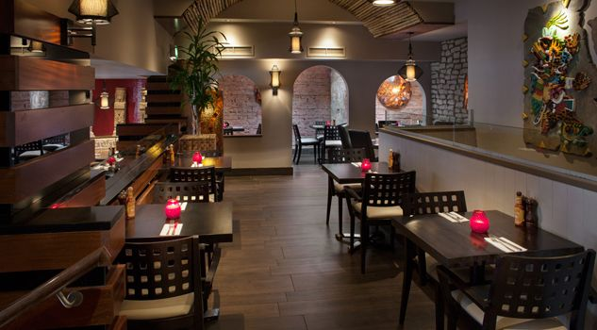

- Business Brochure

  - Following on from paragraph 3.4 above, we are looking at the ‘Kettering: Central to Business’ brochure – with a view to ensuring it meets our requirements for the next few years. We are facing an exciting time for the Borough with new housing, new jobs and improved facilities; and this brochure will play an important role in attracting investment into the area.

  - The recent survey undertaken with the business community has identified some possible routes for getting in touch about the services and opportunities on offer in the Borough. This will form the basis of our approach going forward.

- Town Centre Round-up

  - Work continues on delivering a scheme for improving the public realm through High Street, Meadow Road, Lower Street and Gold Street. We should be in a position to showcase the new design in early autumn – further proof that the future of Kettering town centre is an exciting one!
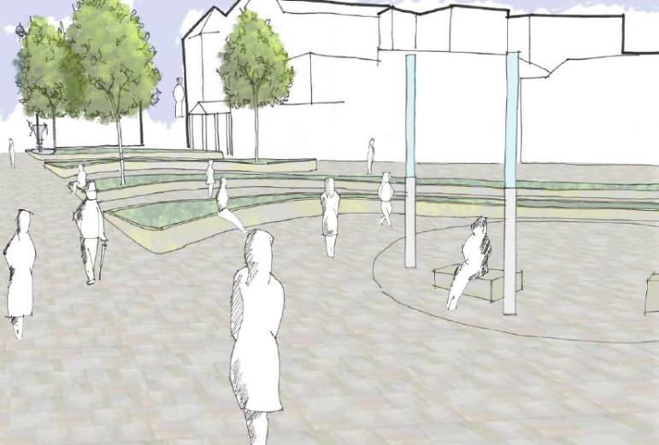

  - Kevin Jones, the selected developer for The Yards development off Market Street has also taken the lease on 1 Horsemarket – which is being converted into two units. A successful online interior furnishings business will open the first of its shops there within the next month. The planning applications for the yards development itself are currently being considered by Development Services.

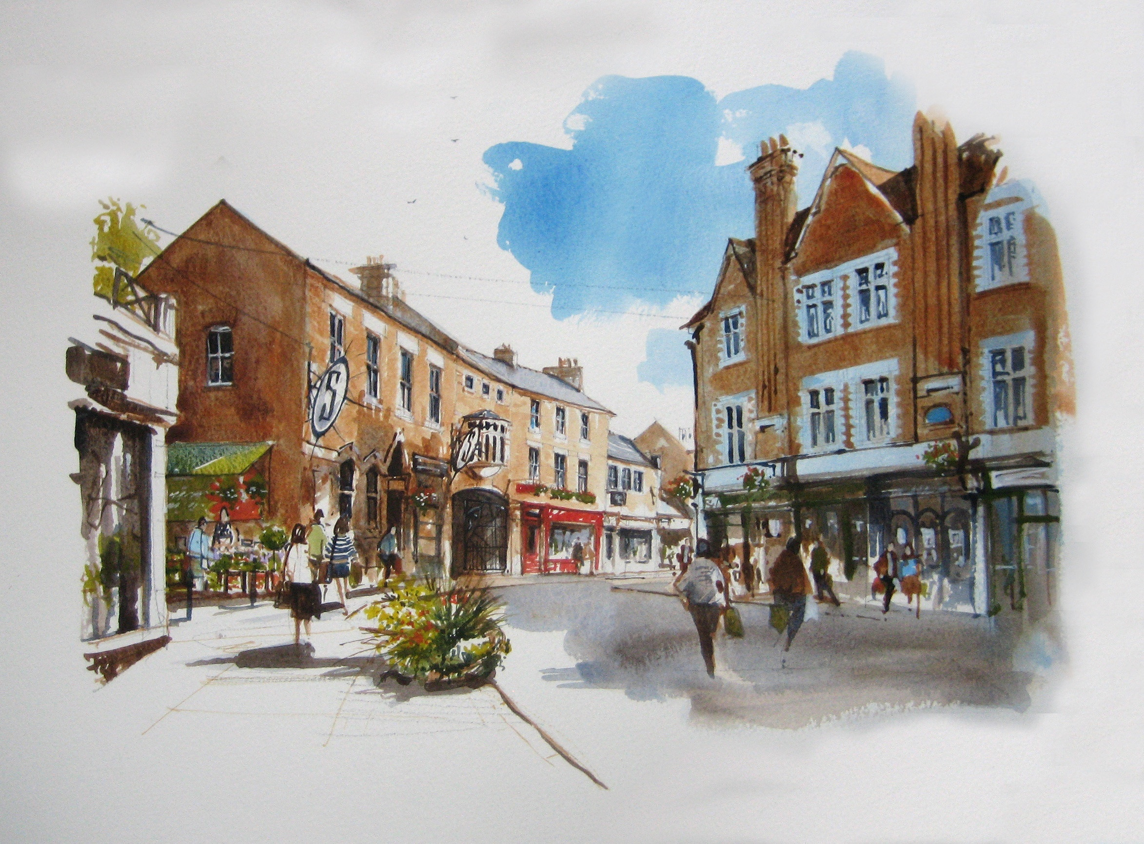

  - The internal works to the Newlands Centre continue – with an expected finish later in September. The proposed signage for Gold Street, Newlands Street and Tanner’s Lane has gained planning consent – and should follow the internal works in due course. We are in discussions with NCC and Ellandi with regards to Newlands Street and what improvements can be made in the short, medium and long terms.

- POLICY IMPLICATIONS AND USE OF RESOURCES

  - Members have made their priorities for infrastructure and jobs-led growth clear – these are the prerequisites of growth. Members have indicated they wish to use the growth agenda to leverage three key and interrelated ambitions for the borough; namely:-

- A better offer for our town centres
- A better education and training offer
- A better employment offer – high grade, higher density jobs

  - The projects outlined above are, in essence, about delivering a better borough. This vision has been externally validated by an independent planning inspector, and now sits firmly within our planning policy for Kettering Town Centre.
8 RECOMMENDATION

That the Executive Committee:

  - Notes the success of the capacity funding bids and the progress made

  - Joins us in welcoming Chimichanga to Kettering, and supports our marketing activities

  - Appreciates the need for an updated brochure

  - Notes the various updates contained within the town centre round-up

