Local Requirements for Planning Applications

Please note – For the purposes of this guidance, ‘Major Applications’ are applications of 10 or more dwellings (or over 0.5 hectares) and 1000sqm (or 1.0 or more hectares).

NATIONAL REQUIREMENTS: No’s 1 - 3

- General Requirements for Plans, Drawings and Documents (Article 6, DMPO)
- All plans and drawings submitted must be clear, legible and able to be viewed electronically once scanned
- All plans and drawings must be drawn to an appropriate metric scale, which should clearly be identified on the drawing, e.g. 1:100 @ A1/1:200 @ A3.
- Vertical and horizontal scale bars assist with measuring from enlarged or reduced drawings
- Drawings should be accurate. Ambiguous statements such as "Do not scale" "Not to scale" or similar call into question the accuracy of the drawing and therefore cannot be accepted. Any quoted dimensions must scale
- Electronic documents must be no larger than 7MB
- Electronic drawings can only be accepted in pdf and tif formats

For paper submissions, one original and two copies of all documentation should be submitted. For larger applications further copies may be requested at
pre-application stage.

- Drawings Necessary to Describe (Article
6, DMPO)
Plans to identify the site (location plan) – for all applications other than tree works.
- The application site (including access to the highway) must be shown by red edging; any adjoining land that you have an interest in must be edged in blue
- The scale of the location plan must be appropriate to sufficiently identify the site. In most cases an up to date map to a scale of 1:1250 or 1:2500 will be adequate
- Should normally be A4 sized
- Include a "North" point
Scale 1:1250
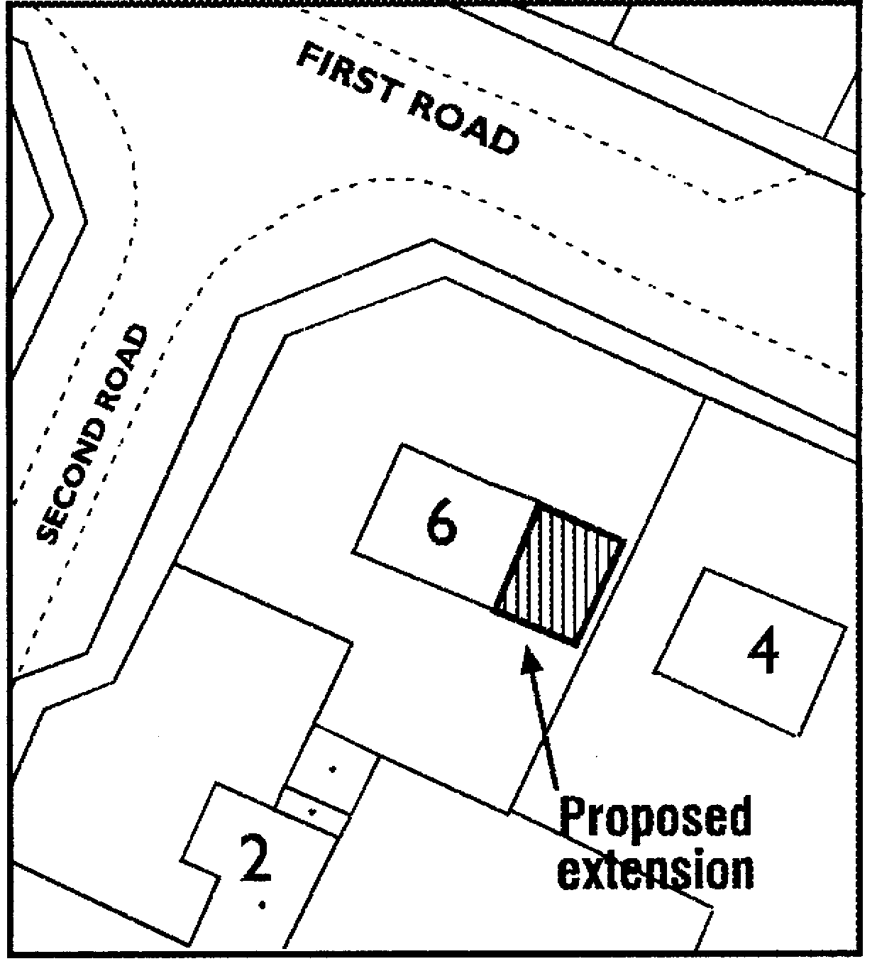
- Show surrounding buildings; and
N
- Ideally show two named roads

Site layout / block plan – for all applications except prior notification applications.

Shed to be demolished

- The plan must be to a scale appropriate to the site and development (normally 1:500 or 1:200, although for particularly large sites, other scales may be more appropriate). If in doubt, check with your Local Planning Authority.
Fir tree to be felled
Scale 1:500
- All site layout/block plans to include a “North” point.
The plan should show your proposals for:
- The new works in relation to the site boundaries and other buildings within and surrounding the site;
- New buildings should be shown in context with adjacent buildings including property numbers/names where applicable and roads and footpaths adjoining the site;
- On-site access, parking, and turning arrangements and facilities for cycle parking;
- Vehicle access visibility splays at the highway boundary;
- The species, position and spread of all trees within 12 metres of any proposed building works;
- The extent and type of any hard surfacing;
- Boundary treatment (including all heights and materials);
- Applications for new developments must include provision for the storage and collection of waste and recyclables;

Floor plans - for applications altering/creating floor space or use of floor space;
- These should show the existing and proposed floor layouts of each storey to be built or altered;
- They should normally be to a scale of 1:50 or 1:100;
- New works should be clearly identified and show all openings;

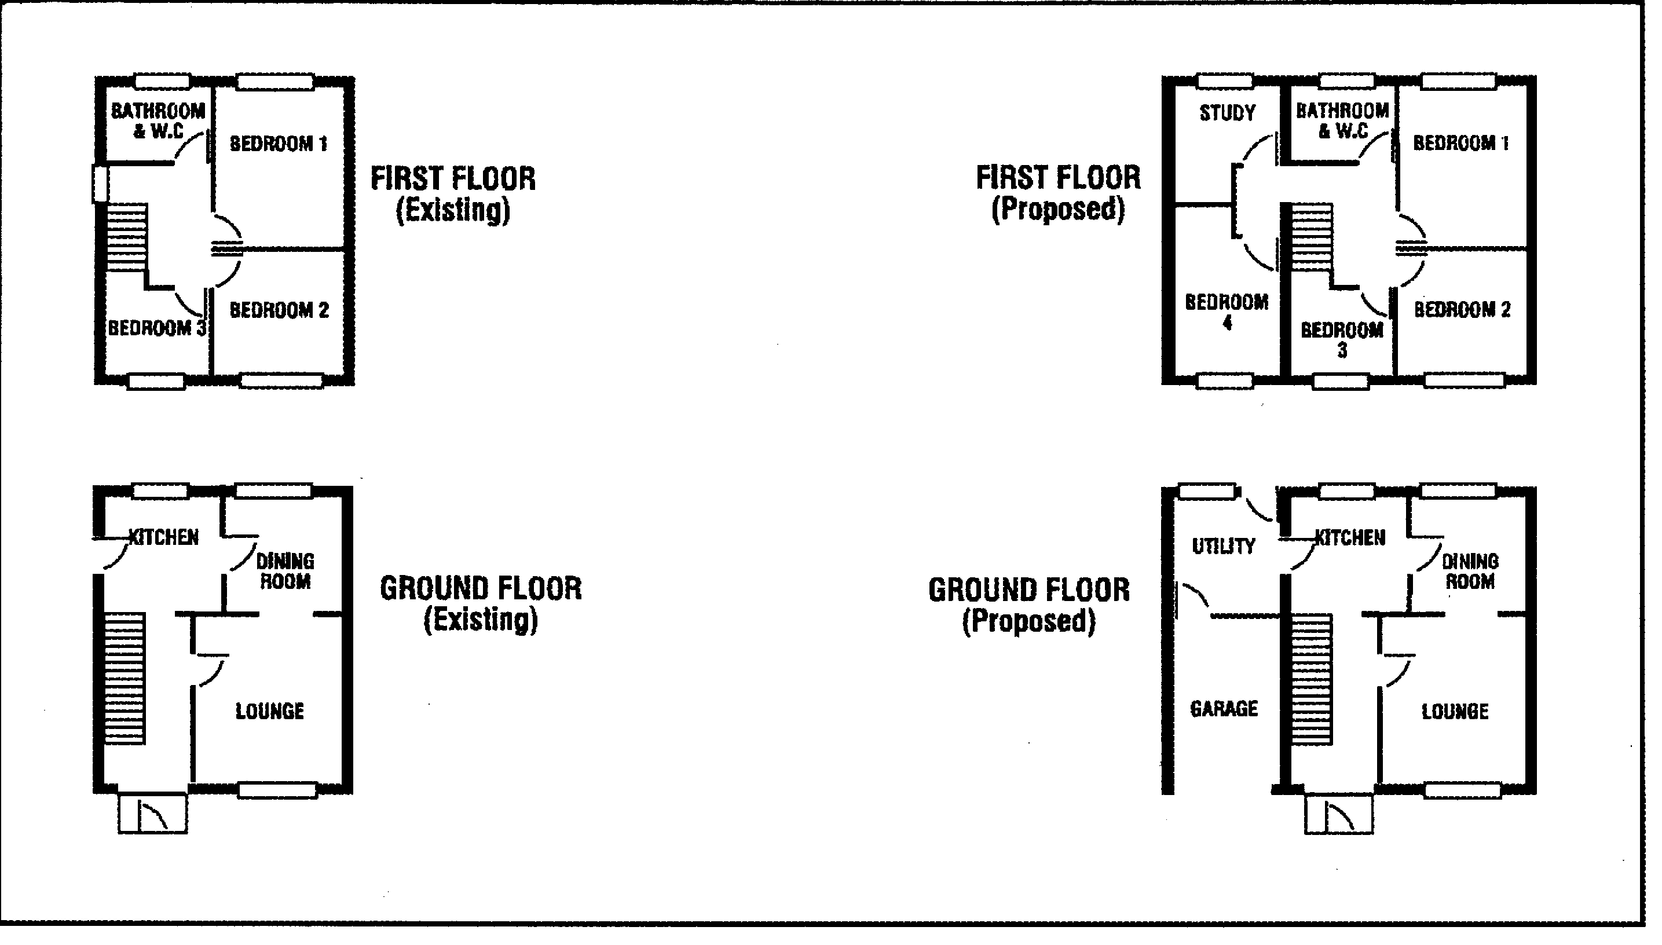
Scale: 1:50
Elevations - for applications erecting or altering exteriors of buildings.
- These should show the existing and proposed elevations of each storey to be built or altered;
- They should normally be to a scale of 1:50 or 1:100
- New works should be clearly identified and show all openings
- These should show all faces of the building affected by the works, including blank walls
- Where the elevation adjoins or is in close proximity to another building, drawings should show the relationship between the buildings and the position of openings on each property

- Existing and proposed drawings should be submitted. Again, they may be drawn separately or the new work may be indicated by shading etc;
- Each elevation should be labelled to show its compass orientation

Site Levels and Site Cross Sections and Finished Floor Levels
- Plans should show existing site levels, final ground and finished floor levels (with levels related to a fixed datum point off site) and also show the proposals in relation to adjoining buildings
- In the case of householder development, the levels may be included on floor plans and elevations, but particularly in the case of sloping sites it will be necessary to show how proposals relate to existing ground levels or where ground levels outside the extension would be modified
- Levels should also be taken into account in the formulation of design and access statements

Site survey
This should show existing:
- Built features including walls, buildings and other structures
- Natural features on or close to the site including trees, hedges, ponds and water courses.

AND ANY OTHER PLANS NECESSARY TO DESCRIBE THE PROPOSALS

3. Design and Access Statements (Article 8, DMPO)

It is a statutory requirement that Design and Access Statements are prepared to accompany some types of planning applications. Please refer to Article 8 of the Town and Country Planning (Development Management Procedure) (England) Order 2010 (as amended) or Regulation 3 of the Listed Building Regulations 2006.

What are they?

Reports that explain the design thinking behind a planning application, and justify what is being applied for.

Why are they required?

For qualifying developments these statements help you to think about the best
design solution for your proposal and to explain how you have chosen the design
which you submit. They are used by us to help assess your proposals. Larger
planning applications require a Design and Access Statement to be submitted
with the application.

When are they required

The only types of applications that will need to be supported by a Design and
Access Statement (DAS) are:

- Major applications for planning permission ANYWHERE
- Where any part of the development would be within a CONSERVATION AREA: Applications for planning permission for one or more dwelling houses or a building / extension creating 100 sqm or more of floorspace (which could include flats within buildings)
- Any application for Listed Building Consent will require a Design and Access Statement, with those proposing no external alterations to the building not requiring the Access part.

In what format should they be?

- A written description and justification of the planning application.
- Photos, maps and drawings may be needed to illustrate points made.
- Cover the headings of amount, layout, scale, landscaping and appearance (for planning applications) and layout, scale and appearance (for Listed Building Consent applications).

What should the statement include?

- The amount of detail they contain should reflect how complex the application is. They need not be long for a relatively small development.
- A Design and Access Statement should not be two separate documents. The design and access components should be interrelated, with each element helping to inform the other.
- For applications within conservation areas, the statement should consider the impact of the proposals on the conservation area and how the proposal relates to the desirability of preserving or enhancing the character or appearance of that area.
- As a general guide the following issues should be covered within the statement, although this will vary depending on the nature of the proposal, whether the application is in full or outline and whether it relates to an application for Listed Building Consent.

The Statement

- The statement should explain the design principles and concepts that have been applied to the development, and how access to and within the development has been dealt with. This should include the following:-

a) Design principles

Explain the design principles and concepts that have been applied to the development.

b) Context

Demonstrate the steps taken to appraise the context of the development and how the design of the development takes that context into account.

c) Access

Explain the policy adopted as to access, and how policies relating to access in relevant local development documents have been taken into account.

d) Consultation

State what, if any, consultation has been undertaken on issues relating to access to the development and what account has been taken of the outcome of any such consultation.

e) Specific Issues

Explain how any specific issues which might affect access to the development have been addressed.

Applications for Listed Building Consent

- The statement should explain the design principles and concepts that have been applied to the works, how the design principles and concepts that have been applied to the works take account of the special architectural or historic importance of the building; the particular physical features of the building that justify its designation as a listed building; the building’s setting; and how access issues have been dealt with.

Designing out Crime

- Design and Access Statements should demonstrate how crime prevention measures have been considered and what measures have been applied to help prevent crime and disorder issues in the design of the proposal. How the
design reflects the seven attributes of safe, sustainable places set out in Safer places – the Planning System and Crime Prevention, the principles of the Secured By Design scheme plus the Council’s Supplementary Planning Guidance: Planning out Crime in Northamptonshire (2004).

Waste Management

- Proposals should have regard to waste arisings associated with development and the management of waste in residential developments including bin storage, recycling facilities and collection points.

For more detailed information on preparing a Design and Access Statement consult “Design and access statements, “How to write, read and use them” produced by Design Council CABE. www.designcouncil.org.uk/our-work/cabe/

LOCAL REQUIREMENTS: No’s 4 - 25

4. Air Quality Assessment

All planning and reserved matter applications that propose development:

- Inside, or adjacent to, an air quality management area (AQMA);
- Where the development could in itself result in the designation of an AQMA (anything which generates large-scale vehicular movement e.g. warehousing or 100 or more houses); or
- The proposed development is close to major infrastructure e.g. the A14, A43 or A6; or
- Where the grant of planning permission would conflict with, or render unworkable, elements of a LA’s air quality action plan.

The assessment will need to be supported by such information as is necessary to allow a full consideration of the impact of the proposal on the air quality of the area. Further advice is available in National Planning Policy Framework, paragraph 124 and Annexe 1 of former PPS23:
http://webarchive.nationalarchives.gov.uk/20120919132719/http://www.communities.gov.uk/documents/planningandbuilding/pdf/pps2annex1.pdf

This information may be provided as part of the Environmental Impact Assessment where applicable or through other validation requirements, for example through information provided on lorry movements.

5. Biodiversity Survey & Report

The Natural Environment and Rural Communities Act 2006 imposed a statutory duty on Local Authorities to have regard to the purpose of conserving biodiversity.

For major applications a Natural Environment Statement will be required to explain how the planning proposal impacts upon existing biological and geological resources both within and in the vicinity of the site, and the measures to be put in place to both mitigate loss or damage and to compensate when such loss or damage cannot be avoided. The statement will also be required to examine the scope for enhancement of the biodiversity value of the site in the context of the planning proposal, and the extent to which this might contribute to meeting both national and local Biodiversity Action Plan targets.

For all other applications a Natural Environment Statement as above will be required in respect of proposals within or adjoining or, in the opinion of the Local Planning Authority, likely to affect sites protected for their nature conservation interest, such as Sites of Special Scientific Interest, Local Nature Reserves, County Wildlife Sites and Regionally Important Geological or Geomorphological Sites.

Statements will also be required in respect of any sites with known ecological or geological interest or the habitats or potential habitats of species protected under any statutory provisions or identified as priority species under the Biodiversity Action Plan. (Information in respect of Badgers should be presented in a separate report for restricted circulation).

Biodiversity can be a complex area. If your proposal will potentially affect a habitat or species we recommend you consult the following guidance and follow the advice of a qualified ecologist. There are many various types of surveys and assessments that may need to be carried out. Some of them, such as species specific surveys can only be carried out at certain times of the year. All decisions taken on development proposals should be based upon good quality and up to date information. Natural England consider ‘up to date’ to be no older than 18 months. Therefore, survey data older than 18 months may not be accepted.

Detailed guidance on dealing with the impacts of development on biodiversity and geological conservation is given in Government Circular ODPM 06/2005 and Good Practice Guide ‘Planning for Biodiversity and Geological Conservation’:

https://www.gov.uk/government/uploads/system/uploads/attachment_data/file/11481/143792.pdf

A Local Biodiversity Action Plan (BAP) identify priorities for action and give guidance on implementing targets to reverse the loss of habitats and species. The BAP is available at:

http://www.northamptonshirebiodiversity.org/default.asp?PageID=17&n=View+the+BAP

Further advice in regards to the BAP is available from the Wildlife Trust:

http://www.wildlifebcnp.org

Where a proposal is likely to have a significant effect on biodiversity interests a broader Environment Statement may be required. This is likely to relate to large scale applications, those affecting watercourses or semi-mature natural environments. Please contact the Local Planning Authority for further advice.

Please see Natural England’s standing advice decision tree for identifying when surveys are required for legally protected species. http://www.naturalengland.org.uk/Images/Decision-tree_tcm6-21619.pdf

6. Flood Risk Assessment

Flood Risk Assessments will be required in respect of all planning applications in Flood Zones 2 or 3 or applications with a site area of one hectare or greater. The need for such assessments is governed by the size and description of the proposed development and the location of the site relative to its flood risk potential. The Environment Agency has produced a flood zone map which is available at:

http://www.environment-agency.gov.uk/homeandleisure/floods/31650.aspx

If your site is identified as being at risk of flooding please contact the Local Planning Authority to establish which flood zone is applicable and therefore the need for a flood risk assessment.

Please review the Strategic Flood Risk Assessment for Kettering which is at:
http://www.kettering.gov.uk/site/scripts/documents_info.php?documentID=465&pageNumber=5 or contact Kettering Borough Council to establish which flood zone is applicable and therefore the need or otherwise for a flood risk assessment.

The flood risk assessment should identify and assess the risks of all forms of flooding to and from the development and demonstrate how these risks will be managed taking climate change into account. Technical guidance to the National Planning Policy Framework March 2012 provides guidance in relation to the undertaking of flood risk assessments and the responsibilities for controlling development where it may be directly affected by flooding or increase flooding elsewhere. The technical guidance can be found at:

https://www.gov.uk/government/uploads/system/uploads/attachment_data/file/6000/2115548.pdf

If a site falls within Flood Zones 2 or 3 and the vulnerability of the development as set out in the technical guidance, is such that a sequential test is required, the sequential test and any exception test shall accompany the planning application.

7. Heritage Statement

If the proposal will affect an historic asset, an Historical Survey or an Impact and Justification Statement will be required to accompany your application.

(a) Historical Survey

Required for applications for planning permission involving operational development affecting historical sites i.e. within or adjacent to
  - a listed building/structure
  - the curtilage of a listed building/structure
  - a conservation area
  - an historic park or garden
  - a Scheduled Ancient Monument
  - an historic battle field

Sometimes this information may be included within a Design and Access Statement. If an application affects such a site an applicant may need to commission an assessment of existing information and submit the results as part of the application in accordance with advice in section 12 the National Planning Policy Framework:

https://www.gov.uk/government/uploads/system/uploads/attachment_data/file/6077/2116950.pdf

(b) Listed Building / Conservation Area Impact and Justification Statement

Statements will be required to support all applications for Listed Building Consent or Conservation Area Consent.

Impact and Justification Statements

In accordance with section 12 of the National Planning Policy Framework applicants for Listed Building Consent must justify their proposals. They will need to show how the works would affect the special architectural and/or historic interest of the building and its setting. You will need to provide the Local Planning Authority with full information to enable them to assess the likely impact of your proposal. This will involve demonstrating an understanding of the part(s) of the building affected, using annotated drawings and photographs as necessary.

You may submit an assessment of the nature, history and construction of
the building to which your proposals relate in order to support your
application. Your assessment need only relate to the scope of the proposed
works.

You will need to demonstrate to the Local Planning Authority how your proposals contribute to the long term future of the building. This may include a specialist surveyor’s or structural engineer’s report, full schedule of works or method statement detailing the effects on the fabric of the listed building, for example - wiring, plumbing and other services.

In some cases you may be required to provide additional information before your application can be fully considered.

8. Housing Statement (Major applications)

All major residential applications (10 or more dwellings / over 0.5 hectares) will require a housing statement including the following:

- Details of the mix of housing, and provision of affordable housing, where appropriate in accordance with relevant Development Plan policies and Supplementary Planning Document / Guidance on Affordable Housing.
- Take into account the findings of the North Northamptonshire Housing Market Assessment http://www.nnjpu.org.uk/docs/North%20Northants%20Compact%20SHMA%20final%20August.pdf and, where appropriate, any village needs survey for affordable housing.
- Details of the size and tenure of dwelling units and any arrangements with social housing providers.
- Details of the numbers of habitable rooms and / or bedrooms, or the floor space of habitable areas of residential units together with details of the number of social rented and intermediate affordable housing units and open market housing.
- If different levels or types of affordability or tenure are proposed for different units this should be clearly and fully explained.

- Land Contamination Assessment

Planning applications for any development where contamination is known or likely to exist will require a Part 1 risk assessment. Examples are development of:

- Previous/historic industrial site
- Former petrol filling stations
- Conversion of agricultural buildings

Applications with sensitive end uses (which include new housing development, schools, hospitals, and children’s play areas) will also require this assessment due to the likely presence of naturally occurring arsenic chromium and vanadium.

A Part 1 risk assessment will comprise:

- Desk study (identifying all previous uses and potential contaminants associated with those uses)
- Walk over site reconnaissance
- Conceptual model identifying potential pollutant sources, pathways and receptors as a basis for assessing the risks and appraising the options for remediation

Applications may also need to include an extended assessment of contamination in line with Annexe 2 of former Planning Policy Statement 23, focussed on local circumstances.

http://webarchive.nationalarchives.gov.uk/20120206163714/http://www.communities.gov.uk/documents/planningandbuilding/pdf/pps2annex2.pdf

Contaminated Land - A Guide for Developers and their advisors can be found at:
http://www.kettering.gov.uk/downloads/file/747/cont_land_developers_guide

10. Landscaping Strategy (Major Applications)

Major applications for planning permission (apart from change of use) shall be accompanied by a landscape strategy.

Applicants must refer to a Tree Survey or Arboricultural Statement in cases where the development proposal would affect existing trees and significant planting.

11. Lighting Assessment (Major Applications)

Applications that include external lighting and applications where developments may have a significant lighting impact on the surroundings relating to a need for adequate lighting on a site (examples include warehouses and outdoor sports facilities) shall be accompanied by a lighting assessment.

The assessment must detail the location, type number, height and intensity of outdoor lighting and all measures for the avoidance of light spillage onto adjoining properties or the public highway.

Further information on lighting is available from:

The Institution of Lighting Engineers, Lennox House, 9 Lawford Road, Rugby, Warwickshire, CV2 12DZ - telephone 01788 576492, www.ile.co.uk or
Lighting in the Countryside: towards good practice, 2001, www.communities.gov.uk

If you require any further guidance or information in regards to Lighting Assessments please contact our Environmental Protection Team on Tel: 01536 534307.

12. Noise Assessment

All planning and reserved matter applications that raise issues of disturbance or are considered to be a noise-sensitive development will need to be supported by a Noise Impact Assessment (which shall include details of mitigation) prepared by a suitably qualified acoustician.

An assessment will be required for:

- Applications for development such as industrial or commercial developments with noisy plant, equipment or machinery or noisy sports that could cause noise and disturbance to the occupants of nearby buildings; or
- For noise sensitive developments such as housing, schools or hospitals that are proposed close to existing sources of noise such as main roads, railways or industrial development.

If you require any further guidance or information in regards to Noise Assessments please contact our Environmental Protection Team on Tel: 01536 534307.

13. Photographs & Photomontages

These can provide useful background information but are not generally essential. Photomontages can help to show how large developments can be satisfactorily integrated within the street scene. Up to date photographs should be provided if the proposal involves: demolition of a building in a conservation area; development affecting a conservation area; or development affecting or works to a listed building. These should show the whole building and its setting and/or the particular section of the building affected by the proposals.

14. Planning Obligations (Major Applications)

Under the Town and Country Planning Act 1990, the Council can seek Planning Obligations (when planning conditions are not appropriate) to ensure the quality of development and to enable developments to proceed in a sustainable manner. Planning Obligations provide a means of ensuring that developers contribute towards the infrastructure and services that the Council considers necessary to facilitate the proposed development. Contributions, depending on the case, may be in cash or kind.

Obligations will be required in support of all applications which generate requirements for planning obligations in accordance with the Council’s adopted Supplementary Planning Guidance/Document, and if specified in pre-application advice. Further advice/guidance on planning obligations is available in the DCLG practice guidance:

https://www.gov.uk/government/publications/planning-obligations-practice-guidance

Highway Contributions

Pre-application discussion with the Local Highway Authority will confirm the potential rates associated with a development. For further advice please contact Northamptonshire County Council Highways Department.

This sets out that contributions towards social and community infrastructure will be negotiated for development above the following thresholds:

10 residential units or more/0.28 hectares or larger site area

- Education
- Affordable housing
- Community facilities
- Libraries
- Flood risk management
- Sustainable Transport
- Healthcare
- Crime and disorder management
- Environment and amenity
- Recycling and waste management
- Public Open Space
- Monitoring fee
- Fire and Rescue
Non residential development floorspace 1,000 sqm/1 hectare

- Flood risk management
- Sustainable transport
- Environment and amenity
- Crime and disorder management
- Monitoring
How are Planning Obligations made?

Planning Obligations are given by a formal legal document (a deed) which may be either an agreement or a unilateral undertaking. All persons with an interest in the land must be signatories, including owners, lessees, mortgages and those who have agreed to purchase the land, and others depending upon the circumstances.

Planning obligations bind the land. All successors in title and those deriving title will be bound by the obligations unless the specific deed creating the obligation releases them. Planning obligations are registered as local land charges.

Planning obligations can have significant effects on the use and the value of the land. It is advisable to take independent legal advice before entering into a planning obligation.

Planning Obligations procedure

It is essential that advice is sought at pre-application stage to prevent delays or the refusal of a planning application.

- Pre-application discussion - you will be advised by the Planning Officer of the requirements regarding planning obligations in relation to the proposal

- At planning application submission stage a supporting statement regarding planning obligations will be required setting out draft agreement terms and/or proposed heads of terms for planning obligations to be drawn up.

- Evidence of title must be submitted at the application submission stage

Note

Planning applications should be submitted in accordance with the Council’s Development Plan and supplementary planning guidance and the above documentation must be submitted within the stipulated time frame. Failure to complete the planning obligation agreement within the application deadline 8/13 weeks will most likely result in the application being refused for failure to deliver the required mitigation measures, without which the impact of the development will be considered contrary to the Development Plan.

Completion

Legal and Administration fees:
You will be required to pay the Council’s Legal fees. In addition there is a requirement for payment of an administration fee to allow the management/monitoring and administration of the planning obligations. This charge is currently set at 5% of the financial contributions payable. Both legal and administration fees will be payable on completion of the deed.

15. Statement of Community Involvement

It is recommended that applications for larger developments, or schemes of a sensitive nature, undertake community involvement with the affected local community. The statement should show how the views of the local community have been sought and taken into account in the formulation of the development proposals.

Larger developments are defined as proposals for residential development of 100 or more dwellings and other land uses where the sum of the floor area within the building is 1000m2 or the site area is one hectare or greater.

Large-scale development applications are likely to require additional community involvement beyond that set out in Appendix 1 of the adopted North Northamptonshire Statement of Community Involvement if the proposal will have a significant impact on the area, or create significant public interest or controversy. A full copy of the adopted North Northamptonshire Statement of Community Involvement can be found at:

http://www.nnjpu.org.uk/docs/NNLDF%20SCI%202006.pdf
.

16. Structural Survey

Applications for Planning Permission

A structural survey will be required to be submitted with applications for barn conversions. In the open countryside proposals for replacement dwellings will require special justification which may include a structural survey. A survey will also be required for applications involving demolition in a conservation area, demolition of any building identified as being of local historic importance or a building covered by an Article 4 Direction.

Applications for Listed Building Consent

A structural survey will be required for works involving demolition or loss or historic fabric, or when structural works are proposed e.g. roof strengthening or large openings in stone walls.

Applications for Conservation Area Consent

A structural survey will be required to accompany all these applications. Surveys must detail the current condition of the building and indicate the level of works required to enable the conversion to be completed.

17. Supporting Planning Statements (Major Applications)

A supporting statement will be required to explain how the development accords with the relevant national and local planning policies.

Development which affects provision of a playing field shall include a statement which explains the reason for and choice of location of development:

- Demonstrate why development of playing field should be permitted.
- Explain the current use of the playing field in terms of uses and sports played and provision of changing facilities.
- State alternative locations considered and replacement provision if any.

18. Sustainable Design and Energy Statement

All planning and reserved matter applications involving new residential development of 1 dwelling or more; all commercial developments (including extensions); and applications for Change of Use including operational development will be required to submit a Sustainable Design and Energy Statement.

The Statement should:

- Include a completed checklist from the Sustainable Design Supplementary Planning Document (SPD).
- State how the development meets the relevant requirements of Core Spatial Strategy Policy 14.
  - part (a) of this policy relates to developments of over 200 dwellings
  - part (b) relates to all other developments and covers sustainable construction, energy efficiency, waste reduction/recycling, water efficiency/recycling and renewable energy generation.
- Outline the use to be made of Sustainable Drainage Systems (SuDS).
- Show the predicted energy demand of the proposed development, the degree to which the development meets current energy efficiency standards.

The checklist will provide a framework for the completion of the Sustainable Design and Energy Efficiency Statement and will help applicants demonstrate that the most appropriate sustainable design solutions are selected, and provide the Local Planning Authority with a systematic method of assessing whether the proposal meets the relevant planning policies and other requirements. Please see Section 10 of the National Planning Policy Framework for further details.

19. Town Centre Uses

A Town Centre Impact Assessment must be undertaken for any ‘main town centre uses’ proposed outside the town centre as defined on the Kettering Town Centre Area Action Plan AAP Proposals Map that is not in accordance with the Development Plan. Main town centre uses are defined Annexe 2 of the National Planning Policy Framework as:

- Retail (including warehouse clubs and factory outlet centres);
- Leisure,
- Entertainment facilities, and
- The more intensive sport and recreation uses (including cinemas,
restaurants, drive-through restaurants, bars and pubs, night-clubs, casinos,
health and fitness centres, indoor bowling centres, and bingo halls);
- Offices, both commercial and those of public bodies;
- Arts, culture and tourism (theatres, museums, galleries and concert halls, hotels, and conference facilities).

Current guidance on the issues to be addressed in the assessment can be found at paragraph 3.4 of Planning Policy Statement 4: Planning for Sustainable Economic Growth. Whilst this PPS has been superseded by the National Planning Policy Framework the guidance has not:

https://www.gov.uk/government/publications/planning-for-town-centres-practice-guidance-on-need-impact-and-the-sequential-approach

The main Development Plan policy concerning main town centre uses is the Kettering Town Centre Area Action Plan, which can be accessed here:

http://www.kettering.gov.uk/site/scripts/documents_info.php?categoryID=494&documentID=1421

- Transport Assessment or Statement

It is important to ensure that the transport implications of development proposals are taken into account before any decisions are made on Planning Applications.

Transport Assessments will be required for all major applications except residential developments proposing less than fifteen houses, and in other circumstances where developments will have significant transport implications, and as may be specified in pre-application advice.

The Transport Assessment should illustrate accessibility to the site by all modes of transport, and the likely modal split of journeys to and from the site. It should also give details of proposed measures to improve access by public transport, walking and cycling to reduce the need for parking associated with the proposal and to mitigate transport impacts. Further guidance can be found in ‘Guidance on Transport Assessment’ (March 2007) published by the Department for Transport:

www.dft.gov.uk/pgr/regional/transportassessments/guidanceonta

When an application may have an impact on the trunk road, the applicant should ensure that the requirements for a Transport Assessment set out in the Department for Transport Circular 02/2007 ‘Planning for the Strategic Road Network’ are adhered to.

These assessments enable local planning and Local Highway Authorities to better assess the application and provide a basis for discussion on details of the scheme, such as the level of parking, the siting of buildings and entrances, the need for further measures to improve access arrangements to the site and any off site mitigation works and potential contributions to facilitate a development.

A Transport Statement is a simplified transport assessment and is used in some cases where transport issues arising out of development proposals may not require a full Transport Assessment.
Transport Statements will be required for all planning applications proposing new build involving 10 dwellings or more or as guided by pre-application discussion with the Local Highway Authority who may determine that a full Transport Assessment is required. All change of use applications should be supported by, at minimum, a Transport Statement.

In very general terms, for small schemes, the Transport Statement would simply outline the transport aspects of the application comparing the existing authorised use of the site in traffic terms with the proposed in traffic terms. For more major proposals, a Transport Assessment would include capacity assessments and look at accessibility to the site by all modes and the likely split of types of journey to and from the site. It should also give details of proposed measures to improve access by public transport, walking and cycling, to reduce the need for parking associated with the proposal and to mitigate transport impacts.

For development that is expected to generate relatively low numbers of trips or traffic flows and thus has relatively small transport implications a Transport Statement (TS) should simply outline the transport aspects of the application comparing the existing authorised use of the site in traffic terms with the proposed in traffic terms. Further guidance on the type of information required for a TS can be found in ‘Guidance on Transport Assessment’ (March 2007) published by the Department for Transport.

Justification will be required where the proposal will exceed the Local Planning Authority's maximum parking standards. Details of any firm proposals to improve the access to a site (particularly where included in the local transport plan) should be taken into consideration when assessing the suitability of a site for development.

Methodology

The Transport Statement / Assessment should quantify the type and frequency of existing traffic movements associated with the existing authorised use of the site, the potential traffic movements associated with an existing use if not currently being used, and the potential traffic movements for the proposed development. This information should be based on a traffic count of existing movements and TRICS data printouts relevant to the uses involved.

Where additional traffic movements are predicted a capacity assessment of the site access and other affected junctions may be required at the discretion of the Local Highway Authority as guided by pre-application discussion with them.

The Transport Statement / Assessment should also include an assessment of pedestrian, cycle and public transport accessibility and provision, reference to a Travel Plan when appropriate and measures to mitigate the effects of the development which may include off site highway works or contributions.

Depending upon the scale of development it may be necessary to assess the impact of the development on planned growth. The Local Highway Authority would have advised at pre-application stages whether a Transport Assessment should include a test against the North Northamptonshire Transport Model to ensure that the proposal does not adversely affect planned growth and makes a reasonable contribution towards highway improvements required to facilitate cumulative.

21. Travel Plan (Major Applications)

A travel plan is a package of measures to encourage alternatives to single-occupancy car use and thereby reduce road traffic and improve accessibility. Travel plans are relevant for all land uses, for both speculative proposals and for schemes where the end-user is known, and also for smaller developments depending on the cumulative impact.

Travel plans should be submitted alongside planning applications which are likely to have significant transport implications, including those for:

- All major developments comprising jobs, shopping, leisure and services;
- Smaller developments comprising jobs, shopping, leisure and services which would generate significant amounts of travel in areas where there are local initiatives or targets set out in the development plan or local transport plan for the reduction of road traffic, or the promotion of public transport, walking and cycling;
- New and expanded school facilities should be accompanied by a school travel plan which promotes safe cycle and walking routes, restricts parking and car access at and around schools, and includes on-site changing and cycle storage facilities; and
- Where a travel plan would help address a particular local traffic problem associated with a planning application, which might otherwise have to be refused on local traffic grounds.

RESIDENTIAL DEVELOPMENT

A framework or interim residential travel plan will be required for residential schemes in excess of 100 dwellings as well as for smaller schemes when the cumulative impact of residential development is taken into account.

There is published guidance on workplace and residential travel plans. This can be found at:

http://webarchive.nationalarchives.gov.uk/20101124142120/http://www.dft.gov.uk/pgr/sustainable/travelplans/work/essentialguide.pdf

and:

http://www.ruralurbanplanning.co.uk/residentialtravelplans.pdf

22. Tree Survey/Arboricultural Implications

All applications involving operational development on sites containing trees/significant planting or where trees are situated on or overhang the site boundary will be required to be accompanied by an arboricultural report incorporating the recommendations set out in the current BS5837: - Trees in Relation to Construction - Recommendations. This report should include.

- Tree survey drawing and schedule showing the species, size, age, condition and life expectancy of trees.
- A consideration of the ecological value and potential of the trees/planting in question.
- A categorization of the trees, tree groups or woodland in terms of their quality and value within their existing context.
- An arboricultural constraints plan showing the tree root protection areas and the effect that the mature height and spread of retained trees would have on the development.
- A tree protection plan.
- An arboricultural method statement.

23. Utility Assessment (Major Applications)

Utilities Statements will be required to accompany applications for developments of 10 or more dwellings or more than 1000sqm of business, industrial, storage, retail or leisure floorspace, or developments for other uses which are of a similar scale; and for other developments on sites containing significant tree cover or affecting an area of known archaeological interest.

A utilities statement should demonstrate:

- That the availability of utility services has been examined and that the proposals would not result in undue stress on the delivery of those services to the wider community.
- That proposals incorporate any utility company requirements for; substations, telecommunications equipment or similar structures.
- That service routes have been planned to avoid as far as possible the potential for damage to trees and known archaeological interest.
- How the proposed development complies with Environment Agency guidance on water conservation e.g. ‘Conserving Water in Buildings’ and the Greywater Information Guide’. Further advice at: http://www.environment-agency.gov.uk/

24. Ventilation & Extraction Statement

Where the application includes a ventilation/extraction system in connection with a business or similar use, a detailed specification of the system, showing the method of installation, design, materials, throughput and method of filtration and odour control will be required to accompany the application. In addition, a noise impact assessment, as set out in section 12 above, will be required.

25. Waste (Major Applications)

A Waste Audit shall be submitted having regard to policy CS7 of the Northamptonshire Minerals and Waste Development Framework Core Strategy and the Minerals and Waste Development Framework Development and Implementation Principles Supplementary Planning Document.

A Waste Management Facilities Strategy shall be submitted having regard to policy CS8 of the Northamptonshire Minerals and Waste Development Framework Core Strategy and the Minerals and Waste Development Framework Development and Implementation Principles Supplementary Planning Document.

Link to the Northamptonshire Minerals and Waste Development Framework Core Strategy:

http://www.northamptonshire.gov.uk/en/councilservices/Environ/planning/policy/minerals/Documents/PDF%20Documents/100312%20D%20Core%20Strategy%20adoption%20final%201.pdf

Link to the Minerals and Waste Development Framework Development and Implementation Principles Supplementary Planning Document:

http://www.northamptonshire.gov.uk/en/councilservices/Environ/planning/policy/minerals/Documents/PDF%20Documents/110921%20D%20Adopted%20SPD.pdf

