1. PURPOSE OF REPORT

The purpose of the report is to:
- Provide Members with a further case study – this time on attracting external funding.

- Provide a reminder of the Council’s medium term financial strategy and associated guiding principles;

- Highlight the success of the Council's financial strategy, in particular through the delivery of efficiency savings for 2012/13 (together with preliminary commentary on the likely outturn for the year);

- Illustrate the medium term financial modelling and the estimated levels of efficiency savings required for future years

- CASE STUDY

  - Members will recall that in previous budget reports we have identified case studies as examples of good practice. The previous examples related to the new arrangements for the following:

- Generic warden service
- Recycling pilots
- Kettering Borough Trainers
- Partnership work with the Citizens Advice Bureau.
- VAT recovery
- Prevent Strategy funding
- Flexible Working
- Printing Function
- Market
- Managing homelessness
- Staff Sessions
- Attracting External Funding to the Borough

  - The case study in this report highlights another example of the success the Council has achieved through attracting external funding and engaging with the community.

Case Study – Attracting External Funding to the Borough

Kettering Borough Council and a ‘Friends of the Park’ group were successful in attracting external funding of £48,000 to create a play area and outdoor fitness zone.

The project, which comes as response to a community consultation, will see the play area enhanced with multi-user play equipment and the creation of a free-to-use ‘Outdoor Gym’. The gym will comprise of up to seven pieces of equipment modeled on conventional indoor gym equipment, such as cross trainers and bench presses.

The Pleasure Park project will provide a fantastic space for local people to get outdoors, get fit and have some fun.

The project has been supported by the NHS Northamptonshire Public Health and Nene Commissioning who are keen to support ‘outdoor gyms’ for the longer term health benefits they provide. Evidence from other areas in the UK clearly shows that free-to-use outdoor gyms are very popular with local communities and are an important tool in the battle against long-term conditions such as obesity, chronic diseases and diabetes.

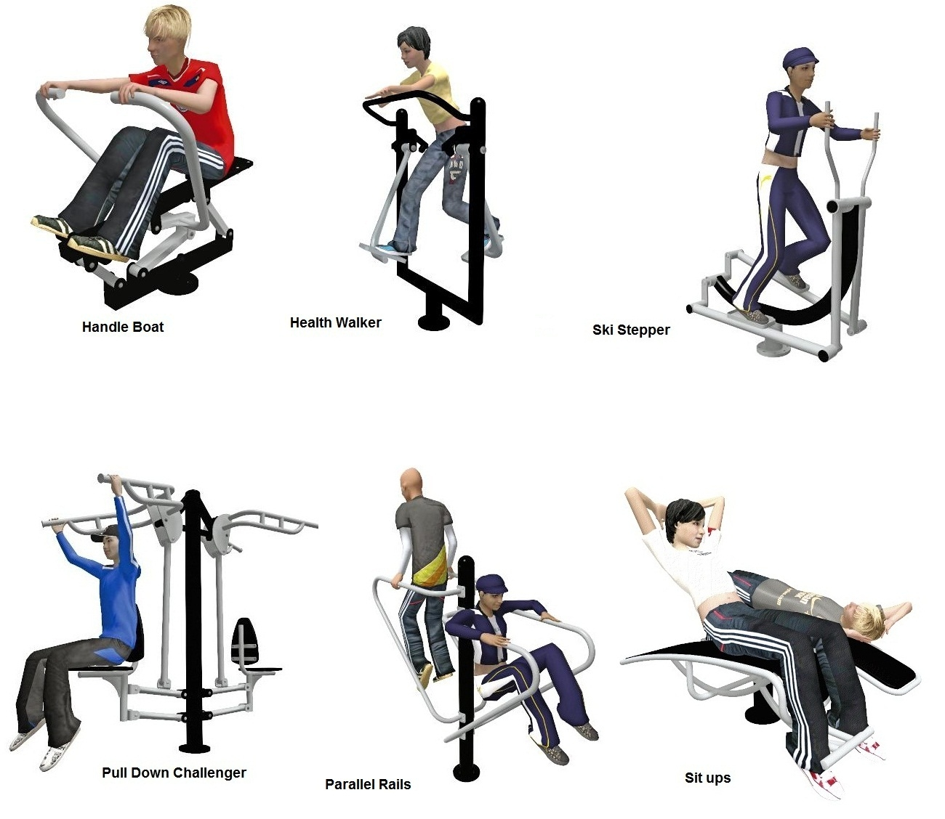

3. BACKGROUND

  - At the March Executive meeting Members approved that the budget delivery framework used in the three previous budget rounds be used for the preparation of the 2014/15 budgets. Specifically, members approved;

“that the same methodology be applied to the formulation of the 2014/15 budget as it applied to the 2013/14 budget, with particular reliance on:-

- the existing guiding principles

- the existing modelling for recovery principles

- the existing budget containment strategy

- the existing eight workstreams”

  - The strategy has to date proved extremely successful and helped provide additional flexibilities from which to address the national funding challenges that face all local authorities.

  - This overall strategy provides the cornerstone on which the Council's long-standing success in both setting a ‘balanced budget’ and delivering within budget are founded. The framework consists of eight workstreams – as illustrated below:


Capital
Review
Service Plans
Fees and
Charges
Review
Prioritisation
Innovation
Group
Staff
Suggestions
Partnership
Working
Lobbying
Budget
Delivery
Framework

  - The financial strategies key ‘guiding principles’ supplemented by the ‘Modelling for Recovery Principles’ and the ‘Budget Containment strategies’ have provided a strong cornerstone for the Council’s medium term financial strategy. For ease of reference, these are reproduced here:-

Financial Strategy Guiding principles:

- Revenue balances should not fall below £1m and overall revenue reserves should not fall below 10% of net revenue expenditure;

- In setting the Council Tax, members should consider the medium term to ensure that a sustainable budgetary position is preserved (with due regard being given to any penalties that might apply);

- The level of household Council Tax to increase each year in line with inflation at least, where the budget is in deficit, to ensure resources remain consistent with budgeted costs;

- When setting the Capital Programme, consideration is given to allocating capital resources to schemes that are beneficial to the Council’s overall revenue budget position;

- To maximise the resources available to the Authority, the Council will actively lobby the Government on relevant issues (e.g. grant distribution/ planning fees).

Modelling for Recovery principles:

- Wherever possible, continue with all planned investments and programmes, to protect the local economy and lever in other investments;

- Given the strength of our Treasury position we should consider debt funding as a means of programme delivery or stimulus – if this can be shown to be sustainable and have a wider economic benefit;

- Organise our fiscal structures and business models to attract and retain the maximum amount of revenue within the local economy;

- To ensure all possible avenues are used within procurement rules to source locally;

- Protect the performance of Council services which come under particular strain;

- Work closely with partners in the voluntary, public and private sectors, to ensure optimum efficiency

Budget Containment Strategy:

- Where a specific grant which funds a specific service is withdrawn, the service stops;

- Where grant funding reduces, which Kettering Borough Council passports through to another organisation, the reduced sum continues to be passported, providing the end recipient organisation feels it can still provide a value-added service at that funding point.
- Where a function is transferred to another provider, the Council leaves all service-provision discussions, including any top-up funding, with the new provider;

- The Council would ordinarily neither seek to buffer nor profit from tax changes.

- The Council should not substitute itself as a provider / funder of services when another public provider cuts such a service.

4 BUDGET UPDATE

GENERAL FUND 2012/13

  - The Council is on course to complete the detailed closure of the financial accounts for 2012/13 by the end of June.

  - This is a very technical process that requires much care and attention. The draft accounts must be compiled by 30th June so that they can be submitted for external audit validation.

  - The audit process will begin on 1st July 2013. The Council will be one of the first to be audited as has been in the case in previous years. The 30th September is the statutory deadline for the audit opinion to be published.

  - Members will recall that when the 2012/13 revenue budget was approved, efficiency savings of £1,330,000 were required. The progress that the Council has made against this target has been the subject of monthly reports to this committee throughout the year – it was confirmed earlier this year that the Council had successfully achieved its target. These were identified and are detailed in Table 1;

  - In addition to achieving the original challenging efficiency savings target, it was reported in the March Executive report that further savings in the region of £750,000 were estimated in excess of the figures approved at revised budget time. These were a combination of one-off and ongoing items. The final outturn figures will be reported to this committee during the summer as part of the durable budget report. Significant work is still ongoing to ensure that the correct figures are validated for big money items such as benefits subsidy and internal cost allocations prior to a technical assessment for items such as debt provisions. The ongoing national changes to the welfare system make this process even more important than ever.

  - In line with the previously agreed policy position of the Executive Committee, any variance in excess of the original £1.3m target will be used to increase earmarked reserves to help provide additional flexibility and protection against business risks / threats.

HOUSING REVENUE ACCOUNT

  - The Housing Revenue Account’s budget for 2012/13 was £14.3m and the provisional outturn for 2012/13 was around £100,000 higher than the budget. The variance between the budget and actual spend was largely due to an increase in voids.

  - Table 2 summarises the projected outturn for the Housing Revenue Account.

  - There has been significant changes to the HRA whereby the subsidy system of housing finance was replaced with a new ‘self financing’ system. In effect, this meant that rather than the Council making a payment to the national housing pool each year (which was £4.367m in 2011/12) the Council had to take on a proportion of the national housing debt. The Council was required to take on debt of £72.9m under the self financing regime.

CAPITAL PROGRAMME

  - Overall, the provisional outturn for 2012/13 was £4.135m compared to the revised budget of £6.908m (i.e. 60% of the approved programme was actually spent).

  - The overall provisional Capital Programme spend will be within 97% of the net budget after taking account of budget carry-forwards.

GENERAL FUND – 2013/14

  - From the recent budget process, Members will recall that additional ongoing savings of £949,000 are required for 2013/14.

  - The early delivery of framework savings and the additional one-off items have resulted in the Council being in a better position from which to move forward. When these are translated into a full year, this means that approximately £350,000 of the savings that were required for the current year have been identified and are being delivered ahead of schedule. This is very encouraging and has justified the faith that members have shown in the Council's budget delivery framework to deliver the savings required. The remaining savings have also been identified in Table 3 and the council is on track to deliver these in the required timescale.

  - Whilst the savings made give confidence that the Council remains “ahead of the curve” in delivering the Medium Term Financial Strategy. Members have previously been advised about the unprecedented scale of uncertainty that currently exists in the period from April 2013.

  - Overall (when compared to many local authorities), the projected outturn for the General Fund continues to look encouraging for the following reasons;

- The guiding principles, modelling for recovery principles and the budget containment strategy are being adhered to by the Executive;

- The budget delivery framework has successfully engaged staff at all levels;

- The early delivery of the savings required for 2013/14 allows attention to be turned to savings for future years;

- Additional flexibility and resources have been secured to help pump prime delivery of future years’ savings and protect against possible future burdens.

  - Whilst the savings made give confidence that the Council remains “ahead of the curve” in delivering the Medium Term Financial Strategy. Members have previously been advised about the significant changes to local government funding and the risk transfer from central government to local government. Such risks include:

- Business Rates Volatility (Government Grant Levels)

- Council Tax Benefits Volatility

- Spending Pressures

GENERAL FUND – 2014/15

  - Table 3 illustrates that, through close engagement with well motivated front-line staff, savings through staff suggestions / innovation have generated savings of around £½ million for 2013/14.

  - The positive engagement with staff will remain a key factor moving forward if we are to remain successful in meeting the budget challenges that we face – our recent experience is testament to the advantages of remaining a flexible and nimble organisation that is light on its feet.

  - As well as monitoring framework savings identified for 2013/14 work continues on identifying savings for the following year – 2014/15. Members are reminded of the current Medium Term Financial Forecast which required an additional £1,250,000 of savings to balance the budget in 2014/15. Approximately £250,000 has already been identified (although not delivered) and work will continue to try and close the remaining gap as the year progresses.

  - During the budget process, members were informed of a number of ‘big ticket’ items. These are typically items of large value that could have a disproportionate impact on the Council's budget if they moved in an adverse fashion. Consequently these are monitored very closely and members and officers may occasionally try to influence (through lobbying) any changes that may take place especially when such changes are triggered through changes in national policy. These items are included in the Councils Swing – o – meter as detailed at Appendix A.

  - The Council’s current Medium Term Financial Forecast is reproduced in Table 4 for information.

Notes to Medium Term Financial Forecast

1 Net Council Budget – This represents the net expenditure prior to the Budget Framework savings.

2 Forecast Resources – These are the Council's main funding streams (excluding fees and charges which are incorporated into Line 1). This illustrates the significant reduction in Central Government Grant and introduces a new line from 2013/14 for the Council Tax Support grant. Following future government announcements the presentation of this will be reviewed but it is thought likely that overall the figures we are modelling on, may be in the right area but the split between years may be different. To enable the total resources required to balance the budget to be identified, no assumptions have been made regarding future council tax increases. The small increase in revenue each year reflects anticipated housing growth in the borough.

3 Budget (Surplus) / Deficit – This illustrates the gap between the budget and the total resources available before identifying budget framework savings.

4a Council Tax Grant – This is a grant the Council receives from central government for four years in return for freezing Council Tax in 2011/12. This is equivalent to the cash that would have been received if a 2.5% increase had been levied.

4b Council Tax Grant 2012/13 – This is a grant the Council receives from central government for one year in return for freezing Council Tax in 2012/13. This is equivalent to the cash that would have been received if a 2.5% increase had been levied.

4c Council Tax Grant 2013/14 – This is a grant the Council receives from central government for two years in return for freezing Council Tax in 2013/14. This is equivalent to the cash that would have been received if a 1% increase had been levied. A Council Tax Freeze has ongoing implications as an increase in Council Tax generates income year on year.

5 Budget Frameworks – This identifies the total savings required and differs to the table shown in 4.5 as a result of the Council decision earlier in the year in relation to members allowances.

6 Savings to be secured – This identifies the total resources required to balance the budget in future years after 2013/14.

  - By reference to Table 4, it can be seen from line 5 that the Council has identified ongoing budget savings of £250,000 in order to set a balanced budget for 2014/15 further ongoing savings of £1m are required.

  - As reported to the April Executive the Government will publish individual departmental budgets on 26 June 2013. This will provide the high level numbers for individual government departments but not the amount that will be received by individual authorities. This will be announced at a later date. We continue to try to influence future years.

  - Given that the next CSR announcements are timetabled for the 26th June, it seems likely the medium term will only really begin to become clear later in the summer, any announcements will be included within future durable budget reports.

  - Members are reminded that the Council is currently modelling the reductions in grant outlined in Table 5.

Table 5 | 2014/15 | 2015/16 | 2016/17 | 2017/18
Grant Reductions | (13.3%)  (£697,000) | (7%)  (£318,000) | (7%)  (£294,000) | (7%)  (£276,000)

  - Whilst the level of grant reductions detailed in Table 5 have been reflected in the Council’s Medium Term Financial Strategy (Table 4) it is the amount at Line 6 in the Medium Term Financial Strategy that identifies the total resources required to balance the budget from 2014/15.

5 CONSULTATION AND CUSTOMER IMPACT
5.1 None as a direct consequence of this report. However members are reminded that the formal budget consultation period is from 15th January 2014 to 26th February 2014 when the Council sets its Council Tax for 2014/15. Comments from the consultation process will be reported to the Executive for consideration at it’s meeting on 12th February 2014.

6 POLICY IMPLICATIONS
6.1 None as a direct consequence of this report.

7 USE OF RESOURCES
7.1 As detailed throughout this report.

1
8. RECOMMENDATIONS
That the Executive;

  - Note the success the Council has achieved in attracting external funding:

  - Note the Council’s Medium Term Financial Strategy and associated guiding principles;

  - Note the Council’s current Medium Term Financial Forecast and the progress being made for the delivery of efficiency savings for 2013/14 and future years;

Background Papers: Previous Reports/Minutes:
Title of Document: Estimate Working Papers Monthly Durable Budget Reports Contact Officers: M Dickenson

