1 PURPOSE OF REPORT

- To provide an update on the Phase 4 of public realm improvements

- To provide an update on ‘The Yards’ development

- To discuss Purple Flag

- To update on business engagement project

- To introduce Chimichangas to Kettering

- To set out the Capacity Funding secured

2 BACKGROUND INFORMATION

2.1 Kettering Borough lies within the South East Midlands, which is predominantly a growth area, and is expected to facilitate growth of some 13,100 homes and 16,200 new jobs by 2021.

2.2 Members have made their priorities for infrastructure and jobs-led growth clear – these are the prerequisites of growth. Members have indicated they wish to use the growth agenda to leverage three key and interrelated ambitions for the borough; namely:-

- A better offer for our town centres
- A better education and training offer
- A better employment offer – high grade, higher density jobs

  - The mutually supportive role of these three aspirations cannot be over-stated. The town centres and the skills base will be persuasive to inward investors. Similarly, high grade employment supports vibrant town centres.

  - The Council has a vision to create town centres that are Characterful, Distinctive, and Fun. This vision has been externally validated by an independent planning inspector, and now sits firmly within our planning policy for Kettering Town Centre.

- PHASE 4 PUBLIC REALM CONSULTATION

  - On Wednesday 20th February 2013 we formally opened consultation on the next phase of Public Realm Works.

  - We have started the process of improving the High Street, to continue with the award winning projects delivered through Market Place, Sheep Street, Market Street and Horsemarket.

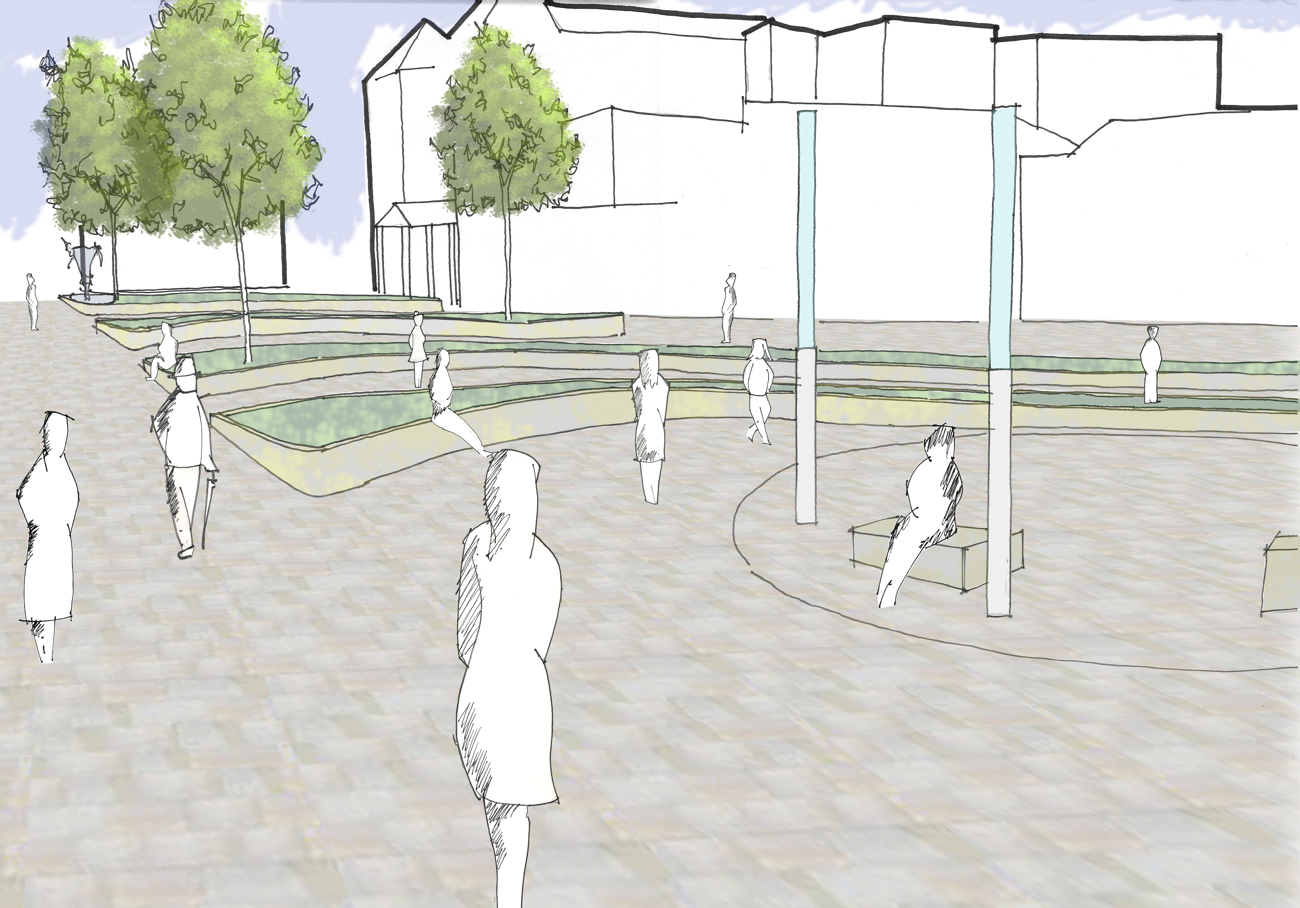
- Reduce traffic in High Street and Gold Street
- Improve the pedestrian and shopping areas
- Allow more events and markets to take place on the street
- Encourage more on-street dining (a ‘café culture’)
- Attract further private investment

  - Northamptonshire Highways have worked on designs on behalf of the Council and have delivered some exciting proposals that are viewable on the website, and will be displayed within a town centre shop unit for the next few weeks. There are three concepts for improving the High Street (inc. Gold Street, Lower Street and Meadow Road) and four options for a town square on the junction of High Street, Gold Street and Lower Street.

  - There has been a very good response to the proposals from the public, with one clear favourite in terms of the main body of the public realm and in terms of the new town square. The use of a town centre shop to help advertise the project was invaluable, as Members will attest from their own attendance within it! It was essential we got as much feedback as possible at this stage, as it will enable us to deliver a preferred design that provides the town centre that Kettering deserves.

  - This phase of consultation ended on Friday 22nd March 2013. We are currently working with Northamtponshire Highways to bring forward a preferred option – which will include a phasing plan for the implementation of the proposals. There has been a clear winner in terms of the public vote – Concept 1 of the High Street, Gold Street, Lower Street and Meadow Road design; and Option 2 of the new town square design. Furthermore, it is clear that disabled parking bays at Gold Street, Lower Street and Meadow Road are the preferred option.

- THE YARDS DEVELOPMENT SITE

  - As you are aware, Kevin Jones was selected as the preferred developer for the important Soan’s Yards (‘The Yards’) development within Kettering town centre. Since then, a planning application has been submitted and is in the process of being determined. You will also have noticed the hoardings that have been put up around the site – including exciting artists impressions of what the built out scheme will look like. We’re working with Mr Jones to deliver a marketing strategy that makes the most of what the scheme has to offer – and brings some added value to existing businesses along Market Street and Horsemarket too.

  - The aim for The Yards development is to create a distinctive destination within the town that delivers niche, independent retail outlets alongside an anchor restaurant/bar. This will bring something new to the town centre – something that will create a higher degree of footfall along Market Street, Market Place and Horsemarket.

  - The redevelopment of this key site within the town centre is also an important marker in terms of Kettering’s ambitious growth plans. Despite the national economic climate, we have thus far been able to make great strides towards the town centre that Kettering deserves, with the redevelopment of the Market Place and Market Place Buildings among other notable success, and The Yards will no doubt prove to be another important step along that path.

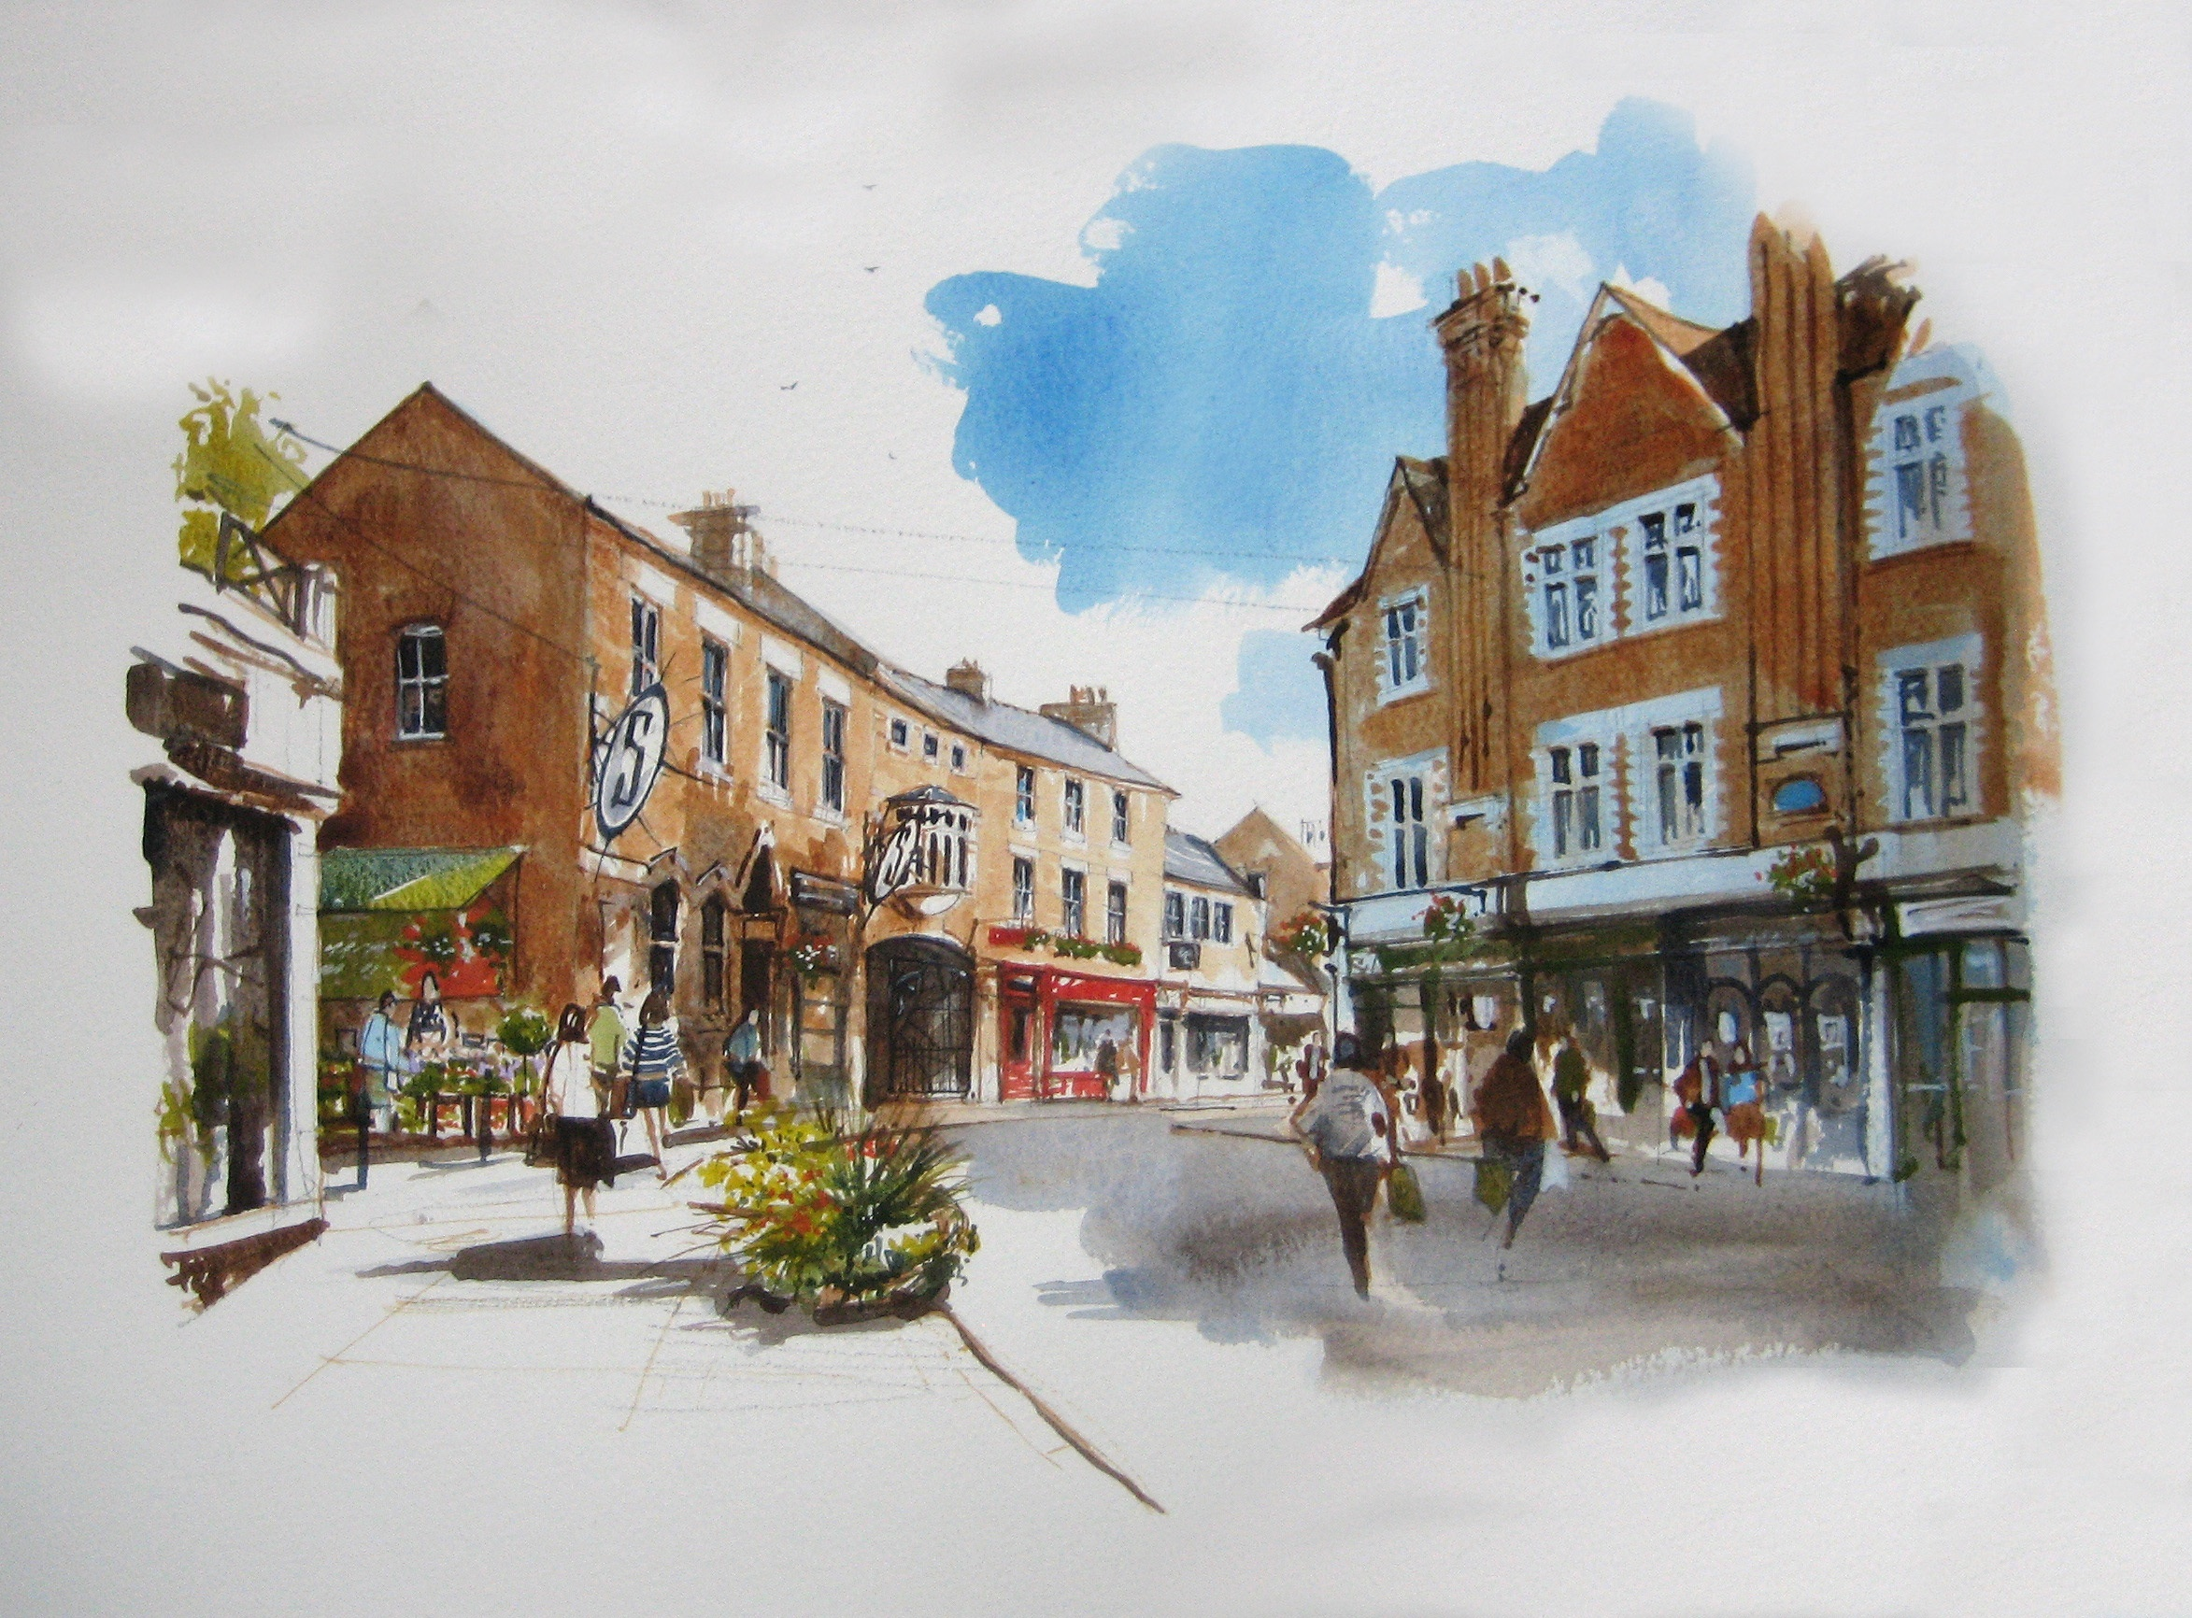

  - We’ll come back to update you with news on the progress made over the next few months.

- PURPLE FLAG

  - Members will know that Kettering Borough Council was successful in securing £10k of funding for a ‘Town Team’ initiative following the Mary Portas Review and pilot scheme process. Our bid was deliberately broad-minded, so as to ensure that we could use the money in the most suitable manner.

  - The preferred approach is to use the funding to go through the ‘Purple Flag’ process. Purple Flag is set up by the Association of Town Centre Management to focus on improving towns’ night time economies. We are working with partners to develop a bid that would look to improve the offer within the town so as to attract a greater proportion of the population from the surrounding areas into the town centre at night.

  - A recent meeting with town centre licence holders was well attended and provided positive feedback on the idea. Further discussions with businesses and partners will take place and Members will be kept informed of progress.

  - A ‘Kickstart Workshop’ was held on 22nd May for KBC staff – a further one will then be organised for colleagues from key partner organisations like the Police, Street Pastors, NHS, and our private sector partners – town centre landlords, taxi firms, etc.

- BUSINESS ENGAGEMENT

  - We have been working with our colleagues in SEMLEP to set up a survey of 250 businesses within the borough – part of a wider SEMLEP survey, that will bring about useful cross-boundary comparisons as well as build on our understanding of the businesses within the borough.

  - The surveys were undertaken by Public Perceptions Ltd, based on questions devised in conjunction with KBC staff. Questions include reference to any support the business has had from KBC or other organisations, growth aspirations, difficulties being faced, etc. Public Perceptions have undertaken similar surveys on behalf of Central Bedfords’, our SEMLEP partner, for the last 4 years. The surveys were carried out over the last month, and a final report will be presented to us in the month.

  - The 250 businesses have been selected based on a demographical study of the borough to make sure that they are representative of the overall total. The study looked at the size of the business in terms of numbers employed, and the sector of industry they work within.

  - Alongside this, an open online survey was made public on our website – so that any business who wished to be included can be. The report will be balanced to ensure that it remains representative, via a very complicated bit of statistical analysis!

- CHIMICHANGAS COME TO KETTERING!

  - Chimichanga, the nationally acclaimed Mexican restaurant chain, has signed a deal with Kettering Borough Council that will see it open a new restaurant in Kettering’s Market Place. The Mexican restaurant will be situated in Unit 1, Market Place Buildings next to the already well established Prezzo restaurant.

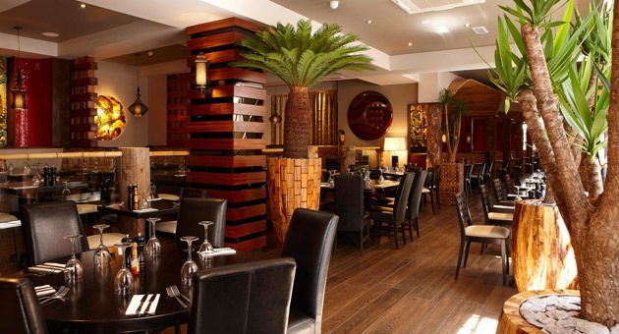

  - The signing of the deal marks the full occupation of the Market Place Buildings, part of the award winning development that was built as part of Kettering’s ongoing rejuvenation programme.

  - Chimichanga has a reputation for providing a family friendly and fun environment with good value, quality food. Chimichanga operations director, Peter Morrison, said:

“We are looking forward to opening our restaurant within Kettering’s Market Place. We believe that Chimichanga will appeal to people of all ages and be a great asset to the town’s social scene.”

  - Fit out works for the new restaurant is expected to commence within the next few weeks with an expected completion date late summer / early autumn this year.

- CAPACITY FUNDING SUCCESS

  - KBC has been successful in a bid for £1.171m of capacity funding from the Department for Communities and Local Government. The funding provides three distinct things – £334,500 for Technical work and design of a new junction on the A14 (associated with East of Kettering SUE); £297,500 for Technical work and design of the ‘Weekley Warkton Avenue’ (again, associated with East of Kettering SUE); and £538,000 towards staff resource to ensure the delivery of the ambitious growth proposed over the next few years. This last element was granted alongside a commitment from KBC to continue to put existing capacity into the project.

  - The use of the staff resource funding was set out in the funding bid, with areas to be covered including marketing, planning, finance, project management and administration. We’ll be meeting over the next few weeks to finalise the posts and get the ball rolling in terms of recruitment.

- POLICY IMPLICATIONS AND USE OF RESOURCES

  - Members have made their priorities for infrastructure and jobs-led growth clear – these are the prerequisites of growth. Members have indicated they wish to use the growth agenda to leverage three key and interrelated ambitions for the borough; namely:-

- A better offer for our town centres
- A better education and training offer
- A better employment offer – high grade, higher density jobs

  - The projects outlined above are, in essence, about delivering a better borough. This vision has been externally validated by an independent planning inspector, and now sits firmly within our planning policy for Kettering Town Centre.

10 RECOMMENDATION

That the Executive Committee:

  - Supports the continued efforts with regard to Phase 4 of the Public Realm, and recognises the importance of ensuring that the feedback from the current public consultation is fed back into the design to deliver the town centre that Kettering deserves.

  - Recognise the importance of delivering the Soan’s Yards site (‘The Yards’), and support the hard work being undertaken by all parties in ensuring that it is delivered in the near future.

  - Welcomes the prospect of a successful Purple Flag bid, and understands the significant work being done to ensure that it is delivered.

  - Endorses the business survey and welcomes the prospect of a deepened understanding of our businesses.

  - Joins us in welcoming Chimichangas to Kettering, and recognises the successful completion of the Market Place Buildings project

  - Notes the successful bid for capacity funding, and appreciates the need to continue ensuring there is sufficient resource available to deliver the Council’s ambitious growth plans.

