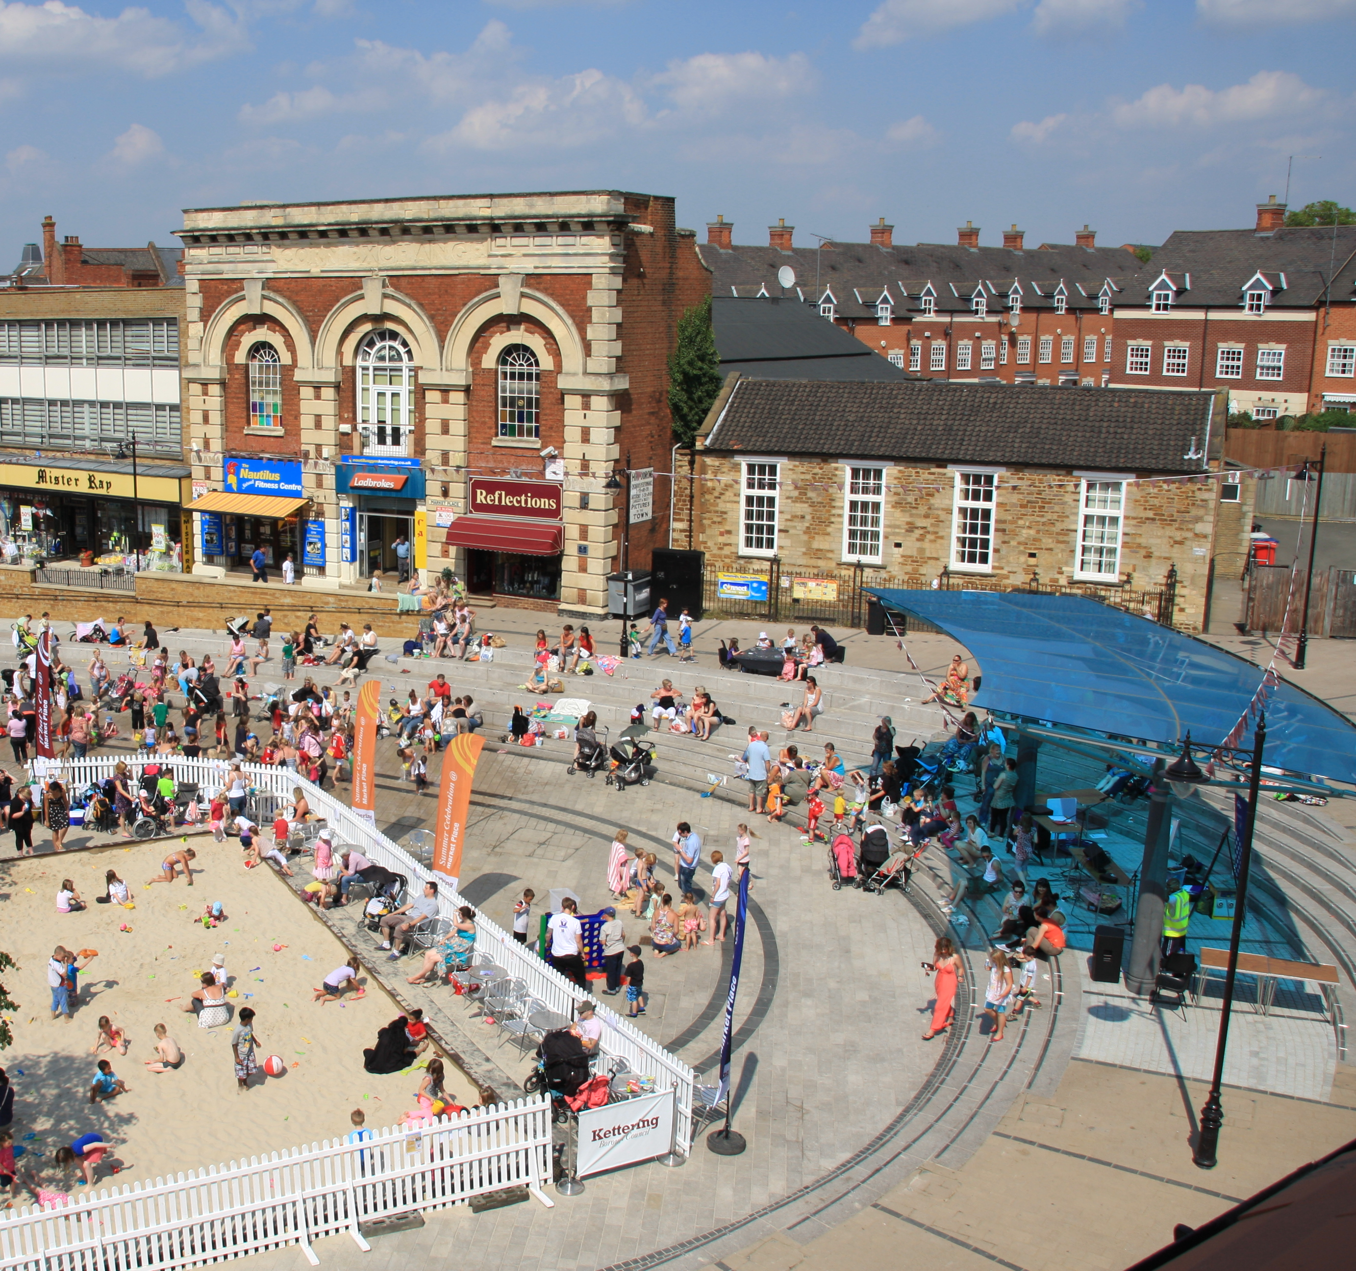

Sustainable Community Strategy
2013 – 2016

Our Borough, Our Future

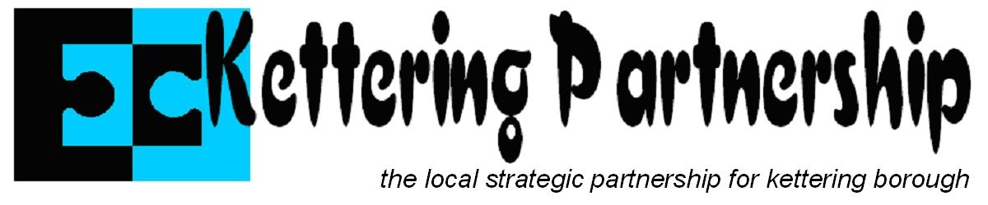
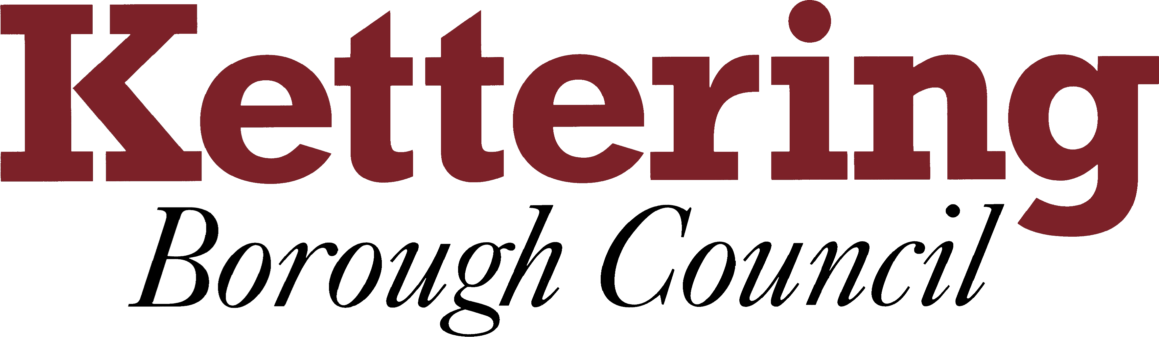

Introduction

Welcome to our Sustainable Community Strategy for our Borough. In this economic climate, we all face unprecedented challenges. Local services are under increasing pressure and it is even more important for us to find a way of working together. Locally, we have a total commitment to sustainable communities and I am proud to chair the LSP which offers a team approach to this work.

I would like to express my gratitude to all those that helped this strategy and I am confident that together we will continue to deliver a better future for our people.

Regular monitoring of the Strategy’s targets will be undertaken and progress reported to the LSP Board.

Behind each of the objectives in this document are detailed Action Plans which provides more information on how we will achieve these objectives.

If you would like to find out more about these objectives or want to know how you could get involved, please visit www.kettering.gov.uk or ring 01536 410333.

Chair of LSP
Cllr Russell Roberts

Our Borough, Our Future

Central Government requires every Local Authority to produce a Community Strategy. Its role is to focus the work of the Partnership to address local issues. These issues have been identified through a number of sources including various consultations carried out by Kettering Borough Council, a Partnership Conference last October and key planning documents as well as comments and suggestions that you’ve made to us.

Every time you’ve contacted your local Councillor, completed a questionnaire about local services, spoken to the police or made any comments or raised a query about something, you’ve help the Kettering Partnership develop this strategy.

Using all of the information we’ve gathered, four themes have been identified and the Partnership has developed targets which it wants to achieve. The next few pages show what the Kettering Partnership will work towards over the next 3 years.

Our Borough

The Borough of Kettering covers an area of approximately 23,000 hectares and is situated in the heart of England. It is characterised by beautiful countryside and market towns, and has a population of over 93,000. The principal town of Kettering has a population of 67,635 and is surrounded by three smaller towns lying on the A6. There are a further 27 villages in the borough, mostly with small populations. Kettering is situated on the A14 and lies between the A1 and M1 corridors with excellent road and rail links to the rest of the country. London is less than an hour away on the train.
Our vision for our Borough

“The best place in England to grow”
We want our Borough to be recognised by everybody as a successful borough where people and communities want to do well, where they take up new ideas and trends, but also celebrate history, heritage and local identity. It will be a borough where people will want to invest, work and enjoy life.

- By 2020 by managing growth carefully, Northamptonshire will have become the leading economy of the East Midlands and a model example of sustainable development.

- By building on the skills and ambition of our varied and growing population, and by making the most of our location.

We have the following aims for Kettering Borough

- We aim to be successful through sustainable growth and regeneration, by making sure that:
  - residents live in housing that is sustainable, affordable and of good quality;
  - we have the right infrastructure such as roads and health service provision to deal with new growth; and
  - we can improve and preserve buildings and the countryside for future generations.

- We aim to develop through having a growing economy with more skilled jobs, where:
  - we encourage and support employers to create the right number, quality and distribution of jobs;
  - workers have the right skills to respond to the employment needs of a dynamic economy; and
  - residents have the opportunity to learn throughout their lives.

- We aim to have safe and strong communities, where:
  - residents have a shared identity and are involved in developing their communities;
  - levels of crime and disorder are lower in all our neighbourhoods; and
  - public services meet the needs of residents.

- We aim to have healthy people who enjoy a good quality of life. To do this we will:
  - support vulnerable people to help them lead fulfilling lives
  - help young people to have the best possible preparation to become adults; and
  - help residents to make choices that improve their health and quality of life.

Kettering Partnership

The Kettering Partnership brings together key organisations that, by working together, can address issues in an integrated and innovative way. Kettering Partnership includes the following organisations:

- Kettering Borough Council
- Northamptonshire County Council
- NHS Nene Clinical Commissioning Group
- Northamptonshire Police
- The Business community
- The Voluntary & Community Sector
- Education and Skills providers
Our Future

Growth and regeneration

The Borough of Kettering is due to expand with more than 13,100 new homes and 16,200 new jobs being created by 2021. In Kettering town centre, we have well developed plans to redevelop key areas of town, improve the public realm and attract in significant new development, whilst at the same time building on the character and heritage that the town already offers.

Some of these plans have started to bear fruit; the award winning Market Place redevelopment, the Sheep Street, Market Street and Horsemarket public realm work. Others are coming forward at the moment, including the development of Soan’s Yard, the High Street, Gold Street, Lower Street and Meadow Road public realm designs and the improvements due to be made to the Newlands Centre.

Planning policies have been developed which will guide the development of urban extensions in all our towns and which will govern the quality, design and sustainability of new development, and provide new public open space. The East of Kettering SUE, comprising 5,500 homes is on track and commencement should begin in 2013.

We have successfully lobbied Government to invest in infrastructure in the Borough with £xxxm provided for the widening of the A14 between Junctions 7 and 9 and £xxxm invested in the electrification of the railway line through the Borough. Both of these important projects are due to commence in 2013.

This approach, growth alongside the delivery of key infrastructure will continue into the future, as we understand the importance of doing so. We are working with others to support new businesses and to develop an office hub around the station, alongside new business parks adjacent to the A14 and the A6. We’ve also enabled the successful development of Academies to replace two secondary schools.

We are working with the relevant agencies to secure major investment in both. We want to:

- Secure new and protect existing open spaces

- Work with developers to obtain the best schools, sport, leisure and community facilities, community groups, libraries, transport, and public art as well as improving the biodiversity of the borough

- Increase the employment land available within the strategic context of Northamptonshire

You’ll know we’re achieving these objectives when:

- Agreements through the planning process for new quality green open space are secured
- Land and funding obtained from developers for a range of community facilities and services of the expected quality that are needed because of major housing extensions
- Employment land is allocated in areas which support sustainable communities

Did you know…?

Can we have a key fact in here and then I will source the relevant image

Town centre

Developing a new town centre will not be enough. Any “new” development will soon be eclipsed by a newer one elsewhere. Internet shopping patterns are changing – rapidly. (Recent research has indicated a one third increase in internet retail spend, compared with around 3% for the traditional retail sector.) Functional shopping will not be sufficient in itself.

For a market town to compete it must offer something else. It must be a rounded experience with lots to offer. This leads to a few key principles:

- Any redevelopment should be characterful to reflect the locality
- The quality of design must be high
- Material quality must be high
- In creating a characterful experience, distinctive zones are advantageous

More detailed information on Kettering Town’s development can be found at www.kettering.gov.uk

Building on the success of what we’ve done so far, we want to:

- Create a vibrant heart for Kettering; a place that is characterful, distinctive and fun. The Town Centre will become a focal point for North Northamptonshire

You’ll know we’re achieving this objective when:

- Kettering Town Centre’s retail offer is improved
- A high quality public realm is developed through High Street, Meadow Road, Gold Street and Lower Street
- The Soan’s Yard development is completed
- The town gains Purple Flag status for an improved night time economy
- Burton Latimer Town Centre is regenerated
- The Rothwell and Desborough Urban Extension Area Action Plan is published

Did you know…?

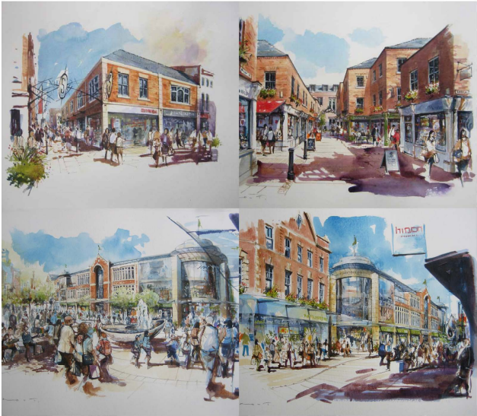

Can we have an interesting fact about the Town Centre

Skills, education and employment

Kettering is experiencing significant housing growth but this needs to be side by side with an increase in jobs.

Kettering benefits from an excellent logistical location but jobs need to be focused on all sectors, with an emphasis on increasing skills and encouraging higher value added activities. We want to increase earnings to a least the national average and have more people who achieve higher level qualifications

We want to:

- Increase the skill levels of the borough
- Help new businesses thrive through access to excellent quality accommodation and support
- Encourage high quality jobs to the borough

We have started work on achieving these objectives by:

- Opening Chesham House Business Centre offering quality, affordable, office and meeting space for local businesses. Working with partners to deliver on site support including:
    - weekly enterprise club
    - executive job club
    - free legal and accountancy session

- Providing funding for the University of Northampton to develop a business support package based at Chesham House commencing April 2013. The focus is to provide micro and small businesses with access to face to face business support and enterprise coaching.
- Supporting Kettering Borough Training in promoting apprenticeships as a valid alternative to full time education and to support both local businesses and local young people to achieve their full potential.
- Holding an annual apprenticeship and jobs fair with local partners and businesses

- Supporting the development two brand new academies in Kettering. Kettering Buccleuch Academy and Kettering Science Academy opened in 2012 seeing an investment of over £50m.
- Working with other local authorities to could support the education sector in developing a more skilled and employable workforce.
- Continuing to support the development of Tresham College with initiatives such as new Employability Centre opened in February 2013 dedicated to supporting full time students who are studying at the college to find work and guaranteed interviews for employment or apprenticeships each year.

You’ll know we’re achieving these objectives when:-

- More new businesses and enterprises are being set up
- More businesses are accessing business support
- More of the working population are qualified to at least level 3 or higher


Did you know…?

Tresham College in Northamptonshire is
to become a Peter Jones Enterprise
Academy Provider

The academy offers BTEC Level 3 in Enterprise and Entrepreneurship; the first qualifications of their kind for 16-19 year olds in the UK.
The Enterprise Academies offer a unique approach, focusing on learning by doing and supporting and encouraging students to realise their ambitions and to turn their own business dreams into reality

Community safety

Community safety means crime reduction, crime prevention and much more. We recognise that we should focus attention not only on efforts to reduce or prevent crime and disorder, but also on introducing social and economic change as a way of preventing crime and disorder from taking place. Community safety activities will aim to reduce offending behaviour, and also the harms experienced by individuals and communities because of crime and disorder, and will seek to improve their quality of life through efforts to change the wider physical and social environment.

In Kettering Borough we are fully committed to working together in partnership with a large number of statutory agencies, voluntary organisations and the business community. Involvement of the local community is also essential in making Kettering Borough a safe place to live, work and visit.

We want to build safer communities by:

- Tackling anti-social behaviour, focusing on responding to repeat victims and repeat neighbourhoods and acknowledging all communities
- Tackling violence, with a focus on alcohol and substance abuse and domestic abuse
- Reducing re-offending, focusing on drugs and alcohol and serious acquisitive crime, in particular domestic burglary and vehicle crime

You’ll know that we have achieved success when:

- The aims and objectives of the Community Safety Partnership Plan are met. For more information please call 01536.

Did you know…?

Can we have an interesting fact about Community Safety and then I’ll source an image
Health and wellbeing

The health of people in Kettering Borough is generally better than the England average. But there are health inequalities by gender, level of deprivation and ethnicity. For example Avondale and Warkton areas are relatively deprived and men in the most deprived group have 6 years shorter life expectancy than those in the least deprived group.

Keep Healthy@ Kettering provides a range of services to reduce health inequality. Early deaths from cancer, heart disease and stroke have decreased over the last 10 years and remain close to the England average. Smoking still kills about 130 people in Kettering each year. While there are already a number of excellent opportunities for people to take part in active recreation overall participation rates amongst our residents are low.

Kettering has an established Health and Wellbeing Forum, which links locally with the LSP and at County Level with the Health and Wellbeing Board. The Forum is made up of representatives of KGH, NHFT, Nene CCG, KBC, NCC, Public Health, Patient Representatives, Local Voluntary Sector. The key strategies for the Forum are:

Focusing On:

- Healthy Business
- Healthy Lifestyles
- Healthy Homes
- The Elderly and Vulnerable

You’ll know we’re achieving these objectives when:

- We have developed a reporting matrix with Public Health to demonstrate effectiveness in these areas and areas relating to the Health and Wellbeing Board.

Did you know…?

Can we have an interesting fact about Health and Wellbeing in here and then I’ll source an image



