1. PURPOSE OF REPORT

The purpose of the report is to:
- Provide Members with a case study on attracting external funding.

- Provide a reminder of the Council’s medium term financial strategy and associated guiding principles;

- Highlight the success of the Council's financial strategy;

- Provide an update of the delivery of efficiency savings for 2012/13, and 2013/14;

- Provide an update following the recent national budget announcement;

- Provide Members with an update on the Council’s Empty Homes Strategy.

- CASE STUDY

  - Members will recall that in previous budget reports we have identified case studies as examples of good practice. The previous examples related to the new arrangements for the following:

- Generic warden service
- Recycling pilots
- Kettering Borough Trainers
- Partnership work with the Citizens Advice Bureau.
- VAT recovery
- Prevent Strategy funding
- Flexible Working
- Printing Function
- Market
- Managing homelessness
- Staff Sessions

  - The case study in this report highlights the success the Council has achieved through attracting external funding and engaging with the community.
Case Study - Attracting External Funding to the Borough

A Play Strategy identified the need for increased play facilities in Desborough. As with many of the projects, the Council looked to attract funding from external sources and identified the Government's flagship play policy 'Playbuilder' as one possible source. The Council applied for and received £49,000.

In delivering the project the Council worked with the local community and used ideas provided by children from the local Junior School. A conceptual design was generated based on a 'Flintstones' type play area, whereby the play area is all wood and stone (apart from the dual slide). The park also has a bespoke sleeping dinosaur made from solid oak which was produced by a local artist and a large 3 meter diameter snakes and ladders style game made from mosaic tiles which is laid flat on the ground on a concrete base.
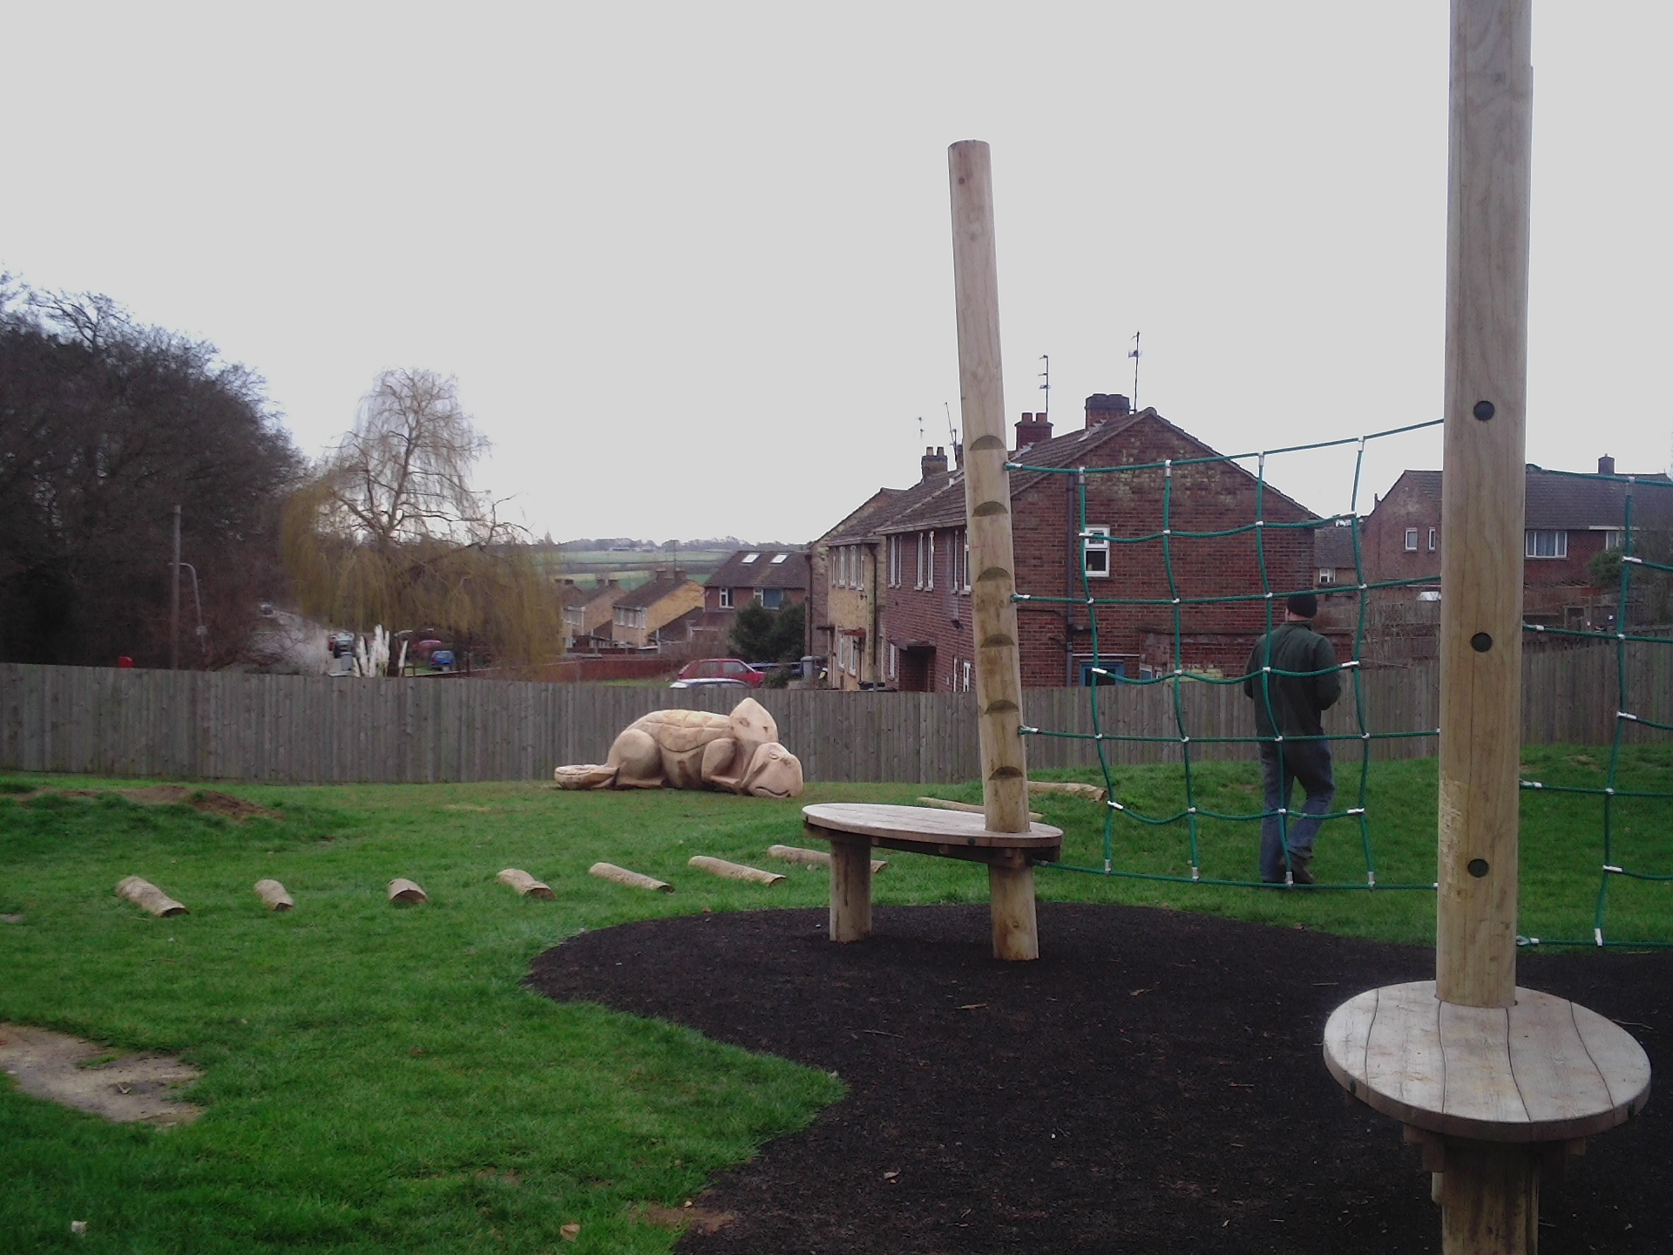
The play area has been very well received and the children are delighted as are the school for being given such a key role in the development of the area. The play area provides space with a focus on imaginative 'game playing'.

3. BACKGROUND

  - At the March Executive meeting Members approved that the budget delivery framework used in the three previous budget rounds be used for the preparation of the 2014/15 budgets. Specifically, members approved;

“that the same methodology be applied to the formulation of the 2014/15 budget as it applied to the 2013/14 budget, with particular reliance on:-

- the existing guiding principles

- the existing modelling for recovery principles

- the existing budget containment strategy

- the existing eight workstreams”

  - The strategy has to date proved extremely successful and helped provide additional flexibilities from which to address the national funding challenges that face all local authorities.

  - This overall strategy provides the cornerstone on which the Council's long-standing success in both setting a ‘balanced budget’ and delivering within budget are founded. The framework consists of eight workstreams – as illustrated below;


Capital
Review
Service Plans
Fees and
Charges
Review
Prioritisation
Innovation
Group
Staff
Suggestions
Partnership
Working
Lobbying
Budget
Delivery
Framework

  - The financial strategies key ‘guiding principles’ supplemented by the ‘Modelling for Recovery Principles’ and the ‘Budget Containment strategies’ have provided a strong cornerstone for the Council’s medium term financial strategy. For ease of reference, these are reproduced here:-

Financial Strategy Guiding principles:

- Revenue balances should not fall below £1m and overall revenue reserves should not fall below 10% of net revenue expenditure;

- In setting the Council Tax, members should consider the medium term to ensure that a sustainable budgetary position is preserved (with due regard being given to any penalties that might apply);

- The level of household Council Tax to increase each year in line with inflation at least, where the budget is in deficit, to ensure resources remain consistent with budgeted costs;

- When setting the Capital Programme, consideration is given to allocating capital resources to schemes that are beneficial to the Council’s overall revenue budget position;

- To maximise the resources available to the Authority, the Council will actively lobby the Government on relevant issues (e.g. grant distribution/ planning fees).

Modelling for Recovery principles:

- Wherever possible, continue with all planned investments and programmes, to protect the local economy and lever in other investments;

- Given the strength of our Treasury position we should consider debt funding as a means of programme delivery or stimulus – if this can be shown to be sustainable and have a wider economic benefit;

- Organise our fiscal structures and business models to attract and retain the maximum amount of revenue within the local economy;

- To ensure all possible avenues are used within procurement rules to source locally;

- Protect the performance of Council services which come under particular strain;

- Work closely with partners in the voluntary, public and private sectors, to ensure optimum efficiency

Budget Containment Strategy:

- Where a specific grant which funds a specific service is withdrawn, the service stops;

- Where grant funding reduces, which Kettering Borough Council passports through to another organisation, the reduced sum continues to be passported, providing the end recipient organisation feels it can still provide a value-added service at that funding point.
- Where a function is transferred to another provider, the Council leaves all service-provision discussions, including any top-up funding, with the new provider;

- The Council would ordinarily neither seek to buffer nor profit from tax changes.

- The Council should not substitute itself as a provider / funder of services when another public provider cuts such a service.

4 SUCCESS OF THE COUNCIL'S FINANCIAL STRATEGY
  - The Council has an impressive track record of delivering against its financial strategy. Members and Officers have worked diligently for many years to ensure that the Council’s budget plans are turned into reality and that ongoing efficiencies are made wherever possible. For information, the following chart illustrates the Council's performance in delivering efficiency measures over the past few years;
Cumulative Efficiency Measures total £5.4m

* savings identified are in the process of being delivered.

  - Just over a year ago when the Council set its budget for 2012/13, it did so by identifying £1,330,000 of budget reductions that would need to be delivered during the year. Despite the size of the task, the Council's innovative approach resulted in the required level of savings being identified and delivered during 2012/13 without impacting on front line services.

  - When the Council recently considered the budget for the current year (2013/14), the budget delivery framework needed to identify £949,000 of additional efficiency measures to set a balanced budget for the year. Despite the enormity of the task, the Council was able to set a balanced budget.

  - In terms of setting a balanced budget, the Council’s strategy to date has been successful. It must however be stressed that the budget setting process is only a paper exercise – it still needs to be turned into reality. Careful monitoring of the progress towards delivery is therefore needed and this will be reported to the Executive as part of the Durable Budget report.
5 BUDGET UPDATE

GENERAL FUND 2012/13

  - The Council is currently busy on the detailed process of closing the accounts for 2012/13. This is a very technical process that requires much care and attention the draft accounts must be compiled by the end of June so that they can be submitted for external audit validation. Once audited they are then reported to members for information.

  - It is currently anticipated that the out-turn figures for 2012/13 will be generally in line with those reported to Members through the recently completed budget process. The final outturn figures will be reported to this committee during the summer as part of the durable budget report. Significant work is still ongoing to ensure that the correct figures are validated for big money items such as benefits subsidy and internal cost allocations prior to a technical assessment for items such as debt provisions.

GENERAL FUND – 2013/14

  - From the recent budget process, Members will recall that additional ongoing savings of £949,000 are required for 2013/14. These have been identified as detailed in Table 1;

  - Table 1 illustrates that, through close engagement with well motivated front-line staff, savings through staff suggestions / innovation have generated savings of just under £500,000 for 2013/14. Members will recall the March Executive report included a case study that outlined the significant success the Council has achieved through engaging with its staff.

  - The positive engagement with staff will remain a key factor moving forward if we are to remain successful in meeting the budget challenges that we face – our recent experience is testament to the advantages of remaining a flexible and nimble organisation that is light on its feet.

  - The early delivery of framework savings and the additional one-off items has resulted in the Council being in a better position from which to move forward. Of the £949,000 required savings for 2013/14, approximately £350,000 has already been delivered ‘early’ whereas the remainder have been specifically identified and are being delivered as planned. This is very encouraging and has justified the faith that members have shown in the Council's unique budget delivery framework to deliver the savings required.

  - Overall, the projected outturn for the General Fund continues to look very encouraging for the following reasons;

- The guiding principles, modelling for recovery principles and the budget containment strategy are being adhered to by the Executive;

- The budget delivery framework has successfully engaged staff at all levels;

- The early delivery of the savings required for 2013/14 allows attention to be turned to savings for future years;

- Additional flexibility and resources have been secured to help pump prime delivery of future years’ savings and protect against possible future burdens.

  - Whilst the savings made give confidence that the Council remains “ahead of the curve” in delivering the Medium Term Financial Strategy. Members have previously been advised about the significant changes to local government funding and the risk transfer from central government to local government. Such risks include:

- Business Rates Volatility
- Council Tax Benefits Volatility

  - During the budget process, members were informed of a number of ‘big ticket’ items. These are typically items of large value that could have a disproportionate impact on the Council's budget if they moved in an adverse fashion. Consequently these are monitored very closely and members and officers may occasionally try to influence (through lobbying) any changes that may take place especially when such changes are triggered through changes in national policy. These items are included in the Council's Swing–o–meter as detailed at Appendix A.

  - The Council’s current Medium Term Financial Forecast is reproduced in Table 2 for information.

Notes to Medium Term Financial Forecast

1 Net Council Budget – This represents the net expenditure prior to the Budget Framework savings.

2 Forecast Resources – These are the Council's main funding streams (excluding fees and charges which are incorporated into Line 1). This illustrates the significant reduction in Central Government Grant and introduces a new line from 2013/14 for the Council Tax Support grant. Following future government announcements the presentation of this will be reviewed but it is thought likely that overall the figures we are modelling on, may be in the right area but the split between years may be different. To enable the total resources required to balance the budget to be identified, no assumptions have been made regarding future council tax increases. The small increase in revenue each year reflects anticipated housing growth in the borough.

3 Budget (Surplus) / Deficit – This illustrates the gap between the budget and the total resources available before identifying budget framework savings.

4a Council Tax Grant – This is a grant the Council receives from central government for four years in return for freezing Council Tax in 2011/12. This is equivalent to the cash that would have been received if a 2.5% increase had been levied.

4b Council Tax Grant 2012/13 – This is a grant the Council receives from central government for one year in return for freezing Council Tax in 2012/13. This is equivalent to the cash that would have been received if a 2.5% increase had been levied.

4c Council Tax Grant 2013/14 – This is a grant the Council receives from central government for two years in return for freezing Council Tax in 2013/14. This is equivalent to the cash that would have been received if a 1% increase had been levied. A Council Tax Freeze has ongoing implications as an increase in Council Tax generates income year on year.

5 Budget Frameworks – This identifies the total savings required and differs to the table shown in 4.5 as a result of the Council decision earlier in the year in relation to members allowances.

6 Savings to be secured – This identifies the total resources required to balance the budget in future years after 2013/14.

  - By reference to Table 2, it can be seen from line 5 that the Council has identified ongoing budget savings of £949,000 in order to set a balanced budget for 2013/14.

HOUSING REVENUE ACCOUNT

  - The projected outturn for the Housing Revenue Account is shown in Table 3. The Housing Revenue Account is currently projected to come in around budget.

CAPITAL PROGRAMME

  - The Capital Programme for 2012/13 is currently estimated to be as per the programme approved by Council on the 27 February 2013.

BUDGET STATEMENT 2013

  - The Chancellor of the Exchequer presented the Budget Statement to Parliament on 20th March 2013. The key announcements likely to impact on Kettering Borough Council are outlined in Sections 5.15 – 5.24.

  - The announcement contained details on public sector spending, this is summarised below:

- 2013/14
Local Government and police allocations that have been set out for 2013/14 will not be changed therefore the grant reduction of 6.3% for this Council still applies. As Councillors are aware, such a reduction was anticipated and managed in our recent budget.

- 2014/15
Further reductions for most departments equivalent to 1% were announced. We will therefore continue to model on a grant reduction of 13.3% for 2014/15.

- 2015/16
The Government will publish individual departmental budgets on 26 June 2013. This will provide the high level numbers for individual government departments but not the amount that will be received by individual authorities. This will be announced at a later date. We will continue to try to influence future years settlements that favour Kettering.

- 2016/17 & 2017/18
Public Sector spending in 2016/17 and 2017/18 is predicted to fall at the same rate as in the 2010 Spending Review period. Our modelling and medium term financial strategy anticipates that scenario.

  - Capital spending plans are set to increase by £3 billion a year from 2015/16. The Government will set out long term plans to 2020/21 for the most economically valuable areas of capital expenditure in the 2015/16 spending round.

  - A single Local Growth Fund for economic growth will be created this will be devolved to the local level through new Local Growth Deals. The Fund will be operational by April 2015 but no further details about how large that pot might be or what funding streams would be included have been provided. This area will also be a priority for our lobbying and influence work.

  - The qualifying period for Right to Buy is to be reduced from five years to three years and the maximum discount in London has been raised to £100,000 from £75,000. Ways of simplifying the application process are to also be explored.

  - The Government will continue with the reform of the planning system and will be publishing significantly reduced guidance by this summer to provide greater simplicity and clarity. Local areas will be asked to put in place be spoke pro growth and delivery arrangements, as part of new Local Growth Deals and through City Deals. The authority's track record and reputation are strong here which will assist both with this initiative and any opportunities under “growth” above.

  - The top forty priority investments are individually listed by the Chancellor and it is gratifying to note this includes the investment into the A14 Kettering Bypass. That is testament both to our efforts to influence and our reputation as an area that can manage growth successfully.

  - The announcements make it plain that the forthcoming years will be extremely difficult with grant reductions predicted to be at a similar trajectory to what we have experienced during the last Comprehensive Spending Review (CSR). It also brings some potentially positive and welcome developments; particularly encouraging is the announcement of the Single Local Growth Fund which may assist in unlocking both housing and business growth. This would help mitigate some of the significant reductions in grant that is likely to take place over the next few years.

  - Given the next CSR announcements are timetabled for the 26th June, it seems likely the medium term will only really begin to become clear later in the summer.

  - The following chart summarises the changes in Public Sector Net Borrowing between the autumn 2010 Statement and the 2013 budget statement. This illustrates that it is expected that public sector net borrowing will continue to fall but at a slower rate than expected in autumn 2012.

£ Billion

  - There also continues to be a higher degree of uncertainty over developments in the euro zone and this could have a significant impact on the outlook for UK growth. The outlook from the three previous Autumn Statements and the 2013 Budget Statement is summarised below:

%

6 EMPTY HOMES

  - At its meeting on 16th January, the Executive Committee approved the Empty Homes Strategy which contains the Council’s plans for reducing the number of vacant residential properties within the Borough. In particular, the Empty Homes Strategy identified a need to maximise opportunities to increase funding for tackling empty homes.

  - Accordingly, when the Homes and Communities Agency invited housing providers to submit bids to bring empty properties into use as affordable homes, a bid was prepared and submitted on 25 March. This project could help bring a number of empty properties back into use as affordable homes, reduce housing need and homelessness, and help to improve the appearance of residential streets. The properties will also attract New Homes Bonus.

  - The Council has bid for £206,000 which will enable us to purchase and repair eight empty homes and to lease and repair another six homes. The average grant requirement will be £14,714 per home. The remaining costs will be met through Right to Buy ‘one for one’ capital receipts, Local Authority Social Housing Grant and rental income. The Homes and Communities Agency will announce allocations in May and, if successful, detailed proposals will be reported to a future meeting of the Executive.

7 CONSULTATION AND CUSTOMER IMPACT
7.1 None.
8 POLICY IMPLICATIONS
8.1 None
9 USE OF RESOURCES
9.1 None as a direct result of this report.

1
10. RECOMMENDATIONS
That the Executive;

  - Note the Council’s Medium Term Financial Strategy and associated guiding principles;

  - Note the success of the Council’s financial strategy;

  - Note the delivery of efficiency savings for 2012/13 and 2013/14;

  - Note the success the Council has achieved in attracting external funding

  - Note the announcements regarding future levels of funding made by the Chancellor in his budget statement.

  - Endorse the Council’s external funding bid of £206,000 for bringing empty properties back into use.

Background Papers: Previous Reports/Minutes:
Title of Document: Estimate Working Papers Monthly Durable Budget Reports Contact Officers: M Dickenson

