1 PURPOSE OF REPORT

The purpose of this report is to:

- outline the draft budget figures for the Council’s three main accounts for 2013/14 (to start the formal budget consultation process);

- consider the main issues that are likely to impact on the Council's budgets in the medium term including changes to major funding regimes for local authorities;

- provide an illustration of the Council’s medium term financial projections.

2 CONTENTS

  - To help Members navigate this report, it contains three sections:

Section A ‘The current years Budget Position (2012/13)’ (pages 3 to 14) – Provides the detail to the current year’s budget position with specific reference to the following:

Context / Background | Page 3
Guiding Principles | Page 4
Policy Position | Page 7
2012/13 Budgets – latest estimates | Page 8
Section B ‘Next years draft Budget Position (2013/14)’ (pages 15 to 21) – Provides the detail to the 2013/14 draft budget

Section C ‘Changing Financial Landscape’ (pages 22 to 26) – Provides details to the following technical aspects of the budget process:

National Economic Indicators | Page 22
Local Government Grant Settlement | Page 24
Resource Review – Business Rates | Page 25
Localisation of Council Tax Benefit | Page 26

Section D ‘The Medium Term Prospects’ (pages 27 to 31) – Provides an update on the Council's Medium Term Financial Strategy

These four sections are then followed by a Summary and Recommendations.

The report contains the following appendices

A – Draft Budget Booklet
B – Budget Consultation Timetable

Section A: The Current Years Budget Position (2012/13)

3 CONTEXT / BACKGROUND

  - Each and every month the Executive Committee receives a detailed report on the Council’s budget position. This particular report brings together all the key messages and figures so that the Council can fulfil its statutory responsibilities to construct and formally consider (and ultimately approve) a number of budgets.

  - When the Council previously set its budget for 2012/13 in February 2012, the following were outlined:-

- Council Tax remains below the national average (around £3 per week for the average household);
- The Council has maintained a balanced budget without cutting front line services or using one-off reserves;

- The Council has maintained it’s overall support for the voluntary sector;
- The budget is of course, only a paper exercise and the challenge of delivering the £1.330m of savings during 2012/13 must not be underestimated. The Council’s focus will remain on maintaining the delivery of high quality front-line services. However, with the level of changes necessary some transition turbulence is inevitable.

- A further £750,000 of savings is estimated to be needed to balance the budget for 2013/14. Work on the budget delivery framework will continue to ensure savings are identified.

- The financial outlook post 2013/14 is difficult to predict with a new government grant regime being introduced. The Council will need to maintain its focus on big ticket items and continue with its successful lobbying strategy;

  - In preparation for the previous budget processes and in light of the imminent reductions in central government grant funding, Kettering Borough Council adopted its own ‘unique budget delivery strategy’.

  - The recession in the national economy caused significant economic and fiscal pressures on businesses and local councils. Councils had to respond quickly to the challenges faced and some found that they hadn’t anticipated the changes and subsequently could not act quick enough to deal with them. In Kettering, our approach ensured that the Council was able to pro-actively deal with the challenges faced through;
- Having high level strategic financial capability (in addition to the council’s operational resources);

- Anticipating and influencing major ‘Big Ticket’ items;

- Having a well motivated and flexible workforce that is pro-actively delivering change.
  - These have allowed us to develop and deliver the strategies necessary to deal with changing financial circumstances including such things as

- establishing (and sticking to) budget guiding principles;

- developing a budget delivery solution that suited KBC;

- finding innovative methods of service delivery.

  - The foundations of the Medium Term Financial strategy are the 'guiding principles,' 'modelling for recovery’ principles and ‘budget containment strategy.’ These three sets of inter-dependent principles have served the Council well and remain the Council's approved policy position going into the budget process for 2013/14. For ease of reference, these are reproduced here:-

Financial Strategy Guiding principles:

- Revenue balances should not fall below £1m and overall revenue reserves should not fall below 10% of net revenue expenditure;

- In setting the Council Tax, members should consider the medium term to ensure that a sustainable budgetary position is preserved (with due regard being given to any penalties that might apply);

- The level of household Council Tax to increase each year in line with inflation at least, where the budget is in deficit, to ensure resources remain consistent with budgeted costs;

- When setting the Capital Programme, consideration is given to allocating capital resources to schemes that are beneficial to the Council’s overall revenue budget position;

- To maximise the resources available to the Authority, the Council will actively lobby the Government on relevant issues (e.g. grant distribution/ planning fees).

Modelling for Recovery principles:

- Wherever possible, continue with all planned investments and programmes, to protect the local economy and lever in other investments;

- Given the strength of our Treasury position we should consider debt funding as a means of programme delivery or stimulus – if this can be shown to be sustainable and have a wider economic benefit;

- Organise our fiscal structures and business models to attract and retain the maximum amount of revenue within the local economy;

- To ensure all possible avenues are used within procurement rules to source locally;

- Protect the performance of Council services which come under particular strain;

- Work closely with partners in the voluntary, public and private sectors, to ensure optimum efficiency.

Budget Containment Strategy:

- Where a specific grant which funds a specific service is withdrawn, the service stops;

- Where grant funding reduces, which Kettering Borough Council passports through to another organisation, the reduced sum continues to be passported, providing the end recipient organisation feels it can still provide a value-added service at that funding point.
- Where a function is transferred to another provider, the Council leaves all service-provision discussions, including any top-up funding, with the new provider;

- The Council would ordinarily neither seek to buffer nor profit from tax changes.

- The Council should not substitute itself as a provider / funder of services when another public provider cuts such a service.

  - Whilst these principles provide a robust framework to work within, the Council’s success comes from an ability to deliver. The Budget Delivery Framework has provided the operational mechanism for delivering the savings required to balance the budget for the past three years. This will continue for maintaining a durable budget into the medium term.
  - The Council operates three main accounts; each requires an annual budget to be considered and approved by members in accordance with statutory requirements. Table 1 outlines what each account is used for.

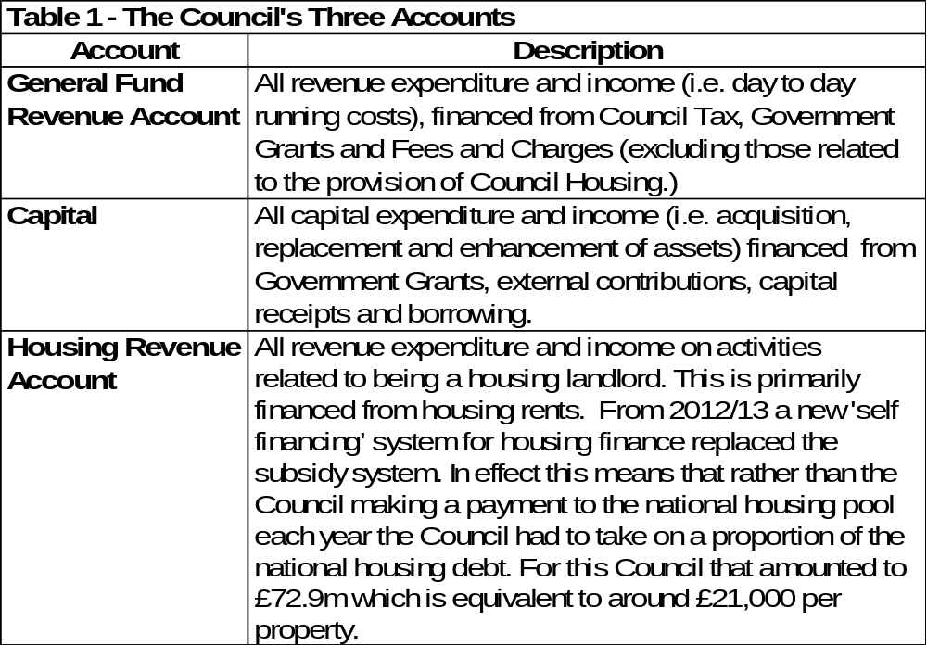
  - With a turnover of £70m the Council is one of the three largest businesses operating in the local economy. Using the tests in the Companies Act the Council would be categorised as a ‘large’ company. It is arguably the most diverse, offering over 100 services to over 100,000 people.

- POLICY POSITION
  - Members are reminded that during 2010 the Council agreed a unique budget delivery framework from which to help deliver its ambitious financial strategy. The framework consisted of eight workstreams – this is illustrated below for ease of reference;


Capital
Review
Service Plans
Fees and
Charges
Review
Prioritisation
Innovation
Group
Staff
Suggestions
Partnership
Working
Lobbying
Budget
Delivery
Framework
  - As previously reported to this committee, the strategy has to date proved extremely successful and helped provide additional flexibilities from which to address the national funding challenges that face all local authorities.

  - This overall strategy provides the cornerstone on which the Council's long-standing success in both setting a ‘balanced budget’ and delivering within budget are founded. The Council's established policy position has been key in providing a stable point of reference – this was recognised at the meeting of the Executive Committee on 14 March 2012 when the following resolution was approved in relation to the budget setting process for 2013/14:

“the same methodology be applied to the formulation of the 2013/14 budget as it applied to the 2012/13 budget, with particular reliance on:-

- the existing guiding principles
- the existing modelling for recovery principles
- the existing budget containment strategy
5 CURRENT YEAR’S BUDGET (2012/13) – LATEST ESTIMATE

  - The following section outlines the latest budget estimates for each of the three accounts:

General Fund Revenue Account – Latest Estimate

  - The projected outturn for the General Fund is shown in Table 2: -

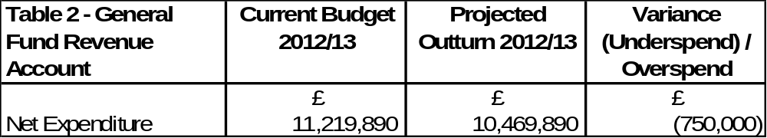
  - Members are reminded that in the current financial year (2012/13) the General Fund required budget savings of £1.330m in order to set a balanced budget. When the Council identifies budget savings these are shown against specific budget headings rather than using unidentified global savings targets, an approach taken by many local authorities. This approach and the resilience testing applied has been extremely successful in the past and means the Council is on track for delivering the savings this year. The savings that were identified during the last budget process are summarised in Table 3:

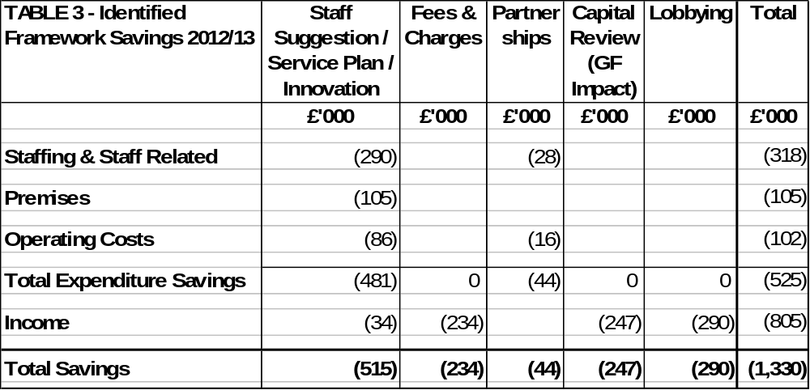
  - In addition to the delivery of £1,330,000 of required savings, we are currently projecting an underspend of £750,000. This is due to a combination of some early ‘locking-in’ of the savings that are required for 2013/14 (c£150,000) and one-off items (c£600,000).

  - A direct consequence of the early delivery of savings for 2013/14 and the one-off items is that the Council has some additional one-off resources to help provide additional flexibility. The Executive have previously approved that further budget savings (either of a one off nature or from the early delivery of framework savings) be used to increase earmarked reserves to help provide additional flexibility and protection against business risks / threats. This approach has previously been endorsed by the Council’s external auditors, KPMG. Accordingly, the smoothing reserves that were supplemented last summer as part of the closedown process (namely, organisational development / invest to save / welfare reform) will be supplemented further.

  - The General Fund working balance is estimated to be £1.5m at 31st March 2013.

  - Through its proactive approach, the Council is delivering a balanced budget and is also able to have a more resilient reserve position. Many local authorities are using their reserves to help set a balanced budget, something which is unsustainable in the medium term.

  - The Council recognised in May 2010 the need to prepare early and to create maximum flexibility to manage the forthcoming national funding reductions. The Council established its plan for dealing not only with the anticipated budget cuts but also a continued period of extraordinary and unprecedented volatility. It should be remembered that in times of recession, demand for many Council services increases sharply (e.g. caseloads for Benefits and homelessness) whilst at the same time many income streams have reduced.

  - Whilst the principles and strategies continue to provide a robust framework to work within the success comes from an ability to deliver. The Council has an excellent track record of delivering in three key areas: spending to budget, driving efficiency savings and attracting external funding. These have been key in the Council achieving the financial standing it currently enjoys. However, it is important the Council continues with the same level of commitment and momentum as there is much uncertainty and significant challenges facing local government in the years ahead.

  - The Council’s impressive record in identifying and delivering efficiency savings in the past four years, including the year under consideration (2013/14), are around £5.4m - as illustrated in Table 4;

Table 4 – Efficiency Savings | £000
2010/11 | 1,260
2011/12 | 1,910
2012/13 | 1,330
Total | 4,500
2013/14 | 950
Total  % Cash Savings (Net Budget) | 5,450  50%

  - The scale and delivery of this level of efficiency savings is particularly impressive given that there has been no detrimental impact on the delivery of front line services and when considering the increased costs of utilities and inflation levels. Over the four year period (as detailed in Table 4) the efficiency savings will be equivalent to approximately 50% (65% in real terms) of the Council’s draft net budget (which stands at £11.2m for 2013/14).

  - Members are reminded that before the efficiency programme commenced a number of years ago, the Council was charging a level of Council tax below the national average yet delivering a level of performance that was above the national average. Despite having to deliver efficiency savings of £5.450m in the past four years, the Council’s level of council tax charged remains below the national average and performance remains above average.

  - Members will recall the following illustration that summarises the Council’s overall position as being a ‘high performing / low cost’ local authority.

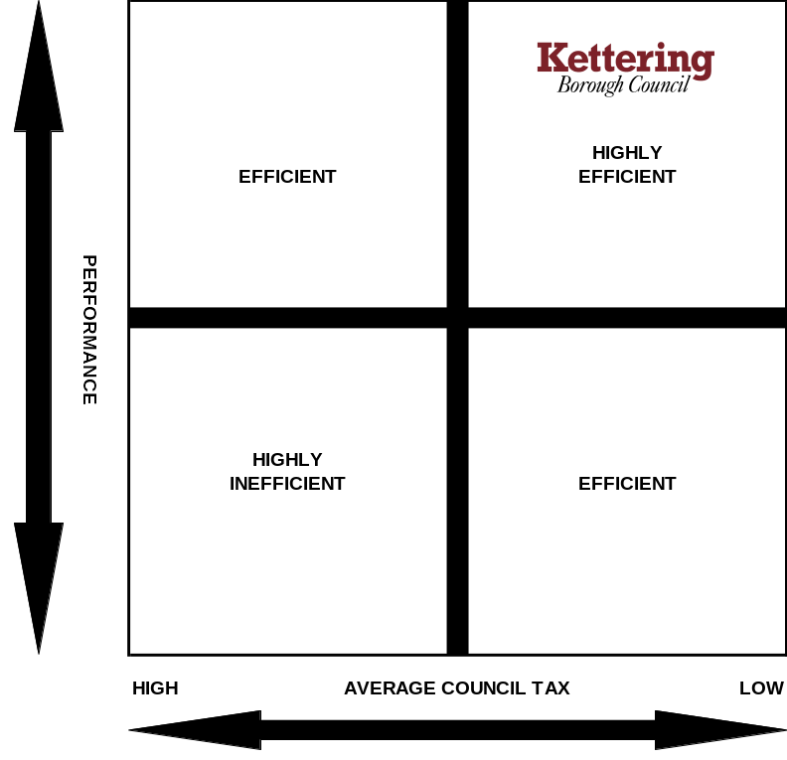

  - The above position was achieved before the Council decided to have no increase in Council Tax in 2011/12 (and before any aspirations for subsequent Council Tax freezes). Members are reminded that despite having no increase in Council Tax in 2011/12 and despite having to deliver the level of efficiency savings (as outlined in Table 4), the Council’s performance in key priority areas remains ‘above average’. Given this context, to maintain the Council’s position as a high performing whilst being low cost local authority has been a significant achievement and has not happened by accident.

  - To achieve this position with no reduction in front line services is an extraordinary effort - one of which both officers and members should be extremely proud.

Capital Programme – Latest Estimate

  - The updated projected outturn for the Capital Programme is shown in Table 5;
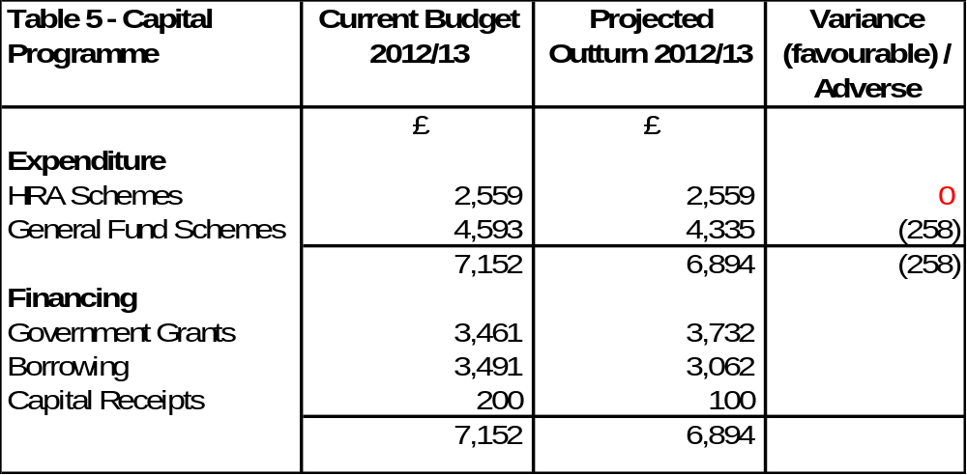

  - The detailed composition of the capital programme can be seen by reference to Appendix A – Section 2.

  - The main updates that have taken place are summarised as follows:

- The capital scheme for the replacement of the cremators has been slipped from 2012/13 into 2013/14.

- The capital scheme to acquire wheeled bins for the introduction of the comingled waste scheme for £710,000 has been brought into the 2012/13 Revised Budget (as agreed by the Executive Committee in 2012).

- A capital budget for the Skate Park in Ise Valley has been included following the successful bid for external funding (£160,000).

- A number of smaller schemes have also been brought into the 2012/13 capital budget update (eg, funding for the demolition of the Hawthorns Leisure Centre, Deeble Road Bridge Renewal and an increase in Disabled Facilities Grants) details of these additions and others can be found in Appendix A – Section 2.

  - Table 5 illustrates that based upon the latest estimates for 2012/13; borrowing of £3,062,000 will be required to finance the programme. This is in accordance with the Council’s guiding principles and Members are reminded that although in the past the Council has not had to borrow from external sources for this funding, it has in effect borrowed the money ‘from itself’ from other cash holdings that the Council has. The borrowing that the Council undertakes to finance its capital programme is required to deliver the Council’s three key objectives and results not only in improvements being made to the locality but also increases the asset valuations that the Council holds on its balance sheet that is published annually in the Statement of Accounts.

Housing Revenue Account – Latest Estimate
  - The updated projected outturn for the Housing Revenue Account is shown in Table 6. The Housing Revenue Account is currently projected to come in on budget.
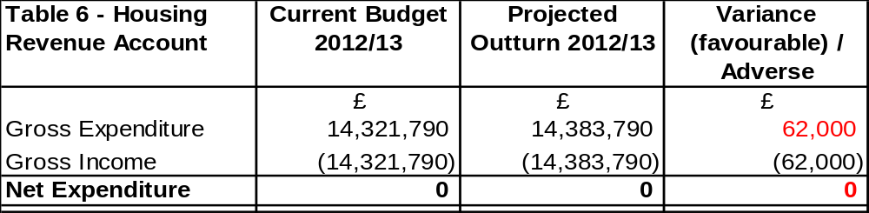
  - The detailed composition of the Housing Revenue Account can be seen by reference to Appendix A – Section 3.

  - Members are reminded that in 2012/13 the housing subsidy system was replaced with a new ‘self financing’ system of housing finance that was introduced across the Country.

  - The Executive Committee approved the Treasury Management Strategy for 2012/13 at its meeting of 15th February 2012. As part of that strategy, the following was approved in relation to financing the housing debt;

The amount to borrow | £72.9m
Who to borrow from | Public Works Loan Board (preferential rates)
A fixed or variable rate loan | Fixed rates
What type of loan(s) | Maturity loans
What period of loan(s) | A number of fixed term loans at different maturity dates (to provide the Council with the flexibility required)

  - It was previously reported to Members that by using ‘maturity loans’, the Council has retained the maximum flexibility that it can. In essence, maturity loans are serviced annually (throughout the duration of the loan) by paying interest to the Public Works Loan Board (PWLB). No principal repayment of the loan takes place throughout the duration of the loan. The Council will however each year make a provision for principal repayment and can then decide at the maturity of each loan whether it wishes to fully repay the outstanding principle or re-finance the loan.

  - The Council has a well balanced borrowing portfolio and was able to take advantage of both the preferential short and long term rates that were made available from the PWLB to finance the self financing transaction.

Section B: Next Years Budget Position (2013/14)

- DRAFT BUDGET – 2013/14

  - The consideration of the draft budgets for 2013/14 is the statutory responsibility that Members will start to discharge when considering this report.

  - The detailed draft budget figures are contained in the budget booklet at Appendix A. The booklet contains:

- Section 1 - General Fund
- Section 2 - Capital Programme
- Section 3 - Housing Revenue Account

DRAFT GENERAL FUND BUDGET 2013/14
  - Following on from the successful delivery of the required framework savings for 2012/13, and the early delivery of some additional savings during the year – Table 7 summarises the estimated financial position for the period to the end of March 2014.

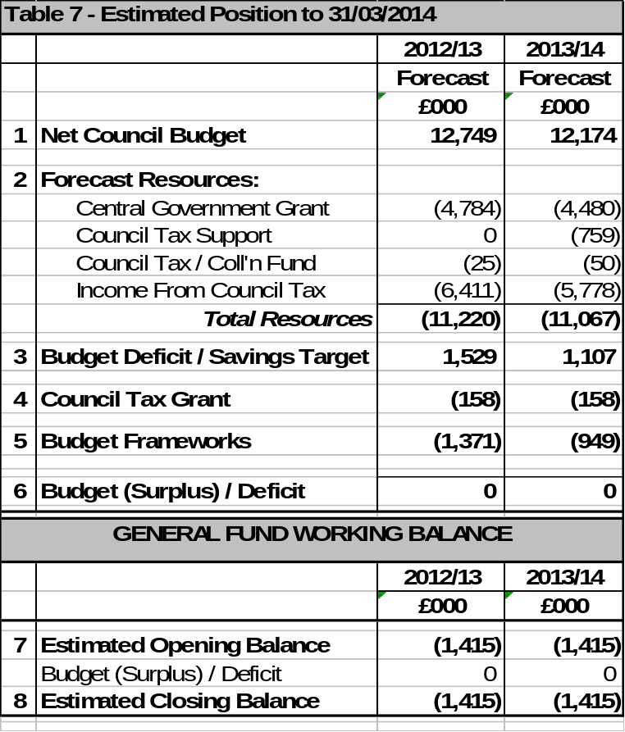
  - The Council has a statutory duty to consider the medium term financial projections when setting its budget for 2013/14 – this is covered later in section C of this report.

  - From Table 7 it can be seen that the Council’s budget delivery framework will need to deliver £949,000 of savings in 2013/14 to maintain a balanced budget. The assumptions will need to be kept under close review during 2013/14.

  - Table 8 summarises how the £949,000 for 2013/14 is anticipated to be found and compares this to the savings of £1,330,000 identified for 2012/13. Despite the success of the delivery of savings for 2012/13, it must be stressed that the majority of the required savings for 2013/14 will still actually need to be delivered in the year – ie, successfully converting them from a paper based exercise to actual delivery. Work continues on resilience testing the ideas and assumptions, and the delivery of the savings is dependent upon the Council adhering to its suite of budget principles and golden rules (previously outlined in Section A).

Table 8 – Identified Framework Savings | 2012/13  £000 | 2013/14  £000
Staff Suggestions / Service Plan / Innovation | (515) | (485)
Lobbying | (290) | (131)
Capital Review | (247) | (144)
Fees and Charges | (234) | (119)
Partnerships | (44) | (70)
Total Identified Framework Savings | (1,330) | (949)

  - The Council will need to continue to keep its key budget assumptions under review throughout 2013/14. These are unprecedented times and the assumptions used for inflation (especially on utility budgets) are likely to require amendment through the year to respond to changes in national pricing structures.

  - Some of the major service risks and pressures the Council face in 2013/14 and the years thereafter include:

Service Pressures
  - Council Tax Support – The Council Tax Support Scheme which is defined by individual local authorities (albeit with much central prescription) introduces a whole new area of volatility for local authorities. The Government have previously stated that they will not be funding the cost of the scheme in full and we will receive around 85% of the current cash grant the remaining 15% will be funded through changes to Council Tax Discounts and Exemptions and some specific scheme changes.
  - From 2013/14 the grant from CLG for Council Tax Support is being shown as a separate grant in Table 7. It is unclear how the government will treat this in future years but it is likely that it may not be identified separately by the government.

  - Homelessness – the Council has successfully managed the level of homelessness during a long period of pressure through innovative measures to prevent the use of bed and breakfast expenditure. The service will continue to be scrutinised carefully to ensure the continued high level of service is maintained at the lowest possible cost. This is a statutory General Fund service paid for by Council Tax.

  - Utilities costs – the assumptions used will need close monitoring during the year in case of further changes. Over the past year the price of utilities particularly gas and electricity has risen sharply. The budget for 2013/14 takes account of these increases however if the trend continues this could place considerable pressure on the Council’s budgets. A 1% change in these costs is around £10,000.

  - Development Control – The Council has for a number of years been heavily involved in lobbying to highlight the inadequacy and inequity of the current levels of statutory fees and lobbied for fees to be calculated on cost recovery basis. The Government increased fees by 15% from October 2012 but restricted the type of developments for which fees are chargeable this has been reflected in the draft budget figures.

Financial Markets
  - Investment Income – the Council earns interest on cash balances and changes in interest rates has an impact on the budget. The Council however has a comparatively low cash balance, which reduces the impact of interest rate changes.

  - Borrowing Costs – borrowing funds, to help finance the Council’s Capital Programme, has a direct cost implication to the Council’s revenue account. The exact amount depends on market conditions but currently every £1m borrowed costs around £30,000 per year in revenue. The borrowing costs (whether internally or externally funded) to support the proposed Capital Programme are factored into the budget model. It should be remembered that capital investment can be an effective way of delivering revenue generation. Members are reminded of the comments made in section 5.19.

DRAFT CAPITAL PROGRAMME (2013/14 – 2017/18)

  - As part of the budget process members are required to consider the Council’s capital programme, and available funding, so that a programme can be agreed for 2013/14 together with indicative funding for the following four years.

  - Members are required to approve the capital programme for 2013/14 and approve a five-year rolling capital programme with commitment given for schemes in years 2 to 5 to assist with scheduling and achieving the programme.

  - The draft capital programme for 2013/14 – 2017/18 is detailed in Appendix A – Section 2. The high level summary is reproduced in Table 9.

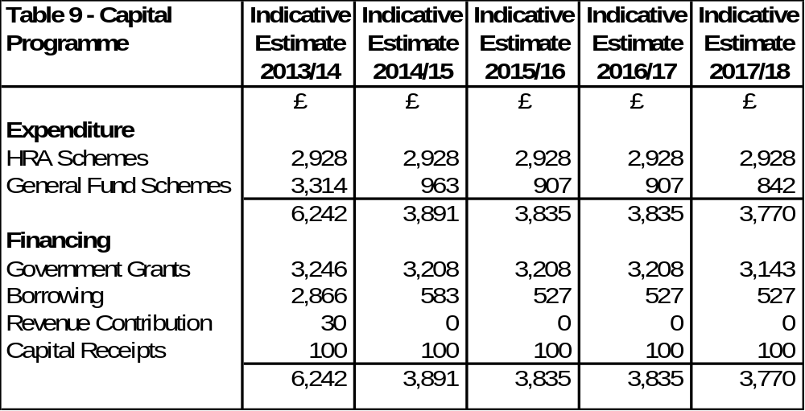
  - From reference to Table 9 it can be seen that:

- The programme for 2013/14 is £6,242m

- The programme from 2014/15 – 2017/18 is approximately £3.8m per annum.

- Some of the key issues to note from the 2013/14 programme include;

- The rolling forward of the capital budget from 2012/13 for the cremator replacements at the crematorium. This is scheduled to commence in April 2013, the procurement process has been completed;

- Invest to save capital works at the Council Depot which will generate a revenue income stream greater than the capital cost and therefore benefit the revenue budget (in conjunction with the fleet replacement project);

- £200,000 one-off supplement to the Disabled Facilities Grants budget to help overcome the current peak in demand;

- £150,000 for pedestrianisation work to Kettering Town Centre.

  - As in previous years the draft capital programme contains budgetary provision to fund private sector housing schemes. These fall into the following three categories:

- Disabled Facilities Grants – allowing elderly and disabled people to adapt their homes so that they are more accessible. As previously mentioned, the budget for 2013/14 has been increased by £200,000 to help deal with the current demand issues. It is understood that a national review of DFG’s will be undertaken during 2013/14 - this could assist the Council when reviewing future year budgets.

- Decent Homes Grants – enabling owner occupiers on welfare benefits to improve their homes and helping private landlords with empty, non-decent homes to bring these properties back into use.

- Social Housing Grants – providing assistance to housing associations to provide new properties in return for nomination rights.

  - Capital Receipts – Under the previous housing finance rules, when a house was sold under the right to buy legislation – the Council could retain 25% of the proceeds with 75% being paid to the Government. Prior to the introduction of the new housing finance system it was suggested that local authorities should retain 100% of the receipts – this made sense given that they have 100% of the debt. By the time the new system came into being, the position had changed significantly and had reverted back to local authorities retaining 25% of the proceeds with 75% being paid to Government. The Government on 2 April 2012 announced that the maximum Right to Buy discount in Kettering would increase from £24,000 to £75,000 per property (a three-fold increase!). Ministers also confirmed their intention that the proceeds from any additional sales (sales over and above that assumed in the self financing settlement) would be used to fund replacement homes on a one-for-one basis across the country as a whole. The capital programme for 2013/14 to 2017/18 assumes funding from Right To Buy receipts of £100,000 per annum.

  - Major Repairs Allowance (MRA) – MRA can only be used for Housing Revenue Account (HRA) capital projects. The estimate for 2013/14 is £2.928m.

  - Borrowing – the estimate for borrowing for 2013/14 is £2.866m. The revenue impact of borrowing (be it external or internal) in 2013/14 is included in the revenue budgets. Members are reminded that the majority of this borrowing relates to the Crematorium – Mercury Abatement scheme, which is estimated to generate significant revenue savings over and above the borrowing costs incurred. Members are reminded of the earlier comments made in paragraph 5.19.

DRAFT HOUSING REVENUE ACCOUNT (HRA) 2013/14

  - A summary of the draft HRA budget for 2013/14 is included at Appendix A - Section 3 of the budget booklet. The high level summary is reproduced in Table 10:
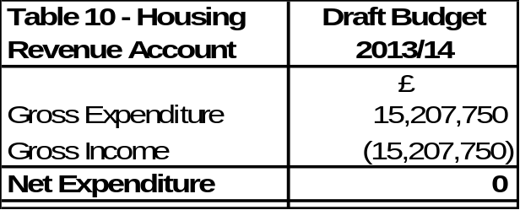

  - The Housing Revenue Account (HRA) includes all the income and expenditure items associated with maintaining a landlord account for the Council’s housing stock. The Council has a statutory obligation to produce a balanced “ring-fenced” HRA. The account must operate in a surplus position and this is achieved by adopting the principle that an agreed minimum balance of £300,000 should be the HRA’s primary strategic aim over the medium to long term. The level of the minimum balance is risk assessed and takes account of the limited nature of the service, the fact that budgets are less volatile than in the General Fund and transactions tend to be high in number but low in value.

  - To adhere to the Government’s rent convergence targets, the Council will need to implement a rent increase of 4.75% for 2013/14. This ensures that the Council is on target to achieve rent convergence by 2015/16. The draft budget will be discussed by the Tenants’ Forum at its meeting of 31st January 2013 along with the proposal for rent setting. This will be reported back to the Executive meeting on 13th February 2013 for approval.

  - Sections 5.22 – 5.25 referred to the new ‘self financing’ system of housing finance and the borrowing strategy undertaken to finance this transaction. Whilst this is the second year of the new housing finance system – it is the first time the Council has been able to benefit from the greater certainty the new system provides from a budgeting perspective.

  - Prior to the new system the Council would have received an annual subsidy determination usually in December notifying the Council of the amount of subsidy payable in the following financial year. The Council was paying in the region of 34% of the rent it collects from its tenants over to the Government (approximately £4.5m for 2011/12).
  - The subsidy payments have now been replaced with principal repayments and interest payments which are a direct result of the borrowing of £72.9m undertaken to finance the ‘self financing’ payment.

  - The other key elements of the budget are;
- Rents – income expected from tenants.
- Repairs & Maintenance – The costs for response and planned maintenance.
- General Management – The costs of managing the Council’s housing stock.
- Special Services – Income/expenditure relating to flats & sheltered housing.

  - Appendix A – Section 3 shows the make-up of the draft budget for 2013/14. The budget includes some re-alignment of previous budgets to better reflect where expenditure is estimated to take place during the year – an internal project is currently looking at the repairs and voids process and it is likely that when this is complete it may require further fine tuning of the budgets. A report will be bought to the Executive Committee later in the year outlining the medium term HRA business plan.

  - Changes to Welfare Reform remains a key risk to the HRA. The Council has worked hard and successfully to maintain rent arrears levels but these will continue to come under pressure due to Welfare Reform and will need to be closely monitored.

Section C – Changing Financial Landscape

  - This section looks at five issues:

- National Economic Indicators
- Local Government Grant Settlement
- Local Government Resource Review – Business Rates
- Localisation of Council Tax Benefit

National Economic Indicators

  - There is much uncertainty facing local government. This section looks at two key national economic indicators (Public Sector Net Borrowing and Gross Domestic Product). In addition, this section also focuses on the provisional grant settlement and provides an update on the latest position on the Business Rates Reform and Pooling. It also considers Council Tax Levels.

  - The following chart summarises the changes in Public Sector Net Borrowing between the 2010 and 2012 Autumn Statement. This illustrates that it is expected that public sector net borrowing will continue to fall but at a slower rate than expected in autumn 2010 and 2011.

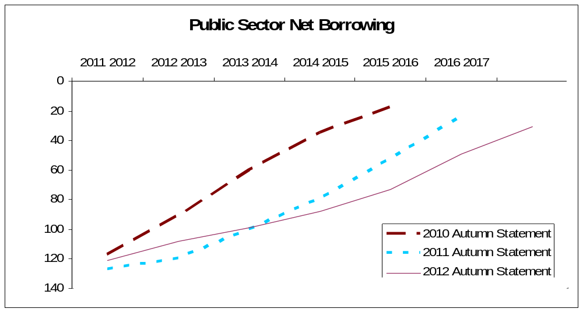
£ Billion

  - The outlook for GDP growth is also summarised in the following graph:

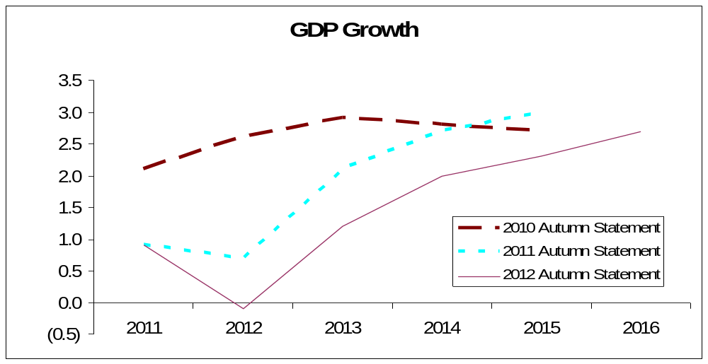

%

  - The fact that Public Sector Borrowing is higher and GDP lower than anticipated a year ago could result in less favourable conditions for local government and the public sector in the coming years.

Local Government Grant Settlement

  - It was reported to the December Executive that the Council anticipated having a balanced budget for 2013/14 based on the grant assumptions that were being used. This was however prior to the announcement of the provisional settlement, which was announced on 19 December 2012. The announcement was much later than in previous years.

  - The Council’s provisional grant settlement for 2013/14 is £4,480,000; this represents a cash reduction in grant of £303,000 (6.35%) from 2012/13. The Council had been modelling a reduction in grant for 2013/14 of 6% therefore the modelling undertaken was in the right range and enables the Council to have a balanced draft budget for 2013/14.

  - Members will recall from the December meeting if the provisional financial settlement resulted in a higher grant reduction than the Council was modelling, the Council has a number of different triggers that it could consider changing to help deal with the additional grant reduction. One possible strategy was to have a different phasing in relation to the use of new homes bonus monies. Whilst this strategy was not required for 2013/14 it will be an area the Council will need to review for subsequent years to achieve a balanced budget position.
  - The Council had also been modelling for a grant reduction of 6% for 2014/15 however the provisional settlement for 2014/15 indicates that the reduction is likely to be around 13%.

  - The following table illustrates the levels of grant reductions that have taken place. This shows a cash reduction in government funding of 41% (£2.660m) over the four year period which is closer to a real terms reduction of 55%.

Year | Reduction in Central Government Core Grant |  | Status
 | % | £
2011/12 | -15.2% | -£958,000 | Actual
2012/13 | -12.8% | -£700,000 | Actual
2013/14 | -6.3% | -£303,000 | Provisional
2014/15 | -13.3% | -£697,000 | Indicative

  - The recent announcements also indicate that the trajectory of future grant reductions for the next spending review period (which covers 2015/16 to 2018/19) will be similar to those experienced in the previous four year period. The Council will need to keep the assumptions in the Medium Term Financial Strategy under review. An announcement regarding funding for the period 2015/16 – 2018/19 is likely to be made before the end of June 2013

  - Local Authorities, and in particular Shire Districts, have recently received very challenging grant settlements. The following chart illustrates how each class of local authority were impacted upon in the recent settlement and how it compares to the position for this council;

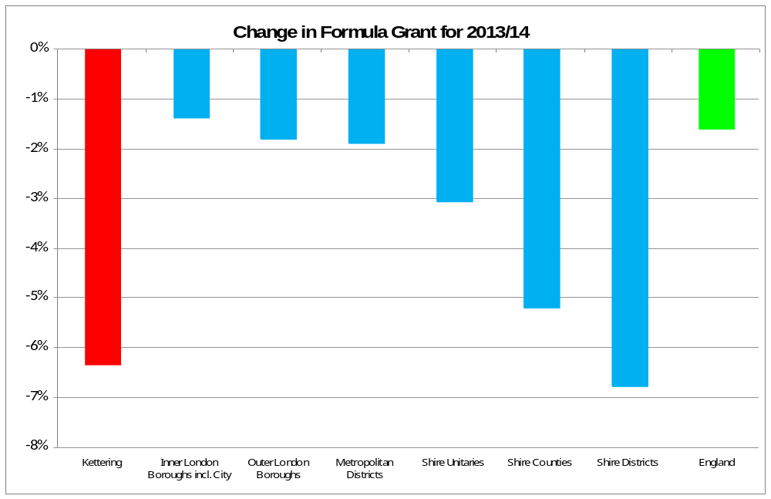

  - The floors and ceilings mechanism sees the Council’s grant damped by £452,000 in 2013/14. Therefore, if this mechanism was not operated the Council would have received an additional £452,000, being the sum calculated under the formula for distributing grant. Details of grant damping levels for 2014/15 are still to be provided by CLG.

  - The Government have also confirmed that local authorities that do not increase their council tax for 2013/14 would be eligible to receive a one-off cash grant during the year equivalent to the proceeds of a 1.0% increase – for Kettering Borough Council this would equate to around £65,000. This is explained further in Section C of the report.

Local Government Resource Review – Proposals for Business Rates Retention

  - The way that the Government provides funding to local authorities from April 2013 has changed significantly. Kettering has played a leading role on the national stage in relation to Business Rates Reform and the persistent and effective lobbying at the highest levels by senior officers has significantly influenced the content of the current scheme.

  - The December report to this Committee included a Case Study outlining the success this Council has achieved by lobbying on two key areas namely on moving the baseline position for which growth will be measured from a five year average to a two year average and limiting the levy rate to 50%. This means that Councils will be able to retain growth of 20% which is a significant increase from the proposals outlined in the summer. Therefore the Council has a lower base for which growth will be measured and a lower levy rate being applied to growth resulting in the Council retaining more of the benefits from growth.

  - The move to a two year average, combined with a levy cap of 50% is good news. To put this into context the Council’s Business Rates Baseline will be around £2m lower compared to a 5 year average and could result in the Council receiving around £200,000 each year that it would not have received without these changes.

  - As reported to the December Executive a number of important issues were still to be clarified following the Governments Business Rates Retention Policy Statement and clarification would be provided as part of the provisional grant settlement. The provisional grant settlement contained provisional figures for both the local share of the Business Rates Baseline and the Business Rates Spending Baseline for 2013/14.

Localisation of Council Tax Benefit

  - A special Executive Committee was held on 18 December 2012 where the Committee made recommendations to full Council about how the Council Tax Support Scheme should operate from April 2013.

  - Council will consider this issue at its meeting of 22 January 2013 and make a final decision about how the scheme will operate.

  - In summary, the Government have reduced national funding for Council Tax Benefit by around £880,000 (15%) for Kettering Borough from April 2013. The Council is required to approve a new local scheme and the recommendations from the Executive propose to balance the books through a combination of reducing / removing Council Tax discounts and exemptions whilst also making some changes to the actual scheme criteria that will reduce the amount of ‘benefit’ that claimants can receive.

  - The Executive received a detailed report on this issue at its meeting of 18 December 2012, it is available at the following link for members background information;

http://www.kettering.gov.uk/meetings/meeting/1099/executive_committee

Section D – The Medium Term Prospects

  - This section brings together the Council's financial model for the General Fund for the period up until 2017/18.

  - The Budget Position for the 2013/14 year – ie, the first year of ‘Zone 1 of unpredictability’ was dealt with in Section A. The period from April 2014 to March 2018 is the subject of this section of the report.

  - The figures in the model are shown prior to the consideration of any increase in levels of Council Tax. Council Tax levels can only be determined annually by the Council once it has received and considered the report of its officers.

  - The Council's Medium Term Financial Forecast is summarised in Table 11. It is however predicated on a number of assumptions (as mentioned earlier in the report). It is also subject to higher levels of volatility than previously due to the number and significance of changes in the financial landscape for local government – these have been briefly outlined in paragraph 7.14 – 7.19.

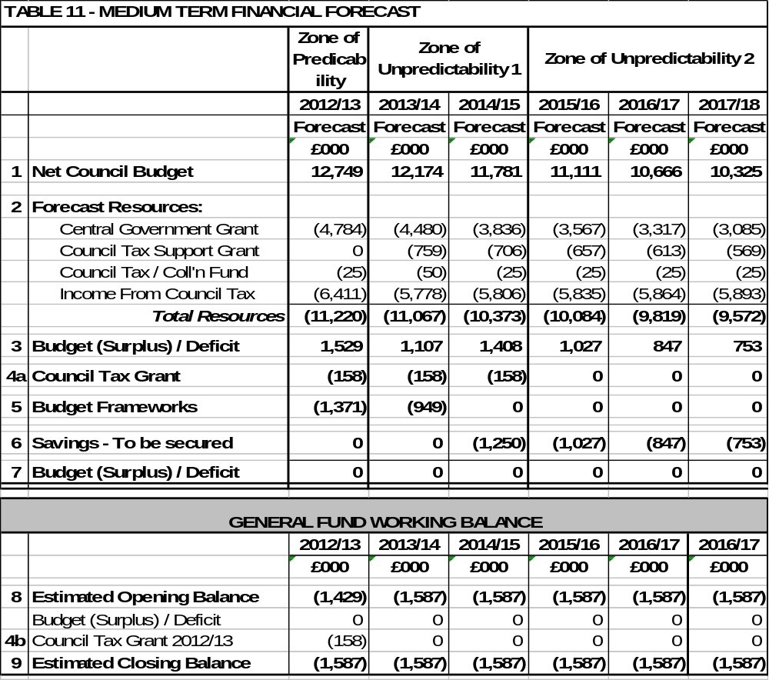
Notes to Medium Term Financial Forecast

1 Net Council Budget – This represents the net expenditure prior to the Budget Framework savings.

2 Forecast Resources – These are the Council's main funding streams (excluding fees and charges which are incorporated into Line 1). This illustrates the significant reduction in Central Government Grant and introduces a new line from 2013/14 for the Council Tax Support grant. Following future government announcements the presentation of this will be reviewed but it is thought likely that overall the figures we are modelling on, may be in the right area but the split between years may be different. To enable the total resources required to balance the budget to be identified, no assumptions have been made regarding future council tax increases. The small increase in revenue each year reflects anticipated housing growth in the borough.

3 Budget (Surplus) / Deficit – This illustrates the gap between the budget and the total resources available before identifying budget framework savings.

4a Council Tax Grant – This is a grant the Council receives from central government for four years in return for freezing Council Tax in 2011/12. This is equivalent to the cash that would have been received if a 2.5% increase had been levied.

4b Council Tax Grant 2012/13 – This is a grant the Council receives from central government for one year in return for freezing Council Tax in 2012/13. This is equivalent to the cash that would have been received if a 2.5% increase had been levied.

5 Budget Frameworks – This identifies the total savings required and differs to the table shown in 5.3 as a result of the Council decision earlier in the year in relation to members allowances.

6 Savings to be secured – This identifies the total resources required to balance the budget in future years after 2013/14.

  - Based upon the figures in the model it can be seen that the following levels of savings maybe required over the new few years (prior to the consideration of any increase in council tax);

2014/15 £1,250,000
2015/16 £1,027,000
2016/17 £ 847,000
2017/18 £ 753,000

  - As previously outlined in the report, the figures are predicated on a number of budget assumptions that will require careful monitoring as we move forward. They are also dependent upon the Council sticking to the budget guiding principles and associated rules that were previously outlined in Section A. In doing so, it is recognised that it will become increasingly difficult for the Council to do everything it wishes when trying to resolve issues and problems if it is to live within a financial strategy that continues to pursue the Council’s three core objectives of:

- A better offer for our town centres
- A better education and training offer
- A better employment offer – high grade, higher density jobs

Whilst at the same time deal with the challenging (and changing) financial landscape. The challenge is amplified even further by reference to the Executive Committee’s stated desire to follow a ‘triple zero’ approach

- Zero increase in Council Tax
- Zero cuts to front line services
- Zero cuts to the voluntary sector funding envelope.

  - Members should be aware that the indicative savings levels for the period 2015/16 onwards are subject to a number of high level assumptions. One of these is about the potential level of government grant. For the purpose of modelling we have assumed an overall annual cash reduction of 7% for 2015/16 up to and including 2017/18 (from 2015/16 only the RSG element which accounts for around half of the total grant will be subject to similar reductions to those of the current Comprehensive Spending Review) - when more detail is announced about the local government resource review we will be in a better position to review this. It is thought likely that overall the figures we are modelling on, may be in the right area, however, the split between years may be different.

  - Line 6 is the sum that is required to achieve a balanced budget. Every 1% increase in council tax generates around £58,000 towards that sum (prior to Council Tax Support this was around £65,000). Formal decisions on each year’s council tax increases can only be taken by Council at the February budget setting meeting after the consideration of a report from its officers.

  - The Government will provide a grant for one year equivalent to a 1.00% increase in Council Tax (this is before the changes to the Tax Base resulting from Council Tax Support). This is approximately £65,000. If members are minded to levy a 0% Council Tax increase, it would be appropriate (given its one-off nature) to treat any one-off grant as a windfall grant outside of the revenue budget.

  - The parameters that the Government intend to apply in relation to Council Tax capping have been announced for 2013/14 For District Councils the ‘cap’ is set at 2.00%.

  - The setting of Council Tax can have significant implications on the sustainability of the Council's budget in the medium term. Members are reminded of their statutory responsibility to consider the medium term financial position when setting Council Tax for 2013/14.

  - When considering the budget and council tax levels for 2013/14, Members are reminded of the current global levels of inflation and inflation targets;

Current Inflation Rate = 2.70% (CPI Nov 2012)
Government Target Rate (in future years) = 2.00%
  - If the current rate of inflation is used as a reference point, in effect local residents have experienced a real terms reduction in their local council tax for Kettering Borough Council during the year as a result of the Council decision to have a 0% increase from 2011/12. If the Council were to levy a similar level of increase into the medium term, further real terms reductions would be experienced by council tax payers at the same time as the Council having to deal with its own inflationary pressures (eg, utility bills) and deliver significant levels of ongoing efficiency savings. Table 12 summarises the real terms impact this has when compared to Council Tax freezes

Table 12 | Actual / Estimated Inflation Rate | Council Tax Increase | Cumulative Real Terms Reduction
2011/12 | 4.80% | 0.00% | 4.80%
2012/13 | 2.70% | 0.00% | 7.50%
2013/14 | 3.00% | 0.00% | 10.50%
2014/15 | 3.00% | 0.00% | 13.50%

  - The Council tax level for 2013/14 will be considered by the Executive in February but can only be set by full Council at its meeting on 27th February, once the budget consultation has been completed and the officers’ report has been fully and properly considered. When discharging their statutory duties, Members will need to give due regard to the issues facing the authority in the medium term, especially in relation to the changing financial landscape in relation to those issues outlined in paragraph 6.9 – 6.15.

9 SUMMARY & CONCLUSIONS
2012/13

  - The Council has continued to use its own specific ‘budget delivery framework’ for the consideration and subsequent delivery of the £1.3m of savings required for the General Fund for 2012/13.

  - Once the budget was approved in February 2012, the challenge was to turn the ‘paper based savings exercise’ into reality so that the £1.3m of savings were actually delivered.

  - From the information contained in the budget report (and previously reported to the Executive Committee through a series of Durable Budget Reports) it can be seen that the original savings target of £1.3m is being delivered successfully.

  - In addition to the original target, the Council is currently projecting a further £750,000 under-spend during 2012/13, these are a combination of some early delivery of the on-going savings required to balance the budget in 2012/13 (c£150,000) and a number of one-off items (c£600,000). As previously approved by the Executive, this underspend will be put into reserves to help the Council protect itself from the many service and budget pressures that exist in the post April 2013 world.

2013/14

  - The national landscape is changing significantly from 1 April 2013 with the introduction of the Business Rates Reform and Localisation of Council Tax Benefit. This brings greater uncertainty and volatility to future projections.

  - The Council needs to continue its excellent track record of delivering budget savings to balance the budget for 2013/14.

  - Prior to the consideration of any council tax increase, it is estimated that £949,000 of savings will be required. We will start 2013/14 in a similar position to 2012/13 because of the continued use of the Council’s successful budget delivery framework which has resulted in the Council already having secured some of the on-going savings required for 2013/14. The remaining savings have also been identified and the Council is confident that these will be delivered during 2013/14.

  - A capital programme of in excess of £6m is not inconsiderable for a District Council of Kettering’s size and non doubt a welcome boost to the local economy.

  - The Council uses the budget “swingometer” as detailed at Appendix A – Section 1 to highlight and assess the sensitivity of the most volatile and material budgets. The “swingometer” shows some significant swings reflecting the economic climate. It must be stressed however that the Council has an excellent track record of spending at or around budget, even when faced with significant in year pressures, and a strong balance sheet with a level of reserves sufficient to cover the risks outlined in the “swingometer”.

The Medium Term

2014/15 and Beyond

  - Assumptions have been made for future levels of government grant (and other funding changes) and a decrease of 13% has been applied for 2014/15 following the provisional settlement and further annual decreases in overall funding of 7% for 2015/16 and beyond. This will need to be reviewed when more information becomes available.

  - The current economic times are unprecedented. Therefore the delivery of the budget is dependent upon successfully tracking the other budget assumptions that have been made (eg, inflation and interest rates) and it must be recognised that any major changes in such variables can have a significant impact on the Council’s budget figures and resultant levels of required savings.

  - Based upon the assumptions applied, the future years’ budgets would require ongoing year on year savings of:

2014/15 £1,250,000
2015/16 £1,027,000
2016/17 £ 847,000
2017/18 £ 753,000

  - The new system of government funding effectively transfers significant risks from central to local government. Such risks include;

- Business Rate Volatility

Future changes in business rates yield will have a direct impact on a significant proportion of the grant received by the council in the future. The Council has most of the risk of any downward movement whilst can retain a small element of any increased yield. This is a new element of risk for the council and will need to be monitored very closely.

Business rate appeals will also impact on the councils future funding – again this is a new risk for local authorities and will need to be monitored.

- Council Tax Benefits Volatility

It is anticipated that future levels of council tax support funding will be reduced in line with the reductions in central government core grant. It is also likely that the council will have to bear the cost of increased caseload over the medium term – given the current economic outlook this is a real and present risk.

Other Considerations

  - The projections in all years rest on the Executive’s adherence to the “Guiding Principles” the “Modelling for Recovery Principles” and the Budget Containment Strategies (para 3.6).

  - Depending on the decisions taken in relation to Council Tax, year on year savings of these magnitudes have and will continue to take capacity out of the organisation. The priority has been front line delivery and accordingly members may notice a reduction in some areas of internal delivery, as well as our capacity to influence longer term strategic issues.

  - Many of the changes to be implemented are untested and it is inevitable some transition turbulence may be experienced even with the focus on protecting front line service delivery.

  - All the council’s partners, elected councillors and staff should feel proud of reaching this point. However we must maintain this extraordinary effort if we are to continue to achieve our ambitious objectives.

10 CONSULTATION AND CUSTOMER IMPACT

10.1 The formal budget consultation period is from 16th January 2013 to 27th February 2013 when the Council sets its Council Tax for 2013/14. The budget timetable is detailed at Appendix B. Comments from the consultation process will be reported to the Executive for consideration at it’s meeting on 13th February 2013.

11 POLICY IMPLICATIONS

11.1 There are no direct policy implications as a result of this report.

12 USE OF RESOURCES
12.1 The implications on the Council’s resources will be considered throughout the durable budget reports.

13 RECOMMENDATIONS

The Executive Committee is recommended to:

  - Note the current budget position for 2012/13.

  - Recognise the savings that the budget delivery framework has generated to set a balanced budget for 2013/14.

  - That the Executive refers the draft budgets for 2013/14 (as contained in the separate budget booklet) to Scrutiny for comment in accordance with the Council’s Constitution.

Background Papers: Previous Reports/Minutes:

Title of Document: Estimate Working Papers Monthly Durable Budget Reports
Contact Officers: M Dickenson (April 2010 to date)

