- PURPOSE OF REPORT

The purpose of the report is to:

- Remind members of the background to the national abolition of Council Tax Benefit (CTB) and proposed introduction of Localised Council Tax Support (LCTS) from April 2013;

- Remind members of the consultation programme outlining the key strategic choices available to the Council;

- Outline the findings from the consultation process;

- Request the Committee to make a recommendation to Council in relation to a Council Tax Support Scheme to be effective from 1st April 2013.

The report comprises the following sections;

- Purpose of the report

- Context

- Re-cap on key background issues

- Options agreed for consultation

- Outcome of the consultation

- Options available to the council

- Government transitional grant scheme

- Policy implications

- Use of Resources

2. CONTEXT

  - Each month, the Executive Committee receive a ‘Durable Budget Report’. Previous reports have provided members with details about how the current national system of Council Tax Benefits will change significantly from April 2013.

  - At a meeting of the Executive Committee on 13 August 2012, Members identified a preferred option for public consultation in relation to how the new scheme may operate from April 2013. A formal consultation process followed that decision, which closed on the 30th October.

  - This report provides

- A re-cap on the key background issues,
- The option(s) that was agreed for public consultation,
- The outcome of the consultation
- The options available to the Council.

  - For member’s information, the report considered by the Executive Committee at its meeting of 13 August is reproduced at Appendix A. Some of the key sections from that report are also reproduced in the following sections.

3. RECAP ON KEY BACKGROUND ISSUES

  - The Government has previously announced that from April 2013 Council Tax Benefit will be replaced with a Council Tax support scheme. Unlike Council Tax Benefit (CTB) which is set by Central Government, the new Council Tax support scheme must be defined by individual Local Authorities (albeit with much central prescription).

  - The following illustrations highlight some of the key changes;

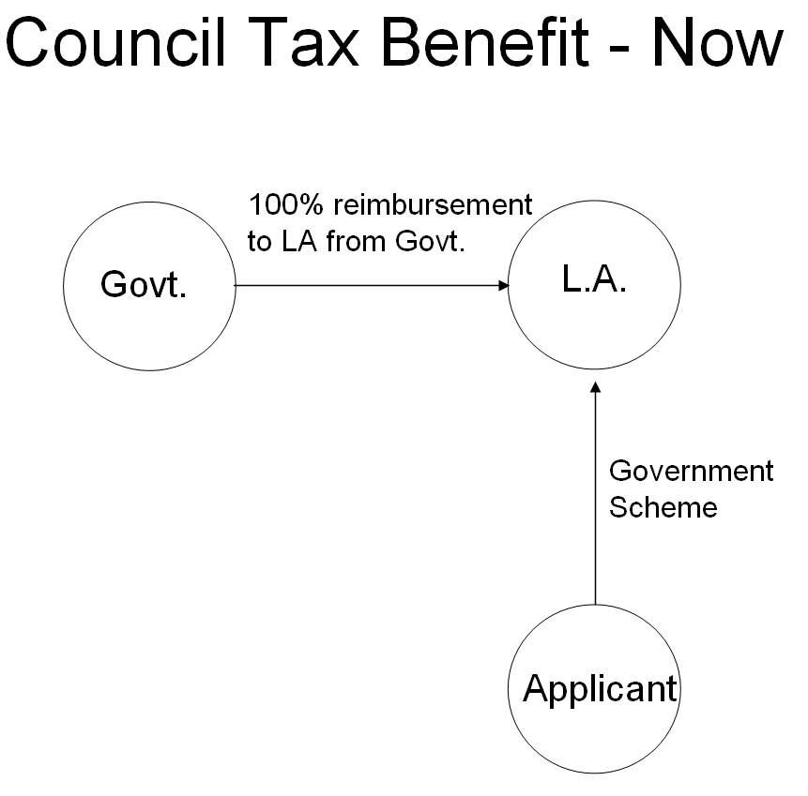

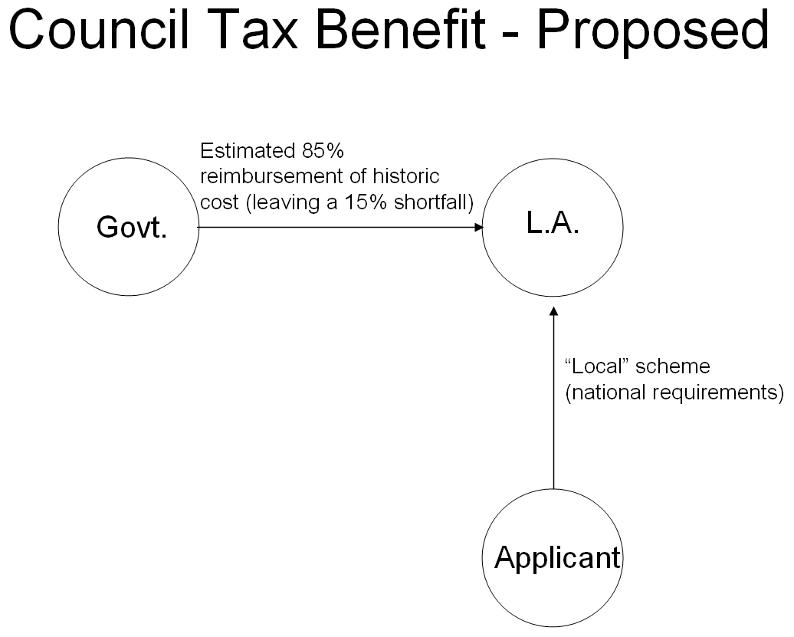
Table 1 - Comparison of current national scheme with changes from April 2013
 | NOW | APRIL 2013
Scheme Structure | National | National & Local
Administration | Local | Local
Funding | National | Local Govt – with a ‘fixed’ cash grant of historic cost (likely to be only 85% for KBC)

Table 2 - Impact on Categories of Claimants
Category | Schemes from April 2013
Pensioners | Protected – ‘local schemes’ must give the same level of benefits to pensioners (national policy requirement)
‘Vulnerable Groups’ | In theory a Local Choice but must give regard to vulnerable groups when designing a local scheme. In practice, most of this group will also be protected.
Others | Local Choice

  - Nationally these changes are designed to save around £500m which has been trailed nationally as around a 10% reduction. In essence, this means each local authority will have to either cut its council tax support or find compensatory savings and efficiencies, and additionally carry (at a local level) the risk for upward pressure in claimant numbers due to the economic circumstances.

  - The Government have stated that they will not be funding the cost of the scheme. It is expected that locally we will receive around 85% of the current cash grant, leaving an initial shortfall for KBC of about £129,000 (equivalent of 2% on the Council Tax). It is anticipated that any future rise in caseload will not attract any national funding and will need to be met at local level also. The overall funding shortfall for the borough (when the County Council and the police share are included) is estimated to be around £880,000.

  - It currently remains unclear whether the grant will increase on an annual basis - clearly there is a correlation between the economic climate and the level of benefit applicants, so this gap has the potential to widen further and it is wise to plan on the basis that there are unlikely to be any annual uplifts from Government even if caseload rises.

  - The following points are to remind members of some of the key issues / challenges that local authorities are facing in relation to this issue;

- Local Authorities are required to set their own scheme by 31st January 2013. If they do not a default scheme will be imposed by Central Government on the basis of the current scheme, but with reduced resources.

- To meet the timeline set by the Government, local authorities have had a number of challenges to overcome, specifically in relation to;

  - Timescales - Local schemes must be approved by 31st January 2013 at the very latest. In reality, they need to be approved significantly before this to facilitate paperwork and processes to be dealt with.

  - Consultation – Local Authorities had to undertake statutory consultation with major preceptors and stakeholders. This will normally take between 8 and 12 weeks to complete.

  - Software – The software that runs IT systems will need to be amended and rigorously tested.

  - Training – staff will need to be properly trained to administer the new system effectively.

- The Government have stated that they will not be funding the cost of the scheme. It is expected that locally we will receive around 85% of the current cash grant, leaving an initial shortfall for KBC of about £129,000 (equivalent of 2% on the Council Tax). It is anticipated that any future rise in caseload will not attract any national funding and will need to be met at local level also. The overall funding shortfall for the borough (when the County Council and the police share are included) is estimated to be around £880,000.

- All financial risks will transfer to billing authorities and the major precepting authorities.

- The Government has confirmed that pensioners must be protected from any change under the new scheme. For Kettering Borough Council this equates to 45% of our existing caseload. Authorities are also required to consider what protection is appropriate for vulnerable groups and this will be at local discretion. This means that any reduction in cost will be borne by a smaller group of people.

Table 3 - Impact on Categories of Claimants

Category | Schemes from April 2013
Pensioners | Council’s must give the same level of benefits to  pensioners (national policy requirement) | 45%
‘  Vulnerable Groups’ | In theory a Local Choice but must give regard to vulnerable groups when designing a local scheme. In practice, most  of this group will also be protected. | 38%+/-?
Others | Local Choice | 17%

- The timescales for implementation are very short and consultation had to be carried out for a period of 8 weeks. This was the maximum number of weeks that the Council could facilitate and ensure that all statutory deadlines were complied with.

  - The following tables illustrates the level of expenditure on Council Tax Benefits over the past few years together with the change in caseload;

Table 4  Year | CTB subsidy Expenditure | Caseload
 | £000 | Numbers | Year on Year Increase | Cumulative Increase
2007/08 | 4,163 | 6,314
2008/09 | 4,602 | 6,684 | 6% | 6%
2009/10 | 5,420 | 7,599 | 14% | 20%
2010/11 | 5,850 | 7,896 | 4% | 24%
2011/12 | 5,959 | 8,140 | 3% | 27%
2012/13 | 6,049 | 8,350 | 3% | 30%
  - The grant will be paid to both billing and major precepting authorities, reducing each authority’s council tax requirement and off-setting partially or fully the reduction (subject to local decision) on the council tax base. Council Tax support grant from central government will now be applied as a discount to each billing authority’s council tax base.

  - Each £1 of Council Tax is distributed as follows;

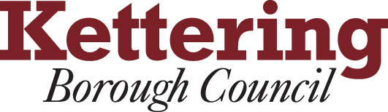



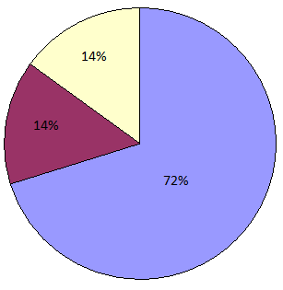

  - If the indicative funding levels are used as an illustration, overall the Borough will receive a funding reduction in the region of £880,000. If this is allocated across the major precepting authorities (as above) it would mean the following reductions against each local authorities actual base budgets;

Authority | Reduction
NCC | £631,000
NPA | £120,000
KBC | £129,000
Total | £880,000

  - Following on from the points outlined in section 3.6, any future increase in caseload that cannot be contained within the cash grant the government provides will need to be met by local authorities – it is anticipated that any costs associated with this will be met in the same proportions as above.

4. OPTIONS AGREED FOR CONSULTATION

  - This section of the report details the option agreed by members for public consultation at the special executive held on 13th August, 2012.

  - The following high-level original proposed timetable is reproduced from the August Executive report for members information;

July to September 2012
- Consultation
- Financial modelling
- Discussions with software suppliers
- Updates through the Durable Budget Report

September / October 2012
- Update report to Executive
- Executive to recommend preferred scheme (Oct 2012)

October 2012 to November 2012
- Implementation planning

December 2012
- Final scheme recommendations to be considered by members

  - The timetable above has been amended to ensure a thorough and full consultation process was able to be undertaken. The amendments to the original timetable have enabled officers sufficient time to collate, communicate and present all findings from the public consultation process to members. The current timetable is detailed below for members information;

July to October 2012
- Consultation
- Financial modelling
- Discussions with software suppliers
- Updates through the Durable Budget Report

November / December 2012
- Update report to Executive
- Executive to recommend preferred scheme (Dec 2012)

December 2012 to January 2013
- Implementation planning

January 2013
- Final scheme recommendations to be considered by members

  - The government has stated that councils will not be permitted to reduce council tax support for pensioners. This will be achieved by retaining the default national rules for pensioners, with eligibility and rates defined broadly similar regulations as those for Council Tax Benefit.

  - The Government has also said that LA’s are expected to maintain an appropriate level of support for other ‘vulnerable groups’. The definition of these groups have not been clearly defined, however, the Government’s response to the consultation ‘Localising support for council tax in England’, which was published in December 2011 refers to local authorities responsibility towards vulnerable groups under various acts including:

- Child Poverty Act 2010
- Disabled Persons (Services, Consultation and Representation) Act 1986
- Chronically Sick and Disabled Persons Act 1970
- Housing Act 1996

  - The Council currently has 8,357 Housing Benefit and Council Tax Benefit claimants. It is important to note that claimants will have to claim their housing support costs from the DWP, as part of their overall benefits under Universal Credit. This may be confusing for customers locally, as they will have to make a separate claim for Council Tax Support with their local council.

  - The following table shows the categories of claimants for KBC;
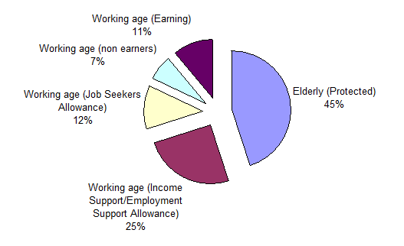

  - From the analysis in the table, the potential impact upon the different categories of claimants can be gained. Given that pensioners are to be protected through national regulations (45% of our caseload) that means that in theory the estimated funding reduction of 15% would need to be applied in some way to the remaining 55% of caseload. However, approximately 38% of the remaining caseload are potentially in the vulnerable category which could result in the funding reduction being applied disproportionately to the remaining small group.
  - Prior to discussing the options members endorsed a simple set of additional guiding principles that would help frame the discussion about which option was preferable. These were;

- In the medium term, the cost of a local scheme must be contained within the grant made available from the Government (to comply with the existing budget guiding principles)

- The scheme should incentivise work

- The impact on working age claimants should as far as possible be minimised through considering changes to Council Tax exemptions and discounts.

  - At its August meeting, the Executive Committee resolved the following;

- the contents of the report be noted;

- the guiding principles contained in Section 4.11 of the report be endorsed;

- the preferred option for consultation was Option 4 – with Option 2 being the primary source of funding (i.e. elements pursued) supported by elements of Option 3; and

- the consultation approach as set out in the Appendices to the Report be approved.

  - In effect, this resulted in the preferred option for consultation being to close the estimated funding gap firstly through the removal/reduction of Council Tax discounts and exemptions, and secondly through other detailed changes to way the system would need to operate (eg, changing tapers and reliefs).

  - In coming to its preferred solution, the Executive Committee gave due regard to the Councils Financial Strategy and the guiding principles that underpin that strategy. The following extracts from the Council’s Budget Containment Strategy, are of direct relevance;

Budget Containment Strategy:

1. Where a specific grant which funds a specific service is withdrawn, the service stops;

2. Where grant funding reduces, which Kettering Borough Council passports through to another organisation, the reduced sum continues to be passported, providing the end recipient organisation feels it can still provide a value-added service at that funding point.
5. The Council should not substitute itself as a provider / funder of services when another public provider cuts such a service.

  - The public consultation therefore looked at the following potential options for change;

Council Tax Discounts and Exemptions

- Charging normal Council Tax on all of the following;

  - Second Homes
  - Unoccupied and Unfurnished Dwellings
  - Uninhabitable Dwellings
  - Repossessions

- Charging a premium on homes that are left empty for longer than two years.

There was no legal requirement for the Council to consult on a) or b), however as these potential changes may impact on the overall decision for Council Tax Support a decision was made at the special executive in August 2012 to include them in the formal public consultation.

Specific Scheme Changes

- Reducing support for all claimants (except pensioners) by only funding a percentage of council tax liability

- Restrict support to the level for a Band D property or lower.

- Restrict an award to nil if the calculated award is below a prescribed figure

- Consider whether incomes such as Child Benefit and Maintenance should still be disregarded in full when calculating an award

- Review the maximum amount of capital that a claimant may hold before becoming ineligible for council tax support

- Review Second Adult Rebate

- Review Non Dependant Deductions

- Adjust means testing such as changing disregards and tapers

  - Members at this meeting are being asked to make a recommendation to full Council about how the new scheme should operate, effective from 1st April 2013.

5. OUTCOME OF THE CONSULTATION

  - The Council had a legal obligation to undertake a public consultation which included major precepting authorities (ie, the County Council and the Police Authority), the voluntary sector and the public in respect of the abolition of Council Tax benefit from 1st April 2013 and the introduction of Council Tax Support.

  - The Council were not required by law to consult on the potential changes in respect of Council Tax discounts and exemptions, however as Kettering Borough Council is a council that believes in transparency, members agreed to include the potential changes in the public consultation undertaken (Section 4.11 – a and b).

  - The Council made every effort to ensure that there was a high quantity, varied and co-ordinated consultation programme, which provided both online and offline opportunities to engage.

  - The form of consultation and number of customers notified of the public consultation is detailed below:

Table 5  Form of Consultation | No. of Customers Notified / Reviewed
Via Post | 19,317
On line | 1,658
Public Consultation | 2,150
Total Number | 23,125

  - The number of written responses to the public consultation received by the Council totalled just over 100. Bench marking undertaken against other local authorities within Northamptonshire showed a better than average response rate for Kettering.

  - Within the responses received by the Council were a number of landlord responses, there concerns were predominantly around the changes to exemptions for uninhabitable dwellings (Class A) and New Empty and Unfurnished Properties (Class C). The Council were not required by law to consult on these changes. All comments from all consultee’s have been highlighted in this report and can be found in detail at Appendix B

  - The consultation programme engaged with internal and external partners, the third sector, council tax payers, and Council Tax Benefit recipients. This list is not exhaustive. The Council also ran a number of focus groups, workshops and utilised local meetings and social media.

  - The results to the questions asked in the public consultation are detailed below:

No. | Question | Yes | No | Don’t Know
1 | Do you understand that from the 1st April 2013, the current Council Tax benefit system will end? | 80.90% | 19.10% | 0.00%
2 | The Council is proposing that the replacement system should be funded from the Government grant that is made available. Does this seem a sensible approach? | 58.30% | 18.50% | 23.20%
3 | The reduction in Government funding will leave a significant funding gap for the new scheme-the Council propose to initially close the gap through reducing or removing Council Tax discounts and exemptions to minimise the impact. Do you think this is a fair approach? | 45.00% | 51.00% | 4.00%
4 | Please indicate whether you support the proposed changes to Council Tax discounts and exemptions as detailed below:

Exemption Discount | Current Discount | Proposed Discount | Yes | No | Don’t Know
Second Homes | 10% | None | 69.00% | 18.00% | 13.00%
Uninhabitable (Class A) | 100% for 12 months | None | 42.00% | 37.00% | 21.00%
New Empty and Unfurnished Properties (Class C) | 100% for 6 months | None | 45.00% | 40.00% | 15.00%
Repossessed Properties (Class L) | 100% indefinitely | None | 51.00% | 24.00% | 25.00%
Long Term Empty Homes | None | 50% premium after 2 years | 61.00% | 25.00% | 14.00%

No. | Question | Yes | No | Don’t Know
5 | The Council is proposing that charges should apply immediately when a property falls empty. Do you agree this is fair? | 37.70% | 46.20% | 16.10%
6 | Alongside the proposed changes to Council Tax exemptions and discounts, the Council will also have to change the current benefit award scheme to close the rest of the funding gap. Do you think this is fair? | 52.00% | 42.00% | 6.00%
7 | The Council has looked at a variety of changes to the current scheme that could be implemented. Please indicate whether you support the proposed changes as detailed in the consultation document and listed below

Council Tax benefit area of change | Current | Proposed | Yes | No | Don’t Know
Reduction in percentage liability used to calculate entitlement | 100% liability used | Between  75-95% | 51.00% | 23.00% | 26.00%
Restrict support to Band D or Lower | Paid as per band of the property | Restrict to Band D or lower | 49.00% | 31.00% | 20.00%
Restrict if award is below a prescribed figure | No minimum | Minimum of £5 or less | 51.00% | 21.00% | 28.00%
Abolish disregard on Child Benefit | Disregarded in full | No disregard | 40.00% | 33.00% | 27.00%
Abolish disregard on Child Maintenance | Disregarded in full | No disregard | 45.00% | 30.00% | 25.00%
Capital limits amended | £16,000 | £10,000  or lower | 42.00% | 38.00% | 20.00%
Abolish second adult rebate | Awarded where entitled | Abolished | 46.00% | 36.00% | 18.00%
Review non dependant deductions | At Government prescribed levels | Increase above Government prescribed levels | 39.00% | 30.00% | 31.00%
Review other disregards | At government prescribed levels | Reduce below Government prescribed levels | 29.00% | 35.00% | 36.00%
Review Taper | At Government prescribed levels | Increase above Government prescribed levels | 27.00% | 29.00% | 44.00%

No. | Question | Yes | No | Don’t Know
8 | The Council proposes that the funding gap will be closed using a mixture of the two options, changes to Council Tax discounts and exemptions and scheme changes. Do you agree that a mix of these two is the fairest approach? | 58.50% | 24.50% | 17.00%

No. | Question
9 | Have you any general comments you would like to make about the scheme?
 | The additional comments can be found at Appendix B

Consultation Findings

  - The consultation findings show the vast majority of customers responding to the consultation understood Council Tax benefit would end from 1st April 2013.

  - The findings from the consultation clearly identifies customers agree that implementation of a local scheme should fit the reduced national funding.

  - A small majority responding to the public consultation disagreed with closing the gap through reducing or removing Council Tax discounts and exemptions to minimise the impact. Although the consultation results do not provide the composition of feedback from different groups, it is likely that this specific point has been made by private sector landlords rather than claimants.

  - If discounts and exemptions are to be changed the majority of customers responding to the consultation agreed with the changes proposed through the consultation documents, however of these customers a number felt very strongly against specifically the potential changes to Class C exemption (New Empty and Unfurnished Properties).

  - The majority of respondents indicated that if there was to be a change to discounts and exemptions it should not apply immediately when a property falls empty.
  - The majority of customers agreed that it was fair the Council should also have to change the current benefit award scheme to close the remainder of the funding gap.

  - The findings of the consultation show customers feel there should be specific changes to the current benefit award scheme to close the rest of the funding gap eg, adjusting awards, rebates and deductions. However the majority of customers didn’t know with regards the change to a review of tapers.

  - The majority of customers responding to the consultation agreed that the funding gap should be closed using a mixture of changes to Council Tax discounts and exemptions and benefit changes.

  - The Council’s public consultation plan and documentation can be found at Appendix B

6. OPTIONS AVAILABLE TO THE COUNCIL

  - The estimated central government grant reduction of £880,000 is spread between the Borough Council, the County Council, as follows;

Authority | Reduction
NCC | £631,000
NPA | £120,000
KBC | £129,000
Total | £880,000

  - Closing the funding gap by changes through Council Tax discounts and exemptions is a primary method to close the funding gap, however it is recognised that by itself, it is unlikely to generate sufficient income for the medium term - the following diagram illustrates this point;

Other Chg’s
Disc & Exemptions
Yr 1
Yr 2
Yr 3
Estimated
Funding
Gap
Disc & Exemptions
Disc & Exemptions
Disc & Exemptions
Other Chg’s
Other Chg’s

  - Following the consultation exercise, the following sections outline the options that were consulted on, the range of available options and their estimated financial impact, together with a recommended course of action.

  - The options available in relation to discounts and exemptions are looked at first and then the options available in relation to the scheme detail are considered.

Discount and Exemptions

  - To reduce the funding gap in a way that limited the potential impact upon vulnerable groups, members have previously expressed a preference to remove / reduce council tax discounts as far as possible before considering any specific scheme changes.

  - The following table outlines the proposed changes and the estimated financial (impact). The options that are highlighted are the options that members are recommended to adopt;

TABLE 6 - COUNCIL TAX DISCOUNTS / EXEMPTIONS
 | Exemption Discount | Current Discount | Proposed discount | Income Estimate £  (Mid Point)
1 | Second Homes | 10%  (ie, pay 90% of normal council tax) | 0%  (ie, to pay ‘normal council tax’ from day 1) | 15,400
2 | Repossessed Properties (Class L) | 100%  (ie, pay no council tax) | 0%  (ie, to pay ‘normal council tax’ from day 1) | 18,800
3 | Uninhabitable (Class A); | 100% (12 months)  (ie, pay no council tax for up to 12 months, then pay normal council tax) | 0%  (ie, to pay ‘normal council tax’)  - From day one (immediately)  - After one month  - After three months  - After six months  - After nine months | 78,700  70,300  53,000  37,000  13,600
4 | New Empty and Unfurnished Properties (Class C) | 100% (6 months)  (ie, pay no council tax for up to 6 months, then pay normal council tax) | 0%  (ie, to pay ‘normal council tax’)  - From day one (immediately)  - After 1 day  - After 3 days  - After 7 days  - After 14 days  - After 21 days  - After 28 days (1 month) | 567,700  537,300  496,600  435,700  379,100  335,300  302,200
5 | Long Term Empty Homes | 0%  (ie, to pay ‘normal council tax’) | An additional 50% Premium after the property has been empty for 2 years  An additional 25% Premium after the property has been empty for 2 years | 66,200  33,100

  - If members were to adopt the highlighted options from the table, it is estimated that this would contribute the following to help close the £880,000 funding gap;

Table 7 | Estimated Additional Income (£000)
Second Homes | 15,400
Repossessed Properties (Class L) | 18,800
Uninhabitable (Class A) | 78,700
New Empty and Unfurnished Properties (Class C) | 496,600
Long Term Empty Homes | 66,200
Total | 675,700

6.8 The suggested changes to discounts and exemptions (shown in section 6.6) would take effect from the start of the 2013/14 financial year. The suggested scheme takes note of the comments made during the consultation about not having an immediate requirement to pay council tax on Class C properties (new empty and unfurnished) however given the financial envelope in which the overall Council Tax support scheme must operate, Members are recommended to agree to a three day ‘grace’ period. The operation of the discount and exemptions scheme will need to be reviewed each year in the light of the financing requirements of the council tax support scheme, as such they may need to be tightened up further in subsequent years if caseload increases (or the government grant decreases further).

Council Tax Support (Specific Scheme Changes)

  - The public consultation also looked at potential changes to the current awards of council tax benefit which could be changed to help address any remaining funding gap and also create a prudent buffer for future years.

  - The following table outlines the options that were consulted upon together with their estimated financial impact. The options that are highlighted are the options that members are recommended to adopt – it can be seen that only option ‘3’ and ‘5 (iv)’ are being recommended at this time.

TABLE 8 - COUNCIL TAX BENEFIT – SPECIFIC SCHEME CHANGES
 | Council Tax benefit area of change | Income Estimate £  (Mid Range)
1 | Abolish disregard on Child Benefit  Affects – Families with children only and mainly customers in employment and standard claims | 108,500
2 | Abolish disregard on Child Maintenance  Affects – Families with children only and mainly customers in employment and standard claims | 18,500
3 | Abolish second adult rebate  Affects - Few customers who are treated as being able to afford the Council Tax | 7,800
4 | Review non dependant deductions  Affects – Few customers across all customer types | 17,800
5 | Reduction in percentage liability used to calculate entitlement  - 8.5% cut  - 10% cut  - 13.5% cut  - 15% cut  - 20% cut  - 25% cut  Affects – All claimants | 185,500  218,100  293,600  325,800  432,700  538,600
6 | Reduction in percentage liability used to calculate entitlement &  Reduced Taper  - 8.5% cut & 25% taper  - 10% cut & 25% taper  - 13.5% cut & 25% taper  - 15% cut & 25% taper  - 20% cut & 25% taper  - 25% cut & 25% taper  Affects – Primarily those in employment | 224,000  255,500  328,600  359,800  463,300  565,800
7 | Restrict support to Band D or Lower  - Band D restriction  - Band C restriction  - Band B restriction  - Band A restriction  Affects – Residents of higher banded properties | 13,800  29,500  75,700  211,100
8 | Capital limits amended  - Based on 10,000 maximum capital  - Based on 6,000 maximum capital  Affects – Customers with savings | 6,300  17,000
9 | Restrict if award is below a prescribed figure  - Based on a minimum award of £5 per week  - Based on a minimum award of £3 per week  - Based on a minimum award of £1 per week  Affects – Mainly those in employment and standard claims | 16,200  4,800  -
10 | Review other disregards  Half disregard - Assumes disregards halved on single and couple households with and without children  Affects – Customers in employment only | 22,000

  - By recommending option 5(iv), the council is able to demonstrate that consideration has been given to all vulnerable groups to the same level as within council tax benefit, additional top ups currently available to vulnerable customers will remain in the proposed council tax support scheme. Whilst under normal circumstances this is not an option that the council would wish to implement, in the context of the reduced national funding that will be available and the Executive’s stated desire to keep within its financial strategy guiding principles, it seems to be an appropriate way to proceed.

  - If members were to adopt the highlighted options from the table, it is estimated that this would close the funding gap as follows;

 | Item | Estimated Additional Income (£000)
3 | Abolish 2nd Adult rebate | 7,800
5(iv) | 15% liability reduction | 325,000
 |  | 332,800

  - The suggested changes to council tax discounts and exemptions, and specific scheme changes would result in the following budgetary position (in relation to the £880,000 funding reduction);

Income from Discounts and Exemptions 675,700

Income from Specific Scheme Changes 332,800

Less Buffer (128,500)

= Identified Funding Gap 880,000

  - Members are reminded of the diagram that was included at section 6.2 in relation to the above. The buffer effectively builds in some flexibility to deal with possible future changes in caseload and to potentially provide a small level of assistance to help deal with extreme circumstances. Accordingly the scheme should be able to operate for the medium term without the need for constant review if this approach is followed.

  - If having considered the contents of this report, members decide to implement a different combination of options (from those highlighted in table 6 and 8), it is important to note that the financial implications of any suggested changes need to collectively address the £880,000 funding gap (together with a reasonable buffer) if the Executive are to honour the guiding principles that are contained within the Council’s medium term financial strategy.

7. GOVERNMENT TRANSITIONAL GRANT SCHEME

  - On the 18th October 2012 the government announced a transitional grant scheme which would be open to all local authorities to bid for (provided that their local council tax support scheme met specific criteria as set down by the government).

  - The transitional grant scheme will be funded from a national funding pot of £100m. It is available for 2013/14 only (ie, one year only as a one-off revenue grant).

  - Initial guidelines from CLG indicate that Kettering share of the £100m funding pot would be around £140,000. This is about 16% of the national funding reduction that the Council expects to receive.

  - The following criteria would need to be met (from the local Council Tax Support Scheme) if the Council wanted to qualify to submit a bid for the one-off funding;

- Those who would be on 100% support under current council tax benefit will pay between zero and no more than 8.5% of their council tax liability in 2013/14

- The benefit taper rate does not increase above 25%

- There is no sharp reduction in support for those entering work – for claimants currently entitled to less than 100% support, the taper will be applied to an amount at least equal to their maximum eligible award.

- The government in allowing flexibility over aspects of the scheme, would not expect Council’s to impose large additional increases in non dependant deductions.

  - Given the one-off temporary nature of this funding, members are strongly advised to consider the following approach;

- Medium Term

The decision about what scheme the council should adopt must be based upon the medium term rather than the short term.

Accordingly, Members are advised to decide on a scheme that can hopefully operate into the medium term without constant change, amendment and additional un-necessary consultation exercises.

To do this, members should firstly decide on the scheme that they wish to operate without consideration of the transitional grant. This will allow the council to make a decision about what the scheme will be into the medium term.

- Possible Transition for 2013/14 only

Should members wish to consider applying for the one-off transitional grant for 2013/14, it should only be considered if it is possible to effectively ‘adjust’ the preferred medium term scheme (see above) so that it can qualify for the transitional funding. In essence, 2013/14 would be a transitional year until the new scheme was fully adopted. If members were minded to apply for the transitional grant, the scheme that would operate in 2013/14 would effectively limit the % reduction to 8.5% (rather than the suggested 15% - see table 8) and the reduced income that the Council would collect would be recompensed by the one-off transitional grant of £140,000. The level of the buffer would reduce slightly under this approach (see table 9)

  - Based upon latest estimates, if members wanted to consider applying for the transitional scheme for 2013/14, the overall funding gap of £880,000 would be addressed something like;

Table 9 | 2013/14 | 2014/15*
Overall funding shortfall | 880,000 | 880,000
Transitional funding grant for one year only 2013/14 | 140,000 | 0
Remaining Gap to be filled (2013/14) | 740,000 | 880,000
Estimated additional Income from changes to Discounts / Exemptions | 675,700 | 675,700
Estimated additional Income from specific scheme changes | 185,500 | 332,800
Buffer for future years | 121,200 | 128,500

* Prior to consideration of future caseload changes

7.4 The timetable around applying for the one off transitional grant is not straightforward. If members are mindful to include the application for the transitional grant within their overall decision – the following timelines must be made clear to enable members a full understanding of the potential implications if the Council were to be unsuccessful in its application ;

7.5 Full legislative details of the Government transitional scheme can be found at Appendix C

8. POLICY IMPLICATIONS

8.1 This report will determine a local policy for the Council Tax Support Scheme.

9. USE OF RESOURCES

  - The financial implications have been clearly outlined throughout the report.

  - Based upon the recommendations contained within this report, the estimated reduction in central government funding of £880,000 would be financed as follows;

Table 10 | Estimated Additional Income (£)
Estimated Funding Gap  To be funded from;  Discounts & Exemptions;  - Second Homes  - Repossessed Properties (Class L)  - Uninhabitable Properties (Class A)  - New Empty and Unfurnished Properties (Class C)  - Long Term Empty Homes  Specific Scheme Changes;  - Abolish 2nd adult rebate  - 15% liability reduction  Buffer Level | 880,000  15,400  18,800  78,700  496,600  66,200  7,800  325,000  128,500

  - The analysis in the above table may alter slightly should the Executive decide to recommend that the Council applies for the Government transitional funding. Table 9 illustrates such a variation.

  - As previously outlined in section 4.11 and 4.12, at its August meeting the Executive Committee’s preferred option for consultation was to close the estimated funding gap firstly through the removal/reduction of Council Tax discounts and exemptions, and secondly through other detailed changes to way the system would need to operate (eg, changing tapers and reliefs).

  - In coming to its preferred solution, the Executive Committee gave due regard to the Councils Financial Strategy and the guiding principles that underpin that strategy. The following extracts from the Council’s Budget Containment Strategy, are of direct relevance;

Budget Containment Strategy:

1. Where a specific grant which funds a specific service is withdrawn, the service stops;

2. Where grant funding reduces, which Kettering Borough Council passports through to another organisation, the reduced sum continues to be passported, providing the end recipient organisation feels it can still provide a value-added service at that funding point.
5. The Council should not substitute itself as a provider / funder of services when another public provider cuts such a service.

Administration Grant

  - Currently the authority receives a grant of £631,000 for the administration of Housing and Council Tax Benefit. Central Government had indicated that changes to support for Council Tax and to Housing Benefit would impact on the level of administration grant we could expect to receive.

  - The figures published show a real terms reduction in grant of 6.33%. The table below details the breakdown of subsidy for Council Tax benefit. The increase in subsidy takes into account the Council’s caseload increase year on year;

Council Tax Benefit | 2008/09  £000 | 2009/10  £000 | 2010/11  £000 | 2011/12  £000 | 2012/13  £000
Benefit Subsidy | 4,602,279 | 5,419,711 | 5,850,010 | 5,958,837 | 6,385,909
Administration Grant | 587,069 | 664,165 | 661,734 | 644,014 | 631,220

  - Although the issue of administration grant is not directly relevant to the issues under consideration in this report, it nevertheless provides a broader picture of the overall government funding reductions for this area.

10. RECOMMENDATIONS

That the Executive Committee;

  - Note the comments that were submitted as part of the consultation process and thank those that took part in the process

That the Executive Committee recommends the following to Council;

  - That with effect from 1st April 2013, the following changes are made to Council Tax Discounts and Exemptions;

- Second Homes – to pay normal tax from day 1 (no discount)

- Repossessed Properties (Class L) - to pay normal tax from day 1 (no discount)

- Uninhabitable Properties (Class A) - to pay normal tax from day 1 (no discount)

- New Empty and Unfurnished Properties (Class C) - to pay normal tax after 3 days (no discount)

- Long Term Empty Homes – in addition to the current charge, to pay a 50% premium after 2 years.

  - That the following specific scheme changes are made to the existing Council Tax Benefit scheme, with effect from 1st April 2013 (if the Council does not apply for / receive government transitional grant funding), or with effect from 1st April 2014 (if the Council does apply for / receive government transitional grant funding);

- Abolish the 2nd adult rebate

- A 15% reduction in percentage liability used to calculate entitlement

  - Whether or not the Council should apply for the Government transitional funding for 2013/14.

  - If the Council decides to apply for the transitional funding, delegated authority is granted to the Chief Financial Officer to amend the Council Tax support scheme for 2013/14, to ensure that it is in line with the government’s stated criteria.

Appendices

Appendix A - August Executive Report

Appendix B – Consultation comments, Consultation Action plan (complete)

Appendix C – Legislative detail for transitional grant scheme

Appendix D - Equality impact assessment

Background Papers: | Various
Title | Various
Date | 2012
Contact Officer | Julie Trahern

Previous Minutes/Reports: | Executive Committee
Ref:
Date: | August 2012

