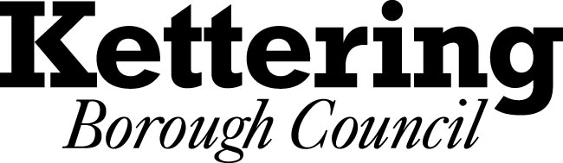

NOTICE OF INTENTION TO HOLD ALL OR PART OF AN EXECUTIVE MEETING IN PRIVATE
THE LOCAL AUTHORITIES (EXECUTIVE ARRANGEMENTS) (MEETINGS AND ACCESS TO INFORMATION) (ENGLAND) REGULATIONS 2012
Pursuant to paragraph 5 of the Local Authorities (Executive Arrangements) (Meetings and Access to Information) (England) Regulations 2012, notice is hereby given of the intention that part of the meeting of the Executive to be held on 16th January 2012 will be held in private.
The reason for the intention to hold part of the meeting in private is that the following item is due to be considered at the meeting, during which it is likely that, if members of the press and public were present, there would be disclosure of exempt information as defined in the relevant paragraph of Part 1 of Schedule 12A of the Local Government Act 1972 as set out below: -
Date and Time of  Meeting | Key  Decision   | Work Programme  Ref No. | Report Title | Reason
16th January 2013  7.00 pm |  | A12/054 | The Yards, Kettering | This item will be considered in private and confidential as it is likely to contain information which relates to the financial and business affairs of a particular person, including the authority holding the information

If you have any queries about the above decision being taken in private, please contact:-

Sue Lyons
Head of Democratic and Legal Services
Municipal Offices
Bowling Green Road
Kettering NN15
or by email to: suelyons@kettering.gov.uk

