To all Members | Direct Line: (01536) 534398  Email: anneireson@kettering.gov.uk  Our Ref: AI  Your Ref:  Date: 4th December 2012



Dear Councillor

You are summoned to a meeting of Kettering Borough Council to be held in the Council Chamber on Wednesday, 12th December 2012 at 7.00 pm.

Yours faithfully

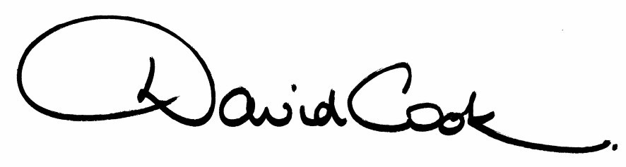

D Cook
Chief Executive

Prior to the commencement of the meeting The Kettering Carnival Queen and Princesses will address Council, followed by festive songs from the Starlight Choir

A G E N D A

1. Apologies

2. Minutes of the meeting of the Council held on 26th September 2012 to be approved as a correct record and signed by the Mayor

3. Declarations of Interest*
- Disclosable Pecuniary Interests
- Personal Interests

4. To receive any announcements from the Mayor and/or the Leader of the Council

5. Report of the Chief Executive

6. The Mayor to ask members of the public present if they want to speak on any item on the agenda

7. Presentation of Civic Society Rose Bowl

8. Appointments to Committees

Reports:

9. Homelessness Strategy

10. Designated Public Places Order

11. Review of the Statement of Licensing Policy as required under Section 349 of The Gambling Act 2005

12. To consider motions received in accordance with Council Procedure Rule 16 as follows:-

(i) To be proposed by Councillor Maggie Don and seconded by Councillor Linda Adams:-

"It is understood that Kettering Borough Council are now aware of the proposals being put together by the Healthier Together Project. It is likely to mean significant changes affecting what services will be delivered at Kettering General Hospital some of which could have a significant impact on the delivery of health care to the residents of this Borough.

A full consultation exercise will begin in January 2013 and a final decision will be made in April 2013.

Under the Health and Social Care Bill Local Authorities have a role to play in the provision of local health services. We believe that Kettering Borough Council have a duty to ensure that residents of the Borough are fully aware of any proposals that could impact detrimentally on local health care provision in the Borough and to take action to oppose if necessary.

The Borough could take an example from Bedford Borough Council whose Mayor is leading a campaign to protect services in Bedford including the setting up of an on line petition. Bedford General Hospital is in a similar situation as Kettering General Hospital in that these two sites are the smallest out of the 5 Hospitals involved in the Healthier Together Project. It is likely that in the options outlined in the proposals these are the 2 sites which will see changes that appear to be a downgrading of services.
We therefore call on Kettering Borough Council to show leadership on this matter and become involved in a campaign to protect local health services."

13. To receive questions from members

14. Any matters of urgency that the Mayor decides should be considered

- Members are asked to make any declarations of financial or other interests they may have in relation to items on this agenda. Members are reminded to make a declaration at any stage throughout the meeting if it becomes apparent that this may be required when a particular item or issue is considered.

4.12.12
Fire Alarm

All meetings shall be adjourned immediately on the sounding of the fire alarm. The alarm is a continuous two-tone siren. On hearing the alarm please leave the building by the nearest emergency exit. There are emergency exits at both ends of the corridor outside the meeting rooms. On leaving the building please cross the car park and assemble on the grassed area by the church. Do not attempt to drive out of the car park as this may impede the arrival of emergency vehicles. Please do not return to the building until you are told it is safe to do so by a Council employee.

Toilets

There are toilets in the corridor off the main entrance to the building you came through to get to the meeting room.

Facilities for Babies and Children

If you wish to use a private area to feed your baby please ask a member of staff. There are changing facilities in the corridor off the main entrance adjacent to the toilets.

.Access for Disabled People

There are allocated parking bays outside the main entrance to the Municipal Offices for disabled people. The meeting rooms are located on the ground floor and access is gained for wheelchair users via the main entrance. If you require assistance, please ask the attendant on duty in the reception area.

No Smoking

Smoking is not permitted in the Municipal Offices.

