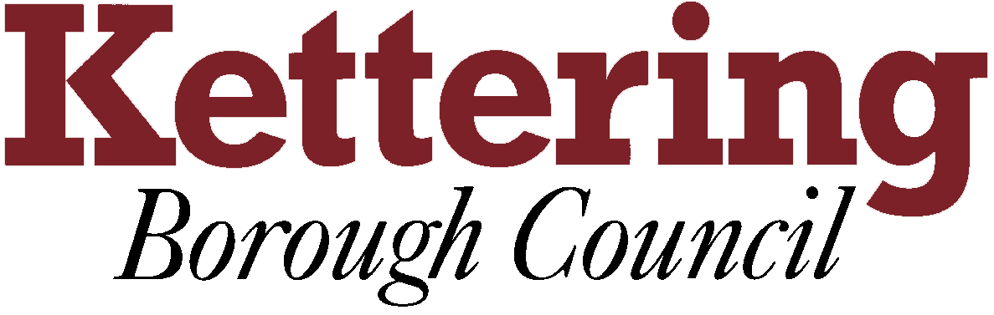

KETTERING BOROUGH TENANTS FORUM

8th November 2012

HRA BUSINESS PLAN 2013/14 - 2042/43
This report asks the Tenants Forum member to comment on the themes of the draft HRA Business Plan

For Comment

1 A new self financing system for council housing was launched in March 2012. Under this system, the Council has more freedom to make strategic decisions about the management, maintenance and improvement of the housing stock over the long term. Self-financing is also a more transparent system which will increase our accountability to tenants. The new financial regime demands a more strategic and business-like approach to the management of council housing. This involves a greater focus on customers, asset management and the need to achieve value for money. The HRA Business Plan will assist us in managing our housing stock by setting out our plans for the Council’s landlord service over the next 30 years. It will be reviewed every year to take account of our changing operational environment.

2 Stock Profile
The Council owns and manages 3,808 homes; almost all of which comprise traditionally constructed houses and low-rise flats. All of our housing meets the Decent Homes Standard. However, a third of our housing stock was built before 1945 and will require substantial investment over the next 15 to 20 years.

3 Tenant Profile
More than 60% of our tenants are elderly and retired with almost half of all households comprising an elderly person living alone. In contrast, only 6% of our tenants are under the age of 30. Similarly, families with children are under-represented among tenants with 8.8% of households comprising one parent families and 6.3% of households being two parent families.

4 The Key Challenges
In managing and maintaining its housing stock, the Council is facing some significant challenges:
- Making sure that council housing in Kettering continues to meet local housing needs.
- Ensuring that the housing stock remains fit for purpose and easy to let over the next thirty years.
- Managing services in an era of tight public finances.
- Responding to the Government’s fast-moving policy agenda, including the Localism Act 2011, Welfare Reform Act 2012 and HRA self-financing.
- Continuing to meet demand for housing-related support from a growing number of elderly and disabled tenants following the end of Supporting People.
- Providing practical support to tenants who wish to develop new skills or take advantage of training, educational or employment opportunities.

5 Making progress
Over the past ten years, we have made considerable progress as a landlord:
- 100% of council housing in Kettering now meets the Decent Homes standard.
- Rent arrears have been reduced from £540,000 in March 2002 to £158,000 at the end of 2011/12.
- We have established a HomeMove service which, since it was established in 2009, has helped 65 tenants move to smaller properties.
- Our training programme for young people - Move On, Move In - has helped 133 young people to keep their tenancies and develop their life skills.
- LifePlan, which provides one-to-one support to tenants who want to take up education, training and employment opportunities has helped 122 customers.
- We have achieved a year on year reduction in complaints about anti-social behaviour.

6 Our strategy for landlord services

As a landlord, our mission is to provide great homes in neighbourhoods where people are happy to live.

This means:
- ensuring that our housing stock is safe, comfortable and easy to let;
- delivering first rate landlord services that provide excellent value for money;
- making neighbourhoods safer and better places to live; and
- helping customers to make the most of their lives.

The introduction of the new funding regime for council housing has provided a unique opportunity to develop services in partnership with our tenants and invest in our properties over the long term. First of all, we must first develop the Council’s capacity to manage the landlord service in the context of the new funding regime and ensure that our business basics are fit-for-purpose. Our short term priorities are:

- Developing our skills, expertise and knowledge
- Working with tenants to develop overview and scrutiny of the landlord service
- Verifying and updating our stock condition data
- Continuing our work to improve performance and achieve better value for money
- Start thinking about the future strategic direction of the landlord service

Our longer term priorities focus on neighbourhood management, asset management, tenancy support services, tenant participation and building new homes.

7 Neighbourhood management – Our plan is to move from an essentially reactive estate management service to one where we our approach is more strategic and where services are designed around customer needs. We will work with tenants and their representatives to identify the issues that concern them and to devise appropriate solutions.

8 Asset management – We have developed a balanced asset management strategy which combines:
- Major investment in our older homes to ensure the long term viability of the housing stock.
- Planned maintenance programmes which ensure that all homes meet the Decent Homes standard and are safe, weatherproof and comfortable.
- Improvement works to improve the environment of our estates, and
- A day-to-day repairs service that is responsive, reliable and valued by our customers.
This approach is reflected in our capital programme through which we will invest £47.469 million over the next ten years.

9 Pre war housing estates
We will commence works in 2014/15 with a phased 15 year programme of works which will be based on the “Homes for the Future” pilot project at Top Dysons in Cranford. As well as ensuring that the properties are structurally sound and fit-for-purpose over the long term, it is likely that the programme will include energy-saving measures and environmental improvements which will benefit the wider neighbourhood.

10 Post war housing estates
In most cases, our post war estates are in good structural condition and have better internal layouts than pre-war housing. As a result it is proposed to focus on planned renewal of building elements so that properties continue to comply with the Decent Homes standard. Accordingly, we aim to continue the kitchen and bathroom renewal programme with expenditure of £6.190 million over the next ten years. We will also invest £9.227 million over the next decade in the renewal of building elements such as roofs, windows, boilers and electrical circuits.

11 Medium rise flats
Around 10% of the Council’s housing stock comprises medium rise flats of three to five storeys which were built in the 1960’s and 1970’s. The investment needs of these properties will generally be met through the renewal of time-expired building elements and the upgrading of kitchens and bathrooms. There will also be a call on capital budgets to upgrade fire precautions and communal areas so that residents are safe and secure both inside and outside their homes.

12 Sheltered housing
The Council’s sheltered housing stock was substantially upgraded in the 1990’s and early 2000’s and now provides modern self contained accommodation. In 2013, we will carry out a strategic review of sheltered housing to ensure that our sheltered schemes are viable over the next thirty years. This review will look at future demand for sheltered housing, the demographic outlook and the suitability of the existing housing stock in meeting that demand.

13 Disabled adaptations
In recent years, the Council has allocated an annual budget of £300,000 for disabled adaptations to the council housing stock. However, demand for adaptations from tenants has far out-stripped the available resources. As a result, there are now 56 households on the waiting list for adaptations. With the new funding regime, there is now scope to increase the budget for adaptations to £400,000 from 2013/14.

14 Tenancy Support
An increasing number of our tenants are vulnerable and have significant support needs. With the impending reform of the welfare benefits system and the introduction of five year flexible tenancies, the need to provide practical support and advice for vulnerable tenants will increase significantly. We will therefore look at investing in further tenancy support provision to minimise the incidence of tenancy breakdown.

15 Tenant participation and consultation
The Tenants Forum is the Council’s primary mechanism for consulting tenants about the management of the landlord service. Over the past two years, the Tenants Forum has played a pivotal role in the development of HRA self financing in our Borough.

A Tenants Overview and Scrutiny Panel has been established during 2012 to closely monitor the Council’s performance as a landlord. The Panel will receive monthly reports on the performance of key activities such as rent arrears, voids and repairs. In addition, the Tenants Overview and Scrutiny Panel will undertake an annual scrutiny programme which will focus on areas where there are concerns about performance or cost.

As well as working with tenants’ representatives, we want to hear from all tenants with their views about our services. Accordingly, we will introduce the HouseMark STAR tenant satisfaction survey during 2013. We also want to improve how we involve tenants in developing and managing capital projects.

16 Building new homes
For the first time in a generation, the new HRA self-financing system provides local authorities with the opportunity to build new affordable homes for rent on a large scale. We will undertake a feasibility study to ascertain the potential for developing new council housing in Kettering which will involve identifying suitable locations for affordable homes, which may be vacant sites or redevelopment opportunities on existing estates, where the result is a net housing gain.

17 Next Steps
At the Tenants Forum on 8 November, tenant representatives will be invited to comment on the main themes of the draft HRA Business Plan. Tenants’ views will be incorporated in the draft plan which will then be submitted to the Council’s Executive Committee in January and full Council in February.

John Conway
Head of Housing
2nd November 2012

