1. PURPOSE OF REPORT

The purpose of the report is to:
- Provide Members with a reminder of the Council’s medium term financial strategy and associated guiding principles;

- Illustrate the latest budget model, the delivery of efficiency savings for 2012/13 and the estimated level of budget savings that may be required over the next few years;

- Outline the budget timetable for 2013/14;

- Provide an update on the National Resource Review.

2. BACKGROUND

  - The budget delivery framework used in the two previous budget rounds (2011/12 & 2012/13) was approved by Members as the basis for the preparation of the 2013/14 budgets. Specifically, members approved;

“that the same methodology be applied to the formulation of the 2013/14 budget as it applied to the 2012/13 budget, with particular reliance on:-

- the existing guiding principles

- the existing modelling for recovery principles

- the existing budget containment strategy

- the existing eight workstreams”

  - The strategy has to date proved extremely successful and helped provide additional flexibilities from which to address the national funding challenges that face all local authorities.

  - This overall strategy provides the cornerstone on which the Council's long-standing success in both setting a ‘balanced budget’ and delivering within budget are founded. The framework consists of eight workstreams – as illustrated below;


Capital
Review
Service Plans
Fees and
Charges
Review
Prioritisation
Innovation
Group
Staff
Suggestions
Partnership
Working
Lobbying
Budget
Delivery
Framework

  - The financial strategies key ‘guiding principles’ supplemented by the ‘Modelling for Recovery Principles’ and the ‘Budget Containment strategies’ have provided a strong cornerstone for the Council’s medium term financial strategy. For ease of reference, these are reproduced here:-

Financial Strategy Guiding principles:

- Revenue balances should not fall below £1m and overall revenue reserves should not fall below 10% of net revenue expenditure;

- In setting the Council Tax, members should consider the medium term to ensure that a sustainable budgetary position is preserved (with due regard being given to any penalties that might apply);

- The level of household Council Tax to increase each year in line with inflation at least, where the budget is in deficit, to ensure resources remain consistent with budgeted costs;

- When setting the Capital Programme, consideration is given to allocating capital resources to schemes that are beneficial to the Council’s overall revenue budget position;

- To maximise the resources available to the Authority, the Council will actively lobby the Government on relevant issues (e.g. grant distribution/ planning fees).

Modelling for Recovery principles:

- Wherever possible, continue with all planned investments and programmes, to protect the local economy and lever in other investments;

- Given the strength of our Treasury position we should consider debt funding as a means of programme delivery or stimulus – if this can be shown to be sustainable and have a wider economic benefit;

- Organise our fiscal structures and business models to attract and retain the maximum amount of revenue within the local economy;

- To ensure all possible avenues are used within procurement rules to source locally;

- Protect the performance of Council services which come under particular strain;

- Work closely with partners in the voluntary, public and private sectors, to ensure optimum efficiency.

Budget Containment Strategy:

- Where a specific grant which funds a specific service is withdrawn, the service stops;

- Where grant funding reduces, which Kettering Borough Council passports through to another organisation, the reduced sum continues to be passported, providing the end recipient organisation feels it can still provide a value-added service at that funding point.
- Where a function is transferred to another provider, the Council leaves all service-provision discussions, including any top-up funding, with the new provider;

- The Council would ordinarily neither seek to buffer nor profit from tax changes.

- The Council should not substitute itself as a provider / funder of services when another public provider cuts such a service.

- BUDGET MONITORING & PLANNING
GENERAL FUND 2012/13 – CURRENT FINANCIAL YEAR

  - From the recent budget process, Members will recall that additional ongoing savings of £1.3m were required for 2012/13. These were identified as detailed in Table 1;

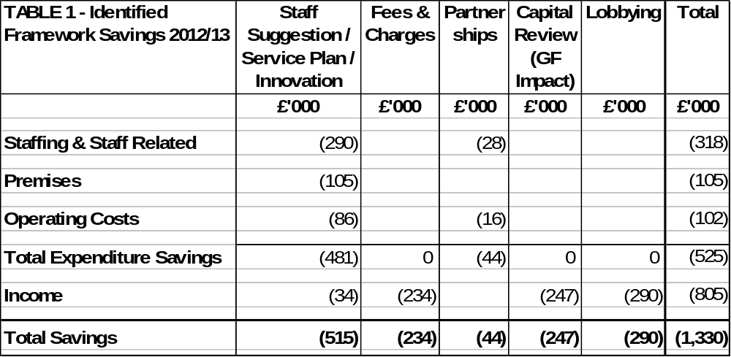
  - The chart below shows the actual realisation of the ‘cash’ savings against the target for the year. It can be seen that as well as the £1.3m having now been ‘locked in’ it is also on schedule in terms of its cash delivery throughout the year.
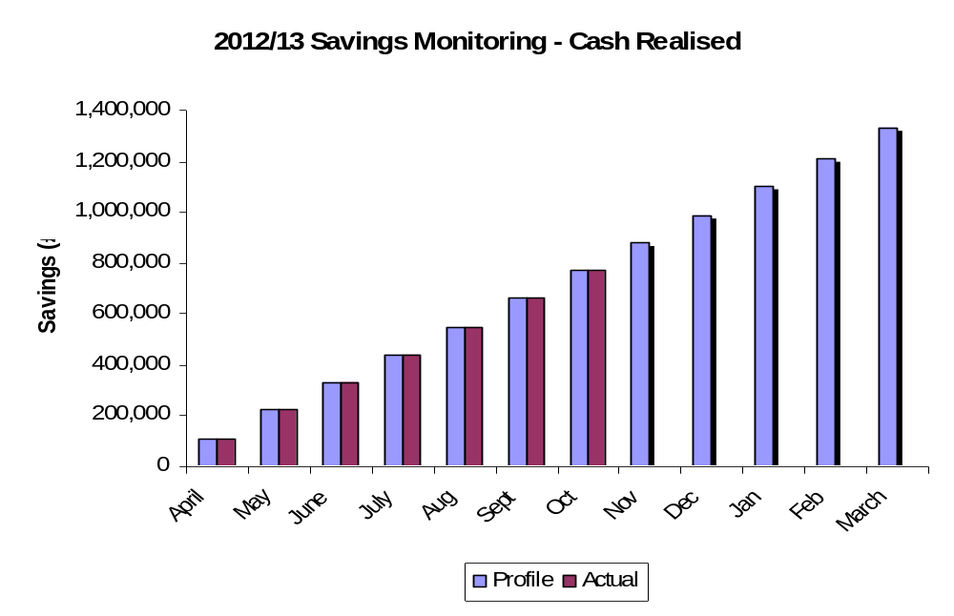

  - Whilst it is recognised that the above chart is somewhat simplistic, it highlights the fact that the required level of savings are actually being delivered ‘on target’ throughout the year as on-going budget savings.

  - Officers are currently progressing with the detail of the 2013/14 budget and will continue to ‘lock-in’ savings that are resilience tested at the earliest opportunity this approach will allow for further in year savings to be generated.

  - As in previous years, it is likely that we will have some additional in-year savings in addition to the £1.330m original requirement. The majority of these are likely to be of a one-off nature although there may be an element of on-going savings if some of the savings required for 2013/14 are able to be implemented early. Such figures are being validated through the budget preparation process and will be reported as part of future budget reports when further resilience testing has been undertaken.

  - Following on from the above, we will continue with the approach used last financial year in relation to any underspends for 2012/13, i.e., the early delivery of savings and the additional one-off items will result in the Council being able to put resources aside to help provide some earmarked resources to assist in actually delivering future ongoing budget reductions – very much in the style of the ‘invest to save’ initiatives of previous years. At the same time, some of the one-off resources need to be earmarked to help protect the Council against specific business risks/threats required in the current economic conditions.

  - The Council’s impressive record in identifying and delivering efficiency savings in the past three years, including the year under consideration (2012/13), are around £4.5m - as illustrated in Table 2;

Table 2 – Efficiency Savings | £000
2010/11 | 1,260
2011/12 | 1,910
2012/13 | 1,330
Total  Cash Savings (%) | 4,500  40%

  - The scale and delivery of this level of efficiency savings is particularly impressive given that there has been no detrimental impact on the delivery of front line services and when considering the increased costs of utilities and more recent inflation levels. Over the three year period (as detailed in Table 2) the efficiency savings are equivalent to approximately 40% (50% in real terms) of the Council’s net budget (which stands at £11.2m for 2012/13).

  - Members are reminded that before the efficiency programme commenced a number of years ago, the Council was charging a level of Council tax below the national average yet delivering a level of performance that was above the national average. Despite having to deliver efficiency savings of £4.5m in the past three years, the Council’s performance remains above average and the level of council tax charged remains below the national average.
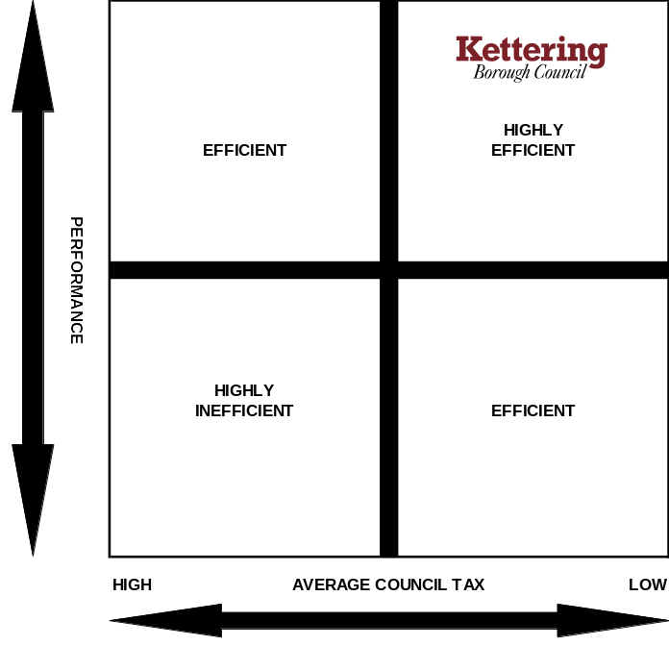

GENERAL FUND 2013/14 – BUDGET PROSPECTS NEXT FINANCIAL YEAR

  - As well as monitoring framework savings identified for 2012/13 work continues on identifying savings for the following year - 2013/14. Members are reminded of the current Medium Term Financial Forecast which requires an additional £777,000 of savings to balance the budget in 2013/14. This is prior to the consideration of Council Tax.

  - In the previous durable budget report (to the October meeting of the Executive Committee) it was reported that an early start had already been made on identifying the savings required for 2013/14 – a figure of £485,000 was reported. Table 3 shows that the figure now stands at £635,000 which is very encouraging and is significantly ahead of schedule. (We have indentified around 80% of the savings target at this stage).

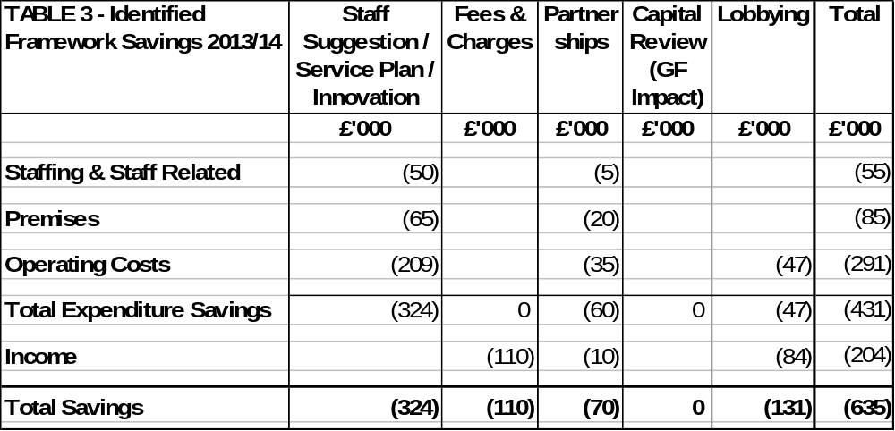

MEDIUM TERM FINANCIAL FORECAST

  - The Council’s latest Medium Term Financial Forecast is shown in Table 4;

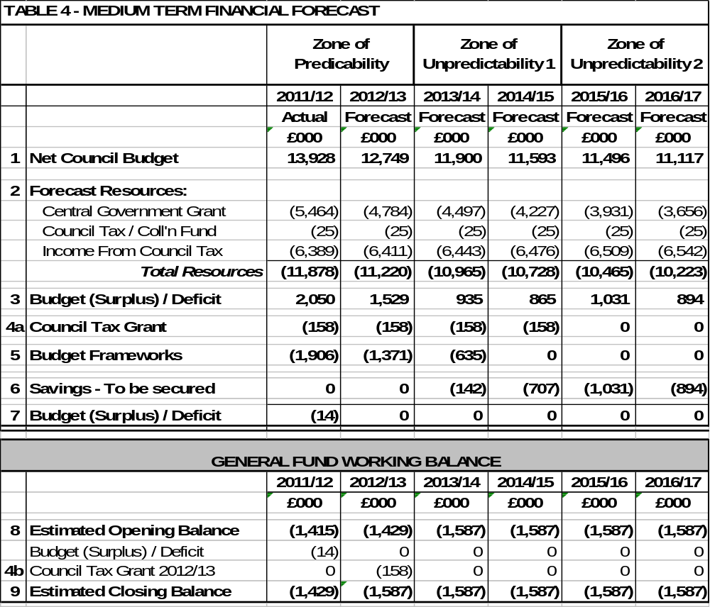
Notes to Medium Term Financial Forecast

1 Net Council Budget – This represents the net expenditure prior to the Budget Framework savings.

2 Forecast Resources – These are the Council's main funding streams (excluding fees and charges which are incorporated into Line 1). This illustrates the significant reduction in Central Government Grant. To enable the total resources required to balance the budget to be identified, no assumptions have been made regarding future council tax increases. The small increase in revenue each year reflects anticipated housing growth in the borough.

3 Budget (Surplus) / Deficit – This illustrates the gap between the budget and the total resources available before identifying budget framework savings.
4a Council Tax Grant – This is a grant the Council receives from central government for four years in return for freezing Council Tax in 2011/12. This is equivalent to the cash that would have been received if a 2.5% increase had been levied.

4b Council Tax Grant 2012/13 – This is a grant the Council receives from central government for one year in return for freezing Council Tax in 2012/13. This is equivalent to the cash that would have been received if a 2.5% increase had been levied.

5 Budget Frameworks – This identifies the total savings required and differs to the table shown in 3.1 as a result of the Council decision earlier in the year in relation to members allowances.

6 Savings to be secured – This identifies the total resources required to balance the budget in future years after 2012/13.

  - The autumn statement will be announced on 5 December. Therefore it is expected the provisional grant settlement will be around mid December. This makes it increasingly difficult for budgeting purposes. There are also growing concerns that the reduction in grant in 2013/14 and 2014/15 could be greater than the 6% the Council is currently modelling. To put this into context a reduction of 1% reduces the Council's grant by around £45,000. The CLG have indicated that the level of grant reduction for Local Government could be in the region of 12% for 2013/14 this would require additional ongoing framework savings of around £270,000.

HOUSING REVENUE ACCOUNT 2012/13 – CURRENT FINANCIAL YEAR
  - A summary of HRA monitoring at 30th September is shown in Table 5. The projected outturn is a £69,000 underspend resulting from income being higher than budgeted.

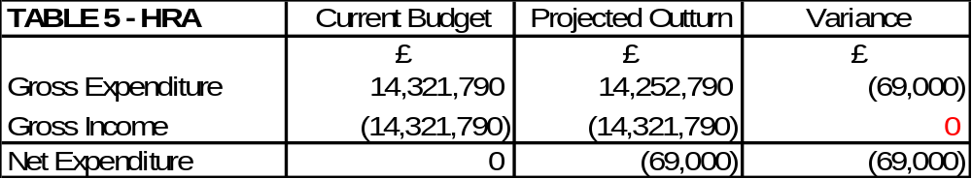

CAPITAL 2012/13 – CURRENT FINANCIAL YEAR

  - A summary of the projected Capital Programme outturn monitoring statement as at 30th September 2012 is shown in Table 6: -
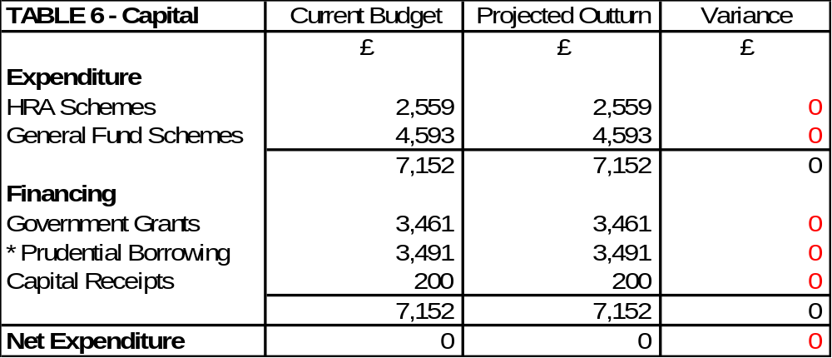
* The Council has no long term cash debt but uses internal borrowing, in line with its “modelling for recovery” principles to support capital investment.

  - A number of amendments to the capital programme for 2012/13 are being prepared and will be reflected in the Revised Budget in January.

4 CASE STUDIES

  - Members will recall that in previous budget reports we have identified case studies as examples of good practice. The previous examples related to the new arrangements for the following:

- Generic warden service
- Recycling pilots
- Kettering Borough Trainers
- Partnership work with the Citizens Advice Bureau.
- VAT recovery
- Prevent Strategy funding
- Flexible Working
- Printing Function
- Market

  - The case study in this report highlights the proactive approach the Council has taken in managing homelessness.

Case Study – Homelessness Prevention

Suzanne, aged 20, approached Housing options for advice after being asked to leave her partner's room in a House in Multiple Occupation, which she had no legal right to occupy. Suzanne was pregnant with her first child and her baby was due four weeks later.

Suzanne was given extensive housing options advice and decided to pursue a private tenancy. Our Landlord Liaison Officer worked with Suzanne to source a suitable 2 bed flat for her which she was delighted with. To secure the property Suzanne needed £450 for the deposit, which she borrowed from her step-father; and an additional £450 for the rent in advance, which we paid as a grant from the Homelessness Prevention Budget. As a comparison our average cost of putting someone into bed and breakfast is £470.


The payment from the Homelessness Prevention budget enabled Suzanne to be re-housed in the privately rented sector, allowing her to get settled into her new accommodation before her baby was born. If this payment had not been made it is likely that Suzanne would have exercised her legal right to make a homelessness application which would have resulted in the Council providing temporary accommodation for her.

The Landlord Liaison Officer referred Suzanne to the Council’s Move On Move In tenancy training course as he felt that she would benefit from developing her skills as a private tenant.
*Library Image

Suzanne successfully completed Move On Move In and is working with our LifePlan Advisor to complete Practical Housing Units which are workbooks which ensure tenants have the key skills they need to maintain a successful tenancy. Suzanne feels much more confident in managing her tenancy and once her child is older she will work with our LifePlan Advisor to find part-time employment.

Our interventions have solved Suzanne's housing needs quickly and effectively before she reached a crisis and given her the confidence to continue developing her skills, not only to prepare her for work, but also to play a far greater part in her community in the future. Dealing with these issues in a proactive way has financial benefits and the social benefits, whilst not easy to quantify are significant.

5 BUDGET TIMETABLE

  - A summary budget timetable is provided at Appendix A.

  - Members should note that the formal budget consultation period starts on the date of the January Executive Committee. Members will however be aware that the budget process at Kettering Borough Council is an ongoing process throughout the year that has been evidenced by the ongoing consideration of the durable budget report at each meeting of the Executive Committee.
6 NATIONAL RESOURCE REVIEW
6.1 In previous reports to this committee, detailed updates have been provided in relation to the Government’s National Resource Review – namely in relation to the proposed changes to the administration of Business Rates, and the requirement to implement a local scheme for Council Tax Support effective from April 2013.

6.2 The report contained at Item 12b provides an update in relation to the latest proposals for Business Rates, looking in particular at the issue of Business Rates Pooling.

6.3 The consultation that the Council is undertaking to evaluate the options available to construct a local scheme of Council Tax Support (to replace the current scheme of Council Tax Benefit) closes on the 31st October. The Executive will receive a detailed report at its next meeting where it will need to recommend a scheme to full Council for adoption. Since the last meeting of the Committee, there has been an announcement by the Government that requires reporting to members. Government have announced that £100m will be made available to local authorities (as a one-off transitional grant) provided that their local scheme meets certain criteria. The initial announcement contained little detail and further clarification is due shortly. Clearly, this issue will be referred to in the December report once more is known about it. It would appear that the grant would be approximately £140,000 which compares to the anticipated overall funding reduction of £880,000. It is important that the Council creates a scheme that it is sustainable in the medium term (as reported to Committee in August 2013), the ‘offer’ of transitional grant needs to be evaluated and considered with this in mind.

7 CONSULTATION AND CUSTOMER IMPACT
7.1 None as a direct consequence of this report. However members are reminded that the formal budget consultation period is from 16th January 2013 to 27th February 2013 when the Council sets its Council Tax for 2013/14. Comments from the consultation process will be reported to the Executive for consideration at it’s meeting on 13th February 2013.

8 POLICY IMPLICATIONS
8.1 None as a direct consequence of this report.
9 USE OF RESOURCES
9.1 None as a direct consequence of this report.

10. RECOMMENDATIONS
That the Executive;

  - Notes the Council’s Medium Term Financial Strategy and associated guiding principles;

  - Notes the current Medium Term Financial Forecast and the progress being made for the delivery of efficiency savings for 2012/13 and future years;

  - Continues to recognise the significance of changes facing the authority beyond April 2013.

  - Notes the summary budget timetable for 2013/14 (as outlined in Appendix A)

Background Papers: Previous Reports/Minutes:
Title of Document: Various Monthly Durable Budget Reports Contact Officers: M Dickenson

