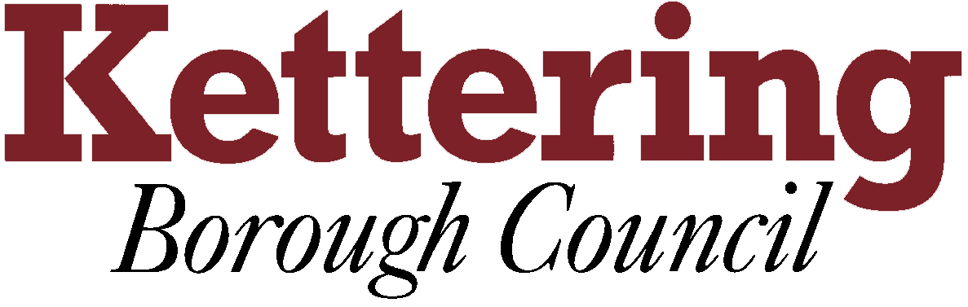

KETTERING BOROUGH TENANTS FORUM

Thursday 11th October 2012

Tenant’s Forum Representatives Code of Conduct
This report asks the Tenants Forum to discuss the Code of Conduct of the Tenants Forum as a reminder of meeting protocols and to suggest any amendments that may be needed to reflected the changing role of the Forum
For Information

1 All members of the Tenants Forum have signed up to the Tenants Forum Representatives Code of Conduct, this discussion will enable all tenant members to refocus on why they signed up, act as a reminder of confidentiality and reinforce meeting protocols

2 Attached to the this report at appendix B is a copy of the Code of Conduct, all tenant members are asked to read this and make any note that will enable them to fully participate in the discussion.

3 This will also be an opportunity to make any amendments to the Code of Conduct in light of the changing role of the Tenants’ Forum and the role it will be playing in Scrutiny

Linda Nash
Housing Communications Officer
3rd October 2012

