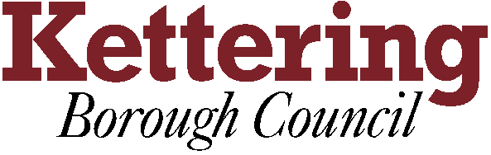

Community Watch Service Specification

TOTAL AMOUNT ALLOCATED OVER THE FOUR YEAR PERIOD:

To be agreed at Executive, 12 September 2012

(To be split into equal annual amounts with grants being paid in advance in two stages during the year).

Mandatory and discretionary council tax relief (subject to eligibility).
Contribution towards car parking costs of volunteers while they are working in the town centre.

Community Watch is a generic term that includes Neighbourhood Watch scheme, however is wider in scope and also includes Dog Watch, Allotment Watch, Park Watch. All such schemes are about supporting local people to positively impact on local policing issues.

Core Service Objectives

1. To support the development of community led crime reduction schemes such as Neighbourhood Watch, Dog Watch, Allotment Watch, Park Watch.

Minimum Requirements

- To contribute to ‘community watch’ type schemes, to provide a dedicated officer whose responsibility includes to support, develop and maintain such schemes within the Kettering Borough focusing on the areas with the most need.
- To assist new and existing groups in the recruitment of members.
- To provide support and advice to existing schemes.
- To liaise closely with the Police and ‘community watch’ groups to ensure the effective flow of information.
- To ensure that the scheme is promoted through a variety of methods.
- Acknowledge the funding and support from Kettering Borough Council when providing this service.

Outcomes
More people feeling more confident that they are part of the solution for reducing incidents of burglary, vehicle crime and violent crime and anti-social behaviour in their local area

Performance indicators
a) No. of schemes development such as Neighbourhood Watch, Dog Watch, Allotment Watch and other similar schemes.
b) No. of schemes established targeted areas linked to SCT priorities.
c) Reflect where appropriate issues from the emergent office of the Northants Police Commissioner

Added Value

I Demonstrate partnership working with other voluntary and statutory agencies that help achieve the objectives of this specification.
II Explain how your organisation’s activities also support other local priorities (the Council’s Corporate Priorities, the Community Strategy, the Community Safety Partnership Plan, Health & Wellbeing Partnership and emerging Police & Crime Commissioner priorities).
III Evidence of implementation of Quality Management systems including the quality of data for management purposes.

SIGNED

On behalf of the Management Committee of the Service Provider

Management position of signatory

DATE:

SIGNED

On behalf of Kettering Borough Council

Position of the Signatory within the Council

DATE:

