Kettering Town Centre Health
Check Monitoring Report: 2008-2009

1. INTRODUCTION

As part of the growth agenda, Kettering will see major development over the next 15-25 years and a key aim is to ensure that this development is planned and delivered in an environmentally, socially and economically sustainable manner. A major part of this strategic aim will be on managing and developing the role and function of Kettering Town Centre.

As outlined in Planning Policy Statement 4: Planning for Sustainable Economic Growth (PPS4, 2009), the Government considers the promotion of a town centre’s vitality and viability to be a key part in delivering sustainable economic development. PPS4 advocates the use of town centre health checks as a way of drawing together retail and other applicable information as a means of monitoring vitality and viability, whilst assessing whether policy is responding to signs of change and identifying suitable action points if required.

This is the first Kettering Town Centre health check monitoring report to be carried out by Kettering Borough Council, and will establish the baseline position demonstrating the current health of the town centre, and assist in the formulation of policies for the emerging Kettering Town Centre Area Action Plan (AAP). An awareness of the current local context and the well being of our Town Centre will also ensure that we are able to better define Kettering’s role by understanding and enhancing its strengths as a town centre. It will also help to recognise new opportunities to attract shoppers, visitors and investors to the town and the Borough.

This report will become the benchmark in the formation of consistent and measurable indicators of performance and improvement for future annual checks, and will also be used to assess the performance of the policies in the AAP, once adopted. It is the Council’s aim to update this report on an annual basis as part of the annual monitoring process. This will allow for local changes and trends to be systematically observed overtime and reflected within the directional aims of future planning policy.

The range of indicators contained within this report considers the economic, environmental and social health of a town, and have been identified by PPS4 as a means of monitoring vitality and viability (full list of indicators shown in Appendix 1). As the monitoring framework is still in its early stages, it has not been possible to collect information on all of the indicators. In time, future health checks will consider all of the indicators outlined in PPS4.

The indicators selected for the 2009 town centre health check have been grouped into two indicator categories; market and qualitative and together will provide a good picture of the town centre.

- Market Indicators: Rents, yields and vacancy levels: These indicators will provide a good indication of town centre health through the pricing system of the commercial property market.

- Qualitative Indicators: Diversity of uses, pedestrian flows, accessibility, crime and safety and environmental quality. These indicators will provide a good indication of town centre health in terms of the mix of uses, town centre vigour, the range of different attractions, the ease of public access and the quality of the public realm.

2. PLANNING POLICY AND KETTERING TOWN CENTRE

This Health Check Monitoring Report has been compiled following the guidance stated in Annex D of Planning Policy Statement 4: Planning for Sustainable Economic Growth (PPS4). The following section outlines national planning policy and how this in turn influences planning decisions at a local level.

NATIONAL PLANNING POLICY:

Planning Policy Statement 4: Planning for Sustainable Economic Growth (PPS4)
The current national planning policy which relates to town centres is contained set within Planning Policy Statement 4: Planning for Sustainable Economic Growth (2009). The Governments overarching objective is to deliver sustainable economic growth and a key tenant of this is to promote the vitality and viability of town and other centres as important places for communities by:

- new economic growth and development of main town centre uses to be focused in existing centres, with the aim of offering a wide range of services to communities in an attractive and safe environment and remedying deficiencies in provision in areas with poor access to facilities
- competition between retailers and enhanced consumer choice through the provision of innovative and efficient shopping, leisure, tourism and local services in town centres, which allow genuine choice to meet the needs of the entire community (particularly socially excluded groups)

- the historic, archaeological and architectural heritage of centres to be conserved and, where appropriate, enhanced to provide a sense of place and a focus for the community and for civic activity (PPS4 pg4)

Policy EC3 of PPS4 states that local planning authorities should, as part of their economic vision for their area, set out a strategy for the management and growth of centres over the plan period. As part of their strategies local planning authorities should:
- Set flexible policies for their centres which are able to respond to changing a. economic circumstances and encourage, where appropriate, high-density development accessible by public transport, walking and cycling
- Define a network and hierarchy of centres that is resilient to anticipated future economic changes, to meet the needs of their catchments.
- Ensure extensions to centres are carefully integrated with the existing

- Strengthening centres which are in decline by promoting the diversification of uses and improving the environment

- Define the extent of the centre and the primary and secondary shopping areas and set policies that make clear which uses will be permitted in such locations

- encourage residential or office development above ground floor retail, leisure or other facilities within centres, ensuring that housing in out-of-centre mixed-use developments is not, in itself, used as a reason to justify additional floorspace for main town centre uses in such locations

- Use tools such as local development orders, area action plans, compulsory purchase orders and town centre strategies to address the transport, land assembly, crime prevention, planning and design issues associated with the growth and management of their centres

Policy EC4 of PPS4 states that Local planning authorities should proactively plan to promote competitive town centre environments and provide consumer choice by:

- supporting a diverse range of uses

- planning for a strong retail mix

- identifying sites in the centre for accommodating larger format developments where a need for such development has been identified

- retaining and enhancing existing markets and, where appropriate, e. re-introducing or creating new ones, ensuring that markets remain attractive and competitive by investing in their improvement

- taking measures to conserve and, where appropriate, enhance the established character and diversity of their town centres

- managing the evening and night-time economy in centres

REGIONAL PLANNING POLICY:

Milton Keynes-South Midlands Sub-Regional Strategy (MKSM SRS)

The MKSM was adopted March 2005 and covers the whole of Northamptonshire and three regions; East Midlands, South East and East of England. Policy 4 of the MKSM SRS Northamptonshire states that the focus of development in Kettering will be to maintain and develop the role of the town centre with the protection and enhancement of the existing basic comparison shopping, development of a regionally important niche market and development of a range of cultural attractions. The MKSM is now incorporated within the East Midlands Regional Plan 2009.

The East Midlands Regional Plan (EMRP March 2009)
Policy 22 of the EMRP states that local authorities should bring forward retail development in town centres, based on an identified need. As stated above Policy 4 of the MKSM SRS Northamptonshire requires the focus for Kettering to be on maintaining and enhancing the existing role of the town centre, through the promotion and protection of the existing comparison shopping offer. It is clear from these two policies that the protection of the retail function of Kettering Town Centre is a key issue.

Policy 23: Regional Priorities for Town Centres and Retail Development, of the Regional Plan states that the vitality and viability of town centres should be promoted. ‘Where town centres are under-performing, action should be taken to promote investment’.

LOCAL PLANNING POLICY CONTEXT:

North Northamptonshire Core Spatial Strategy (CSS) (June 2008)

The Joint Core Spatial Strategy is the development framework for North Northamptonshire which builds upon and adds detail to the issues outlined in the East Midlands Regional Plan and MKSM. The CSS provides the strategic level planning policy for Kettering Borough, as well as the other districts of Corby, Wellingborough and East Northamptonshire.

Policy 1: Strengthening the Network of Settlements, of the CSS states that development should be principally concentrated towards the urban cores and growth towns of Kettering, Corby and Wellingborough with the emphasis on regeneration of the town centres. In terms of retail development, Policy 12 states ‘the scale of retail development should be appropriate to the role and function of the centre where it is located’, and although Corby and Wellingborough are considered to be key foci for town centre uses, Kettering will continue to be the main retail centre as it has the potential to be a strong sub-regional centre.

Figure 1: Focus of Town Centre Development
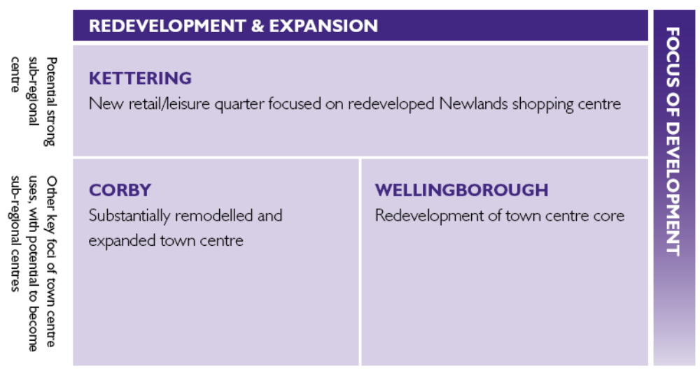

Kettering Borough Council Local Plan (January 1995)

Saved Policy K20: Changes of use in the established shopping area: Planning permission for changes of use defined under the Town and Country Planning (Use Classes) order 1987 from Class Al (Shops) to Class A2 (Financial and Professional Services) or Class A3 (Food and Drink) or other non-retailing uses in the established shopping area as shown on the Proposals Map:
i will not be granted at ground floor level in the shopping frontages shown as “restricted” on the Proposals Map; and
ii will be granted in the shopping frontages shown as “unrestricted” on the Proposals Map, provided that they do not involve uses for hot food takeaway, wholly or partially

Saved Policy 64: Shopping: Development within Established Shopping Areas, of the Local Plan for Kettering Borough designates the established shopping area for Kettering Town Centre. Here planning permission should only be granted where development ‘would improve the range or quality of shopping facilities or the shopping environment’.

Kettering Town Centre Masterplan (May 2005)

In order for Kettering town to be the first choice destination for shopping, employment, financial services and leisure pursuits for people both within and beyond the Borough’s boundary, the town centre will need to grow and adapt to the changing needs of the population.

In May 2005, the Borough Council adopted the Kettering Masterplan – a visionary document to outline a vision for the development of the town centre during the Plan period. The Masterplan identified four distinct Quarters within the Town Centre, and the basis of this work was incorporated within the proposals for the Kettering Town Centre Area Action Plan.

Local Development Framework and Kettering Town Centre AAP

The Local Development Framework will consist of a suite of documents including the Kettering Town Centre Area Action Plan (AAP). The portfolio of documents being prepared by Kettering Borough Council is shown below. The documents being prepared on a North Northamptonshire wide basis are highlighted in pink:

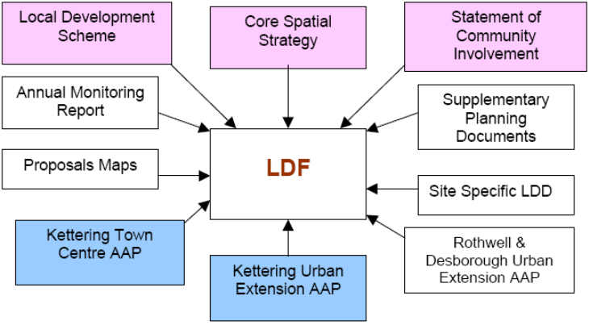
Figure 2: Local Development Framework
Issues and Options

The publication of the “Issues and Options Paper” for the Kettering Town Centre and Kettering Urban Extension Area Action Plans (highlighted in blue above) was accompanied by widespread community involvement during September, October and November 2006. This community involvement included a substantial mail-out of documents, notices and information letters, workshops, leafleting, posters, drop-in sessions, exhibitions and consultation with Council Panels and other groups. The document sought the views of stakeholders on a series of “issues” identified in the areas in question, and “options” for addressing them.

Preferred Options
Taking the outcomes of the Issues and options consultation and other work Kettering Borough Council produced and consulted on a Preferred Options in August 2008. The preferred options document sets out Kettering Borough Council’s vision for Kettering Town Centre. It outlines options considered based on evidence and previous consultations and provides a clear strategy for the town centre.
The regeneration priorities of the Kettering Town Centre AAP are focussed on creating a town centre that has distinct zones of use that are complimentary to each other in terms of proximity and function. As such eight urban quarters were proposed and are shown in Figure 3.
Figure 3: Kettering Town Centre Preferred Options AAP: The Quarters
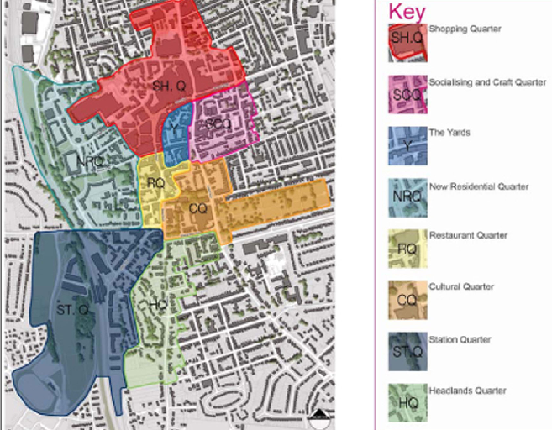
Based on the results of the Preferred Options consultation and further technical work, the Borough Council is due to publish the Proposed Submission AAP during 2010.
3. KETTERING TOWN CENTRE PROFILE

Kettering Town Centre is designated within the adopted Kettering Borough Local Plan (January 1995) and is identified as being the principal centre for the Borough which supports a number of purposes including shopping, employment and administrative functions. As identified above Kettering Borough and its Town Centre has a larger role to play within the wider North Northamptonshire context. Under the Joint Core Spatial Strategy (CSS) Kettering Borough will continue to be the most populous area within North Northamptonshire and the main retail centre with the potential to be strong sub regional centre. In this context it is important that we understand the existing role and functioning of the town centre, in order for us to respond to and expand to meet the needs of existing and future populations of Kettering Borough and beyond.
Definition of the Study Area:

The Town Centre Boundary for the purposes of this report will be defined by the 1995 Local Plan for Kettering Borough as illustrated on the Local Plan Proposals Map. The designated town centre is relatively compact with the retail focus centred on Gold Street, High Street, The Newland Centre and Newland Street. The older areas of the town centre are predominantly located around the Market Square which is situated at the southern end, with the more modern constructs, such as The Newland Centre sited towards the northern end of the town centre.

However, given the age of the adopted Local Plan and the long term strategic policies outlined in the 2008 CSS, it is considered prudent to also report on data which pertains to the Town Centre boundary as proposed by the emerging Kettering Town Centre Area Action Plan (AAP). This is considered important as it will enable emerging policies to respond to the existing baseline conditions, and provide a reference point for future health checks once the AAP has been through public examination and adopted in 2010.

National Retail Ranking:

The following table shows the relative retail rankings of the three main centres in North Northamptonshire and the lower the number the better the position of the centre within the national centre hierarchy. The rankings are produced by Management Horizons Europe (MHE) and Javelin Venuescore (JV) which are calculated using a weighted system which takes account of each location’s provision of non-food multiple retailers and anchor store strength, and provides us with a useful comparison to compare Kettering Town Centres performance with that of the other growth towns.

From the data Kettering appears to be in a much stronger position than both Corby and Wellingborough for it is the only centre out of the three to have improved its national retail ranking since 1998/99. This is perhaps a continuing reflection of the status attributed to the town centres within the previously outlined Core Spatial Strategy.

Figure 4: Retail Rankings for Kettering, Corby and Wellingborough
 | Kettering | Corby | Wellingborough
MHE Index 1998/99 | 184 | 269 | 290
MHE Index 2000/01 | 187 | 259 | 282
MHE Index 2003/4 | 171 | 344 | 360
JV 2006 | 154 | 364 | Data unavailable
JV 2007 | 160 | Data unavailable | Data unavailable
JV 2008 | 160 | 352 | 414
CHANGE | +24 | -83 | -124
Source: Management Horizons Europe (MHE) and Javelin Venuescore (JV)
Notes: Javelin’s first Venuescore was produced in 2006. It uses an almost identical method for ranking centres as the previous rankings produced by MHE, however, is ranks the UK’s top 2,226 shopping venues rather than MHE which ranked the UK’s top 1,672 retail centres, so caution must be employed when directly comparing the two data sets.

Diversity of Uses:

A town centre’s vitality and viability is dependent not only on its retail function but also on the mix of uses that contribute to the centre’s attractiveness to those who live, work and visit the area. Leisure and entertainment facilities including cafes, bars and restaurants can add variety to a town centre and can also generate an evening economy. As such it is important to monitor the different uses within the restricted and unrestricted shopping areas in order to prevent an over proliferation of particular uses.

Use Classes:

A survey conducted in August 2009 audited the different ground floor uses within the established shopping area for Kettering Town Centre area as defined in the Local Plan Proposals Map (1995) and the proposed boundary for the proposed Kettering Town Centre AAP. The survey was undertaken with the aim of giving a snapshot of the Town Centre, however, it must be remembered that the Town Centre is subject to constant change so the results will be subject to these ongoing changes. The categories used are those defined under the Use Classes Order 2005 which is further explained in Appendix 2. In addition the survey measured the width of the units frontage (in metres) in order to ascertain the total meterage and percentage of frontages designated to each use class. The purpose of which was to establish an evidence base upon which the policy direction for the Kettering Town Centre AAP could be based.

Local Plan Shopping Boundary: Restricted and Unrestricted Shopping Frontages:

The restricted shopping frontage is the retail core of the Town Centre which covers Market Place and runs up High Street, Gold Street and Market Street and incorporates the Newland Centre and parts of Silver Street, Horse Market and Dalkeith Place. The unrestricted shopping frontages form the fringe area of the Town Centres retail core and are located along Montagu Street, parts of Silver Street and the Horse Market.
Figure 5: RESTRICTED SHOPPING FRONTAGE: Summary
Use | Meterage | Percentage | Units | Units percentage
Total A1 primary meterage | 1439.9 | 60.93% | 139 | 67.47%
Total A2 primary meterage | 315.2 | 13.34% | 33 | 16.02%
Total A3 primary meterage | 117.6 | 4.98% | 9 | 4.37%
Total A4 primary meterage | 187.8 | 7.94% | 7 | 3.4%
Total A5 primary meterage | 73.5 | 3.11% | 7 | 3.4%
Total other primary meterage | 229.3 | 9.70% | 11 | 5.34%
Total primary meterage | 2363.3 | 100% | 206 | 100%
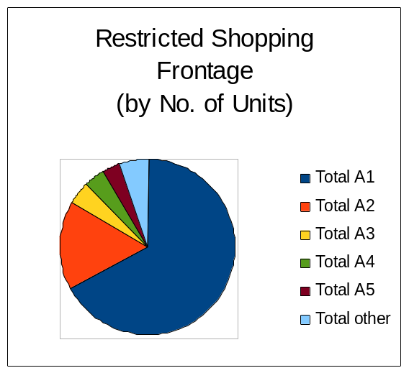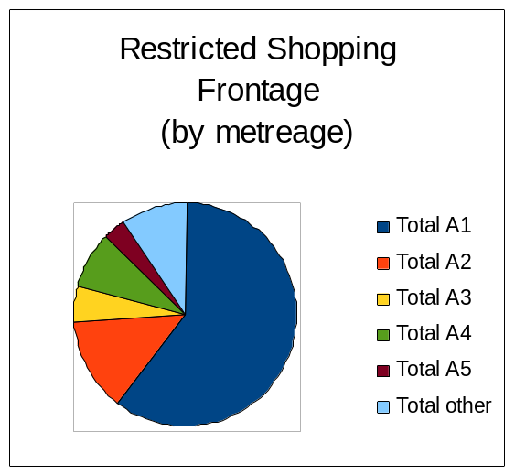

As can be seen in Figure 5 non A1 (retail) uses within the restricted shopping frontage account for 32.53% of the number of units, and 39.07% of the active frontages. The majority of non retail uses within this restricted frontage are A2 uses which are financial and professional services. The percentage of non-retail uses within this location is considered to be high and if left unmonitored could undermine Kettering’s retail offer. In order to control this, policy K20 of the Local Plan (1995) has been saved which seeks to control changes of use within both the restricted and unrestricted frontages. It provides that planning permission for changes of use from Al (Shops) to Class A2 (Financial and Professional Services) or Class A3 (Food and Drink) or other non-retailing uses will not be granted at ground floor level in the shopping frontages shown as “restricted” on the Proposals Map. It is advised that any future policy direction should provide for stricter policies regarding non-retail uses within the main retail area. It is considered that the provision of upper limits of non-retail uses is provided which would restrict the total proportion of the non-retail uses.

Figure 6: UNRESTRICTED SHOPPING FRONTAGE: Summary
Use | Meterage | Percentage | Units | Units percentage
Total A1 primary meterage | 668.7 | 53.05% | 73 | 56.15%
Total A2 primary meterage | 207.7 | 16.47% | 22 | 16.92%
Total A3 primary meterage | 136.4 | 10.82% | 15 | 11.54%
Total A4 primary meterage | 130.8 | 10.37% | 7 | 5.38%
Total A5 primary meterage | 43.7 | 3.46% | 8 | 6.16%
Total other primary meterage | 73.2 | 5.80% | 5 | 3.85%
Total primary meterage | 1260.5 | 100% | 130 | 100%

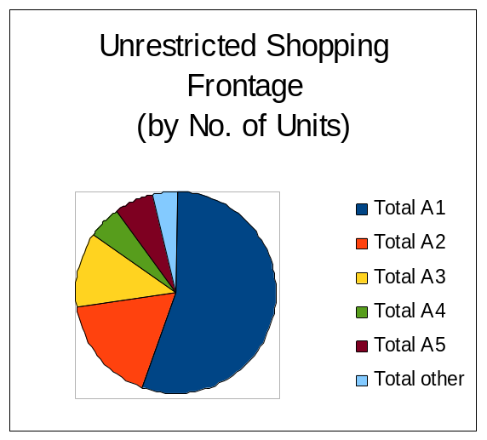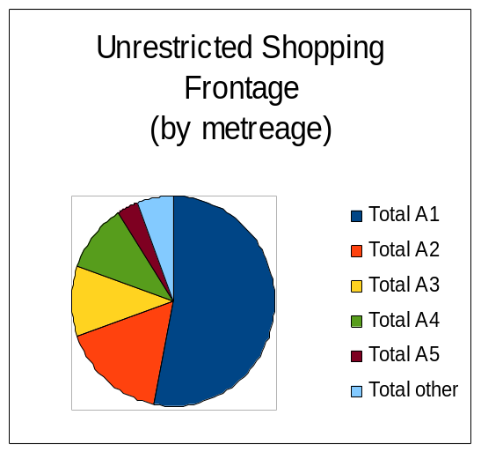

With regards to the unrestricted shopping frontage, saved Policy K20 of the Local Plan (1995) provides that planning permission for changes of use from Al (Shops) to Class A2 (Financial and Professional Services) or Class A3 (Food and Drink) or other non-retailing uses will be granted in the shopping frontages shown as “unrestricted” on the Proposals Map, provided that they do not involve uses for hot food takeaway, wholly or partially. The August 2009 survey found that A1 uses accounted for 56.15% of the unit numbers and 53.05% of the active frontages. Although policy K20 does not provide a figure for the total proportion of non-retail units permissible along the unrestricted frontage the current levels which are above 50% are considered broadly acceptable. However, concern has been expressed with regards to the proliferation of A5 uses located on Silver Street and Montagu Street, despite the restrictive function of policy K20. A5 uses within this area currently account for 8 units (6.16%). As such this situation will need to monitored closely and responded appropriately not only in the determination of planning applications but also future policy requirements until the Kettering Town Centre AAP.

Proposed AAP Shopping Boundary: Primary and Secondary Frontages

As shown in Appendix 3, the Shopping Boundary will consist of a designated Primary Shopping Area with both primary and secondary shopping frontages and a Restaurant Quarter. The primary shopping frontage runs up High Street, Gold Street, Newland Street and incorporates the Newland Centre. The Shopping Quarter will form the majority of the Primary Shopping Area and will include large-scale retail redevelopments projects at Wadcoft and Newlands phase 1 with a department anchor store. The secondary frontage is located on parts of Rockingham Road, Montagu Street, Silver Street, Dalkeith Place and incorporates the units around Market Place which forms the proposed Restaurant Quarter (see Appendix 4).
A map showing the different use classes within the primary and secondary frontages is shown in Appendix 5.
Figure 7: PRIMARY FRONTAGE: Summary
Use | Meterage | Percentage | Units | Units percentage
Total A1 primary meterage | 1,685.4 | 76.53% | 148 | 76.68%
Total A2 primary meterage | 265.6 | 12.06% | 26 | 13.47%
Total A3 primary meterage | 88.9 | 4.04% | 6 | 3.11%
Total A4 primary meterage | 75.0 | 3.41% | 5 | 2.59%
Total A5 primary meterage | 5.3 | 0.24% | 1 | 0.52%
Total other primary meterage | 82.0 | 3.72% | 7 | 3.63%
Total primary meterage | 2,202.2 | 100.00% | 193 | 100%

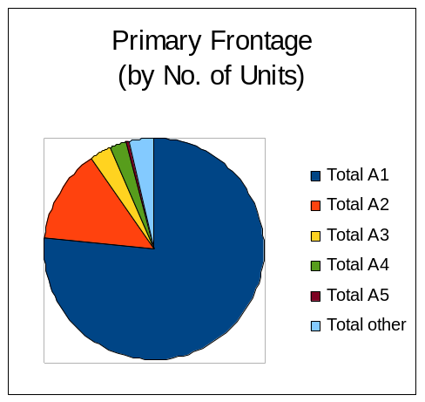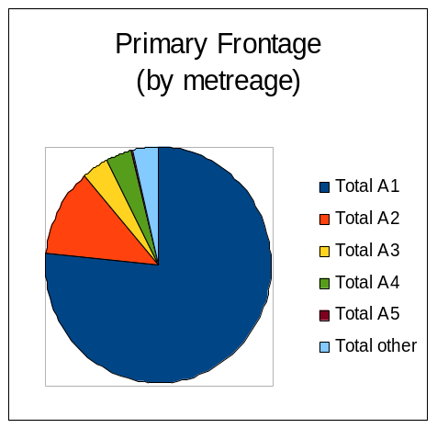

Within the proposed primary shopping frontage A1 (retail) uses currently account for 76.68% of the total number of units. It is considered that this level is broadly acceptable, however, will this need to be monitored closely through the development of the AAP and in the determination of planning applications, in order to retain and enhance the core retail offer.

Figure 8: SECONDARY FRONTAGE: Summary (excl Restaurant Quarter)
Use | Meterage | Percentage | Units | Units percentage
Total A1 secondary meterage | 639.3 | 46.22% | 75 | 53.19%
Total A2 secondary meterage | 204.4 | 14.78% | 27 | 19.15%
Total A3 secondary meterage | 121.0 | 8.75% | 13 | 9.22%
Total A4 secondary meterage | 221.8 | 16.04% | 7 | 4.96%
Total A5 secondary meterage | 103.1 | 7.45% | 13 | 9.22%
Total other secondary meterage | 93.6 | 6.77% | 6 | 4.26%
Total secondary meterage | 1383.2 | 100.00% | 141 | 100.00%
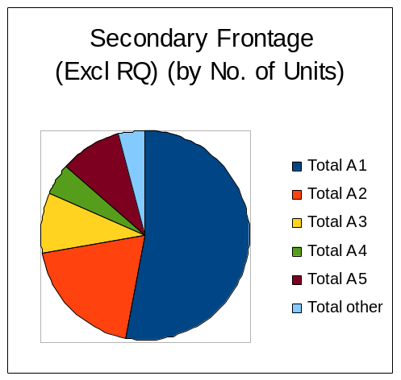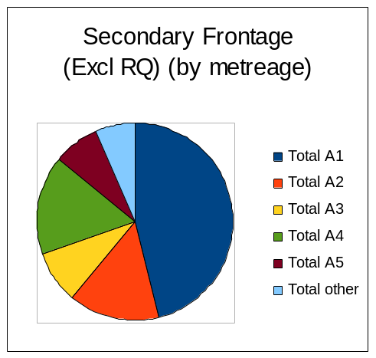

Figure 8 indicates that there is currently a high concentration of A4 and A5 uses. It is considered that there is currently a lack of leisure facilities and an evening economy which is of limited quality and choice and is based largely around a high number of large pubs and nightclubs (largely at first floor), which can cause high levels of anti-social behaviour, disturbance and litter. These findings echo concerns made during the AAP adoption process regarding an over-concentration of A4, A5 and nightclubs uses within the Town Centre especially along Montagu Street, Silver Street and Dalkeith Place. To avoid a further over-concentration of A4 and A5 uses and the unacceptable cumulative impacts from this, it is recommended that a percentage calculation is set within the AAP, across the Primary Shopping Area, which will restrict the number of A4 and A5 uses within the Primary and Secondary Shopping Frontage.

Figure 9: RESTAURANT QUARTER: Summary
Use | Meterage | Percentage | Units | Units percentage
Total A1 RQ meterage | 51.9 | 18.81% | 6 | 28.57%
Total A2 RQ meterage | 58.5 | 21.20% | 6 | 28.57%
Total A3 RQ meterage | 29.8 | 10.80% | 3 | 14.29%
Total A4 RQ meterage | 30.4 | 11.02% | 3 | 14.29%
Total A5 RQ meterage | 8.8 | 3.19% | 1 | 4.76%
Total other RQ meterage | 96.5 | 34.98% | 2 | 9.52%
Total RQ meterage | 275.9 | 100.00% | 21 | 100.00%

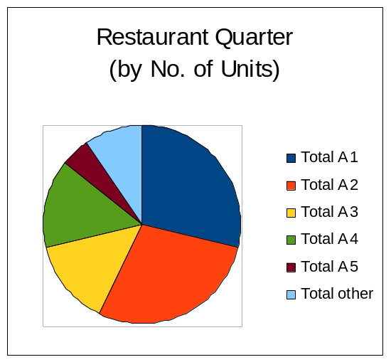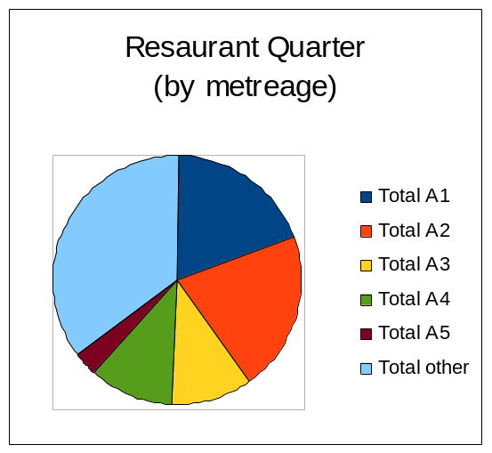

As can be seen in Figure 9, A1 and A2 uses are currently (August 2009) the most predominant within the proposed Restaurant Quarter in terms of both unit numbers (28.57% each) and active frontage (18.81% and 21.20%). A3 and A4 uses both account for a further 14.29% each with A5 contributing to 4.76% of the units.

The Vision for the Restaurant Quarter is to create a high quality public realm, surrounded by restaurants (A3). A multi-purpose civic space enclosed by a range of activities – a place where people want to stop, sit and spend time during the day and the evening. However, the results of the town centre use class survey indicate that in order to deliver that vision within such a small quarter, restrictions should be placed upon the types of uses permissible within this location.

As A4 and A5 uses already exist in this relatively small quarter, it is not considered that further provision of this use type is required. With regards to A2, there is already a high percentage of this type of use within this quarter and further A2 units are not required. If further provision of these types is allowed then this could ultimately prevent the delivery of the vision, limiting the space available within the quarter for further restaurants A3 and other complimentary uses

Diversity of uses

Figure 10 shows the diversity of uses in Kettering Borough and presents it as an indexed score of 23 retail and services sub-categories; the index approach takes 100 to be the UK average, and therefore those sub-categories with an index score over 100 are over-represented in the Borough, and those with a score of under 100 are under-represented. It must be acknowledged that these scores represent the situation across the Borough as a whole and not just Kettering Town Centre; however, many of the findings are representative of the current situation within the Kettering Town Centre.

Figure 10: Diversity of uses in Kettering Borough (source: Estates Gazette Town Report, June 2009)
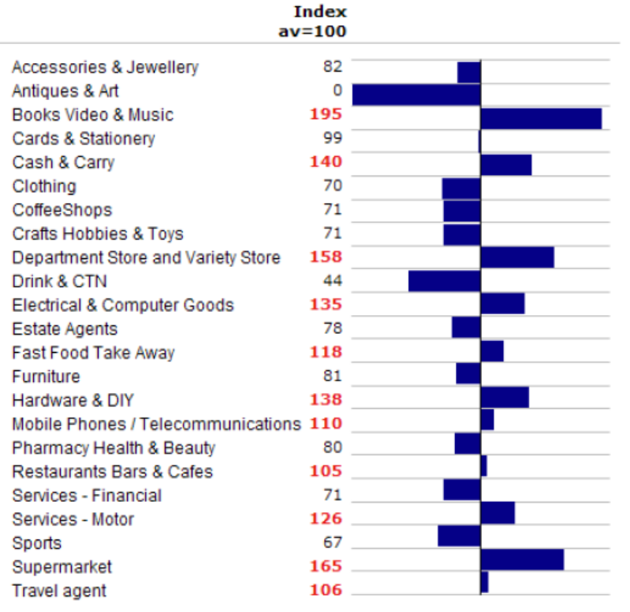

The main findings indicate that there is a very strong representation of the ‘books, video and music sub-category’ with an index score of 195. In addition the ‘supermarkets and department/variety stores’ categories is also strongly represented with index scores of 165 and 158 respectively. A noticeable deficiency is the ‘Antiques and art’ category with no representations within the Borough. In addition there is an under-representation of the clothing sector with an index score of 70.

With regards to the provision of coffee shops, restaurants, bars and cafés’ overall there is an underrepresentation in the Borough, with an over representation of takeaway uses. As such there is potential for improvement in order to encourage ‘dwell time’ during the day, an active evening economy and an overall increase in the visitor spend and footfall within Kettering Town Centre. As noted previously the proposed AAP will be designating the area around Market Place as the Restaurant Quarter (see Appendix 4) and it is anticipated that this situation will be steadily improved over the lifetime of the plan.

Retailer Representation:

PPS4 advises that retailer representation and the intentions of retailers to change representation, including: existence and changes in representation of types of retailer, including street markets, and the demand of retailers wanting to come into the centre, or to change their representation in the centre, or to reduce or close their representation are all key indicators of health and vitality of town centres.

In line with work undertaken by Roger Tym’s Retail Study 2009 the performance analysis of this indicator will be largely drawn from a benchmarking exercise which takes a ‘basket’ of fifty main national ‘High Street’ retailers which can be considered to be principal drivers of footfall within a town centre, and a comparative exercise will be made for Corby, Kettering and Wellingborough’s Town Centres. It must be acknowledged that this assessment is concentrated upon the mainstream retailers rather than the overly high end retailers. The results can be seen in the following table.

The results (see Appendix 6) indicate that Kettering scored the highest in the benchmarking exercise, scoring 35 out of 50 retailers in comparison to Corby who had 28 and Wellingborough with 23 out of 50. This appears to reflect Kettering’s role as a sub regional centre in terms of its shopping provision, and the retail representation is considered to be relatively strong. Some of the key retailers present within Kettering’s Town Centre include HMV, TK Maxx, TJ Hughes and Marks and Spencer and the draw of these shops is considered to be relatively wide, however, many of the retailers present can also be found at both Corby and Wellingborough. In addition there is noticeable deficiency in fashion retailers within the town centre, with H&M, Primark, River Island and Monsoon are all absent and Next trades at the out of town Kettering Retail Park. As such people living within Kettering are likely to still travel to Leicester and Peterborough for higher end goods and in particular fashion purchases.

As fashion outlets are a key driver of footfall within a town centre the proposed AAP is seeking to improve the retail offer through the allocation of a shopping quarter with the main focus around the redevelopment for retail purposes of Wadcroft and the Newlands. Which is located at the junction of High Street, Gold Street and Lower Street. It is anticipated that this will provide an additional net floorspace for retail of between 14-15,000sq.m and it is anticipated that a large department store will become the anchor store for this development.

Street Level Vacancies

The number of vacant units in a centre can be a useful indicator of the health of a town centre. However, this indicator must be used with care, as vacancies can arise even in the strongest town centres, and are simply an indicator of the level of demand. For example some properties may lay vacant because they are poorly maintained, unsuited to modern retailing requirements or simply not being actively marketed. Conversely a low vacancy rate does not necessarily mean that a centre is performing well. For example, if there is a proliferation of charity shops and other uses not usually associated with a town centre it may be a sign of decline, particularly where these uses are located in prime locations. Despite these potential issues, it is still a useful indicator of town centre performance.

Street Level Vacancies: Local Plan Boundary

Figure 11: Vacancy Rates in the Restricted Frontage
Use | Meterage | Percentage | Units | Units Percentage
A1 | 202 | 8.55% | 23 | 11.16%
A2 | 34.3 | 1.45% | 2 | 0.97%
A3 | 0 | 0% | 0 | 0%
A4 | 0 | 0% | 0 | 0%
A5 | 0 | 0% | 0 | 0%
Other | 12 | 0.5% | 1 | 0.48%
TOTAL | 248.3 | 10.5% | 26 | 12.61%
Figure 12: Vacancy Rates in the Un-Restricted Frontage
Use | Meterage | Percentage | Units | Units Percentage
A1 | 102.4 | 8.13% | 12 | 9.23%
A2 | 40 | 3.17% | 4 | 3.08%
A3 | 22 | 1.75% | 3 | 2.31%
A4 | 0 | 0% | 0 | 0%
A5 | 5.5 | 0.44% | 1 | 0.77%
Other | 6 | 0.48% | 1 | 0.77%
TOTAL | 175.9 | 13.97% | 21 | 16.16%

Figures 11 and 12 indicate that at August 2009 47 units within the established shopping centre were vacant which equates to 13.98% of the total number of units. Within the restricted frontage the vacancy rate is 12.61% while 16.16% of the units in the un-restricted frontage are vacant. This is an increase of 14 units from April 2008. This is perhaps a reflection of the current economic climate and will be carefully monitored by future health check reports.

Street Level Vacancies: Proposed Kettering Town Centre Area Action Plan

Figure 13: Primary Frontage Vacancy
Use |  | Meterage | Percentage | Units | Units Percentage
A1 |  | 214 | 9.97% | 25 | 12.95%
A2 |  | 22.5 | 1.04% | 1 | 0.51%
A3 |  | 6.5 | 0.3% | 1 | 0.51%
A4 |  | 0 | 0% | 0 | 0%
A5 |  | 0 | 0% | 0 | 0%
Other |  | 0 | 0% | 0 | 0%
TOTAL |  | 243 | 11.31% | 27 | 13.97%
Figure 14: Secondary Frontage Vacancy: ex RQ
Use | Meterage |  | Percentage | Units | Units Percentage
A1 | 145.4 |  | 10.51% | 15 | 10.63%
A2 | 49.5 |  | 3.57% | 5 | 3.54%
A3 | 15.5 |  | 1.12% | 2 | 1.41%
A4 | 0 |  | 0% | 0 | 0%
A5 | 5.5 |  | 0.39% | 1 | 0.7%
Other | 6 |  | 0.43% | 1 | 0.7%
TOTAL | 221.9 |  | 16.02% | 24 | 16.98%
Figure 15: Restaurant Quarter Vacancy
Use | Meterage |  | Percentage | Units | Units Percentage
A1 | 0 |  | 0 | 0 | 0
A2 | 0 |  | 0 | 0 | 0
A3 | 0 |  | 0 | 0 | 0
A4 | 0 |  | 0 | 0 | 0
A5 | 0 |  | 0 | 0 | 0
Other | 0 |  | 0 | 0 | 0
TOTAL | 0 |  | 0 | 0 | 0

The above tables indicate that there are currently 51 vacant units within the town centre (August 2009), which equates to 14.36% of the units. Within the primary shopping frontage 13.97% of the units are vacant, this equates to 27 units of which 25 units are A1. Within the secondary frontage 16.98% of the units are currently vacant; however, there are currently no vacancies within the proposed Restaurant Quarter.

Potential Capacity for Growth

PPS4 advises that the potential capacity for growth or change of centres in the network and any opportunities for centres to expand or consolidate, typically measured in the amount of land available for new or more intensive forms of town centre development is a key indicator of the current and predicted strength of a town centre.

As identified in section 2 of this health check report, various studies have identified that Kettering Town Centre has the capacity to expand and meet the demands of the planned growth. In response the proposed Kettering Town Centre AAP provides the vision and policy support for the future economic, social and environmental enhancement for the Town Centre up to 2021. It proposes 8 urban quarters and within these a number of key sites have been identified for redevelopment (see Figure 3).

A minimum of 20,500 sqm of net additional saleable comparison floor space is required by 2021 and the main retail development will be located within the Shopping Quarter and The Yards.

Shopping Quarter: Site SHQ1 Wadcroft and SHQ3 Newlands Phase 1: The proposed AAP identifies this area as a prime opportunity for large scale retail led redevelopment. The scale of the site would allow for larger retail stores and potentially a department store to be provided, which would improve the footfall and retail offer of the town and allow Kettering to compete with other larger shopping centres. It is envisaged that this large scale retail redevelopment would be supported by the smaller sites at SHQ5 Land South of Northall Street (Iceland car park), SHQ6 Land South of Northall Street (Tanner’s Gate 1) and SHQ7 Land South of Northall Street (Tanners Gate 2).

The Yards: Whilst the majority of this growth will be located in the Shopping Quarter in particular on sites SHQ1 and ShQ3, the Yards has also been identified as a suitable location to contribute to the need for additional retail floorspace. Sites Y1 Job’s Yard North and Y2 Soans Yard are in a unique location and size of units that could be accommodated in the Yards would complement the larger format units to be provided in the Shopping Quarter and help make Kettering a unique shopping destination, offering a range of comparison shopping experiences.

- In addition to the proposed retail development, the Restaurant and Socialising and Craft Quarters will broaden the mix of leisure activities within the town centre and enhance the existing evening economy.

- The cultural quarter will offer civic amenity space for the town centre which is tranquil and responsive to the existing landscaped structure. The commercial investment will be focused around the Station Quarter.

- Residential Quarter- new housing will be located within to support the mix use of the town centre and provide for sustainable communities.

- Headlands Quarter- retain this residential area as an historic assets.

Retail Rents

The level of rent that retailers are prepared to pay for space in a centre is an indication of the perceived attractiveness of that centre. Rental values can also provide a measure of the primacy of streets and locations. If rental levels are rising, it is generally considered an indication of an increased popularity of a centre. Equally, falling rents suggest the centre is becoming less attractive to retailers.

Figure 16: Zone A Retail Rents

Centre | 2001 | ‘02 | ‘03 | ‘04 | ‘05 | ‘06 | ‘07 | ‘08 | Change
Kettering | 753 | 646 | 646 | 646 | 807 | 915 | 915 | 969 | + 22%
Corby | 538 | 538 | 538 | 646 | 646 | 700 | 753 | 753 | + 29%
Wellingborough | 646 | 700 | 700 | 753 | 807 | 915 | 915 | 915 | + 29%
Source: Colliers CRE UK In Town Retail Rents Maps 2008

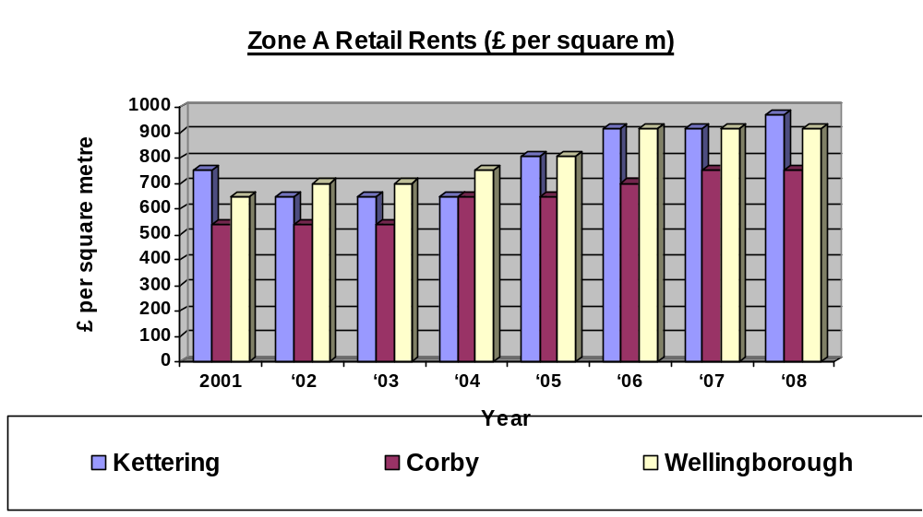

From Figure 16 the retail rents (£ per sq.m per annum) for Kettering from 2002 have steadily increased, with an overall increase of 22% from 2001, and are higher than both Corby and Wellingborough. This would appear to indicate that Kettering is considered to be a more desirable and popular retail destination than both Corby or Wellingborogh, which reflects the sub-regional status of Kettering. However, it must be noted that both Corby and Wellingborough have both improved at a higher percentage than Kettering since 2001, and it will be for future monitoring reports to analyse the impact of completed (Willow Place, Corby) or planned retail redevelopments (Wadcroft and Newlands Redevelopment in Kettering) upon the desirability rental value of the retail floor space within the three growth towns.

Rental Yields

Commercial yields on non-domestic properties (i.e. the capital value in relation to the expected market rental) can demonstrate the confidence of investors in the long-term profitability of the town centre. The Valuation Office monitors prime retail yields in 550 shopping centres throughout England, and measure a yield in terms of the ratio of rental income to capital value, and is expressed in terms of the open market rents of a property as a percentage of the capital value. Therefore, the yields quoted in the following table are ‘all risk yields’ and have been calculated by dividing the annual rent by the capital value of sale of the property. Thus, the higher the yield the lower the rental income is valued, and vice versa. A high yield is an indication of concern by investors that rental income might grow less rapidly and be less secure than in a property with a low yield, and as such is a simple benchmark of the comparative attractiveness of a shopping centre.

However, the application of such a measure needs to be used with care, and should not be viewed in isolation. Instead it should be used in conjunction with other indicators and measured consistently overtime, in order for it to give us a clearer indication of the direction in which the town centre is moving, and aid with the preparation and review of town centre focused planning policies. In view of this the following table, highlights the calculated yields for Kettering for the period 2001-2008, and overlays this will the comparative figures for both Corby and Wellingborough.

Figure 17: Rental Yields
Shopping Centre | 1/10/  00 | 1/4/  01 | 1/10/  01 | 1/4/  02 | 1/10/  02 | 1/4/  03 | 1/1/  04 | 1/7/  04 | 1/1/  05 | 1/7/  05 | 1/1/  06 | 1/7/  06 | 1/1/  07 | 1/7/  07 | 1/1/  08 | 1/7/  08
Kettering | 6.75 | 6.75 | 6.75 | 6.75 | 6.75 | 6.5 | 6.5 | 6.5 | 6.5 | 6.5 | 6.5 | 6 | 6 | 5.75 | 5.75 | 6
Corby | 7.5 | 7.5 | 7.5 | 7.5 | 7.5 | 7.5 | 7.5 | 7.5 | 7.5 | 7.5 | 7.5 | 7 | 6.75 | 6 | 6 | 6
Wellingborough | 6.75 | 6.75 | 6.75 | 7 | 7 | 7 | 7 | 7 | 7 | 7 | 7 | 6.5 | 6.5 | 6.25 | 6.25 | 6
Source: Valuation Office: Property Market Report July 2008

As can be seen from the Figure 17 above, Kettering has been performing well when compared to the other major retail centres in North Northamptonshire. Yields have been generally lower than the other areas with a gradual decline seen from Oct 2000- Jan 2008, which may indicate that the town centre is moving in the right direction, and a sign of investor confidence. However, from January to July 2008 there was a 0.25% increase in the yield, which resulted in the convergence of a 6% yield rate over the three towns. There maybe a number of reasons for this such as the downturn in the current economic market, however as of yet no figures are available for 2009 and it will be for future reports to interpret whether this is an isolated anomaly or not.

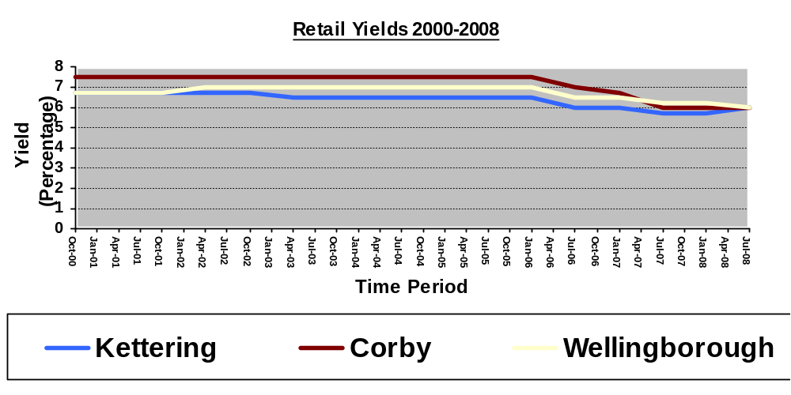

Pedestrian Flows

PPS4 advises that pedestrian flows (footfall) are a key indicator of the health and vitality of shopping streets. Footfalls are measured by the numbers and movement of people on the streets, in different parts of the centre at different times of the day, who are available for businesses to attract into shops, restaurants or other facilities. The usefulness of this indicator will become more evident overtime as it can be used to identify trends both as a result of local and national influences.

On Monday 8th December and Friday 12th December 2008 a pedestrian count was undertaken in 11 locations (see Appendix 7) in the Town Centre over two time periods 10:30-10:45 and 10:50-11:05. The counts included pedestrians passing in both directions.

Figure 18: Footfall Survey Count Locations and Results

No. | Count Location | Date/ Time  8th Dec 08 | Count | Date/Time  12th Dec 08 | Count
1. | Sheep Street/ Piccadilly Buildings- opposite Library | 10:30-10:45 | 68 | 10:30-10:45 | 71
2. | Market Place | 10:30-10:45 | 173 | 10:50-11:05 | 178
3. | Southern end of High Street | 10:50-11:05 | 309 | 10:30-10:45 | 260
4. | Mid High Street- between Huxloe Place & Walkers Lane | 10:30-10:45 | 381 | 10:30-10:45 | 476
5. | Lower Street- outside Peacock Inn | 10:50-11:05 | 322 | 10:50-11:05 | 339
6. | Southern end of Gold Street | 10:30-10:45 | 673 | 10:30-10:45 | 508
7. | Northern end of Gold Street | 10:50-11:05 | 198 | 10:50-11.05 | 253
8. | Newland Street (outside no.6) | 10:30-10:45 | 268 | 10:50-11:05 | 258
9. | Dalkeith Place- outside no. 10, nr Jobs Yard | 10:50-11:05 | 114 | 10:30-11:05 | 110
10. | Dryland Street | 10:30-10:45 | 51 | 10:30-10:45 | 34
11. | Eastern end of Market Street- outside Room 21 Bar | 10:50-11:05 | 82 | 10:50-11:05 | 120

The survey results (see Figure 18 above) show that the busiest location was at the southern end of Gold Street in both days. The mid point on the High Street was the next busiest location, closely followed by Lower Street. This indicates that the junction of Gold Street, Lower Street and High Street is a key point in terms of pedestrian flows and this is reflected by its location within the heart of the main shopping area. As such this location is a prime candidate for further retail development as proposed by the Wadcroft and Newlands redevelopment within the proposed Kettering Town Centre AAP. The areas with the lowest footfall counts were Dryland Street and Sheep Street/ Piccadilly Buildings and the eastern end of Market Street which is perhaps a reflection of the fewer shopping opportunities in these areas.

As this is the inaugural health check report there is no comparable data. However, this will provide a baseline in which future studies can be compared against and as such this indicator will be important in future years for analysing the effectiveness of the Kettering Town Centre Area Action Plan, completed redevelopment projects, and provide a basis for review and development of the policy direction. In addition it is envisaged that further survey work will be carried to establish seasonal and time variances across the selected counts locations.

Accessibility

PPS4 advises that accessibility is a major indicator of the state of town centres. Health checks should consider the ease and convenience of access by a choice of means of travel, including the quality, quantity and type of car parking; the frequency and quality of public transport services and the range of customer origins served; and, the quality of provision for pedestrians, cyclists and disabled people and the ease of access from main arrival points to the main attractions.

Kettering benefits from good road and public transport accessibility. It is served by the A43 and A14 which forms part of the Trans- European Network of roads. Good bus services operate in and around Kettering and the Borough also has good train links, with direct services to both Sheffield and London St Pancras International. Although Kettering Train Station is located within walking distance of the Town Centre, the current urban realm surrounding the station and the approach to the Town Centre is considered to be a barrier to pedestrian movement and in need of improvement.
There are 6 main public car parks and 2 small car parks located within Kettering Town Centre, which in total provides 2088 parking space of which 83 are disabled parking spaces. The Council provides 695 parking spaces in the centre of Kettering, for which charges are made. There are also 41 reserved spaces for disabled drivers. All car parks are covered by CCTV. The car park locations and details are shown in Figure 19.
Figure 19: Car Park Locations
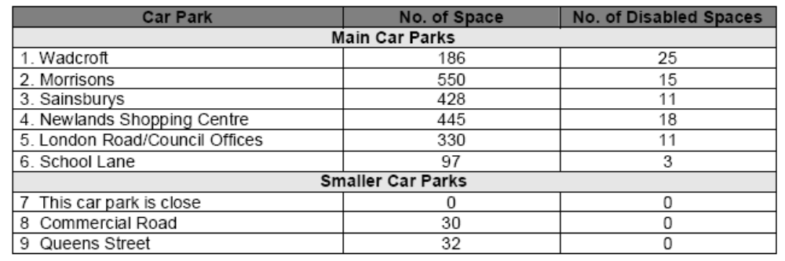

Although the current levels of public transport and accessibility is considered to be adequate, the planned growth in housing and employment will put additional pressures upon the existing transport network and this will need to be accommodated for and integrated within future planning policies and strategies.

As part of the Transport Strategy for Growth, agreed by Northamptonshire County Council in September 2007, issues of transportation in Kettering town centre will be addressed through the Kettering Town Centre AAP. It is considered crucial that an effective transportation network is delivered to assist with the development of the eight urban quarters being progressed through the AAP. In response the Kettering Town Centre Transport Strategy seeks to improve transport conditions in Kettering and to meet the transport challenges arising from growth of the town. An important theme running through the Strategy is the aim to encourage a modal shift to more sustainable modes of transport including through the promotion of pedestrian and cycle usage as well as access to public transport and the railway station. This position and implementation of this strategy will be monitored and reported in future health check reports.

Some of the current issues surrounding accessibility within Kettering Town Centre are as follows:

- Road Network and Junctions – There is a need to improve the north/south access through the town and to improve traffic flows around the town centre and to reduce congestion and allow efficient traffic circulation but without allowing traffic to dominate the Town Centre.

- Parking – The current parking provision within the Town Centre is adequate for the present levels of demand, however with the planned expansion at Wadcroft and the Newlands there is pressure to meet this growth.

- Public Transport – there is a need to promote bus services by improving the operational environment for buses and improving accessibility and penetration of bus services to the Town Centre and Railway Station and therefore to assist in promoting mode shift away from private cars to buses.

- Pedestrian and Cycle – there is a need to improve facilities for pedestrians and cycles to ensure safe and convenient routes and thereby to assist in promoting mode shift away from cars to more sustainable modes.

Figure 20: The key characteristics of the proposed transport strategy
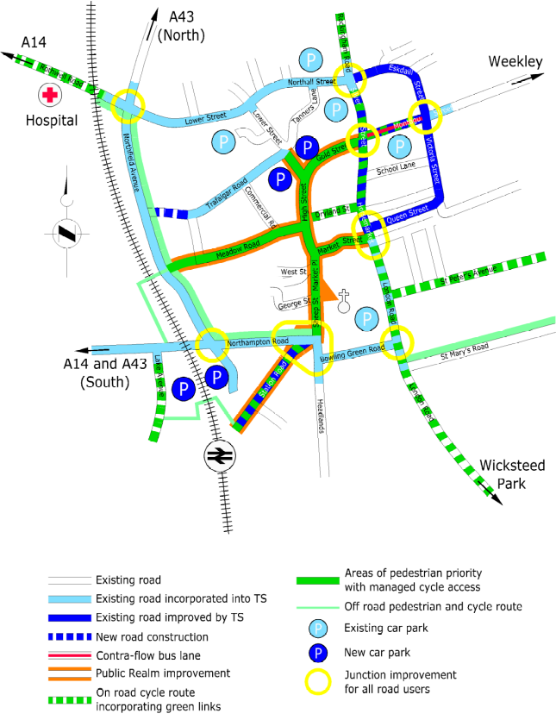
Basic traffic circulation | - Two way circulation on all main roads  - Widening works where necessary on Eskdail Street, Victoria Street and Queen Street
Main junction improvements | - Rothwell Road Roundabout  - Northfield Av/ Northampton Road  - Northampton Road/ Station Road/ Sheep Street/ Bowling Green Road  - London Road/ Bowling Green Road  - Queen Street/ Horsemarket  - Montagu Street/ Victoria Street  - Eskdail Street/ Northall Street
New road | - Extension of Trafalgar Road to Northfield Avenue to provide access to Wadcroft Development Area Car Park
Pedestrian cycle and limited access routes | - High Street/ Gold Street  - Meadow Road  - Silver Street
Roads with bus priority and/ or bus only access | - Montagu Street  - Market Street (possible to be determined)  - Sheep Street
Roads with emphasis on improved public realm | - Market Place (completed)  - Market Street  - Sheep Street  - Station Road  - Silver Street
Principal bus stop areas | - Station  - Sheep Street  - Eskdail Street  - Newlands
Parking (off street) | - Retention of existing car parks at Newlands, Morrisons and Sainsbury’s  - Removal of ground level car parks at Wadcroft, Commercial Road and Market Place  - Removal of existing north and south car parks at Station and provision of three new multi-storey ar parks at i) Station west ‘interceptor’ car park, ii) Station east side car park and iii) new Wadcroft shopping centre  - Seek policy of unification of Town Centre car parking charges  - Variable message signing system to balance car park demand and supply
Parking (on-street) | - Minor removal of on-street parking spaces to permit public realm improvement and provision of alternative adequate access and frontage servicing arrangements.  - Strengthening enforcement of traffic regulations
Environment and Public Realm

Environmental quality is an important factor in encouraging civic pride, customer loyalty, sense of place and attracting visitors from outside of Kettering. A good environment depends on a number of factors such as quality of buildings, the appearance and usability of the public realm, and the cleanliness of the streets.

Although the majority of the town centre is pedestrianised, the quality of Kettering’s shopping environment and public realm is varies across the town. The civic hub incorporating the Council Offices, art gallery, museum and library located near Sheep Street represents the historic core of the town centre and provides an attractive setting with a well maintained green open space. However, much of the 1970s redevelopment in the north of the centre around Lower Street looks tired and is in need of redevelopment. In addition some parts of Silver Street, Gold Street and Montagu Street are uninspiring with some poor shop fronts and there is a need for investment.

Figure 21: Key Urban Space Analysis
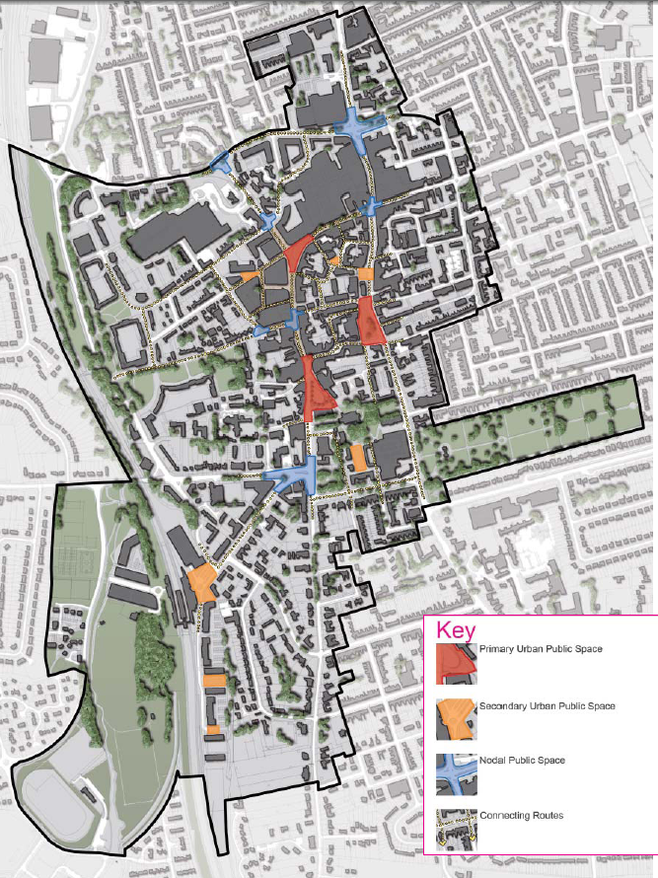

There are currently three primary urban public spaces within the Town Centre; these are the Market Place, Horsemarket and the junction of High Street, Gold Street and Lower Street with a number of secondary spaces highlighted in Figure 21.

Market Place is located near Sheep Street and adjacent to the Church of St Peter and Paul and until recently lacked character, usability and was visually uninteresting. It also appeared empty and windswept with few all year round activities. However, the first phase of the prestigious Market Place re-development is now complete (see Figure 22) which has significantly improved the public realm and has provided a multi-functional space which is an attractive and fun place that will be used to stage a range of public events throughout the year. In recognition of the projects success the Market Place project was recently awarded the 2009 East Midlands Royal Town Planning Institute’s Award for Town Regeneration. The next phase of the project will be undertaken in during 2010, which will provide new restaurant and residential properties next to the Market Place, at the site of the old car park. This will help transform this area into a new restaurant quarter which will complement the new public space. In addition, work is being carried out to improve the visual appearance of the public space (roads and pavements) on Market Street and Sheep Street.

Figure 22: Phase One of the Market Place Redevelopment

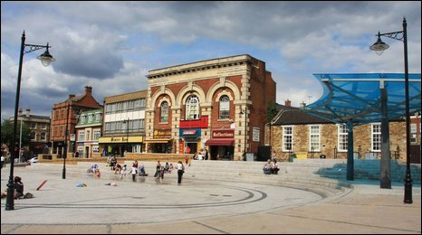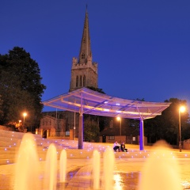

The Horsemarket is an historic trading space which provides linkages to a number of other streets, including Silver Street/ Dalkeith Place and Market Street. It currently includes a grassed mound with setting and well established vegetation. There are a number of attractive historic ironstone buildings predominantly located on the western and southern frontages and the Church spire of St Peter and Paul can be seen from within this space which provides an attractive backdrop. However as seen from the pedestrian counts this space suffers from a relatively low footfall, this is perhaps due in part to the dominance of vehicles and few retail outlets.

The junction of High Street, Gold Street and Lower Street currently includes seating. However; this public space is not conducive to relaxed sitting due to the existing conflict between vehicles and pedestrians and the area could be improved to offer a more attractive and useful urban space.

Crime and Disorder

During the 2008-2009 monitoring year, 1172 crimes were reported within Kettering Town Centre, with theft/handling and violent offences accounting for 43.94% and 24.65% of the total. Crime figures have generally reduced across the Borough, and in particular there was a 19.7% decrease in the violent crime being reported within the Town Centre during the 2008-2009 reporting year when compared to the previous year (Source: Kettering Community Safety Partnership)

Figure 23: No. of Crimes reported in Kettering Town Centre by month

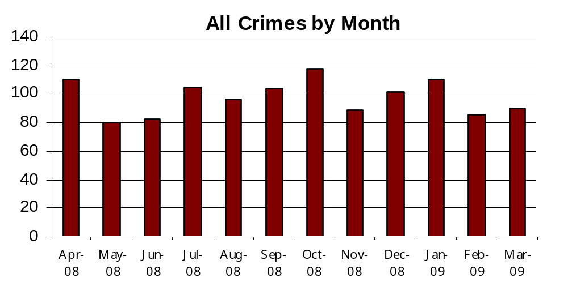
(Source: Northamptonshire Police)

Figure 24: Types of Crimes reported in Kettering Town Centre

CRIME GROUP | NO OF CRIMES
THEFT/HANDLING | 515
VIOLENCE OFFENCES | 289
CRIMINAL DAMAGE | 130
BURGLARY OTHER | 48
DRUG OFFENCES | 48
DECEPTION/FRAUD | 38
OTHER OFFENCES | 32
THEFT FROM MOTOR VEHICLES | 27
ROBBERY | 17
SEXUAL OFFENCES | 12
THEFT OF MOTOR VEHICLES | 9
BURGLARY DWELLING | 7
TOTAL | 1172
(Source: Northamptonshire Police)

The town centre is considered to be relatively safe with adequate street lighting down the prime shopping streets of High Street and Gold Street. However, concerns have been raised with regards to the impacts of anti-social behaviour from takeaways, nightclubs and pubs during the evening. During the 2008-2009 monitoring year 799 instances of anti-social behaviour were recorded in Kettering Town Centre. The highest recorded type of anti social behaviour was rowdy or inconsiderate behaviour which accounted for 86.6% of the total.
Figure 25: Number of instances of Anti Social Behaviour recorded in Kettering Town Centre by month during the 2008/09 monitoring year
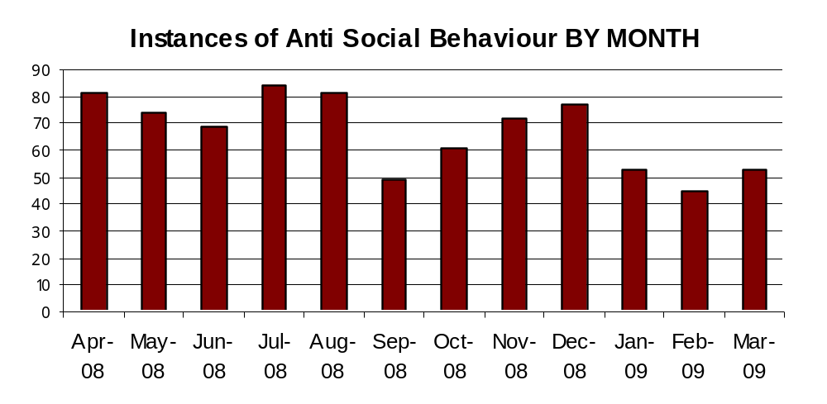
(Source: Northamptonshire Police)

Figure 26: Types of Anti-Social Behaviour recorded in Kettering Town Centre during the 2008/09 monitoring year

ANTI-SOCIAL BEHAVIOUR GROUP | COUNT OF INCIDENTS
ROWDY OR INCONSIDERATE BEHAVIOUR | 692
VEHICLE NUISANCE & INAPPROPRIATE VEH USE | 24
HOAX CALLS | 21
MALICIOUS/NUISANCE COMMS | 18
BEGGING/VAGRANCY | 14
STREET DRINKING | 9
AB VEH NOT STOLEN/OBSTRUCT | 7
NOISE | 6
NEIGHBOURS | 4
ANIMAL RELATED INCL ANTI-SOCIAL | 1
ENVIRONMENT DAMAGE OR LITTER | 1
INAPPROP SALE/USE FIREWORKS | 1
TRESPASS | 1
TOTAL | 799
(Source: Northamptonshire Police)

This issue is currently being managed through the creation of partnerships between the Local Authority, police, local businesses and residents in order to develop a strategy to co-ordinate planning and licensing, improve facilities at night, encourage diversity of uses and users and keep the town centre clean and safe. There are currently two Council/Police lead schemes

- The Town Centre Task Force (sharing best practice and reducing the incidence of crime and anti-social behaviour as well as monitoring the cumulative impacts of a concentration of licensed premises)
- Night Time Enforcement Officer (reducing incidence of crime and enforcing licensing laws etc)
And one locally led scheme:
- Pub watch (run and attended by local pubs and clubs, Local Authority, Council Members and Police to address issues and impose responsible drinking procedures).

These groups, as well as street cleaners (litter collecting seven days a week), work together to reduce the negative effects from the existing over-concentration of pubs and clubs along Silver Street, Dalkeith Place and Montagu Street and throughout the rest of the town centre. The Kettering Borough Three Year Partnership Plan (2008) sets targets to reduce crime within the town centre and provide a cleaner environment across Kettering Borough. The resultant impact of a large number of additional large pubs, bars, nightclubs and hot-food takeaways would put unnecessary pressure on these working groups to their detriment.

In addition to these measures the role of planners, policy makers and developers is also important as good design principles can all be secured at the planning application stage and will help to reduce the opportunities for and instances of anti-social behaviour. Good design principles should include:

- Enhancing natural surveillance through the incorporation of active, continuous building frontages overlooking the street and provision of mixed uses, including residential to provide a ’24 hour’ community;
- Designing out opportunities for vandalism through the use of robust materials and again, good surveillance;
- Increasing visibility through the use of good street lighting
- Carefully considering how new and existing vegetation and street trees may restrict visibility; and
- Improving perceptions of safety through the use of lighting and CCTV

Further guidance can be found at www.securedbydesign.com and Planning Out Crime in Northamptonshire’ (Northamptonshire County Council, 2004)

It is considered that the importance of this indicator will increase overtime as it will enable the Council to track the progress of initiatives and respond in an informed manner.

Conclusion

The findings of the first Kettering Town Centre Health Check Report indicate that the town centre is relatively healthy and performing well in relation to a number of health check indicators. However, it must be noted that the importance of monitoring these indicators will increase with future health check reports as trends can be analysed and responded to.

Kettering appears to be in a stronger position than both Corby and Wellingborough when measured against retail rankings, retailer representation, rental rents, and non-commercial yields. Despite this there are some weaknesses which need to be addressed in order for Kettering Town Centre to fulfil is sub-regional and compete with surrounding centres. There is a need to maintain or enhance the number of A1 uses within the primary shopping frontage and diversify the retail offer to include higher end shops. There is a currently a concern regarding the dominance of A4 and A5 uses within the secondary shopping frontages, and it is considered that a more diverse evening economy is required. There are currently a relatively high proportion of street level vacancies which could be a sign of the current economic climate. However, this situation will need to be closely monitored in future years to understand whether this is a systemic problem or not. Parts of the town centre are starting to look tired and public realm improvements are required to improve the attractiveness and usability of the space.

However, there is potential for a substantial amount re-development and growth and the town centre is currently in a state of transition, pending the examination and adoption of the Kettering Town Centre Area Action Plan which is due during 2010. It is an exciting time for the Town Centre and some improvements to the public realm have already been completed with phase 1 of the Market Place.

APPENDIX 1:
PPS 4 Indicators to Measure Vitality and Viability in Town Centres

PPS4 Indicators to Measure Vitality & Viability in Town Centres | Description
Diversity of main town centre uses | The amount of space in use for different functions- such as offices; shopping; leisure, cultural and entertainment activities; pubs, cafes and restaurants; hotels.
Amount of retail, leisure and office floorspace in edge of centre and out of centre locations. | See above
Potential capacity for growth or change of centres in the network | Opportunities for centres to expand or consolidate, typically measures in the amount of land available for new or intensive forms of town centre development
Retailer representation and intentions to change representation | Existence and changes in representation of types of retailer, including street markets, and the demand of retailers wanting to come into the centre, or to change their representation in the centre, or to reduce or close their representation.
Shopping Rents | Pattern of movement in Zone A rents within primary shopping areas (i.e. the rental value for the first 6 metres depth of floorspace in retail units from the shop window).
Proportion of vacant street level property | Vacancies can arise even in the strongest town centres, and this indicator must be used with care. Vacancies in secondary frontages and changes to other uses will also be useful indicators
Commercial yields on non-domestic property (i.e. the capital value in relation to the expected market rental) | Demonstrates the confidence of investors in the long-term profitability of the centre for retail, office and other commercial developments. This indicator should be used with care.
Land values and the length of time key sites have remaining undeveloped | Data in changes in land value and how long key town centre and edge of centre sites have remained undeveloped provide important indicators for how flexible policies should be framed and can help inform planning decisions.
Pedestrian flows (footfall) | A key indicator of the vitality of shopping streets, measured by the numbers and movement of people on the streets, in different parts of the centre at different times of the day and evening, who are available for businesses to attract into shops, restaurant or other facilities.
Accessibility | Ease of convenience of access by a choice of means of travel, including- the quality, quantity and type of car parking, the frequency and quality of public transport services and the range of customer origins served; and, the quality of provision for pedestrians, cyclists and disabled people and the ease of access from main arrival points to the main attractions.
Customer and residents views and behaviour | Regular surveys will help authorities in monitoring and evaluating the effectiveness of town centre improvement and in setting further priorities. Interviews in the town centre and at home can be used to establish views of both users and non-users of the centre, including the views of residents living in or close to the centre. This information could also establish the degree of linked trips.
Perception of safety and occurrence of crime | Should include views and information on safety and security, and where appropriate, information for monitoring the evening and night time economy.
State of the town centre environmental quality | Should include information on problems (such as air pollution, noise, clutter, litter and graffiti) and positive factors (such as trees, landscaping and open spaces).

APPENDIX 2:
Use Class Definitions

TCPA Use Classes Order 2006 | Use / Description of Development | Permitted Change
A1: Shops | Shops, retail warehouses, hairdressers, undertakers, travel and ticket agencies, post offices, pet shops, sandwich bars, showrooms, domestic hire shops, dry cleaners and funeral directors | No permitted change
A2: Financial & Professional Services | Banks, building societies, estate and employment agencies, professional and financial services and betting offices | A1 (where there is a ground floor display window)
A3: Restaurants & Cafés | For the sale of food and drink for consumption on the premises – restaurants, snack bars and cafes | A1 or A2
A4: Drinking Establishments | Public houses, wine bars or other drinking establishments (but not a night club) | A1, A2 or A3
A5: Hot Food Take-away | For the sale of hot food for consumption off the premises | A1, A2 or A3
B1: Business | - Offices, other than a use within Class A2 (Financial Services)  - Research & Development of products or processes  - Light industry | B8 (where no more than 235m²)
B2: General Industrial | General Industry: use for the carrying out of an industrial process other than one falling in Class B1 | B1 or B8 (limited to 235m²)
B8: Storage & Distribution | This class includes open air storage | B1 (where no more than 235m²)
C1: Hotels | Hotels, boarding and guest houses where no significant element of care is provided | No permitted change
C2: Residential Institutions | Residential care homes, hospitals, nursing homes, boarding schools, residential colleges and training centres | No permitted change
APPENDIX 3:
Kettering Town Centre Area Action Plan (Primary and Secondary Frontages)

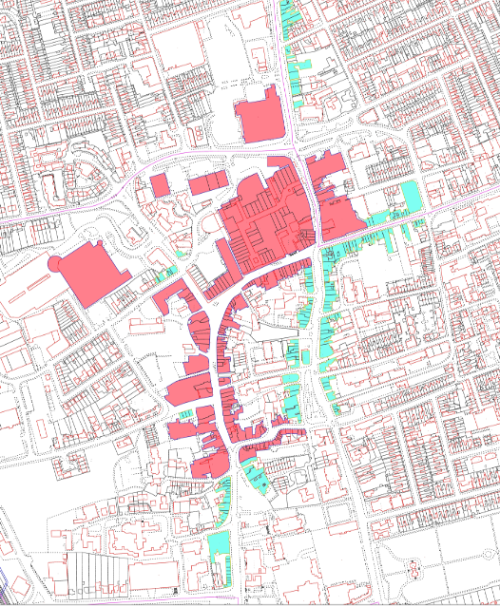

KEY:
Red: Primary Shopping Frontage Blue: Secondary Shopping Frontage

APPENDIX 4:
Kettering Town Centre Area Action Plan: Restaurant Quarter

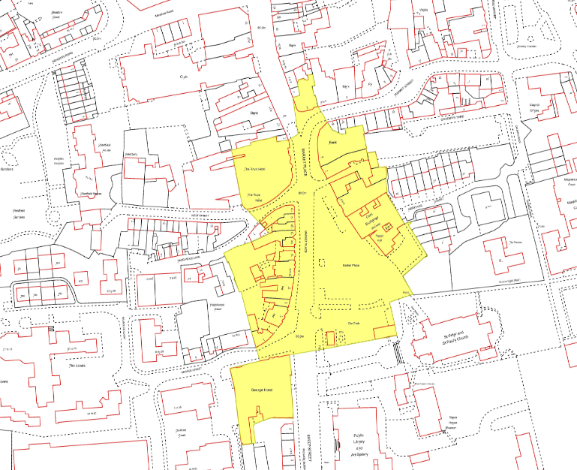

APPENDIX 5:
Kettering Town Centre Use Class Map

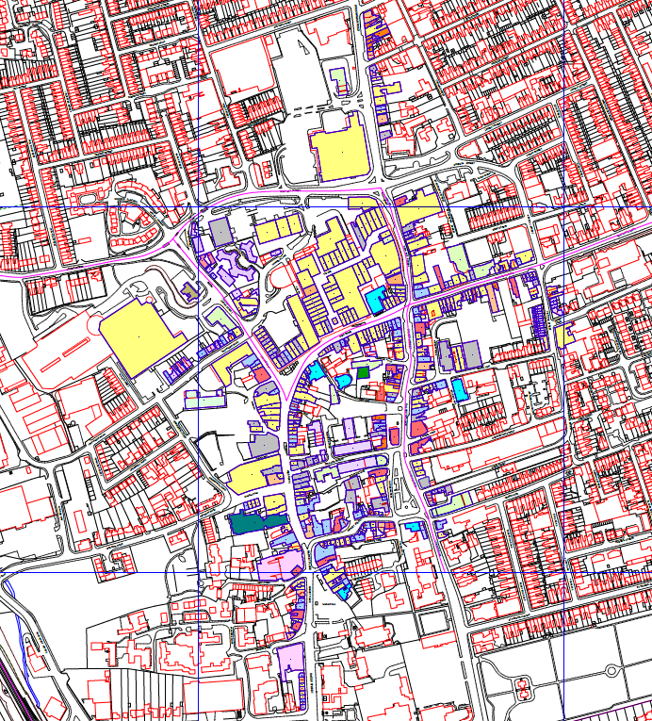

Town Centre Use Class Key

Use class | Colour
A1 | 
A2 | 
A3 | 
A4 | 
A5 | 
B1(a) | 
B2 | 
C1 | 
C3 | 
D1 | 
D2 | 
Sui Generis | 
Vacant | 

APPENDIX 6:
Kettering Town Centre: Retailer Representation

Store Name | Corby | Kettering | Wellingborough
Argos | 1 | 1 | 1
Bank Fashion | 0 | 0 | 0
The Body shop | 1 | 1 | 0
Boots the Chemist | 1 | 1 | 1
Burton | 1 | 1 | 1
Carphone Warehouse | 1 | 1 | 0
Claires Accessories | 1 | 1 | 1
Clarks | 1 | 1 | 1
Clinton Cards | 1 | 1 | 1
Currys Digital | 0 | 0 | 0
Dorothy Perkins | 1 | 1 | 1
Early Learning Centre | 0 | 1 | 0
Evans | 1 | 1 | 0
F Hinds | 0 | 0 | 1
Game | 1 | 1 | 1
Gamestation | 1 | 1 | 0
H&M | 0 | 0 | 0
H Samuel | 1 | 1 | 0
Holland and Barrett | 1 | 1 | 1
HMV | 0 | 1 | 1
JD Sports | 1 | 1 | 0
Jessops | 0 | 1 | 0
JJB Sports | 0 | 0 | 0
Lush | 0 | 0 | 0
M&Co/Mackays | 0 | 1 | 1
Marks and Spencer | 0 | 1 | 0
Millets | 0 | 1 | 0
Monsoon | 0 | 0 | 0
New Look | 1 | 1 | 1
Next | 0 | 0 | 0
Republic | 0 | 0 | 0
Peacocks | 1 | 1 | 1
Phones 4U | 1 | 1 | 1
Primark | 1 | 0 | 1
River Island | 1 | 0 | 0
Ryman | 0 | 0 | 0
Savers Health and Beauty | 1 | 1 | 0
Schuh | 0 | 0 | 0
Shoe Zone | 1 | 1 | 1
Specsavers Opticians | 1 | 1 | 1
Sports Direct | 0 | 0 | 1
Superdrug | 1 | 1 | 1
Thorntons | 0 | 1 | 1
Topshop | 0 | 1 | 0
T J Hughes | 1 | 1 | 0
TK Maxx | 1 | 1 | 0
USC | 0 | 0 | 0
Waterstones | 0 | 1 | 0
WH Smith | 1 | 1 | 1
Wilkinson | 1 | 1 | 1
TOTAL | 28 | 35 | 23

APPENDIX 7:
Footfall Survey Count Locations

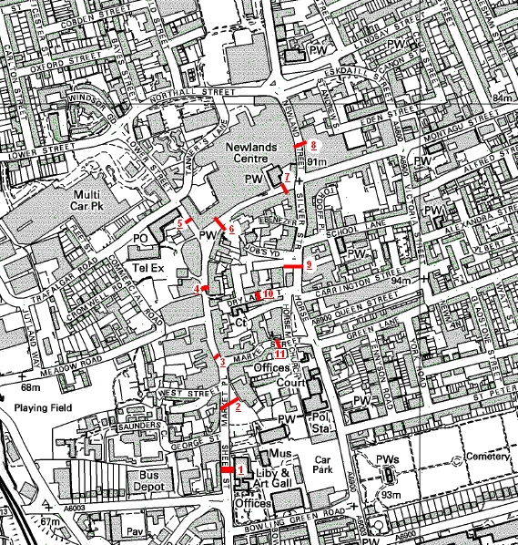

No. | Count Location
1. | Sheep Street/ Piccadilly Buildings- opposite Library
2. | Market Place
3. | Southern end of High Street
4. | Mid High Street- between Huxloe Place & Walkers Lane
5. | Lower Street- outside Peacock Inn
6. | Southern end of Gold Street
7. | Northern end of Gold Street
8. | Newland Street (outside no.6)
9. | Dalkeith Place- outside no. 10, nr Jobs Yard
10. | Dryland Street
11. | Eastern end of Market Street- outside Room 21 Bar

