1. PURPOSE OF REPORT

To make Members away of the North Northamptonshire Joint Planning Unit consultation on reviewing Core Strategy housing requirements and agree a response on behalf of the Borough Council.

2. INFORMATION

2.1 The Government is committed to increased housing growth, but want it to be driven by local ambitions rather than top-down targets – as was the case through Regional Spatial Strategies. The Government is due to consult upon financial incentives it will offer to authorities who provide growth, in the form of a fund entitled “New Homes Bonus”.

2.2 The revocation of Regional Spatial Strategies removed the top-down housing requirements approach. The target for North Northamptonshire was 52,100 dwellings, this was fed through in to the Core Spatial Strategy. Kettering Borough’s requirement for this is to deliver 13,100 dwellings. There is now the flexibility to reconsider through the review of the Core Strategy the levels of growth appropriate over and above existing commitments, or whether any commitments are not considered deliverable. There is also the opportunity to consider the level of growth for the period 2021 to 2031.

2.3 The Government has indicated by letter from the Chief Planner dated 6 July 2010 that authorities wishing to review housing requirements “should quickly signal their intention to undertake an early review so that communities and landowners know where they stand”.

2.4 Over the 9 years to 2009-10, Kettering Borough has delivered to its housing target. Since 2001 Kettering Borough has delivered 4,934 new homes, with an average delivery rate of 548 units per year. Despite the prevailing economic market conditions, 395 new homes were built during the 2009-2010 monitoring year, with approx a further 400 units expected to be completed this financial. Kettering Borough’s performance is very favourable when compared to the housing delivery performance of the other districts within North Northamptonshire, as Kettering is the only authority to have met and exceeded its CSS targets. East Northamptonshire is 291 units down, Wellingborough are short by 810 units and Corby has undersupplied by 1978 units. The table below summaries the latest available North Northamptonshire-wide positions.

District/  Borough | 2001-02 | 2002-03 | 2003-04 | 2004-05 | 2005-06 | 2006-07 | 2007-08 | 2008-09 | 2009-10 | Total | CSS Require-ment to date | Under/ over supply
Corby | 96 | 184 | 422 | 293 | 369 | 573 | 497 | 476 | 318 | 3,228 | 5,206 | - 1,978
East Northants | 467 | 606 | 482 | 609 | 661 | 504 | 536 | 170 | 211 | 4,246 | 4,537 | - 291
Kettering | 572 | 572 | 572 | 572 | 572 | 572 | 685 | 422 | 395 | 4,934 | 4,923 | + 11
Wellingboro’ | 306 | 175 | 280 | 415 | 345 | 392 | 475 | 295 | 155 | 2,838 | 3,648 | - 810

2.5 It remains important for authorities to demonstrate a five-year housing land supply of deliverable sites. Not maintaining a five-year supply creates pressure to permit additional housing sites that are not in accordance with the spatial vision of the Core Strategy or emerging Area Action Plans. In 2007/8 Kettering Borough could only offer between 1.8 years and 2.7 years of housing land supply. As a result, this helped lead to two appeals being allowed at Cranford Road, Burton Latimer (208 dwellings) and Higham Road, Burton Latimer (248 dwellings). The following year a further appeal at Harrington Road, Rothwell (117 dwellings) was dismissed but on grounds of noise, the Council maintained an improved housing land supply but unfortunately it could still not demonstrate a five-year supply.

2.6 At a recent appeal for 80 dwellings at Hawthorn Road, Burton Latimer, the Borough Council contested it could demonstrate a 5.69 year land supply. Unfortunately the Inspector was not persuaded by the Councils case, in particular he doubted the delivery projections for East Kettering and that the Kettering Town Centre brownfield (Strategic Housing Land Availability Assessment (SHLAA)) sites were likely to come forward in the next 5 years. Consequently, the Inspector reduced the Council’s land supply to 4.6 years, to which he also considered this to be ‘optimistic’. This appeal decision has highlighted the challenge faced in demonstrating deliverable sites in this time of economic uncertainty.

2.7 Kettering has a good rate of housing delivery. The Borough is in line with its Core Spatial Strategy targets. Kettering Borough has a large number of consented dwellings, 8090 dwellings in total. However, the recession has caused delivery issues. Housing commitments do not always equal 5 year housing land supply, this mainly through constraints on delivery rates. As a result, the Council continues to find it difficult not to look favourably on applications it would normally refuse, due to a shortfall in its 5-year housing land supply.

2.8 The annual average completions in the last 20 years amounts to 479 dwellings per annum.

2.9 The Joint Planning Committee met on 22 September, where the following conclusions were agreed:

  - the Core Strategy housing requirements cannot be delivered by 2021, this is not because of a shortage of sites but due to the impacts of the recession on the development industry
  - the existing Core Strategy targets were based upon levels of job creation, infrastructure investment and market demands which have not been realised, and the prospects of them being achieved in the future will be impacted by national policy and availability of public funding
  - the review of the Core Strategy will assess Options for differing housing levels to 2031

  - The Joint Planning Unit agreed to prepare a statement of intent to reassess housing requirements through the Core Strategy Review to 2031 and that existing targets be delivered over a longer timescale. It was agreed that this statement be consulted upon to gauge the partner authorities’ aspirations for growth and also that this position statement be a material consideration for the purposes of calculating 5-year housing land supply.

  - The Joint Planning Unit worked up a series of scenarios indicating varying build rates.

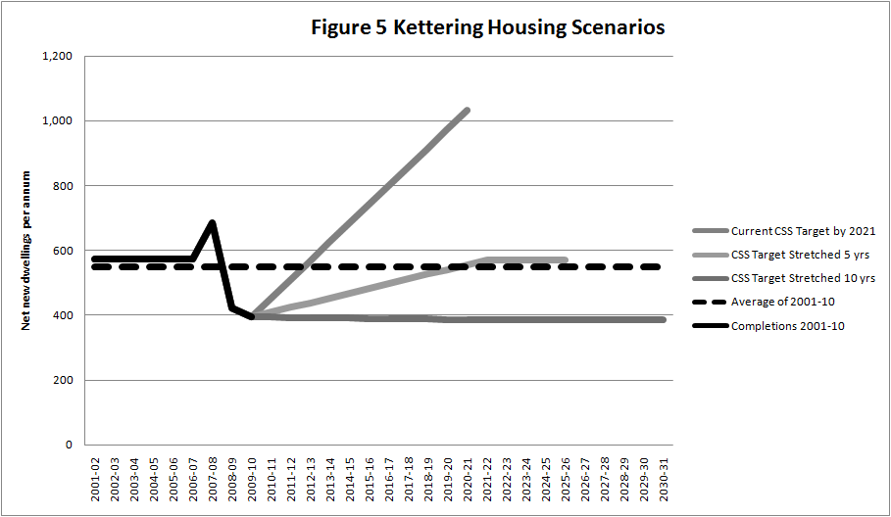

Suggested KBC Response

  - Kettering Borough Council thanks the Joint Planning Unit for the work it has undertaken in considering and reassessing the housing delivery targets contained within the Core Spatial Strategy. Although Kettering Borough has a proven record in housing delivery, and is well placed to continue to deliver housing through its substantial housing commitments, it is unlikely the housing numbers required in the Core Strategy will be delivered by 2021. Stretching the current delivery targets to 2026 would appear a logical and deliverable target for the Borough.

  - Extending the existing targets to 2026 will reduce the Council’s five-year housing land supply target, improving the Council’s potential for demonstrating a five-year supply and better managing land it releases for development.

  - Based upon completion rates, the Borough considers itself more resilient to recession, this is shown by the continued levels of delivery, even in recession. Stretching the existing targets to 2026 is considered a favourable approach, stretching the targets beyond that date to 2031 would lose credibility as the existing target of 13,100 is likely to be overtaken well before then as developers complete on those sites already with consent.

  - The Core Strategy Review will provide the forum for Members to discuss and select the most appropriate growth rates beyond 2026.

3. CONSULTATION AND CUSTOMER IMPACT

The North Northamptonshire Joint Planning Unit has conducted this consultation, of which Kettering Borough Council is a consultee. The development industry has been consulted on this Statement

4. POLICY IMPLICATIONS

The Statement of intent will be a material consideration for the purpose of calculating five-year housing land supply and bringing forward Development Plan Documents

5. USE OF RESOURCES

The consultation is being conducted by the North Northamptonshire Joint Planning Unit. There are no financial or resource implications arising from this report.

6. RECOMMENDATION

That Members note the contents of this report and agree the response detailed in paragraph 2.12 to 2.15.

Background Papers: Previous Reports/Minutes:

Title of Document: Ref:
Date: Date:
Contact Officer: Simon Richardson

