Site Specific Proposals Local Development Document (LDD)

Background Paper - Options for Re-use and Redevelopment of Rural Buildings and Farm Diversification

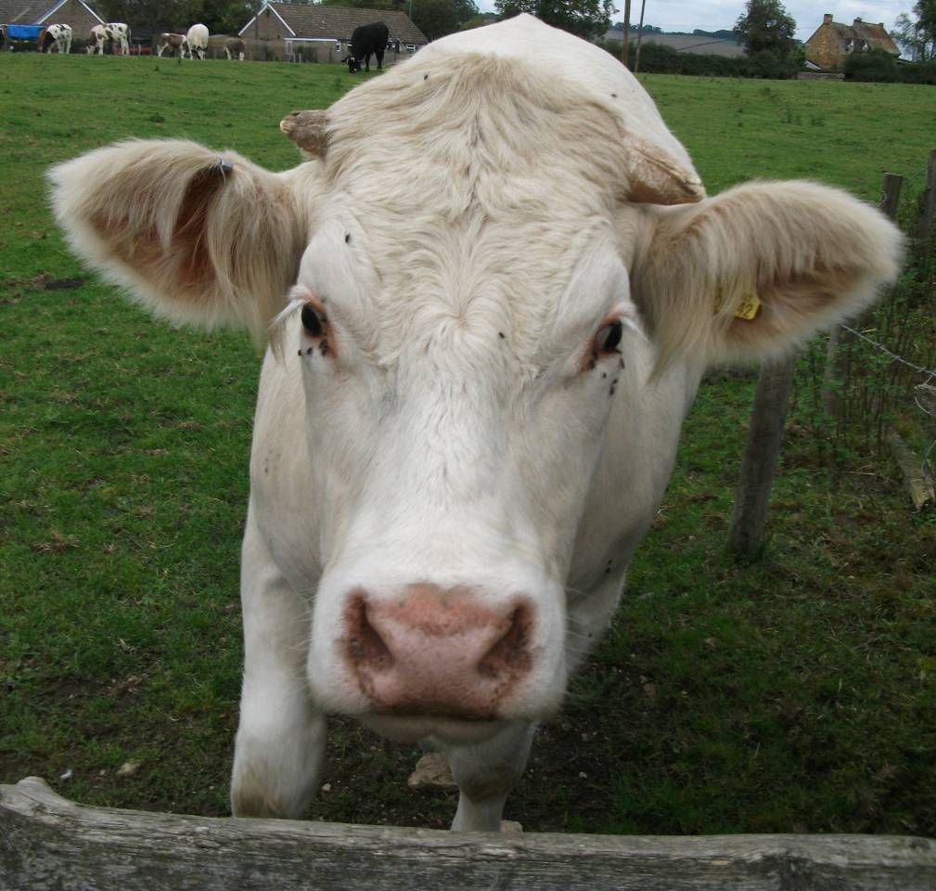

August 2011



Contents: | Page No
1. Introduction | 3
2. Policy Context & Evidence Base | 3
3. Consultation Feedback | 7
4. Options Development & Sustainability Appraisal of Options  i) Re-use and Redevelopment of Rural Buildings  Conclusions  ii) Farm Diversification  Conclusions | 21  21  28  30  34

1. Introduction
The purpose of this paper is to assess the need and justification for a policy, or policies to be included in the Site Specific Proposals Local Development Document (hereafter SSLDD) to cover the re-use and redevelopment of rural buildings and farm diversification. Kettering Borough is generally a very rural district and a significant part of the Borough’s character, community and economy is based around the countryside and its associated activities. A key element of the SSLDD will be putting in place policies to support and sustain rural communities and the rural economy. Two important issues within this are what to do with redundant rural buildings and farm diversification, with diversification from core agricultural activities becoming increasingly important to the continuing viability of many farm enterprises.

In preparing the SSLDD decisions will need to be made on the level of detail the document should provide in terms of rural development. This could range from a detailed approach including outlining any necessary criteria; a generic policy approach to guide applications for development; to a ‘do nothing’ approach which relies on national policy and guidance in the CSS. This paper looks at all of the options available in relation to this topic and assesses the sustainability implications of each option.

2. Policy Context & Evidence Base

Below is a brief summary of the policy context in which the options developed in this paper have been formulated.

National Guidance

Planning Policy Statement 7 (PPS7) - Sustainable Development in Rural Areas

Sets out the Government’s overall aim for the countryside, to protect it “for the sake of its intrinsic character and beauty, the diversity of its landscapes, heritage and wildlife, the wealth of its natural resources and so it may be enjoyed by all.”

Identifies the following issues that Local Planning Authorities should address:

• Need to develop competitive, diverse and thriving rural enterprise that provides a range of jobs and underpins strong economies

Agriculture and farming
• Need to promote sustainable, diverse and adaptable agriculture sectors where farming achieves high environmental standards, minimising impact on natural resources, and manages valued landscapes and biodiversity, contributes both directly and indirectly to rural economic diversity; is itself competitive and profitable, and provides high quality produces that the public wants.
• Recognise the important and varied roles of agriculture, including the maintenance and management of the countryside and most of our valued landscapes. Support development proposals that will enable farming and farmers to:
􀂾 Become more competitive, sustainable and environmentally friendly
􀂾 Adapt to new and changing markets
􀂾 Comply with changing legislation and associated guidance
􀂾 Diversify into new agricultural opportunities (e.g. renewable energy crops) or
􀂾 Broaden their operations to ‘add value’ to their primary produce
- Recognise that diversification into non-agricultural activities is vital to the continuing viability of many farm enterprises:
- Set out criteria to be applied to planning applications for farm diversification projects
- Be supportive of well-conceived farm diversification schemes for business purposes that contribute to sustainable development objectives and help to sustain the agricultural enterprise, and are consistent in their scale and their rural location.
- Encourage the re-use or replacement of existing buildings where feasible and have regard to the amenity of nearby residents or other rural businesses that may be affected by new types of on-farm development.
- PPS7 suggests that LPAs should provide policies to protect specific areas of the best and most versatile agricultural land from speculative development

Forestry
- Manage existing woods and forests sustainably
- Encourage the continued expansion of woodland areas to provide more benefits for society and the environment
- The planning system is the principal means for regulating the rate at which land is transferred from woodlands to other rural and urban uses.

Commercial equestrian activity
- Recognise that horse riding and other equestrian activities are popular forms of recreation in the countryside that can fit in well with farming activities and help to diversify rural economies.
- Horse training and breeding businesses play an important economic role. Local planning authorities should set out policies for supporting equine enterprises that maintain environmental quality and countryside character.
- These policies should provide for a range of suitably located recreational and leisure facilities and, where appropriate, for the needs of training and breeding businesses.
- They should also facilitate the re-use of farm buildings for small-scale horse enterprises that provide a useful form of farm diversification.

- Re-use for economic development purposes will usually be preferable, but residential conversions may be more appropriate in some locations, and for some types of building. Planning authorities should therefore set out in LDDs their policy criteria for permitting the conversion and re-use of buildings in the countryside for economic, residential and any other purposes, including mixed uses.

- These criteria should take account of:
– the potential impact on the countryside and landscapes and wildlife;
– specific local economic and social needs and opportunities;
– settlement patterns and accessibility to service centres, markets and housing;
– the suitability of different types of buildings, and of different scales, for re-use;
– the need to preserve, or the desirability of preserving, buildings of historic or
architectural importance or interest, or which otherwise contribute to local character.

- Local planning authorities should be particularly supportive of the re-use of existing buildings that are adjacent or closely related to country towns and villages, for economic or community uses, or to provide housing in accordance with the policies in PPS3, and subject to the policies in paragraph 7 of this PPS in relation to the retention of local services.

- Recognising that diversification into non-agricultural activities is vital to the continuing viability of many farm enterprises, local planning authorities should:
(i) set out in their LDDs the criteria to be applied to planning applications for farm diversification projects;
(ii) be supportive of well-conceived farm diversification schemes for business purposes that contribute to sustainable development objectives and help to sustain the agricultural enterprise, and are consistent in their scale with their rural location. This applies equally to farm diversification schemes around the fringes of urban areas; and
(iii) where relevant, give favourable consideration to proposals for diversification in Green Belts where the development preserves the openness of the Green Belt and does not conflict with the purposes of including land within it.

Planning Policy Statement 4 (PPS4) - Planning for Sustainable Economic Growth

POLICY EC6 (Planning for Economic Development in Rural Areas) states that
Local planning authorities should ensure that the countryside is protected for the sake of its intrinsic character and beauty, the diversity of its landscapes, heritage and wildlife, the wealth of its natural resources and to ensure it may be enjoyed by all.

Policy EC6.2, states that, in rural areas, Local Planning Authorities should:
- Strictly control economic development in open countryside away from existing settlements, or outside areas allocated for development in development plans
- Identify local service centres (which might be a country town, a single large village or a group of villages) and locate most new development in or on the edge of existing settlements where employment, housing (including affordable housing), services and other facilities can be provided close together
- Support the conversion and re-use of appropriately located and suitably constructed existing buildings in the countryside (particularly those adjacent or closely related to towns or villages) for economic development
- Set out the permissible scale of replacement buildings and circumstances where replacement of buildings would not be acceptable
- Seek to remedy any identified deficiencies in local shopping and other facilities e. to serve people’s day-to-day needs and help address social exclusion
- Set out the criteria to be applied to planning applications for farm diversification, and support diversification for business purposes that are consistent in their scale and environmental impact with their rural location
- Where appropriate, support equine enterprises, providing for a range of suitably located recreational and leisure facilities and the needs of training and breeding businesses that maintain environmental quality and countryside character.

North Northamptonshire Core Spatial Strategy (CSS)
Policy 1 of the CSS states that urban areas will be the focus for development. In the remaining rural area development will take place on sites within village boundaries, subject to criteria to be set out in development plan documents. Development adjoining village boundaries will only be justified where it involves the re-use of buildings or, in exceptional circumstances, if it can be clearly demonstrated that it is required in order to meet local needs for employment, housing or services. Development will be focussed on those villages that perform a sustainable local service centre role.

Paragraph 3.76 of the CSS promotes diversification of the rural economy, in particular through the conversion of buildings within settlements to economic re-use.

Living Buildings in a living landscape: finding a future for traditional farm buildings (English Heritage/ Countryside Agency, 2006)

- Provides guidance on the reuse of farm buildings and provides a regional overview of the types of buildings to be found in the East Midlands.
- Development plan policies for traditional farm buildings should, wherever possible, be evidence-based and should balance the intrinsic architectural and historic interest and landscape significance of farm buildings with their potential for adaptive re-use.
- Where local authorities are making decisions about change of use, they should require a detailed analysis and assessment of the architectural and historic interest of historic buildings and their settings in accordance with the principles set out in Planning Policy Guidance 15: Planning and the Historic Environment (DoE/DNH 1994) and Planning Policy Guidance 16: Archaeology and Planning (DoE 1990).This should be an integral part of the process of developing conversion proposals that respect cultural significance and minimise loss of historic character and fabric.
- There should be more emphasis on the quality of design, both traditional and contemporary, including appropriate detailing, materials and craftsmanship and the setting of buildings.
- Traditional farming building stock should be the subject of policies designed to conserve, protect and sustain it. This will be achieved through a combination of conservation policy, rural development policy and land-use planning policy.
- Wherever possible, policy makers should develop policy which:
• protect the features, settings, cultural significance and wildlife interest of traditional farm buildings;
• retain the contribution that traditional farm buildings make to local distinctiveness and to countryside character; and
• conserve the environmental capital embodied in traditional farm building stock by promoting their sustainable long-term use.
- Decisions concerning individual applications for the replacement or conversion of traditional farm buildings should take place within a strategic framework provided by Development Plans and Supplementary Planning Documents.
- The best option for retaining the overall historic and landscape integrity of traditional farming landscapes is, wherever possible, to keep buildings in active agricultural use or related low-key usage.
- Where continued active or low-key agricultural use is no longer practicable, the re-use of buildings for farm-related business purposes should normally be encouraged. Sensitive conversion to farm offices, workshops, farm shops, etc. for farm-related business diversification will generally help to retain the overall agricultural character of the farm building and farmstead.
- Where a local authority is satisfied that a traditional farm building no longer has a viable mainstream or low-key agricultural use, it may be prepared to grant permission for conversion to a new use. These uses include:
• non-agricultural industrial use (e.g. workshop or storage units);
• community use;
• office use;
• holiday accommodation;
• housing;
- recreational and/or educational uses.
- Local planning policies should acknowledge the fact that some of these alternative uses can be more damaging to the cultural significance of individual buildings or a whole farmstead than others. In many cases, conversion to workshop, light industrial or storage use can be more successfully accommodated than conversion to residential, retail or office use. Conversion to residential use is usually considered to be the most damaging in terms of its impact on historic features (such as spaces and finishes), and the setting and legibility of buildings.
- In sensitive landscape settings, it is generally less intrusive and more sustainable to use an adapted traditional building than to build a new structure, and planning authorities should always carefully scrutinise proposals to demolish traditional farm buildings and replace them with new structures.
- The aim of a local authority in determining conversion applications should be to seek a scheme that: retains as much historic fabric and as many features of interest as possible; respects the agricultural character of the buildings, including their general robustness and simplicity of design; protects the building’s farmstead and landscape setting and its relationship to the farmhouse; and safeguards protected species.
- Highways, transport and servicing issues can be a major impediment to the re-use of many traditional farm buildings especially for business usage and particularly in remote areas. Where significant historic buildings at risk would benefit from adaptive re-use for business purposes, local authorities should consider exceptions to normal highways requirements to facilitate this.
- In general terms, traditional farm buildings located in settlements are more suitable for conversion to residential use than buildings that are isolated in remote countryside.

3. Consultation Comments
During the Options consultation stage of the SSLDD several comments were submitted in relation to rural diversification and the re-use of rural buildings, summarised as:
- General support for re-use and redevelopment of old farm buildings, particularly for employment or small business and similar uses (subject to consideration of issues such as traffic generation and residential amenity);
- Strong support for farm diversification and a policy framework which supports agricultural economic activities;
- Support for encouraging suitable job opportunities within rural areas;
- Some concern that the re-use of agricultural buildings should not be used as an excuse for overdevelopment;
- Some recognition that the social, economic and environmental characteristics of villages can be positively enhanced by enabling development of this type;
- Some support for policies which enable existing rural enterprises to expand and for the construction of new buildings, not just the re-use of existing ones; and
- Support for separate policies on farm diversification and the reuse and redevelopment of rural buildings.

The following table reproduces all of the comments submitted in relation to this subject. Column 2 presents the responses made by Officers to the consultation feedback during the consultation stage. An officer response of “noted” means that the representation has been given due consideration in the formulation of the options presented in this paper.
ID | Full Name | Organisation Details | No. | Your view | Reason for comment | KBC response
43 | mr Bernard Rengger | Chairman Sutton Bassett Parish Meeting | Q. 14 | Agree | Policy RA5 appears to have worked up till now | Noted.
44 | Mr. Bernard Rengger | Chairman Sutton Bassett Parish Meeting | Q. 14 | Agree | Again policy RA14 appears to have worked in the past | Noted.
108 |  | OWNERS ECKLAND LODGE | Q. 14 | No opinion | Q14 requests the criteria to be used. The question of agreeing or disagreeing does not feature. The criteria that should be used are found in PPS7 Paras 17 to 20. But it should also be recognised that PPS7 is a countrywide document and 'suitably located' should be seen to exclude genuinely isolated farm complexes. Those within easy reach of existing settlements which would benefit economically by additional employment from the conversion/replacement of farm buildings should be encouraged. The relationship of distance from the complex to the size of nearby settlements would be a criterion to be included in any assessment. The replacement of existing agricultural buildings in line with para 19 is considered to be an important addition to the previous policies of the 1995 Local Plan. | Noted.
127 | Mr Nick Richards | Chair Wilbarston Parish Council | Q. 14 | Agree | Agreement to re-use agricultural buildings should not be used as an excuse for overdevelopment. | Noted
185 | Mrs Carolyn Mackay | Clerk Rothwell Town Council | Q. 14 | Agree | Rothwell Town Council supports the use of redundant farm buildings for local light industrial and rural use. | Noted. Consideration will be given to including criteria covering local light industrial and rural use in a policy covering the redundant farm buildings in the next stage of the plan.
243 | Mrs Leigh Parkin | Clerk Desborough Town Council | Q. 14 | Agree | Concur that re-use and redevelopment of old farm buildings into small business and similar uses should be encouraged. | Noted
214 | Rosalind Willatts | Historic Buildings Consultancy | Q. 14 | No opinion | The reuse of agricultural and other buildings is important, but this should be limited to the more traditional agricultural buildings. Large portal buildings should generally be excluded as their scale is too great for the environment when not in use for agricultural purposes. Some smaller scale modern (post 1920) agricultural beings could be reasonably converted for workshop/community/educational use as long as they are small scale and their visual conversion is appropriate. The conversion of the 1960s pigsties at Dallacre Farm in Rushton Road in Wilbarston to industrial/craft workshops is a useful provision for crafts, employment and workshops for the village. Policies should not prevent such good use elsewhere. | Noted, the points raised here however could form part of the criteria applied to determining appropriate re-use and re-development of rural buildings.
341 | Mrs Rosie Warne | Clerk Pytchley Parish Council | Q. 14 | Agree | Those in PPS 7, provided they are strictly applied and enforced | Noted.
367 | Ms Liberty Stones | Buccleuch Property / Boughton Estate | Q. 14 | No opinion | It is essential that planning policies enable the re-use, conversion and redevelopment of rural buildings and existing employment sites for employment, leisure and residential uses, as appropriate, and which accord with Government guidance as contained in paragraphs 17 and 18 of PPS7. In so doing, it should be recognised that the social, economic and environmental characteristics of the village can be positively enhanced by enabling development of this type. | Your comments have been noted.
437 | Mr Peter Quincey | Clerk Cranford Parish Council | Q. 14 | No opinion | As is. (But you haven’t explained it). | Noted
621 | Mr Keith Allsop | Hon Tech Sec CPRE | Q. 14 | No opinion | It should only be allowed where it contributes to the vigour of the rural economy without compromising the rural quality of the area. Design of any building is crucial so that it complements its location and a major consideration should be any generation of motor traffic. Future growth of any development should be the subject of a new planning application to enable a review of the above principles. Future growth of any development should be the subject of a new planning application to enable a review of the above principles. | Noted
572 | Miss Ann Plackett | Regional Planner, East Midlands Region English Heritage | Q. 14 | No opinion | Living Buildings in a living landscape: finding a future for traditional farm buildings (EH/ Countryside Agency, 2006) on the HELM website provides guidance on the reuse of such buildings and provides a regional overview of the types of buildings to be found in the East Midlands. | Noted
663 | Ch Supt Paul Fell | Northants Police | Q. 14 | No opinion | The re-use and redevelopment of rural buildings is not a problem from a policing perspective provided the redevelopment and re-use provides a safe environment for its use. Rural buildings are usually fairly remote and therefore can become targets for crime. Crime Prevention Design Advisors should be contacted to discuss the best ways to mitigate the potential for crime. | Noted
530 | Mr John Strutt | Parish Clerk Dingley Parish Council | Q. 14 | No opinion | Any plan for re-use or redevelopment of rural buildings must contain a realistic assessment of the additional traffic that would be generated by the development and the effect of such additional traffic on the surrounding villages. | Noted
128 | Mr Nick Richards | Chair Wilbarston Parish Council | Q. 15 | Agree | The new use should be relevant and meet local needs. | Noted
244 | Mrs Leigh Parkin | Clerk Desborough Town Council | Q. 15 | No opinion | Should provide good quality local employment opportunities. | Noted
215 | Rosalind Willatts | Historic Buildings Consultancy | Q. 15 | No opinion | Farm diversification is to be encouraged but any uses must be reasonably discreet such that a theme park/ retail park / honey pot for much traffic should not be created. Workshops or office space is a good use. Diversifications should relate to local needs. | Noted
412 | Ms Vanessa Clipstone | R P S Planning Transport & Environment | Q. 15 | No opinion | We consider that farm diversification should not be subject to the same policy criteria as those applied to the reuse and redevelopment of rural buildings. Whilst some criteria may cross over PPS7 provides separate guidance for farm diversification and re-use of farm buildings. PPS7, paragraph 30 recognises that diversification into non-agricultural activities is vital to the continuing viability of many farm enterprises and local authorities should set out criteria in their LDD to apply to applications for farm diversification projects. It goes on to state that local authorities should be supportive of well-conceived farm diversification schemes for business purposes that contribute to sustainable development objectives and help to sustain the agricultural enterprise, and are consistent in their scale with their rural location. In this context PPS22, sets out on page 6 the four elements of the Government's sustainable development strategy, which include: ''rural areas, renewable energy projects have the potential to play an increasingly important role in the diversification of rural economies." Wind farms are an excellent example of farm diversification. Wind farms can coexist alongside existing farm activities, with minimal impact on the ongoing farm operation. Wind farms also have the advantage of providing a regular additional income to farmers and agricultural landowners, which supplements traditional farming incomes. | Farm diversification will be considered as the Site Specific Proposals LDD is progressed and will need to have regard to draft PPS4 regarding Economic Prosperity, which updates elements of PPS7.  Officer notes:  Issues around renewable energy, including windfarms, will be considered in the review of the Core Spatial Strategy.
438 | Mr Peter Quincey | Clerk Cranford Parish Council | Q. 15 | Agree | Yes, providing the diversification does not affect detrimentally adjacent properties. | Noted.
368 | Ms Liberty Stones | Buccleuch Property / Boughton Estate | Q. 15 | No opinion | In view of the need to maintain suitable job opportunities within the rural area it is considered that planning policies should enable farm diversification. In this context, the accommodation of economic development in the countryside frequently seems to be perceived as an activity confined to converted barns. Although there is no doubt that the re-use of existing buildings has provided a significant amount of commercial floorspace, it should not be seen as the sole means of providing for farm diversification and new employment uses within the rural area. Furthermore in view of the importance in garnering success and maintaining suitable job opportunities within rural areas, it is also essential for businesses to be able to expand their premises or where this is not possible, for there to be suitable units available for them to expand into. It is only in this way that a range of employment opportunities can be retained and the sustainability of small rural communities enhanced. It is therefore essential that planning policies also enable farm diversification, including the development of new purpose built business units on suitable sites within and adjoining villages, and provision for quasi-commercial activities which necessitate a rural location. | Noted. PPS7 is supportive of farm diversification and recognises the important contribution these schemes make to the viability of many farming enterprises.
531 | Mr John Strutt | Parish Clerk Dingley Parish Council | Question 15 | No opinion | Yes. Diversification projects should be appropriate to the vicinity. | Noted
622 | Mr Keith Allsop | Hon Tech Sec CPRE | Question 15 | No opinion | It should only be allowed where it contributes to the vigour of the rural economy without compromising the rural quality of the area. Design of any building is crucial so that it complements its location and a major consideration should be any generation of motor traffic. Future growth of any development should be the subject of a new planning application to enable a review of the above principles. | Noted
Additional representation from Smith Stuart Reynolds (SSR) on behalf of Buccleuch Property / Boughton Estate, 21st July 2011 |  |  | Summary:  Support the sustainable growth of rural businesses and promote the development and diversification of agricultural businesses.  In practical terms, if the policy framework for rural areas provides for the presumption in favour of sustainable development on previously developed sites, for example agricultural farmyards, then there will be increased interest and investment coming forward to deliver development to meet rural needs. A flexible rural policy would ensure the organic evolution of villages, combined with the conservation of vernacular buildings and reuse of agricultural brownfield sites, providing for investment opportunities for either market or affordable housing, commercial or community uses, or a mixture, as defined by the market and the needs of the local community.  Smaller scale brownfield sites and / or unused buildings within the village’s present opportunities for organic growth and evolution. We consider that it is essential that local policies are in place which enable the re-use, conversion and redevelopment of rural buildings and existing employment sites; in turn assisting farm diversification, business expansion and the sustainability of the smaller villages. |  |  | Officer notes:  Noted. This submission, and all others on this subject, will be considered in the drafting of policy options for this topic.

Parish & Town Council Meetings
No specific issues relating to this subject were made during consultations with the Parish and Town Councils.

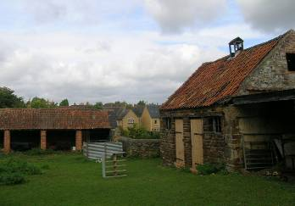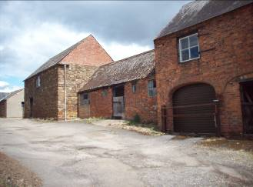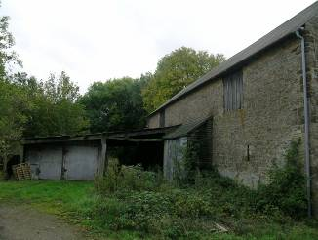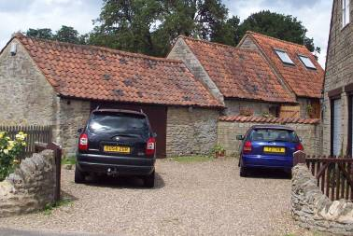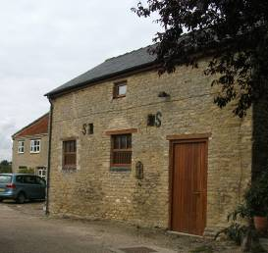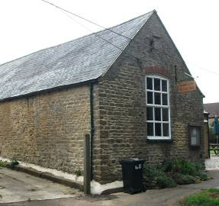
4. Options Development & Sustainability Appraisal of Options

National policy is clear that Local Planning Authorities should, in their Development Plan Documents, address issues around the re-use or redevelopment of rural buildings and farm diversification. Given the Borough’s rural context, policies which strive to ensure that agriculture and rural economies and communities can be sustained are very important. With the scarcity of land and need to protect the open countryside, what to do with existing buildings in rural areas which fall out of use is also a key concern. Options have therefore been developed to address agricultural diversification and the re-use and redevelopment of buildings in the Site Specific Proposals LDD.

In drafting these options, it is clear that there is a balance to be struck between the need to sustain and enhance rural communities and economies with the overarching national policy agenda of sustainable development patterns (directing development to the most accessible and sustainable locations – existing centres) and the associated desire to strictly control economic development in the open countryside. The options have therefore been drafted with this balance in mind and this dichotomy has been prominent in the Sustainability Appraisal process.

The issues have been separated out into 2 draft policy options, each of which will be discussed in turn:

i) Re-use and Redevelopment of Rural Buildings
ii) Farm Diversification

i) Re-use and Redevelopment of Rural Buildings
Kettering Borough contains a stock of rural buildings, predominantly constructed to support agriculture. Where buildings are no longer required for their original use they can provide a valuable opportunity for redevelopment for positive re-use. However, due to their location, such developments must be carefully controlled. It is crucial that such proposals place design at their forefront and take account of the character, history and appearance of the existing building, and the surrounding area. The traditional farm building stock is an important part of this rural heritage and a major contributor to the character, beauty and diversity of the countryside. Traditional farm buildings make a great contribution to local distinctiveness and to the character of the Borough’s countryside.
It is important that future uses are carefully controlled. Pressure is likely to be highest for conversion of rural buildings to residential use. However, this may not necessarily be the most sustainable or suitable use, and unchecked such conversions could undermine rural vitality, viability and character. An unbalanced policy approach which favoured residential re-use could lead to an undesirable impact on farming, with otherwise viable and vital agricultural operations under pressure to yield buildings to residential development.
National policy instead encourages uses which contribute more to rural sustainability such as those which provide jobs and support the rural economy. Potential uses include employment use (commerce and industry), tourism or recreation. There is also potential for ‘high tech' or ‘green’ industries, contributing to providing a greater diversity of employment opportunities across the rural district. The re-use and adaptation of redundant rural buildings that are worthy of retention can be an important resource for meeting the needs of new and expanding rural enterprises, while encouraging farmers to diversify their operations.
However, even where proposed uses are suitable, developments should be of a scale appropriate to their location. For example, large employment developments in the countryside may conflict with the principles of sustainable development and result in unsustainable traffic movements and potential environmental harm. Developments resulting in significant numbers of employees or visitors should be located within or near to settlements or be accessible by public transport, cycling, or walking. In areas without such access, small-scale business development may still be appropriate where it results in only a modest increase in daily vehicle movements.
Given the complexity of this issue an option has been drafted to include a policy in the SSLDD to set out local requirements and guidelines for proposals to re-use, redevelop or replace existing rural buildings. The alternative option is to not develop a policy. Each option is discussed in turn:
Option a) - To include a policy setting out requirements for the re-use or redevelopment of rural buildings
This policy must consider several important aspects, discussed in turn below, to include.
- Applicable buildings;
- Location of buildings;
- Suitable uses;
- Impact & character; and
- Replacement buildings.

Applicable buildings
Importantly, this policy must apply only to appropriate permanent buildings in the countryside whose retention or redevelopment would be beneficial to the rural environment, for example historic stone barns or farmhouses. Some buildings, primarily modern structures in agricultural use, would not be suitable for re-use or conversion. Structures which should be excluded from the policy (and therefore not permitted for redevelopment for non-agricultural uses) include temporary or semi-permanent structures which, were they not fulfilling their agricultural role, would be incongruous to their rural setting, and therefore inappropriate for redevelopment, for example large modern barns or grain stores.
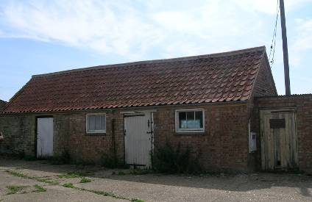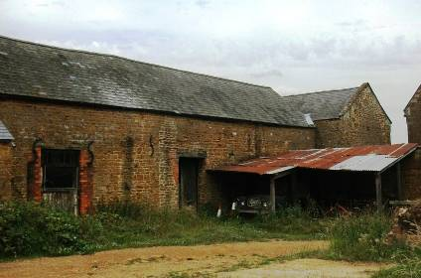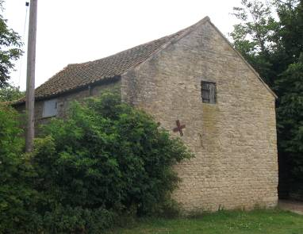
Above: Examples of rural buildings which would be suitable for appropriate re-use or redevelopment

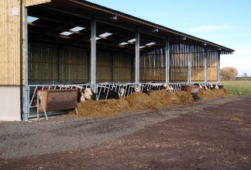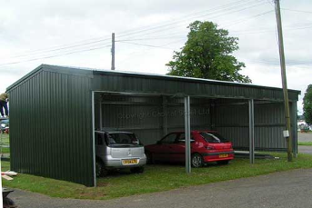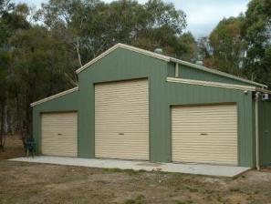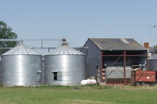
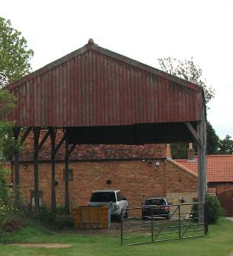
Above: Examples of rural buildings which would not be suitable for re-use, conversion or redevelopment

This would need to be controlled by the policy clearly defining what buildings it is to be applied to, for example by setting criteria – for example where the building is:
- Soundly built and of permanent, substantial, traditional construction, originally comprising 4 walls;
- Primarily of stone, brick or timber construction;
- Have been built for a period of 10 years or more;
- The form, bulk and general design of the buildings are in keeping with their surroundings; and
- Suitable for the proposed use without substantial rebuilding or extension and the proposed alterations protect or enhance the character of the building and its setting.

Location of buildings
The policy must balance the competing objectives and potential harmful impacts on the sensitive rural environment, discussed above. As such a detailed yet flexible policy is suggested which could:
- Differentiate between buildings within, adjacent or close to villages and buildings in the open countryside;
- Include criteria for the acceptable re-use, redevelopment or replacement of rural buildings;
- Prioritise preferable uses; and
- Set out the permissible circumstances and scale for replacement buildings.

In order to reflect the variety of locations buildings are likely to crop up in, the policy could apply more or less stringent requirements or criteria according to its location, and relationship with its nearest settlement. This could enable a degree of discretion or control over buildings according to their location, for example buildings in the open countryside could be more tightly controlled than those within or close to villages. The policy could make a distinction between buildings located:
- Within village boundaries;
- Adjacent to or within 200m of a settlement; or
- In the open countryside.

Suitable uses
The history and heritage of traditional farm buildings make a great contribution to local distinctiveness and to the Borough’s rural character. Kettering Borough Council (KBC) are keen to conserve the environmental capital embodied in traditional farm building stock by promoting their sustainable long-term use. It is recognised that the best option for retaining the overall historic and landscape integrity of traditional farming landscapes is, wherever possible, to keep buildings in active agricultural use or related low-key usage. Only where a traditional farm building no longer has a viable mainstream or low-key agricultural use, should consideration be given for conversion to a new use.

National policy requires that appropriate business use be given priority in the re-use of rural buildings. The district has a large number of rural buildings some being attractive agricultural barns of historic and architectural value. There is pressure to convert these to residential uses. However this has to be restricted in order to support the rural economy and provide local employment opportunities.

It is acknowledged that some of these alternative uses can be more damaging to the historical significance of individual buildings or a whole farmstead than others. In many cases, conversion to workshop, light industrial or storage use can be more successfully accommodated than conversion to residential, retail or office use. It is generally less intrusive and more sustainable to use an adapted traditional building than to build a new structure, and proposals to demolish traditional farm buildings and replace them with new structures will be carefully scrutinised.

A policy approach is suggested which requires a hierarchical approach to preferred uses for rural buildings. The policy would encourage the most preferable uses, for example employment generating or agriculturally related uses, to be developed in preference to those which are less preferable, for example residential. Only where an application could demonstrate that a preferable use, or mix of preferable uses, is not feasible, practicable or viable for that building would a less preferable use be permitted. A draft hierarchy of preferable uses is detailed below:
- Use related to agriculture or equine activities;
- Employment generating use – commercial, light industrial, operations linked to agriculture, offices;
- Community uses;
- Retail – where selling produce linked to the countryside; location-specific; or serving purely local needs;
- Leisure / tourism – where linked to the countryside; or location-specific;
- Live / work units;
- Residential – affordable housing;
- Residential –market housing.

Impact & Character
The aim of a policy covering re-use of traditional farm buildings should be to seek schemes that:
- Retain as much historic fabric and as many features of interest as possible;
- Respect the agricultural character of the buildings, including their general robustness and simplicity of design;
- Protect the building’s farmstead and landscape setting and its relationship to the farmhouse; and Safeguard protected species.

Criteria are suggested which would ensure that proposals for re-use or redevelopment of rural buildings must not have negative impacts on their heritage, setting or rural communities to be deemed permissible. These criteria would cover:
- For buildings in economic or agricultural use, the economic viability of the current (or last operational) use, likely to be predominantly agricultural. Unless the proposed re-use is materially linked to its existing use, applicants would need to demonstrate vacancy and active marketing of the building for that use for a period of at least 6 consecutive months. This would seek to protect the loss of the limited number of buildings which are available for farming from inappropriate development and seek to protect agricultural vibrancy;
- Suitability – The building would need to be suitable for the proposed use without substantial rebuilding or extension. The proposed alterations should protect or enhance the character of the building and its setting. The policy may need to limit the scale of any replacement or new build elements to a scheme, for example an additional floorspace threshold of 20%;
- Issues of history, design, character, visual impact, environment and landscape. There is a need to protect locally important traditional farm buildings from loss or conversions that would harm the character of such buildings and their surroundings. In particular large scale alterations including new openings and extensions out of scale with the building should be avoided;
- Amenity;
- Safety - the redevelopment and re-use must provide a safe environment for its use to reduce the risk of crime in isolated locations;
- Traffic generation; and
- Removal of permitted development rights.

Replacement buildings
The policy would also need to detail guidelines for the circumstances and scale which are considered acceptable for replacement buildings in the rural area. Extensions to existing businesses should be permissible where it is of a scale appropriate to the existing development and would not have a detrimental effect on the character or amenity of the area.

All proposals would also need to be in conformity with the requirements of all other policies in the SSLDD, for example the policies covering main town centre uses, design principles, etc.

Summary of Sustainability Appraisal

The advantages of this approach, as assessed in the Sustainability Appraisal (SA), are summarised against the relevant SA topic below:
- Accessibility - should result in developments which are accessible to people in rural areas, particularly employment opportunities.
- Housing - will enable the re-use of some rural buildings for residential use and prioritises affordable housing through the hierarchical approach.
- Community - The draft policy also hierarchically prioritises community uses and there is a positive impact from appropriate redevelopment of redundant buildings which could otherwise fall derelict and blight the community.
- Liveability – The re-use of redundant buildings for appropriate uses should enhance the liveability of rural areas where derelict buildings detract from their liveability. The provision of employment opportunities in rural areas will also aid rural vitality, viability and liveability.
- Built Environment - positive impacts through criteria promoting quality of design and preventing inappropriate uses, conversions or additions which would have a negative impact on the built environment.
- Soil and Land - re-use of existing buildings reduces the amount of Greenfield land needed for new developments.
- Employment - policy will promote re-use of buildings for employment-generating use and encourage sustainable economic development by prioritising these uses hierarchically.
- Wealth creation - should facilitate agricultural prosperity and economic development by prioritising these uses hierarchically.

There is an uncertain impact against the topic of crime. A potential negative impact is noted in that rural buildings are usually fairly remote and therefore can become targets for crime. However, a potential positive impact results from re-use of redundant buildings which might otherwise become magnets for crime or anti-social behaviour. It is considered that the potential negative impact could be mitigated by policy criteria requiring the redevelopment and re-use provides a safe environment for its use.

Some potential disadvantages were identified in the SA, though the SA process has identified that these potential negative impacts can be mitigated through careful policy development. These are summarised below:
- Landscape – there could potentially be negative impacts on landscape if inappropriate redevelopments take place which impact poorly on the surrounding landscape. This could be mitigated by policy criteria requiring the redevelopment and re-use to be in keeping with and well related to its surrounding landscape.
- Climate change - uses which generate high numbers of additional visitors by car to rural areas may have a negative impact. However, the potential negative could be mitigated by a policy criterion assessing the traffic impact of redevelopment and re-use to be within reasonable limits enabling the refusal of proposals which would generate high numbers of additional visitors by car.

Option b) - To not develop a policy addressing the re-use or redevelopment of rural buildings

The alternative approach to option a) is to not detail a policy addressing rural buildings and their re-use or redevelopment. This would be contrary to the direction of PPS7 and PPS4 which requires Local Planning Authorities to develop policies covering these issues, as detailed in section 2.

Such an approach would mean applications would be determined against national guidance and the generic direction in the CSS. This framework is generally very restrictive of any development in the open countryside outside of villages. This could mean that applications for sustainable re-uses of otherwise redundant buildings in the borough are refused by blanket application of the generic national ‘no rural development’ policy direction. Such an interpretation, however, misses opportunities to deliver wider national policy objectives to sustain, support, diversify and enhance the rural economy and rural communities. It could also lead to the waste of a potential resource of usable buildings and introduce the risk of blight from derelict buildings detracting from the countryside environment. Such concerns were drawn out in the Sustainability Appraisal of this option, summarised below.

Summary of Sustainability Appraisal
No positive impacts were noted against this ‘do nothing’ option which has a largely neutral impact against most of the SA topics together with some significant negative impacts against the following:
- Employment and wealth creation - Failure to encourage economic re-use of rural buildings would result in the potential loss of productive farms or economic development and have a negative impact on rural economies and job creation. Not setting out a policy framework runs the risk of all conversions coming forward for residential development, for which there is most pressure, undermining the supply of buildings for agriculture and employment use.
- Community – Redundant buildings could fall derelict and blight the community. Prevention of the development of local facilities or opportunities for employment could be to the detriment of community.
- Liveability – Redundant buildings could fall derelict and undermine liveability. Prevention of the development of local facilities or opportunities for employment could be to the detriment of liveability.
- Built environment - Redundant buildings could fall derelict and blight the built environment.

Potential negative impacts were considered possible against:
- Crime – from preventing the re-use of redundant buildings which might otherwise become magnets for crime or anti-social behaviour.
- Landscape - Not setting a policy framework for re-use of buildings could result in inappropriate schemes being developed which impact negatively on the landscape.

Other options considered

Prevent all residential conversions. This would be inflexible and lead to inappropriate conversions; potential traffic problems and derelict rural buildings.

Allow residential reuse. This would result in inappropriate conversions; the spread of residential uses and characteristics within open countryside; and reduce the already limited stock of buildings for agricultural or business use.

Allow all redevelopment proposals. This would result in the encouragement of unsustainable patterns of development; inappropriate development in the open countryside; the potential loss of productive farms or economic uses; inappropriate conversions; loss of rural identity and character; and potential traffic problems.

i) Conclusions
As demonstrated by the Sustainability Appraisal, option a) to include a policy covering this topic, performs the best in terms of sustainability. This option is therefore taken forward in the SSLDD as a ‘preferred option’ put forward for public consideration. The ‘do nothing’ approach is also taken forward as an option for consideration. All other options considered have been discounted at this stage for the reasons outlined above and in the Sustainability Appraisal.

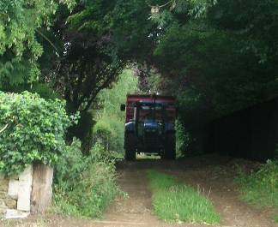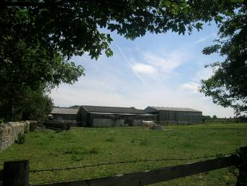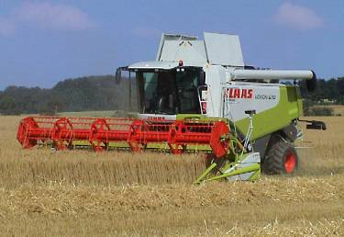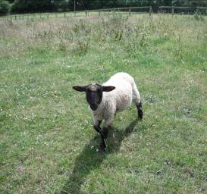

ii) Farm Diversification

The rural context and the importance of the agricultural sector to Kettering Borough have been outlined above. Section 2 also discussed how national policy is clear that Local Planning Authorities should detail in their LDDs, a policy framework to guide and support agricultural diversification. Therefore an option is presented to develop a policy to cover this issue. The alternative option is to not develop a policy. Each option is discussed in turn:

Option a) – To include a policy addressing agricultural diversification
Farm diversification may involve various types of enterprise, including the introduction of different methods of agricultural production, the use of new crops, adding value to farm products, farm-based food processing and packaging, farm shops, craft workshops, tourism, recreation, planting of woodland, nature trails, holiday accommodation, equestrian businesses, fishing lakes and leasing land or buildings to other non-agricultural businesses. Some of these schemes do not require planning consent. However, where consent is required, it is important to ensure that proposals for diversification would bring long-term and genuine benefits to individual farm operations and the wider rural area.
Farming makes an important contribution to the local economy, but increasingly farms are having to diversify into non-agricultural activities, for the business to remain viable. It is important that planning policies are in place to support such diversification, where appropriate to support the agricultural sector and rural employment and economy. In order to protect the quality and distinctiveness of the local landscape KBC wishes to prevent uncoordinated or unsuitable development in rural areas and the piecemeal stripping of assets from farms without regard for the viability of the holding.
A balance must be struck between supporting the agricultural sector, promoting rural economic activity and diversification, and the overarching twin objectives of sustainably located development and protection of the open countryside. Development of this option must strive to encourage farm enterprises to diversify into new agricultural and non-agricultural business activities that will not only help to sustain the Borough’s rural economy but also are compatible with protecting and, where possible, enhancing its rural character and environmental resources.
It is important that diversification proposals are well founded in terms of effectively contributing to the farm business and the rural economy and integrating new activities into the environment and the rural scene.
This option must be considered in conjunction with option i) a) (above) which seeks to make the best possible use of existing buildings, through their suitable re-use or redevelopment. New build development should generally be discouraged except where it is regarded as the only viable option, or enables the clearance and replacement of poorly-sited buildings. Where new building on undeveloped sites is necessary, the intention is to ensure that the size of any such development is limited.

Horse riding and other equestrian activities are popular forms of recreation in the countryside that can fit in well with farming activities and help to diversify rural economies. Horse training and breeding businesses play an important economic role. KBC wish to, where appropriate, support equine enterprises, and provide for a range of suitably located recreational and leisure facilities and the needs of training and breeding businesses provided that they maintain environmental quality and countryside character. It is important to ensure that all equestrian development, whether domestic or larger commercial activities, is of an appropriate scale and design to reflect its rural location. Careful attention should be given to siting and landscaping details to ensure that proposals do not detract from the locality's character and appearance. Farm diversification schemes could include schemes for the re-use of rural buildings to accommodate small-scale equestrian development, in accordance with option i) a) (above).

A criteria-based policy is suggested which would outline the circumstances in which proposals for farm diversification or equine enterprises would be permissible. The policy would clearly define applicable circumstances for development, for example land or buildings associated with a working or formerly working farm (as opposed to development in the open countryside). Criteria are suggested which would ensure proposals must be genuinely capable of supporting and diversifying the economic operation and must not have negative impacts on their rural communities. Criteria would be positively worded so as to encourage well conceived proposals which conform with the principles. These criteria would cover:
- Demonstrating the proposal’s necessity and contribution to the rural business and diversification of the local economy. One way this could be achieved is through a requirement for proposals to be accompanied by a concise Farm Diversification Plan, which establishes how it will assist in retaining the viability of the agricultural enterprise;
- Aspects to be encouraged - employment creation, equine uses, or positive environmental impacts;
- Scale of development – development must be of an appropriate scale to the rural location, the surroundings and well related to any existing buildings on site;
- Re-use of existing buildings or infrastructure;
- Intensification of use – for example traffic, visitor generation etc.; and
- Impact on development - upon rural character, landscape, biodiversity, residential amenity, including through unreasonably intensified noise or pollution.

All proposals for farm diversification would also need to be in conformity with the requirements of all other policies in the SSLDD, for example the policies covering main town centre uses, design principles, etc.

Summary of Sustainability Appraisal

The positive impacts of this option, as assessed in the Sustainability Appraisal (SA), are summarised against the relevant SA topic below:
- Accessibility - provision of suitable employment opportunities which are accessible to people in rural areas.
- Community - support to the agricultural sector and provision of local employment opportunities would positively impact on rural communities and vitality.
- Skills - encourage diversification of the rural economy and associated diversification of the types of jobs available, boosting skills.
- Liveability - support of a thriving agricultural sector and provision of employment opportunities in rural areas will aid rural vitality, viability and liveability.
- Soil and Land - re-use of existing rural agricultural brownfield land and buildings reduces the amount of Greenfield land needed for new developments.
- Employment - support for a vibrant and successful agricultural and equine economy, encourage sustainable economic development and diversification and promote employment generating proposals.
- Wealth creation - support a vibrant and successful agricultural and equine economy, encourage sustainable economic development and diversification and promote employment generating proposals, entrepreneurship and rural economic prosperity.

An uncertain impact is noted against the topic of climate change. With a potential negative impact being uses which generate high numbers of additional visitors by car to rural areas may worsen emissions. However, this could be mitigated by policy criteria requiring the traffic impact of development proposals to be within reasonable limits and to refuse developments which generate high numbers of additional visitors by car. In addition potential positive impacts are possible if local employment or facilities are developed to serve rural areas so that people will not need to travel day-to-day by car, to access employment; and the policy could encourage ‘green technology’ industries or proposals which have positive environmental impacts which could result in a positive impact in the long term.

Some potential negative impacts were identified in the SA, though the SA process has identified that these potential negative impacts can be mitigated through careful policy development. These are summarised below:
- Landscape - inappropriate developments may impact poorly on the surrounding landscape.
- Built Environment - inappropriate, poorly designed or scaled, developments may impact poorly on the character of the rural area.

Option b) – To not include a policy addressing agricultural diversification

The alternative approach to option a) is to not detail a policy addressing farm diversification. This would be contrary to the direction of PPS7 and PPS4 which requires Local Planning Authorities to develop policies covering these issues, as detailed in section 2.

Such an approach would mean applications would be determined against national guidance and the generic direction in the CSS. This framework is generally very restrictive of any development in the open countryside outside of villages. This could mean that applications for sustainable economic development of farms are refused by blanket application of the generic national ‘no rural development’ policy direction. Such an interpretation, however, misses opportunities to deliver wider national policy objectives to sustain, support, diversify and enhance the rural economy, skills base, and rural communities and sustain and create rural employment opportunities. It could also risk hindering the economic success of farms causing some to fail, undermine the economic competitiveness of the district, and risk blight from derelict buildings detracting from the countryside environment, to the detriment of community, liveability, and the built environment. Such concerns were drawn out in the Sustainability Appraisal of this option, summarised below.

Summary of Sustainability Appraisal

The positive impacts of this option, as assessed in the Sustainability Appraisal (SA), are summarised against the relevant SA topic below:
- Landscape – this approach would protect the current agricultural landscape and prevent inappropriate development which would negatively impact on the landscape.

The negative impacts identified in the SA against this option are summarised below:
- Skills - Presumption against development in the countryside would prevent proposals to diversify farm operations and increase the skills base.
- Employment - Failure to encourage farm diversification could result in the potential loss of productive farms or economic uses and have a negative impact on rural economies, job provision and diversification of employment opportunities in rural areas.
- Wealth creation - Failure to encourage farm diversification would have a negative impact on rural economies and job creation, and undermine the facilitation of employment generating proposals, entrepreneurship and rural economic prosperity.
- Soil and Land - Not enabling rural brownfield land to be re-used would result in more Greenfield land being needed for economic development.
- Community - Failing to support sustainable economic agricultural growth and diversification could undermine communities in the medium-long term if farms fail because agriculture plays an integral role in the rural community.
- Liveability - Failing to support sustainable economic agricultural growth and diversification could undermine liveability, of which agriculture is an important part, in the medium-long term if farms fail. Redundant buildings could fall derelict and undermine liveability.
- Built environment - Redundant farm buildings could result in the medium-long term and fall derelict and blight the built environment.

Other options considered
Protect farms for purely agricultural use - A policy for the protection of productive farm-holdings for agriculture could be included. This approach would seek to ensure the overriding agricultural use of land, and farm productivity for food is preserved. However the diversification of farms, for business developments, is strongly supported through national guidance providing certain criteria are met. A more restrictive approach would be difficult to implement, would harm farm diversification and unreasonably fetter market forces, the economic competiveness of the district, and sustainable economic development. This option was discounted at this stage for these reasons.

ii) Conclusions
As demonstrated by the Sustainability Appraisal option a) (to include a policy supporting sustainable agricultural or equine diversification enterprises including setting out criteria to be applied to proposals for farm diversification) performs the best in terms of sustainability. Numerous positive impacts are noted, especially against economic impacts including wealth creation and employment. The SA has demonstrated how potential negative impacts can be mitigated through a robust policy and criteria based assessment of individual proposals. This option is, therefore, taken forward in the SSLDD as a ‘preferred option’ put forward for public consideration. The ‘do nothing’ approach is also taken forward as an option for consideration. All other options considered have been discounted at this stage for the reasons outlined above and in the Sustainability Appraisal.

