Site Specific Proposals Local Development Document (LDD)

Background Paper - Options for Flood Risk and Water Management

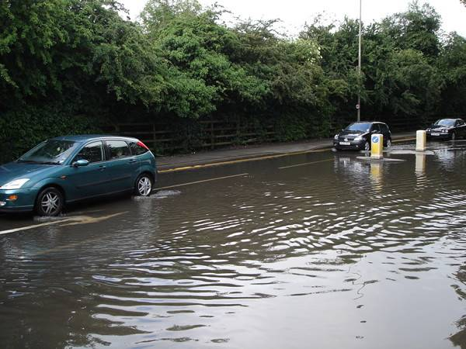

July 2011

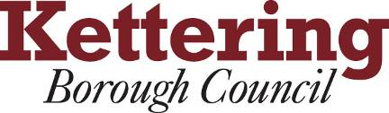

Contents: | Page No
1. Introduction | 2
2. Policy Context | 2
3. Evidence Base | 4
4. Consultation Feedback | 10
5. Options Development & Sustainability Appraisal of Options | 15
6. Conclusions | 20

1. Introduction

The purpose of this paper is to assess the need and justification for a policy, or policies to be included in the Site Specific Proposals Local Development Document (hereafter SSLDD) to cover flood risk and water management, including the potential allocation of a site for a strategic reservoir. As is well documented elsewhere, the Core Spatial Strategy sets out plans for significant growth in Kettering Borough for the period to 2021. This growth must be accommodated sustainably in terms of flood risk and water management – i.e. the risk of water related problems, especially flooding, should not be increased through new development. Instead growth should, where possible, bring about measures which improve the water environment and reduce or mitigate existing flood risk.

In preparing the SSLDD decisions will need to be made on the level of detail the document should provide for future development in terms of flood risk. This could range from generic based policies to guide applications for development, to more a detailed approach including any necessary allocations, to a ‘do nothing’ approach which relies on national policy and guidance in the CSS and supporting documents. This paper looks at all the options available in terms of water management and assesses the sustainability implications of each option.

2. Policy Context

Below is a brief summary of the policy context in which the options developed in this paper have been formulated.

Planning Policy Statement 1 (PPS1)
PPS1 sets an overarching objective for the planning system to deliver sustainable development, defined as “development that meets the needs of the present without compromising the ability of future generations to meet their own needs.” A key element of sustainable development is the water environment which includes issues such as flood risk, water efficiency and pollution.

PPS1 states that Development plan policies should:
- Avoid new development in areas at risk of flooding
- Take account of environmental issues such as the protection of groundwater from contamination
- Should seek to promote and encourage the sustainable use of water resources; and the use of Sustainable Drainage Systems (SUDS) in the management of runoff.

Planning Policy Statement 25 (PPS25)
The aims of PPS 25 (which replaced PPG 25) is to ensure that flood risk is taken into account at all stages in the planning process to avoid inappropriate development in areas at risk of flooding, and to direct development away from areas at highest risk. Where new development is exceptionally necessary in such areas, it aims to make it safe without increasing flood risk elsewhere and where possible, reducing flood risk overall.

PPS 25 requires local authorities to apply a risk-based sequential approach as part of the identification of land for development in areas at risk of flooding. The purpose of the sequential approach is to ensure that areas of low risk are developed in preference to areas of higher risk, within this, ensuring that the developments that are most vulnerable to flood risk are located at the lowest risk areas. The application of the sequential approach needs to be underpinned by an appropriate assessment of flood risk. The sequential approach process then uses this information to avoid the highest flood risk areas and where this is not possible, take opportunities to substitute higher vulnerable land uses in higher flood risk areas for lower vulnerable uses in lower flood risk areas, or mitigate the risk of flooding; in that order.

The sequential test is an important aspect of the sequential approach which is required at the local planning authority (LPA) level. It is a test to show that land allocation has been made in the lowest possible flood zone (as defined in Table D.1 of PPS 25) that is available within the relevant geographical area for the type of development being proposed.

The SFRA is at the core of the PPS 25 approach. It is a freestanding strategic assessment of flood risk which all local planning authorities (LPAs) are required to carry out in preparation of their Local Development Documents (LDDs) to enable sustainability appraisals, land allocation and development control policies to be informed by an understanding of the catchment-wide flooding issues that affect the area.

PPS 25 recommends a staged process for the development of SFRAs to enable the detail of the assessment to be related to the risk posed by new development. A Level 1 SFRA, principally a desk based study, is required to provide the LPA with flood risk information to apply the sequential test. Where it is clear that proposed development and infrastructure is not able to be accommodated in accordance with the sequential test, taking account of the flood vulnerability category of the intended use (as outlined in Tables D.2 and D.3 of PPS 25), then a more detailed Level 2 SFRA is required to facilitate the application of the exception test (as outlined in paragraph D.9 of PPS 25).

As was flagged up during the Issues consultation on the SSLDD, the existing SFRA for Kettering dated back to 2005, and was therefore only complaint with PPG 25 standard rather than the superseding PPS25 requirements. A PPS25 compliant Level 1 SFRA across the Kettering and Wellingborough Planning Authority area was therefore commissioned in order to form a key part of KBC’s evidence base for its LDF. This was published in spring 2011. Additionally, KBC identified the need for a more detailed Level 2 SFRA analysis of the area around Kettering Town Centre, where it was identified that some development would be allocated in the Kettering Town Centre AAP in areas at risk of flooding. The findings of both SFRAs are summarised under the heading ‘evidence base’, below.

Additionally PPS25 provides some guidance on the use of Sustainable Drainage Systems (SUDS). It states that LPAs should in determining planning applications ‘give priority to the use of SUDS’ and is clear that LPAs should ensure the use of SUDS are promoted through their policy making as part of LDF development:

F8: ...local authorities should promote the use of SUDS for the management of runoff.28 Local planning authorities (LPAs) should ensure that their policies and decisions on applications support and complement Building Regulations on sustainable rainwater drainage. These give priority to the use of infiltration drainage systems over first watercourses and then sewers.

F14: RPBs and LPAs should further the use of SUDS by:
• incorporating favourable policies within Regional Spatial Strategies;
• adopting policies for incorporating SUDS requirements in Local Development
Documents;
• encouraging developers to utilise SUDS wherever practicable in the design of development, if necessary through the use of appropriate planning conditions or by planning agreements;
• developing joint strategies with sewerage undertakers and the Environment Agency to further encourage the use of SUDS as an aid to mitigating the rate and volume of surface water flows; and
• promoting the use of SUDS to achieve wider benefits such as sustainable development, water quality, biodiversity and local amenity.

North Northamptonshire Core Spatial Strategy (CSS):
Sections of the CSS relevant to this topic are summarised below:
Policy 13 of the CSS states that development should:

Not cause a risk to (and where possible enhance) the quality of the underlying groundwater or surface water, or increase the risk of flooding on the site or elsewhere, and where possible incorporate Sustainable Drainage Systems (SuDS) and lead to a reduction in flood risk
.
Policy 5 touches upon water management:
A net gain in green infrastructure will be sought through the protection and enhancement of assets and the creation of new multi functional areas of green space that promote recreation and tourism, public access, green education, biodiversity, water management,

In terms of water efficiency, the CSS sets out requirements for attainment of the Code for Sustainable Homes. This Code is intended as a single national standard to guide industry in the design and construction of sustainable homes. There are six levels of the Code, each with minimum energy efficiency/carbon emissions and water efficiency standards. Policy 14 of the CSS requires large new residential developments to meet the levels of the Code necessary to deliver the three steps to achieving zero carbon emissions by 2016. Policy 14 states that:

a) Proposals for large developments3 including the Sustainable Urban Extensions, should demonstrate that:
i. residential units to be delivered 2008 – 2012 will meet the Code for Sustainable Homes (CSH) level 3 as a minimum; those delivered 2013 – 2015 will meet CSHcode level 4 as a minimum; and those delivered from 2016 onwards will meet CSHcode level 6 as a minimum
ii. non-residential development will be compliant with a BREEAM/Eco-building assessment rating of at least ‘very good’
(b) Elsewhere, development proposals should demonstrate that:
i. the development incorporates techniques of sustainable construction and energy efficiency
ii. there is provision for waste reduction/recycling
iii. there is provision for water efficiency and water recycling…

Additionally, the supporting text of Policy 14 states that the policy is supported by a Sustainable Design SPD – see below.

North Northamptonshire Sustainable Design SPD (February 2009):
The SPD sets out guidance and a series of questions, or a checklist, to encourage sustainable development. Including:
- Provides an example of water efficiency measures required to achieve a CFSH code 3 – a home designed to use no more than about 105 litres of water per person per day.
- Developments should demonstrate that strategic solutions to flood risk, water resources and wastewater infrastructure are addressed, and that any such infrastructure is not piecemeal’.
- New roads should be resilient to flooding.
- Natural assets should be maximised, such as water, riversides, slopes, trees and other planting that helps to create attractive spaces, facilitate flood risk management and encourage biodiversity.
- 2 questions particularly relevant to water issues, reproduced below:

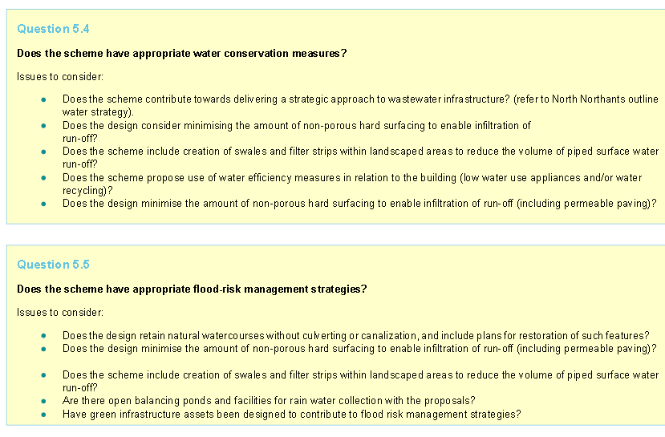

3. Evidence Base

This topic is very well served in terms of an evidence base. There are a number of detailed studies which have assessed water management and flooding at the regional, sub-regional and local level. These studies, and specifically their implications for the SSLDD are summarised below.

North Northants Detailed Water Cycle Strategy
The North Northants Detailed Water Cycle Strategy (WCS) is a very detailed technical document to identify the water services infrastructure requirements to support the levels of growth identified in the CSS. The document is neatly summarised in the Kettering & Wellingborough Level 1 Strategic Flood Risk Assessment (SFRA) Update and reader should consult this document for the full details. The key findings of the WCS are:
- A Surface Water Management Plan (SWMP) may be necessary for Kettering (as taken forward in the Kettering Town Centre AAP, see below)
- Storage on the Slade Brook upstream of the railway culvert in Kettering should be pursued as the preferred option and a design study should be commissioned to assess in more detail the required volumes and costs of the facility;
- Strategic flood storage may be possible on the Alledge Brook to offset potential development to the east of Kettering.

River Nene Catchment Flood Management Plan
Catchment Flood Management Plans (CFMP) are a high level study at the river basin catchment scale which aim to promote a sustainable approach to managing flood risk within the catchment over the next 100 years. The majority of the Borough falls within the area covered by the River Nene CFMP was published by the Environment Agency in December 2009 with the catchment being sub-divided into sixteen policy units with policy recommendations made for different geographical areas. Figure 1.1, below summarises the findings of the CFMP for Kettering Borough.

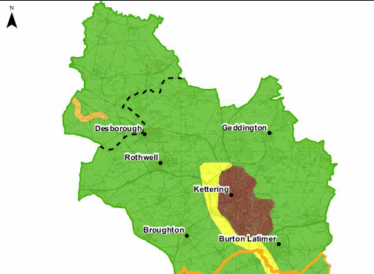

(Reproduced from the Kettering & Wellingborough Level 1 Strategic Flood Risk Assessment (SFRA) Update)

The preferred policy for both the towns of Kettering and Wellingborough is Policy 4: Take further action to sustain flood risk now/and in the future. The preferred policy for the River Ise corridor is Policy 6: Take actions with others to store water or manage runoff in locations that provide overall risk reduction or environmental benefits locally or elsewhere in the catchment. Finally, in the rest of the Nene catchment within Kettering Borough the preferred policy is Policy 2: Reduce current levels of flood risk management.

The River Nene CFMP includes an Action Plan which is to help the Environment Agency and its partners to deliver successfully its preferred policies. This Action Plan is summarised in the Kettering & Wellingborough Level 1 Strategic Flood Risk Assessment (SFRA) Update and reproduced here:

A key finding of the River Nene CFMP is the importance of exploring opportunities for flood storage along the River Nene floodplain in order to prevent an increase of flood risk to the main urban area of Kettering. If upstream flood storage cannot be developed then the report highlights that other measures within urban centres may be necessary to provide the protection needed for development.

River Welland Catchment Flood Management Plan
The remainder of the Borough falls within the area covered by the River Welland CFMP. Within Kettering Borough, the River Jordan corridor falls within Policy 3: Continue with existing or alternative actions to manage flood risk at the current level. The River Welland corridor and the remainder of the Welland sub-catchment fall within Policy 2: Reduce current levels of flood risk management. The Action Plan for the Welland catchment is summarised in the Kettering & Wellingborough Level 1 Strategic Flood Risk Assessment (SFRA) Update and reproduced here:

Kettering & Wellingborough Level 1 Strategic Flood Risk Assessment (SFRA) Update
The SFRA makes the following policy recommendations:
Kettering Town Centre Level 2 Strategic Flood Risk Assessment (SFRA)
A Level 2 SFRA is required by PPS25 to provide additional information on the nature and spread of flood risk across the flood zones to enable a sequential approach to site allocation for development to be adopted within and across flood zones. It will also provide information on the proposed developments and associated flood risk management measures that are required to allow exception tests to be carried out to show that the development will be safe, without increasing flood risk elsewhere and where possible, will reduce flood risk overall.

A Level 2 SFRA was necessary to support the allocations made in the Kettering Town Centre AAP. The key findings of this study mostly relate to the area covered by the AAP but some key findings have wider implications and are therefore of relevance to this SSLDD:

- Kettering Town Centre contains localised areas that are prone to flooding from a range of sources including rivers, sewers and surface water. The dominant source of flood risk is from the Slade Brook which runs through the centre of Kettering.
- The Level 2 SFRA explored the requirements for flood storage at a suitable site upstream of Kettering on the Slade Brook and assessed the impacts this would have on flood risk throughout the town centre.
- Surface water flooding relating to inadequate drainage systems is also a problem in Kettering town centre but this issue is addressed through the AAP (and subsequent planned SWMP and Slade Brook GI Strategy).

The upstream storage reservoir on the Slade Brook was identified as the optimum sustainable flood risk alleviation mechanism for the Slade Brook catchment area and the policy recommendations in relation to this was taken forward in the Kettering Town Centre AAP (see below). A key conclusion of the SFRA was:

The implementation of flood storage upstream of Kettering would provide a 1% AEP (1 in 100), with climate change, flood event standard of flood protection, reducing water levels for adjacent proposed development sites to the present day 1.33% AEP (1 in 75) flood event levels. Kettering Borough Council to prepare/commission a 'feasibility study' for flood risk management to further investigate the implementation of flood storage upstream of Kettering town centre.

The SFRA identifies a site for the reservoir and this will be discussed further in the Options Development section of this document.

The SFRA also made site specific recommendations for sites in the APP and these were addressed through the AAP. As well as the following recommendation which may be of relevance to the SSLDD:

All new development within Kettering must contribute to the reduction of surface water flood risk in the form of an integrated strategic SUDS scheme. Opportunities of joint working with the Environment Agency, The River Nene Wildlife Trust and Anglian Water should be taken to ensure the management of the Slade Brook fits well and integrates with the green corridor, SUDS measures and their benefits for flood risk reduction, water quality, amenity and habitat improvement through the Kettering town centre area. Section 5.3.2 provides more detail.

North Northants Flood Risk Management Strategy.
The North Northamptonshire Flood Risk Management Study aims to create an overall flood risk management strategy within North Northamptonshire by bringing together existing flood risk information for each of the four councils (i.e. Corby, Kettering, Wellingborough and East Northamptonshire). The document informed the updated Level 1 SFRA.

Kettering Town Centre Area Action Plan (AAP)
Whilst matters relating to flooding and water management for the Kettering town centre are adequately covered by the AAP itself, the policy framework bears summarising here due to its relevance to the Slade Brook catchment area and association with potential strategic storage solutions on this watercourse.

The AAP notes the need for strategic flood solutions in the Slade Brook corridor in order to make some allocated development sites partially within Flood Zones 2 and 3a safe for development. It highlights the SFRA’s identification of a potential solution to fluvial flood risk in the form of a strategic upstream flood storage reservoir upstream of the railway culvert on the Slade Brook. The reservoir being shown to:
- Provide fluvial flood protection for a 1 in 100 year (with climate change) Annual Event Probability flood event to areas falling within Flood Zones 2 and 3a in the AAP Plan Area;
- Facilitate the safe development of allocated development sites in Flood Zones 2 and 3a; and
- Provide enhanced protection to the whole area of Kettering currently at risk of flooding from the Slade Brook.

The AAP seeks contributions from development in the AAP Plan Area towards the delivery of strategic and site level measures to address flood management.

The plan also acts upon the SFRA recommendation in relation to the production of a Surface Water Management Plan (SWMP) by making provision for the SWMP to be produced for the AAP Plan Area, to assess flood risk from sewer systems and surface water considering additional pressure from future new developments and from climate change. Prior to the production of the SWMP development of sites in the AAP Plan Area will be phased sequentially with those at lowest risk of surface water flooding being developed first.

The AAP also sets out how a Green Infrastructure Strategy will be prepared to address Green Infrastructure (GI) and river and surface water flooding management along the Slade Brook corridor. Opportunities will be identified to deal with GI and flood risk holistically and to use green spaces multi-functionally, for example through river channel re-naturalisation and Sustainable Drainage Systems (SUDS) measures which can also deliver amenity and habitat improvements. The AAP goes on to provide guidance on SUDS which are required wherever possible in the AAP plan area.

4. Consultation Comments

The following comments in relation to water and flooding were submitted during the Issues Paper consultation stage of the SSLDD. Column 2 presents the responses made by Officers to the consultation feedback during the consultation stage, supplemented, where necessary, by additional Officer notes which describe the policy direction taken. An officer response of “noted” means that the representation has been given due consideration in the formulation of the options presented in this paper.

Issues Paper comments | Officer response & notes
Environment Agency (EA):
Flood Risk  It is disappointing that little reference is made to flood risk within this document though is does identify and acknowledge flooding as a constraint for development. In accordance with Planning Policy Statement 25: Development and Flood Risk (PPS25), development should be steered away from areas at risk in flooding. | Issues paper Officer response: Noted
Green Infrastructure can be integrated with flood risk management strategies. We therefore request that the LDD includes reference to flood risk management strategies. This will encourage the incorporation of SUDS in open spaces and contribute towards strategic surface water management. | Issues paper Officer response: Noted
Biodiversity should be protected and enhanced to contribute to a high quality natural environment both now and in the future. Green Infrastructure and open spaces should be planned for strategically to allow wildlife to migrate and adapt whilst also protecting essential habitats. Links should be made with the North Northants detailed water cycle study and the RNRP green infrastructure suite (http://www.rnrpenvironmentalcharacter.org.uk/) to help deliver strategically planned green infrastructure. | Issues paper Officer response: Noted
The Document should refer to the River Nene Regional Park's (RNRP) Green Infrastructure Strategy. The Strategy was launched by the RNRP in November 2006. An objective of the Strategy is to 'increase opportunities for access, leisure and recreation' and looking to create 'opportunities for linking communities to multi-functional green spaces'. The RNRP Green Infrastructure Strategy states additional benefits can be gained by configuring schemes to 'allow grey water recycling and sustainable flood water defences'. | Issues paper Officer response: Noted
With reference to PPS1 Planning and Climate Change Supplement pages 14 – 15, the LDD should select employment sites and buildings that promote sustainable development and which are able to adapt to the impacts of climate change. In order to reduce the vulnerability of developments to climate change, the LDD should aim to reduce the need to travel, use natural resources wisely, adopt surface water management plans and promote onsite low carbon energy generation. | Issues paper Officer response: CSS policy 14 and the Sustainable Design SPD both deal with issues relating to energy efficiency and climate change. This LDD does not seek to repeat issues which have been covered by other elements of the LDF.
Gypsy and traveller accommodation  Planning Policy Statement 25: Development and Flood Risk (PPS25) classifies development types according to their vulnerability to flood risk and gives guidance on which developments are appropriate in each Flood Zone.  Site proposing caravans, mobile homes and park homes intended for permanent residential use are classed a highly vulnerable in accordance with Table D.2 of PPS25. Tables D.1 and D.3 of PPS25 make clear that this type of development is not compatible and should not therefore be permitted within Flood Zone 3. Please be informed that due to the reasons above, the Environment Agency would be minded to object in principle to site proposing caravans, mobile homes and park homes intended for permanent residential use (i.e. gypsy and traveller accommodation). | Issues paper Officer response: Noted. CSS Policy 17 outlines criteria to follow in choosing sites for gypsy and travellers. One of the criteria is to avoid sites which are environmentally sensitive i.e. at risk of flood. Notwithstanding this consideration will be given to explicitly referencing the issue of flood risk in relation to this policy in the next iteration of the plan and consideration of flood risk will be uppermost in decisions relating to any subsequent allocation of land for Gypsy and Traveller accommodation.  Officer notes: This point will be addressed in the Policy covering Gypsy and traveller accommodation, which will be informed by the evidence base related to flooding especially the identification of Flood Zones in the SFRAs. This Policy will be made in conjunction with the development of the policy direction covering flooding to ensure the 2 are consistent.
Water efficiency  Houses should be built to the highest environmental standard possible and should aim to achieve zero carbon emissions. The LDD should set the standard in promoting and achieving resource efficiency within Northamptonshire. Water efficiency measures should be promoted on all proposed development, with metering encouraged on all new and existing buildings. In compliance with the RSS8 Environmental Strategy, ‘future developments in East Midlands should recognise the limited availability of water and incorporate efficiency measures and SUDS at the planning stage’. In addition to this, the LDD should promote the Code for Sustainable Homes as best practise with both developers and LPA acknowledging and anticipating the challenges to be faced in delivering the Code (Managing Growth-Revised East Midlands Regional Housing Strategy 2008-2016). Working partnerships between developers, LPA, builders and utility companies will be the most effective way of achieving the standards of the Code. | Issues paper Officer response: Noted. Issues relating to resource efficiency are well covered in other LDDs like the CSS and Sustainable Design SPD, however consideration will be given to explicitly referencing these requirements or supplementing them in the next stage of the Site Specific LDD.
In accordance to the MKSM Sub-Regional Strategy Paragraphs (53-55), environmental infrastructure should be strategically planned for with development sites allocated based on adequate and timely infrastructure provision. The document needs to be informed by the North Northants Water Cycle Strategy to ensure environmental capacity is not compromised when allocating development sites. | Issues paper Officer response: Noted. Considerations of environmental infrastructure will be assimilated into the formation of the next stage of the plan, including accordance with the North Northants Water Cycle Strategy (when published).
Buccleuch Property / Boughton Estate (Ms Liberty Stones):  As referred to in paragraph 8.2.4 of the Site Specific Proposals LDD, Policy 14 of the Core Spatial Strategy sets out energy and sustainable construction targets which include the provision of on-site renewable energy, waste reduction, water efficiency, recycling and the incorporation of energy efficient techniques. More detail on these measures is also provided for in the recently adopted Sustainable  Design SPD. It is therefore considered that there is no need for this LDD to address any other issues relating to Climate Change. | Issues paper Officer response: Thank you for your comments which have been duly noted.
Desborough Town Council (Mrs Leigh Parkin):  Preference should be given for technology providing 24/7/365 power and combined heat and power systems. We are close to the low lying areas of east Anglia, the source of much foodstuff, Tide/Wave/Windpower solutions should be supported which also provide flood and soil erosion protection. Particularly critical as a sea level rise of up to 1m is being predicted, this would prove calamitous to our region. New reservoirs may be needed to store water for the new developments these to be designed wherever possible to be ‘pumped storage systems’ enabling power generation to be undertaken. Encouraging use of heat pumps and solar heating as part of new housing criteria would be a positive benefit. | Issues paper Officer response: Noted
EA comments on Sustainability Appraisal (SA) Scoping Report:
Table 3: Sustainability Appraisal Matrix  It's difficult to see how there is no relationship between 'Water Conservation and Management' and both 'Safe, attractive, healthy and sustainable environment' and also 'Natural environment'. Good water quality and resource are intrinsically linked to these themes, in terms of supporting ecosystems and maintaining environmental regimes. We would class them as compatible. | Issues paper Officer response: Noted
Water  Reference should be made to the relevant Catchment Abstraction Management Strategy (CAMS). These set out how the Environment Agency will manage existing abstraction licences and the availability of water for further abstraction.  Reference should be made to wastewater infrastructure including sewerage collection network and treatment facilities. This is to help protecting water quality and is in line with the East Midlands Sustainable Development Framework 2008, which includes the environmental objective ‘To enhance and conserve the environmental quality of the region by increasing the environmental infrastructure’ | Issues paper Officer response: Noted
Flooding and Surface Water  Paragraph D5 of PPS25 requires decision-makers to steer new development to areas at the lowest probability of flooding by applying a ‘Sequential Test’. The aim of the Sequential Test is to steer new development to area at the lowest probability of flooding; Flood Zone 1 (see PPS25 paragraphs 16, 17 and D1 - D8).  The Sustainability Appraisal refers to the Planning Policy and Guidance Note 25 (PPG25) standard SFRA for the Kettering administrative area. This SFRA is yet to be updated to Planning Policy Statement 25 (PPS25) standard and as such does not incorporate the latest information on flood risk from fluvial and non-fluvial sources in the catchment area. It is recommended that Kettering Borough Council revise their SFRA to PPS25 standards to form a key planning reference document and assist the application of the Sequential Test. | Issues paper Officer response: Noted  Officer notes: The updated SFRA completed in 2011 is PPS25 compliant and is a key part of the evidence base.
SUDs  Paragraph 3.91 states that “developments have the potential to explore opportunities to minimise surface water runoff through the installation of Sustainable Drainage Systems”. Support for the SUDS approach to managing surface water runoff is set out in paragraph 22 of Planning Policy Statement 1 (PPS): Delivering Sustainable Development and in more detail in Planning Policy Statement 25: Development and Flood Risk at Annex F. Paragraph F8 of the Annex notes that "Local Planning Authorities should ensure that their policies and decisions on applications support and complement Building Regulations on sustainable rainwater drainage". | Issues paper Officer response: Noted
Surface water  One key issues of this chapter is the “need to minimise surface water runoff and reduce risk from flooding”. A Flood Risk Assessment should be undertaken and submitted for proposed developments within Flood Zone 3 and/or 2 or if the site area is over one hectare. These FRAs should be undertaken and comply with the requirements set out in Annex E, paragraph E3 of PPS25. | Issues paper Officer response: Noted – covered by PPS25
Groundwater  Little consideration has been given to groundwater. The geology of the area is dominated by Northampton Sands Formation outcropping in areas from the Whitby Mudstone. The Northampton Sands may have been locally quarried out in places, but the remainder is a Minor Aquifer as classified under the Environment Agency's 'Policy and Practice for the Protection of Groundwater'. This means that it is locally important for both water supplies and for providing baseflow to rivers. There are also some outcrops of Wellingborough and Blisworth Limestone Formations to the east of the area, which form aquifers. This classification needs to be considered and controlled waters need to be protected from risk of pollution during development of the area. | Issues paper Officer response: Noted
Foul water  Sewage is one of the most common sources of pollution. The Site Specific Proposals LDD should be informed by the detailed North Northants Water Cycle Strategy regarding water and sewer capacity. With reference to MKSM SRS Policy 3, proposed development should ‘involve promoting the highest level of environmental performance, not only in the design of new buildings but also in masterplanning and managing development’. Adequate and timely environmental infrastructure provision is essential if new houses are to be built within the environment’s capacity to cope with the additional impacts.  Anglian Water Services Ltd. should be consulted and be requested to demonstrate that the sewerage and sewage disposal systems serving the development will have sufficient capacity to accommodate the additional flows, generated as a result of the development, without causing pollution or flooding. | Issues paper Officer response: Noted
General comments:
Several representations were made which covered issues of flood risk in relation to individual sites put forward for assessment for development, including:  - Redrow Homes Ltd - land to the west of Polwell Lane Barton Seagrave;  - Brian Barber Associates - Hog’s Hollow, Burton Latimer;  - Land to the east of Nos. 1 & 3 St. Botolphs Road and to the south of Barton Road, Barton Seagrave;  - Executors of Sherwin - Land to the east of New Road and south of the meadows, Geddington; | Issues paper Officer response: Your comments have been noted. All sites put forward during the consultation process will be considered as the emerging Site Specific Proposals Document is developed.  Officer notes: Issues of flood risk affecting individual sites will be considered as part of detailed site assessments made as part of the options development for policies dealing with allocations of development. These assessments will be made in conjunction with the development of the policy direction covering flooding to ensure the 2 are consistent.

Parish & Town Council Meetings - comments relating to flooding
No specific issues relating to flooding were made during consultations with the Parish and Town Councils.

5. Options Development & Sustainability Appraisal of Options

Analysis of the above context has identified effectively 2 options in relation to this issue, which are discussed in turn:

Option a) - To include a policy addressing flood risk and sustainable water management for the Borough

This policy would take forward the recommendations of the extensive evidence base, outlined in section 3, into LDF policy. The policy would supplement the national guidance contained in PPS25 with detail specific to the Borough’s river catchments. The policy would entail:
- Ensure new development is located in the areas identified in the SFRA as least vulnerable to flooding. This could be achieved by showing the identified Flood Zones on a Proposals Map(s) or similar and referencing in Policy. Repetition of PPS25 requirements for uses and Flood Zones would not be necessary.
- Allocate a site for a strategic storage reservoir upstream on the Slade Brook – to be discussed below.
- Provide locally specific requirements and guidance for Sustainable Drainage Systems (SUDS) – to be discussed below.
- Identify opportunities to reduce flood risk and improve the water environment, including opportunities to simultaneously improve Green Infrastructure and biodiversity. This could include identifying any high risk areas or areas for special actions, identified in the evidence base.

Flood Risk
The Policy would be an ideal mechanism to take forward the necessary strategic flood solutions in the Slade Brook corridor. It provides a chance to allocate a site for the optimum identified solution to fluvial flood risk - a strategic upstream flood storage reservoir. The reservoir is shown to:
- Provide enhanced protection to the whole area of Kettering currently at risk of flooding from the Slade Brook.
- Provide fluvial flood protection for a 1 in 100 year (with climate change) Annual Event Probability flood event to areas falling within Flood Zones 2 and 3a in the AAP Plan Area;
- Facilitate the safe development of allocated AAP development sites in Flood Zones 2 and 3a; and

The Level 2 SFRA assess the potential sites for flood storage reservoirs on the Slade Brook upstream of the proposed development sites in Kettering a simple screening exercise was conducted considering key aspects such as geology and by using LiDAR topography. This process identified the most suitable location as being a site upstream of the railway embankment which is downstream of the town of Rothwell and upstream of Kettering. This location has the most space available for flood storage and would be able to attenuate flows from a significant proportion of the catchment. The main limitations to flood storage in this location are the electricity pylons that cross the valley adjacent to the railway. The SFRA concludes that a reservoir on this site is both technically and financially feasible to provide the significant levels of flood protection outlined above. The location of this site is shown in Figures 1.1 and 1.2, below.
Figure 1.1: Potential flood storage reservoir location

Figure 1.2: Potential flood storage reservoir location in relation to Kettering

Surface Water Management and Sustainable Drainage Systems
Issues of surface water, SUDS and a requirement for a Surface Water Management Plan for Kettering town centre are covered within the Kettering Town Centre AAP. This policy option considers a policy which would complement this policy and cover the rest of the Borough.

In the context of climate change, wetter winters and the increased incidence of intense rainfall events will increase pressure on drainage systems and increase the risk of flooding and pollution of watercourses from storm water runoff. Environment Agency and SFRA mapping shows significant areas of the Borough are potentially at risk of surface water flooding, as shown below.

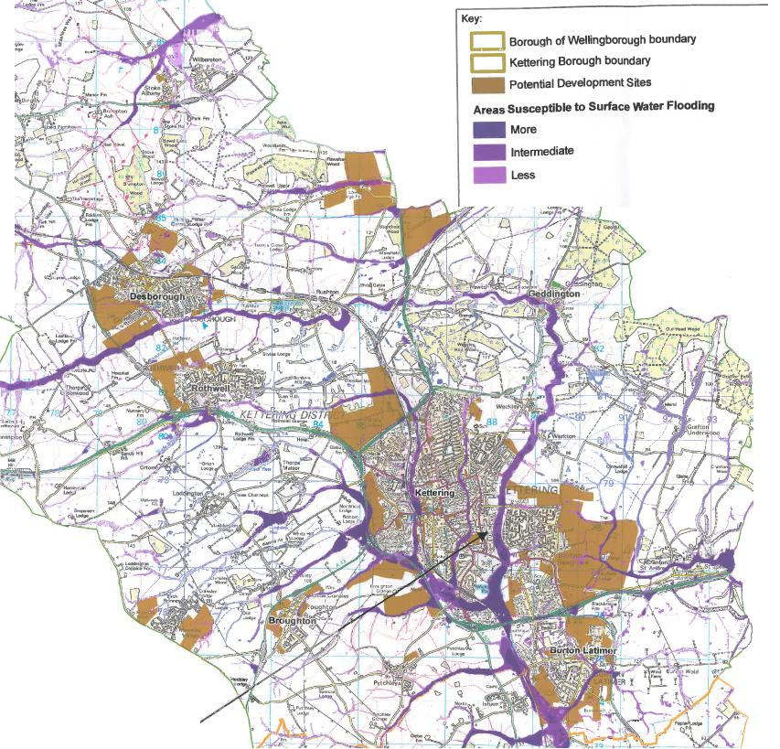
Figure 1.3: Areas susceptible to surface water flooding – Kettering Borough

Figure 1.4: Areas susceptible to surface water flooding – Kettering town centre

Sustainable Drainage Systems (SUDS) can be an important tool in minimising flood risk by increasing permeable surfaces in an area which allows water to seep into the ground rather than running off into the drainage system and can reduce the impact of diffuse pollution from runoff and flooding. SUDS can be used multi-functionally as part of a development’s recreation, Green Infrastructure and biodiversity provision and can form design features enhancing the quality and aesthetics of the public realm. Water storage areas may provide permanent water features as well as provision for excess water in times of heavy rainfall. SUDS can enhance biodiversity by providing wetland habitats and reed beds which will also help to improve the water quality from surface water runoff.
SUDS measures can include:
- Permeable and porous surfacing of minor roads, parking areas and pavements;
- Green roofs;
- Filter strips/filter drains;
- Infiltration basins/trenches;
- Two stage open drains in green corridors, which would serve as a public amenity space and provide a balancing function during storms;
- A series of linked wetland features, detention basins, retention ponds, and reed beds in the public open space parts of the sites; and
- Swales or soakaways for temporary storage of flood runoff.
A local policy on SUDS could supplement the generic encouragement of the use of SUDS provided in the CSS. This could include guidance on where SUDS should be used, perhaps setting criteria for certain sized developments or development in certain geographical or high risk areas, e.g. the Slade Brook or River Ise valleys. This would provide the advantages of a consistency of approach across the district and afford the issue more certainty than national and CSS ‘encouragement’.

Summary of Sustainability Appraisal
The advantages of this approach, as assessed in the Sustainability Appraisal (SA), are summarised against the relevant SA topic below against which positive impacts are noted:
- Housing – Policy will ensure new housing is located in areas least vulnerable to flooding and use of SUDS reduce the risk of surface water flooding.
- Liveability - Multi-functional SUDS can enhance liveability. In the medium-long term a strategic flood storage reservoir would improve liveability for areas downstream on the Slade Brook corridor by preventing flooding.
- Biodiversity – SUDS, and in the medium-long term reservoir creation would present opportunity for habitat creation which could boost biodiversity.
- Climate change – Sustainable water management, including reservoir implementation, would mitigate the impacts of climate change in terms of increased flood risk from predicted intense and extreme weather events.
- Water quality - Betterment opportunities and sustainable flood water storage prevents inundation of sewers and drains, and thereby pollution, and potentially allows for natural pollution control such as reed beds to be incorporated.
- Water Conservation and Management - Sustainable water management is at the heart of the policy.
- Natural hazard - Policy would substantially reduce the risk from the natural hazard of flooding through development in the least vulnerable places, the development of strategic flood solution(s) and increased use of SUDS.
- Town centres – Strategic flood management measures in the Slade Brook corridor would have a significant positive impact on Kettering town centre, enabling some allocated development sites in the Kettering Town Centre to be safely developed without risk of flooding, aiding its regeneration.

The disadvantages, as assessed in the SA, are summarised against the relevant SA topic below:
- Soil and land – Storage of flood water, including a reservoir would inevitably involve the use of land. This could be mitigated through using space multi-functionally.
- Landscape - an uncertain impact is noted here in that a reservoir could improve the landscape or detract from it depending on its scale, design and scale of hard engineering, i.e. damming. However, negative landscape impacts could be mitigated through policy stipulation for the design of the scheme and for screening of any necessary infrastructure such as a dam.

A further risk with this policy direction is that it could repeat national policy, in that PPS25 already states that development must be located in zone at lowest risk of flooding and outlines requirements for FRAs. The policy would have to be considered carefully to focus on the aspects which would add the most value – for example allocating a flood storage reservoir, setting specific guidance for SUDS etc., rather than reiterating national policy.

Option b) – To not include a policy addressing flood risk and sustainable water management at the district level and instead rely on national guidance and the CSS.

Not including a detailed policy in this document on overall flood risk would mean applications would have to refer to PPS25 and practice guidance, the limited guidance in the CSS and supporting guidance. It would also mean the policy recommendations of the SFRAs, CFMP and WCS would not be taken forward into our LDF.

Summary of Sustainability Appraisal
No positive impacts were assessed in the Sustainability Appraisal (SA). However, the ‘do nothing’ option would avoid the risk of repeating national policy.

The disadvantages, as assessed in the SA, are summarised against the relevant SA topic below:
- Climate change - Failing to implement the findings from the Level 2 PPS25 complaint SFRA which assessed likely impacts of climate change would mean the Borough is mitigated not against the impacts of climate change in terms of increased flood risk from predicted intense and extreme weather events ;
- Water quality, water conservation and management – Failure to implement sustainable, strategic flood risk management and to ensure development is located in the least vulnerable places, could increase the instance of flooding from flash runoff which increases the risk of pollution ;
- Natural hazard and Town centres - Failure to encourage SUDS and implement the reservoir would miss the opportunity for the identified optimum strategic solution to flood risk in the Slade Brook corridor and would mean that any new development which runoff into the Slade Brook catchment would increase the risk of flooding downstream. Some sites in Kettering town centre would therefore need to investigate alternative measures for flood mitigation.
- Additionally, potential negative impacts were noted against Housing and Liveability through failing to ensure new housing is located in areas least vulnerable to flooding and not preventing future incidents of flooding through SUDS and strategic storage in the Slade Brook corridor. Some impacts are uncertain as it could be argued that this would not worsen the current status quo.

Other options considered

A third option was considered, somewhere in between the above 2 options. This would set out some generic guidance on surface water management and SUDS to supplement national guidance but stop shirt of locally specific measures such as criteria. It was considered, however, that this option would represent the worst of both worlds in that it would not add much value to guidance already out there, and no locally specific detail, certainty or consistency of approach and risk repeating national policy.

6. Conclusions
The SA process indicates that the option a) to include a policy on flood risk performs best in terms of sustainability, with numerous positive impacts against only 1 negative impact and an uncertain one. Option b) performed less well and the SA process indicates that not including a policy on flood risk would miss opportunities to sustainably manage flood risk with numerous associated benefits. In particular, the implementation of the reservoir would delivery significant sustainability advantages. This option is therefore taken forward as the preferred option to be consulted upon.

