Site Specific Proposals
Local Development Document

Background Paper: Gypsy and Traveller Site Allocations

November 2011

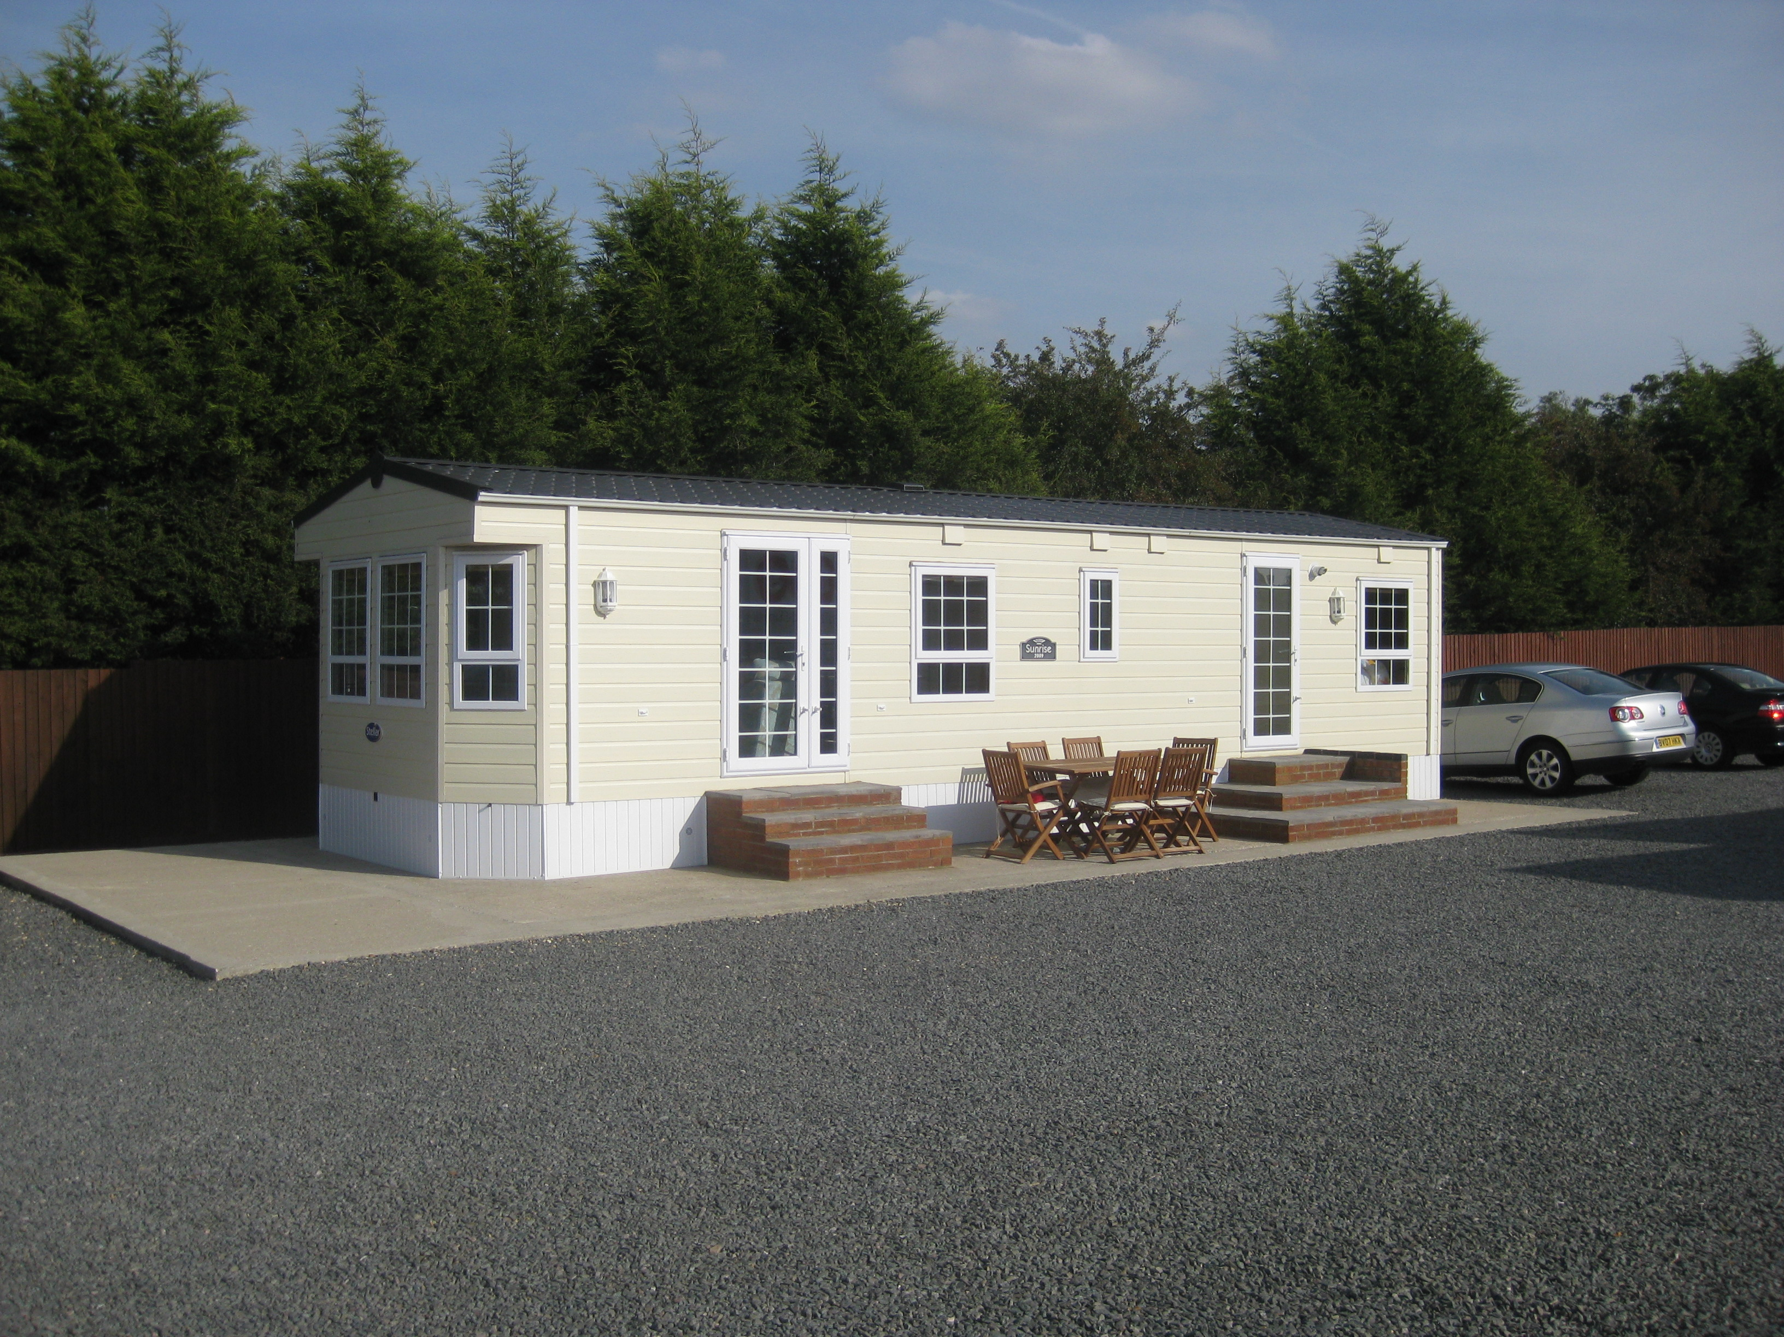

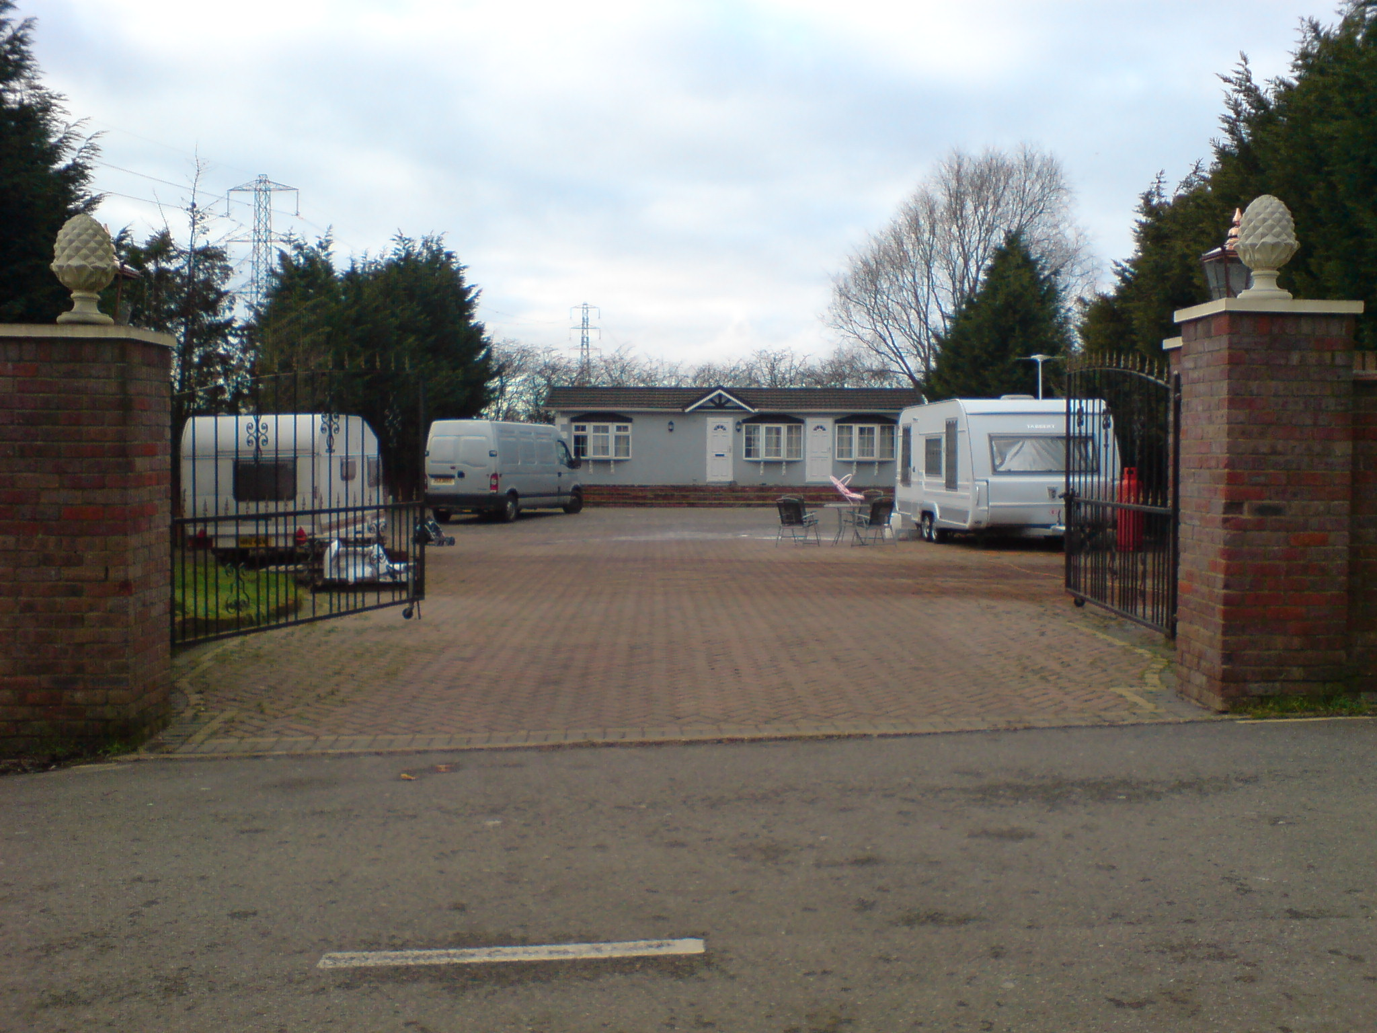



Contents | Page No.
1.0 Background | 2
Part I: Policy Context/Legislative Framework for Gypsy and Travellers  - National Policy  - Regional Policy  - Core Spatial Strategy  - Development Plan Documents | 3  4  4  5
Part II: Meeting Gypsy and traveller Accommodation Needs in Kettering Borough  - Current Pitch Provision  - Identified Need for Travellers in Kettering Borough | 6  6
Part III: Approach to site selection and Policy Direction  - Site Selection Methodology  - Stage 1 – Identification of potential sites  - Stage 2 – Assessment of sites | 8  8  10
Appendix 1 - List of traveller sites in Kettering Borough | 18

1.0 BACKGROUND

ODPM circular 01/2006 defines Gypsy and travellers as persons of nomadic habit of life whatever their race or origin, including such persons who on grounds only of their own or their family’s or dependants’ educational or health needs or old age have ceased to travel temporarily or permanently, but excluding members of an organised group of travelling show people or circus people travelling together as such.

PPS3 advocates for the need to provide a mix of housing including the need to accommodate Gypsys and Travellers. This approach is consistent with the Housing Act 2004 which requires Local Planning authorities to take account of accommodation needs of gypsies and travellers in the same way as they do for the settled community.

Local authorities in England and Wales have statutory duties in respect of homelessness under Part VII of the Housing Act, 1996 and in fulfilment of their obligation under the Race Relations Act 2000(As amended). Councils have a general duty to seek to eliminate unlawful discrimination and to promote equality of opportunity and good race relations

Under Article 8 of the European Convention on Human Right, there is an obligation by member states to facilitate the Gypsy way of life. This requires the identification of their housing needs and the allocation of sites to meet it.

As part of the Coalition Government’s effort at providing affordable housing and promoting inclusive communities the government has adopted a new definition for Affordable Housing to include the definition contained within PPS3 as well as pitches for Gypsy and Travellers owned and managed by local authorities. The government is also consulting on bringing the policy framework for Travellers in line with mainstream housing.

In view of the aforementioned background, Kettering Borough Council is committed to planning for and meeting the housing needs of Gypsys and Travellers within the Borough through a Site Specific Proposals LDD as part of the Local Development Framework (LDF) .The LDF is a suite of documents forming the Planning Policy framework for making development decisions.

This paper seeks to achieve three main objectives. Firstly, the paper provides an overview on the legislative and planning policy framework for allocating sites for Gypsys and Travellers. The paper then discusses Gypsy and Traveller accommodation need in the Borough. Finally the paper sets out a methodology for identifying and assessing potential Gypsy and Traveller sites.

This paper will inform the preparation of the options consultation on Gypsy and Traveller Site allocations policy as part of the Site Specific Proposals LDD.

PART I: LEGISLATIVE AND POLICY FRAMEWORK

2.1 National Policy Framework for Gypsy and Travellers

Current national planning policy and guidance for Gypsys and Travellers is set out in Circular 01/2006 and 04/2007. Circular 01/2006 covers policies for ‘Gypsy and Traveller’ sites. Circular 04/2007 covers policies for travelling showpeople. The Government are committed to reforming the planning system. Through this reform the Government intends to return power to local communities to help them shape development and have shorter and fewer statements of planning policy.

In April 2011 the Government published a consultation document ‘Planning for traveller sites’. The Government’s intention is to replace circulars 01/2006: Planning for Gypsy and Traveller Caravan Sites and 04/2007: Planning for Travelling Showpeople with a single Planning Policy Statement (PPS) for traveller sites. The intention is that the policy contained in this PPS will eventually be incorporated into the National Planning Policy Framework (NPPF).

The policies in the ‘Planning for traveller sites’ consultation document are part of a broader range of policy initiatives in relation to traveller communities that have been announced. The Government’s key policy commitments are to:

- Include traveller sites in the New Homes Bonus scheme, to incentivise local planning authorities to provide appropriate sites.
- resume traveller site grant funding from April 2011
- set up a cross-Government, ministerial-level working group to address the discrimination and poor social outcomes experienced by traveller communities
- bring local authority traveller sites into the Mobile Homes Act (1983) to give residents improved protection against eviction•
- contribute funding to Local Government Improvement and Development to support their programme of work with elected members on traveller site provision
- limit the opportunities for retrospective planning applications, in relation to any form of development
- provide stronger enforcement powers for local planning authorities to tackle breaches of planning control: and
- abolish undemocratic regional strategies and the top-down housing and traveller pitch targets they contain.

The new policy proposed in the ‘Planning for traveller sites’ consultation document aims to:
  - enable local planning authorities to make their own assessment of need for the purposes of planning
  - enable local planning authorities to use their assessment of need to set their own targets for pitch/ plot provision
  - encourage local planning authorities to plan for sites over a reasonable timescale
  - protect Green Belt from development
  - ensure that local planning authorities, working collaboratively, develop fair and effective strategies to meet need through the identification of land for sites
  - promote more private traveller site provision while recognising that there will always be those travellers who cannot provide their own sites
  - reduce the number of unauthorised developments and encampments and make enforcement more effective if local planning authorities have had regard to this policy
  - ensure that the development plan includes fair, realistic and inclusive policies
  - increase the number of traveller sites, in appropriate locations with planning permission, to address under provision and maintain an appropriate level of supply
  - reduce tensions between settled and traveller communities in plan making and planning decisions
  - enable provision of suitable accommodation from which travellers can access education, welfare and employment infrastructure

The consultation document proposes to introduce a requirement for local planning authorities to maintain a five-year supply of traveller pitches/ plots. If a local authority has not planned for a five-year supply of traveller pitches/ plots the draft policy asks them to ‘treat favourably’ applications for temporary permission.

2.2 Regional Spatial Strategies (RSSs)

Under the current planning system, assessments of accommodation needs for Gypsy and Travellers are fed into the regional planning process and regional bodies set out pitch/ plot targets for each local authority.

The Government has stated its intention to abolish regional planning through the introduction of the Localism Bill which is currently going through Parliament. Once this Bill is passed and made law the need identified through Gypsy and Traveller Accommodation Assessments (GTAAs) will be used to directly inform the preparation of DPD’s. However until this Bill is passed RSSs remain part of the development plan.

Policy 16 of the East Midland Regional Plan (RSS8) includes a regional priority for provision for Gypsy, Travellers and Travelling show people. The policy requires local planning authorities and other relevant public bodies to identify land for additional pitch provision based on clearly evidenced assessment of land working together across administrative boundaries where appropriate.

Policy 16 of the RSS8 goes further to provide minimum targets for additional pitches to be provided for within the various districts within the region. For Kettering Borough, a minimum of 2 pitches was allocated until 2012. Beyond 2012, the plan calls for GTAAs to be regularly updated and allocation made in response to future needs.

2.3 Core Spatial Strategy (CSS)

The North Northamptonshire Core Spatial Strategy was adopted in June, 2008. Policy 17 of the CSS states that, where a need is identified for additional accommodation for Gypsies, Travellers or Travelling Show People, planning permission may be granted, or site allocated when all the following criteria are met:

- The site should be in accordance with locational guidance set out in Policy 9 (Local and Distribution of Development) and it should also meet the criteria set out in Policy 13( General Sustainable Development Principles)
- It should not be within an area designated as environmentally sensitive
- It is closely linked to an existing settlement within an adequate range of services and facilities in order to maximise the possibilities for social inclusion and sustainable patterns of living

2.4 Development Plan Documents (DPDs)

The Site Specific Proposals Local Development Document (LDD) for Kettering Borough is an emerging document which will allocate suitable and sustainable sites within the Borough to meet the need of Gypsies and Travellers. This document is scheduled to be adopted in April, 2013. Details of policy options and site selection criteria will be discussed in part III of this paper.

The chart below shows the current policy framework for addressing the accommodation needs of Gypsies and Travellers within Kettering Borough.

Fig1: Policy Situation in Kettering Borough
Northamptonshire Gypsy and Traveller Accommodation Assessment (GTAA) adopted in May, 2008 projected need for 18 pitches until 2017

East Midlands Regional Plan set a minimum target of 2 pitches (+ 3 transit pitches) for KBC until 2012. GTAAs should be reviewed to inform LDFs beyond 2012
Joint Core Spatial Strategy Policy 17 sets criteria for assessing unallocated sites and guides allocations

Kettering Borough Site Specific LDD to allocate sites by spring 2013 to meet identified need
North Northamptonshire Gypsy and Traveller Accommodation Assessment Oct 2011 Update projects need for 3 pitches to 2017 and 10 pitches 2017-22

PART II: MEETING GYPSY AND TRAVELLER ACCOMMODATION NEEDS IN KETTERING BOROUGH

3.1 Current Pitch provision

Table 1 provides a breakdown of the number of sites within the Borough by tenure. There are currently 61 occupied pitches within the Borough. Out of the 55 authorised pitches, 5 pitches have temporary permission. These temporary pitches (constituting 9% of the total authorised pitches) are currently occupied pending the preparation of a Site Specific Proposals LDD to allocate suitable sites at sustainable locations.

Approximately 10% of all the pitches occupied by Gypsy and travellers within the Borough are unauthorised. For the purposes of clarification, unauthorised encampment refers to sites on land not owned by the Travellers, whereas unauthorised developments are on land that is owned by the occupants or with the owner’s permission. Details of site addresses and tenures can be seen as appendix 1.

Table 1 - Current Occupied Pitches (Sept, 2011)
Authorised Pitches |  |  | Unauthorised Pitches
Private Permanent | Private Temporary | Public Permanent | Encampment | Development
35 | 5 | 15 | 1 | 5
55 |  |  | 6

3.2 Identified Need for Traveller Accommodation

S.225 of the Housing act, 2004 requires Local authorities to carry out an assessment of the accommodation needs of Gypsy and Travellers as part of the review of housing needs within their districts.

In May, 2008 a Northamptonshire Gypsy and Traveller Accommodation Needs Assessment (GTAA) was adopted by Kettering Borough Council. In October 2011 an update to this assessment was completed for North Northamptonshire looking at the period 2012 to 2022. The main findings and recommendations of the North Northamptonshire Gypsy and Traveller Accommodation Assessment (GTAA) Update 2011 are as follows:

Table 2: Total Pitch/ Plot requirement for Kettering Borough:
 | 2012 - 2017 | 2017 – 2022
Residential Pitches | 3* | 10
Transit Pitches | 1 | 0
Travelling Showpeople Plots | 0 | 0
* This figure is the number required if the 7 pitches planned at The Pastures are built.
Source: GTAA, Oct, 2011

As well as quantifying accommodation need, the study also makes recommendations on how provision can be brought forward. The main ones can be summarised as follows:

- Based on the 2008 survey with local Gypsies and Travellers, the preferred size for permanent/residential sites is 11 – 15 pitches, which tend to have fewer inter-family tensions and are therefore easier to manage. The stakeholder meeting undertaken as part of the 2011 GTAA update confirmed this fact.
- A mix of public and private sites will be required dependent on need. Specific sites available should be outlined in future DPDs and guidance offered on the type of land that is likely to obtain planning permission as well as land that is unlikely to. Specific advice on the planning process should also be offered.
- Such an approach would also assist Travelling Showpeople, for whom the shortage of accommodation is derived from difficulties obtaining planning permission for new land or extensions on existing yards.
- While the GTAA needs calculations suggest a requirement for a network of transit pitches and/or emergency stopping places in North Northamptonshire to further reduce the number of unauthorised encampments, the priority should be in bringing forward residential pitches. If transit pitches are provided before the shortfall in residential pitches is met, there is a risk that they will effectively be used as permanent / residential sites with all the ensuing management issues this would incur.
- Local housing authorities should include Gypsy and Irish Traveller categories on ethnic monitoring forms to improve data on population numbers, particularly in housing.
- The population size and demographics of Gypsies and Travellers can change rapidly; their accommodation needs should be reviewed every three to five years.

PART III: APPROACH TO SITE SELECTION AND POLICY DIRECTION

4.1 Site Selection Methodology

This site selection methodology proposes a two stage approach to identifying and assessing potential sites for Gypsy and Traveller Accommodation. The consultation on the Site Specific Proposals LDD – Issues Paper (March 2009) included a call for sites for Gypsy and Traveller accommodation, however no sites were submitted. It is therefore necessary for the first stage of the methodology to address the identification of sites to be considered for Gypsy and Traveller accommodation.

4.2 Stage 1 – Identification of potential sites

The following responses were received to the question regarding provision of Gypsy and Traveller sites in the Site Specific Proposals LDD Issues Paper consultation:

Issues Paper Q28 - Are there sites you think would be suitable for allocation of gypsy and traveller sites?
Respondent | Comments
Environment Agency | Planning Policy Statement 25: Development and Flood Risk (PPS25) classifies development types according to their vulnerability to flood risk and gives guidance on which developments are appropriate in each Flood Zone. Site proposing caravans, mobile homes and park homes intended for permanent residential use are classed a highly vulnerable in accordance with Table D.2 of PPS25. Tables D.1 and D.3 of PPS25 make clear that this type of development is not compatible and should not therefore be permitted within Flood Zone 3. Please be informed that due to the reasons above, the Environment Agency would be minded to object in principle to site proposing caravans, mobile homes and park homes intended for permanent residential use (i.e. gypsy and traveller accommodation).
Rothwell Town council | We suggest that the existing gypsy and traveller sites should be expanded, rather than creating new ones.
Wilbarston Parish Plan | We support the existing situation in Wilbarston Parish.
Government Office of East Midlands | The inclusion of site provision for Gypsies and Travellers is welcomed and supported.
Desborough Town Council | Further traveller sites close to Desborough should not be permitted.
Historic Building Consultancy | As there are already a large number of Travellers pitches in Wilbarston parish, it would be better if pitches were not all concentrated in one parish.

These consultation responses along with a number of stakeholder meetings with the Gypsy and Traveller Steering Group have led to the identification of the following options for identifying sites for Gypsy and Traveller Accommodation.

Option 1 – Identifying additional pitches on existing sites or in close proximity to existing sites (temporary and permanent sites). This will involve identifying spaces within existing sites or land adjacent to existing sites, accessing the possibility of accommodating more pitches, exploring the willingness of landowners to accommodate future travellers and allocating the preferred sites after subjecting candidate sites to the proposed assessment criteria.

Option 2: Provide new sites away from existing ones. This will involve a search for available land with landowners willing to offer land for travellers or publicly owned land suitable for traveller accommodation. These sites will then be assessed based on the assessment criteria and the preferred sites allocated to deliver the identified need

Option 3: Identify the ideal site using a set of search criteria. This involves looking for the ideal sites using a set of suitability and sustainability criteria. Candidate sites (which could be either occupied or Greenfield land) will then be investigated for landownership and the available site selected and allocated within a plan.

Option 4: A combination of the above options: This could involve providing for some of the need within existing sites and also searching for new sites away from existing ones using search criteria.

4.3 Analysis of Options

The tables below show the various options identified and the potential advantages and disadvantages of each of the options:

OPTION 1: Provision of pitches on or in close proximity to existing sites

Advantages | Disadvantages
- Lower risk of land purchase cost or negotiation difficulties  - Socially preferred by travellers to facilitate natural family growth.  - Better ecologically as no encroachment on unused land.  - Principle of development already established  - Settled community may be used to existence of sites | - Potential increased densities on sites resulting in over development of sites.  - Potential pressure on local amenities of nearby settled community due to increased population  - Increased pitches on sites may result in problems with site management.  - Challenges of accommodating mixed ethnicity  - May not be in the most sustainable locations

OPTION 2: Providing new sites away from existing ones

Advantages | Disadvantages
- Will promote even distribution of sites within the Borough  - Prevent high densities and perceived overconcentration of sites  - Possible reduced tension between settled community and Gypsy and Traveller community | - Risk of unavailability of land and unwilling land landowners  - Could go against the natural choice of places for travellers  - Potential delays due to land acquisition difficulties

OPTION3: Identify the ideal sites through a search criteria

Advantages | Disadvantages
- Stronger evidence base for justifying sites location  - Most sustainable sites can be allocated | - Sustainability criteria may not meet the natural choice of places for travellers  - Potential difficulties in accessing land owners resulting in delays in allocating sites.  - Risk of unavailability of land and unwilling land landowners

Option 4: A combination of the other options

Advantages | Disadvantages
- This approach is aimed at minimising the disadvantages of an options in order to maximising its advantages

These options will be consulted on through the Site Specific Proposals LDD – Options consultation. Following this consultation responses received will be considered and an approach for identifying sites agreed. This approach will then be applied to enable potential Gypsy and Traveller sites in the Borough to be identified.

4.3 Stage 2 – Assessment of Sites

Once the potential Gypsy and Traveller sites have been identified these will be assessed using a site assessment sheet. This site assessment sheet has been prepared using the ‘Site Assessment Matrix’ developed by Roger Tym and Partners for East Northamptonshire Council and links the assessment criteria with the relevant Sustainability Appraisal objectives.

The assessment uses a ✓/~/✗ scoring system which will enable the sites to be compared in terms of the number of positive, neutral or negative scores a site achieves. Those sites which receive more ticks will be the preferred sites, however the assessment of sites will need to be qualitative as there may be one negative issue on a site, which otherwise scores well, which would mean the site would not be suitable for development. The qualitative assessment will also consider how easily constraints can be overcome and the impact this would have on the deliverability of sites.

Stage 2 – Site Assessment

Assessment Topic |  | Assessment criteria | Scoring | Method of assessment and Justification
Accessibility
Access to Services | Distance to Primary School | Within 200m | Summary of all 7 factors:  Majority in box 1 = ✓✓  Majority in box 2 = ✓  Majority in box 3 = ~  Majority in box 4 = ✗ | GIS National guidance promotes accessibility of services and facilities and sustainable modes of travel
Access to Services | Distance to Primary School | 200-400m
Access to Services | Distance to Primary School | 400m-800m
Access to Services | Distance to Primary School | More than 800m
Access to Services | Distance to Local Shops | Within 200m |  | GIS National guidance promotes accessibility of services and facilities and sustainable modes of travel. In towns the distance is measured to the nearest neighbourhood centre, in villages it is to the food shop.
Access to Services | Distance to Local Shops | 200-400m
Access to Services | Distance to Local Shops | 400m-800m
Access to Services | Distance to Local Shops | More than 800m
Access to Services | Distance to Playing field/ park/ open space | Within 200m |  | GIS National guidance promotes accessibility of services and facilities and sustainable modes of travel
Access to Services | Distance to Playing field/ park/ open space | 200-400m
Access to Services | Distance to Playing field/ park/ open space | 400-800m
Access to Services | Distance to Playing field/ park/ open space | More than 800m
Access to Services | Distance to Secondary School | Within 500m |  | GIS National guidance promotes accessibility of services and facilities and sustainable modes of travel
Access to Services | Distance to Secondary School | 500-1000m
Access to Services | Distance to Secondary School | 1000-2000m
Access to Services | Distance to Secondary School | More than 2000m
Access to Services | Distance to Health Centre | Within 500m |  | GIS National guidance promotes accessibility of services and facilities and sustainable modes of travel
Access to Services | Distance to Health Centre | 500-1000m
Access to Services | Distance to Health Centre | 1000-2000m
Access to Services | Distance to Health Centre | More than 2000m
Access to Services | Distance to indoor sports/ leisure | Within 500m |  | GIS National guidance promotes accessibility of services and facilities and sustainable modes of travel
Access to Services | Distance to indoor sports/ leisure | 500-1000m
Access to Services | Distance to indoor sports/ leisure | 1000-2000m
Access to Services | Distance to indoor sports/ leisure | More than 2000m
Access to Services | Distance to a town centre | Within 500m |  | GIS National guidance promotes accessibility of services and facilities and sustainable modes of travel
Access to Services | Distance to a town centre | 500-1000m
Access to Services | Distance to a town centre | 1000-2000m
Access to Services | Distance to a town centre | More than 2000m
Pedestrian/ cycle links |  | Site has safe pedestrian or cycle access to the nearest local centre | ✓✓
 |  | Safe pedestrian or cycle access could be provided to the nearest local centre | ~
 |  | Safe pedestrian or cycle access could not be achieved or would be difficult to achieve | ✗✗
Access to employment |  | Within 500m | ✓✓ | GIS (measured to established employment area or town centre)National guidance promotes accessibility to employment and sustainable modes of travel
 |  | 500-1000m | ✓
 |  | 1000-2000m | ~
 |  | More than 2000m | ✗
Access to public transport |  | Within 200m of a route to a main urban centre. | ✓✓ | GIS National guidance promotes accessibility to sustainable modes of travel.
 |  | 200 to 400m of a route to a main urban centre. | ✓
 |  | 400m-800m of a route to a main urban centre | ~
 |  | Greater than 800m to a route to a main urban centre | ✗
Location in terms of settlement hierarchy |  | Located within or adjacent to Kettering | ✓✓ | GIS It is important that new development fits within the strategy set out in the Core Spatial Strategy
 |  | Located within or adjacent to Burton Latimer, Desborough or Rothwell | ✓
 |  | Located within or adjacent to another settlement | ~
 |  | Located in the open countryside | ✗
Health
Impact on existing sporting or recreation facilities |  | Development would not result in the loss of open space, sport or recreational facilities. | ✓✓ | GIS/ site visit National guidance supports the protection of open space and recreation facilities. (PPG17)
 |  | Development would result in the loss of open space, sport or recreation facilities but loss could be mitigated. | ~
 |  | Development would result in the loss of open space, sport or recreation facilities which could not be mitigated. | ✗
Skills
Would the site have an impact on school provisions? |  | Sufficient capacity. | ✓✓ | Consultation with NCC education It is important to consider capacity of schools when considering new development to reduce the need for travel.
 |  | Insufficient capacity but constraint could be overcome. | ~
 |  | Insufficient capacity and constraints cannot be overcome. | ✗
Liveability
Impact of noise or odour (trunk road, railway) |  | Development would not be effected by noise or odour | ✓✓ | Site visit/ Consult environmental health re- appropriate distances National planning policy requires LPA’s to ensure that the impact of noise is taken into account in planning decisions.
 |  | Development is likely to be effected by noise or odour but this could be mitigated | ~
 |  | Development is likely to be significantly effected by noise and odour and impact could not be mitigated | ✗
Would development be compatible with neighbouring uses? |  | Development would be compatible. | ✓✓ | Site visit It is important that new development is compatible with neighbouring uses to ensure conflicts do not arise.
 |  | Development would be compatible with mitigation measures. | ~
 |  | Development would be incompatible. | ✗
Size of site |  | 10 pitches or fewer | ✓✓ | Site visit. The Police favour smaller sites and the GTAA indicated that the G&T community favour sites of 11-15 pitches followed by sites of 6-10 pitches.
 |  | 11-15 pitches | ✓
 |  | More than 15 pitches | ✗
Biodiversity
Impact on a nationally, regional or local site of biodiversity or geological value or affect legally protected species |  | Site would not impact on a nationally, regional or local site of biodiversity or geological value or affect legally protected species. | ✓✓ | GIS/ consultation with Natural England and Wildlife trust National planning policy requires designated wildlife sites to be protected. (PPS9)
 |  | Site would impact on a nationally, regional or local site of biodiversity or geological value or affect legally protected species but could be satisfactorily mitigated. | ~
 |  | Site would impact on a nationally, regional or local biodiversity or geological value or affect a legally protected species and could not be satisfactorily mitigated. | ✗✗
Other ecological features (Including BAP priority habitats and species, trees, woodland etc) |  | Development of the site is likely to enable the retention and enhancement of existing features | ✓✓ | Consultation with English Nature and the Wildlife Trust/ site visit  PPS9 National planning policy required ecological habitats and species to be protected and considered in planning decisions. (PPS9)
 |  | Development of the site would impact on the ecological quality of the site but impact could be mitigated or compensated | ~
 |  | Development of the site would have an unacceptable impact on the ecological quality of the site and impact could not be mitigated or compensated | ✗✗
Landscape
Landscape designation and capacity of landscape to accommodate development |  | Landscape has low sensitivity to development (not visible, existing landscape is poor quality, existing features could be retained) | ✓✓ | National planning guidance recognised the importance of locally important landscape and the need to ensure these are considered when assessing new development.
 |  | Landscape has medium sensitivity to development | ✓
 |  | Landscape has no impact on landscape character (e.g. in built up area) | ~
 |  | Site has medium to high sensitivity to development (Development likely to detract from landscape, existing features unlikely to be retained in entirety) | ✗
 |  | High sensitivity to development (Development would significantly detract from the landscape and important features unlikely to be retained and mitigation not possible) | ✗✗
Cultural Heritage
Heritage and Archaeology (Listed buildings, conservation areas, SAM’s, Historic Parks and Gardens) |  | Development has the potential to enhance the historic or cultural environment | ✓✓ | GIS National policy requires the protection of important historic assets.
 |  | Site unlikely to impact on the historic or cultural environment | ✓
 |  | Development is likely to have a negative impact on the historic environment or cultural but this impact could be mitigated | ~
 |  | Development is likely to have a significant negative impact on the historic or cultural environment | ✗✗
Built Environment
Relationship to existing urban area |  | Within and existing urban area. | ✓✓ | Site visit. National policy strictly controls development in the open countryside
 |  | Adjacent to and existing urban area | ✓
 |  | Detached from an existing urban area. | ✗
Water Conservation and Management
Flood risk zone |  | 25% - 0% of the site is in flood zone 2 or 3 | ✓ | GIS  The assessment is based on guidance given by the Environment Agency to Corby BC during the production of their Site Specific Allocations DPD National guidance requires flood risk to be an important consideration in planning decisions.
 |  | 50% - 26% of the site is in flood zone 2 or 3 | ~
 |  | 75% - 51% of the site is in flood zone 2 or 3 | ✗
 |  | 100% - 76% of the site is in flood zone 2 or 3 | ✗✗
Soil and Land
Agricultural Land |  | Development would not result in the loss of the best and most versatile agricultural land. | ✓ | GIS National guidance gives high protection to the best and most versatile agricultural land
 |  | Partial loss of grade 1 or 2 agricultural land or loss of grade 3 agricultural land. | ~
 |  | Development would result in the loss of the best and most versatile agricultural land (grades 1 and 2) | ✗
Is the site previously developed land? |  | Wholly previously developed. | ✓✓ | GIS/ site visit National guidance promotes the redevelopment of previously developed land in preference to Greenfield sites
 |  | Mixed >75% pdl. | ✓✓
 |  | Mixed 50-75% pdl. | ✓
 |  | Mixed 25-49% pdl. | ✓
 |  | Mixed < 25% pdl. | ~
 |  | Wholly Greenfield. | ✗
Unstable Land/ Land Contamination (Land contamination over and above the naturally occurring contamination found throughout the Borough) |  | Site is not unstable or contaminated land. | ✓✓ | Consultation with environmental health Contamination of land is an important consideration when assessing suitability and deliverability of sites.
 |  | Site is unstable or contaminated land but could be mitigated. | ~
 |  | Site is wholly unstable or contaminated land which could not be mitigated. | ✗✗
Minerals
Is the site located within an area identified for mineral extraction or a mineral safeguarding area |  | Site is not located in an area identified as an existing / permitted minerals / waste site or allocation in the MWDF | ✓✓ | GIS  The minerals and waste development framework identifies and protects areas for minerals extraction and safeguards know reserves for future extraction.
 |  | Site is located in an area identified as an existing / permitted minerals / waste site or allocation in the MWDF | ✗✗
Infrastructure
Access to highway network |  | Satisfactory access can be gained to the site. | ✓✓ | Consultation with NCC Gaining safe access is critical to the suitability of the site for development.
 |  | Satisfactory access cannot be gained to the site. | ✗✗
Capacity of the highway network |  | Sufficient capacity no constraints. | ✓✓ | Consultation with NCC and HA Impact on the highway network is an important consideration when assessing the suitability of sites.
 |  | Capacity limited or insufficient capacity but constraints can be overcome. | ~
 |  | Insufficient capacity and constraints cannot be overcome. | ✗✗
Provision of basic infrastructure |  | Basic infrastructure is available on the site or within reasonable distance of the site to enable practical connection. | ✓✓
 |  | Basic infrastructure is not available within a reasonable distance of the site to enable practical connection | ✗✗
Capacity of existing infrastructure and services (water, sewage, electricity, gas) |  | Sufficient capacity. | ✓✓ | Consultations with Anglican water and utility providers. Ability to service the site is an important consideration when assessing its suitability.
 |  | Capacity limited or insufficient but constraints can be overcome. | ~
 |  | Insufficient capacity and constraints cannot be overcome. | ✗✗
Drainage infrastructure |  | Extensive new drainage infrastructure would be required | ✗✗ | The need for new infrastructure will impact of viability and deliverability of site.
 |  | Extensive new drainage infrastructure would not be required | ✓✓
Availability
Is the site subject to any ownership constraints and is it likely to be attractive to the market? |  | Interest in developing the site and willing land owners. | ✓✓ | Site submissions
 |  | No interest in developing site or ownership constraints | ✗✗ | Site submissions
Are there any insurmountable physical, environmental or legal constraints that may prejudice development of the site? |  | No | Summary of extent of constraints
 |  | Yes
Deliverability
What is the time scale for delivery of the site? |  | Developable within 5 years | ✓✓
 |  | Developable in 6-10 years | ✓
 |  | Developable in 11-15 years | ~
 |  | Developable beyond 15 years | ✗
Other information
Relevant planning history
Summary of Assessment

Table: Acceptable Walking distances (Institute of Highway and Transport)
Walking distances | Local facilities* | District Facilities** | Other
Desirable | 200m | 500m | 400
Acceptable | 400m | 1000m | 800
Preferred Maximum | 800m | 2000m | 1200
*Includes food shops, public transport, schools, crèches, Local Play area
** Includes employment, secondary school, health facility, community/recreational facilities

Appendix 1: Current Gypsy and Traveller site in Kettering Borough
Reference | Location | Pitches | Type
DPAR1 | The Pastures-Stoke Albany Road, Desborough | 15 | Permanent  (publicly owned)
DPAR2 | Land near Stoke Albany Road  Fred’s site under negotiation | 10 | Permanent  (extant)
DPAR3 | Land to the south west of Pastures -former scrap yard | 7 | Permanent  (extant)
DPAR4 | Woodside-Stoke Albany Road | 1 | Permanent  (extant )
BRSF1 | Springfield’s-North west of Braybrooke | 1 | Permanent
BRSF2 | Springfield’s-North west of Braybrooke | 1 | Temporary
BBCR1 | 3 Park Lane, Braybrooke Crossroads | 3 | Permanent
BBCR2 | Animal corner Braybrooke crossroads | 7 | Permanent
BBCR3 | Braybrooke stables  Braybrooke crossroads | 3 | Permanent
BBCR4 | Brookside, Braybrooke Road | 2 | permanent
DBLP | Black Paddock,Braybrooke | 3 | Temporary
DSPC1 | Spinney Close-North-west of Desborough | 1 | Permanent
DSPC2 | Spinney Close-North-west of Desborough | 5 | Permanent on 10yr rule
BLSS | Spencer Street-Burton Latimer | 1 | permanent
BR43 | Broughton A43 | 10  1 | permanent  unauthorised
BGAC | Greenfields,Great oxendon Road,  Braybrooke Road | 5 | unauthorised
RHOL | Hollands-At the edge of Rothwell West | 1 | unauthorised
DWFT | Woodcroft,stoke Albany Road | 1 | Temporary  (Extant)

