1. PURPOSE OF REPORT

The purpose of the report is to;

- Remind members of the background to the national abolition of Council Tax Benefit (CTB) and proposed introduction of Localised Council Tax Support (LCTS) from April 2013;

- Outline the key strategic choices that may be available to the Council;

- Suggest a set of guiding principles that members may wish to consider;

- Ask the Committee to identify a preferred scheme(s) so that a consultation process can be undertaken in line with statutory requirements.

2. CONTEXT

  - Each month, the Executive Committee receive a ‘Durable Budget Report’. Previous reports have provided members with details about how the current national system of Council Tax Benefits will change significantly from April 2013. The report considered by the Executive Committee on 18 July 2012 provided a detailed assessment of the proposed changes and the potential implications for the authority.

  - When discussing the report at the last meeting of this Committee, Members were advised that they needed to identify a preferred option in relation to how any new scheme would operate from April 2013. Such a decision would facilitate a formal consultation process to be undertaken with stakeholders.

  - This report provides a re-cap on the key issues and options that are available to the Council to enable a preferred option to be chosen.

  - The Welfare Reform Act (WRA), which received royal assent on the 8th March 2012, abolished both Housing Benefit and Council Tax Benefit and will be brought into force by means of commencement orders made by the Secretary of State. Housing costs will eventually be met through Universal Credit (UC), the current Housing Benefit administration will be transferred from local authorities (LA’s) to the Department of Work and Pensions (DWP) over a phased period, currently expected to be from October 2013 to March 2017. A local Council Tax Support Scheme (note change of name from ‘benefit’) is to be administered by Local Authorities from 1st April 2013.

  - The Local Government Finance Bill (LGFB) is the mechanism for introducing the new CTS scheme and is currently workings its way through parliament. The bill introduces a number of changes to Council Tax, introducing a local support scheme and also some technical reforms to discounts and exemptions.

3. BACKGROUND

  - The Government has previously announced that from April 2013 Council Tax Benefit will be replaced with a Council Tax support scheme. Unlike Council Tax Benefit (CTB) which is set by Central Government, the new Council Tax support scheme must be defined by individual Local Authorities (albeit with much central prescription).

  - The following illustrations highlight some of the key changes;

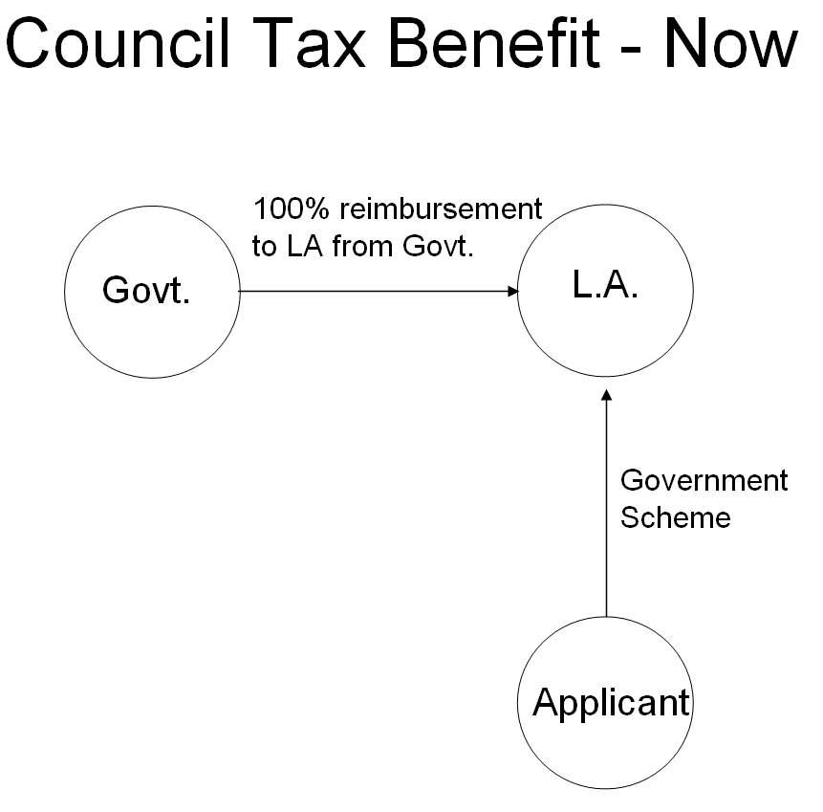

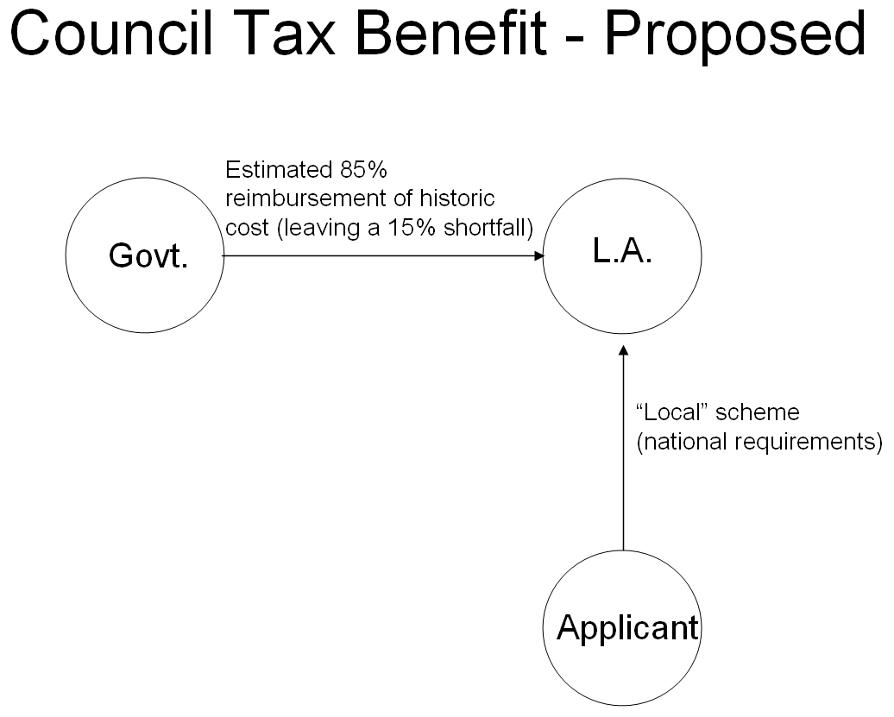

Comparison of current national scheme with changes from April 2013
 | NOW | APRIL 2013
Scheme Structure | National | National & Local
Administration | Local | Local
Funding | National | Local Govt – with a ‘fixed’ cash grant of historic cost (likely to be only 85% for KBC)

Impact on Categories of Claimants
Category | Schemes from April 2013
Pensioners | Protected – ‘local schemes’ must give the same level of benefits to pensioners (national policy requirement)
‘Vulnerable Groups’ | In theory a Local Choice but must give regard to vulnerable groups when designing a local scheme. In practice, most of this group will also be protected.
Others | Local Choice

  - Nationally these changes are designed to save around £500m which has been trailed nationally as around a 10% reduction. In essence, this means each local authority will have to either cut its council tax support or find compensatory savings and efficiencies. Additionally carry at a local level the risk for upward pressure in claimant numbers due to the economic circumstances.

  - Members will recall from the June report to this committee that two policy papers were published by CLG in May. The two papers issued to date are as follows:

Policy Papers; Localising Support for Council Tax:
- Funding Arrangements Consultation and Statement of Intent
- A Statement of Intent

Further documents were published in July 2012.

  - These policy papers contained indicative details of the provisional funding each authority will receive for the new scheme. The provisional grant for KBC is £751,000. This compares to estimated expenditure for Council Tax support of £880,000 in 2013/14 resulting in a shortfall of 15% (ie £129,000). This is significantly greater than the 10% the Government have previously indicated and is equivalent to 2% on the local council tax.

  - It is currently also unclear whether the grant will increase on an annual basis - clearly there is a correlation between the economic climate and the level of benefit applicants, so this gap has the potential to widen further and it is wise to plan on the basis that there are unlikely to be any annual uplifts from Government even if caseload rises.
  - The following points identify some of the key issues / challenges that local authorities face in relation to this issue;

- Local Authorities are required to set their own scheme by 31st January 2013. If they do not a default scheme will be imposed by Central Government on the basis of the current scheme, but with reduced resources.

- To meet the timeline set by the Government, local authorities have a number of challenges to overcome, specifically in relation to;

  - Timescales - Local schemes must be approved by 31st January 2012 at the very latest. In reality, they need to be approved significantly before this to facilitate paperwork and processes to be dealt with.

  - Consultation – Local Authorities must undertake statutory consultation with major preceptors and stakeholders. This will normally take between 8 and 12 weeks to complete.

  - Software – The software that run IT systems will need to be amended and rigorously tested.

  - Training – staff will need to be properly trained to administer the new system effectively.

- The Government have stated that they will not be funding the cost of the scheme. It is expected that locally we will receive around 85% of the current cash grant, leaving an initial shortfall for KBC of about £129,000 (equivalent of 2% on the Council Tax). It is anticipated that any future rise in caseload will not attract any national funding and will need to be met at local level also.

- All financial risks will transfer to billing authorities and the major precepting authorities.

- Currently the authority receives a grant of £631,000 for the administration of Housing and Council Tax Benefit. Central Government has indicated that changes to support for Council Tax and to Housing Benefit will impact on the level of administration grant we can expect to receive. No figures have yet been published regarding this. It is expected that further real reductions will be experienced.

- The Government has confirmed that pensioners must be protected from any change under the new scheme. For Kettering Borough Council this equates to 45% of our existing caseload. Authorities are also required to consider what protection is appropriate for vulnerable groups and this will be at local discretion. This means that any reduction in cost will be borne by a smaller group of people.

- The timescales for implementation are very short and consultation must be carried out for a period of between 8 - 12 weeks depending on the complexity of the proposals.

  - The following tables illustrates the level of expenditure on Council Tax Benefits over the past few years together with the change in caseload;

Year | CTB subsidy Expenditure | Caseload
 | £000 | Numbers | Year on Year Increase | Cumulative Increase
2007/08 | 4,163 | 6,314
2008/09 | 4,602 | 6,684 | 6% | 6%
2009/10 | 5,420 | 7,599 | 14% | 20%
2010/11 | 5,850 | 7,896 | 4% | 24%
2011/12 | 5,959 | 8,140 | 3% | 27%
2012/13 | 6,049 | 8,350 | 3% | 30%

  - It is expected that the grant will be paid to both billing and major precepting authorities, reducing each authority’s council tax requirement and off-setting partially or fully the reduction (subject to local decision) on the council tax base. Council Tax support grant from central government will now be applied as a discount to each billing authority’s council tax base.

  - Each £1 of Council Tax is distributed as follows;

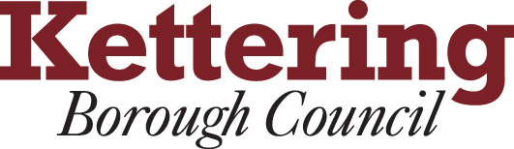


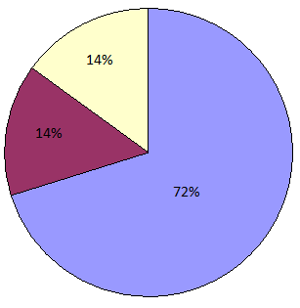

  - If the indicative funding levels are used as an illustration, overall the Borough will receive a funding reduction in the region of £880,000. If this is allocated across the major precepting authorities (as above) it would mean the following reductions against each local authorities actual base budgets;

Authority | Reduction
NCC | £631,000
NPA | £120,000
KBC | £129,000
Total | £880,000

  - Following on from the point outlined in section 3.6, any future increase in caseload that cannot be contained within the cash grant the government provides will need to be met by local authorities – it is anticipated that any costs associated with this will be met in the same proportions as above.

4. AVAILABLE OPTIONS

  - This section of the report considers the broad strategy options that are available for member consideration.

  - Members at this meeting are being asked to decide which of the options they would like to identify as their consultation option. Members are not making a final decision on what the scheme will be at this point, that will be made at a later meeting of the Executive when the Committee consider the results of the consultation process.

  - The following high-level timetable is reproduced from the last report for members information;

July to September 2012
- Consultation
- Financial modelling
- Discussions with software suppliers
- Updates through the Durable Budget Report

September / October 2012
- Update report to Executive
- Executive to recommend preferred scheme (Oct 2012)

October 2012 to November 2012
- Implementation planning

December 2012
- Final scheme recommendations to be considered by members

  - The following options were previously outlined to members;

Option No | Option
1 | Continue with the current scheme (ie, do nothing approach)
2 | Implement a local scheme (to fit the reduced national funding) where normal council tax is charged (where permitted) in relation to exemptions and discounts
3 | Implement a local scheme (to fit the reduced national funding) through specific scheme adjustments eg, adjusting tapers, awards, rebates and deductions.
4 | Implement a local scheme (to fit the reduced national funding) through the use of all the elements permitted through option 2 plus some elements of option 3

  - The government has stated that councils will not be permitted to reduce council tax support for pensioners. This will be achieved by retaining the default national rules for pensioners, with eligibility and rates defined broadly similar regulations as those for Council Tax Benefit.

  - The Government has also said that LA’s are expected to maintain an appropriate level of support for other ‘vulnerable groups’. The definition of these groups have not been clearly defined, however, the Government’s response to the consultation ‘Localising support for council tax in England’, which was published in December 2011 refers to local authorities responsibility towards vulnerable groups under various acts including:

- Child Poverty Act 2010
- Disabled Persons (Services, Consultation and Representation) Act 1986
- Chronically Sick and Disabled Persons Act 1970
- Housing Act 1996

  - The Council currently has 8,357 Housing Benefit and Council Tax Benefit claimants. It is important to note that claimants will have to claim their housing support costs from the DWP, as part of their overall benefits under Universal Credit. This may be confusing for customers locally, as they will have to make a separate claim for Council Tax Support with their local council.

  - The following table shows the categories of claimants for KBC;
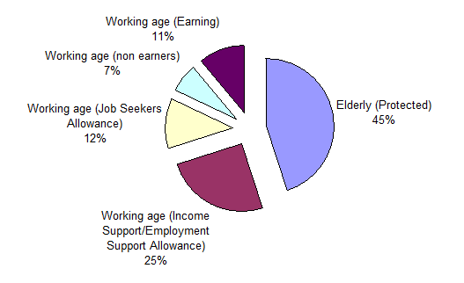
4.9 From the analysis in the table, the potential impact upon the different categories of claimants can be gained. Given that pensioners are to be protected through national regulations (45% of our caseload) that means that in theory the estimated funding reduction of 15% would need to be applied in some way to the remaining 55% of caseload. However, approximately 38% of the remaining caseload are potentially in the vulnerable category which could result in the funding reduction being applied disproportionately to the remaining small group.
  - As previously outlined, the following broad strategy options are available;

Option No | Option
1 | Continue with the current scheme (ie, do nothing approach)
2 | Implement a local scheme (to fit the reduced national funding) where normal council tax is charged (where permitted) in relation to exemptions and discounts
3 | Implement a local scheme (to fit the reduced national funding) through specific scheme adjustments eg, adjusting tapers, awards, rebates and deductions.
4 | Implement a local scheme (to fit the reduced national funding) through the use of all the elements permitted through option 2 plus some elements of option 3

  - Prior to discussing the options in a little more detail, members may wish to consider whether they should have a simple set of additional guiding principles that would help frame the discussion about which options are preferable. The following provides some initial thoughts around this;

- In the medium term, the cost of a local scheme must be contained within the grant made available from the Government (to comply with the existing budget guiding principles)

- The scheme should incentivise work

- The impact on working age claimants should as far as possible be minimised through considering changes to Council Tax exemptions and discounts.

  - The following are the main options that appear open to the Council to consider. Further details are provided in Appendix A for members to consider.

Option 1 – Continue with the current scheme (do nothing option)

In effect this would be what is being termed the ‘default scheme’ although it would still require work to be undertaken to formally adopt this as the authority’s scheme.

The reduction in national funding (currently looking like 15% for KBC) would need to be made-up by one or more of the following;

- On-going reductions in other KBC service budgets
- Specific Increase in Council Tax (perhaps via a local vote)
- Other available funding sources

It is important for members to recognise that if this was to become the adopted scheme this would break the Councils Budget Containment Strategy and would also have a major financial impact on other major precepting authorities.

Option 2 - Implement a local scheme (to fit the reduced national funding) where normal council tax is charged (where permitted) in relation to exemptions and discounts

This option would result in the following;

- Charging normal Council Tax on all of the following;

  - Second Homes
  - Unoccupied and Unfurnished Dwellings
  - Uninhabitable Dwellings
  - Repossessions

- Charging a premium on homes that are left empty for longer than two years.

Appendix A contains further information about how the above changes could operate together with the potential financial impact.

Option 3 – Implement a local scheme (to fit the reduced national funding) through specific scheme adjustments eg, adjusting tapers, awards, rebates and deductions.

In essence this would mean designing a local scheme that would have to fit the new reduced funding envelope – it could include:

- Reducing support for all claimants (except pensioners) by only funding a percentage of council tax liability
- Restrict support to the level for a Band D property or lower.
- Restrict an award to nil if the calculated award is below a prescribed figure
- Consider whether incomes such as Child Benefit and Maintenance should still be disregarded in full when calculating an award
- Review the maximum amount of capital that a claimant may hold before becoming ineligible for council tax support
- Review Second Adult Rebate
- Review Non Dependant Deductions
- Adjust means testing such as changing disregards and tapers.

Appendix A contains further information about how a scheme using these elements could operate together with an estimate of its possible financial impact. Appendix A also contains some worked examples.

Option 4 – Implement a local scheme (to fit the reduced national funding) through the use of all the elements permitted through option 2 plus some elements of option 3
In effect this is a combination of options 2 & 3 (a hybrid scheme) although it would initially look to get the maximum funding available released through the use of option 2 (implement all options in full) and then rely upon elements of option 3 to fund any remaining budget gap.

4.13 By applying the Council’s golden rules, Option 1 is effectively ruled out. There are three relevant golden rules that are contained within the Council’s Budget Containment Strategy, they are reproduced below;

Budget Containment Strategy:

1. Where a specific grant which funds a specific service is withdrawn, the service stops;

2. Where grant funding reduces, which Kettering Borough Council passports through to another organisation, the reduced sum continues to be passported, providing the end recipient organisation feels it can still provide a value-added service at that funding point.
5. The Council should not substitute itself as a provider / funder of services when another public provider cuts such a service.

  - For the purposes of consultation, there is merit in keeping all other options so that the Council can receive the full range of feedback to help inform its final decision later in the year. To this end, the Committee is recommended to choose Option 4 as its preferred option for consultation.

  - While recommending Option 4, the Committee are encouraged to consult on the possible ways in which Option 2 (charging normal council tax) can be used to its full effect to help address the funding gap created by the decrease in national funding. The various elements of Option 3 should also be explored through the consultation process so that overall the Council can develop a local scheme through the use of these two options that can be contained within the reduced funding budget that will be available. Option 2 is recommended as the primary method to close the funding gap however it is recognised that by itself, it is unlikely to generate sufficient income for either the first or subsequent years and therefore elements of option 3 are also required- the following diagram illustrates this point;
Option
3
Option
2
Option
3
Option
3
Option
2
Option
2
Yr 1
Yr 2
Yr 3
Estimated
Funding
Gap

5. CONSULTATION AND CUSTOMER IMPACT

5.1 There is a legal requirement to consult with the major precepting authorities and the public. Given the impact on the borough’s residents any consultation will need to be accessible and proportionate.

5.2 The consultation strategy is detailed in Appendix B. The Council will ensure that a high quality, co-ordinated consultation, which provides both online and offline opportunities to engage is carried out.

5.3 The consultation will engage with internal and external partners, the third sector, council tax payers, and Council Tax Benefit recipients. This list is not exhaustive. The Council will also run a number of focus groups, workshops and utilise local meetings and social media.

5.4 Full equality impact assessments have been completed prior to consultation (Appendix C). Following the completion of consultation a review of the equality impact assessments will be undertaken, this is to identify the groups of people being or likely to be disadvantaged by any new scheme prior to full adoption.

6. POLICY IMPLICATIONS

6.1 This report effectively starts the formal process of determining a local policy for the Council Tax Support Scheme.

7. USE OF RESOURCES

7.1 Option 1 (the do nothing option) will cost Kettering Borough Council initially in the region of £129,000 per annum (based upon existing caseload). It will result in the Council’s golden rules being breached and also pass on additional costs to our partners.

7.2 To comply with the Council budget guiding principles, a scheme should be designed that aims to fit the level of available government grant. It may be desirable to keep some level of contingency to deal with future caseload changes.

7.3 Whatever scheme is eventually chosen by the Council, there will be a need to monitor the level of council tax collection rates which are currently around 98%.

7.4 Current assumptions are that the government funding will be fixed in advance for the year. This means that the Council will bear the risk of claims being different to budgeted levels in-year. It is not clear how funding will be determined in the medium term but unless future funding is linked to demand levels the Council will also bear the risk of changes in the numbers of claims due to the economic climate. In theory fixed-funding could also benefit the Council if claims reduce, but this is unlikely in the short term and current assumptions are for an annual increase of around 3%. With no additional funding this would create a further cost pressure for the Council.

8. RECOMMENDATIONS

That the Executive Committee;

- Note the contents of the report;

- Endorse the guiding principles contained in section 4.11;

- Agree that the preferred option for consultation is Option 4 – with option 2 being the primary source of funding (ie, all elements pursued) supported by elements of option 3.

- Approve the consultation approach as set out in the Appendices to this Report.

Appendices

Appendix A – Summary: Local Council Tax Support proposed scheme options

Appendix B - Consultation Strategy

Appendix C - Equality Impact Assessment

Background Papers: Previous Reports/Minutes:

Title of Document: Ref:
Date: Date:
Contact Officer:

