TO ALL MEMBERS | Direct Line: (01536) 534200  Email: anneireson@kettering.gov.uk  Our Ref: AI  Your Ref:  Date: 15th November 2004

Dear Councillor

You are summoned to an Extraordinary Meeting of the Borough Council to be held at 6.30 pm in the Council Chamber, Municipal Offices, Bowling Green Road, Kettering on Wednesday, 24th November 2004. Following a short break, the Special Debate Meeting will commence immediately after the Extraordinary Meeting.

Yours faithfully
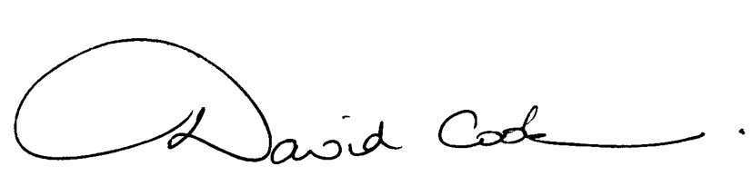

Chief Executive

A G E N D A

1. Apologies.

2. Minutes of the meeting of the Council held on 28th July 2004 to be approved as a correct record and signed by the Mayor.

3. Minutes of the State of the Borough meeting held on 15th September 2004 to be approved as a correct record and signed by the Mayor.

4. Declarations of Interest.

5. To receive any announcements from the Mayor and/or the Leader of the Council.

6. Reports of the Chief Executive.

7. The Mayor to ask members of the public present if they want to speak on any item on the agenda.

8. To receive questions from, and provide answers to, the public in relation to matters which have been included on the agenda

9. To consider the extension of periods of absence in respect of two members of the Council who are currently ill.

10. To receive a petition from Geddington, Newton and Little Oakley Parish Council

11. Periodic Electoral Review (report attached). Members are asked to bring their copy of the draft submission to the meeting.

12. To consider any items of urgent business accepted by the Mayor.

At this juncture the meeting will adjourn for 10 minutes

13. To receive a petition from the Users' Group of the Kettering Centre for the Unemployed

14. To consider the motions submitted by the leaders of each group on the following issues:

Labour Group

Motion to be circulated at the meeting.

Conservative Group

"Kettering Borough Council:

(a) notes that Northamptonshire's Chief Constable has stated that at least another 200 police officers are required for the Northamptonshire Police

(b) recognises the contribution that it itself has been able to make in the local fight against crime and anti-social behaviour with measures including:

(i) the part funding of 6 (and soon to be 8) Police Community Support Officers for the Borough

(ii) co-operation with the Police on introducing the Borough’s first Dispersal Order, and

(iii) the establishment of a Taskforce on the night-time economy

(c) thanks all local police officers and others who are involved in the fight against crime and anti-social behaviour for their dedication and hard work

(d) calls on the Home Office:

(i) to provide the Northamptonshire Police Authority with a full and proper financial settlement to include the requisite funding for all the additional police officers needed by the Chief Constable without passing the financial burden onto local council taxpayers, and

(ii) to recognise the Borough Council’s own role in the fight against crime and disorder by providing further funds to help expand its efforts, including more Police Community Support Officers."

Independent Group

"British democracy is more than dictatorship by a party which has gained a majority in an election"

(Members are requested to note that, when considering items which involve the likely disclosure of exempt information as defined by Schedule 12A to the Local Government Act 1972, it will be necessary to exclude the press and the public from the meeting.)

Fire Alarm

All meetings shall be adjourned immediately on the sounding of the fire alarm. The alarm is a continuous two-tone siren. On hearing the alarm please leave the building by the nearest emergency exit. There are emergency exits at both ends of the corridor outside the meeting rooms. On leaving the building please cross the car park and assemble on the grassed area by the church. Do not attempt to drive out of the car park as this may impede the arrival of emergency vehicles. Please do not return to the building until you are told it is safe to do so by a Council employee

Toilets and Baby Changing Facilities

There are toilets and baby changing facilities in the corridor off the main entrance to the building you came through to get to the meeting room. The Council actively supports breastfeeding mothers. If you wish to use a private area please ask a member of staff.

Access for Disabled People

There are allocated parking bays outside the main entrance to the Municipal Offices for disabled people. The meeting rooms are located on the ground floor and access is gained for wheelchair users via the main entrance. If you require assistance, please ask the attendant on duty in the reception area.

No Smoking

Smoking is not permitted in the Municipal Offices.

Private and Confidential Items

The press and members of the public can be excluded from business of the meeting on the grounds that it involves items of business which include the likely disclosure of exempt information as defined by Paragraphs 1-15 of Schedule 12A to the Local Government Act 1972.

