- PURPOSE OF REPORT

  - To present the sequence of events leading to the news that Prezzo have applied for a licence for unit two of the Market Place Restaurants.
  - To update Members on interest in three other key units in the town centre.
  - To inform Members of recent discussions between the County Council and Ellandi, the owners of the Newland Centre.
  - To seek approval for the appointment of MGWSP to carry out the design work for the pedestrianisation of Kettering Town Centre’s main shopping area (Public Realm Phase 4) and to request approval of a £190,000 budget for these works.
  - To consider the introduction of a pilot scheme in London Road and the Municipal Offices car parks to help increase dwell time in the town centre.
  - To consider a proposal to acquire a trailer-mounted big screen television for screening events throughout the Borough.

- BACKGROUND INFORMATION

2.1 Kettering Borough lies within the South East Midlands, which is predominantly a growth area, and is expected to facilitate growth of some 13,100 homes and 16,200 new jobs by 2021.

2.2 Members have made their priorities for infrastructure and jobs-led growth clear – these are the prerequisites of growth. Members have indicated they wish to use the growth agenda to leverage three key and interrelated ambitions for the borough; namely:-

- A better offer for our town centres
- A better education and training offer
- A better employment offer – high grade, higher density jobs

  - The mutually supportive role of these three aspirations cannot be over-stated. The town centres and the skills base will be persuasive to inward investors. Similarly, high grade employment supports vibrant town centres.

  - The recent announcement of the interest from national restaurant chain Prezzo is good news for the town. At a time when the economy is at a particular low, news of this potential investment is a demonstration of the success of the Council’s innovative approach to town centre regeneration.
The Market Place Buildings Story

Introduction
Kettering Borough Council has a strong, and unrelenting, vision for its town centre. This vision is backed-up by planning policy and has been externally validated as an imaginative and deliverable plan. But even the most deliverable of plans can get stuck in difficult economic markets.

The Market Place buildings were commenced at the end of an economic boom and were finished in the middle of a double-dip recession. Feedback on the units was consistently fantastic, but restaurant operators were nervous about investing in this economic climate.

Despite all this, Kettering Borough Council has just received a licensing application from Prezzo, who are interested in being the first occupier of the new Market Place Restaurants.

This is the story of how a dynamic and innovative Council was prepared to make bold decisions and stay true to its vision as it delivered the Market Place Buildings.

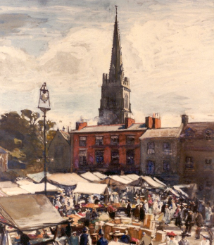
In 1908 the former Market Place Buildings were demolished. They comprised a run of shops and businesses of two and three storeys that sat at the southern end of the Market Place, framing views of the Parish church.

Their loss made way for a Market Store and car park, which were later joined by a collection of public toilets. Walter Gash’s painting (right) gives a flavour of what the Market place would have looked like at the turn of the 20th Century.

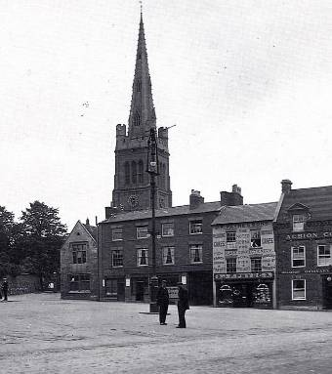
A photograph of the buildings (taken around the same time as the painting) shows the informality of the market place.

One hundred years later, in June 2008, the Council made its first bold choice for the regeneration of Kettering Town Centre. Faced with considerable housing growth, Kettering Borough Councillors made it clear that, before the houses were developed, the appropriate infrastructure and jobs would need to be in place. The focus of much of the infrastructure would be a new, improved, town centre which was ‘characterful, distinctive and fun’.

The Council set about delivering its priority; a new restaurant quarter focussed on a refurbished market place.

In March 2009 the Council approved the design brief for the new Market Place Buildings. It demanded that any new buildings in such a sensitive location should echo those that came before them. It was also decided that the buildings should be purpose-built for restaurant use – what else would you expect for a new development in the new restaurant quarter.

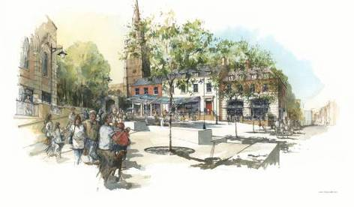
Implicit in the design brief was a decision to remove the existing buildings and uses (a market store, a toilet block and a small car park) from the site. This decision had its critics, but Councillors were adamant that, in order to deliver the best possible development for the town, uses such as these would have to be relocated or replaced.

In April 2009 Kettering Borough Council secured the funding necessary to deliver the Market Place Buildings. This external challenge funding was won against competition from other towns and other growth areas. If the money had not been brought to Kettering to deliver the Market Place Restaurants, it would have gone to another town and been spent on another development.

August 2009 saw the completion of the Market Place – the first phase in the delivery of regeneration for Kettering Town centre – on-time and on-budget. The fencing came down on the morning of the 7th August and by the afternoon there were children playing in the fountains as they were tested prior to the big switch-on.

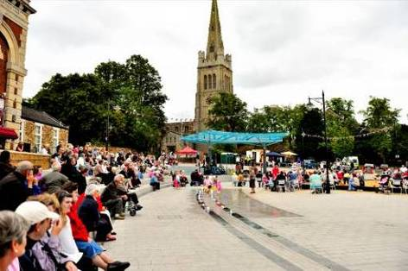
Although the refurbishment of the Market Place has its critics from day one, public feedback since its completion has been very positive, with many residents and visitors to the town contacting us to say how much they like the fountains and how they look forward to seeing new restaurants around the market place.

The public opening of the Market Place was celebrated with a five-day summer festival which took place over the August Bank Holiday Weekend.

In September 2009 the earth was broken on the Market Place Buildings. Councillors, partners and the contractors for the new development, came together to signal the start of works.

Unfortunately, the cutting of the first sod coincided with the cutting of the external challenge funding.

It was at this point that Kettering Borough Councillors made their second bold decision; at a meeting of the Executive they voted unanimously to continue with the development and to gap-fund the money lost from the cut in challenge funding.

The development would go ahead.

In December 2009 the new restaurant quarter received a boost with news that the work to refurbish Kettering Market Place had been recognised in a prestigious awards ceremony. The Royal Town Planning Institute gave Kettering Market Place the Best Town Centre Regeneration Project Award and an award for the Best Overall Project – beating off competition from High Cross Shopping Centre in Leicester.

February 2009 saw the biggest step forward in the development of the Market Place Buildings, as the scheme gets full planning consent.

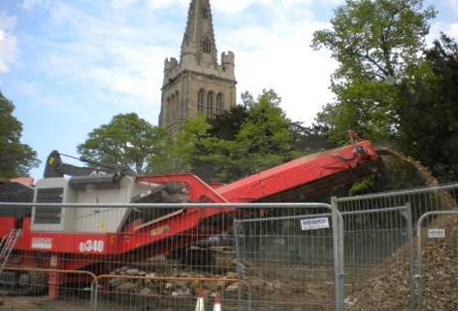
April 2010 saw the start of construction works with the erection of the site hoardings and palisade fencing.

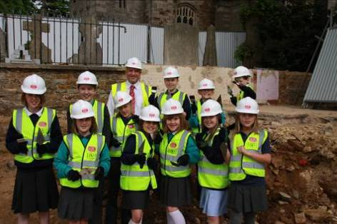
In June 2010 the Children of Brambleside School visited the site to assist with the archaeology dig. Bones and pottery dating back to the 14th Century were found as the site was fully documented and recorded for posterity.

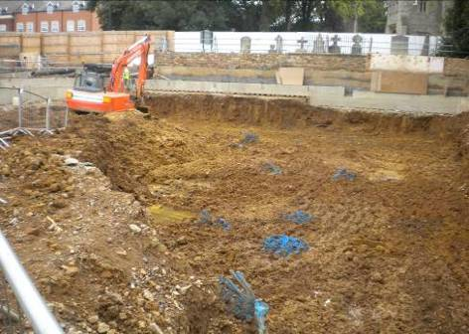
August 2010 saw the foundations laid…

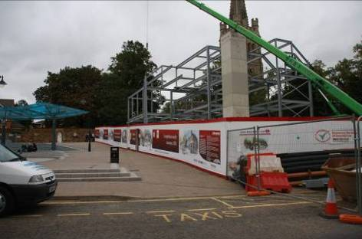
…. followed in September 2010 with the start of the steelworks….

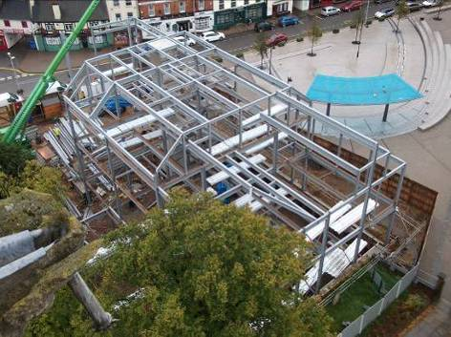
…which are completed in October 2010.

In October, the Market Place Buildings site also received its first visit from a dignitary, as Lord Best visited to take a look at progress.


Dignitaries of a slightly smaller nature also visited in October, as children from Brambleside School came back to see how things were getting on.

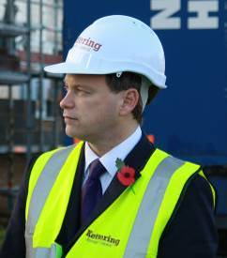
In November 2010, Grant Shapps MP – the Minister for Housing – visited the site to launch a new government initiative; the New Homes Bonus.

The Minister braved gale force winds and near-horizontal rain to launch the scheme to regional and national press and television cameras.

He won’t be forgetting the time he spent in Kettering in a hurry!

In January 2011, despite unusually harsh weather conditions, works continue apace.

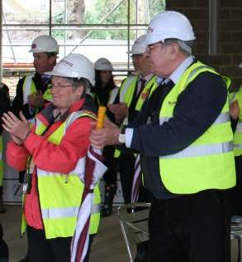
March 2011 saw Kettering Borough Council and its partners celebrate the topping-off of the Market Place Buildings development.

The Market Place Buildings were now wind and watertight, which meant that works on the interior of the buildings could proceed.

In August 2011 the first phase of the Market Place Buildings development is completed.

Between September and October 2011 all 10 of the apartments are let and start to deliver a good return to the Council.

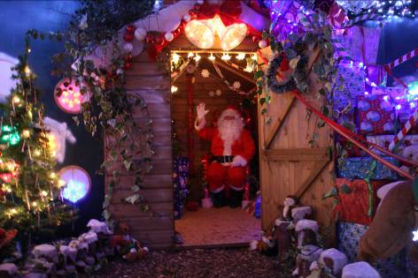
Christmas 2011 saw Unit 1 of the Market Place Restaurants used as a Santa’s Grotto, raising money for local charities.

Work continues on attracting a national restaurant chain to the Market Place Restaurants. There is extremely positive feedback from all who visit to view, but this is tempered by a nervousness regarding the national economic picture.

Some local businesses start expressing a desire to see something (anything?) fill the restaurant units, but the Council holds firm on its vision for national restaurant operators.

In late April there is a very encouraging ‘nibble’ from a national restaurant chain.

In May 2012 Prezzo confirm their interest in Unit 2 and apply for a drinks licence.

- UPDATE ON VACANT UNITS

  - Kettering has received more good news over the last few weeks as one other restaurant and two cafes look to invest in the town centre.

  - Popular Indian restaurant Mazza has just lodged an application to convert the Borough Council-owned property at 1 Horsemarket into a second outlet. The application has only just been registered so there is currently no indication as to when they will open if they are successful in securing planning consent.

  - Wellingborough coffee house Bewitched have been granted consent to convert 34 High Street into their first outlet in Kettering. Owner, Matt Fountain is relishing the competition that will be provided by Costas, should their application for a second unit in Kettering be successful at 32 High Street.

  - The clustering of Costas and Bewiched is a very real demonstration of the theory behind the ‘quarters’ approach to the wider Kettering Town Centre Area Action Plan: similar uses like to be grouped together

- REDRESSING THE BALANCE BETWEEN VEHICLES AND PEDESTRIANS - RECLAIMING THE TOWN CENTRE FOR SHOPPERS

  - At its meeting in March 2012, the Council’s Executive approved the set of aims that would guide the removal of vehicular traffic from Kettering’s main Town Centre shopping area. To recap, these were:

1 | To take forward the public realm principles as already implemented on Market Place, Horsemarket, Market Street and Sheep Street.
2 | To redress the balance between vehicles and pedestrians and to re-attract town centre users and investors to this part of the town centre;
3 | To provide a design that is safe, functional and robust, and which does not detract from the town’s key buildings
4 | To ensure proposals consider the needs of the public, businesses and other key stakeholder groups but not to the detriment of the overarching vision of creating an improved shopping experience.
5 | To ensure the proposals are integrated with other town centre schemes
6 | To ensure proposals are fully costed and represent value for money
  - Following this approval, the County Council’s Highways Consultants, MGWSP, were asked to respond to a brief (in which these aims which were encapsulated).

Fee Proposal

  - An original fee proposal of £250,000 was received from MGWSP in early April. Detailed discussions and negotiations ensued and a second proposal of £190,000 was subsequently submitted in late May.

  - The commission will include:

- Survey work to determine ground conditions and the position of utilities

- A concept design upon which a first phase of consultation would be carried out

- Consultation with local residents and all businesses in the study area

- A final design for approval

- Detailed/technical design of the first phase of the project to be delivered (this is likely to be the ‘gateways’ which will help - probably through the installation of rising bollards – to control traffic entering the pedestrianised area.

- Work towards the agreement of Traffic Regulation Orders which will prohibit the entry of certain types of traffic into the pedestrianised area at certain time of the day (this will be determined through consultation and the design stages)

  - The commission will not include:

- Any physical works (such as the installation of bollards)

- The detailed/technical design of all of the Pedestrianised Area

  - It is anticipated the physical works as designed will be funded either through a future capital programme, or through S106 monies from development within the Borough.

  - This report seeks approval for the appointment of MGWSP and a £190,000 budget to carry out the commission as described above.

Funding

  - The one-off capital budget will need to be financed through a combination of external and internal sources:

    - A bid for £40,000 funding was submitted to NNDC’s Discretionary Fund last month. The project Sub-committee which comprises three of NNDC’s main board Members approved £30,000 of funding against this bid.

    - £40,000 funding from Section 106 money from Polwell Lane, which is due on first occupation.

    - The balance of £120,000 will need to be met by Kettering Borough Council.

  - The Council contribution of £120,000 is currently not provided for in the Capital Programme. It will need to be financed from either borrowing (in accordance with the Council’s approved Treasury Management Strategy) or from earmarked reserves. The precise funding mechanism will be allocated when the half yearly review of the Capital Programme is undertaken which will be reported back to this Committee in September.

Procurement

  - It is proposed that the Borough Council work in partnership with the County Council, who will appoint MGWSP to carry out the design works behind the pedestrianisation project. It is considered that this approach would reduce unnecessary costs, resources and time associated with the Borough Council appointing its own highways expertise, and provide best value for the Council.

  - Normally, a tender process would be undertaken to appoint contractors, however the County Council conducted its own OJEU procurement process to appoint MGWSP, as its preferred highways contractor. Kettering Borough Council can take advantage of the rates procured through this process by working with the County Council to deliver the project.

- Working with Partners

  - April’s update paper recognised the importance of partnership working in order to deliver town centre regeneration and highlighted those projects which were imminent, or planned, and what our role in them would be.

  - The table presented in the update paper is reproduced overleaf and references works to the Newland Centre’s façade to Newland Street and our role in facilitating discussions between the County Council and the Newlands Centre owners, Ellandi.

Project | Our Role(s) | Partner | Their Role
Newlands Centre; Refurbishment | - Support | Ellandi | - Delivery
Newlands Centre; Gold Street Entrance | - Support  - Planning Authority | Ellandi | - Delivery
Newlands Centre; Newlands Street façade | - Planning Authority  - Facilitating discussions with the County Council and Stagecoach | Ellandi | - Building owner and potential part-funder
Newlands Centre; Newlands Street façade |  | Northants County Council | - Owner of bus shelter  - Highways Authority
Newlands Centre; Newlands Street façade |  | Stagecoach | - Bus operator
Newlands Centre; Newlands Phase 1 | - Land owner  - Planning Authority  - Investor? | Ellandi | - Building owner  - Investor?
Public Realm Phase 4; Pedestrianisation | - Delivery | Northants County Council | - Highways Authority  - Potential Delivery Partner

  - Ellandi have raised concerns about the County Council-owned bus shelters and the impact that their placement is having on their ability to let the former TJ Hughes Unit to a high quality operator. Their proposal is for the bus shelters to be removed, although they are very keen that the bus stop facility remains, albeit accommodated in a different way

  - In mid-May, at the request of the Newlands Centre owners, Council officers brokered a conversation between the County Council and the Manager of the Newlands Centre. We hope that these conversations will continue and that a solution will be agreed.

  - Kettering Borough Council are also in dialogue with the County Council about the priorities for the next phase of works to improve the traffic circulation in and around the town centre. The transport plans – as set out in the Kettering Town Centre Area Action Plan - were responsible for the successful development of the two roundabouts at the bottom of Northampton Road last year.

  - The discussions were prompted by the County Council’s accumulation of enough section 106 contributions to design the new scheme, and expectations that receipts over the coming 2 or 3 years would be enough to deliver that scheme.
- Pilot Scheme to help increase dwell time in Kettering Town Centre

  - Members have indicated previously that they wish to encourage shoppers, and visitors to stay for longer periods, increase footfall in quieter areas of town and at the same time protect the Council’s revenue streams.

  - One way in which these various objectives could be met is by introducing a pilot parking scheme in London Rd car park and the adjacent Municipal Offices car park. There are two options which could be explored:-

Option 1: Temporarily replace the existing 1 hour and 2 hour individual rates with a new combined 2 hour rate of £1.50 (the current 2 hour rate is £2.20). This would apply to the London Rd and the Municipal Offices car park only and take place on Saturdays during the period of the pilot scheme.

Option 2: As option 1 but operate the pilot scheme on Saturdays plus other specified days (or time periods) of the week.

  - The advantages and disadvantages of each of these options are considered in the table overleaf.

  - The financial assessment of the impact of such a change cannot be absolute, but modelling the new charge against the existing usage levels in these two car parks shows that the change is likely to have a minimal financial impact. That does not take account however of any change that might be experienced in the number of excess ticket charges issued, nor, crucially, in movements of users between car parks. For example, those who purchase a ticket in Wadcroft now for two hours might choose to park in London Rd in future, thereby reducing income from other car parks.

  - Because any change in car parking fees has the potential to influence behavioural changes which are impossible to predict, it would therefore be best to test these changes for a period of time so an assessment of usage levels could be made. A trial period could be for 6, 9 or 12 months could be considered.

 | Option 1 | Option 2
ADVANTAGES

Will help promote greater dwell time | 
Will put more footfall into the southern part of town.

Will increase dwell time in town, and help restaurants and shops.
May encourage more visitors to town

Will help swimming pool users.

Potential to combine with a money back scheme if retailers etc wish to run one.
Provides wide range of options for people – pop and shop for an hour, ordinary one hourly rates and this two hour proposal
Matches the two hour rate of £1.50 in Newlands multi-story car park, but at the other end of town.
Utilises most under-used car parks on a Saturday

Least likely to affect Wadcroft car park usage as this is predominately one hour only usage on a Saturday
Utilises under-used car park all week long

DISADVANTAGES

Potential small loss of income. | 
Potential for greater loss of income
May relocate shoppers from other car parks rather than increase the total number of people using car parks.
Will not be possible to include Municipal Offices car park as this is in use Monday-Friday
Smaller amount of spare capacity available Monday-Friday than on a Saturday.
Greater exposure to financial risk

  - Having considered the advantages and disadvantages of the potential pilot scheme, members will need to decide;

- Is a pilot scheme desirable?
- If so, is Option 1 or Option 2 the preferred choice?
- If Option 2 is the preferred choice, which days will the pilot scheme operate?
- How long should the pilot scheme operate (6, 9 or 12 months).

  - When considering initiatives to increase the dwell time in the town it should be recognised that the Council is a minority provider of car parking spaces in the town. There are already a number of alternatives available such as free on-street parking, private car parking facilities and other parking options.

- Mary Portas and an outdoor screen for the Borough.

  - Kettering Borough Council was not one of the towns selected as a pilot for assistance from Mary Portas. Our bid for funding towards a ‘fun bus’, a new trip-planner website and support for the existing loyalty card was judged against over 370 other bids, and on this occasion, our bid was unsuccessful.

  - This is not, however, all bad news. Many of the recommendations that were made through Mary Portas’ report are already being worked on (or have been delivered) in Kettering, and our failure to attract additional funding will not prevent us from continuing to invest in our town centre.

  - Bids which were unsuccessful in the first round of Portas Pilot Funding are automatically considered in the second round. There is also the opportunity to tweak or change the bid entirely. A lot of time and effort - from our partners and ourselves - went into the unsuccessful first submission. Whilst our partners would no doubt look to support us once again, this may not be the best use of our time and their’s.

  - One of the elements of our original consideration of the Mary Portas report - but which did not form part of our final bid submission - was the acquisition of a large screen television which would be used to screen events in the Market Place.

  - The big screen would be used to screen televised events (this year’s events might include things like the Olympics and Wimbledon) on Kettering Market Place to attract more people into town through a more varied offer. The screen could also be used (at times when it was not required on Kettering Market Place) throughout the Borough in support of other community events.

  - Investigation into the costs of hiring or acquiring a suitable screen has been carried out, and the results are set out below:

 |  |  |  | Hire
Option | Size | Type | Acquire | 3 week | 2 month | 3 month
A | 8 sqm | mobile | £49,950 | n/a | n/a | n/a
B | 5 sqm | fixed | £49,000 | n/a | n/a | n/a
C | 15 sqm | fixed | n/a | £21,000 | £39,000 | £55,000

  - It is clear from the table above that there is an economy in acquiring the screen, should it be determined that there is a long-term need for one. The events on the market place to date have demonstrated that this is certainly the case.

  - Whilst Options A and B are a similar cost, option A is a mobile screen, which would allow it to be used elsewhere in the Borough (subject to power and licensing) and for it to be safely stored away after use. Option B is for a fixed screen; this is the format that screen suppliers would normally wish to sell their screens in – a mobile screen could be seen to compete with their hire business.

  - This report seeks approval for the acquisition of a mobile outdoor screen. If agreed, it would be funded as a one-of item from the Council’s earmarked reserves. As previously outlined in Section 4.9, the exact funding mechanism will be allocated as part of the half yearly Capital Programme review that will be reported to the Executive in September.

  - There are additional costs and requirements over and above the capital cost of acquiring the screen. These would be the same for whichever screen was acquired and would consist of staff time in setting-up and overseeing the event, and routine maintenance of the screen.

- Financial and Policy Implications

  - This report seeks approval for two schemes:

- £190,000 for the design of Public Realm Phase 4 (Pedestrianisation of High Street, Gold Street and Lower Street). Kettering Borough Council’s contribution to this scheme would be £120,000.
- £50,000 for the acquisition of an outdoor screen

  - The precise funding of these schemes will be allocated when the half yearly review of the Capital Programme is undertaken which will be reported back to this Committee in September.

  - There are policy implications other than those set out in the main body of the report.

- RECOMMENDATIONS

- That the Executive Committee recognises its role in:

  - Stimulating interest in unit 2 of the Market Place Restaurants

  - Stimulating the current interest in three other key units in the town centre, and

  - Brokering discussions around the refurbishment of Newland Street.

- that the Executive Committee:

  - Approves a one-off capital budget of £190,000 to carry out design works on the fourth phase of public realm works and agree the proposed procurement method to appoint MGWSP.

  - Approves a one-off capital budget of £50,000 for the acquisition of an outdoor screen (subject to satisfactory inspection and appropriate guarantees) for showing televised events on the Market Place and for support at community events elsewhere in the Borough.

- that the Executive Committee indicates if it wishes to carry out a pilot scheme on the London Rd and Municipal car parks, in order to increase dwell time in town and encourage more visitors, and if so,

  - indicate its preferred option for the pilot scheme

  - indicate the time period over which the pilot scheme will operate

