1 PURPOSE OF REPORT

- To provide an update on our progress in Delivering Town Centres, and

- To provide Members with the opportunity to take forward their Kettering Town Centre Market aspirations in the form of a bid for Portas Pilot funding.

- BACKGROUND INFORMATION

2.1 Kettering Borough lies within the South East Midlands, which is predominantly a growth area, and is expected to facilitate growth of some 13,100 homes and 16,200 new jobs by 2021.

2.2 Members have made their priorities for infrastructure and jobs-led growth clear – these are the prerequisites of growth. Members have indicated they wish to use the growth agenda to leverage three key and interrelated ambitions for the borough; namely:-

- A better offer for our town centres
- A better education and training offer
- A better employment offer – high grade, higher density jobs

  - The mutually supportive role of these three aspirations cannot be over-stated. The town centres and the skills base will be persuasive to inward investors. Similarly, high grade employment supports vibrant town centres.

- UPDATE ON DELIVERING TOWN CENTRES

  - As we approach the beginning of a new financial year, and as the Council’s services publish their plans for delivery over the short to medium terms, it is, perhaps, a good time to reflect on what has been achieved in our town centres to date:

Projects Delivered |  | OUTPUTS ACHIEVED
- Chesham House – Offices for start-up businesses |  | - Costas trading well from town centre location
- Market Place – new venue for events in the restaurant quarter |  | - 10 high quality apartments lift the town centre housing market
- Public Realm and pedestrianisation of Market Street and Sheep Street |  | - Significant challenge funding leveraged from KBC pump-priming
- Market Place Buildings – apartments fully let and restaurant units ready for occupation |  | - Shopping Centre sells to new private investors and redevelopment discussions underway
- Junction Improvements – in partnership with the County Council |  | - Key properties around the market place sell for above guide price
- Demolition of redundant buildings in readiness for redevelopment |  | - 2 historic hotels acquired and refurbished
 |  | - QD stores successfully trade from old Woolworths’ unit
 |  | - Successive years of successful Market Place events
 |  | - Waitrose trial new Boots store concept
 |  | - Partnerships with local stakeholders cemented
 |  | - Improved town centre bus services and routes
 |  | - One new restaurant open in the refurbished Horsemarket. A second underway.

  - We continue to make good progress on projects which play a part in the delivery of better town centres for the Borough. At January and February’s meetings of the Executive, reports were considered that demonstrated how the Borough Council is able to utilise different approaches to the provision of services in order to lower barriers to development and improve the offer available to our customers.

The Yards Phase 2

  - Agents have now been appointed and marketing commenced on the newest development opportunity in Kettering Town Centre. The approach approved by Executive has enabled the Council’s Modelling for Recovery Principles to be applied to encourage the right developers to invest at a time when the capital markets might suggest otherwise.

Markets

  - At its meeting on the 15th February, the Executive decided to continue to run the Kettering and Desborough Markets in-house, recognising that:

- A vibrant and varied market offer, with events markets as a regular feature of the town centre, would help fulfil the wider vision for the town centre – characterful, distinctive and fun.
- A market which enabled and supported new business start ups and provided experience in running a business would support the local economy.
- Events markets which tied into other initiatives in the Borough would be mutually beneficial to both the town centre and those events.

  - It was felt that the potential of expanding the offer of the market to include local start-ups and other specialist markets was best achieved with the Borough Council at the helm.

Toilets

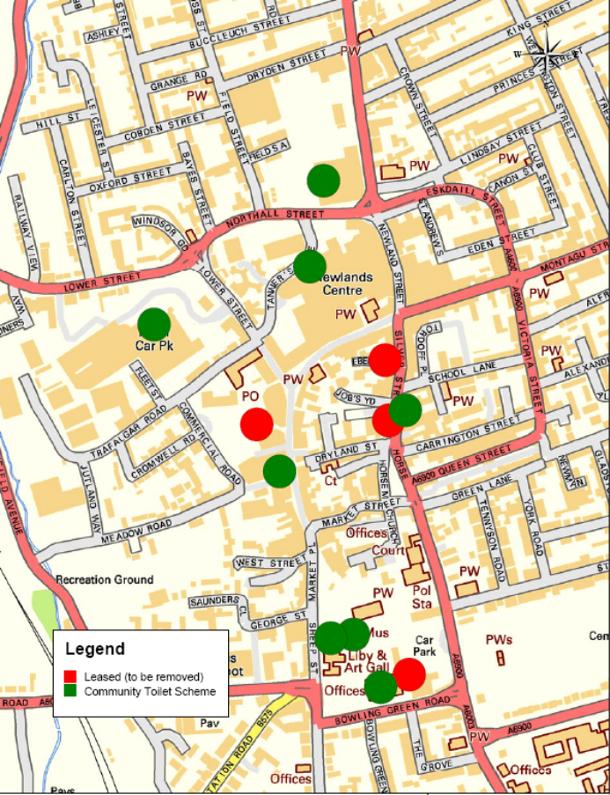
  - In considering the provision of toilets in the town centres, the Executive noted and endorsed the recommendations of the Research and Development Committee (1st June 2011). This will achieve an increase in the number of toilets available to the public from five to eight (see map below) with ongoing discussion to further increase the number.

  - This new toilet provision will provide better facilities and a greater geographical coverage than the current continental-style toilets, as well as reducing the cost of this service to the Council Tax Payer.

- PORTAS PILOT

  - On the 4th February 2012, Grant Shapps MP launched a new pilot scheme aimed at breathing life back into the High Street. The scheme is based on Mary Portas’ High Street Review which makes recommendations to Government, Local Authorities and Businesses about what can be done to help high streets deliver something new.

  - More details on the scheme can be found here: http://www.communities.gov.uk/news/corporate/2082138

  - Mary Portas’ High Street Review makes 28 recommendations and the Portas Pilot scheme uses the first and the last as the key criteria for the pilot scheme:

RECOMMENDATION | DETAIL
1 | Put in place a ‘town team’; a visionary, strategic and strong operational management team for high streets.
28 | Run a number of high street pilots to test proof of concept

Our Vision

  - We are not strangers to the sentiment of the above recommendations; it is important to note that the Executive has received regular reports over the last three years updating them on progress made in the delivery of their vision for Kettering Town Centre. Executive has a strong vision to - and performs a strategic role in – creating a town centre that is:

  - Characterful,
  - Distinctive, and
  - Fun

  - Our Characterful and Distinctive vision comes from our desire to be more than just ‘another town’ with the same shops, albeit in a different location. Our vision recognises the need to provide an experiential offer that persuades people to stay in the town for the day and to experience cultural, eating, meeting and shopping offers.

  - With regards to the ‘fun’ element, aside from our own programme of events on the Market Place, Executive have recognised - through their deliberations over support for Wicksteed Park’s own grant bids - that Wicksteed Park forms a major part of the attractiveness of the town as a whole and that stronger links to it from the town centre could do much to support both the town centre and/ one of the regions most important visitor attractions.

High Street Pilots

  - Executive has also received reports of how pilot schemes have been used to engage with shoppers and traders (through the town centre shop) and to create stronger links between the town centre offer and other key attractors in the town (through the fun train that connected the Market Place with Wicksteed Park as part of the Market Place’s opening celebrations).

  - In addition, we are already making progress on a number of other fronts as set out in paragraph 3.1. This is not to say that there is not more we can do to continue to breathe new life into our town centre.

Bid for Funding

  - Members have made it clear that they wish to offer additional support to the Borough Council-run Market in Kettering and to expand its offer to start-up businesses and speciality markets as part of a new USP (Unique Selling Point) for the town centre. Some of this work was begun late last year.

  - One option that is therefore available to Members is to utilise their new links with traders in a public/private bid for Portas Pilot funding. This type of project would undoubtedly support the town’s existing shopping offer and would add new impetus to Kettering’s Market town status. One consideration is that whilst an improved market offer would understandably improve choice for existing shoppers, it does not uniquely differentiate Kettering from other Market Towns in the area. In time a much improved Market offer could act as a key attractor in its own right, but that might take time and considerable funding to achieve. That is not to say work should not begin – rather are there other strands to add.

  - Other options revolve around an enhancement of our existing vision for the town centre (as discussed above):

OTHER OPTIONS | DETAIL
Acquire an ‘Eco’ Bus to create permanent ‘green’ link between Wicksteed Park, Kettering Conference Centre (with kids play and the National Volleyball Centre) and the Odeon Cinema. | The Eco Bus would help to support our ‘Fun’ offer for the town centre, with an experience that is more than just shopping.
Acquire large screen for the Market Place. | With the Olympics, Paralympics and Euro 2012 Football tournament, there is a summer full of sporting excellence which can help to support our events offer on the Market Place.
Create an incentive scheme to support and accelerate our Zoned approach to the town centre | We have distinct pockets of development where similar uses can be grouped together to create key shopping attractions. The arrival of the vintage festival in the summer will add extra impetus to this idea, with vintage traders utilising our flourishing market and new development opportunities such as the Yards Phase 2.
Expanding Kettering Town’s Loyalty Card scheme | The reported success of the current Loyalty Card for Kettering Town Centre is encouraging, but would benefit from greater retail participation and an offer that is, perhaps, more than just the town centre.

  - Members are invited to consider the bid options contained within this report and consider how to develop a proposal(s) in conjunction with delivery partners, with a view to submitting a proposal to the Portas Pilot scheme. The deadline for entries is 30th March 2012.

  - It is clear from the trade press that there has been a lot of interest in the pilot idea and that competition for the 12 pilot areas will be fierce.

- FINANCIAL AND POLICY IMPLICATIONS

  - Schemes will have to demonstrate value for money and in this respect it is recommended that match-funding will help to support any bid.

  - There is currently no capital money allocated to the town market.

- RECOMMENDATION

That the Executive Committee:

- Notes progress to date in Delivering Our Town Centres,

- Selects idea(s) to consider with partners for submission re the Portas Pilot fund

- Nominate Members of the Cabinet who will work alongside officers and partners to submit the selected scheme for Portas Pilot challenge funding

