BOROUGH OF KETTERING

Committee | Full Planning Committee - 28/02/2012 | Item No: 5.7
Report Originator | Louise Haggan-Craig  Development Officer | Application No:  KET/2012/0039
Wards Affected | Burton Latimer
Location | 28 Tweed Close, Burton Latimer
Proposal | Full Application: Two storey side extension
Applicant | Mr R Jarratt

1. PURPOSE OF REPORT

  - To describe the above proposals
  - To identify and report on the issues arising from it
  - To state a recommendation on the application

2. RECOMMENDATION

THE DEVELOPMENT CONTROL MANAGER RECOMMENDS that this application be APPROVED subject to the following Condition(s):-

1. The development hereby permitted shall be begun before the expiration of 3 years from the date of this planning permission.
REASON: To comply with Section 91 of the Town and Country Planning Act 1990 (as amended) and to prevent an accumulation of unimplemented planning permissions.

2. The materials to be used in the construction of the external surfaces of the development hereby permitted shall match, in type, colour and texture those on the existing building.
REASON: In the interests of visual amenity in accordance with policy 13 h) of the North Northamptonshire Core Spatial Strategy.

3. The window at first floor level on the side elevation shall be glazed with obscured glass and any portion of the window that is within 1.7m of the floor of the room where the window is installed shall be non openable. The window shall thereafter be maintained in that form.
REASON: To protect the privacy of the immediate property and to prevent overlooking in accordance with Policy 13 l of the North Northamptonshire Core Spatial Strategy.

Notes (if any) :-
NONE

Justification for Granting Planning Permission

The proposal is in accordance with national and local policies as set out in Planning Policy Statement 1, Policy 2 of The East Midlands Regional Plan and Policy 13 of the North Northamptonshire Core Spatial Strategy. There are no material considerations that indicate against the proposal.

Officers Report

3.0 | Information

Relevant Planning History
KE/79/1275 – Garage Approved

Site Description
Officer's site inspection was carried out on 7th February 2012.

This application site is situated to the south western side of Burton Latimer in a small cul de sac comprising two storey semi detached properties. The application property lies adjacent to a separate garage which lies within the curtilage of 56 Park Road a neighbouring which is situated to the north east of the site. This building shields much of the application property from view on entrance to Tweed Close and is also set back slightly from the highway.

Proposed Development
This application is for the development of a two storey side extension to form a new garage area, passage way and additional bedroom accommodation on the first floor. The monopitch roof above the porch will be extended to incorporate the garage building and new windows are proposed on the front and rear elevations of the extension. A shower room window is also proposed on the side elevation of the extension but this is to comprise obscure glass.

Any Constraints Affecting The Site
None.

4.0 | Consultation and Customer Impact

Burton Latimer Town Council
No comments received at the time of writing the report.

Neighbours
Objection letter received 6th February 2012. Stating the following concerns:
- The extension will overshadow and overlook our property
- It will give us less privacy
- It would seriously block light to the rear of our property

5.0 | Planning Policy

National Policies
PPS1 – Delivering Sustainable Development

Development Plan Policies

East Midlands Regional Plan
Policy 2 – Promoting Better Design

North Northamptonshire Core Spatial Strategy
Policy 13 General Sustainable Development Principles

6.0 | Financial/Resource Implications
 | None
7.0 | Planning Considerations
The key issues for consideration in this application are:-

- Principle
- Character
- Residential Amenity

Principle
Policy 13 of the North Northamptonshire Core Spatial Strategy is supportive of householder development provided the proposals do not result in adverse impacts upon highway safety, character, appearance and residential amenity. Therefore, subject to the satisfaction of Development Plan criteria the principle of development is acceptable.

Character
The proposed application is for a two storey side extension and as such will be prevalent from the immediate street scene. However, as mentioned previously the site is set back from the highway and partly shielded on entrance to Tweed Close by a single storey pitched roof garage building. The proposed extension will follow the building line of the existing dwelling house and reflects its design, proportions and fenestration by utilising matching materials and window detailing. It is a modest addition which will sit neatly within the proposed space. There are already a number of extensions and additions to other properties within the immediate vicinity and subject to conditions to ensure that materials match the existing property, the application is not considered to adversely affect the character and appearance of the street scene. It therefore complies with Policy 13 h) of the North Northamptonshire Core Spatial Strategy.

Residential Amenity
A letter of objection has been received from a neighbouring property which shares part of a boundary with the application site. Concerns raised primarily relate to loss of privacy and loss of light and as such these matters will be discussed in turn.
It is accepted that the proposed extension will involve development up to the boundary of the application site. However, this boundary is shared with an existing pitched roof garage building which sits within the curtilage of 56 Park Road, the neighbour to the north east of the site. This not only shields the existing property in part but also means that an existing building sits in closer proximity to the properties in Park Road specifically 56 and 58. As such the development of the extension will not increase levels of overshadowing to such an extent that a reason for refusal could be upheld on these grounds. The edge of the side elevation of the extension lies in excess of 10 metres from the neighbouring objector whose property (No 58) sits at an angle to the application site. As such the rear elevation of the application property and proposed extension faces away from the rear elevations of properties along Park Road. In any case the distance between the properties is such that in my opinion existing levels of privacy will remain unaffected. Although the side elevation of the proposed extension includes a window, this is for a small shower room and will be conditioned to ensure it is obscurely glazed. It is therefore considered to be an acceptable insertion in this instance. Overall, the application is considered to be acceptable in amenity terms and complies with Policy 13 l) of the North Northamptonshire Core Spatial Strategy.

Conclusion

Subject to the imposition of recommended planning conditions, there are no material considerations which would outweigh policies in the Development Plan. The proposal is therefore recommended to Members for approval.

Background Papers |  | Previous Reports/Minutes
Title of Document: |  | Ref:
Date: |  | Date:
Contact Officer: | Louise Haggan-Craig, Development Officer on 01536 534316

SITE LOCATION PLAN

28 Tweed Close, Burton Latimer
Application No.: KET/2012/0039

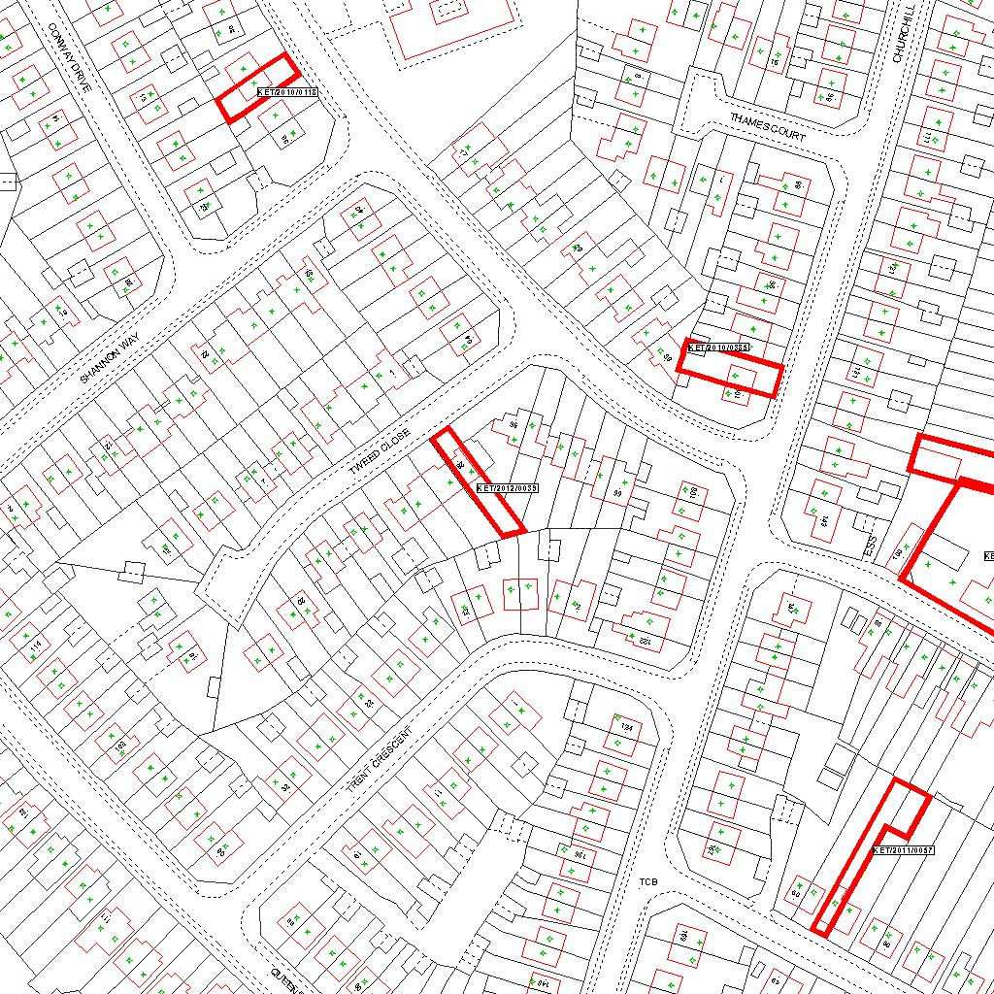

Reproduced from the Ordnance Survey mapping with the permission of the Controller of Her Majesty’s Stationery Office © Crown copyright. Unauthorised reproduction infringes Crown copyright and may lead to prosecution or civil proceedings.  LA078344 |  | N
Date: 19/01/2012 Do not scale from this map. For illustrative purposes only.

