BOROUGH OF KETTERING

Committee | Full Planning Committee - 28/02/2012 | Item No: 5.5
Report Originator | Chris Rose  Development Officer | Application No:  KET/2012/0005
Wards Affected | Ise Lodge
Location | 1 St Magdalenes Road, Kettering
Proposal | Full Application: Two storey rear extension
Applicant | Mrs S Zarwalski

1. PURPOSE OF REPORT

  - To describe the above proposals
  - To identify and report on the issues arising from it
  - To state a recommendation on the application

2. RECOMMENDATION

THE DEVELOPMENT CONTROL MANAGER RECOMMENDS that this application be APPROVED subject to the following Condition(s):-

1. The development hereby permitted shall be begun before the expiration of 3 years from the date of this planning permission.
REASON: To comply with Section 91 of the Town and Country Planning Act 1990 (as amended) and to prevent an accumulation of unimplemented planning permissions.

2. The materials to be used in the construction of the external surfaces of the development hereby permitted shall match, in type, colour and texture those on the existing building.
REASON: In the interests of visual amenity in accordance with policy 13 of the North Northamptonshire Core Spatial Strategy.

3. Notwithstanding the provisions of Article 3 of the Town and Country Planning (General Permitted Development) Order 1995 (or any Order revoking and re-enacting that Order with or without modification) no additional openings permitted by Schedule 2, Part 1 Classes A or C shall be made in the east or west elevation or roof plane of the extension hereby permitted.
REASON: To protect the amenity and privacy of the occupiers of adjoining property in accordance with policy 13 of the North Northamptonshire Core Spatial Strategy.

Notes (if any) :-
NONE

Justification for Granting Planning Permission

The proposal is in accordance with national and local policies as set out in Planning Policy Statement 1, Policies 2 and 3 of The East Midlands Regional Plan, Policies 1, 9 and 13 of the North Northamptonshire Core Spatial Strategy, and Policy 35 of the Local Plan for Kettering Borough. There are no material considerations that indicate against the proposal.

Officers Report

3.0 | Information

Relevant Planning History
None

Site Description
Officer's site inspection was carried out on 03/02/2012. The site is a brick built 2 storey detached dwelling and its curtilage. The rear elevation currently has a single storey conservatory extension which runs the width of the house.

The topography slopes quite markedly from west to east. No. 1 St Magdalenes Road is elevated from neighbouring no. 3 St Magdalenes Road and lower than neighbouring no. 16 St Vincents Avenue.

Proposed Development
Two storey rear extension.

Any Constraints Affecting the Site
None

4.0 | Consultation and Customer Impact

Neighbours
Two representations received. Objections raised in relation to:
- Loss of light to conservatory and garden of no. 3 St Magdalenes Road
- Overlooking of garden of no. 3 St Magdalenes Road
- Windows to ground floor east elevation – should be non-opening
- Loss of light to garden of no. 16 St Vincents Road
- Overlooking of no. 16 St Vincents Road
- Proposed french doors will cause a noise nuisance

5.0 | Planning Policy

National Policies
PPS1 - Delivering Sustainable Development

East Midlands Regional Plan
Policy 2 - Promoting Better Design
Policy 3 - Distribution of new development

North Northamptonshire Core Spatial Strategy
Policy 1 - Strengthening the network of settlements
Policy 9 - Distribution and location of development
Policy 13 - General Sustainable Development Principles

Local Plan
Policy 35 - Housing: Within Towns

6.0 | Financial/Resource Implications
 | None
7.0 | Planning Considerations
The key issues for consideration in this application are:-
- Principle of Development
- Impact on Residential Amenity
- Design
- Other matters

Principle of Development
The application site is within the town boundary of Kettering, as defined by Policy 35 of the Local Plan, in an established residential area. Policy 1 and 9 of the Core Spatial Strategy direct development to existing urban areas. The proposal is for an extension of an existing dwelling within its curtilage which is surrounded by similar residential units. As such, the principle of such development in this area is established.

Impact on Residential Amenity
Policy 13, criterion l, of the North Northamptonshire Core Spatial Strategy (CSS) requires that development would not result in an unacceptable impact on the amenities of neighbouring properties, by reason of noise, vibration, pollution, loss of light or overlooking.

The proposed extension is 2 storey and staggered in depth - it would extend the dwelling to the rear by 3.4 metres on the eastern elevation and by 2.6 metres on the western elevation.

Any potential negative impacts on residential amenity are limited to those dwellings which directly neighbour the site. To the rear the dwellings of no.s 6 and 8 St Nicholas Close back onto the site at an angle of approximately 50°. The proposed extension would decrease the gap between the dwelling and the boundary of these properties to approximately 9-10 metres at the closest point, and the gap between the buildings to approximately 22 metres. These distances are considered sufficient to protect amenity. The siting and orientation of the dwellings and the topography are such that it is considered that the proposal would not result in unacceptable loss of light or overlooking to the neighbouring dwellings to the rear.

To the side elevations, the dwelling is neighboured by no. 3 St Magdalenes Road to the east and by no. 16 St Vincents Road to the west. The ground slopes from west to east so that the dwelling is elevated above no.16 and lower than no. 3. Both neighbouring dwellings have conservatories which extend out around 3-4 metres. Two objections were raised concerning the potential detrimental impact which would arise from the proposal on the amenity of no. 3 St Magdalenes Road, in terms of loss of light to the conservatory and garden and overlooking of the garden, and of no. 16 St Vincents Road in terms of loss of light and overlooking. These issues will be discussed below.

The row of dwellings are north facing. Given the proposal’s height and orientation, relative to the daily path of the sun, it would result in partial overshadowing of the conservatory and garden of no. 16 St Vincents Road in the early morning and partial overshadowing of the conservatory and garden of no. 3 St Magdalenes Road late in the day. However, due to the northerly orientation and extent of the proposed extension, this would be limited to a very partial loss of light limited to certain hours (during the mornings or evening and during the winter months when the sun is set lower in the sky). Both conservatories are large 3 sided structures constructed of glass, including glass roofs, so adequate light would still be provided to them. Both gardens are of sufficient size that sufficient garden area would remain unfettered in terms of light by the proposed extension. In terms of loss of light to neighbouring 1st floor windows of habitable rooms – a line of sight from the midpoint of each window could be achieved without obstruction from the proposed extension at a 45° angle, meaning sufficient light can enter the rooms.

The potential impact on no. 3 St Magdalenes Road is further lessened by virtue of it being elevated, by approximately 0.5 metres, above the level of no. 1 and by the fact the 2 closest 1st floor windows to the proposed extension are obscure glazed. The potential impact on no. 16 St Vincents Road, to which the proposal is elevated, is lessened by the stepping in of the extent of the extension on this elevation to 2.6 metres. This ensures the 45° line can be maintained and sufficient light provided to this dwelling’s windows.

In terms of overlooking to the adjacent properties, no side windows are proposed on the facing side elevations and an existing facing window to the east elevation would be removed. Two rooflights set high in the roof would not result in any overlooking. Conditions are proposed to remove permitted development rights for any future 1st floor windows in the side elevations and any further openings in the roof of the proposed extension. It is not considered that the rear windows of the proposed extension would be materially different in terms of overlooking of the adjacent rear gardens than the existing windows. Both already face out northwards and allow lines of site into adjacent gardens. The proposed windows being on an elevation 2.6 metres - 3.4 metres further north, would not unacceptably increase this level of overlooking. The context of the area is a modern estate development at a medium-high density where a degree of overlooking is to be expected owing to the layout of development.

4 new windows at the ground floor level are proposed – 2 to the west elevation and 2 to the east. No overlooking issues would arise from these windows which, in any case, could be installed under Permitted Development rights.

Due to the topography, scale and staggered extent of the proposed extension it is not considered that the extension would have an overbearing impact on neighbouring properties. The scale of the proposal is proportionate to the original dwelling and does not present an overly large or overbearing mass to surrounding dwellings.

It is therefore considered that the proposal would not have any unacceptable impacts on neighbouring amenity, and is in accordance with CSS Policy 13.

Design
Policy 13 of the CSS requires new development to be of a high standard of design and to respect the character of its surroundings.

The dwelling is a brick built, pitched roof structure of simple design in a modern architectural style, typical of suburban residential developments constructed in the 1990s. As is surrounding development. The majority of dwellings in the area have been extended, ranging from conservatories to 2 storey additions to the front and rear of properties.

All development would be to the rear so there would be no impact on the streetscene. The proposal’s design, scale and mass reflects the existing dwelling and the character of the surrounding area.

Materials are proposed to match the existing dwelling, primarily the red facing brick of the existing house, and this could be secured by condition.

The proposal accords with PPS1, East Midlands Regional Plan Policy 2 and criteria H of Policy 13 of the Core Spatial Strategy.

Other matters
Internal alterations are proposed including conversion of the garage into an office and store. Such alterations benefit from Permitted Development under the 1995 Town and Country Planning General Permitted Development Order. There would be no alterations to the front of the dwelling (the garage door being retained) and off road parking for 2 vehicles would be retained, which is considered to be sufficient.

3 further issues were raised in objections to the proposal:
- Windows to ground floor east elevation – should be non-opening – the installation of these windows would benefit from Permitted Development under the 1995 Town and Country Planning General Permitted Development Order.
- Proposed french doors will cause a noise nuisance – It is considered that no additional noise pollution will arise from the proposal than that ordinarily associated with a domestic dwelling.

Conclusion

The proposed extension is in accordance with the relevant policies of the Development Plan and there are no material considerations which indicate planning permission should not be granted. The principle of development is established, there would be no unacceptable detrimental impact on neighbouring residential amenity and the design is appropriate. The application is recommended for approval, subject to conditions.

Background Papers |  |  | Previous Reports/Minutes
Title of Document: |  |  | Ref:
Date: |  |  | Date:
Contact Officer: |  | Chris Rose, Development Officer on 01536 534316
SITE LOCATION PLAN

1 St Magdalenes Road, Kettering
Application No.: KET/2012/0005

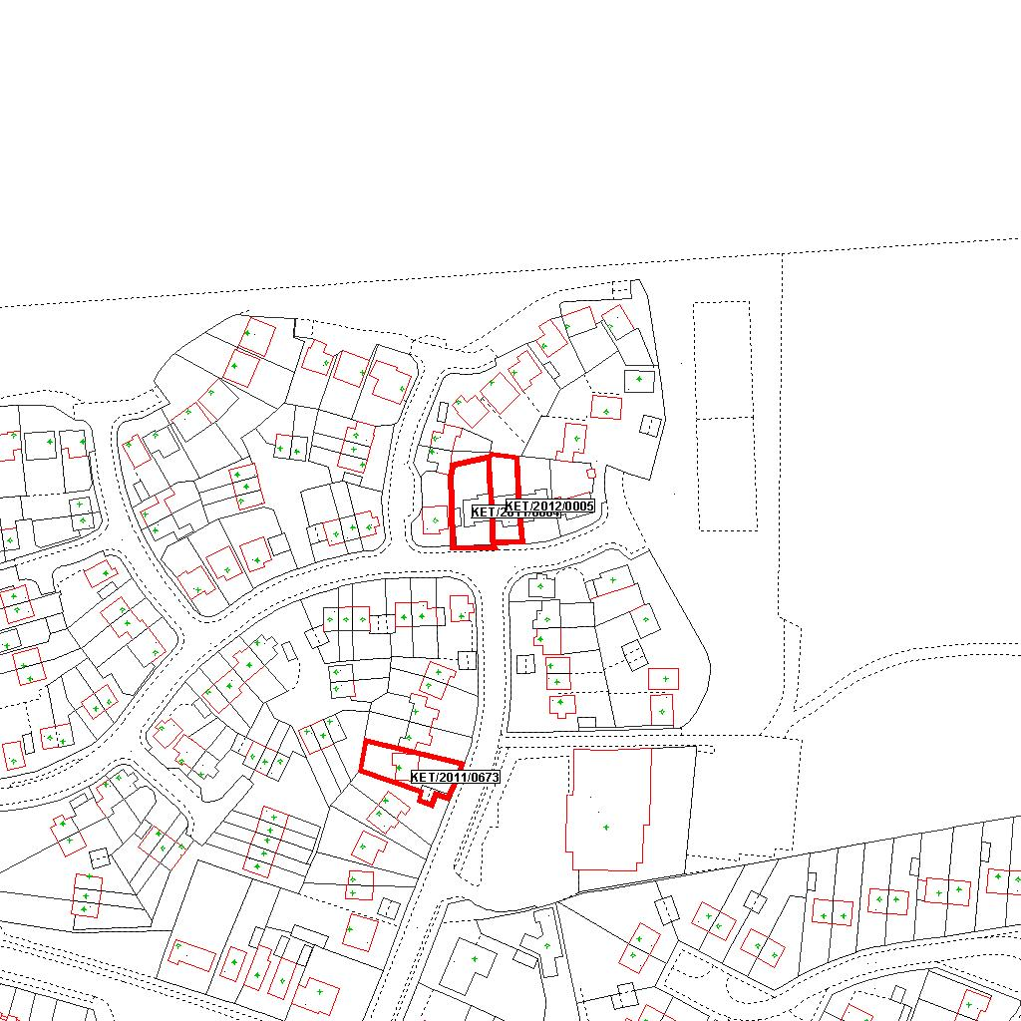

Reproduced from the Ordnance Survey mapping with the permission of the Controller of Her Majesty’s Stationery Office © Crown copyright. Unauthorised reproduction infringes Crown copyright and may lead to prosecution or civil proceedings.  LA078344 |  | N
Date: 04/01/2012 Do not scale from this map. For illustrative purposes only.

