BOROUGH OF KETTERING

Committee | Full Planning Committee - 28/02/2012 | Item No: 5.4
Report Originator | Anne Dew  Senior Development Officer | Application No:  KET/2011/0806
Wards Affected | St. Peters
Location | 10a Gipsy Lane, Kettering
Proposal | Full Application: Change of use of garages and flat to provide 4 no. additional bedrooms for existing residential care home
Applicant | Mr I Sumoreeah

1. PURPOSE OF REPORT

  - To describe the above proposals
  - To identify and report on the issues arising from it
  - To state a recommendation on the application

2. RECOMMENDATION

THE DEVELOPMENT CONTROL MANAGER RECOMMENDS that this application be APPROVED subject to the following Condition(s):-

1. The development hereby permitted shall be begun before the expiration of 3 years from the date of this planning permission.
REASON: To comply with Section 91 of the Town and Country Planning Act 1990 (as amended) and to prevent an accumulation of unimplemented planning permissions.

2. The materials to be used in the construction of the external surfaces of the development hereby permitted, including window detail and sills, shall match, in type, colour and texture those on number 8 Gipsy Lane.
REASON: In the interests of visual amenity in accordance with policy 13 of the North Northamptonshire Core Spatial Strategy.

3. The use hereby permitted shall not be occupied other than as part of the adjoining nursing home known as number 8 Gipsy Lane.
REASON: The unit of accommodation is not of a satisfactory standard to be occupied separately from the nursing home in the interests of amenity in accordance with policy 13 of the North Northamptonshire Core Spatial Strategy.

Notes (if any) :-
- NONE

Justification for Granting Planning Permission

The proposal is in accordance with national and local policies as set out in Planning Policy Statements/Guidance Notes 1, 4 and 5, Policies 2 and 3 of The East Midlands Regional Plan and Policies 1, 9 and 13 of the North Northamptonshire Core Spatial Strategy. There are no material considerations that indicate against the proposal.

Officers Report

3.0 | Information

Relevant Planning History

Application Site
KE/99/0337 Change of use to staff accommodation and garage in association with existing nursing home at 8 Gipsy Lane. CC 20.08.1999. This application covers the application site.

Nursing Home
KE/93/0425 Proposed two storey extension to provide additional 8 bedrooms. Lift, living room. The extension was proposed to the rear of the nursing home and would increase the number of bedrooms from 20 to 28 and the number of residents would increase by 5 to 33. Refused 07.08.1993 on grounds of; overdevelopment to the detriment of amenity and general character and increase in traffic to the detriment of highway safety.
Appeal: Dismissed January 1994. The Inspector concluded the following:-
- the footprint of the extension would be out of proportion with the original house which would detract from the character of the original house and its setting.
- issue of residential amenity was not so harmful to warrant dismissing the appeal on these grounds alone.
- The Increase in traffic would not be harmful to road users, however the need for additional car parking provision would be harmful to the character of the building.

KE/92/432 – Single storey extension to provide staff rest room. To be approved subject to a legal agreement. Legal agreement was not signed and application was withdrawn Jan 2004

KE/91/0686 – Extension to provide conservatory, dining/ physiotherapy room and w.c’s. Approved 22.10.1991. This decision was included within the section 106 agreement for KE/91/0517 and signed 10.12.1991

KE/91/0517 – Extension to nursing home. This provided for 8 additional bedrooms. Approved 10.12.1991 subject to a S106 which restricted future development and stipulating that the remainimg grounds were to remain free of new buildings apart from necessary ancilary access facilities and timber garden storage facilities in order to preserve the present setting of the main building.

KE/90/1069 – Extension of existing nursing home. Single storey extension to provide 8 additional bedrooms and living room. Refused 12.02.1991 on the grounds of adverse impact on character and amenity. Appeal submitted and withdrawn.

KE/90/0959 - 12 bedroom extension. Refused and dismissed at appeal June 1991. The Inspector concluded that the extension would be an obtrusive and unbalanced addition.

KE/90/0954 Single storey extension to provide 12 additional single bedrooms. Refused 04.121990 on grounds that it would detract from the character of the area and will have an adverse impact on amenity of occupants of nearby dwellings. Appeal Dismissed 14.06.1991. The Inspector concluded the following:-
- The extension would result in a discordant and unacceptable extension, harming the basic character of the house as well as the residential garden area.
- The extension would have an overpowering and overbearing effect on neighbours

KE/90/0771 – Alterations to existing building. This application was for replacement windows and doors. Approved 29.10.1990

KE/90/0325 Change of use. Conversion of existing house for residential nursing care. Approved 22.05.1990.

KE/90/0110 Change of use of existing building to nursing home and two storey extension to provide 32 additional single bedrooms. Refused on the grounds of impact on character of area, density is excessive, and adverse impact on amentiy of nearby dwellings and occupants.

KE/89/0460 Change of use of existing building into residetnial home and single storey extension to provide 30 single bedrooms and two living rooms. Refused on the grounds of design, intensification of use, loss of trees and density.

Site Description
Officer's site inspection was carried out on 30/01/2012.

The application site comprises two garages on the ground floor and staff accommodation on the first floor. Number 10a is attached to both numbers 8 and 10 Gipsy Lane. Number 10 is occupied as a single dwellinghouse and number 8 forms Beaumont Nursing Home.

No 8 Gipsy Lane comprises a large brick building built in 1891 by John Alfred Gotch and is protected by way of an Article 4 direction in 1990. The nursing home and attached building the subject of this application is built of local red Kettering bricks in stretcher bond brickwork, with stone detailing, red clay tiled roof and black cast iron gutters and downpipes. The nursing home sits within a large plot which is well landscaped and provides a complimentary setting for the house.

Gipsy Lane is residential in character, comprising many large dwellings of individual design. Vehicular access from the site is from Gipsy Lane.

Proposed Development
The application is for the change of use of a building attached to the existing nursing home form garaging and staff accommodation to extra accommodation for the nursing home. The scheme will provide for four extra four bedrooms and a small room for hair dressing for residents of the home. To facilitate this change of use internal walls will be removed to provide a connection on both the ground and first floors with the existing nursing home. External alterations are also proposed to the front and rear elevations. The two existing garage doors on the front elevation will be replaced by two windows and the two rear facing windows will be replaced by glazed doors.

Whilst there will be an increase in the number of bedrooms, there will be no increase in residency as the existing double rooms in the nursing home will all become single occupancy. Currently there are 21 bedrooms (14 singles and 7 doubles) and the proposed scheme will provide for 26 rooms all of which will be single.

Any Constraints Affecting The Site
The nursing home (but not including the application site) is protected by way of an Article 4 Direction which removes all permitted development.

Planning permission KE/91/0517 (Extension to nursing home) was subject to a S106 obligation which restricted future development in the grounds.

B Road

4.0 | Consultation and Customer Impact

Neighbours Two third party representations received. Objections are on the grounds of:-

- Flat 10a does not form part of the nursing home
- Access boundary line is incorrect
- Existing single vehicular access is busy
- Delivery vans block access
- Parking issues and highway safety implications
- Bedrooms will look out onto congestion
- The existing garage floods
- Noise and odour as no cavity wall insulation
- Site is unique as designed by Alfred Gotch

5.0 | Planning Policy

National Policies
PPS1 Delivering Sustainable Development
PPS4 Planning for Sustainable Economic Growth
PPS5 Planning for the Historic Environment
PPG13 Transport

Development Plan Policies

East Midlands Regional Plan
P2 Promoting Better Design
P3 Distribution of New Development
P26 Protecting and Enhancing the Region’s Natural and Cultural Heritage
P27 Priorities for the Historic Environment
P48 Regional Car Parking Standards

North Northamptonshire Core Spatial Strategy
P1 Strengthening the Network of Settlements
P9 Distribution and Location of Development
P13 General Sustainable Development Principles

Local Plan
K15 Character and Density in Defines Housing Areas

SPGs
Sustainable Design

6.0 | Financial/Resource Implications
 | None
7.0 | Planning Considerations
The key issues for consideration in this application are:-

- Principle of Development
- Design/ Impact on Character of the Area
- Impact on Residential Amenity
- Highway Safety Implications

Principle of Development
Policy 3 of the East Midlands Regional Plan and polices 1 and 9 of the North Northamptonshire Core Spatial Strategy focus new development within the growth town of Kettering. The application site is located within the town boundary of Kettering in a location that is accessible by a choice of means of travel.

PPS4 is also of relevance as the proposal will provide employment opportunities. Policy EC10 ‘Determining Planning Applications for Economic Development is applicable and this requires that developments are planned over the lifetime of their developments to limit carbon dioxide emissions; they are accessible by a choice of means of transport; they provide for a high quality and inclusive design; they impact on economic and physical regeneration and they impact on local employment. It is considered that the use of the building as an extension to the nursing home meets all these criteria; it will provide for the re-use of a currently under utilised building; it is located in an accessible location, being close to the town centre and public transport that runs along Northamptonshire Road; its design is appropriate for its setting and it will provide for local employment opportunities.

Saved Policy K15 of the Local Plan for Kettering Borough classifies the site as part of the Gipsy Lane/ Northampton Road defined housing area where planning permission will not be granted for residential development involving redevelopment, infilling or the sub-division of a property’s curtilage. The purpose of this policy is to ensure that the character of the area (large detached dwellings set within large grounds) is maintained, residential amenity is not affected and that a range of housing within the town is maintained. The application site is already linked to the use of number 8 Gipsy Lane as a nursing home as will the proposed change of use. Given this link, it is not considered that the change in use of the building will compromise the objectives of policy K15. Character and Amenity implications are discussed below and the loss of staff accommodation will not result in the loss of a large dwelling house.

In conclusion, the principle of development is considered acceptable. The scheme meets the requirements of policy 3 of the East Midlands Regional Plan, policies 1 and 9 of the North Northamptonshire Core Spatial Strategy and policies within PPS4.

Design/ Impact on Character of the Area
Policy 13(h) of the North Northamptonshire Core Spatial Strategy requires that developments be of a high standard of design, architecture and landscaping and enhance the character of its surroundings. In addition, policy 13(i) of the North Northamptonshire Core Spatial Strategy requires that developments strengthen the distinctive historical and cultural qualities and townscape of the town.

The application site is attached to and associated with number 8 Gipsy Lane (Beaumont Nursing Home) which is protected by an Article 4 Direction to ensure that no unsympathetic alterations take place to the building. One of the objectives of PPS5 and policy 27 of the East Midlands Regional Plan is to conserve heritage assets in a manner appropriate to their significance.

It is not considered that the change of use itself will have any adverse impact upon the character of the area. The building is already associated with the use of number 8 Gipsy Lane and will continue to do so and will not result in any increase in activity as the number of residents will remain the same. The external alterations associated with the building comprise replacement of the garage doors on the front elevation with two windows and the replacement of two ground floor windows with glazed doors on the rear elevation. All new openings will be timber, as will the surrounds in the front elevation and all alterations will be made good with matching materials and finishes. The change of use of the building will not have any impact on the setting of the nursing home as no alterations are proposed to any of the garden area which is protected by way of the S106 obligation. The applicant has confirmed that there is no need for this staff accommodation and thus there will be no pressure in the future for further extensions to the nursing home for such accommodation.

In concussion, subject to conditions requiring materials to match existing, it is considered that the scheme meets the requirements of PPS5 and policy 27 of the East Midlands Regional Plan and policies 13(h) and (l) of the North Northamptonshire Core Spatial Strategy.

Impact on Residential Amenity
Policy 13(l) of the North Northamptonshire Core Spatial Strategy requires that development do not result in an unacceptable impact on the amenities of neighbouring properties of the wider area, by reason of noise, vibration, smell, light or other pollution, loss of light or overlooking.

The applicant has confirmed that whilst the number of bedrooms will increase, there will be no increase in residents and thus no increase in activity to the existing arrangement. It is thereby considered that the change of use will not result in any greater levels of noise and disturbance to the amenity of occupiers of nearby dwellings than the current arrangement. Concern has been expressed by the occupier of the attached dwelling house at number 10 Gipsy Lane and internal noise, however, this matter will be addressed with any associated Building Regulations approval.

The alterations proposed to the building will not result in any increase in overlooking to occupiers of adjacent dwellings given that first floor windows will remain as habitable rooms.

Concern has been expressed by third parties that the parking of vehicles immediately in front of number 10a will result in adverse levels of noise and disturbance to residents using these rooms. The applicant has confirmed that the hard standing area in front of these windows will not be used for car parking and as such any such amenity issue will not arise.

In conclusion, the use of the building as an extension to the existing nursing home, which can be secured by condition, will not have give rise to any adverse amenity implications.

Highway Safety Implications
Policy 13(n) of the North Northamptonshire Core Spatial Strategy requires that developments do not have an adverse impact on the highway network and do not prejudice highway safety.

The applicant has confirmed that whilst the scheme will result in an additional four bedrooms, the number of residents will not increase with the transition from double to single bedrooms. The current nursing home has a car park which can accommodate 10 car parking spaces and the scheme does not propose any alterations to this. Given there will be no increase in residents, it is not considered that this application generates any additional need for car parking than the existing nursing home. Currently there is an arrangement that an occupier of a nearby dwellings park in front of the existing garages, however the applicant has advised that this agreement is informal and they have also confirmed that this land forms part of the application site. Concern has been raised by third parties about the loss of this car parking space, however, this is an informal agreement which could cease at any time.

Conclusion

The proposal is considered to be in accordance with local and national policy. The scheme will not detract from the character of the building or the surrounding area nor does it raise any adverse implications for amenity or highway safety.
Background Papers |  |  | Previous Reports/Minutes
Title of Document: |  |  | Ref:
Date: |  |  | Date:
Contact Officer: |  | Anne Dew, Senior Development Officer on 01536 534316
SITE LOCATION PLAN

10a Gipsy Lane, Kettering
Application No.: KET/2011/0806

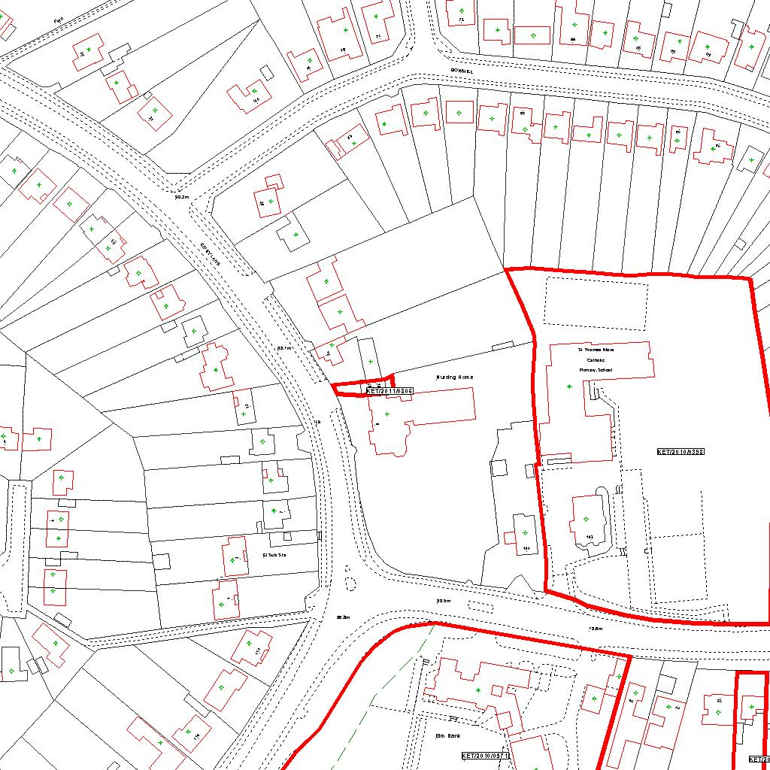

Reproduced from the Ordnance Survey mapping with the permission of the Controller of Her Majesty’s Stationery Office © Crown copyright. Unauthorised reproduction infringes Crown copyright and may lead to prosecution or civil proceedings.  LA078344 |  | N
Date: 13/12/2011
22/12/2011
13/12/2011
13/12/2011
13/12/2011
13/12/2011
13/12/2011
13/12/2011
13/12/2011
13/12/2011
13/12/2011
13/12/2011
13/12/2011
13/12/2011
13/12/2011
13/12/2011 Do not scale from this map. For illustrative purposes only.

