BOROUGH OF KETTERING

Committee | Full Planning Committee - 28/02/2012 | Item No: 5.2
Report Originator | Michael Boniface  Development Officer | Application No:  KET/2011/0260
Wards Affected | Barton
Location | Barton Seagrave Hall, Barton Road, Barton Seagrave
Proposal | Application for Listed Building Consent: Change of use to hotel, wedding venue, conference centre, and associated ancillary works
Applicant | Mr T Hazelton Hazelton Group & Wicksteed Trust,

1. PURPOSE OF REPORT

  - To describe the above proposals
  - To identify and report on the issues arising from it
  - To state a recommendation on the application

2. RECOMMENDATION

THE DEVELOPMENT CONTROL MANAGER RECOMMENDS that this application be APPROVED subject to the following Condition(s):-

1. The works to which this consent relate shall be begun before the expiration of 3 years from the date of this consent.
REASON: To comply with Section 18 of the Planning (Listed Buildings and Conservation Areas) Act 1990 (as amended) and to prevent an accumulation of unimplemented consents.

2. The works hereby permitted shall not be carried out other than in accordance with the amended plan numbers 1061-24F, 1061-30F, 1061-25F, 1061-29C, 1061-43 and 1061-23B received by the Local Planning Authority on 16th November 2011.
REASON: To clarify the terms of the consent and to avoid detriment to the character and appearance of the listed buildings in accordance with advice contained wihin PPS5.

3. The principal buildings shall not be occupied until the works to the Orangery hereby approved have been implemented in full.
REASON: To ensure that the proposed Orangery is brought back into viable use and further damage and deterioration prevented in accordance with advice contained within PPS5.

4. The proposed timber clad link building between the Dovecote and the Stable Buildings shall not be constructed other than in accordance with a sample panel which shall have been constructed on site and approved in writing by the Local Planning Authority prior to the commencement of development. As approved, the sample panel shall be retained on site and kept available for re-inspection throughout the construction period. The weatherboarding shall be finished in dark brown or black stain on all areas indicated on drawing 1061-30F. The boarding is to be no less than 180mm in total width along its vertical plane and 25mm is depth along its thickest edge. Shiplap and waney edge timber shall not be used. The weatherboarding shall be retained in this manner thereafter.
REASON: In the interests of preserving the architectural and historic interest of the listed building in accordance with the advice contained within PPS5.

5. No works shall take place on site until full details of the design, materials and method of fixing the proposed link between the spa building and principal buildings have been submitted to and approved in writing by the Local Planning Authority. The works shall not be carried out other than in accordance with these details.
REASON: In the interests of preserving the architectural and historic interest of the listed building in accordance with the advice contained within PPS5.

6. No works shall commence on site until a scheme detailing all external appurtenances have been submitted to and approved in writing by the Local Planning Authority. No new plumbing, pipes, soil stacks, flues, vents, extracts ductwork, grilles, security alarms, lighting, cameras or other external appurtenances shall be installed other than in accordance with the approved scheme.
REASON: In the interests of preserving the architectural and historic interest of the listed building in accordance with the advice contained within PPS5.

7. No works shall commence on site until a sample panel of all facing materials has been constructed on site and approved in writing by the Local Planning Authority. The works shall not be carried out other than in accordance with the approved details. As approved, the sample panel shall be retained on site and kept available for re-inspection throughout the construction period. The samples panel must demonstrate the proposed walling material, mortar type, bond, coursing and pointing.
REASON: In the interests of preserving the architectural and historic interest of the listed building in accordance with the advice contained within PPS5.

8. No works shall commence on site until details of the types and colours of all roofing materials to be used, together with samples, have been submitted to and approved in writing by the Local Planning Authority. The works shall not be carried out other than in accordance with the approved details. The samples shall include a minimum of 3 tiles and a ridge tile along with details of the source/supplier.
REASON: In the interests of preserving the architectural and historic interest of the listed building in accordance with the advice contained within PPS5.

9. No development shall take place until a strategy for dealing with any damp and/or infestation has been carried out by a suitably qualified expert and been submitted to and approved in writing by the Local Planning Authority. No remedial damp proofing or infestation works shall be carried out other than in accordance with the approved strategy.
REASON: To avoid unnecessary and potentially harmful works to the fabric of the listed building and protect its character and appearance in accordance with advice contained within PPS5.

10. No works shall commence on site until a method statement detailing the introduction of services, plumbing, electrical works and all other internal interventions has been submitted to and approved in writing by the Local Planning Authority. The statement shall include, but not be limited to, the methods for lifting any floor boards and skirting boards and details of any repair methods.
REASON: In the interests of preserving the architectural and historic interest of the listed building in accordance with the advice contained within PPS5.

11. No doors, fireplace surrounds, fitted cupboards or other historic fixtures shall be removed or altered other than in accordance with a Schedule of Works which shall first have been submitted to and approved in writing by the Local Planning Authority.
REASON: In the interests of preserving the architectural and historic interest of the listed building in accordance with the advice contained within PPS5.

12. No works shall take place on site until full details of all new timber finishes (including windows and doors), verge detailing and rainwater goods have been submitted to and approved in writing by the Local Planning Authority. The works shall not be carried out other than in accordance with the approved details.
REASON: In the interests of preserving the architectural and historic interest of the listed building in accordance with the advice contained within PPS5.

13. No works shall take place on site until full details of all new windows and doors have been submitted to and approved in writing by the Local Planning Authority. The details shall include window and door elevations at a scale of at least 1:10, horizontal and vertical cross sections at a scale of at least 1:5 and details of specific mouldings at a scale of at least 1:2. Window details shall also include proposals for the depth of reveal (to face Brickwork) and include opening method and sill. The works shall not be carried out other than in accordance with the approved details and shall be retained in that form therafter.
REASON: In the interests of preserving the architectural and historic interest of the listed building in accordance with the advice contained within PPS5.

14. No pointing works shall take place until details of the proposed mix and techniques have been submitted to and approved in writing by the Local Planning Authority. Pointing works shall not be carried out other than in accordance with the approved details.
REASON: In the interests of preserving the architectural and historic interest of the listed building in accordance with the advice contained within PPS5.

15. All new openings shall be made by hand and all disturbed fabric shall be made good using materials and treatments matching that of the existing building.
REASON: In the interests of preserving the architectural and historic interest of the listed building in accordance with the advice contained within PPS5.

16. Notwithstanding the submitted details, all roof lights hereby approved shall be of a conservation type. No part of the roof light shall protrude from the roof plane by more than 50mm and all flashings and soakers shall be lead.
REASON: In the interests of preserving the architectural and historic interest of the listed building in accordance with the advice contained within PPS5.

17. No opening shall be created between the proposed dining areas until details of the proposed method of structural support have been provided along with a method statement detailing the techniques, materials and processes to be used in making good the disturbed fabric. The works shall not be carried out other than in accordance with the approved details.

REASON: In the interests of preserving the architectural and historic interest of the listed building in accordance with the advice contained within PPS5.

18. No works shall take place on site until details of the proposed method of fixing the conservatory to the principal building as well as its relationship with the existing arched recess have been submitted to and approved in writing by the Local Planning Authority. The conservatory shall not be installed other than in accordance with these approved details.
REASON: In the interests of preserving the architectural and historic interest of the listed building in accordance with the advice contained within PPS5.

19. The cobbled floors, timber stalls, hay racks, hoppered viewing windows and sliding sash windows above stable doors within the stable buildings shall be retained within the development in accordance with drawing number 1061-24F.
REASON: In the interests of preserving the architectural and historic interest of the listed building in accordance with the advice contained within PPS5.

Notes (if any) :-
NONE

Justification for Granting Planning Permission

Not applicable

Officers Report

3.0 | Information

Relevant Planning History
KET/2007/0686 – Certificate of lawfulness sought to formalise use of the building for catering, lecures and meetings – REFUSED 05/10/2007

KET/2007/0685 – Internal alterations to upgrade Orangery – REFUSED 28/03/2008

KET/2006/0581 – Repair to Orangery including cathodic protection of buried ironwork – APPROVED 09/08/2006

KET/2006/0181 – Replace 3 dormer windows in west wing (casements only) – APPROVED 12/04/2006

KET/2006/0121 – Change of use from nursing home to NHS office suite (ground floor) and art studios with ancillary offices (first floor) – APPROVED 31/03/2006

KET/2002/0907 – Change of use from nursing home to NHS office suite (ground floor) and art studios with ancillary offices (first floor) – APPROVED 23/01/2003

Site Description
Officer's site inspection was carried out on 31/08/2011.

The site lies to the north of Barton Seagrave and accommodates a large stone built country house and associated outbuildings. Barton Seagrave Hall is a country house dating mainly from the 18th century, with an earlier core of the 16th century and later additions. It is listed Grade II* which places it in the top 8% of listed buildings in England. It is on English Heritage’s Heritage at Risk Register. The site includes the Grade I listed 18th century Orangery, also on the Heritage at Risk Register, and a Grade II listed stable block. It lies within Barton Seagrave Conservation Area and a Schedule Ancient Monument opposes.

A modern residential development adjoins the site to the east with the historic settlement of Barton Seagrave itself opposing on the south side of Barton Road. Open fields otherwise surround creating a rural setting for the building albeit with distant views of Kettering. The site generally slopes downwards to the west towards Kettering. Vehicular access is gained directly from Barton Road.

Proposed Works
The proposals involve an extension to the rear of the principal building, a new swimming pool and spa building on the site of existing dilapidated barns to the north of the site, creation of a car park within the walled garden, reinstatement of an existing conservatory and a series of both external and internal alterations to accommodate a change of use to 52 bedroom hotel, wedding venue, conference centre and spa facility.

Any Constraints Affecting The Site
- Barton Segrave Hall – Grade II* listed
- Orangery – Grade I listed
- Stable block - Grade II listed
- Conservation Area

4.0 | Consultation and Customer Impact

English Heritage
Support. The proposals to convert the Hall and associated buildings into a hotel, and build a new spa complex in the grounds, are generally sympathetic to the character, significance and setting of the historic buildings and will secure their repair and long-term future. We have assessed the proposals in line with the guidance contained in Planning Policy Statement 5 (PPS5): Planning for the Historic Environment, and in particular policies HE7, HE9 and HE10. In our view the public benefits of the proposals will outweigh any harm caused to the significance of the designated assets, and any new development on the site will be appropriate in terms of scale, height and massing.

NCC Archaeology
A Heritage Assessment and Building Survey have been provided but are lacking detail in some areas. It is suggested that a survey has been carried out in line with English Heritage’s Level 2 requirements however the photographs do not sufficiently record the external elevations or internal rooms and circulation spaces. No recording of the ruined buildings within the walled garden and the areas to the north have been provided due to accessibility issues; this should be arranged. There is no indication of the recoding methods used or the contents of the project archive. Whilst a good level of information has been provided further detail is necessary and should be secured by condition.

Ancient Monuments Society
Barton Seagrave Hall, its stables and outbuildings including orangery form an exceptional group and the proposed re-use is welcomed. It is however noted that the proposal involves the creation of an opening between the dining room and the library. This is the oldest part of the house (1550-1600) and this has not been sufficiently justified. Similarly, no photographs have been provided of the service stairs to be removed and their significance should be established prior to determination.

5.0 | Planning Policy
S.16(2) and S.72(2) – Planning (Listed Buildings and Conservation Areas) Act 1990

National Policies
PPS5 – Planning for the Historic Environment

6.0 | Financial/Resource Implications
 | None
7.0 | Planning Considerations
The key issues for consideration in this application are:-

- Impact on Listed Building;
- Impact on the Conservation Area.

1. Impact on Listed Building
Section 16(2) of the Planning (Listed Buildings and Conservation Areas) Act 1990 requires that “in considering whether to grant listed building consent for any works the local planning authority or the Secretary of State shall have special regard to the desirability of preserving the building or its setting or any features of special architectural or historic interest which it possesses”.

PPS5 provides national policy guidance and advises Local Planning Authorities to consider the significance of the heritage asset in question and the extent to which the proposed works would impact upon the significance of the building and its setting.

Barton Seagrave Hall is listed Grade II* and described in the list description as an early 18th century country house with later additions. During pre-application discussions and site inspections it became evident that there is an earlier core to the house, and this has been confirmed by the Archaeological Survey accompanying the applications. The earliest phase of the house in fact dates from the 16th or early 17th century, with the main construction phases carried out in the 18th century and some later additions. The Hall is on English Heritage’s Heritage at Risk Register, as it is in a state of slow decay and only partially in use. Both the Council and English Heritage have been concerned about the deteriorating state of some of the fabric, and the absence of any long term solution for its use for some time.

Adjacent to the Hall is the Grade I listed Orangery dating from the late 18th century. It is a rare survival of its type and is of exceptional architectural and historic interest on a national scale. Despite having been repaired with grant aid from English Heritage, it remains on the Heritage at Risk Register because it is not in use and suffers from vandalism. It is therefore considered that a sympathetic scheme to convert Barton Seagrave Hall into a hotel and spa complex will be beneficial in securing a viable future for the site, leading to repairs and ongoing use for both the Hall and the Orangery. The Hall has long ceased to be a single dwelling and has undergone numerous alterations for institutional use in the 20th century, many of them unsympathetic. While a hotel scheme will necessitate some new development and some sub-division of internal spaces, this can be done sympathetically and there is an opportunity to repair, enhance and better reveal significance by removal of unsightly additions.

A grade II listed stable block also stands within the site and survive in good condition accommodating cobbled floors, timber stalls, hay racks, hoppered viewing windows and sliding sash windows above stable doors. The buildings therefore provide great historic interest in their own right but also as an important part of the overall group of listed buildings on the site.

It is of course important that any proposals avoid substantial harm to the listed buildings and their setting (in line with PPS5, policy HE9.1), and that any harm that would be less than substantial be balanced against the public benefits of the scheme (PPS5, policy HE9.4). The applicants have gone to some lengths to minimise harm to the significance of the designated assets and their setting, and also to ensure that any new development on the site makes a positive contribution to the character and local distinctiveness of the historic environment (in line with PPS5, policy HE7.5). A good level of supporting documentation and historical analysis accompanies the applications (see PPS5, policies HE6 and HE7.1) including a Heritage Assessment, Archaeological Survey, Design and Access Statement and Structural Survey.

The applicant has also been forthcoming with amendments during the course of the application to address concerns and ensure the best possible solution for the buildings with minimal adverse impacts and interventions. Concerns were initially raised in regards to the following aspects:
- loss of the staff stairs and a decorative partition in the C18th service range,
- design of the replacement conservatory and failure to re-use existing internal fittings and floor tiles,
- remodelling of the grade II stable block involving loss of internal fittings and replacement of doors with windows,
- failure to make use of the existing Orangery,
- No mention of historic mounting block,
- Design of link to Dovecote.
All of these issues have now been addressed and the application is considered on the basis of the amended plans.

The Principal Building (Grade II*)
The works to Barton Hall itself comprise removal of modern partition walls and reorganisation of the internal spaces however the original walls and plan form are to be retained as far as possible. The main proposals in this area include:

- Creation of an opening between the C16th hall and cross wing and the late C18th library to the north,
- Remodelling of the lobby area to create a reception including an extension,
- Loss of the Victorian Sash Windows on the western frontage,
- Replacement conservatory,
- Rear extension to modern buildings and link to Dovecote.

Whilst the creation of an opening between the C16th hall and the C18th library will undoubtedly result in detriment to the historic fabric of the building and its historic plan form, it is accepted that the new opening to link the proposed dining spaces and the remodelling of the entrance is necessary to meet modern requirements for a restaurant. The changes are required to make the scheme viable for the applicant and the level of harm inflicted on the building is not so great as to amount to substantial harm requiring the refusal of planning permission. The sense of historic separation between the cross wing and former library would still be discernible with an opening of the width proposed and the works could be reversed at a later date so as to restore the former plan form of the building. Conditions should be used to secure full details of the proposed method of structural support to be introduced.

It is proposed to replace the existing windows on the West elevation which appear to be later additions. Although the windows are not original, they nonetheless form part of the narrative of the building and may represent features from the Victorian remodelling works. The windows do however appear to have been altered over the years and represent little merit in themselves. They are in a poor state of repair and their replacement with single glazed 6 over 6 sash windows more in keeping with other openings in this part of the building is considered acceptable.

Reinstatement of the former conservatory on the east side of the hall is a positive proposal as the remnants of the internal fittings still remain but are currently exposed to the elements. It is noted that the design, size and form of the proposed structure seek to reflect that of the previous conservatory in line with the photograph provided. The original tiled floor will be reinstated and the slate table and ornate cast iron legs will be refurbished, restored and retained within the conservatory. These are important historic features which contribute to the character of the original building and their retention serves to enhance the listed building. Details as to how the proposed conservatory would be fixed to the masonry of the hall and how it would accommodate the porch and arched recess should be secured by condition.

A modest single storey extension is proposed to the rear of the building so as to increase the size of the proposed kitchen facilities. The addition would impact a range of late C20th brick built additions which are insensitive to the principal building and the alterations therefore provide an opportunity to improve the design and appearance in this area. The extension would also provide a link to the existing Dovecote building in order for this area to provide an effective functional use.

A small addition would also be provided along the south edge of the internal courtyard which has again been subject to previous alterations; this would provide back office facilities behind the proposed reception area. The addition is very small and subject to the use of appropriate materials would not detract significantly from the character of the building. The addition would be accessed via an existing door serving modern toilets and the existing sash windows would be retained in situ.

The contents of the structural survey are noted and the necessity for the remedial work prescribed is largely accepted. I am sceptical however about the need for, or effectiveness of, proposed damp proof courses as an early remedial option. The building is inherently porous being of limestone and so in the first instance I would expect to see leaking rainwater goods repaired, broken and missing roof tiles replaced and internal plumbing renewed. These actions, accompanied by lowering ground levels, perhaps with soakaways, and better ventilation may solve some problems without costly invasive work being necessary. Whilst this is so, the building will undergo significant works in order to accommodate the proposed development and the effectiveness of the measures described above would take some time to ascertain. If ineffective, invasive works will be necessary to prevent deterioration of the building and it would be far more practical to carry out such works whilst the building was undergoing other works and remains unoccupied. I consider that the proposed damp proofing would not amount to significant harm to the character of the building and is necessary in ensuring viable long-term use.

The Orangery (Grade I)
The Orangery has been restored using grant funding from English Heritage but has since been boarded up and unused leading to vandalism. It is imperative that this Grade I listed building is brought back into use as part of the development so as to avoid deterioration. The scheme now proposes the installation of a small kitchen area and reinstatement of toilet facilities (fittings and pipe work remain in place). The building would thereafter be used ancillary to the remainder of the development. It is considered reasonable to impose a condition on any planning permission granted requiring the proposed works to the Orangery to take place prior to occupation of the development so as to ensure their implementation and viable reuse of the structure.

Outbuildings containing stables (Grade II)
These are described in paragraph 5.24 of the Heritage Assessment Statement while section 2.2.6 of the Archaeological Survey states “stables internally survive in generally good condition…Considerable care was taken during their recent conversion into artists studios to retain cobbled floors, timber stalls and hay racks”. The buildings also retain their hoppered viewing windows and horizontal sliding sash windows positioned above stable doors. These features define the buildings character as a functional stable block and it is therefore considered that their retention is essential in maintaining this character and the significance of the building. The proposals have therefore been amended accordingly to make use of the existing openings, maintain the plan form (albeit with small openings to allow access between stables) and for internal fixtures to be retained. This should be secured by condition but will successfully allow reuse of the building whilst retaining its character.

The Dovecote barn is largely unaltered at present however the proposed works represent a sympathetic conversion, which deftly handle the subdivisions required, minimise the loss of historic fabric, keep the inherent ruggedness of the building and maintain as far as possible the sense of internal space. This would result in only limited implications for the significance of the asset. Good external detailing for doors and windows will be vital to preserve the building’s existing character and appearance and its contribution to the hall group and should be secured by condition.

Existing timber garages currently occupy the space between the stables and dovecote but present little historic merit as clearly modern additions. These structures would be demolished and a two storey link would be provided providing access to the first floor. This would be a clearly modern addition which could blur the distinction between the stable block and the dovecote and care has therefore been taken to ensure a subordinate appearance. The addition would appear as a modern infill and would be highlighted as such through the use of horizontal timber cladding on the south elevation to retain the distinction between the historic and modern buildings.

The walled garden complex (curtilage structure)
These contribute significantly to our understanding of the level of provision for a house of this type in this part of Northamptonshire. The walls themselves and their existing openings are to be retained although large parking areas are to be introduced in place of the existing grassed areas and overgrown shrubs. The former use of the area will remain identifiable by virtue of the walls and the potting sheds (which are to be converted and reused) however the surface treatments will be important in ensuring that the area does not become overly engineered in appearance. Conditions should be used to secure details of the proposed materials. It is noted that some of the larger trees existing on the peripheries of the walled gardens are to be retained and this will help to soften the appearance of the parking area.

Former farm buildings (curtilage structures)
The most extensive modern extensions are to occur in this area. It is unclear what archaeological potential these buildings contain as vegetation prevents their inspection however it is quite clear that the buildings are in a poor state of repair. The roof has collapsed and walls appear unstable as great amounts of trees and vegetation have taken over.

The design of the proposed spa is quite intensive but appears to lie on or only slightly over the existing footprint and the location would not appear to impinge on the setting of the principal listed buildings unacceptably. The building has been designed to maintain a barn like appearance with simple rectangular plan formed (viewed externally) and minimal openings which take on the proportions and appearance of former agricultural openings. The building would present a larger mass that that of the existing barns however this is necessitated by the nature of the proposed use which incorporates a swimming pool and spa facilities. Overall, the design and appearance of the structure would be sensitive to its surroundings and would not detract from the setting of the principal buildings.

The link to the spa building is acceptable subject to appropriate materials and finishes. It would help if a differentiating material was used for the link building so as to maintain the definition between the older buildings that is currently created by the existing gap between them. The proposed drawings indicate that glazing could be used to achieve this however limited detail has been provided and this should be secured by condition.

2. Impact on the Conservation Area
The site stands within a designated conservation area; Section 72 of the Planning (Listed Buildings and Conservation Areas) Act 1990 requires that “special attention shall be paid to the desirability of preserving or enhancing the character or appearance of that area”.

The proposed alterations are likely to result in only very subtle changes to the character of the Conservation Area. The front elevation of the building which is prominent from the public realm despite large trees and the existing stone boundary wall would be largely unaltered with only repair and restoration works proposed. Glimpses of the reinstated conservatory are likely to be possible however this has been designed to reflect the former structure which is in keeping with the character of the building and would therefore preserve its setting. The proposed parking area would stand close to Barton Road and the adjacent footpath however this would be entirely surrounded by the existing walled garden and this will provide effective screening from the public realm. Very limited visual impact would therefore result from this element of the scheme and the character and appearance of the conservation area would again be preserved. In all other respects the proposals, as they are described would enhance the local character.

Conclusion

The proposed works would preserve the character, appearance and special interest of the listed buildings in accordance with Section 16 of the Planning (Listed Buildings and Conservation Areas) Act 1990 and Listed Building Consent should therefore be granted subject to appropriate conditions.

Background Papers |  | Previous Reports/Minutes
Title of Document: |  | Ref:
Date: |  | Date:
Contact Officer: | Michael Boniface, Development Officer on 01536 534316

SITE LOCATION PLAN

Barton Seagrave Hall, Barton Road, Barton Seagrave
Application No.: KET/2011/0260

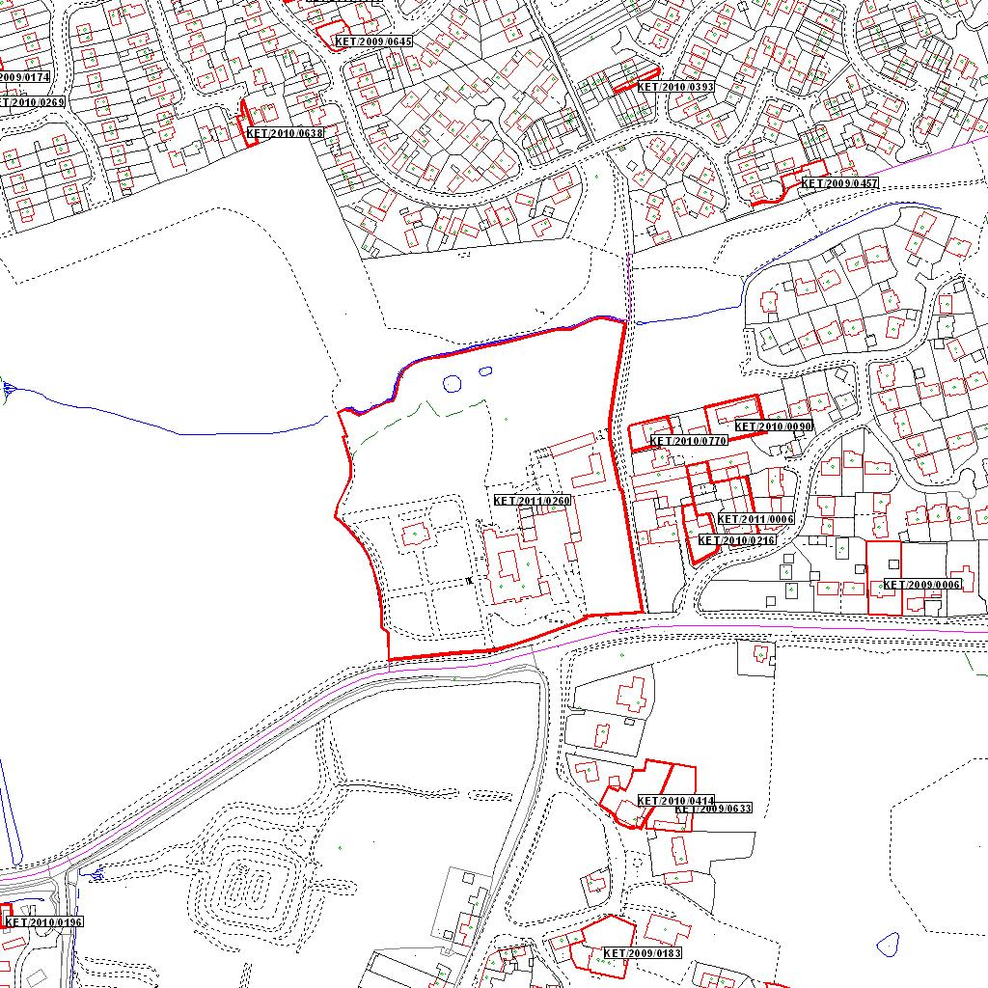

Reproduced from the Ordnance Survey mapping with the permission of the Controller of Her Majesty’s Stationery Office © Crown copyright. Unauthorised reproduction infringes Crown copyright and may lead to prosecution or civil proceedings.  LA078344 |  | N
Date: 04/05/2011 Do not scale from this map. For illustrative purposes only.

