To all Members | Direct Line: (01536) 534398  Email: anneireson@kettering.gov.uk  Our Ref: AI  Your Ref:  Date: 15th February 2012

Dear Councillor

You are summoned to a meeting of Kettering Borough Council to be held in the Council Chamber on Thursday, 23rd February 2012 at 7.00 pm.

Yours faithfully

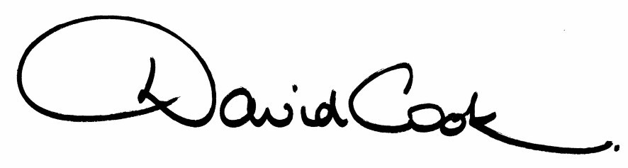

D Cook
Chief Executive

A G E N D A

1. Apologies.

2. Minutes of the Special Meeting of the Council held on 14th December 2011 to be approved as a correct record and signed by the Mayor

3. Minutes of the Ordinary Meeting of the Council held on 14th December 2011 to be approved as a correct record and signed by the Mayor

4. Minutes of the Budget Consultation Meeting held on 26th January 2012 to be approved as a correct record.

5. Declarations of Interest:-

- Personal
- Prejudicial

6. To receive any announcements from the Mayor and/or the Leader of the Council.

7. Report of the Chief Executive.

8. The Mayor to ask members of the public present if they want to speak on any item on the agenda.

9. Nomination for Deputy Mayor 2012/13

Reports:

10. Budget Proposals for General Fund, Housing Revenue Account and Capital 2012/13 (to follow)

11. Treasury Management Strategy – Prudential Indicators (to follow)

12. Localism Act 2011 (to follow)

13. To consider motions received in accordance with Council Procedure Rule 16 as follows:-

(i) To be proposed by Councillor Jonathan West and seconded by Councillor Maggie Don:-

"This Council notes the continuing improvements to our town centres' environments and utilises the present opportunity consider nominating a named officer to act a 'Town Centres Manager', so enabling full engagement with our local traders and other interested parties in considering future developments such as parking and toilet provision."

14. To receive questions from members.

15. Any matters of urgency that the Mayor decides should be considered.

15.2.12
Fire Alarm

All meetings shall be adjourned immediately on the sounding of the fire alarm. The alarm is a continuous two-tone siren. On hearing the alarm please leave the building by the nearest emergency exit. There are emergency exits at both ends of the corridor outside the meeting rooms. On leaving the building please cross the car park and assemble on the grassed area by the church. Do not attempt to drive out of the car park as this may impede the arrival of emergency vehicles. Please do not return to the building until you are told it is safe to do so by a Council employee.

Toilets

There are toilets in the corridor off the main entrance to the building you came through to get to the meeting room.

Facilities for Babies and Children

If you wish to use a private area to feed your baby please ask a member of staff. There are changing facilities in the corridor off the main entrance adjacent to the toilets.

.Access for Disabled People

There are allocated parking bays outside the main entrance to the Municipal Offices for disabled people. The meeting rooms are located on the ground floor and access is gained for wheelchair users via the main entrance. If you require assistance, please ask the attendant on duty in the reception area.

No Smoking

Smoking is not permitted in the Municipal Offices.

