BOROUGH OF KETTERING

Committee | Full Planning Committee - 31/01/2012 | Item No: 5.6
Report Originator | Mark Coleman  Assistant Development Officer | Application No:  KET/2011/0779
Wards Affected | Burton Latimer
Location | 111 High Street, Burton Latimer
Proposal | Application for Listed Building Consent: 18 no. solar panels to south roof plane
Applicant | Mr I Griffiths

1. PURPOSE OF REPORT

  - To describe the above proposals
  - To identify and report on the issues arising from it
  - To state a recommendation on the application

2. RECOMMENDATION

THE DEVELOPMENT CONTROL MANAGER RECOMMENDS that this application be REFUSED for the following reason(s):-

1. The photovoltaic panels are located on the oldest part of the original building which is considered most significant to its special interest. The photovoltaic panels are also located within a highly prominent position which will be visible at close proximity from the High Street and will have a harmful impact on the setting of the listed building and the contribution the building and setting make to the Conservation Area. Policy HE9.1 of Planning Policy Statement 5 states that there is a presumption in favour of the conservation of designated heritage assets. The Local Planning Authority having weighed up all considerations, considers that there will be substantial harm to the character of the building and its setting. In addition, the proposal fails to justify why opportunities for the siting of the photovoltiac panels or other forms of renewable energy sources elsewhere within the site which would have a lesser adverse impact on the listed building have not been demonstrated. In this instance, national and local support for renewable energy and improved energy efficiency does not outweigh these considerations. The proposal is therefore unacceptable and contrary to Policies HE9.1, HE9.2, HE.10.1 of National Planning Policy Statement 5, Policy 27 of the East Midlands Regional Plan and Policy 13 of the North Northamptonshire Core Spatial Strategy.

Notes (if any) :-
- NONE

Justification for Granting Planning Permission

Not applicable

Officers Report

3.0 | Information

Relevant Planning History
KET/2010/0383LB – Mezzanine floor to store 2, re-alignment of staircase linking store 1 and store 3, repositioning of roller shutter door and adjacent door, in-filling of window to store 1, inner skin of blockwork to store 1 (Approved – 12.08.10)

KET/2009/0160 – Insertion of roof lights, erection of covered way and other external alterations (Approved – 01.07.09)

KET/2009/0159LBC – Create office above existing kitchen with insertion of roof lights. Door removed and openining bricked up to store 3. New covered way to stores 2 an 3. Removal of internal walls to store 3. Roof refurbishment to roof over kitchen and proposed office area. Lowering of kitchen ceiling (Approved – 01.07.09)

KET/2009/0051LBC - Removal of internal thatch and strengthening of roof structure (Approved – 01.04.09)

KET/2008/0752 - Vary condition 1 on Ket/2007/0668 from temporary change of use to allow permanent approval of change of use (Approved – 30.10.2008)

KET/2008/0692 – Raise and replace store 1 roof. Replace roof on stores 2 and 3 with slates. New Security gate (Approved 02.10.08)

KET/2008/0691LBC – Removal of detached garage and lean-to. Renovation of existing stores. New windows and external doors. Raise and replace store 1 roof. Replace roof on stores 2 and 3 with slates. New security gate (Approved - 02.10.08)

KET/2007/0668 - Change of Use: From dairy and associated living accommodation to offices and storage (Approved - 10.10.2007)

Site Description
Officer's site inspection was carried out on 13th December 2011 and 10th January 2012. The Old Dairy, 111 High Street is located on the main thorough fair and shopping street of Burton Latimer. It is a grade II listed building. The principle building fronts the highway with a collection of barns and outbuildings of various ages to the rear (east). The principal building is dated from around 18th Century with later alterations. The building is constructed from coursed limestone with the street elevation painted. Replacement double glazed windows are evident within the principal building.

The outbuildings to the rear consist of a 19th century brick and stone. The majority of outbuildings are covered with a grey slate replacement roof. A garage building is also present which is covered with a grey corrugated profile steel roof. A small timber summerhouse is located in the rear (east) corner of the site. The rear yard is relatively large and laid out to either concrete base or loose chippings. Some large trees are located to the rear of the site along the north and south boundary. Vehicular access to the rear yard is provided by a solid 6ft high sliding gate located to the north of the principal building.

Proposed Development
The proposal is for the installation of 18 no. Mono-crystalline photovoltaic solar panels on the south facing roof of no. 111 High Street which is a grade II listed building. The photovoltaic’s are for the generation of renewable electricity, and will cover approximately 75% of the south facing roof.

Any Constraints Affecting The Site
C Road
CA (Conservation Area)
LB - Grade II (19th June 1992)
LB Curtilage

4.0 | Consultation and Customer Impact

Parish/Town Council
Comment of objection on the grounds that there are too many solar panels on the roof the listed building and that they are in a prominent position.

Neighbours
No comments received

Councillors
Comment of support from Cllr Zanger, giving support to the proposal on the grounds that the proposal will improve the energy efficiency of the property, and that they will be barely visible from the street. In addition, the works are reversible without detrimental effect.

5.0 | Planning Policy

National Policies
Planning Policy Statement 5: Planning for the historic Environment
(including policy HE1: Heritage Assets and climate change; Policy HE8: Additional policy principle guiding the consideration of applications for consent relating to heritage assets that are not covered by policy HE9; Policy HE9 : Additional policy principles guiding the consideration of applications for consent relating to designated heritage assets; Policy HE10: Additional policy principles guiding the consideration of applications for development affecting the setting of designated heritage asset; and sub-policies referred to within).

Development Plan Policies

East Midlands Regional Plan
Policy 2: Promoting better design
Policy 27: Regional priorities for the historic environment

North Northamptonshire Core Spatial Strategy
Policy 13: General Sustainable Development Principles

6.0 | Financial/Resource Implications
 | None
7.0 | Planning Considerations
The key issues for consideration in this application are:-

1. Impact on the special interest of the designated heritage assets (the listed building)
No. 111 High Street is grade II listed building, constructed in the early 18th century as a dwelling house, before being used as a dairy by ‘Meads Dairy’ before reverting back to a domestic use. The present use as a commercial office commenced around 2007 when permission was granted for a change of use to offices with storage (KET/2007/0668). The building is located within the Burton Latimer Conservation Area.

In considering applications affecting listed buildings, Section 66 of the Planning (Listed Buildings and Conservation Areas) Act 1990, states that ‘the local planning authority….shall have special regard to the desirability of preserving the building or its setting or any features of special architectural or historic interest which it possesses’.

The original building itself is constructed from limestone rubble with coursed ironstone bands, and is finished with a steeply sloping slate roof, which covers what was originally thatch. Over time, the building has been extended to the north and east, resulting in an arrangement of interconnecting buildings each with small rooms. In accordance with policy HE7.1 of PPS5, it is considered that the linear plan form, small connecting rooms, together with the architectural design and materials used in the construction of the building all contribute towards its special architectural and historic interest.

The significance of a heritage asset and its setting are material considerations when determining applications (Policy HE8.1 of PPS5). As a heritage asset, Policy 9.1 of PPS5 also makes a presumption in favour of its conservation, and states that any loss which may affect the heritage asset will require clear and convincing justification and that substantial harm should only be made under exceptional circumstances.

Policy 9.4 of PPS5 states that where the harmful impact on the significance of the listed building is less than substantial, the harm should be weighed up against the public benefit, and justification for any harm to the listed building should be proportionate under these circumstances.

The applicant’s justification for the proposal is based on the grounds that the proposal will improve the energy efficiency of the existing building which accords with the government’s aims as set out in policy HE1.1 of PPS5. In addition, the applicant considers that the roof tiles on the existing building are not significant to its special interest of the building as they replace the thatch which was originally present and has since been removed. Further justification is given on the grounds that the proposal is not readily obvious from the adjacent street, and that the works are reversible. Additional justification is given in terms of supporting planning policy. As far as the application for listed building consent is concerned, consideration is given to the impact on the listed building and its setting. This would include the fact that the listed building’s setting makes a significant contribution to the character and appearance of the Conservation Area.

In terms of improving the energy efficiency of the existing building, the applicant proposes the use of Mono-crystalline solar panels which are the most efficient type of photovoltaic panel currently available; these are estimated to generate 3278.10kwh and save 1.787 tonnes of CO². Whilst the roof slope of the listed building faces south, it is angled at approximately 55° which is less than optimal (optimal being 30°, as stated in English Heritage guidance on small-scale solar thermal energy and traditional buildings). In addition, overshadowing from no. 117 High Street (to the south) which has a 3 storey element to the rear may affect the lower section of the roof slope through overshadowing. The calculation presented by the applicant may therefore be optimistic.

Whilst it is acknowledged that Policy HE1.1 gives support to the modification of heritage assets to improve their environmental performance, English Heritage Guidance ‘Energy Conservation in Traditional Buildings (2008)’ endorses alternative measures to improve energy performance of existing buildings before considering methods which are likely to have a more damaging impact on the historic significance of the building such as the ones described.

In the spirit of this guidance, the applicant has confirmed that they have already installed loft insulation, replacement double glazed units [approved under KET/2008/0691LBC], and sensor controlled energy saving lighting, all of which improve the energy performance of the building.

The applicant’s commercial enterprise is informally understood to involve the sale and installation of a range of renewable energies including air and ground source heat pumps and solar equipment; as a result, there is a business case in support of the proposal to provide a working example of photovoltaic’s in a historically sensitive environment. A formal submission on this basis has been made. However, whilst it may form a consideration, little weight is given to it under this listed building consent application, as the primary focus should be on preserving the special interest of the listed building and its setting.

Whilst works to fix the photovoltaic panels to the roof slope are reversible in the sense that the panels can in theory, be removed, in practice, after substantial investment this must be unlikely at least for any foreseen period. The submitted method statement explains how the photovoltaic panels will be fixed to a 6 bar aluminium framing system which in turn will be attached to the building using 24 screw penetrations across the span of the roof. These will drill through the existing roof slates and into the existing timber rafters of the building. Although some repair works to the existing roof structure were carried out under KET/2009/0051LBC, it is considered that the installation will still damage the historic fabric of the listed building. In addition, whilst the welsh slate roof was not originally present when the building was originally constructed, it was present at the time of the building’s listing and represents an important stage in the building’s historic evolution. The visual impact of the panels would be highly disruptive to the building’s character and to the context of the setting within the Conservation Area.

Comments from the Town Council and those from Cllr Zanger contrast with respect of the prominence of the photovoltaic panels; the former stating that they are excessive and ‘prominent’, the latter stating that they are ‘barely visible’. I consider that the location of the proposed works is in a highly prominent position as they will be visible along a wide section of the High Street when viewed from the south, which forms part of the designated as Conservation Area. The prominence of the photovoltaic panels on one of the most prominent elevations of the building is considered to have a harmful impact on the building and the contribution the setting makes to the Conservation Area.

Given the size of the site (approximately 0.1ha) there is significant scope to locate photovoltaic panels in less prominent position. There is also scope to consider other renewable technologies which would improve the environmental performance of the building without giving rise to the same concerns. The applicant has verbally stated that location of the photovoltaic’s to the rear of the site is not possible due to existing trees and the need for use of the yard, whilst location on the less significant two storey rear extension is no longer possible as the roof plane is now occupied by roof lights [approved under KET/2009/0159 in July 2009]. No reason has been given to why other types of renewables could not be adopted instead which would focus on heating, such as ground or air source heat pumps. These systems can be sited without having such a significant detrimental impact on the historic fabric or setting of the listed building.

It is considered that whilst the applicant has already put in place many measures to improve the environmental performance of the building, these objectives are outweighed by the harm of the proposal to the heritage assets. In this case, the visual harm is significant to not only the character of the building but its setting within the Conservation Area. The possibility of alternatives being explored further leads me to conclude that in terms of policy HE9 of Planning Policy Statement 5, the proposal has not been sufficiently justified and should be resisted. Furthermore, the proposed location of the panels is likely to result in a less than optimal output which in part justifies their existence on the south facing roof plane, and limits their benefit. In addition, their presence in this prominent location will have a harmful impact on the setting of the listed building.

2. Comments on other points raised by proposal
The applicant is aware that the proposed works do not benefit from permitted development rights and that express planning permission is also required. However, a separate planning application has not been submitted to date.

Conclusion

For reasons discussed in this report, the proposal is not considered to be fully justified and will have a harmful impact on both the historic fabric, setting, and special interest of the building. In the absence of all the information required to assess this proposal, it is considered that it will result in substantial harm which without proper justification should not be allowed. The proposal is therefore recommended for refusal.

Background Papers |  | Previous Reports/Minutes
Title of Document: |  | Ref:
Date: |  | Date:
Contact Officer: | Mark Coleman, Assistant Development Officer on 01536 534316

SITE LOCATION PLAN

111 High Street, Burton Latimer
Application No.: KET/2011/0779

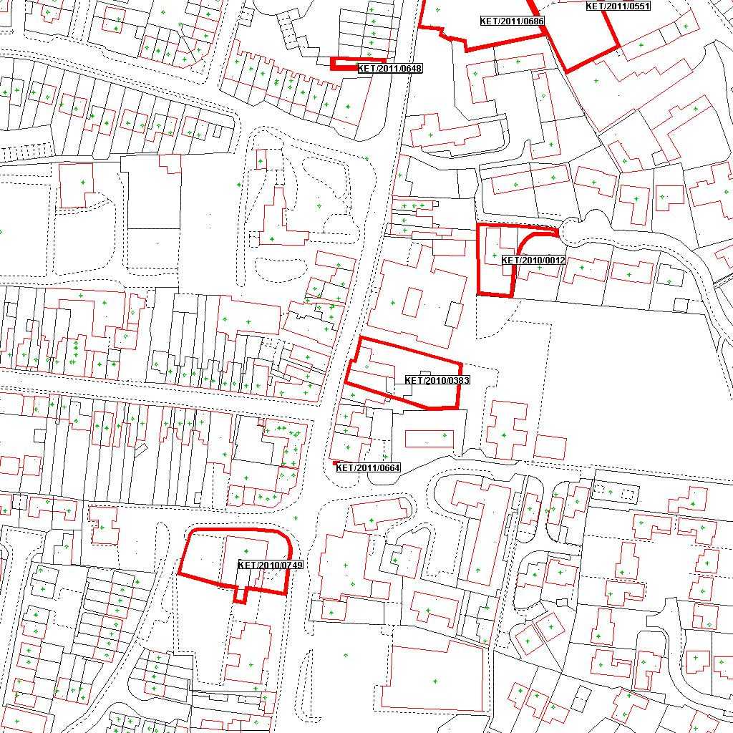

Reproduced from the Ordnance Survey mapping with the permission of the Controller of Her Majesty’s Stationery Office © Crown copyright. Unauthorised reproduction infringes Crown copyright and may lead to prosecution or civil proceedings.  LA078344 |  | N
Date: 02/12/2011 Do not scale from this map. For illustrative purposes only.

