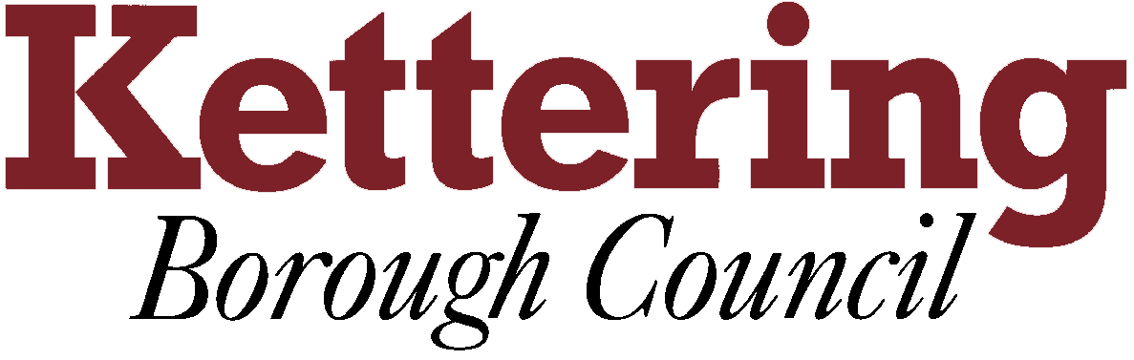

KETTERING BOROUGH TENANTS FORUM

January 12th 2012

Draft Tenancy Agreement/Handbook consultation
This report will provide the Tenants’ Forum members with information on the consultation on the above documents.

For Information

1 Draft Tenancy Agreements and Tenant Handbooks are available to view for consultation from 5th December 2011 to 16th January 2012.

1.1 This report is to update members on the feedback from the consultation.

2 There will be a short presentation on the different format for the new handbook as agreed by the Tenancy Review Group and the Silver Service Forum.
There will also be an update of costs, including the posting or delivery of the new handbook to all existing tenants.

3 We would like the members’ opinions on the new documents.

Clare Harper
21st December 2011

