To all Members   | Direct Line: (01536) 534398  Email: anneireson@kettering.gov.uk  Our Ref: AI  Your Ref:  Date: 6th December 2011

Dear Councillor

You are summoned to a meeting of Kettering Borough Council to be held in the Council Chamber, Municipal Offices, Bowling Green Road, Kettering on Wednesday, 14th December 2011 at 7.30 pm.

Please note that I am happy to welcome the Salvation Army band and songsters, who will be singing carols prior to the commencement of the formal part of the meeting and, as usual the Mayor has kindly invited all members to a reception in the Parlour after the meeting.

Yours faithfully

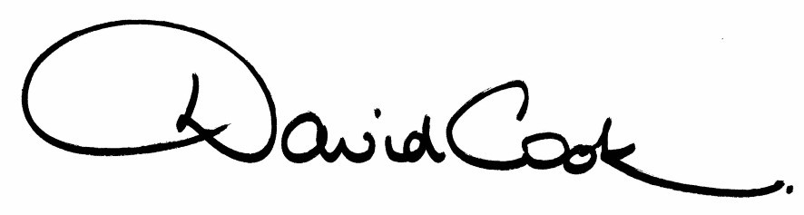
D Cook
Chief Executive

A G E N D A

1. Apologies.

2. Minutes of the meeting of the Council held on 28th September 2011 to be approved as a correct record and signed by the Mayor.

3. Declarations of Interest:

(a) Personal
(b) Prejudicial

4. To receive any announcements from the Mayor

5. To receive any announcements from the Leader of the Council
6. Report of the Chief Executive.

7. The Mayor to ask members of the public present if they wish to speak on any item on the Agenda.

8. To receive any deputations and petitions from members of the public.

Mrs Sam Hutchings will present a petition containing 1,677 signatures on behalf of Market Street Traders and members of the public:-

'Further to the Council's Executive Meeting of the 12th October 2011 where increases were proposed to the car parking charges for all of the Council's current parking spaces, I wish to make it clear that I do not agree with this decision. I am signing the petition below to urge the council to reconsider its decision.'

9. Amendments to the Constitution (report attached)

10. Bribery Act 2010 (report attached)

11. Treasury Management Strategy and Prudential Indicators - Update (report attached)

12. To consider motions received in accordance with Council Procedure Rule 16 as follows:-

(i) To be proposed by Councillor Paul Corazzo and seconded by Councillor David Bishop:-

"That this Council will use all the powers at its disposal to encourage the highest standards of animal welfare in our Borough."

(ii) To be proposed by Councillor Roberts and seconded by Councillor Malin:-

"That this Council recognises the good work that has and is being done to support young people's progress from education to work. The continuing challenge of ensuring that more young people access apprenticeships and the workplace can only be tackled in partnership with schools, colleges, employers and other public sector partners. The support of the Local Strategic Partnership, the Northamptonshire Leadership Group and central government to make a positive difference is one we should capitalise on; this Council is committed to developing effective ways of improving the training and employment prospects for all young people and will work to bring partners together to do just that, starting with a conference in the near future."

(iii) To be proposed by Councillor Zanger and seconded by Councillor Jelley:-

"That this Council welcomes the latest government initiative called "Home Swap Direct" which will give tenants the opportunity to move anywhere within the United Kingdom whether it is to be closer to a new job, their family or indeed to a property more suited to their needs. In addition, £1 million has been provided for projects and Kettering Borough Council has been chosen to pilot the scheme, exploring whether greater mobility can reduce health and social care costs, investigating the types of support – such as helplines and dedicated staff – which can best help tenants through the process of moving, including mutual exchange and transfers."

13. To receive questions from members.

14. Any matters of urgency that the Mayor decides should be considered.

6.12.11

Fire Alarm

All meetings shall be adjourned immediately on the sounding of the fire alarm. The alarm is a continuous two-tone siren. On hearing the alarm please leave the building by the nearest emergency exit. There are emergency exits at both ends of the corridor outside the meeting rooms. On leaving the building please cross the car park and assemble on the grassed area by the church. Do not attempt to drive out of the car park as this may impede the arrival of emergency vehicles. Please do not return to the building until you are told it is safe to do so by a Council employee.

Toilets

There are toilets in the corridor off the main entrance to the building you came through to get to the meeting room.

Breastfeeding and Baby Changing Facilities

The Council actively supports breastfeeding mothers. If you wish to use a private area please ask a member of staff. There are baby changing facilities in the corridor off the main entrance adjacent to the toilets.

.Access for Disabled People

There are allocated parking bays outside the main entrance to the Municipal Offices for disabled people. The meeting rooms are located on the ground floor and access is gained for wheelchair users via the main entrance. If you require assistance, please ask the attendant on duty in the reception area.

No Smoking

Smoking is not permitted in the Municipal Offices.

Private and Confidential Items

The press and members of the public can be excluded from business of the meeting on the grounds that it involves items of business which include the likely disclosure of exempt information as defined by Paragraphs 1-7 of the Local Government (Access to Information) (Variation) Order 2006 in respect of Schedule 12A to the Local Government Act 1972. The reason for discussing the issue in private is indicated on the Order of Business.

