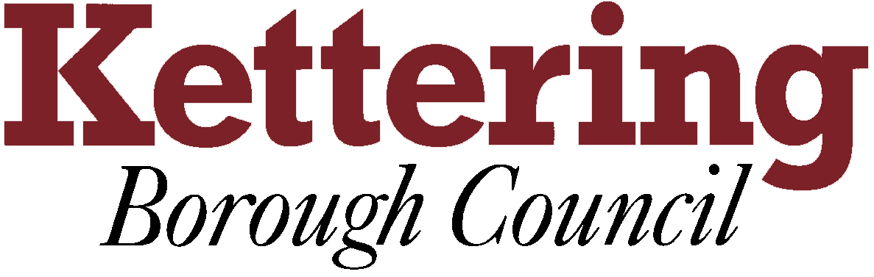

KETTERING BOROUGH TENANTS FORUM

8th December 2011

Discussion on the significant findings from the fire risk assessments
This report asks the Tenants Forum to note the significant findings of the Fire Risk Assessment Project

For Information

1 The purpose of this report is to inform the Tenants Forum on the significant findings of the fire risk assessment project.

2 Kettering Borough Council has carried out fire risk assessments to communal areas of 118 general needs blocks of flats and has recorded any significant findings.

- Paul will be attending the Forum to:

- Discuss the most common types of significant findings.
`
- Explain how Kettering Borough Council is prioritising the works.

- Discuss how to best convey fire safety messages to all tenants.

- A 5 minute session will be set aside for representatives to raise fire safety questions.

Paul Davies
24th November 2011

