BOROUGH OF KETTERING

Committee | Full Planning Committee - 06/12/2011 | Item No: 5.1
Report Originator | Peter Chaplin  Development Manager | Application No:  KET/2011/0399
Wards Affected | Rothwell
Location | 36 High Street, Rothwell
Proposal | Full Application: Change of use from retail unit to restaurant; new exterior door to west side; bricking up of existing door to ancillary building.
Applicant | Mr M Dewirdag Yellowvale Ltd,

1. PURPOSE OF REPORT

  - To describe the above proposals
  - To identify and report on the issues arising from it
  - To state a recommendation on the application

2. RECOMMENDATION

THE DEVELOPMENT CONTROL MANAGER RECOMMENDS that this application be APPROVED subject to the following Condition(s):-

1. The development hereby permitted shall be begun before the expiration of 3 years from the date of this planning permission.
REASON: To comply with Section 91 of the Town and Country Planning Act 1990 (as amended) and to prevent an accumulation of unimplemented planning permissions.

2. The use hereby permitted shall not be carried out [The premises shall not be open to the public] before 11.00am hours or [remain open] after 22.00 hours on Mondays to Saturdays. There shall be no permitted use nor opening hours between 22.00 hours on Saturdays and 11.00am Mondays.
REASON: To protect the amenities of the occupiers of nearby properties in the interests of amenity in accordance with policy 13 of the North Northamptonshire Core Spatial Strategy.

3. Notrwithstanding the submitted details no restauant or permitted use shall first commence unless and until details of the proposed extraction systems including their position and appearance, and the means to satisfactorily control noise and odour, have been first submitted to and approved by the Local Planning Auithority. Thereafter, the use or development shall not proceed or continue other than in accordance with the approved extractions systems/ flues being in place and being maintained in good working order.
REASON: In the interest of residential amenity and in accordance with CSS Policy 13

4. The proposed internal first floor level shall not be first brought into use until a means for screening at eye level at the first floor inside the south facing windows (looking toward High Street, has been put in place and thereafter retained, in accordance with details first submitted to and approved by the Local Planning Authority.
REASON: In the interest of residentail amenity and in accordance with CSS Policy 13.

5. The use herby permitted shall not take place at any time on any exterior roof area, and there shall be no external smoking area within the property.
REASON: In the interest of residential amenity and in accordance with CSS Policy 13

6. Notwithwithstanding the provisions of the Town and Country Planning General Permitted Development Order 2008 or as amended nor the Use Classes Order 2005 or as amended, the use hereby approved shall be for a restaurant or use within A3. Uses within Classes A4 and A5 are not permitted.
REASON: In the interest of residentail amenity and in accordance with Policy 13 of the CSS

Notes (if any) :-
NONE

Justification for Granting Planning Permission

The proposal is in accordance with national and local policies as set out in Planning Policy Statements/Guidance PPS1, PPS4, PPG24 Policy 3 and para 4.1.8 of The East Midlands Regional Plan, Policies 1,9,13 of the North Northamptonshire Core Spatial Strategy The proposal is also in accordance with adopted Supplementary Planning Document Sustainable Design. The background papers for the emerging Site specific proposals has been noted. There are material considerations inluding that of parking and amenity issues that have been raised and examined, but none are considered as overriding so as to indicate against the proposal.

Officers Report

3.0 | Information

Relevant Planning History
KET/2001/0591 Proposed change of use for made to measure tailoring with garments on show for retail. Temporary consent till 2004.

Signage at the property shows “Marton Rose Interiors” which may have been the use.

An existing application under fer KET/2011/0398 re Express Advertisement Consent fo exernally iluminated fascia and 2 No. illuminated hanging signs. Implementation of any approved signage being dependent on the proposed change of use being allowed

Site Description
Officer's site inspection, accompanied by the Agent was carried out on 12 August 2011. The site is located close to Rothwell Town Centre, near to the junction of the former A6 with Bridge Street, and between the former A6 and School Lane, which is a turning off the north side of Bridge Street.

The site includes (former bank) principal building, somewhat monumental in size relative to surrounding area, and of red brick with a classical stone façade. It fronts the junction and is the dominant visual point looking north from High Street. The building is currently vacant or unused. It sits at the back of the footway. The former bank building has a large area of flat roof behind a parapet (stone at the front and brick to sides. Outside the parapet at the rear of the principal building the area of flat roof is close to Ashgate cottage, see below.

Attached to the main building at the west side, but set back is a modest single storey redbrick extension. In front of the smaller building and around the west side is a small area of incidental open space. This is behind an ironstone boundary wall in which is a pedestrian gate alongside the street.

Neighbouring the site beyond the north side, land is in residential use. The closest properties are the more modern dwelling at 2 Desborough Road to the west side; and Ashgate Cottage, a traditional dwelling in the local ironstone to the east side. The latter is also a Grade II Listed Building. These dwellings are a few metres from the site.

Other uses to the south and east are typical town centre retail activities.

The site lies within the designated Rothwell Conservation Area

Proposed Development
- The application (as amended) seeks a change of use to form a restaurant utilising the large space inside with the introduction of a new internal floor which would be visible from outside through the large glazed openings of the classical façade.

As revised the hours of operation/ open to the public are stated as Monday to Saturday 11.00am-11.00pm.

- A door opening is proposed to the west side of the principal building changing an existing window opening which has a stone surround.
- A door facing the front of the ancillary building is intended to be bricked up.
- Extraction units, details to be approved. The provisional position is shown as proposed to be located at the rear of the single storey secondary building, though this is subject to approval following submission of final details.
- The open area at the west side , behind the frontage boundary wall, is intended for bin storage;

All other physical alterations, apart from proposed signage which is subject to a separate application, are internal and not subject to planning controls, rather building regulations. However, the introduction of an internal first floor across the openings has raised an objection from a resident at 33 High Street about overlooking, see below. The planning response is explained in the relevant part of this report.

NB (1) An initial proposal to create a rear terrace for customers on the flat roof of the principal building was withdrawn, after Officers advised that this would be unacceptable in terms of neighbouring residential amenity.

(2) A proposed smoking area was designated indicated on the submitted plan behind the frontage boundary wall, but this element has been withdrawn too

Any Constraints Affecting The Site
Implications of proximity to neighbouring dwellings and considerations arising from any propsed physical changes on the Conservation Area; Close to junction with no immediate parking on street

4.0 | Consultation and Customer Impact

Rothwell Town Council
Whilst Rothwell Town Council would not object to the proposed change of use from retail unit to restaurant, we do oppose this particular application on the following grounds:-
(1) A roof terrace would be totally inappropriate here because people on the terrace would overlook the surrounding properties, especially No.2 School Lane, and the noise would also carry and create a disturbance for neighbouring residents.
(2) We are concerned that there is inadequate parking provision in the area for customers and for delivery vehicles.
(3) No permission should be given for the premises to be open later than 12 midnight on any day.
(4) There must be an adequate air conditioning system to ensure no cooking smells permeate into the surrounding area.

Highway Authority
In principle, no highway objection subject to standard conditions regarding any ground floor doors that may open over the highway, ie these to open inward

They also advise: “No works of any nature may commence within the highway without their expressed permission.

Neighbours:
Letters received with following objections or strong objections from:
- the two closest neighbours at Ashgate Cottage and 2 Desborough Road;
- 2 properties in Ashgate Court;
- the owner of a property in Ashgate Court who is residing elsewhere;
- 3 properties in Leys Avenue;
- additional letter from the daughter (living elsewhere) of a lady who lives in Leys Avenue;
- 2 properties in High Street,
- Town Farm Stables, and another property (No.8) in Desborough Road;
- 1 property in School Lane;
- one from a person in Rushton;

Parking/deliveries/ road safety
- Overriding and ever present of lack of parking facilities/ no parking within easy distance near the property, customers cars and delivery vehicles would be a real hazard on a busy junction; School Lane is always heavily congested; Rothwell Market Hill is frequently full;
- No consideration given to parking/ Market Square is already very busy/ conceivable that customers will use Town Farmhouse property for parking as when E-on worked on the (electricity) sub station at the rear (of application site)
- Increased traffic/ congestion/ contributes to traffic dangers in the area;
- School Lane is a small road and at most times cars are parked on both sides: where are delivery vehicles going to park, case of an ambulance going to property not being able to park because of existing parking on School Lane;
- Customers will not wish to walk from car park (which is very often full) so park in School Lane/Leys Ave; chronic parking problem in Bridge Street, School Lane and Leys Ave; abuse of parking eg outside ATM on corner of Bridge; “police have less interest in doing something about it”
- Promise that traffic measures would be provided never happened when other proposed building work planned (residents in this immediate area complained on numerous occasions about parking when other planning applications have been agreed);
- 200m from infants school so delivery vehicles could be a safety hazard;
- Taxis and delivery vehicles would still use the road as drop off. Pick up parking area which would make the roundabout and public footpaths of Desborough Rd/ School Lane extremely dangerous;
- Dangerous when deliveries occur as it is on a roundabout/ bus route/narrow pavement will make walking difficult when young parents collect children from school;
- “An earlier application, circa 2000, before the bank was converted to retail/ tailors was refused by Kettering Council on safety issues. The safety issues have got considerably worse over the years, as vehicles and lorries do not use the by pass as intended.

Originally proposed Roof terrace
- Loss of privacy: Objection to overlooking of Ashgate Cottage/2 Desborough Rd from proposed roof terrace;
- Overlooking of bungalow in Ashgate Court;
- Take away availability to spend time in garden because of overlooking;
- Roof terrace will overlook my neighbours house/ bedrooms and garden;
- Intrusion of privacy from open terrace of restaurant into main family bedrooms/ family sitting rooms/ dining room;
- Noise of open terrace during use of main family bedrooms;
- Letter of objection from 2 Desborough Road stating that main objection was the proposed roof terrace: with late night open air dining/smoking/drinking it would be an unacceptable intrusion into family life from noise, smells etc If the roof terrace was omitted the occupiers of 2 Desborough Road would not object.

NB: Officer also identified this as unacceptable impact, and this element has been removed from application as stated previously)

Other amenity issues/comments:
- Impact on 33 High Street: Illumination of terrace and restaurant into all front facing rooms; Intrusion of privacy from first floor of restaurant into main family bedrooms/ sitting rooms/dining room; Noise from late night closing into all facing rooms;
- (Subject to separate application: Occupier of 33 High Street states illuminated signs and building lighting glare directly into bedrooms, lounge and dining room of No.33)
- Application stated that would be open from 11.00 am-midnight (M-Sat) by time customers cleared could be 1.00am or later with severe impact on homes in vicinity; noise/ kitchen smells;
- Opening hours impact on predominantly residential area: parking, noise pollution and customers smoking outside premises will congest the pavement on a very busy corner;
- Although on edge of town this is a relatively quite area: “The presence of a licensed premises opposite our house will cause the occasional noise as customers come and go;
- Noise from proposed business late at night;
- “Late night opening will have a huge impact on me and my neighbours” cooking smells and noise to contend with;
- Proximity to several households: The disturbance and violation to privacy to neighbouring households, plus residents in other nearby properties would be extreme;
- “It is felt that our premises (Town Farm Stables) would be affected by people parking up our private entrance opposite in search for a convenient place to park and our privacy would be invaded”;
- People leaving the premises who are intoxicated a real danger exists of people falling into road;
- One neighbour has commented on the revised proposal: “Whilst welcome the removal of the terrace from the plans, we feel that the noise and air pollution resulting from the newly proposed smoking area will be a disturbance and disruption to the local environment;
- Litter associated with takeaways

Other:
- Appalled that neither of the two residents in the immediate area knew absolutely nothing about this proposed development.
- “devalue my property”
- In a Conservation Area
- Rothwell has enough eating places; within the vicinity of this proposal there are 13 businesses, can the town support another one or will some businesses close?
- Road surface is already under strain from non Leys Avenue users and this will get worse;

Northamptonshire Police: No formal objections adding that if the establishment is going to sell alcoholic beverages they will need to apply for a liquor licence and comply with all regulations

5.0 | Planning Policy

National Policies
PPS 1 Delivering Sustainable Development’
PPS 4: Planning for Sustainable Economic Development
PPG 24 Planning and Noise

Development Plan Policies

East Midlands Regional Plan:
Policy 3: In assessing the suitability of sites for development priority should be given to making the best use of previously developed land and vacant or underused buildings in urban and other sustainable locations.

Para 4.1.8 The smaller towns of…..Rothwell… will seek to consolidate and extend their roles in providing local services.

North Northamptonshire Core Spatial Strategy
Policy 1: Strengthening the network of settlements: The smaller towns of…. Rothwell….will provide secondary focal points for development within the urban core;
Policy 9: Preference will be given to locations that are accessible by a choice of means of travel.

Policy 13:Development should meet need (flexible designs for buildings, design out anti-social behaviour) have satisfactory means of parking, servicing, manoeuvring in accordance with adopted standards; not have an adverse effect on the highway network and will not prejudice highway safety, conserve and enhance designated built environment assets and their settings

Local Plan: Saved Policy R4. Rothwell: Area of Special Advertisement Control

Emerging Policies (Local Development Framework) Site Specific proposals for Local Development Document (LDD) Background papers and consultation proposals considered at Planning Policy Committee on 4 October 2011

SPD: Sustainable Design

6.0 | Financial/Resource Implications
 | None
7.0 | Planning Considerations
Section 38 (6) of the Planning and Compulsory Purchase Act 2004 requires Planning Authorities to determine applications in accordance with the Development Plan unless material considerations indicate otherwise.

The key issues for consideration in this application are:-

- The principle of development:
National policy guidance and the Development Plan policies stated are the starting point for considering sustainability in regard the re use of this property. The site’s location is sustainable. In principle, subject to the issues discussed below, a suitable re use is welcomed.

The site lies outside the defined established shopping area as defined by the Rothwell inset plans from the Local Plan of 1995. However, it is close to the town centre and previously professional services/tailors appears to have taken place at the site.

There was recognition of this site in the papers that following the Planning Policy Committee on 4 October 2011 are to be considered material, ie in a background paper for the emerging policy Site Specific proposals of the Local Development Document, (LDD) this site’s relationship to the town centre was identified when this site was included in a possible revised boundary for the town centre. With its former commercial or professional services uses, and as a visually significant building for the town, a suitable reuse of this property is desirable. Furthermore, due to its size and property boundary, it seems unlikely to be brought forward for a residential use.

However, an open permission for some forms of retail especially hot food takeaway may be unsuitable, including for some of the reasons that objectors have pointed out. The principle of a sit down restaurant in this building though would fit with its possible inclusion in the town centre, subject to specific amenity issues being satisfactorily resolved.

2. Noise and odour control
Critical to the recommendations of the Environmental Health Officers is assessing the impact of the proposed use in terms of control of noise and odour from the kitchen, and the location of extracts and odour control equipment for the kitchen.

The applicants have commissioned a Noise assessment (dated 4th Nov 2011) in accordance with BS4142:1997. This concluded that the calculated noise level of the proposed kitchen extract system equates to 32 dBA outside the nearest residential windows, with the measured ambient noise level in the locality at the time of the survey (02/11/11 from 22 00 hours to 23.00 hours, the most sensitive time of day) The report’s author adds that “when the extract ventilation system is finalised the fan silencing should be checked to ensure the silencing is correct for the fan and system.

The odour risk assessment is dependent upon the height and position of the discharge, and consideration of cooking type. The applicant’s agent has stated that the external pipe would be taken up above the parapet of the raised flat roof of the former and smell to be controlled. The final design and position to be conditioned

Subject to these issues being resolved as anticipated, it is anticipated that the Environmental health officer will be able to confirm that the matters are to be addressed in ways that will control noise and smell to enable the use to take place without detriment to the local area.

3. Highway parking and traffic generation
I note the concerns raised by the Town Council and residents of the locality about parking in the area. Given the proximity to the town centre, reliance on public car parking is expected to be the only way in the short term for this site to be serviced. Some limited on street parking exists, in addition to the car parks in the centre. It is inevitable that comings and goings would have to be carefully managed, including that of the expected 4 full time, 6 part time staff. The deliveries would be one van (approx 35cwt up to 5 deliveries, approx once a day during the hours 9.00am-5.00pm

I note that the Highway Authority have not raised an objection on ground of lack of parking etc. On balance, I conclude that as in recognition of its proximity to the town centre, it would not be sufficient to refuse the proposals on the basis of the lack of on site or street parking; a situation not uncommon in many towns.

4. Comments on other points raised by proposal
As the applicant has agreed to also omit the proposed out door smoking area, I am satisfied that this deals with a potential nuisance in that regard.

The comments made by the town Council have raised specific concerns The lack of parking is a matter for judgement given that the proposed use is not untypical in locations of this sort where close parking is limited. In other respects concerns are to be addressed through the revised submission and by conditions.

Some comments made by third parties eg people dropping litter are not so likely to occur from a sit restaurant use.

I have considered that concerns raised by the residents of 33 High Street about potential overlooking from the proposed first floor. The minimum distance of 13 metres across the road between the two first. If necessary some screening up to eye at first floor could be provided.

Bin storage behind the exterior wall will provide some appropriate screening.

Conclusion

Issues of amenity have been considered, with the removal of the proposed external terrace and outside smoking area, and subject to the conditions stated, I am able to support this revised proposal

Background Papers |  | Previous Reports/Minutes
Title of Document: |  | Ref:
Date: |  | Date:
Contact Officer: | Peter Chaplin, Development Manager on 01536 534316

SITE LOCATION PLAN

36 High Street, Rothwell
Application No.: KET/2011/0399

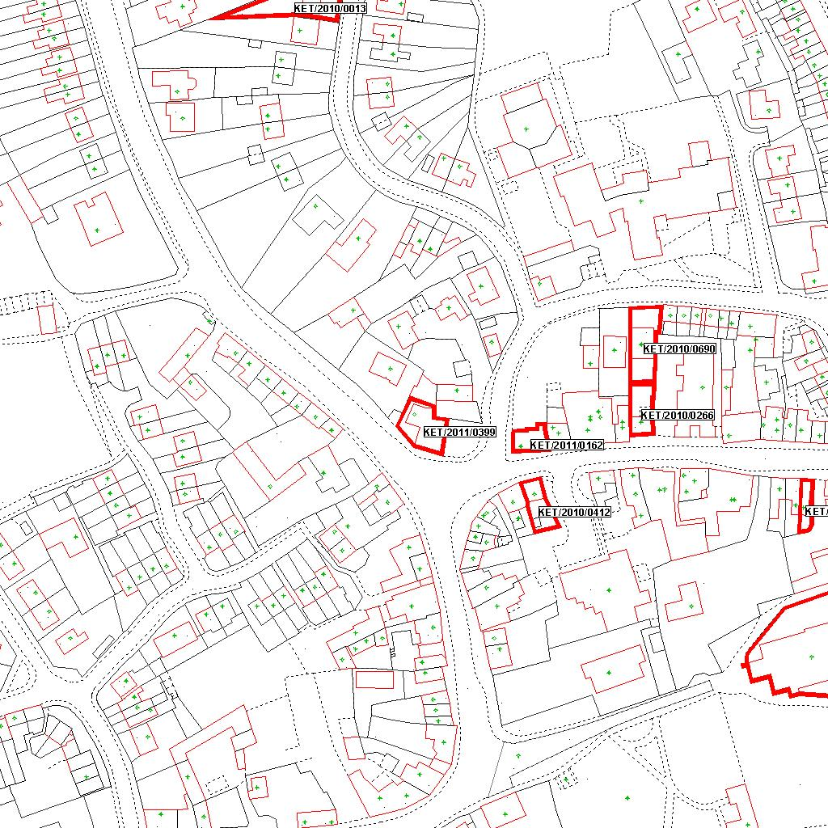

Reproduced from the Ordnance Survey mapping with the permission of the Controller of Her Majesty’s Stationery Office © Crown copyright. Unauthorised reproduction infringes Crown copyright and may lead to prosecution or civil proceedings.  LA078344 |  | N
Date: 01/07/2011 Do not scale from this map. For illustrative purposes only.

BOROUGH OF KETTERING

Committee | Full Planning Committee - 06/12/2011 | Item No: 5.2
Report Originator | Michael Boniface  Development Officer | Application No:  KET/2011/0599
Wards Affected | Burton Latimer
Location | 5 Charles Court, Burton Latimer
Proposal | Full Application: Detached double garage
Applicant | Mr & Mrs Robinson

1. PURPOSE OF REPORT

  - To describe the above proposals
  - To identify and report on the issues arising from it
  - To state a recommendation on the application

2. RECOMMENDATION

THE DEVELOPMENT CONTROL MANAGER RECOMMENDS that this application be APPROVED subject to the following Condition(s):-

1. The development hereby permitted shall be begun before the expiration of 3 years from the date of this planning permission.
REASON: To comply with Section 91 of the Town and Country Planning Act 1990 (as amended) and to prevent an accumulation of unimplemented planning permissions.

2. The materials to be used in the construction of the external surfaces of the development hereby permitted shall match, in type, colour and texture those on the existing dwelling.
REASON: In the interests of visual amenity in accordance with policy 13 of the North Northamptonshire Core Spatial Strategy.

3. No development shall take place until a plan prepared to a scale of not less than 1:500 showing details of existing and intended final ground and finished floor levels has been submitted to and approved in writing by the Local Planning Authority. The development shall not be carried out other than in accordance with the approved details.
REASON: To preserve the character of the area and avoid detriment to neighbouring amenity in accordance with policy 13 of the North Northamptonshire Core Spatial Strategy.

Notes (if any) :-
- This planning permission is subject to "pre-commencement" conditions which require details/drawings to be submitted to and approved in writing by the Local Planning Authority before ANY development may lawfully commence. Any development commenced in breach of these "pre-commencement" conditions will be unauthorised, a breach of planning control, and liable to immediate Enforcement and Stop Notice action.

Justification for Granting Planning Permission

The proposal is in accordance with national and local policies as set out in Planning Policy Statement 1, Policy 2 of The East Midlands Regional Plan and Policy 13 of the North Northamptonshire Core Spatial Strategy. There are no material considerations that indicate against the proposal.

Officers Report

3.0 | Information

Relevant Planning History
KET/2007/0759 – One dwelling (revised design) on plot 5 (KET/2006/0416) – APPROVED 27/11/2007

KET/2006/0416 – Reserved Matters: 4 houses and 1 dormer bungalow – APPROVED 17/07/2006

KET/2005/0381 – Outline: residential development – APPROVED 13/06/2005

Site Description
Officer's site inspection was carried out on 05/10/2011.

The site comprises a substantial two storey detached dwelling within a modern residential development of similar properties all of which have private vehicular accesses and garages. Further residential properties surround the site. Land levels are consistent within the site although the properties to the west stand at a lower level.

Proposed Development
Detached garage.

Any Constraints Affecting The Site
None.

4.0 | Consultation and Customer Impact

Parish/Town Council
Objection as the garage would be sited in the position of soakaways associated with the residential development and the building would be elevated compared with properties in Park Road.

Neighbours
3 letters of objection for the following reasons:
- Height of the garage is intrusive.
- Overdevelopment of the site.
- The main soakaways serving plots 4 and 5 Charles Court and the gulley from the estate road lies beneath the proposed development. The development is therefore likely to result in flooding. Pipework should remain accessible.
- Proposal does not comply with original building plans.
- Adverse impact on view from rear windows.
- Loss of light.
- Would devalue neighbouring property.
- Garage is not needed as the property already has one.

5.0 | Planning Policy

National Policies
PPS1 – Delivering Sustainable Development

Development Plan Policies

East Midlands Regional Plan
2 – Promoting Better Design

North Northamptonshire Core Spatial Strategy
13 – General Sustainable Development Principles

6.0 | Financial/Resource Implications
 | None
7.0 | Planning Considerations
The key issues for consideration in this application are:-

- Principle of Development;
- Design, Character and Appearance;
- Amenity;
- Highways and Parking;
- Other Matters.

1. Principle of Development
Policy 13 of the North Northamptonshire Core Spatial Strategy is supportive of householder development subject to a number of sustainable development criteria including that proposals do not result in adverse impact upon neighbouring properties or the highway network and that schemes present a good standard of design.

2. Design, Character and Appearance
The proposed garage would be located in the south west corner of the site between the principal building and the neighbouring bungalow. The garage building would be typical in appearance presenting a square footprint under a shallow pitched hipped roof. It would be constructed from materials matching that of the existing dwelling and incorporate similar brick detailing so as to achieve an appropriate visual relationship.

The building would occupy an existing area of garden land which is surrounded by a 1.8m close boarded fence. Although its addition would erode the openness in this part of the site, an appropriate separation would be maintained between the neighbouring property similar to that of other plots within the development. The building would be modest in scale and would not result in a cramped of overdeveloped appearance.

3. Amenity
The proposed garage would be located between the flank wall of the principal building and that of the neighbouring bungalow, neither of which are fenestrated. The scale and siting are such that no adverse impact would result in terms of overshadowing or overbearing impact. Furthermore, the existing boundary treatments are sufficient to maintain neighbouring privacy.

Concerns have been raised by neighbours to the rear of the site in Park Road due to the higher ground levels within the site. No details of the finished floor levels have been provided however the site is relatively flat and I would not anticipate any need for raised levels as part of the scheme. A condition should be used to secure details of the proposed levels to ensure an appropriate relationship with the neighbouring properties. Although ground levels are higher within the site than the neighbouring properties, the building would be well removed (approximately 12m) and the scale and mass of the building are such that no significant detriment would result. A small amount of overshadowing may impact the rear gardens associated with properties in Park Road early in the morning however this would be for a short period only given the daily path of the sun.

4. Highways and Parking
Although the proposed extension would increase the size of the dwelling, the property would remain a single planning unit and the increase in size would not significantly increase the intensity of traffic attracted to the site. The existing vehicular access would be retained and the driveway extended to accommodate access to the proposed garage. It is unclear whether the applicant intends to retain the existing garage in addition to that now proposed as conversion of the existing would be permitted development (not requiring express consent from the Local Planning Authority). Whilst retention of both garages is likely to result in an overprovision of parking contrary to the objectives of PPG13 which seeks to reduce the reliance on private motor vehicles in favour of more sustainable modes of travel, the parking level is not considered so excessive as to warrant the refusal of planning permission in this instance.

5. Other Matters
Concerns have been raised that the garage would be sited on existing soakaways associated with the development. In fact, each property within the development is served by its own soakaways within their plots. The soakaway approved in relation to the property in question is in fact located in the north west corner of the site and would therefore be unaffected by the development. Some foul drainage infrastructure may be located in the vicinity of the site however access to this private infrastructure remains the responsibility of the land owner and could be facilitated in construction of the scheme. The applicant will be asked to do so.

Impacts on private views, querying the need for an additional garage and potential devaluation of a neighbouring property are not material planning matters.

Conclusion

The proposed development accords with both national and local planning policy and there are no material planning matters that indicate against the scheme; as such, planning permission should be granted.

Background Papers |  | Previous Reports/Minutes
Title of Document: |  | Ref:
Date: |  | Date:
Contact Officer: | Michael Boniface, Development Officer on 01536 534316

SITE LOCATION PLAN

5 Charles Court, Burton Latimer
Application No.: KET/2011/0599

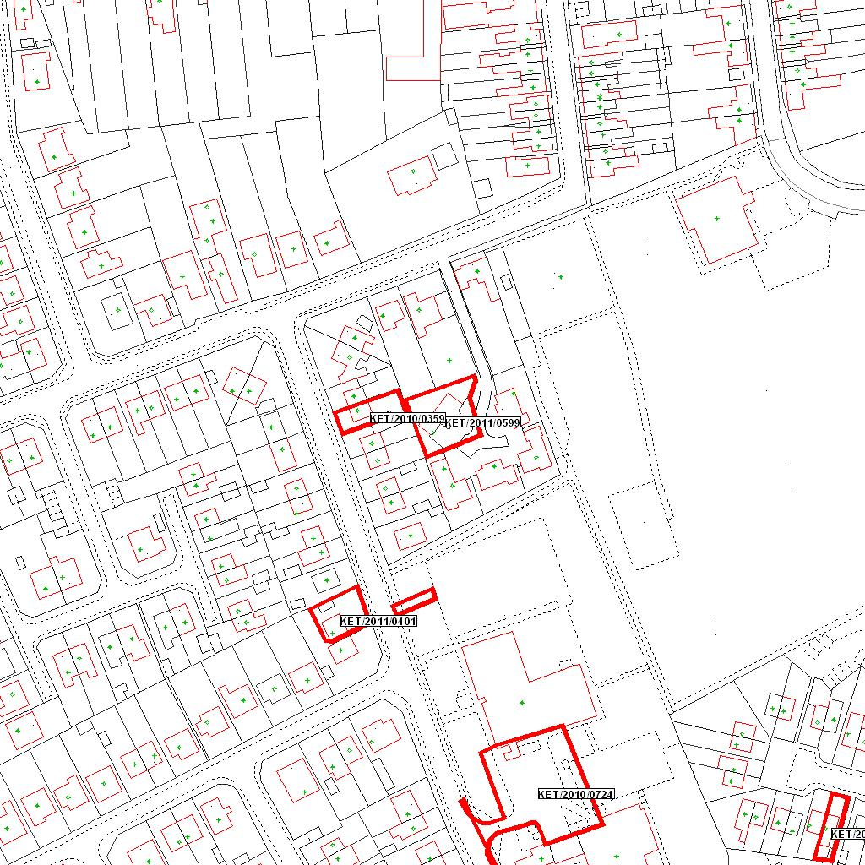

Reproduced from the Ordnance Survey mapping with the permission of the Controller of Her Majesty’s Stationery Office © Crown copyright. Unauthorised reproduction infringes Crown copyright and may lead to prosecution or civil proceedings.  LA078344 |  | N
Date: 20/09/2011 Do not scale from this map. For illustrative purposes only.

BOROUGH OF KETTERING

Committee | Full Planning Committee - 06/12/2011 | Item No: 5.3
Report Originator | William Agroh  Development Officer | Application No:  KET/2011/0658
Wards Affected | Barton
Location | 10 Orton Road, Barton Seagrave
Proposal | Full Application: Replacement garage
Applicant | Mr B Cole

1. PURPOSE OF REPORT

  - To describe the above proposals
  - To identify and report on the issues arising from it
  - To state a recommendation on the application

2. RECOMMENDATION

THE DEVELOPMENT CONTROL MANAGER RECOMMENDS that this application be APPROVED

1. The development hereby permitted shall be begun before the expiration of 3 years from the date of this planning permission.
REASON: To comply with Section 91 of the Town and Country Planning Act 1990 (as amended) and to prevent an accumulation of unimplemented planning permissions.

2. The materials to be used in the construction of the external surfaces of the development hereby permitted shall match, in type, colour and texture those on the existing building.
REASON: In the interests of visual amenity in accordance with Policy13 of the North Northamptonshire Core Spatial Strategy.

Notes (if any) :-
- NONE

Justification for Granting Planning Permission

The proposal is in accordance with national and local policies as set out in Planning Policy Statement 1, Policy 2 of The East Midlands Regional Plan, Policy13 of the North Northamptonshire Core Spatial Strategy. There are no material considerations that indicate against the proposal.

Officers Report

3.0 | Information

Relevant Planning History
None relevant

Site Description
Officer's site inspection was carried out on 16/11/2011
Orton Road is a residential street located within an established residential area at the south western part of Barton Seagrave. The street scene is characterised by a mixed of two storey semi-detached and single storey semi-detached dwellings built around the 70s and 80s.

Looked at from the west side of Orton Road, the subject dwelling is the right hand of the pair of two-storey semi-detached dwellings set back from the road. It features puff bricks and tiled roof. There is currently a single storey flat roofed garage attached to the subject dwelling measuring 2.2m high and 10.2mdeep. No.8 Orton Road (the adjoining property to the north) features a single storey rear extension and an outbuilding further back along the shared boundary with the application site.

The gable end of No.8 Orton Road includes two first floor windows (not affected by the proposal) and ground floor kitchen windows and a door serving a kitchen.

Proposed Development
It is proposed to demolish the existing flat roofed garage and replace with a single storey side and rear extension close to the boundary with No.8 Orton Road.

Any Constraints Affecting the Site
None

4.0 | Consultation and Customer Impact

Parish/Town Council- None received

Neighbours-A letter of objection was received from occupants of No 8 Orton Road objection to the proposal on grounds of loss of light, overbearing impact and impact on the character of the area. These issues have been addressed under section 7 of this report.

5.0 | Planning Policy

National Policies
PPS1-Delevering Sustainable Development

Development Plan Policies

East Midlands Regional Plan

Policy2- Promoting Better Design

North Northamptonshire Core Spatial Strategy
Policy 13. General Sustainable Development Principles

6.0 | Financial/Resource Implications
 | None
7.0 | Planning Considerations
The key issues for consideration in this application are:-

- Principle of Development
- Street Scene/Character
- Residential; Amenity.

1. Principle
Policy13 of the CSS sets out the principles of sustainable development which seek among others to raise standards and protect assets. The proposed extension is considered to be in line with the shared principles applicable within established residential areas like Orton Road. The proposed extension is therefore considered acceptable subject to its impact on amenity and on the street scene been acceptable.

2. Street Scene/character.
Policy 13 states that development should be of a high standard of design and enhance and protect the character of its surroundings.

The proposed single storey extension will feature a width of 4.6m, an eaves height of 2.2m, and a depth of 10.2m with a pitched roof.

Given it size and bulk in relation to the existing dwelling, it will appear sub-ordinate to the existing dwelling. Orton Street and its surroundings currently feature varied properties with varied extensions to the side and rear. It is therefore considered that, provided the materials are conditioned to match the existing, the extension will not have a harmful impact on the appearance of the existing building neither will it constitute an incongruous feature on the street scene.

Occupants of no. 8 Orton Road raised concerns about the possible overbearing impact of the proposed extension on them. In response, it is considered that given the fact that the roof will be hipped away from the shared boundary with No8; any potential overbearing impact will not be materially harmful.

3. Residential Amenity

Among other things the aim of policy 13 of the CSS is to protect assets by ensuring that developments do not result in unacceptable impact on the amenities of neighbouring properties by reason of loss of light and overlooking,

The extension is single storey and will feature no windows to the side. It will therefore not have any impact on the privacy of neighbouring occupants through overlooking.

The proposals main impact is in relation to the kitchen windows on the ground floor of no.8 Orton Road. However, these are affected by the present garage. Due to it size, shape and location, any loss of light from the replacement garage will not be materially different. Also, No. 8 features secondary windows facing west and provide additional source of light into the kitchen. It is considered therefore that the proposal will not have any significantly adverse impact on the light enjoyed by neighbouring occupants in No.8

Conclusion

The proposal accords with the development plan and there are no other material considerations that indicate otherwise. It is therefore recommended for approval.

Background Papers |  | Previous Reports/Minutes
Title of Document: |  | Ref:
Date: |  | Date:
Contact Officer: | William Agroh, Development Officer on 01536 534316

SITE LOCATION PLAN

10 Orton Road, Barton Seagrave
Application No.: KET/2011/0658

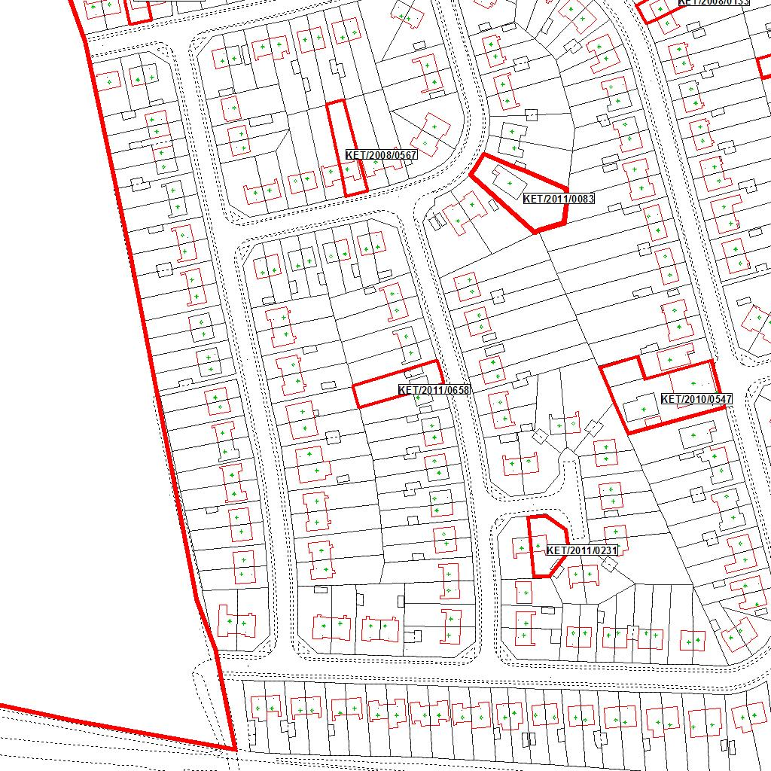

Reproduced from the Ordnance Survey mapping with the permission of the Controller of Her Majesty’s Stationery Office © Crown copyright. Unauthorised reproduction infringes Crown copyright and may lead to prosecution or civil proceedings.  LA078344 |  | N
Date: 12/10/2011 Do not scale from this map. For illustrative purposes only.

BOROUGH OF KETTERING

Committee | Full Planning Committee - 06/12/2011 | Item No: 5.4
Report Originator | Alex Jelley  Development Officer | Application No:  KET/2011/0685
Wards Affected | Desborough Loatland
Location | Plot 6 Spinney Close, Desborough,
Proposal | Full Application: Formation of vehicular access and driveway
Applicant | Mr S Holland

1. PURPOSE OF REPORT

  - To describe the above proposals
  - To identify and report on the issues arising from it
  - To state a recommendation on the application

2. RECOMMENDATION

THE DEVELOPMENT CONTROL MANAGER RECOMMENDS that this application be APPROVED subject to the following Condition(s):-

1. The development hereby permitted shall be begun before the expiration of 3 years from the date of this planning permission.
REASON: To comply with Section 91 of the Town and Country Planning Act 1990 (as amended) and to prevent an accumulation of unimplemented planning permissions.

2. The gradient of the drive shall not exceed 1 in 15 within 5 metres of the edge of the carriageway of the adjoining highway.
REASON: In the interests of highway safety in accordance with policy 13 of the North Northamptonshire Core Spatial Strategy.

Notes (if any) :-
- No works may commence within the existing highway without the express written permission of the Local Highway Authority. This Planning permission does not give or infer such consent. However such consent may be forthcoming subject to the completion of a suitable licence or Agreement under the Highways Act 1980. Any works within the highway shall comply with NCC Specifications.

Justification for Granting Planning Permission

The proposal is in accordance with national and local policies as set out in Planning Policy Guidance 13, Policy 13 of the North Northamptonshire Core Spatial Strategy. There are no material considerations that indicate against the proposal.

Officers Report

3.0 | Information

Relevant Planning History
KET/2011/0247 – Dropped kerb and driveway – Refused 23.06.2011
- “The applicant has failed to demonstrate that a satisfactory vehicular access can be provided to the site, specifically in respect of vehicle visibility, to the detriment of highway safety. The scheme is thereby contrary to the requirements of Policy 13 of the North Northamptonshire Core Spatial Strategy and PPG13”

KET/2005/0018 – Replace temporary dwelling with new dwelling – Approved 18/.03.2005

Site Description
Officer's site inspection was carried out on 18.11.2011

The application site consists of Spinney Close, Braybrooke Road, Desborough. The site is used as a permanent gypsy and traveller site, and currently has 6 mobile home plots. There is an existing access point to the southeast corner of the site, off Braybrooke Road which lies to the south of the site. It is approximately 350m from the boundary of Desborough to the east.

There is a grass verge immediately adjoining the highway, which slopes down to a narrow drainage ditch and some shrubs that run along the boundary fence of the site. The location of the proposed access point follows this approach, with a close boarded fence currently in position.

Proposed Development
This application seeks permission for a dropped kerb and access point at Plot 6 Spinney Close, Braybrooke Road, Desborough.

Any Constraints Affecting the Site
C Road

4.0 | Consultation and Customer Impact

Desborough Town Council
Objection.
- “DTC believes that this is an overdevelopment at this location and should not be permitted. The removed hedgerow and drainage ditch should be reinstated. This site has one entrance off a busy road.”

Highway Authority
No objection.

5.0 | Planning Policy

National Policies
PPG13. Transport

North Northamptonshire Core Spatial Strategy
Policy 13. General Sustainable Development Principles

6.0 | Financial/Resource Implications
 | None
7.0 | Planning Considerations
The key issues for consideration in this application are:-

- Principle of Development
- Design and Character
- Highways

1. Principle of Development
Section 38(6) of the Planning and Compulsory Purchase Act 2004 requires local planning authorities to determine planning applications in accordance with the Development Plan unless material planning considerations indicate otherwise.

In 2005 an application was approved (KET/2005/0018) for a replacement dwelling on the site. In the Officer’s Report for that application the site is described as follows:

“The existing bungalow stands in the southern part of the site whilst the remainder of the land is used for the siting of residential caravans and also storage of caravans – unauthorised uses. Enforcement and Stop Notices relating to these uses were never served because the site has been recognised to meet the criteria of Policy 119 of the Local Plan”.

Policy 119 of the Local Plan has since been superseded by Policy 17 of the North Northamptonshire Core Spatial Strategy (CSS), however, the relevance of the above passage remains. The site is close to the boundary of Desborough; which has a range of services available, it is not within an area designated as being environmentally sensitive, and is in accordance with Policy 9 and 13 of the CSS. Furthermore, aerial photographs of the site appear to show a constant and regular use in its current state since 2000. As such, the question of the lawfulness of the use of the site is not currently under question.

Policy 13 of the CSS provides for new accesses onto the highway, in accordance with the Development Plan and national guidance documents, subject to specific criteria being satisfied. In particular; accesses should be suitable in terms of their design and the character of the site and surrounding area; and they should form a suitable relationship with the highway network. PPG13 supports this approach, highlighting the important role matters relating to the highway network have in ensuring road safety and sustainable development.

It is considered that the proposal is acceptable in principle, subject to the detailed matters discussed below.

2. Design and Character
The proposed access would be located in the northwest corner of the site, roughly 80m to the northwest of the existing access point. According to the application submitted the access driveway would be constructed of tarmacadam, while the edges would be grassed. It is considered that the proposals represent a form of access that is similar in character to those already in place among this part of Braybrooke Road. As such, the application conforms to the general character of the area, and is deemed to be acceptable from a design and character perspective. Therefore the Policy 13(h)(i) of the CSS are adhered to.

Desborough Town Council has referred to the loss of a mature hedgerow along the site boundary. From my site visit it appears that the precise location of the proposed access point is on a part of the site boundary that does not benefit from having a hedgerow along it. Instead there is a fairly standard close boarded fence. Whether a hedgerow was or was not removed from this section of the boundary prior to my site visit, I can not say. However, it is my opinion that this concern is not one that would constitute a reason for refusal.

3. Highways
The previous application, KET/2011/0247, was refused solely on the basis of an objection from the Highway Authority which stated the following concerns:
- Incorrectly drawn and substandard visibility splays showing 2m x 150m instead of 2m x 215m. Visibility requirements could be reduced subject to a validated speed survey indicating that speeds are slower than 60mph
- Gradient of access being steeper than 1:15 for the first 5m from the highway
- Access should be 6m in width to enable a turning vehicle with a trailer to avoid causing damage to the adjacent and opposite verges.
The Highways Authority response indicated that it was not likely that the above issues could be remedied on the site.

These concerns and the Highways Authority objection have been rescinded following discussions between the applicant and officers from NCC. The Highways Authority has made the following comment:

“I have spoken with the applicant following the consideration of the previous proposal. On a site visit, I agreed that the visibility on offer in both directions I satisfactory for the location of the new access across the verge, despite the fact that the road at this point is derestricted (i.e. is subject to the national speed limit).

I noted that the advanced direction sign on the approach to the roundabout of the A6 is in line with the visibility from the proposed access; however I also noted that vehicle speeds were lower from this direction due to the proximity of the roundabout and the rising gradient towards the site.

The design and dimensions of the proposal have been submitted based on a similar access on the other side of the road. As such I am comfortable that the arrangement would be acceptable from a highway safety perspective.

Confirmation should be sought that the gradient of the access is no steeper than 1:15 for the first 5m from the kerb. I believe this is easily achievable.”

As such, it is considered that with an appropriate condition relating to gradient, the resultant development would form a suitable relationship with the highway network. The application therefore complies with Policy 13 (d)(n) of the CSS and PPG13.

Conclusion

The application is in accordance with the Development Plan and there are no material planning considerations that would indicate against approval.

Background Papers |  | Previous Reports/Minutes
Title of Document: |  | Ref:
Date: |  | Date:
Contact Officer: | Alex Jelley, Development Officer on 01536 534316

SITE LOCATION PLAN

Plot 6 Spinney Close, Desborough,
Application No.: KET/2011/0685
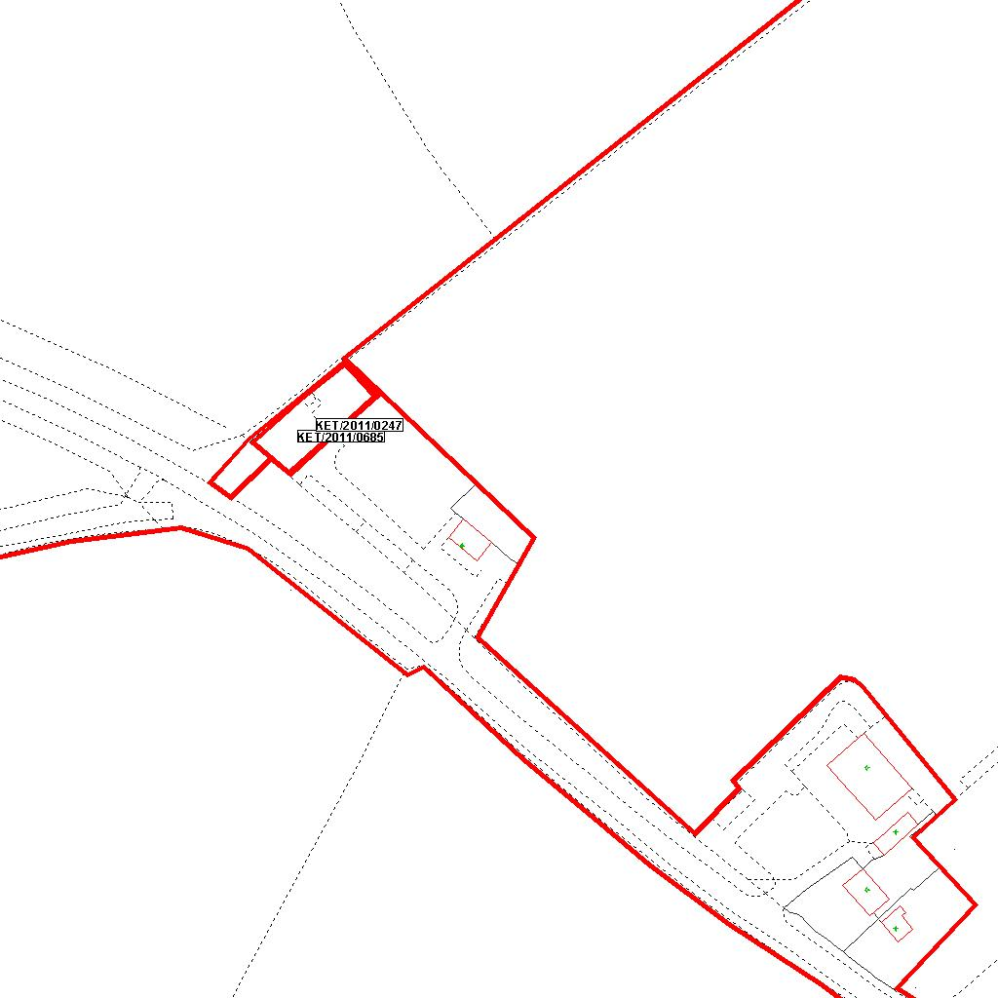

Reproduced from the Ordnance Survey mapping with the permission of the Controller of Her Majesty’s Stationery Office © Crown copyright. Unauthorised reproduction infringes Crown copyright and may lead to prosecution or civil proceedings.  LA078344 |  | N
Date: 21/10/2011 Do not scale from this map. For illustrative purposes only.

BOROUGH OF KETTERING

Committee | Full Planning Committee - 06/12/2011 | Item No: 5.5
Report Originator | Mark Coleman  Assistant Development Officer | Application No:  KET/2011/0699
Wards Affected | Slade
Location | 11 Grange Road, Cransley
Proposal | Full Application: 1 no. dwelling. Modified vehicular access and parking to existing house
Applicant | Mr C Goodall

1. PURPOSE OF REPORT

  - To describe the above proposals
  - To identify and report on the issues arising from it
  - To state a recommendation on the application

2. RECOMMENDATION

THE DEVELOPMENT CONTROL MANAGER RECOMMENDS that this application be APPROVED subject to the following Condition(s):-

1. The development hereby permitted shall be begun before the expiration of 3 years from the date of this planning permission.
REASON: To comply with Section 91 of the Town and Country Planning Act 1990 (as amended) and to prevent an accumulation of unimplemented planning permissions.

2. The materials to be used in the construction of the external surfaces of the development hereby permitted shall match, in type, colour and texture those on the adjacent dwelling known as no. 11 Grange Road, in accordance with drawing no. 82.126.23 received on 26th October 2011.
REASON: In the interests of visual amenity in accordance with policy 2 of the East Midlands Regional Plan and Policy 13 of the North Northamptonshire Core Spatial Strategy.

3. No development shall take place until there has been submitted to and approved in writing by the Local Planning Authority a scheme of landscaping which shall specify species, planting sizes, spacing and numbers of trees and shrubs to be planted. The approved scheme shall be carried out in the first planting and seeding seasons following the occupation of the building. Any trees or plants which, within a period of 5 years from the date of planting, die, are removed or become seriously damaged or diseased shall be replaced in the next planting season with others of similar size and species.
REASON: To improve the appearance of the site in the interests of visual amenity in accordance with policy 2 of the East Midlands Regional Plan and Policy 13 of the North Northamptonshire Core Spatial Strategy.

4. Notwithstanding the provisions of Article 3 of the Town and Country Planning (General Permitted Development) Order 1995 (or any Order revoking and re-enacting that Order with or without modification) no hard surface shall be constructed to the front (northwest) or the new dwelling hereby approved as permitted by Class F of Part 1 of Schedule 2 of the Order.
REASON: In the interests of protecting highway safety in the area in accordance with Policy 2 of the East Midlands Regional Plan and Policy 13 of the North Northamptonshire Core Spatial Strategy.

5. The use of the new vehicular access located to the rear of the dwelling hereby approved (accessed from Rose Close) shall not commence until works have been completed to permanently remove the existing vehicular access leading from Grange Road to the front (northwest) of the new dwelling and the raised kerb reinstated in accordance with drawing no. 82.126.22 Rev A received on 24th November 2011.
REASON: To protect highway safety in accordance with Policy 2 of the East Midlands Regional Plan and Policy 13 of the North Northamptonshire Core Spatial Strategy.

6. The new dwelling hereby approved shall not be occupied until it has been completed in full accordance with the submitted Sustainability Appraisal & Energy Statement received by the Local Planning Authority on 26th October 2011.
REASON: In the interests of achieving a sustainable and energy efficient form of development in accordance with Policy 2 of the East Midlands Regional Plan and Policy 14 of the North Northamptonshire Core Spatial Strategy.

7. Prior to first use or occupation of the new dwelling hereby approved, the new vehicular access and dropped kerb serving no. 11 Grange Road shall be provided in accordance with drawing no. 82.126.22 Rev A and shall include pedestrian visibility splays of 2.4m x 2.4m either side of the access and shall be permanently retained in that form thereafter. These measurements are taken from and along the highway boundary. Any features within or affecting the resultant triangular areas shall not exceed 0.6m above access/footway level.
REASON: In the interest of protecting highway safety in accordance with Policy 2 of the East Midlands Regional Plan and Policy 13 of the North Northamptonshire Core Spatial Strategy.

8. Unless otherwise agreed by the Local Planning Authority, development other than that required to be carried out as part of an approved scheme of remediation must not commence until parts A to D have been complied with. If unexpected contamination is found after development has begun, development must be halted on that part of the site affected by the unexpected contamination to the extent specified by the Local Planning Authority in writing until condition d has been complied with in relation to that contamination.

A. Site Characterisation

An investigation and risk assessment, in addition to any assessment provided with the planning application, must be completed in accordance with a scheme to assess the nature and extent of any contamination on the site, whether or not it originates on the site. The contents of the scheme are subject to the approval in writing of the Local Planning Authority. The investigation and risk assessment must be undertaken by competent persons and a written report of the findings must be produced. The written report is subject to the approval in writing of the Local Planning Authority. The report of the findings must include:

(i) a survey of the extent, scale and nature of contamination;

(ii) an assessment of the potential risks to:
- human health,
- property (existing or proposed) including buildings, crops, livestock, pets, woodland and service lines and pipes,
- adjoining land,
- groundwaters and surface waters,
- ecological systems,
- archaeological sites and ancient monuments;

(iii) an appraisal of remedial options, and proposal of the preferred option(s).

This must be conducted in accordance with DEFRA and the Environment Agency's 'Model Procedures for the Management of Land Contamination, CLR 11(or any model procedures revoking and replacing those model procedures with or without modification)'.

B. Submission of Remediation Scheme

A detailed remediation scheme to bring the site to a condition suitable for the intended use by removing unacceptable risks to human health, buildings and other property and the natural and historical environment must be prepared, and is subject to the approval in writing of the Local Planning Authority. The scheme must include all works to be undertaken, proposed remediation objectives and remediation criteria, timetable of works and site management procedures. The scheme must ensure that the site will not qualify as contaminated land under Part 2A of the Environmental Protection Act 1990 in relation to the intended use of the land after remediation.

C. Implementation of Approved Remediation Scheme

The approved remediation scheme must be carried out in accordance with its terms prior to the commencement of development other than that required to carry out remediation, unless otherwise agreed in writing by the Local Planning Authority. The Local Planning Authority must be given two weeks written notification of commencement of the remediation scheme works.

Following completion of measures identified in the approved remediation scheme, a verification report (referred to in PPS23 as a validation report) that demonstrates the effectiveness of the remediation carried out must be produced, and is subject to the approval in writing of the Local Planning Authority.

D. Reporting of Unexpected Contamination

In the event that contamination is found at any time when carrying out the approved development that was not previously identified it must be reported in writing immediately to the Local Planning Authority. An investigation and risk assessment must be undertaken in accordance with the requirements of condition A, and where remediation is necessary a remediation scheme must be prepared in accordance with the requirements of condition B, which is subject to the approval in writing of the Local Planning Authority.
Following completion of measures identified in the approved remediation scheme a verification report must be prepared, which is subject to the approval in writing of the Local Planning Authority in accordance with condition C.

REASON: To ensure that risks from land contamination to the future users of the land and neighbouring land are minimised, together with those to controlled waters, property and ecological systems, and to ensure that the development can be carried out safely without unacceptable risks to workers, neighbours and other offsite receptors in accordance with Policy 13 of the North Northamptonshire Core Spatial Strategy.

Notes (if any) :-
- The applicant is advised that a licence must be obtained from the Highway Authority before any works are carried out on any footway, carriageway, verge or other land forming part of the highway and should make contact with the Highway Authority at Northamptonshire County Council, tel. 01604 654358.

Informative: Due to the underlying geology present throughout Northamptonshire at which the levels of some naturally occurring contaminants frequently exceed the levels at which the risk to human health would be considered acceptable for residential land use; it is expected that there may be unacceptable risks to future occupiers of the site therefore the required investigations must take naturally occurring contaminants into consideration. Further guidance on Contaminated Land investigations can be found in the Northants Contaminated Land Group Developers Guide. This document is downloadable at http://www.kettering.gov.uk/downloads/developers_guide_may_04.pdf

If you wish to discuss the requirements of the investigations further please contact Mrs Alex Gratrix, Team Leader (Environmental Protection) on (01536) 534348; or email at contaminatedland@kettering.gov.uk

Justification for Granting Planning Permission

The proposal is in accordance with national and local policies as set out in Planning Policy Statements/Guidance Notes 1, 3, 13, Policies 2, 11, 48 of The East Midlands Regional Plan, Policies 1, 9, 10, 13, 14 of the North Northamptonshire Core Spatial Strategy and Policy RA3 of the Local Plan for Kettering Borough. The proposal is also in accordance with adopted Supplementary Planning Document Sustainable Design. The issues relating to impact on character, highway safety, parking and drainage are material planning considerations and, in reaching the decision to approve the proposal, have been carefully weighed against all relevant policy considerations.

Officers Report

3.0 | Information

Relevant Planning History
KE/1998/0595 – Perimeter fence to side and rear of property, 2m high gates across in line with front of garage (approved – 08.12.98)

Site Description
Officer's site inspection was carried out on 11.11.11. It is noted that the address of the application is ‘Cransley’, although for planning purposes it is described as being within the settlement boundary of Broughton as shown on the adopted proposal maps contained within the Local Plan.

The corner site is located towards the northeast of the village on a small 1960’s housing estate, occupying a corner position with Grange Road and Rose Close. A single, semi-detached, two storey dwelling is located within the site. The dwelling is constructed from brown brick with Canterbury spar relief panel to first floor (front elevation) and timber clad relief to ground floor; the roof is covered with grey concrete interlocking tiles. A central chimney is shared by the adjoining properties. To the side (west) is a single storey, flat roofed tandem garage with driveway; behind this is a timber shed. Further west is a side garden which is separated from the highway and enclosed by 6ft close boarded timber. To the rear (southeast) of the site is a small electricity sub-station beyond which is no.1 Rose Close which sides on to the site. Within the garden of the site are three established trees (Buddelia; Japenese Cherry; and Maple) and a number of conifers.

Proposed Development
The proposed development involves demolition of the existing garage, and the erection of a two storey dwelling, detached dwelling with detached garage to the rear. Off road parking is provided to the front and rear.

Any Constraints Affecting The Site
None

4.0 | Consultation and Customer Impact

Parish/Town Council
Objection on grounds of adverse impact on the character of the area; increase in on-street parking; adverse impact on highway safety; and adverse impact on existing sewer system.

Highway Authority
Comment of no objection subject to removal of access to the new dwelling off served from Grange Road.

Environmental Health, Kettering Borough Council.
No Objection, subject to contaminated land condition and associated informative.

Neighbours
No objection, but concerns raised by the occupiers of no. 42 Grange Road, Cransley. Areas of concern relate to congestion resulting from the proposal; increase in parked vehicles on the highway; highway safety; and impact on the existing sewer system which is believed to be inadequate.

Objection from the occupiers of no. 8 Rose Close on the grounds of increased congestion resulting from the new access connected to Rose Close and its adverse impact on highway safety. Further grounds of objection are based on impact on the character of the area, and adverse impact on the existing sewer network.

Objection from the occupiers of no. 4 Rose Close. Grounds of objection include adverse impact on character of the area; increase in parked vehicles on the highway; and adverse impact on the existing sewer network.

5.0 | Planning Policy

National Policies
PPS1. Delivering Sustainable Development
PPS3: Housing
PPG13. Transport
PPS23: Planning and Pollution Control

Development Plan Policies

East Midlands Regional Plan
Policy 2. Promoting Better Design
Policy 11: Development in the Southern Sub-Area
Policy 48. Regional Car Parking Standards

North Northamptonshire Core Spatial Strategy
Policy 1: Strengthening the Network of Settlements
Policy 9. Distribution & Location of Development
Policy 10. Distribution of Housing
Policy 13. General Sustainable Development Principles
Policy 14: Energy Efficiency and Sustainable Construction

Local Plan
Policy RA3. Rural Area: Restricted Infill Villages

SPGs
Sustainable Design

6.0 | Financial/Resource Implications
 | None
7.0 | Planning Considerations
The key issues for consideration in this application are:-

- The principle of development
Policies within the North Northamptonshire Core Spatial Strategy provide for the erection of new dwellings, subject to detailed criteria being satisfied. In particular, Policy 13 (CSS) seeks that the proposed development must be of a high standard of design; it must respect and enhance the character of the surroundings; and it must not result in an unacceptable impact on the amenities of existing or future occupiers of neighbouring properties or the wider area by virtue of noise, vibration, smell, light or other pollutions, loss of light or overlooking. Policy 2 (EMRP) also seeks for the continuous improvement of design in relation to these issues, which will result in improving the quality of life of local people.

National policy in PPS1 promotes the sustainable use of existing land and buildings, focussing on the importance design and amenity, whilst PPS3 reiterates this approach to design, and seeks to achieve a mix of housing which will strengthen communities.

The design of the proposed development broadly meets these requirements and will increase variety of housing provision within the area. Whilst the development is within a restricted infill village, it complies with the principal issues referred to in Policy RA3 (Local Plan), and as the location of the proposed development is within an existing settlement area, it is also supported by policies 1, 9 and 10 (CSS) and Policy 1 and 11 (EMRP). As a result, subject to other material considerations being considered accepted, the proposed development is acceptable in principle.

- Character and appearance
The character of the area is best described as open plan, and the provision of an additional dwelling on the corner plot will erode this character to some degree. However, in this instance, it is considered that the site is big enough to absorb the proposed development and retain sufficient front and side garden area to preserve this open character of the area. This will be facilitated further by the removal of part of the existing boundary treatment which currently detracts from the open character of the area.

The proposal takes direct design reference from the neighbouring semi-detached dwelling located within the site, albeit detached in form. As a result, the scale, layout and appearance responds to existing development in the area, and continues the established building line; the close positioning of the proposed dwelling to no. 11 Grange Road reflects the semi-varied rhythm of development within the street.

Whilst the building is shown to be slightly taller than its neighbour, it is not considered that this will be visually incongruent within the street scene as the finished height of the building responds to slightly higher ground levels. The proposal will result in the loss of a number of trees, although submitted landscape details indicate that these will be replaced by further planting. As a result, subject to condition to control materials used in the construction of the dwelling and landscaping, the proposal is considered to have an acceptable impact on visual amenity, and accords with the relevant parts of PPS1, Policy 2 (EMRP), and criteria (h) and (i) of Policy 13 (CSS).

- Residential amenity
The siting of the proposed development on the established building line does not generate new impacts on residential amenity which would affect properties to the northwest or west. The nearest dwelling to the southeast is no. 1 Rose Close which faces side on to the rear of the proposed dwelling. The only windows present on the side elevation are to first floor, which serve a landing area and bathroom. As these windows do not serve a habitable room, it is considered that loss of amenity due to direct overlooking is limited.
The proposed roof lights to the second floor sit 1.2m above finished floor level (at its lowest point) and whilst they have the potential to give rise to overlooking this is likely to be limited to the flank wall of no. 1 Rose Close and its front garden; furthermore, head clearance is limited in the room which would restrict the use to storage. As a result, it is not considered necessary to condition use of the room or the roof lights. Furthermore, a separation distance of approximately 17m is maintained, which is also considered adequate to protect amenity in terms of overlooking and loss of access to natural light.

Infill of the site will leave sufficient amenity space for the existing dwelling, and the proposed dwelling. No other residential amenity issues are identified. The proposal is therefore considered to be in compliance with relevant parts of policy 2 (EMRP) and criteria (l) of Policy 13 (CSS).

- Parking and highway safety
The original proposal included parking for the proposed dwelling to both front and rear, with off-road parking provided to the front for the existing dwelling. Comment from NCC Highways objected to two vehicular accesses serving a single property, but, subject to the front access being removed from the proposed new dwelling, had no objection to the proposal in terms of its impacts on parking and highway safety despite pedestrian visibility splays being substandard with respect of the rear access serving the new property; where a visibility splay has been provided, this has been included within the wider verge area adjacent the site off Rose Close which remains under the control of NCC Highways.

As a result of the above comments, the scheme has been amended to remove the vehicular access from the front of the proposed new dwelling. Both properties now benefit from two parking spaces each which are clear of the highway.

It is noted that to the front of no. 11 Grange Road the verge is narrower; it is therefore considered appropriate to seek control over pedestrian visibility splays. Whilst this will also exert control over land falling within the curtilage of the new dwelling, the land currently remains under the ownership of the applicant. Such a condition is therefore considered reasonable.

Whilst there have been objections raised with respect of the impact of the proposal on highway safety and congestion, it is considered that the aforementioned parking provision is sufficient. Together with the aforementioned condition and condition

controlling the use of new accesses until such time that secondary accesses have been removed, highway safety will be protected.

In the absence of sustained objection from NCC Highways, it is considered that the proposal will not have a significant impact on parking or highway safety, subject to the aforementioned conditions and condition removing permitted development rights for laying of hard standing to the front. Subject to this, the proposal accords with the relevant parts of PPG13, Policies 2 and 48 (EMRP) and criteria (d) and (n) of Policy 13 (CSS).

- Sustainable construction and energy efficiency
Policy 14 of the North Northamptonshire Core Spatial Strategy states that development should meet the highest viable standards of resource and energy efficiency and reduction in carbon emissions. The submitted sustainability appraisal and energy statement demonstrates that the proposal will achieve a code level 3 rating, by using energy monitoring equipment, efficient white goods, cycle storage, photovoltaic’s, water efficiency devices, etc. This is considered acceptable, and subject to condition requiring the development to be carried out in accordance with the submitted statement, the proposal is considered acceptable and in accordance with relevant parts of policy 2 (EMRP) and Policy 14 (CSS)

- Impact on drainage/sewer network
Planning controls should not seek to duplicate other control regimes, and should assume that these will be properly applied and enforced. In this instance, the connection of any new dwelling to an existing sewer system will require the agreement and permission from the Water Authority (Anglian Water). Whilst comments received from Broughton Parish Council state that the existing sewer system is unadopted, this should remain subject of automatic adoption in accordance with Anglian Water advice. As a result, objections relating to the impact of the proposed dwelling on the existing sewer network are not considered to provide a defendable reason for refusal, and are not considered further.

Conclusion

The proposal is acceptable in principle and in terms of its impact on neighbouring/visual amenity, parking and highway safety, and sustainability. The impact of the development on the drainage network is not considered to provide sufficient reason for refusal and will be controlled by the relevant water authority. Subject to conditions referred to above, the proposal is considered acceptable and recommended for approval.

Background Papers |  | Previous Reports/Minutes
Title of Document: |  | Ref:
Date: |  | Date:
Contact Officer: | Mark Coleman, Assistant Development Officer on 01536 534316

SITE LOCATION PLAN

11 Grange Road, Cransley
Application No.: KET/2011/0699

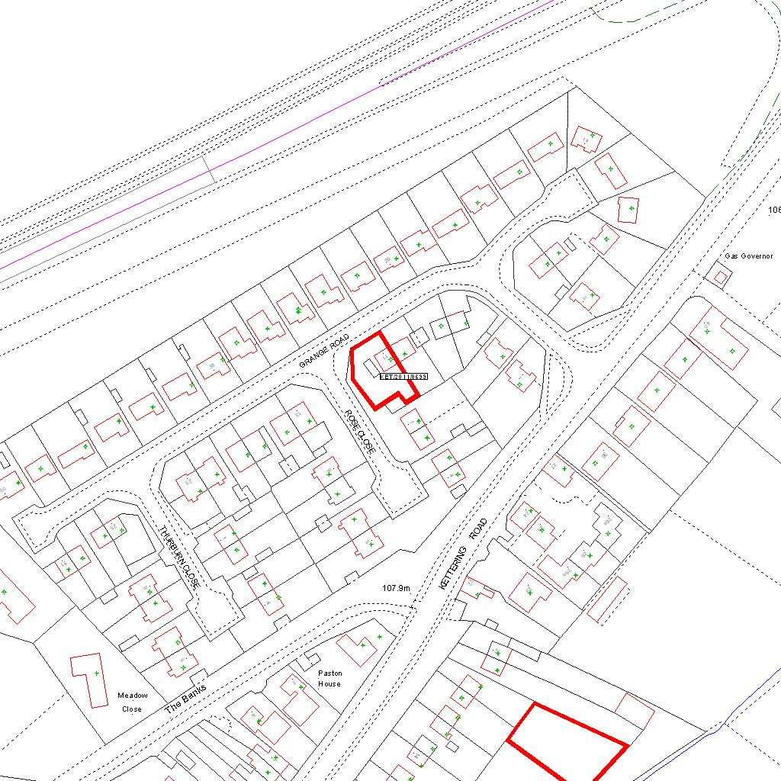

Reproduced from the Ordnance Survey mapping with the permission of the Controller of Her Majesty’s Stationery Office © Crown copyright. Unauthorised reproduction infringes Crown copyright and may lead to prosecution or civil proceedings.  LA078344 |  | N
Date: 27/10/2011 Do not scale from this map. For illustrative purposes only.

