BOROUGH OF KETTERING

Committee | Full Planning Committee - 08/11/2011 | Item No: 5.7
Report Originator | Alex Jelley  Development Officer | Application No:  KET/2011/0587
Wards Affected | All Saints
Location | 100 Britannia Road, Kettering
Proposal | Full Application: Demolition of bungalow and construction of a pair of semi detached two storey houses and outhouses to rear
Applicant | Mr I Umar

1. PURPOSE OF REPORT

  - To describe the above proposals
  - To identify and report on the issues arising from it
  - To state a recommendation on the application

2. RECOMMENDATION

THE DEVELOPMENT CONTROL MANAGER RECOMMENDS that this application be APPROVED subject to the following Condition(s):-

1. The development hereby permitted shall be begun before the expiration of 3 years from the date of this planning permission.
REASON: To comply with Section 91 of the Town and Country Planning Act 1990 (as amended) and to prevent an accumulation of unimplemented planning permissions.

2. The development hereby permitted shall not be carried out other than in accordance with the approved plans and details submitted with the application.
REASON: In the interests of sustainable development in accordance with Policy 13 of the North Northamptonshire Core Spatial Strategy and PPS1.

3. No development shall commence on site until details of the types and colours of all external facing and roofing materials to be used, together with samples, have been submitted to and approved in writing by the Local Planning Authority. The development shall not be carried out other than in accordance with the approved details.
REASON: In the interests of the visual amenities of the area in accordance with policy 13 of the North Northamptonshire Core Spatial Strategy.

4. Unless otherwise agreed by the Local Planning Authority, development other than that required to be carried out as part of an approved scheme of remediation must not commence until parts A- D have been complied with. If unexpected contamination is found after development has begun, development must be halted on that part of the site affected by the unexpected contamination to the extent specified by the Local Planning Authority in writing until part D has been complied with in relation to that contamination.

A. Site Characterisation

An investigation and risk assessment, in addition to any assessment provided with the planning application, must be completed in accordance with a scheme to assess the nature and extent of any contamination on the site, whether or not it originates on the site. The contents of the scheme are subject to the approval in writing of the Local Planning Authority. The investigation and risk assessment must be undertaken by competent persons and a written report of the findings must be produced. The written report is subject to the approval in writing of the Local Planning Authority. The report of the findings must include:

(i) a survey of the extent, scale and nature of contamination;
(ii) an assessment of the potential risks to:
o human health,
o property (existing or proposed) including buildings, crops, livestock, pets, woodland and service lines and pipes,
o adjoining land,
o groundwaters and surface waters,
o ecological systems,
o archeological sites and ancient monuments;
(iii) an appraisal of remedial options, and proposal of the preferred option(s).

This must be conducted in accordance with DEFRA and the Environment Agency's 'Model Procedures for the Management of Land Contamination, CLR 11'.

B. Submission of Remediation Scheme

A detailed remediation scheme to bring the site to a condition suitable for the intended use by removing unacceptable risks to human health, buildings and other property and the natural and historical environment must be prepared, and is subject to the approval in writing of the Local Planning Authority. The scheme must include all works to be undertaken, proposed remediation objectives and remediation criteria, timetable of works and site management procedures. The scheme must ensure that the site will not qualify as contaminated land under Part 2A of the Environmental Protection Act 1990 in relation to the intended use of the land after remediation.

C. Implementation of Approved Remediation Scheme

The approved remediation scheme must be carried out in accordance with its terms prior to the commencement of development other than that required to carry out remediation, unless otherwise agreed in writing by the Local Planning Authority. The Local Planning Authority must be given two weeks written notification of commencement of the remediation scheme works.

Following completion of measures identified in the approved remediation scheme, a verification report (referred to in PPS23 as a validation report) that demonstrates the effectiveness of the remediation carried out must be produced, and is subject to the approval in writing of the Local Planning Authority.

D. Reporting of Unexpected Contamination

In the event that contamination is found at any time when carrying out the approved development that was not previously identified it must be reported in writing immediately to the Local Planning Authority. An investigation and risk assessment must be undertaken in accordance with the requirements of part A, and where remediation is necessary a remediation scheme must be prepared in accordance with the requirements of part B, which is subject to the approval in writing of the Local Planning Authority.
Following completion of measures identified in the approved remediation scheme a verification report must be prepared, which is subject to the approval in writing of the Local Planning Authority in accordance with part C.
REASON (common to all): To ensure that risks from land contamination to the future users of the land and neighbouring land are minimised, together with those to controlled waters, property and ecological systems, and to ensure that the development can be carried out safely without unacceptable risks to workers, neighbours and other offsite receptors.

5. Prior to first use or occupation of the development hereby permitted, vehicular visibility splays of 2.0m from the carriageway edge along the centre of the vehicular access by a distance of 43m measured from the centre of the vehicular access along the carriageway edge. Any features within or affecting the resultant triangular areas shall not exceed 0.9m above the access carriageway level.
REASON: In the interests of highway safety, residential amenity and in accordance with Policy 13 of the North Northamptonshire Core Spatial Strategy and PPG13.

6. Prior to first use of occupation of the development hereby permitted pedestrian visibility splays of at least 2.4 metres x 2.4 metres shall be provided on each side of the vehicular access. These measurements are taken from and along the highway boundary. Any features within or affecting the resultant triangular areas shall not exceed 0.6 metres above access/footway level.
REASON: In the interests of highway safety and residential amenity in accordance with Policy 13 of the North Northamptonshire Core Spatial Strategy and PPG13.

7. The gradient of the drive shall not exceed 1-15 and shall be paved with a hard bound surface the details of which shall have been submitted to and approved in writing by the Local Planning Authority prior to the first occupation of the buildings and shall be retained thereafter.
REASON: In the interests of highway safety and residential amenity in accordance with Policy 13 of the North Northamptonshire Core Spatial Strategy and PPG13.

8. Prior to the commencement of development a scheme for the provision of the surface and waste water drainage shall be submitted to and approved in writing by the Local Planning Authority. The development shall not be carried out other than in accordance with the approved scheme.
REASON: In the interest of highway safety and residential amenity in accordance with Policy 13 of the North Northamptonshire Core Spatial Strategy and PPG13.

9. No gates, barrier or means of enclosure shall be erected within 5.5m of the highway boundary. Any such feature erected beyond that distance should be hung to open inwards away from the highway.

REASON: In the interest of highway safety in accordance with Policy 13 of the North Northamptonshire Core Spatial Strategy and PPG13.

10. No development shall take place until there has been submitted to and approved in writing by the Local Planning Authority a scheme of landscaping which shall specify species, planting sizes, spacing and numbers of trees and shrubs to be planted. The approved scheme shall be carried out in the first planting and seeding seasons following the occupation of the building. Any trees or plants which, within a period of 5 years from the date of planting, die, are removed or become seriously damaged or diseased shall be replaced in the next planting season with others of similar size and species.
REASON: To improve the appearance of the site in the interests of visual amenity in accordance with policy 13 of the North Northamptonshire Core Spatial Strategy.

11. Before the development hereby permitted is begun, a scheme demonstrating how the development will incorporate techniques of sustainable construction and energy efficiency, provision for waste reduction and recycling and provision for water efficiency and recycling shall have been submitted to and approved in writing by the Local Planning Authority. The development shall thereafter be carried out in accordance with these approved details.
REASON: In the interests of energy efficiency and sustainable construction in accordance with policy 14 of the North Northamptonshire Core Spatial Strategy.

12. Before the development hereby permitted is begun, full details of the solar panels shall have been submitted to and approved in writing by the Local Planning Authority. The development shall thereafter be carried out in accordance with these approved details.
REASON: In the interests of energy efficiency and sustainable construction in accordance with policy 14 of the North Northamptonshire Core Spatial Strategy.

13. Notwithstanding the provisions of Article 3 of the Town and Country Planning (General Permitted Development) Order 1995 (or any Order revoking and re-enacting that Order with or without modification) no additional openings permitted by Schedule 2, Part 1 Classes A or C shall be made in the west or east elevation or roof plane of the building.
REASON: To protect the amenity and privacy of the occupiers of adjoining property in accordance with policy 13 of the North Northamptonshire Core Spatial Strategy.

14. No development shall take place on site until a scheme for boundary treatment has been submitted to and approved in writing by the Local Planning Authority. The development shall not be occupied until the approved scheme has been fully implemented in accordance with the approved details.
REASON: In the interests of the amenities and privacy of the neighbouring property in the interests of amenity in accordance with policy 13 of the North Northamptonshire Core Spatial Strategy.

Notes (if any) :-
- This planning permission is subject to "pre-commencement" conditions which require details/drawings to be submitted to and approved in writing by the Local Planning Authority before ANY development may lawfully commence. Any development commenced in breach of these "pre-commencement" conditions will be unauthorised, a breach of planning control, and liable to immediate Enforcement and Stop Notice action.

No works may commence within the existing highway without the express written permission of the Highway Authority. This Planning permission does not give or infer such consent. however such consent may be forthcoming subject to the completion of a suitable licence or Agreement under the Highways Act 1980. Any works within the highway shall comply with NCC Specifications.

Any new sewer connection required for this development within the highway will require a licence from the Highway Authority under Section 50 of the New Roads and Street Works Act 1991.
Due to the underlying geology present throughout Northamptonshire at which the levels of some naturally occurring contaminants frequently exceed the levels at which the risk to human health would be considered acceptable for residential land use; it is expected that there may be unacceptable risks to futue occupiers of the site therefore the required investigations must take naturally occurring contaminants into consideration. Further guidance on Contaminated Land investigations can be found in the Northants Contaminated Land Group Developers Guide. This document is downloadable at http://www.kettering.gov.uk/downloads/developers_guide_may_04.pdf.

If you wish to discuss the requirements of the investigations further please contact Mrs Alex Gratrix, Team Leader (Environmental Protection) on 01536 534348; or email at contaminatedland@kettering.gov.uk.

Justification for Granting Planning Permission

The proposal is in accordance with national and local policies as set out in Planning Policy Statements/Guidance Notes 1, 3 and 13, Policies 2, 39, 46 and 48 of The East Midlands Regional Plan, Policies 1, 7, 9, 10, 13 and 14 of the North Northamptonshire Core Spatial Strategy, and Policy 35 of the Local Plan for Kettering Borough. The proposal is also in accordance with adopted Supplementary Planning Document Sustainable Design. There are no material considerations that indicate against the proposal.

Officers Report

3.0 | Information

Relevant Planning History
KET/2011/0287 – Demolition of bungalow and construction of a pair or semi-detached 3 storey houses and outhouses to rear – Refused 19/07/2011
- “The proposed dwellings, by virtue of their scale, design and positioning, would have an intrusive and overbearing impact on the occupiers of the adjoining property to the southwest to the detriment of their amenity. Furthermore the scale, height and design of the dwellings, coupled with their juxtaposition with existing dwellings to the southwest which are single storey, will have an unduly dominant impact on the street scene to its detriment. The application is therefore considered to be contrary to PPS1, Policy 2 of the East Midlands Regional Plan and criteria h), i) and l) of Policy 13 of the North Northamptonshire Core Spatial Strategy”.

Site Description
Officer's site inspection was carried out on 21/10/2011

The application site consists of No. 100 Britannia Road, Kettering, which is a detached bungalow style dwelling situated on the south side of the highway. It has a pyramidal roof design, with a central chimney, and is rendered in a rough finish painted white. The roof is made of brown concrete roof tiles. There is a sizeable rear garden, which extends to the southeast, and a smaller front garden that is screened well by a mature hedge.

To the southwest of the site lie two bungalows, and then a two storey Victorian dwelling that is built as if part of a row of terraces. It is however a detached property. To the northeast of the site is a large detached dwelling which is set within large grounds. Between the two properties is a row of tall trees.

Britannia Road has no defined character aside from a very vague ‘residential’ nature. Even in that instance there is a school directly opposite the site. There is a mix of house types, styles, designs and scales along the street.

Proposed Development
This application seeks permission for the demolition of a bungalow and the construction of a pair of semi-detached 2 storey houses with outhouses to the rear. For further detail refer to Section 7.0 of this report.

Any Constraints Affecting the Site
None

4.0 | Consultation and Customer Impact

Highway Authority
No objection. Recommend conditions relating to visibility, drainage, hard surfacing, access gradient and gates.

Environmental Health
No objection. Recommend condition relating contaminated land.

Neighbours
7 letters of objection have been received. They raised the following material concerns:
- overdevelopment of site
- not enough off street parking
- overbearing
- loss of light
- loss of privacy
- the plans show 1.2m fencing to the front, when there is existing 1.8m fencing that is outside of the applicants’ control
- the dropped kerb and crossover appears to be to the whole site, rather than just the single parking space
- the existing chimney at no. 98 Britannia Road would cease to work properly
- new buildings would be too long
- The out buildings are suspicious and could be split from the main buildings to form new dwellings/units

These issues are material planning considerations and are discussed in full in Section 7.0 below. The objection letters also contained the following concerns:
- The dwellings would be within 1m of the boundary, and therefore contrary to Building Regulations
- The window on the side elevation is larger than Building Regulations allow
- The school gates are not shown on the plans
With regards to the first two concerns, these issues will be addressed by Building Control officers in the event of the applicant applying for permission via Building Control. The latter issue is not a material planning consideration, and though the gate is not included on the plans, the relationship between the site and the school is clear from my site visit.

5.0 | Planning Policy

National Policies
PPS1. Delivering Sustainable Development
PPS3: Housing
PPG13. Transport

East Midlands Regional Plan
Policy 2. Promoting Better Design
Policy 39. Regional Priorities for Energy Reduction and Efficiency
Policy 46. A Regional Approach to Behavioural Change
Policy 48. Regional Car Parking Standards

North Northamptonshire Core Spatial Strategy
Policy 1. Strengthening the Network of Settlements
Policy 7. Delivering Housing
Policy 9. Distribution & Location of Development
Policy 10. Distribution of Housing
Policy 13. General Sustainable Development Principles
Policy 14: Energy Efficiency and Sustainable Construction

Local Plan
Policy 35. Housing: Within Towns

SPDs
Sustainable Design

6.0 | Financial/Resource Implications
 | None
7.0 | Planning Considerations
The key issues for consideration in this application are:-

- Principle of Development
- Design and Character
- Residential Amenity
- Highways

A. Principle of Development
Section 38(6) of the Planning and Compulsory Purchase Act 2004 requires local planning authorities to determine planning applications in accordance with the Development Plan unless material planning considerations indicate otherwise.

Policy 1 of the North Northamptonshire Core Spatial Strategy (CSS) defines Kettering as a ‘Growth Town’. Policy 3 of the East Midlands Regional Plan (EMRP) declares that significant growth should be located within the town of Kettering. It should, as a result, provide a focal point for residential development according to Policy 10 of the CSS. Policy 9 of the CSS establishes a priority on the reuse of suitable previously developed land and buildings within urban areas.

Policy 13 of the CSS provides for the form of development proposed, in accordance with the Development Plan and national policy guidance, subject to specific criteria being satisfied. These issues are addressed in full in the following sections. This approach is supported by Policy 2 of the EMRP, which highlights the importance of ensuring that development takes account of local character trends.

National policy in the form of PPS1 promotes the sustainable use of existing land and buildings. It highlights matters relating to design and amenity as playing essential roles in the delivery of sustainable development. PPS3 promotes the delivery of new housing development, and emphasises the importance of ensuring its suitability from a design and amenity perspective.

Planning application KET/2011/0287 was refused for the reason highlighted within Section 1.0 of this report. This is a material planning consideration, and is discussed fully within the sub-sections to follow.

It is considered that the proposed development is acceptable in principle, given its location within the town o Kettering, and the fact that the site is previously developed land. Any approval of the application would, however, be subject to the specific criteria discussed below.

B. Design and Character
The design of the two properties proposed takes its lead from the two dwellings to the West and the dwelling to the East of the site. There is a clear link both in terms of elevational design and scale between them. The current proposals were modified to take account of the reasons for refusal for KET/2011/0287 (as set out within Section 1.0, above), and lead to a form of development that is much more suitable within the street scene, and with regards to the properties immediately surrounding it. The eaves are lower, the ridge height is lower, and the properties are the same length at No. 98 Britannia Road. The front elevation of the properties is fairly basic in style, and it will be essential to ensure that the materials used and the finishes applied are suitable with regards to the existing properties on either side; this can be achieved through a condition. The layout indicates an area of hard standing to the front of the properties, which will provide for a parking space per dwelling. At present the whole front ‘garden’ is shown as being paved, however, it is considered that the land on either side of the parking bays should incorporate some form of landscaping so as to soften the appearance of the buildings. This will also ensure that only one parking space is provided per dwelling – as discussed within sub-section D below.

Concerns relating to the plot size are noted, however, so are existing properties with a similar plot width within the surrounding area. Nos. 43-49 Britannia Road, 121-123 Reservoir Road and 41-47 Hallwood Road are all within 250m of the site, and there are various other examples within the wider area. Therefore it is considered that the density of the site, which would equate to approximately 42dph, is reasonable given the urban location of the site and surrounding morphology.

The outbuildings located at the rear of the fairly extensive rear amenity spaces provided for each dwelling would have pitched roofs and a pavilion-esque design. Concerns relating to the potential for these buildings to be used as separate units are taken into consideration. However, any change of use of them would require planning permission, and therefore it is not necessary to formally link them to the dwellings via condition.

The design-related concerns that partly resulted in KET/2011/0287 being refused are considered to have been met, and as a result the proposed dwellings are in accordance with Policy 13 (h) and (i) of the CSS as well as Policy 2 of the EMRP.

Policy 14 of the CSS states that development should meet the highest viable standards of resource and energy efficiency. Development of the kid proposed should:
- incorporate techniques of sustainable construction;
- provide for waste reduction/recycling;
- provide for water efficiency/recycling
The submitted Design, Access and Sustainability Statement and Sustainable Design SPD Checklist appear to suggest that the proposals would be able to do this. However, no concrete plans are indicated, and as such a condition is necessary to ensure that the development delivers on these issues. The solar panels proposed (3 per dwelling) are a welcome element of the proposals. The detail included of the solar panels is somewhat limited, and therefore a condition is necessary to seek it so as to ensure that the resultant built form is acceptable.

C. Residential Amenity
The main focus for the reason of refusal of the previous planning application, as stated in Section 1.0 above, was the impact of the proposals on the amenity of the neighbouring property to the west. The scale and design of the proposed dwellings was, in that instance, considered to be a problem. The revised scheme that is currently under consideration is a clear attempt to try and meet those concerns. The 3rd floor has been removed entirely, and the shape of the dwellings altered so that the ridge line runs front-back, rather than from side-side. This has the effect of limiting the bulk of the dwellings along the boundary with No. 98 Britannia Road. The overbearing role that was a concern previously has been removed, as the new proposals play a much less dominant role within the street scene. Though they are two storey, rather than the 1.5 storey design of No. 98 Britannia Road, the relationship is not considered to be harmful, as the 3 storey dwellings would have been.

The proposed dwellings would cast a shadow from west to east towards the north through the passing of the day. Though a degree of shadow would therefore be cast towards No. 112 Britannia Road, to the east, it is not considered that it would result in a loss of light in habitable rooms, or indeed to a sufficient loss of light in the garden to warrant refusal. The distance between the two buildings would be approximately 16m, which is considered to be a sufficient separation to ensure against loss of light. No. 98 Britannia Road, to the west, has windows within its east elevation, including a roof light within the roof plane. However, these are not onto habitable rooms (ground floor windows are onto utility rooms) and the roof light is not the main window onto the first floor bedroom.

Concerns relating to overlooking are noted, however, it is considered that none of the proposed windows would threaten the privacy currently enjoyed by the occupiers of adjoining properties beyond the level that could be reasonably expected along a residential street such as Britannia Road. Conditions limiting Permitted Development Rights for new openings along the side elevations will ensure that no future issues arise with regards to this matter.

As a result of the above, it is considered that the proposals would accord with Policy 13 (l) of the CSS.

Concern was raised regarding an existing chimney at 98 Britannia Road. The applicant is currently in the process of having the situation assessed by a competent person. The outcome of this assessment will be delivered to Committee by way of an update to this report.

D. Highways
Each dwelling would benefit from one off-street parking space, accessed via Britannia Road. This number is considered sufficient given the property size and the location, which is close to various bus routes and within walking distance of Kettering town centre amenities. Though concerns have been raised about the development increasing the amount of on-street parking, particularly in relation to the proximity of a school across the road, this concern is not supported by the Highway Authority. The Highway Authority was consulted on this application, and have no objection to the proposals, subject to a number of conditions relating to visibility splays, hard surfacing, gradient and gates.

As discussed in sub-section B, above, the paved area indicated to the front of the properties will need to be altered so that only the parking space is hard surfaced. This will enable the visibility splays required to be implemented, and ensure that only one parking space is provided per dwelling. The rest of the front garden should be landscaped, and a condition requiring this is included. The dropped kerb and vehicular cross over will therefore be limited to the area immediately in front of each parking space – though this is dealt with separately by the Highways Authority. Concerns about the fence on either side of the plot at the front, which is indicated as being 1.2m in height on the plans, but is in reality closer to 1.8m (and outside of the control of the applicant) is therefore no longer a concern. The visibility splays required can be provided within the plot, irrespective of fencing along the boundaries of the site.

As a result of the above it is considered that the proposals are in accordance with Policy 13 (d) and (n) of the CSS along with Policies 46 and 48 of the EMRP and PPG13.

Conclusion
The application is in accordance with the Development Plan and there are no material planning considerations that would indicate against approval.

Background Papers |  | Previous Reports/Minutes
Title of Document: |  | Ref:
Date: |  | Date:
Contact Officer: | Alex Jelley, Development Officer on 01536 534316

..
SITE LOCATION PLAN

100 Britannia Road, Kettering
Application No.: KET/2011/0587

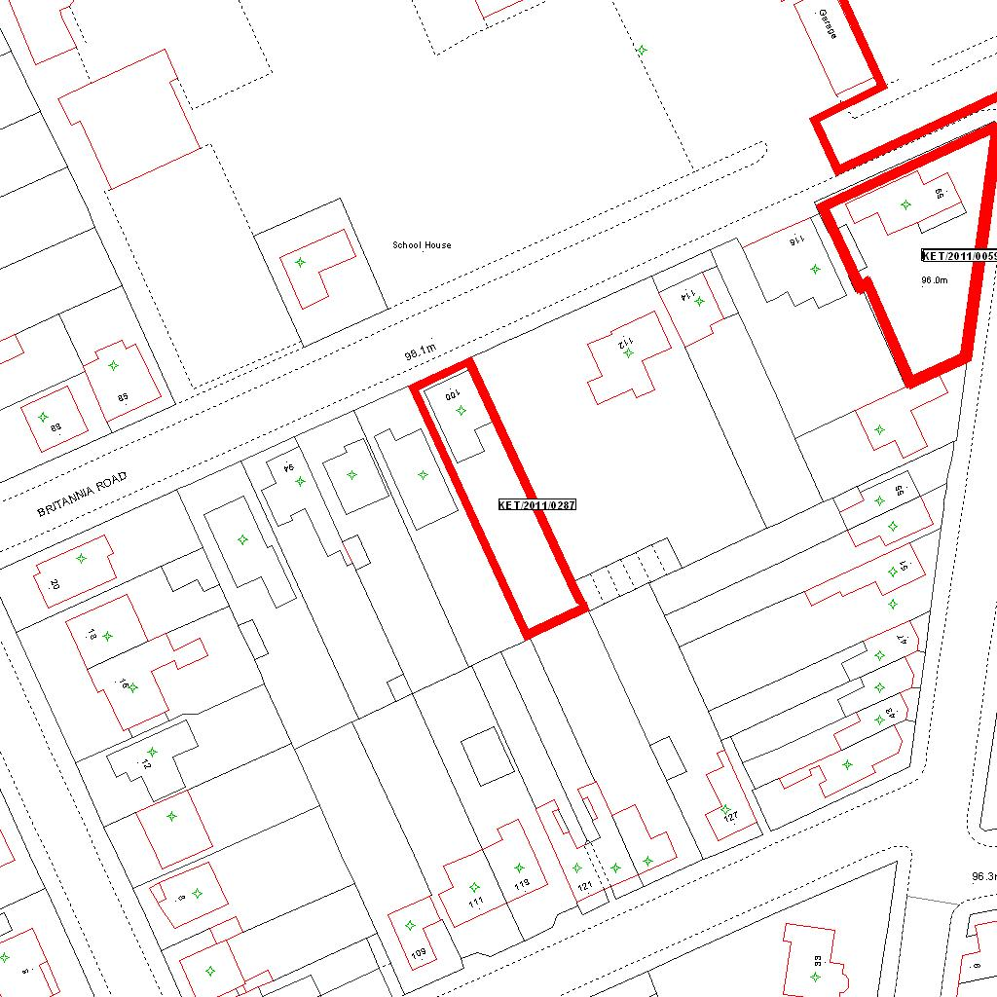

Reproduced from the Ordnance Survey mapping with the permission of the Controller of Her Majesty’s Stationery Office © Crown copyright. Unauthorised reproduction infringes Crown copyright and may lead to prosecution or civil proceedings.  LA078344 |  | N
Date: 15/09/2011 Do not scale from this map. For illustrative purposes only.

