BOROUGH OF KETTERING

Committee | Full Planning Committee - 08/11/2011 | Item No: 5.6
Report Originator | Mark Coleman  Assistant Development Officer | Application No:  KET/2011/0560
Wards Affected | St. Michaels and Wicksteed
Location | 32 Hawthorn Road, Kettering
Proposal | Full Application: Single storey rear extension
Applicant | Mr R Lloyd

1. PURPOSE OF REPORT

  - To describe the above proposals
  - To identify and report on the issues arising from it
  - To state a recommendation on the application

2. RECOMMENDATION

THE DEVELOPMENT CONTROL MANAGER RECOMMENDS that this application be APPROVED subject to the following Condition(s):-

1. The development hereby permitted shall be begun before the expiration of 3 years from the date of this planning permission.
REASON: To comply with Section 91 of the Town and Country Planning Act 1990 (as amended) and to prevent an accumulation of unimplemented planning permissions.

2. The extension hereby permitted shall not be occupied other than as part of the single residential use of the dwelling known as 32 Hawthorn Road, Kettering.
REASON: The unit of accommodation is not of a satisfactory standard and does not have satisfactory private amenity space to be occupied separately from the main dwelling and should be controlled in the interests of protecting the amenity of the occupiers of the host building and neighbouring properties in accordance with National Planning Policy Statement 3, Policy 2 of the East Midlands Regional Plan and Policy 13 of the North Northamptonshire Core Spatial Strategy.

3. The materials to be used in the construction of the external wall surfaces of the development hereby permitted shall match, in type, colour and texture those on the existing building.
REASON: In the interests of visual amenity in accordance with policy 2 of the East Midlands Regional Plan and Policy 13 of the North Northamptonshire Core Spatial Strategy.

4. Notwithstanding the provisions of Article 3 of the Town and Country Planning (General Permitted Development) Order 1995 (or any Order revoking and re-enacting that Order with or without modification) no additional openings permitted by Schedule 2, Part 1 Classes A or C shall be made in the east or west elevation or roof plane of the building.

REASON: To protect the amenity and privacy of the occupiers of adjoining property in accordance with policy 2 of the East Midlands Regional Plan and Policy 13 of the North Northamptonshire Core Spatial Strategy.

5. Prior to first occupation of the development hereby approved, the three windows on the west elevation serving the proposed ground floor bedroom, shower room and toilet shall be glazed with obscured glass (no less than privacy level 4 Pilkington Standard, or equivalent) and be top opening design only, and permanently retained in that form thereafter.
REASON: To protect the privacy of the adjoining property and to prevent overlooking in accordance with Policy 2 of the East Midlands Regional Plan and Policy 13 of the North Northamptonshire Core Spatial Strategy.

Notes (if any) :-
- The applicant is reminded of the provisions of the Party Wall etc Act 1996 which may require notification of the works hereby permitted to all affected neighbours. More detailed information regarding the provisions of 'The Act' should be obtained from an appropriately qualified professional with knowledge of party wall matters.

Justification for Granting Planning Permission

The proposal is in accordance with national and local policies as set out in Planning Policy Statements/Guidance Notes 1 and 3, Policies 1 and 2 of The East Midlands Regional Plan, and Policies 1, 9 and 13 of the North Northamptonshire Core Spatial Strategy. The proposal is also in accordance with adopted Supplementary Planning Document Sustainable Design. The issues relating to loss of access to natural light, overbearing design, loss of privacy and character are all material planning considerations and, in reaching the decision to approve the proposal, have been carefully weighed against all relevant policy considerations.

Officers Report

3.0 | Information

Relevant Planning History
None

Site Description
Officer's site inspection was carried out on 15.09.11 and 24.10.11. The site is located within Kettering Town, close to the town centre and occupied by a mid-terraced, Victorian dwellinghouse.

The dwelling is designed to a typical Victorian terraced typology, constructed over two floors with a tradition ridge roof, moulded stone bay window to the front, projecting mono-pitched gable to the rear on both floors, and mono-pitched single storey wing extending further from the rear to provide a walk in pantry/store, outside toilet and coal shed.

Attached to the property either side are dwellings of a similar design. No. 30 to the east has been extended to the rear with a flat roof extension to provide additional bathroom. No. 34 to the west, benefits from a large first and ground floor rear extension to provide an enlarged kitchen/dining room and bedroom above.

The gardens serving all three properties are long and narrow, measuring approximately 37m (120 ft) x 6m (20ft). The garden within the application site appears level, although on inspecting neighbouring properties either side it is clear that there is a slight incline in a northerly direction. Neighbours either side of the application site have levelled their gardens resulting in land immediately abutting the rear of their properties measuring approximately 0.6m lower than land within the application site (over a distance of approximately 1m - 2m).

The host property is constructed from Kettering brick, Concrete interlocking tiles to the roof, and timber fenestration. The rear elevation faces north-northwest.

Proposed Development
The proposal involves the construction of a single storey rear extension to enlarge the existing kitchen and provide a ground floor bedroom with shower facility. The extension will increase the ground floor footprint by an additional length of 7.3m.

The original proposal was designed with a mono-pitched roof rising towards the boundary of no. 30. In response to neighbour objections, the scheme has been revised to incorporate a flat roof extension instead. It is this scheme which is now under consideration.

Any Constraints Affecting The Site
None

4.0 | Consultation and Customer Impact

Neighbours
Three Objections from the occupiers of no. 34 Hawthorn Avenue. The first objection (received 21.09.11) relates to the original proposal with the mono-pitched roof and clear windows on the side (west) elevation. The grounds for objection relate to the proposed development extending too far beyond the rear building line and resulting in loss of privacy and loss of access to natural light. The objector has stated that an occupier of the property suffers from Seasonal Affective Disorder. Second objection received on 17.10.11 in response to the revised scheme now under consideration. The original grounds for objection are maintained. Final objection received on 24.10.11 maintaining the original objection and referring to concerns over loss of access to natural light.

Two objections from the occupier of no. 30 Hawthorn Avenue, based on the original and revised proposal. The grounds for the first objection was relates to the proposed development extending too far beyond the rear building line and not being in keeping with the character of the area; overbearing design; and loss of access to natural light. A second objection was received on 19.10.11 in response to the revised plans and maintaining their original objections as well as raising concerns about party wall and building regulation issues. Party Wall and Building Regulation issues can be dealt with separately from planning.

5.0 | Planning Policy

National Policies
Planning Policy Statement 1: Delivering Sustainable Development

Development Plan Policies

East Midlands Regional Plan
Policy 1: Regional Core Objectives
Policy 2: Promoting Better Design
Policy 11: Development in the Sub Southern Area.

North Northamptonshire Core Spatial Strategy
Policy 1: Strengthening the Network of Settlements
Policy 9: Distribution & Location of Development
Policy 13: General Sustainable Development Principles

SPGs
Sustainable Design SPD

6.0 | Financial/Resource Implications
 | None

7.0 | Planning Considerations
The key issues for consideration in this application are:-
- Principle of Development
The proposed development is to extend a dwelling within an existing settlement area, and is therefore supported in principle by CSS policies 1 and 9. CSS Policy 13 seeks a high standard of design which respects and enhances the character and visual amenity of the surrounding area; and does not result in unacceptable impacts on neighbouring amenity through loss of light or overlooking. This is supported by national policy advice in PPS1 and PPS3. It is considered that the development broadly meets these policy objectives subject to condition to secure its use as part of the dwellinghouse and subject to detailed considerations being satisfied as discussed below.

- Impact on neighbouring amenity
As previously outlined, the original proposal has been amended by replacing the original mono-pitched roof with a flat roof, and incorporating obscure glazing to the side (west) elevation. Despite these changes, original neighbour objections to the proposal remain.

Both properties either side of the application site have been extended over a similar footprint to each other. No. 30 has been extended to ground floor only, and no.34 has been extended to ground and first floor. Both properties have terraced gardens immediately abutting their rear extensions, resulting in land being up to approximately 0.6m lower than ground levels within the application site. Lower land levels continue for a distance of approximately 1m-2m immediately abutting the neighbouring properties before rising again.

The proposed development will abut the neighbour of no.30 and extend beyond their existing ground floor toilet/bathroom extension by an additional 5.5m, siding on to their main patio area at a height of approximately 2.8m. Because the bathroom/toilet is not a habitable room, little weight is attached potential loss of light affecting this room.

Planning appeal APP/L2820/D/10/2132537 (18 Millenium Close, Kettering NN15 6GX) highlights that the effects of development on the living conditions within garden areas is a material consideration; in that instance the development involved a two storey rear extension to a detached dwellinghouse. Whilst a relevant consideration, different site conditions apply in this instance i.e. the property is terraced and the proposed development is single storey.

Whilst the proposed development will obstruct some access to natural light serving the patio area of no.30, this is likely to be limited to an area of less than half the width of the garden, measured at 1m above ground level. Areas to the rear of the garden together with access to natural light from the east will be unaffected. At 2.8m higher than neighbouring ground levels (measured from the patio area of no.30), the proposed development is not considered to be overbearing in design, particularly when considering the provisions contained within the Town & Country Planning (General Permitted Development) Order 1995 (as amended) which takes an impact based approach to development; the aforementioned provisions allow for fences up to 2m high and incidental buildings up to 2.5m high. As no windows face on to no.30 there will be no loss of privacy, subject to condition preventing new openings on the east and west elevation.

The rear extension to no.34 is significantly shorter than the proposal under consideration, but also includes obscured glazed windows to the side. Despite this, the occupiers of no. 34 remain concerned about loss of privacy from overlooking through the obscure glazed windows. It is considered that subject to sufficient obscure glazing being secured by condition, and side windows being top opening only, then privacy will be protected. Whilst objections relating to loss of access to natural light are maintained, the design of the proposed development has been reduced in height and is sited a sufficient distance away in order to limit these adverse affects to acceptable levels. For similar reasons, the design is not considered to be overbearing. The proposed development maintains sufficient amenity space within the site and does not give rise to any other issues. Consequently, subject to the aforementioned conditions, the proposal is considered acceptable and in accordance with relevant parts of PPS1, Planning Policy Statement 3: Housing, Policy 2 (EMRP) and criteria (l) of Policy 13 (CSS).

- Impact on Visual amenity
The proposed development is located entirely within private realm and will therefore not have a significant impact on the street scene. Objection from neighbours either side raise concerns over the development being out of character with the prevailing development in the area. Whilst the extension protrudes significantly beyond the established rear building line of the neighbouring properties located either side, this is in response to the long narrow plots which properties in the area benefit from. The design of the extension maintains a residential character, albeit utilitarian in appearance, and is not considered to be out of character to the main dwellinghouse or surrounding area. Subject to condition requiring materials to match those used in the construction of the existing dwellinghouse, the proposal is therefore considered acceptable in terms of its impact on visual amenity, and in accordance with relevant parts of Planning Policy Statement 1: Delivering Sustainable Development, Policy 2 (EMRP) and criteria (h) of Policy 13 (CSS) and Sustainable Design SPD.

Conclusion
Subject to conditions discussed throughout the report, the proposed development is considered acceptable in principle and in terms of its impact on neighbouring and visual amenity, and is recommended for approval.

Background Papers |  | Previous Reports/Minutes
Title of Document: |  | Ref:
Date: |  | Date:
Contact Officer: | Mark Coleman, Assistant Development Officer on 01536 534316

SITE LOCATION PLAN

32 Hawthorn Road, Kettering
Application No.: KET/2011/0560

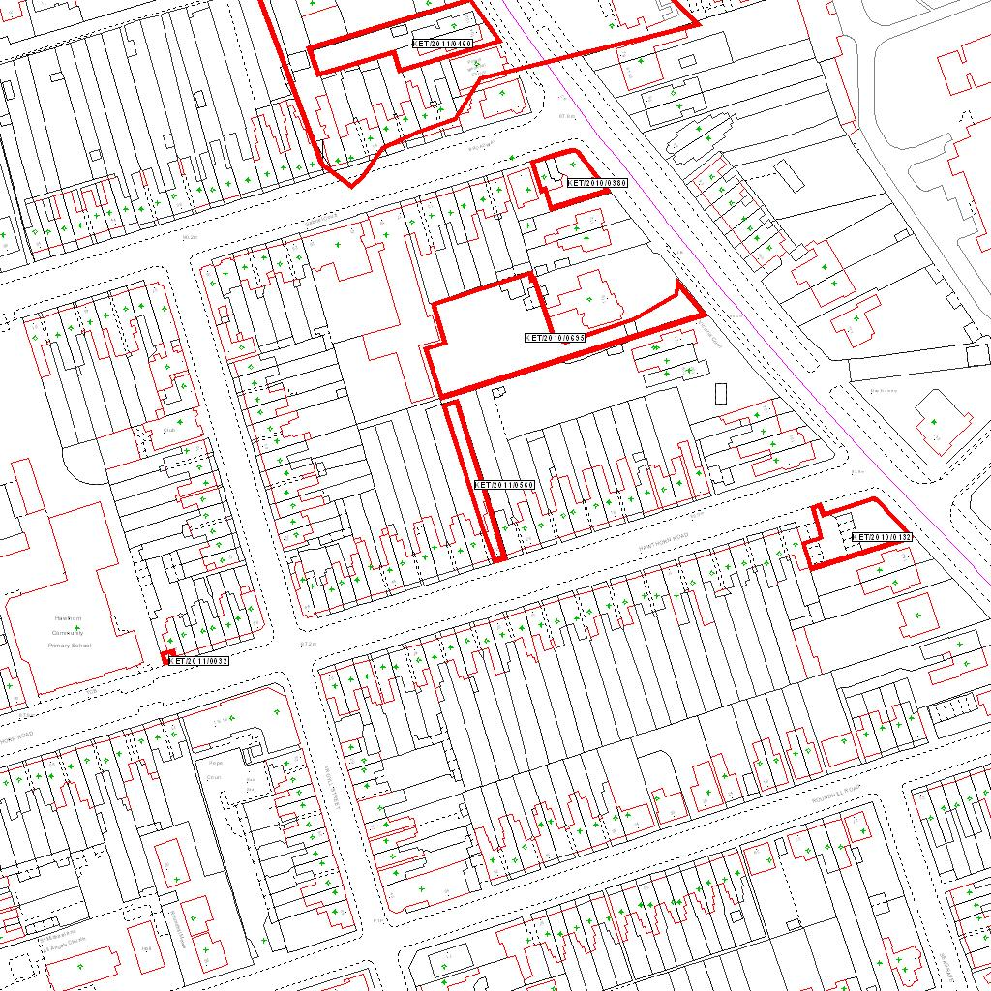

Reproduced from the Ordnance Survey mapping with the permission of the Controller of Her Majesty’s Stationery Office © Crown copyright. Unauthorised reproduction infringes Crown copyright and may lead to prosecution or civil proceedings.  LA078344 |  | N

