BOROUGH OF KETTERING

Committee | Full Planning Committee - 08/11/2011 | Item No: 5.5
Report Originator | Alex Jelley  Development Officer | Application No:  KET/2011/0536
Wards Affected | Welland
Location | Church View, North Lea, Weston By Welland
Proposal | Full Application: Single storey side extension
Applicant | Mr & Mrs R Allsop

1. PURPOSE OF REPORT

  - To describe the above proposals
  - To identify and report on the issues arising from it
  - To state a recommendation on the application

2. RECOMMENDATION

THE DEVELOPMENT CONTROL MANAGER RECOMMENDS that this application be APPROVED subject to the following Condition(s):-

1. The development hereby permitted shall be begun before the expiration of 3 years from the date of this planning permission.
REASON: To comply with Section 91 of the Town and Country Planning Act 1990 (as amended) and to prevent an accumulation of unimplemented planning permissions.

2. No development shall commence on site until details of the types and colours of all external facing and roofing materials to be used, together with samples, have been submitted to and approved in writing by the Local Planning Authority. The development shall not be carried out other than in accordance with the approved details.
REASON: In the interests of the visual amenities of the area in accordance with policy 13 of the North Northamptonshire Core Spatial Strategy.

Notes (if any) :-
- NONE

Justification for Granting Planning Permission

The proposal is in accordance with national and local policies as set out in Planning Policy Statements/Guidance Notes 1, 5 and 13, Policies 2, 46 and 48 of The East Midlands Regional Plan, and Policy 13 of the North Northamptonshire Core Spatial Strategy. There are no material considerations that indicate against the proposal.

Officers Report

3.0 | Information

Relevant Planning History
None

Site Description
Officer's site inspection was carried out on 14.10.2011

The application consists of Church View, North Lea in Weston-By-Welland, which is a single storey detached dwelling with a detached garage on the west side of North Lea. It sits adjacent to the grade II listed St Mary’s Church, and within the Weston-By-Welland Conservation Area. The site is a modern building, with a fairly standard design for a bungalow, albeit in a slightly abnormal layout. There is a large area of hardstanding to the north of the main building, in front of the double garage, and a private amenity space to the south and west of the main building.

The character of the surrounding area is defined by the historic buildings that make up the focal point of the Conservation Area. Weston benefits from some fairly grand buildings set within ample grounds. St Mary’s Church is sat on slightly higher ground than the surrounding roads and lanes, which gives it a dominant role within the street scene.

Proposed Development
This application seeks permission for a single storey side extension. For further detail refer to Section 7.0 of this report.

Any Constraints Affecting The Site
- The site lies within Weston-By-Welland Conservation Area
- The site is adjacent to St Mary’s Church, a Grade II Listed Building

4.0 | Consultation and Customer Impact

Weston-By-Welland Parish Council
No objection. Have concerns about parking, and request condition relating to damage of North Lea green. These issues are addressed within Section 7.0 of this report.

Neighbours
One letter of objection was received. The issues raised were:
- Loss of parking space
- Boundary line shown on plans is not correct
The issue of parking is a material planning consideration and is assessed within Section 7.0 of this report. Issues relating to boundary disputes are civil matters that can not be dealt with through the planning process, therefore no discussion of this issue is contained within this report.

5.0 | Planning Policy

National Policies
PPS1. Delivering Sustainable Development
PPS5. Planning for the Historic Environment
PPG13. Transport

East Midlands Regional Plan
Policy 2. Promoting Better Design
Policy 46. A Regional Approach to Behavioural Change
Policy 48. Regional Car Parking Standards

North Northamptonshire Core Spatial Strategy
Policy 13. General Sustainable Development Principles

6.0 | Financial/Resource Implications
 | None
7.0 | Planning Considerations
The key issues for consideration in this application are:-

- Principle of Development
- Design and Character
- Residential Amenity
- Highways

A. Principle of Development
Section 38(6) of the Planning and Compulsory Purchase Act 2004 requires local planning authorities to determine planning applications in accordance with the Development Plan unless material planning considerations indicate against approval.

Policy 13 of the North Northamptonshire Core Spatial Strategy (CSS) provides for extensions to residential properties, where they are otherwise in accordance with the Development Plan and national policy guidance, subject to specific criteria being satisfied. The relevant criteria in this instance have regard to matters of design and character, residential amenity and highways. These issues are addressed in full within the sub-sections to follow. Policy 2 of the East Midlands Regional Plan supports this approach, and highlights the importance of ensuring that new development takes account of local character trends.

It is considered that the application is acceptable in principle, subject to the detailed matters discussed below.

B. Design and Character
The proposed extension would sit to the side (east) of the existing building and warp around the existing entrance hall in an ‘L’ shape. It would be finished in a fairly modern design, with a large amount of glazing and some wooden panelling above a dwarf brick wall. The principal elevation of the extension would face north, and include a large gable ended glazed projection. The positioning of the extension is important, as it would be hidden from view from the majority of the Conservation Area, apart from North Lea. It would also be clearly separated from the curtilage of the grade II listed St Mary’s Church which adjoins the site on its western boundary. The existing property is a modern introduction into an otherwise traditional village, and it is considered that the proposed extension would be in keeping with its character. The impact on the Conservation Area and adjoining Listed Building would be minimal, and therefore it is considered that the proposals are in accordance with policy 13 (h) and (i) of the CSS, Policy 2 of the EMRP and PPS5.

C. Residential Amenity
The proposed extension would be single storey in nature and due to its positioning, would not result in any loss of light in adjoining properties. The windows proposed in the north elevation would look out over the hardstanding that serves both the application site and the adjoining property, Spindles, to the north. There are no habitable rooms directly opposite these windows, and it is considered that no loss of privacy will occur at Spindles. The windows in the east elevation would look out over North Lea, towards a garage associated with No. 3 Ashley Road. Thus it is considered that no loss of privacy will occur as a result of the proposed extension. As a result of the above, it is considered that the proposals will accord with Policy 13(l) of the CSS.

D. Highways
Concerns have been raised with regards to the loss of hardstanding associated with the proposed development. At present the site benefits from a double garage, and sufficient external parking on hardstanding for approximately 4 vehicles. The extension would remove 2 of the external parking spaces, leaving the site with sufficient off road parking for 4 vehicles. This level of provision is considered to exceed the minimum requirements for a dwelling of this size. Concerns relating to potential damage to North Lea green as a result of vehicle movements/parking are noted. However it is not considered reasonable or necessary to secure the protection/maintenance of North Lea green through condition given the relatively minor scale of development proposed and the continued existence of 4 off road parking spaces on the site. As a result of the above it is considered that the proposals accord with Policy 13 (d) and (n) of the CSS, Policies 46 and 48 of the EMRP and PPG13.

Conclusion
The application is in accordance with the Development Plan and there are no material planning considerations that would indicate against approval.

Background Papers |  | Previous Reports/Minutes
Title of Document: |  | Ref:
Date: |  | Date:
Contact Officer: | Alex Jelley, Development Officer on 01536 534316

SITE LOCATION PLAN

Church View, North Lea, Weston By Welland
Application No.: KET/2011/0536

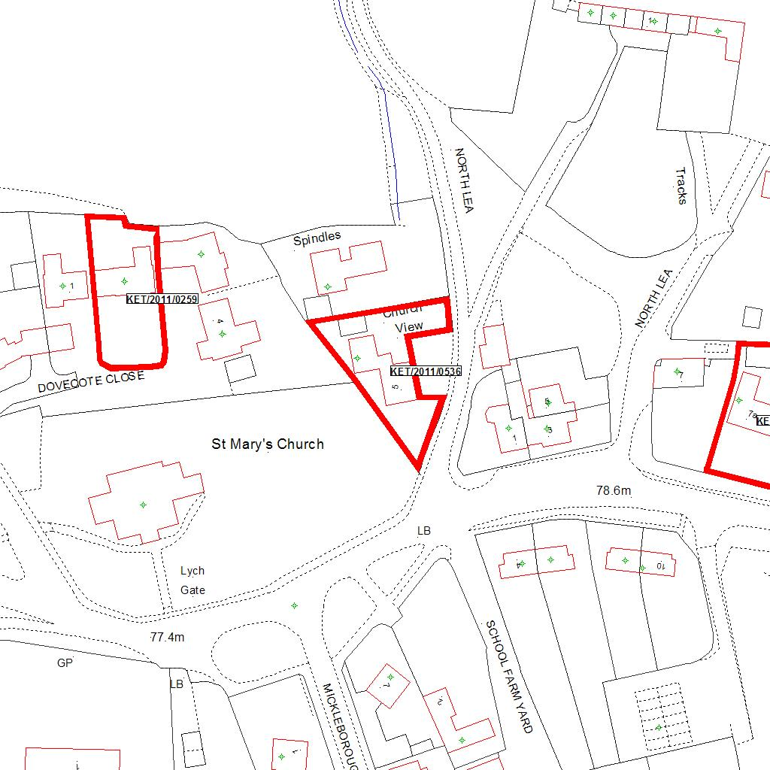

Reproduced from the Ordnance Survey mapping with the permission of the Controller of Her Majesty’s Stationery Office © Crown copyright. Unauthorised reproduction infringes Crown copyright and may lead to prosecution or civil proceedings.  LA078344 |  | N
Date: 30/08/2011
23/08/2011
23/08/2011
23/08/2011
23/08/2011
23/08/2011
23/08/2011
23/08/2011
23/08/2011 Do not scale from this map. For illustrative purposes only.

