BOROUGH OF KETTERING

Committee | Full Planning Committee - 08/11/2011 | Item No: 5.2
Report Originator | Mark Coleman  Assistant Development Officer | Application No:  KET/2011/0420
Wards Affected | Barton
Location | 115 Polwell Lane, Barton Seagrave
Proposal | Full Application: Single storey side extension
Applicant | Mr J Downie

1. PURPOSE OF REPORT

  - To describe the above proposals
  - To identify and report on the issues arising from it
  - To state a recommendation on the application

2. RECOMMENDATION

THE DEVELOPMENT CONTROL MANAGER RECOMMENDS that this application be APPROVED subject to the following Condition(s):-

1. The development hereby permitted shall be begun before the expiration of 3 years from the date of this planning permission.
REASON: To comply with Section 91 of the Town and Country Planning Act 1990 (as amended) and to prevent an accumulation of unimplemented planning permissions.

2. Notwithstanding the provisions of Article 3 of the Town and Country Planning (General Permitted Development) Order 1995 (or any Order revoking and re-enacting that Order with or without modification) no additional openings permitted by Schedule 2, Part 1 Classes A or C shall be made in the south elevation or roof plane of the building.
REASON: To protect the amenity and privacy of the occupiers of adjoining property in accordance with Policy 2 of the East Midlands Regional Plan and Policy 13 of the North Northamptonshire Core Spatial Strategy.

3. The materials to be used in the construction of the external surfaces of the development hereby permitted shall match, in type, colour and texture those on the existing building.
REASON: In the interests of visual amenity in accordance with Policy 2 of the East Midlands Regional Plan and Policy 13 of the North Northamptonshire Core Spatial Strategy.

Notes (if any) :-
- The applicant is reminded of the provisions of the Party Wall etc Act 1996 which may require notification of the works hereby permitted to all affected neighbours. More detailed information regarding the provisions of 'The Act' should be obtained from an appropriately qualified professional with knowledge of party wall matters.

Justification for Granting Planning Permission

The proposal is in accordance with national and local policies as set out in Planning Policy Statements/Guidance Notes 1, 3, 13, Policies 1, 2, 11, 48 of The East Midlands Regional Plan, Policies 1, 9, 13 of the North Northamptonshire Core Spatial Strategy. The proposal is also in accordance with adopted Supplementary Planning Document Sustainable Design. The issues relating to loss of access to natural light is a material planning consideration and, in reaching the decision to approve the proposal, has been carefully weighed against all relevant policy considerations.

Officers Report

3.0 | Information

Relevant Planning History
KET/2006/1112 - Stand alone garage to be attached to main building (Approved 05.02.2007)

Site Description
Officer's site inspection was carried out on 7th September 2011. The site is located directly off Polwell Lane which provides a main route linking Burton Latimer through to Kettering. The area is residential. The site is occupied by a large dormer bungalow which has since been enlarged to the side and rear since its original construction. The property sits on a large plot with generous off-road parking to the front, and further parking down one side (south). To the rear is a large garden measuring approximately 32m. Pedestrian access to the rear is only possible along the northern boundary, as a former garage building has been built up to the southern boundary preventing access.

Either side of the site are similar properties, following the same building line to the front. It is noted that the neighbouring property (no. 117) has a full width conservatory to the rear, with head level obscure glazed windows facing on to the application site where the proposed development is to be located. The back wall of the conservatory on the neighbouring property is broadly in line with the back wall of the proposed extension.

Proposed Development
The proposal comprises of a single storey extension to an existing former garage building which is currently used as a study, to create an enlarged bedroom with en-suite facilities and internal hallway. The proposed extension is confined to the rear of the existing dwellinghouse. Reconfiguration of the existing roof structure is also proposed, to create an intersecting gable design linked in with the existing dwellinghouse which will be visible within the public realm.

Any Constraints Affecting The Site
C Road

4.0 | Consultation and Customer Impact

Parish Council
No objection.

Neighbours
Objection received from the occupier of no.117 Polwell Lane. Ground of objection relates to loss of access to natural light owing to the scale (length and height) of the proposed extension.

5.0 | Planning Policy

National Policies
Planning Policy Statement 1: Delivering Sustainable Development
Planning Policy Statement 3: Housing
Planning Policy Guidance 13: Transport

Development Plan Policies

East Midlands Regional Plan (EMRP)
Policy 1: Regional Core Objectives
Policy 2: Promoting Better Design
Policy 11: Development in the Sub Southern-Area
Policy 48: Regional Car Parking Standards

North Northamptonshire Core Spatial Strategy (CSS)
Policy 1: Strengthening the Network of Settlements
Policy 9: Distribution and Location of Development
Policy 13: General Sustainable Development Principles

SPDs
Sustainable Design

6.0 | Financial/Resource Implications
 | None
7.0 | Planning Considerations
The key issues for consideration in this application are:-

- Principle of Development
- Neighbouring Amenity
- Visual Amenity
- Parking and Highway safety

- Principle of Development
The proposed development is to extend a dwelling within an existing settlement area, and is therefore supported in principle by CSS policies 1 and 9. CSS Policy 13 seeks a high standard of design which respects and enhances the character and visual amenity of the surrounding area; and does not result in unacceptable impacts on neighbouring amenity through loss of light or overlooking. This is supported by national policy advice in PPS1 and PPS3. It is considered that the development broadly meets these policy objectives, subject to detailed considerations discussed below.

- Impact on neighbouring amenity
An objection has been received from the occupiers of no. 117 Polwell Lane, on the grounds that the scale (height and length) of the proposed development would result in a loss of access to natural light which would affect their Conservatory.

The neighbours conservatory was identified at the site visit which is abuts the southern boundary of the application site. The conservatory has obscure glazed head level windows facing on to the application site. These will be approximately 50cm from the south elevation of proposed development, but as they are obscured and head level only, it is considered that the proposed development will not have an overbearing impact.

The conservatory has a fully glazed roof and glazed elevation facing east which will not be affected by the proposed development. As a result, the conservatory will maintain access to natural light for most of the day from the east (from the side elevation and roof), and from the south and west (from the roof). Given that no. 117 sits south of the application site, the only loss of access to natural light is from the north which is more limited in any instance and will therefore not produce a significant overshadowing effect. It is considered that the loss of access to natural light will not be unacceptable or significant.

The proposal does not give rise to a loss of privacy, however a condition to remove permitted development rights for new openings on the south elevation or roof plane is recommended. The proposed development is situated far enough away from other neighbouring properties so as not to give rise to any significant impact on neighbouring amenity, and adequate amenity space remains within the site for the occupiers of the application site. Subject to the aforementioned condition, the proposal is considered acceptable and in accordance with relevant parts of Planning Policy Statement 1: Delivering Sustainable Development, Planning Policy Statement 3: Housing, Policy 2 (EMRP) and criteria (l) of Policy 13 (CSS).

- Impact on visual amenity
The proposed development including the reconfiguration of the existing roof will result in a more coherent and integrated design, which will enhance the appearance of the dwelling within the street scene, subject condition requiring materials to match those on the existing house.

Aspects of the proposal confined to the rear of the property will not be visible from within the public realm.

- Impact on parking and highway safety
Within the site, parking remains unchanged with ample parking for several vehicles clear of the highway. This accords with the principles set out in relevant parts of PPG13, Policies 2 and 48 (EMRP), and criteria (d) and (n) of Policy 13 (CSS). The proposal is therefore acceptable in terms of its impact on parking and highway safety.

Conclusion
The proposal is acceptable principle and in terms on impact on visual amenity, parking and highway safety. Whilst loss of access to natural light is a material consideration, it is considered that the proposed development will not have an unacceptable or significant impact. As a result, the proposal is acceptable in terms of neighbouring amenity. Subject to conditions already discussed, and in accordance with the statutory duty of Section 38 (6) of the Planning and Compensation Act 2004 Act, the proposed development is acceptable and recommended for approval.

Background Papers |  | Previous Reports/Minutes
Title of Document: |  | Ref:
Date: |  | Date:
Contact Officer: | Mark Coleman, Assistant Development Officer on 01536 534316

SITE LOCATION PLAN

115 Polwell Lane, Barton Seagrave
Application No.: KET/2011/0420

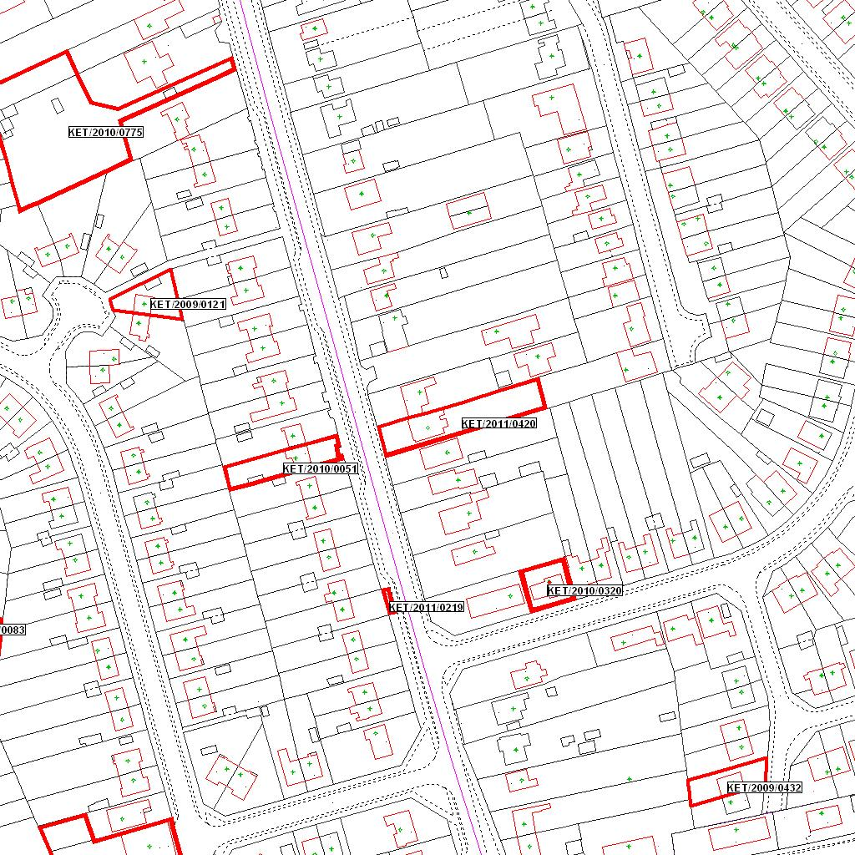

Reproduced from the Ordnance Survey mapping with the permission of the Controller of Her Majesty’s Stationery Office © Crown copyright. Unauthorised reproduction infringes Crown copyright and may lead to prosecution or civil proceedings.  LA078344 |  | N
Date: 11/07/2011 Do not scale from this map. For illustrative purposes only.

