Community Harm Statement

- Introduction

This Community Harm Statement provides a summary of harm caused by the anti social behaviour of the defendant in the local community. This information has been received from 4 households. These households comprise of 3 single adults, one of whom is elderly. The fourth household is a mother with 2 school age children. Further information regarding the defendants’ activity has been received from the local community police team and the Environmental Protection team at Kettering Borough Council

This information has been collected by individual complaints received from neighbours, statements made by residents and Anti Social Behaviour Forum minutes. Residents felt unable to attend court as witnesses in this action due to a fear of reprisals from the defendant.

- Summary of Anti Social Behaviour

For the last 3 years the defendant has caused nuisance to his neighbours with loud music which was found to be a statutory noise nuisance by Environmental Protection in May 2011.
Neighbours experienced problems with loud music coming from the defendants’ property both during the day and throughout the night.

Neighbours have also suffered various acts of criminal damage, verbal abuse and aggressive behaviour from the defendant over the last 3 years. These acts have taken place in the locality of the property and also in the town centre.

- Community Profile

The local neighbourhood is a residential street comprising of houses and low rise flats. The defendant lives in a 2 bedroom first floor flat in a block of four properties. The residents most affected by the defendant’s behaviour are the 3 residents in the block and a resident in the neighbouring block.

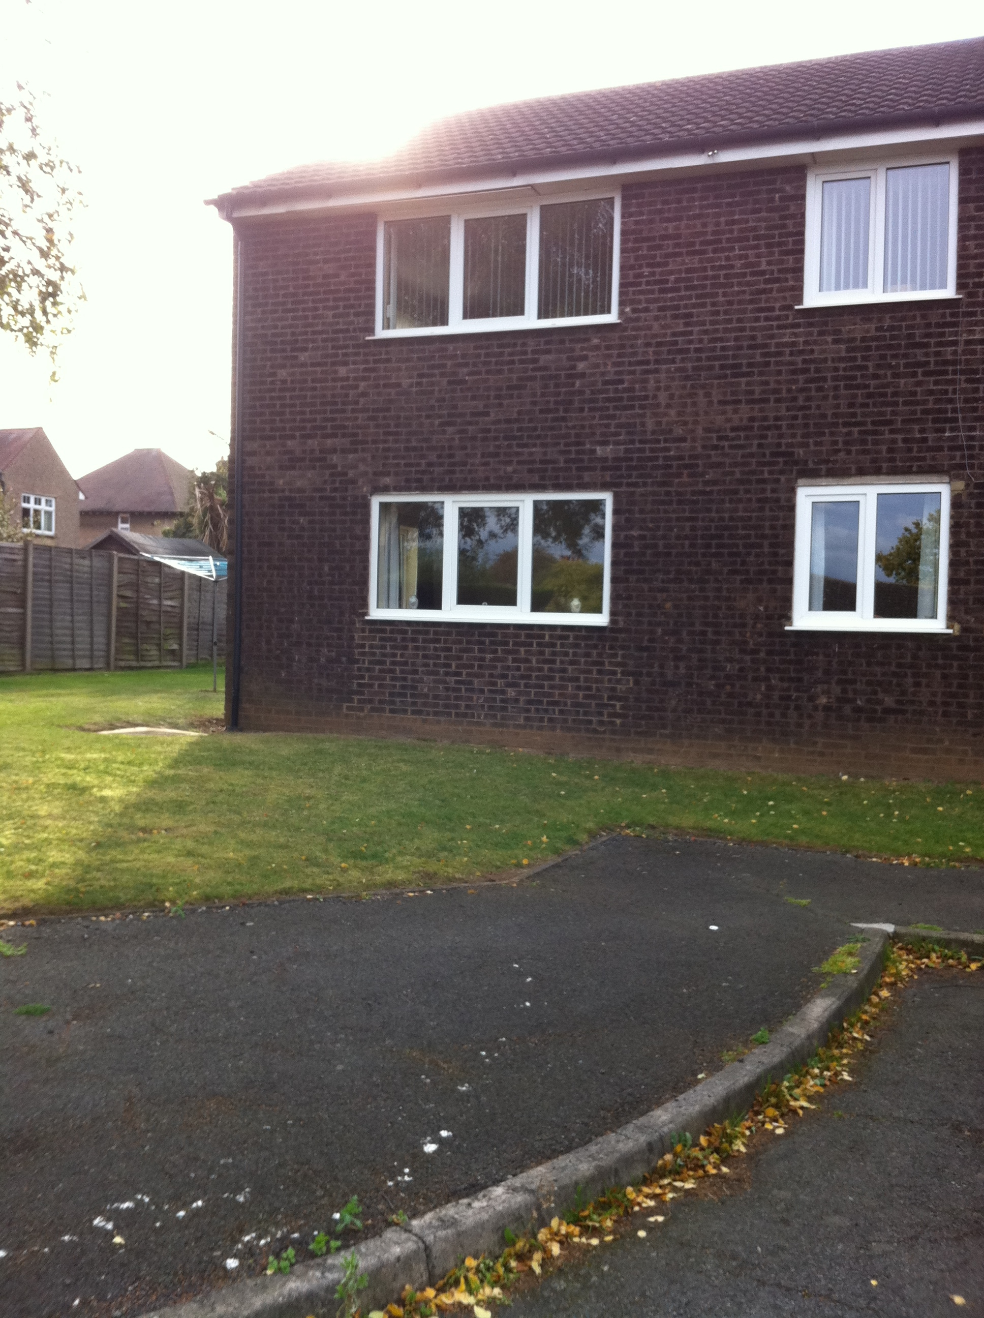

4. Harm caused to the Community

The behaviour of the defendant has caused the following harms to the neighbouring community:

Community Harm 1

A resident reported that it was necessary to leave a particular position of employment as they were unable to park a company vehicle at the address due to previous criminal damage that had been suffered.

Community Harm 2

Residents report that their physical health has suffered due to broken sleep patterns as a result of the noise nuisance and constant domestic disturbances at the property.

Community Harm 3

Residents report that the ongoing situation has impacted their emotional well being. They report feeling anxious and depressed due to the behaviour of the defendant.

Community Harm 4

Residents have reported significant impact on their daily routines. This has included altering their routines in order to avoid contact and any potential confrontation with the defendant.

Community Harm 5

Residents report that they feel unable to have family or friends visit them at the property due to the constant antisocial behaviour of the defendant.

Community Harm 6

Residents have suffered damage to their glazing as well as damage to a vehicle. An associate of the defendant was convicted of criminal damage to the vehicle.

- Local crime and ASB statistics

Between 6 January 2011 and 5 May 2011 Police officers have logged 15 incidents regarding the behaviour of the defendant.

Since the defendant took up the tenancy of the property there have been 10 complaints of noise nuisance made to Environmental Protection.

Housing Services has received 25 complaints alleging breaches of tenancy by the defendant since his tenancy commenced in March 2008.

I believe that the facts stated in the Community Harm Statement are true.

Signed
(insert title):
Print name:
Date:
Senior Officer (insert title):
Print Name:
Date:

