Item 6
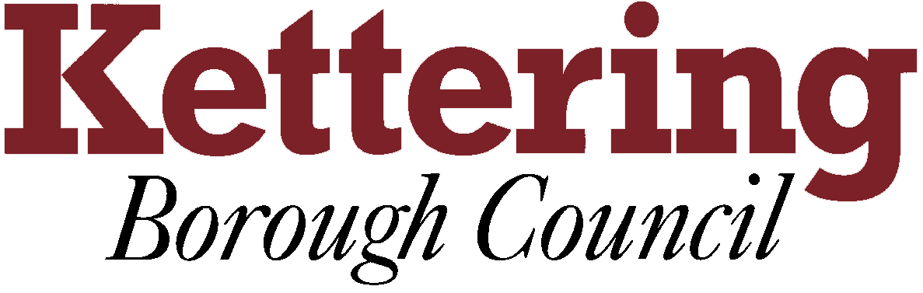

KETTERING BOROUGH TENANTS FORUM

13th September 2011

ANNUAL REPORT FOR TENANTS

This report asks the Tenants Forum to approve the draft Annual Report to Tenants for 2010/11.
This report is for decision

- Last year, the Council published its first Annual Report to Tenants. This was in response to a regulatory requirement from the Tenants Services Authority that all social landlords should publish an annual report so that tenants could see how well their landlords were managing and maintaining their homes and neighbourhoods.
- The Tenants Forum provided valuable feedback on the content and presentation of the first annual report at its meeting in July. This is what tenants told us:
What did you like and dislike about the first Annual Report to Tenants?

- It was open and honest and gave a positive view to the role of housing

- The group felt there was nothing missing from the report

- They did feel that there was no need to have case studies as part of the report

How do you want the report for 2010/11 to look?

- Less text – they felt the last report was too text heavy

- More bullet points should be used to keep text to a minimum

- More graphs should be used but in a simpler way, not pie charts

- The front cover is the ‘hook’ if its bright and colourful then tenants are more likely to open the document

- Keep the cost of the report down by using same distribution methods as last year – limited print run, summary in Connect, sign post information for copies of the report and internet

- The report should be more compact

- More photos should be used of positive achievements
  - Selling, promoting and demonstrating what we do well

What information should we include in the report for 2010/11?

- Achievements

- Performance and costs

- How well we are doing compared to previous years

- Positive comparisons with other landlords

- Areas we need to improve

- Our plans for next year

- We have used the feedback from the Tenants Forum to guide us in writing the second annual report for the financial year 2010/11. The Tenants Reading Panel has provided comments on the first draft.
- Following discussion at Tenants Forum on 13 October, the draft report will be formatted and circulated to Tenants Reading Panel for further comment. The final version will be published later this month and copies will be distributed to members of the Tenants Forum. The report will also be placed in the Council’s website and a summary will be included in the December issue of Connect.
- The draft Annual Report to tenants for 2010/11 is attached as is a specimen page which shows the proposed format of the report.

John Conway
Head of Housing

