Item 5
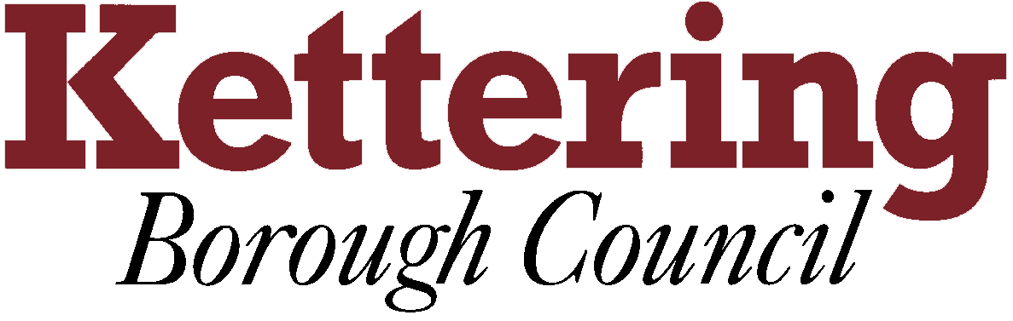

KETTERING BOROUGH TENANTS FORUM

13/10/2011

Welfare Reform
This report asks the Tenants Forum to note the confirmed and proposed changes to the Welfare system

For Information

1 Introduction
The purpose of the presentation is to advise Tenants of the confirmed and proposed changes to the Welfare system

2 The main points covered in the presentation will be changes to Housing Benefit
- that have already occurred
- confirmed for the future
- proposed for the future
  - The following points will also be covered
- Proposed changes to Council Tax benefits
- Proposed changes to Welfare Benefits

3 This report is primarily for information purposes only, once legislation has been passed in law then updates will take place and actions can be confirmed.

Rob Thompson
29/09/2011

