BOROUGH OF KETTERING

Committee | Full Planning Committee - 11/10/2011 | Item No: 5.8
Report Originator | Michael Boniface  Development Officer | Application No:  KET/2011/0528
Wards Affected | Ise Lodge
Location | 1 French Drive, Kettering
Proposal | s.73A Retrospective Application: Amenity land to domestic garden and 1.6m fencing
Applicant | Mr M Digby

1. PURPOSE OF REPORT

  - To describe the above proposals
  - To identify and report on the issues arising from it
  - To state a recommendation on the application

2. RECOMMENDATION

THE DEVELOPMENT CONTROL MANAGER RECOMMENDS that this application be REFUSED for the following reason(s):-

1. The area is characterised by street fronting dwellings set back from the highway boundary behind driveways and garden areas which present an open and spacious appearance. Larger areas of green/landscaped spaces are also common on the corner of streets providing a pleasant and green aspect along with relief from the built form of the area. The spaces also soften the appearance of blank gable ends and inactive boundary treatments. The change of use and associated boundary treatment subject of this application seeks to enclose one such space, an area of incidental amenity space which previously contributed to an open and green aspect on approach to Clive Close and on views from French Drive. The loss of this land is compounded by the position, design and appearance of the timber fencing which is sited directly adjacent to the highway boundary with no opportunity for planting or other appropriate landscaping. The fence presents an inactive and visually intrusive appearance forward of the established building line in Clive Close which appears at odds with the characteristics of the area described above. It is therefore considered that the development significantly detracts from the character and amenity of the area in conflict with policy 13(h) and (i) of the North Northamptonshire Core Spatial Strategy and guidance contained within PPS1.

Notes (if any) :-
- NONE

Justification for Granting Planning Permission

Not applicable

Officers Report

3.0 | Information

Relevant Planning History
None.

Site Description
The site comprises a detached bungalow fronting French Drive but occupying a corner plot adjacent to Clive Close. The building stands within a row of properties of a similar character and appearance and is surrounded by a mix of residential dwellings. Buildings tend to be set back from the public highway behind parking areas and gardens creating an open and spacious aspect. An area of incidental amenity space which was previously landscaped with grass, trees and shrub planting exists adjacent to Clive Close and has now been enclosed by the fence subject of this application.

Proposed Development
Change of use from incidental amenity space to domestic garden and erection of a 1650mm high fence.

This is a retrospective planning application and the development has therefore been carried out. This application seeks to regularise the works.

Any Constraints Affecting The Site
None.

4.0 | Consultation and Customer Impact

Highway Authority
No objection.

Northamptonshire Police
No objection.

Neighbours
1 letter of objection for the following reasons:
- Out of character with Clive Close.
- Loss of green space.
- Fence is oppressive and industrial in appearance.
- Highway safety – no visibility is available from 2 Clive Close.
- Will set a precedent for other fences forward of the building line.

4 letters of support for the following reasons:
- Improves the aesthetic look of the property.
- Fence height is in keeping with others.
- Position is within the grounds.
- Prevents problems with youths drinking and smoking on the land.

- Deters vandalism.
- Improves security.
- Prevents rubbish building up.

5.0 | Planning Policy

National Policies
PPS1 – Delivering Sustainable Development

Development Plan Policies

East Midlands Regional Plan
2 – Promoting Better Design

North Northamptonshire Core Spatial Strategy
13 – General Sustainable Development Principles

6.0 | Financial/Resource Implications
 | None
7.0 | Planning Considerations
The key issues for consideration in this application are:-

- Principle of Development;
- Design and Appearance;
- Neighbouring Amenity;
- Crime and Anti-Social Behaviour;
- Highways and Parking.

1. Principle of Development
Policy 13 of the North Northamptonshire Core Spatial Strategy is supportive of development subject to a number of sustainable development criteria. In particular, development should:
(d) have a satisfactory means of access and provide for parking, servicing and manoeuvring;
(g) not lead to the loss of open space or recreation facilities, unless a site of equivalent quality and accessibility can be provided, serviced and made available to the community prior to use of the existing site ceasing;
(h) be of a high standard of design which would respect and enhance the character of its surroundings;
(i) create a strong sense of place by strengthening the distinctive historic and cultural qualities of the townscape;
(l) not result in an unacceptable impact on neighbouring amenity;
(n) not have an adverse impact on the highway network or highway safety.

2. Design and Appearance
The area is characterised by street fronting dwellings set back from the highway boundary behind driveways and garden areas which present an open and spacious appearance. Larger areas of green/landscaped spaces are also common on the corner of streets providing a pleasant and green aspect along with relief from the built form of the area. These areas also soften the appearance of blank gable ends and inactive boundary treatments.

The change of use and associated boundary treatment subject of this application seeks to enclose one such space, an area of incidental amenity space which previously contributed to an open and green aspect on approach to Clive Close. The loss of this land is compounded by the position, design and appearance of the timber fencing which is sited directly adjacent to the highway boundary (albeit, behind a narrow strip of gravel) with no opportunity for planting or other appropriate landscaping. The fence presents an inactive and visually intrusive appearance forward of the established building line in Clive Close which appears at odds with the characteristics of the area described above. It is therefore considered that the development significantly detracts from the character and amenity of the area.

The Council conducted a detailed open space needs assessment across the borough in 2007 to identify all areas of functional and accessible open space along with any shortfalls. The space subject of this application was not identified as falling within this criteria and it cannot therefore be considered that a net loss of open space has occurred in accordance with PPG17 and policy 13(g) of the CSS. The land is in fact within private ownership and members of the public do not therefore have a right to access the land. This does not however negate the visual amenity which it offered to the local area and the adverse impacts on character identified above. It is also noted that other examples of boundary fences directly abutting the highway are apparent in the vicinity of the site however these are in themselves undesirable and should not be used to justify unacceptable development and further erode the character of the area.

3. Neighbouring Amenity
Whilst the change of use and erection of a boundary fence detract from the amenity of the area, the development does not impact upon neighbouring amenity in terms of noise, vibration, smell, light or other pollution, loss of light or overlooking. The scheme therefore accords with policy 13(l) of the CSS.

4. Crime and Anti-Social Behaviour
The applicant suggests that the land in question has been enclosed by a fence and changed to garden land in order to prevent anti-social behaviour from youths gathering on the site and this has also been commented on by neighbours. Whilst some weight can be attached to these benefits, it is not considered that the current development represents the only solution, nor does this outweigh the clear detrimental impacts identified above in terms of character and visual appearance. No concerns have been raised through consultation with Northamptonshire Police regarding crime or anti-social behaviour in this area.

5. Highways and Parking
Incorporation of the land within the garden of 1 French Drive would not intensify the level of traffic associated with the site. The existing vehicular access and parking arrangements would be unaltered and would remain acceptable.

The fence stands close to the vehicular access associated with 2 French Drive however it has been splayed at the highway boundary in order to maintain visibility. No objection has been received from the Highway Authority and the development is considered acceptable in this regard.

Conclusion

The development results in a significant adverse impact upon the character of the area and results in a visually intrusive form of development. The scheme therefore conflicts with policy 13(h) and (i) of the North Northamptonshire Core Spatial Strategy and should be refused.

Background Papers |  | Previous Reports/Minutes
Title of Document: |  | Ref:
Date: |  | Date:
Contact Officer: | Michael Boniface, Development Officer on 01536 534316

SITE LOCATION PLAN

1 French Drive, Kettering
Application No.: KET/2011/0528

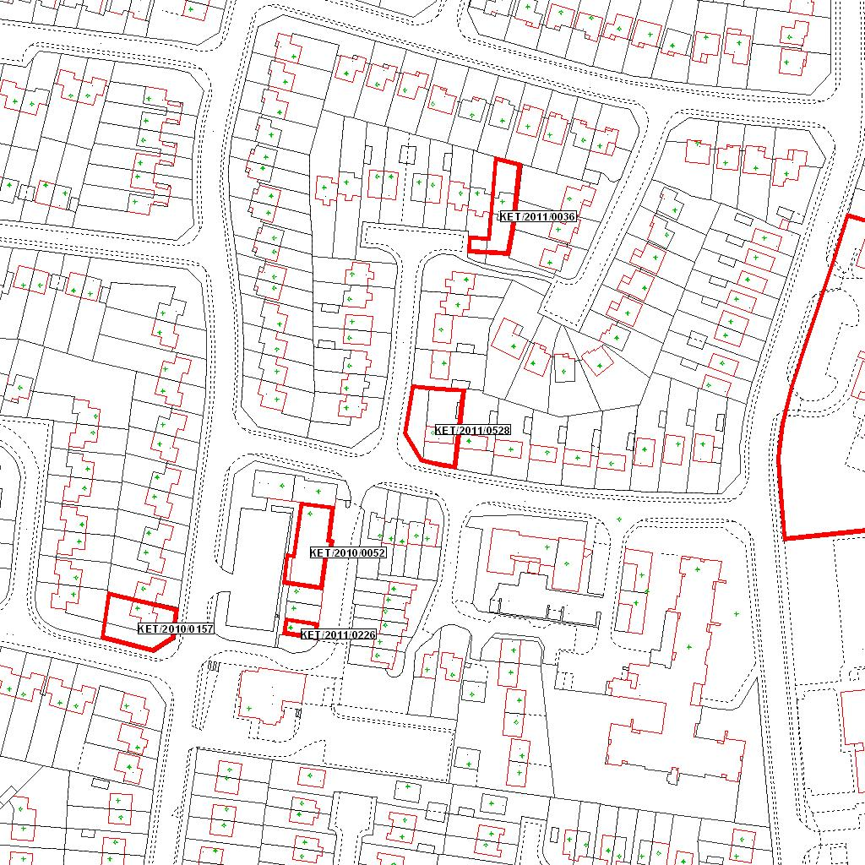

Reproduced from the Ordnance Survey mapping with the permission of the Controller of Her Majesty’s Stationery Office © Crown copyright. Unauthorised reproduction infringes Crown copyright and may lead to prosecution or civil proceedings.  LA078344 |  | N
Date: 18/08/2011 Do not scale from this map. For illustrative purposes only.

