BOROUGH OF KETTERING

Committee | Full Planning Committee - 11/10/2011 | Item No: 5.7
Report Originator | Mark Coleman  Assistant Development Officer | Application No:  KET/2011/0465
Wards Affected | Barton
Location | 4 Salcey Close, Barton Seagrave
Proposal | Full Application: Side extension and conversion of roof space to habitable rooms
Applicant | Mr Robinson

1. PURPOSE OF REPORT

  - To describe the above proposals
  - To identify and report on the issues arising from it
  - To state a recommendation on the application

2. RECOMMENDATION

THE DEVELOPMENT CONTROL MANAGER RECOMMENDS that this application be APPROVED subject to the following Condition(s):-

1. The development hereby permitted shall be begun before the expiration of 3 years from the date of this planning permission.
REASON: To comply with Section 91 of the Town and Country Planning Act 1990 (as amended) and to prevent an accumulation of unimplemented planning permissions.

2. The materials to be used in the construction of the external surfaces of the development hereby permitted shall match, in type, colour and texture those on the existing building.
REASON: In the interests of visual amenity in accordance with policy 2 of the East Midlands Regional Plan and Policy 13 of the North Northamptonshire Core Spatial Strategy.

3. Notwithstanding the provisions of Article 3 of the Town and Country Planning (General Permitted Development) Order 1995 (or any Order revoking and re-enacting that Order with or without modification) no additional openings permitted by Schedule 2, Part 1 Classes A or C shall be made in the south roof plane of the building.
REASON: To protect the amenity and privacy of the occupiers of adjoining property in accordance with policy 2 of the East Midlands Regional Plan and Policy 13 of the North Northamptonshire Core Spatial Strategy.

4. Notwithstanding the provisions of Article 3 of the Town and Country Planning (General Permitted Development) Order 1995 (or any Order revoking and re-enacting that Order with or without modification) no alteration permitted by Class B of Part 1 of Schedule 2 of the Order shall be made to the development hereby approved.
REASON: To protect the amenity of the occupiers of adjoining property and visual amenity of the area from inappropriate development in accordance with policy 2 of the East Midlands Regional Plan and Policy 13 of the North Northamptonshire Core Spatial Strategy.

5. The finished floor levels and position of the roof lights shall be in accordance with the sectional view plan recieved by the Local Planning Authority on 30th September 2011 and hereby approved, and shall be retained in that form thereafter.
REASON: For the avoidance of doubt and to protect the amenity of occupiers of the neighbouring property in accordance with Policy 2 of the East Midlands Regional Plan and Policy 13 of the North Northamptonshire Core Spatial Strategy.

Notes (if any) :-
- The applicant is reminded of the provisions of the Party Wall etc Act 1996 which may require notification of the works hereby permitted to all affected neighbours. More detailed information regarding the provisions of 'The Act' should be obtained from an appropriately qualified professional with knowledge of party wall matters.

Justification for Granting Planning Permission

The proposal is in accordance with national and local policies as set out in Planning Policy Statements/Guidance Notes 1, 3, 13, Policies, 1, 2, 11, 48 of The East Midlands Regional Plan, Policies 1, 9, 13 of the North Northamptonshire Core Spatial Strategy. The proposal is also in accordance with adopted Supplementary Planning Document Sustainable Design. There are no material considerations that indicate against the proposal.

Officers Report

3.0 | Information

Relevant Planning History
KE/04/0931 – Conservatory (Approved 14.10.2004)
KE/1981/0343 – Residential (plots 38-52, 119-146) (Approved 03.06.1981)

Site Description
Officer's site inspection was carried out on 14.09.11. The site is located to the southern edge of Barton Seagrave close to the A14, within an established residential area.

The site is currently occupied by a single storey, 2 bedroom bungalow set within a cul-de-sac location. The property has a long narrow open plan garden to the front; the vehicular driveway crosses the front garden providing parking and access to further parking to the side of the house between itself and no. 5 Salcey Close. A detached garage is located to the rear of the site abutting the boundary of no. 5.

The bungalow has been enlarged to the rear with a conservatory built to standard construction (circa 2004). The rear garden is relatively small, but commensurate to a property of this size, or to larger more recent dwellings. The rear garden is well screened to the west by established leylandi hedge. The bungalow is one of two within the close, with a mix of other two storey dwellings of various size located around the cul-de-sac. All properties are constructed of brick, with open plan gardens.

Proposed Development
The proposal involves raising the ridge height of the existing bungalow to provide living space in the roof area comprising two bedrooms and a bathroom. The existing building will also be extended at the same height to the side (north) to provide additional living space on the ground floor in the form of and enlarged kitchen, dining room, utility and study. To the first floor will be four roof lights (two on each slope).

Any Constraints Affecting The Site
None

4.0 | Consultation and Customer Impact

Parish
No objection.

Neighbours
No objections.

5.0 | Planning Policy

National Policies
Planning Policy Statement 1: Delivering Sustainable Development

Planning Policy Statement 3: Housing
Planning Policy Guidance 13: Transport

Development Plan Policies

East Midlands Regional Plan (EMRP)
Policy 1: Regional Core Objectives
Policy 2: Promoting Better Design
Policy 11: Development in the Sub Southern-Area
Policy 48: Regional Car Parking Standards

North Northamptonshire Core Spatial Strategy (CSS)
Policy 1: Strengthening the Network of Settlements
Policy 9: Distribution and Location of Development
Policy 13: General Sustainable Development Principles

SPDs
Sustainable Design

6.0 | Financial/Resource Implications
 | None
7.0 | Planning Considerations
The key issues for consideration in this application are:-

- Principle of Development
- Neighbouring Amenity
- Visual Amenity
- Parking and Highway safety

- Principle of Development
The proposed development is to extend a dwelling within an existing settlement area, and is therefore supported in principle by CSS policies 1 and 9. CSS Policy 13 seeks a high standard of design which respects and enhances the character and visual amenity of the surrounding area; and does not result in unacceptable impacts on neighbouring amenity through loss of light or overlooking. This is supported by national policy advice in PPS1 and PPS3. It is considered that the development broadly meets these policy objectives, subject to detailed considerations discussed below.

- Impact on neighbouring amenity
It is considered that the proposal will not have a significant impact on properties on Radnor way owing to the existing landscaping treatments which fall under the control of neighbouring properties. The blank gable wall of no. 5 Salcey Close also faces on to the application site from the north, limiting any impact on neighbouring amenity to acceptable levels.

The north (side) elevation of no. 3 Salcey Close includes a kitchen and bathroom window. Natural light to this elevation is already limited owing to separation distance between no.3 and the application site. However, the proposal does not seek to raise the eaves height and the existing angle of the roof slope is only marginally altered, maintaining a 45° clearance. Furthermore, the bulk of the proposed extension sits at the other side of the application site. As a result, it is considered there no unacceptable impact on No.3.

Two roof lights are proposed on the south facing roof plane for the new bedroom and bathroom but will be a minimum of 1.7m above floor level and hence will not adversely affect neighbours’ privacy. This can be secured by condition.

Subject to a condition removing permitted development rights to insert new openings in the roof plane or enlarge the roof area, the proposed development is considered acceptable, and accords with CSS Policy 13 (l).

- Impact on visual amenity
The form of development in the wider area has a mixed character of detached, two storey and bungalow type dwellings. Within Salcey Close there are only two bungalows and six dwelling houses; the character in the close is therefore mixed.

The proposal will increase the ridge height (but not the eaves) of the existing dwelling by approx 1.4m, so that it sits 1.4m higher than its neighbour (to the south) and 1.4m lower than its other neighbour (to the north), creating a more gradual change in building heights within the street scene. Maintaining eaves levels with the neighbouring property also achieves a more consistent appearance within the street scene. The proposal incorporates a double bay fronted appearance to the front elevation, reinforcing a symmetry characteristic of some building typologies in the area.

Overall, subject to a condition to control materials/finished appearance it is considered that the proposed development would continue to reflect the already mixed character and appearance of area and accords with CSS Policy 13 and SPD: Sustainable Design.

- Impact on parking and highway safety
The proposed development will result in a loss of two parking spaces, but retains sufficient off-road parking for two vehicles to the front of the property. This accords with CSS Policy 13 (d) and (n) of (CSS) and is therefore considered acceptable.

Conclusion
The proposal is acceptable in principle and in terms of its impact on neighbouring and visual amenity, and in terms of parking and highway safety. Subject to conditions referred to in this report, the application is recommended for approval.

Background Papers |  | Previous Reports/Minutes
Title of Document: |  | Ref:
Date: |  | Date:
Contact Officer: | Mark Coleman, Assistant Development Officer on 01536 534316

SITE LOCATION PLAN

4 Salcey Close, Barton Seagrave
Application No.: KET/2011/0465

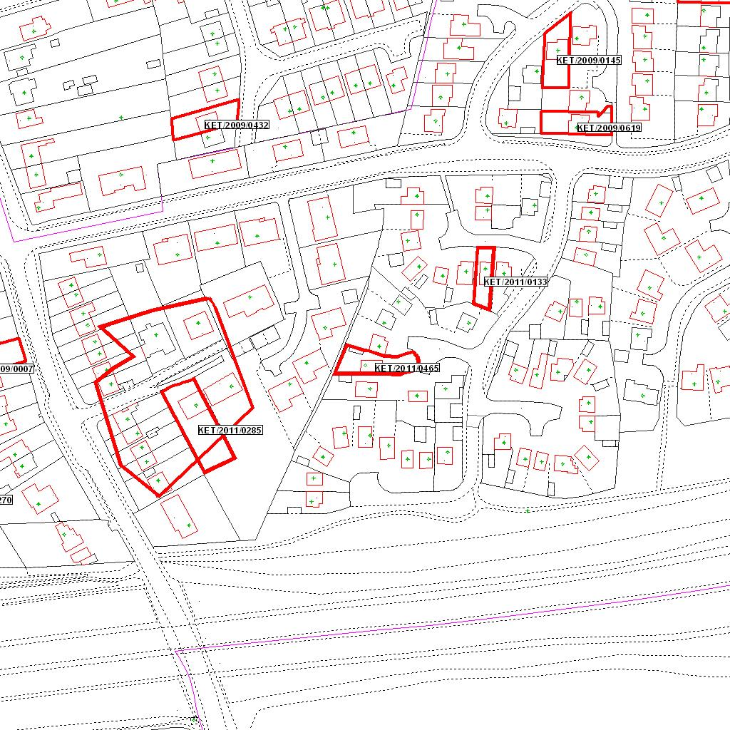

Reproduced from the Ordnance Survey mapping with the permission of the Controller of Her Majesty’s Stationery Office © Crown copyright. Unauthorised reproduction infringes Crown copyright and may lead to prosecution or civil proceedings.  LA078344 |  | N
Date: 02/08/2011 Do not scale from this map. For illustrative purposes only.

