1. PURPOSE OF REPORT

The purpose of the report is to:

- Remind members of the context in which the Council’s budget currently operates;

- Remind members of the agreed policy position for the delivery of the 2012/13 budget (including the budget delivery framework);
- Provide members with an update on the latest budget position for the period up until April 2013 by reference to the following:

  - An update on the delivery of savings for the current year (2011/12)
  - An update on the delivery of savings for the following year (2012/13)

- Start to build a picture of what the national funding picture may look like post April 2013 by reference to the following key Government consultation papers;

- Local Government Resource Review: Proposals for Business Rate Retention (CLG)
- Localising Support for Council Tax in England (CLG)

2. CONTEXT / BACKGROUND

2.1 The ‘maintaining a durable budget’ report is now a standing report to every meeting of the Executive Committee.

  - The Council’s financial strategy and associated budgets were approved at February’s meeting of Full Council. The key messages in relation to the General Fund budget were;

- Council Tax remains below the national average (around £3 per week);
- The Council has maintained its balanced budget without cutting front line services or using one-off reserves;
- The budget is of course only a paper exercise and the challenge of delivering the £2m of savings during 2011/12 must not be underestimated. The Council’s focus will remain on maintaining the delivery of high quality front-line services however with the level of changes necessary some transition turbulence is inevitable.

- A further £1m of savings is estimated to be needed to balance the budget for 2012/13. This will increase to £1¼ million if a 0% council tax is sought. Work on the budget delivery framework will continue to ensure savings are identified.

- The financial outlook past 2012/13 is difficult to predict with a new government grant regime likely to be introduced. The Council will need to maintain its focus on big ticket items and continue with its successful lobbying strategy;

- Attendees at the LGA Conference in July received some reassurance that the Council's forecasting and modelling are “ahead of the curve.”
  - The Council’s unique approach to budget setting and monitoring has been developed to help provide a robust framework to evaluate and deal with the significant cuts in Government funding. The Council had the advantage of starting from a 'strong financial platform' with no reliance on reserves or structural budget deficit. It developed its own budget delivery framework to ensure that the Council had a robust mechanism on which to base its financial strategy.
  - The foundations of the Medium Term Financial strategy are the 'guiding principles,' 'modelling for recovery’ principles and newly approved ‘budget containment strategy.’ which are set out below: -

Guiding principles:

- Revenue balances should not fall below £1m and overall revenue reserves should not fall below 10% of net revenue expenditure;

- In setting the Council Tax, members should consider the medium term to ensure that a sustainable budgetary position is preserved (with due regard being given to any penalties that might apply);

- The level of household Council Tax to increase each year in line with inflation at least, where the budget is in deficit, to ensure resources remain consistent with budgeted costs;

- When setting the Capital Programme, consideration is given to allocating capital resources to schemes that are beneficial to the Council’s overall revenue budget position;

- To maximise the resources available to the Authority, the Council will actively lobby the Government on relevant issues (e.g., grant distribution/ planning fees).

  - The guiding principles have been instrumental in helping the Council deliver a balanced budget The principles discourage the use of one-off reserves to balance the budget in favour of more sustainable methods like proactive budget management, ongoing efficiency savings and attracting external funding.
  - The Council has recognised that as a major economic engine in the Borough it has an important role as a stimulus for the economy and as support to other local businesses. The Council endorsed a set of counter cyclical 'modelling for recovery' principles. The principles were designed to help the Council continue to invest in both infrastructure and services and to help achieve its major objectives of higher grade higher density jobs, better town centres and a better education offer.
Modelling for recovery principles

- Wherever possible, continue with all planned investments and programmes, to protect the local economy and lever in other investments;

- Given that we currently have no long-term debt, we should be prepared to consider debt-funding as a means of programme delivery or stimulus – if this can be shown to be sustainable and have a wider economic benefit;

- Organise our fiscal structures and business models to attract and retain the maximum amount of revenue within the local economy;

- To ensure all possible avenues are used within procurement rules to source locally;

- Protect the performance of Council services which come under particular strain;

- Work closely with partners in the voluntary, public and private sectors, to ensure optimum efficiency.
2.7 During the budget cycle for 2011/12 the Council approved a further set of principles for managing the impact of changes made externally and outside the control of the Council – these were termed the ‘budget containment strategy’.

Budget Containment Strategy:

- Where a specific grant which funds a specific service is withdrawn, the service stops;

- Where grant funding reduces, which Kettering Borough Council passports through to another organisation, the reduced sum continues to be passported, providing the end recipient organisation feels it can still provide a value-added service at that funding point.
- Where a function is transferred to another provider, the Council leaves all service-provision discussions, including any top-up funding, with the new provider;

- The Council would ordinarily neither seek to buffer nor profit from tax changes;

- The Council should not substitute itself as the provider / funder of services when another public provider cuts such a service.

  - Whilst these principles provide a robust framework to work within the Council’s success comes from an ability to deliver. The Budget Delivery Framework has provided the operational mechanism for delivering the savings required to balance the budget for 2011/12 and this will continue for maintaining a durable budget into the medium term.
  - The following statement is repeated from previous durable budget reports to this committee and remains important advice – ‘the budget is of course only a paper exercise and the challenge of delivering the £2m of savings during 2011/12 must not be underestimated. The Council’s focus will remain on maintaining the delivery of high quality front-line services however with the level of changes necessary some transition turbulence is inevitable’.

- POLICY POSITION
  - Members are reminded that during 2010 the Council agreed a unique budget delivery framework from which to help deliver its ambitious financial strategy. The framework consisted of eight workstreams – this is illustrated below for ease of reference;


Capital
Review
Service Plans
Fees and
Charges
Review
Prioritisation
Innovation
Group
Staff
Suggestions
Partnership
Working
Lobbying
Budget
Delivery
Framework
  - As previously reported to this committee, the strategy has to date proved extremely successful and helped provide additional flexibilities from which to address the national funding challenges that face all local authorities.

  - This overall strategy provides the cornerstone on which the Council's long-standing success in both setting a ‘balanced budget’ and delivering within budget are founded. The Council's established policy position has been key in providing a stable point of reference – this was recognised at the meeting of the Executive Committee on 6th April 2011 when the following resolution was approved in relation to the budget setting process for 2012/13:

“the same methodology be applied to the formulation of the 2012/13 budget as it applied to the 2011/12 budget, with particular reliance on:-

- the existing guiding principles
- the existing modelling for recovery principles
- the existing budget containment strategy
- the existing eight workstreams”
- BUDGET MONITORING & PLANNING
GENERAL FUND 2011/12 – CURRENT FINANCIAL YEAR

  - The following table is reproduced from the July Executive report;
  - Table 1 shows that of the £1,906,000 of required savings for the current year (2011/12), over half of these had already been ‘locked in’ before the start of the year. This was a direct consequence of savings being delivered early in the previous year (as reported to the last meeting of this committee). Although many of these ‘locked in’ savings have been secured, they are actually realised in cash terms as the year progresses (eg, each month).

  - As previously reported, the remaining savings (ie, the £866,000) had been identified through the Council’s budget delivery framework before the start of the year but had not at that point been ‘locked in’. We are confident that the required savings have now been ‘locked in’ and are being delivered in cash terms each month – we are currently on target. The following table provides an update on the savings target for 2011/12 across the workstream areas:

  - The only variations that are included in table 2 (when compared against the original analysis when the budget was set) are;

  - New Homes Bonus Funding - additional income of £22,000
  - Highways income from NCC - £22,000 less than budgeted.
  - The chart below shows the actual realisation of the ‘cash’ savings against the target for the year. It can be seen that as well as the £1.906m having now been ‘locked in’ it is also on schedule in terms of its cash delivery through the year.

GENERAL FUND 2012/13 – BUDGET PROSPECTS NEXT FINANCIAL YEAR

  - As well as monitoring framework savings identified for 2011/12 work continues on identifying savings for the following year - 2012/13. Members are reminded of the current Medium Term Financial Forecast which requires an additional £1,043,000 of savings to balance the budget in 2012/13 (this will increase to £1,268,000 if a 0% council tax increase is sought). The table below shows framework savings that have already been found for 2012/13:
  - In the previous durable budget report (to the July meeting of the Executive Committee) it was reported that an early start had already been made on identifying the savings required for 2012/13 – a figure of £345,000 was previously reported. Table 3 shows that the figure now stands at £500,000 which is very encouraging and is significantly ahead of schedule. The main change is in relation to the estimated savings from the ‘capital review’ workstream as a consequence of the approved improvements planned for the crematorium.

  - The following chart identifies framework savings that have already been identified for 2012/13. The savings are plotted in the month they are identified and the comparator is the £1,268,000 identified in 4.6 above. It is particularly encouraging that by September 2011 we have identified 40% of the savings needed for 2012/13.

  - The above chart includes the ‘early wins’ that the Council has already secured against the savings target for 2012/13 due to the cancellation of the public conveniences contract. As previously agreed by the Executive, the contract notice has been served (12 months) and will take effect during 2012/13.

  - An example of the type of initiative being piloted to deliver further budget savings is explained in the following case study:

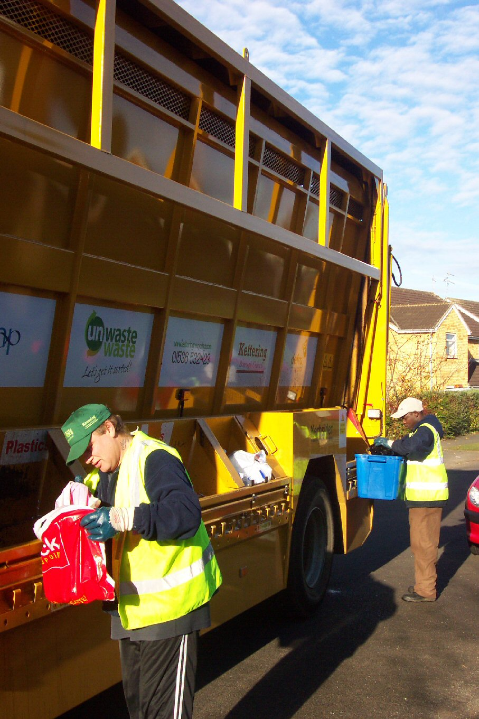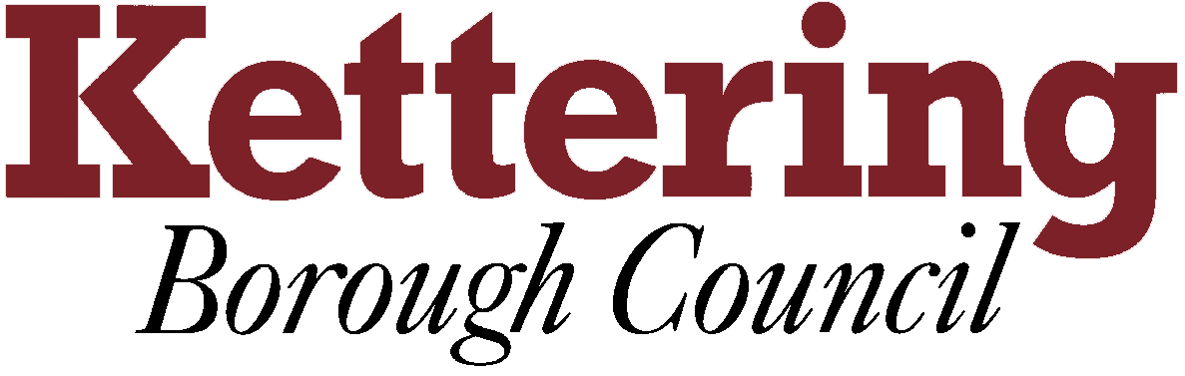
We have indentified an entrepreneurial opportunity to explore a different way of working from the current kerbside recycling process.

Our revised processes designed within the objectives of:-

Not changing the boxes and physical infrastructure used by customers.

Not changing the behaviour expectations of customers

In short our processes and methods need adjusting.

The potential benefits of this new approach are significant. It could mean that:-

It is too early to quantify the exact benefits of the scheme although the pilot will help us to do this. The savings could run into five or six figures. The staff involved are committed to making this arrangement work and we are working hard to ensure that residents involved in the pilot will be kept informed about the initiative.

We are only able to benefit from such suggestions because of the flexibility we have through not being locked into inflexible long term arrangements.
Case Study
Doorstep Recycling Collection Pilot
Between September and November this year the Council will be piloting an exciting new initiative for the collection of household recycling from residents' doorsteps in parts of Burton Latimer and Desborough.

The recycling service already performs very well, with around 50% of all household waste being recycled each year. This places Kettering in the top 10% of all areas in the Country.

We could use standardised refuse and recycling vehicles which would save money

The time to complete a recycling round could decrease, meaning each vehicle and crew can cover a greater area, reducing the overall resources required and providing capacity to absorb housing growth pressures

Fuel costs and carbon emissions could be reduced

Recycling participation rates could be further increased

We will be in a potential better position to be able to respond to new recycling requirements, such as food waste collections
The pilot scheme looks at getting recycled materials into the vehicles faster and more efficiently

HOUSING REVENUE ACCOUNT 2011/12 – CURRENT FINANCIAL YEAR
  - A summary of HRA monitoring at 31st July is shown below. The projected outturn is a £15,000 underspend resulting from a reduction in expenditure on General Management.
HOUSING REVENUE ACCOUNT 2012/13 – NEXT FINANCIAL YEAR
  - The Council continues to make good progress with its preparations for Self Financing of the Housing Revenue Account from April 2012. It is in the process of refreshing the Asset Management Strategy and Business Plan, which will drive the budgets post April.
  - The Council has started to consider borrowing with Sector, (Treasury Management Specialists). The situation is extremely fluid as a number of banks are seeking to enter the market to lend to Local Authorities. This will make the timing of the decision to lend very important. Further reports will be brought to members during the forthcoming budget cycle.
CAPITAL PROGRAMME 2011/12 – CURRENT FINANCIAL YEAR
  - A summary of the projected Capital Programme outturn monitoring statement as at 31st July 2011 is shown in the table below: -
* The Council has no long term cash debt but uses internal borrowing, in line with its “modelling for recovery” principles to support capital investment.
  - The capital programme is currently projected to be ‘on’ budget.
  - The programme incorporates the following variation from the approved programme. Corporate Asset Management Team at its meeting on 21st July 2011 approved a scheme to resurface dangerous parts of London Road and Wadcroft car parks. The total scheme budget is £25,000.
General Fund 2013/14 and beyond – the Medium Term Forecast
  - The preceding sections of this report have dealt with the current and next financial year. This section and those that follow deal with the period post April 2013 and specifically changes in the national framework for Local Government Finance which are to be implemented from April 2013 (ie, “Zone of Unpredictability”). They will radically change how the council’s funding is calculated and there are likely to be new obligations the council may need to consider meeting at a local level.

  - The significant changes in future funding sources have resulted in some changes in presentation of the Council's Budget Model. The table has been split between “Zones of Predictability and Unpredictability” and to enable the total resources required to balance the budget to be identified no assumptions have been made regarding future council tax increases.

  - Line 6 is now in effect the sum which is needed for a balanced budget. Every 1% increase in council tax generates around £65,000 towards that sum. Formal decisions on council tax increases will be taken by Council after considering the advice of its officers.

  - The updated budget model is shown in the following table:

- GOVERNMENT CONSULTATION PAPERS

  - It has previously been reported to members that the way that the Government provide funding to local authorities is likely to alter significantly from April 2013 as is the map of local vs national obligations.
  - The magnitudes of the changes are such that they could have a very significant impact on the Council’s budget and medium term financial strategy.
  - Due to the magnitude of the changes being considered, the Government have already published two significant consultation papers to local authorities. The two key papers that are currently ‘live’ are;
Consultation | Deadline
Local Government Resource Review: Proposals for Business Rate Retention (CLG)  Including no less than eight supplementary technical consultation papers | Monday 24 October 2011
Localising Support for Council Tax in England (CLG) | Friday 14 October 2011
  - In line with the Council’s budget strategy guiding principle ‘e’ (see section 2.4), to help influence major national funding issues officers are actively involved in helping lead the national debate on these consultations and are currently analysing the contents of the consultation papers. Further details will be provided to Members through the October report to this committee – however some of the key issues covered in each paper are;
Local Government Resource Review: Proposals for Business Rate Retention (CLG)
  - The Government released a major consultation paper ‘Local Government Resource Review: Proposals for Business Rate Retention’ on 18 July 2011. The consultation period runs until 24 October.
  - The consultation document is a major piece of work, the outcome of which will determine the way in which a significant proportion of local government funding is allocated from 1st April 2013. In short, the consultation paper proposes that the current system of formula grant is replaced by a system that is directly funded through business rates and a system in which local authorities get to keep a proportion of subsequent increases in their business rate take. In terms of scale, the Council’s core grant from central government is £5.464m in 2011/12 and is likely to be £4.784m in 2012/13. The initial baseline that the government propose to use will be based on the 2012/13 grant level therefore each 5% ‘change’ equates to approaching £250,000.
  - The consultation paper issued on the 18 July is available on the Communities and Local Government website at the following link http://www.communities.gov.uk/publications/localgovernment/resourcereviewbusinessrates. A summary of the consultation paper (written by the Local Government Association) is attached at Appendix A.
  - The consultation paper outlined a broad framework in which the new system may operate however it did not however go into specific detail. The detail is contained in a series of eight separate technical papers that were issued on 19 August 2011. These are very detailed papers and will require thorough reflection and analysis prior to a response being drafted. The eight technical papers covered the following subjects;

Technical Paper | Subject
1 | Establishing the baseline
2 | Measuring business rates
3 | Non-billing authorities
4 | Business rates administration
5 | Tariff, top up and levy options
6 | Volatility
7 | Revaluation and transition
8 | Renewable energy
The eight technical papers are available at the following link http://www.communities.gov.uk/localgovernment/localgovernmentfinance/lgresourcereview/
  - An initial analysis of the eight technical papers has been produced by the Local Government Association – this is attached at Appendix B. From our initial analysis and that done by LGA colleagues it is clear that there is much detail to consider before making a formal response to the Government. Understanding the implications for billing authorities and being clear about the specific implications for Kettering Borough Council of the different options being considered will take some considerable effort but nevertheless is effort worth committing. An initial read of the technical papers clearly shows that the direct input that KBC officers have made to CLG officials over the past few months has been worthwhile in that it has helped influence some of the content.
  - The durable budget report to the next meeting of this committee will summarise the Council's draft response to the consultation. This will also be built upon at the member’s information session on the 19 September.

Localising Support for Council Tax in England (CLG)
  - At the same time as consulting on the future funding arrangements, the Government is also consulting on a proposal to localise Council Tax benefit. In effect the Government will provide a fixed amount of money from which councils will have to try and meet the costs of council tax benefit. The Government as part of its consultation paper “Localising Support for Council Tax in England (Section 2 para. 2.1)” states that it “will reduce expenditure on the current council tax benefits bill by 10%”. If a council cannot achieve that council tax benefit budget saving then the cost burden will fall on their local tax payers. The current expenditure on council tax benefit in Kettering Borough is around £5.5m, of course that is currently met from national resources.

  - Councils will be encouraged to do this through establishing a local scheme of council tax benefits – rather than the national scheme that currently operates.
  - The consultation paper doesn’t propose any specifics scheme details and sets an ambitious target implementation date of April 2013.
  - This consultation is as important for local authorities as the proposals for business rate retention. This is because the new scheme could see a major shift in budget risk away from central government to local government – even small changes in caseload numbers could see local authorities struggling to contain the benefit expenditure within budget.
  - We are currently assessing the implications of the consultation and will summarise the Council's draft response to the consultation in next month’s budget report. In the meantime the summary produced by the LGA may be a useful reference point for members – this is attached at Appendix C.
  - The full consultation paper is available at the following link http://www.communities.gov.uk/publications/localgovernment/localisingcounciltaxconsult

- CONSULTATION AND CUSTOMER IMPACT

  - None as a direct consequence of this report however members are reminded that the formal budget consultation period is from 18th January 2012 to 22nd February 2012 when the Council sets its Council Tax for 2012/13. Comments from the consultation process will be reported to the Executive for consideration at it’s meeting on 15th February 2012.

- POLICY IMPLICATIONS

  - There are no direct policy implications as a result of this report.

- USE OF RESOURCES
  - The implications on the Council’s resources will be considered through out the durable budget reports.

9. RECOMMENDATION

The Executive Committee is recommended to:

  - Note the current budget position.

  - Endorse the amendment to the capital programme at 4.17.

  - Note the progress towards achieving a balanced budget for 2012/13.

  - Recognise the significance of changes facing the authority beyond April 2013.

Background Papers: Previous Reports/Minutes:
Title of Document: Estimate Working Papers Monthly Durable Budget Reports
Contact Officers: P Sutton (April 2010 to date)

