BOROUGH OF KETTERING

Committee | Full Planning Committee - 16/08/2011 | Item No: 5.3
Report Originator | Alan Davies  Assistant Development Officer | Application No:  KET/2011/0367
Wards Affected | Pipers Hill
Location | 13 Hillcrest Avenue, Kettering
Proposal | Full Application: Conservatory to rear
Applicant | Mr R Buckley

1. PURPOSE OF REPORT

  - To describe the above proposals
  - To identify and report on the issues arising from it
  - To state a recommendation on the application

2. RECOMMENDATION

THE DEVELOPMENT CONTROL MANAGER RECOMMENDS that this application be APPROVED subject to the following Condition(s):-

1. The development hereby permitted shall be begun before the expiration of 3 years from the date of this planning permission.
REASON: To comply with Section 91 of the Town and Country Planning Act 1990 (as amended) and to prevent an accumulation of unimplemented planning permissions.

2. The materials to be used in the construction of the external surfaces of the development hereby permitted shall match, in type, colour and texture those on the existing building.
REASON: In the interests of visual amenity in accordance with Policy 13 of the North Northamptonshire Core Spatial Strategy.

Justification for Granting Planning Permission

The proposal is in accordance with national and local policies as set out in Planning Policy Statement 1 and Policy 13 of the North Northamptonshire Core Spatial Strategy. There are no material considerations that indicate against the proposal.

Officers Report

3.0 | Information

Relevant Planning History
KE/1989/0037 – First floor extension. Approved 15/02/1989.

KE/1977/0062 – Extension. Approved with conditions 06/03/1977.

Site Description
Officer's site inspection was carried out on 11/07/2011.

The application property is a two storey semi-detached dwelling on the eastern side of Hillcrest Avenue, Kettering. The front of the dwelling has bay windows at ground and first floor and is part faced with dark red bricks and white-painted render. To the side of the dwelling (southern elevation) is a driveway to access the garage in the rear garden. This access is slightly wider than 2 metres. The rear garden is the full width of the property plus the garage and it extends from the rear elevation of the dwelling by a distance of 22.9 metres. To the south is 15 Hillcrest Avenue, a property of similar appearance and proportions.

Proposed Development
It is proposed to construct a single storey pitched-roof conservatory to the rear of the property. The conservatory will encompass a brick dwarf wall and white uPVC windows and doors. The brick will match with the existing dwelling. The dimensions of the proposed conservatory are 5 metres by 4 metres, with a ridge height of 3.6 metres. The eaves of the conservatory will be 2.5 metres from the ground. The conservatory will connect with the existing garage, allowing access to the garage from the house without the need to go outside.

Any Constraints Affecting the Site
None

4.0 | Consultation and Customer Impact

Neighbours
No objections

5.0 | Planning Policy

National Policies
PPS1. Delivering Sustainable Development

Development Plan Policies

North Northamptonshire Core Spatial Strategy
Policy 13. General Sustainable Development Principles

6.0 | Financial/Resource Implications
 | None
7.0 | Planning Considerations
The key issues for consideration in this application are:-

1. Principle of development
2. Residential amenity
3. Design, character and appearance

1. Principle of development
Section 38 of the Planning and Compulsory Purchase Act 2004 requires Local Planning Authorities to determine applications for planning permission in accordance with the development plan. In this instance the relevant policy of the development plan is Policy 13 of the North Northamptonshire Core Spatial Strategy, which states that development should not result in the detrimental impact upon the amenity of neighbouring residents in terms of loss of light, overbearing impact or increased noise, light or air pollution. It is considered that this proposal satisfies the objectives of Policy 13 and supporting national planning policy in PPS1, which is documented in the subsequent sections of this report.

2. Residential amenity
The north elevation of this proposal will face onto the boundary with 11 Hillcrest Avenue. Due to the height of the proposed conservatory and the existing 2 metre high boundary fence there will be no overlooking of or overbearing impact upon the residents of 11 Hillcrest Avenue. There will be no impact on amenity experienced by the occupants of 11 Hillcrest Avenue either and therefore this proposal will not have a detrimental impact upon the residents of no.11.

To the south of the application property is 15 Hillcrest Avenue. The distance between the south elevation of the proposed conservatory and the garden boundary fence of no.15 is 2.5 metres. This boundary fence is 2 metres high and will effectively screen views between the two properties. Also, there are no windows on the north elevation of no.15 which face directly onto the proposed extension. Therefore the proposal will not have a detrimental impact upon the present or future residents of 15 Hillcrest Avenue and for this reason it is considered to accord with Policy 13 of the North Northamptonshire Core Spatial Strategy.

3. Design, character and appearance
The proposal will not be visible from the public realm and only a small proportion of the roof structure will be noticeable from the rear gardens of the surrounding dwellings. By virtue of it being an extension to an existing dwelling the proposal is sustainable and the mass and scale of the structure result in a development which is appropriate within its context. The proposed use of matching bricks to construct the dwarf wall and the white uPVC doors and windows will all help to blend the structure with the host dwelling. Therefore the proposal is considered to be in accordance with national planning policy PPS1, as it is both a sustainable and appropriately-designed extension to an existing dwelling.

Conclusion

The proposal accords with national and local planning policy and its single storey nature results in a design that will not have a detrimental impact upon the lives of neighbouring residents. The chosen design is appropriate for the host dwelling and therefore it is recommended for approval.

Background Papers |  | Previous Reports/Minutes
Title of Document: |  | Ref:
Date: |  | Date:
Contact Officer: | Alan Davies, Assistant Development Officer on 01536 534316

SITE LOCATION PLAN

13 Hillcrest Avenue, Kettering
Application No.: KET/2011/0367

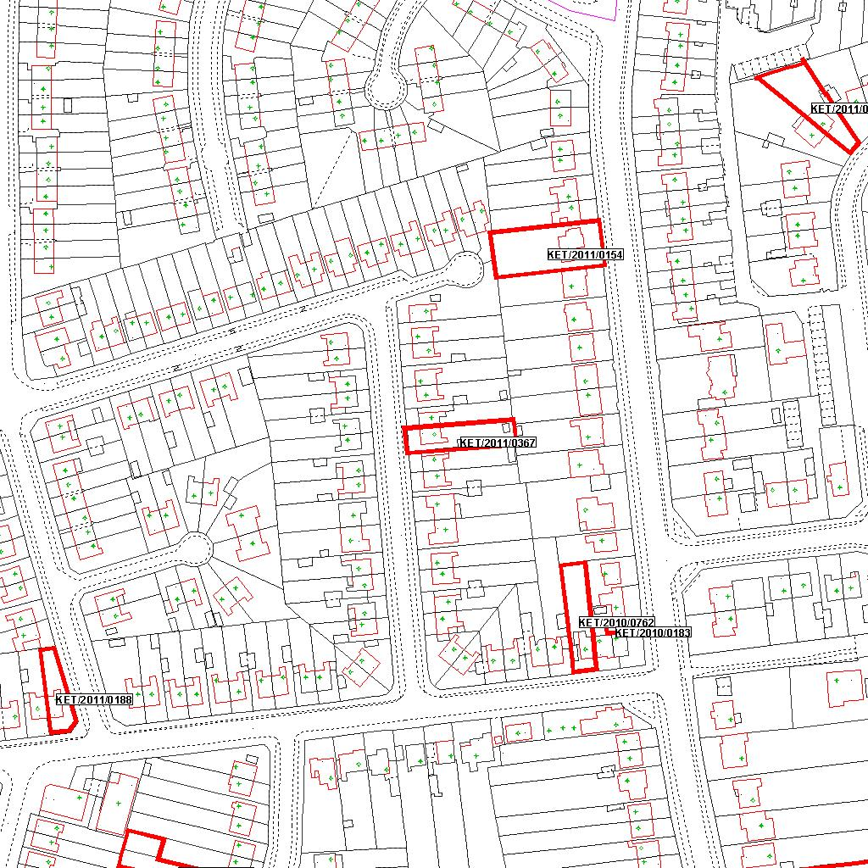

Reproduced from the Ordnance Survey mapping with the permission of the Controller of Her Majesty’s Stationery Office © Crown copyright. Unauthorised reproduction infringes Crown copyright and may lead to prosecution or civil proceedings.  LA078344 |  | N
Date: 16/06/2011 Do not scale from this map. For illustrative purposes only.

