 | Development Services  Bowling Green Road  Kettering  NN15 7QX  01536 534316
Tykes Developments  Flat 8  70 St. Mary's Road  MARKET HARBOROUGH  Leicestershire  LE16 | www.kettering.gov.uk  E-mail: planning@kettering.gov.uk
NOTICE OF APPROVAL

TOWN & COUNTRY PLANNING ACT 1990 (as amended)

REFERENCE No: | KET/2011/0152
APPLICANT: | Tykes Developments
DEVELOPMENT: | Variation of conditions 2 (materials), 4 (noise mitigation), 5 (contamination assessment), 10 (approved drawings), 11 (servicing facilities) and 12 (highway details) of planning permission KET/2007/0449 (permission allows a hotel, ground floor retail unit and basement health club) in order to accommodate planned highway improvements and changes to fenestration
LOCATION: | 16-18a Horsemarket, Kettering

KETTERING BOROUGH COUNCIL, having considered a valid application submitted on 13 April 2011, for the above development in pursuance of their powers under the above mentioned Acts, with the following justification, that:-

The proposal is in accordance with national and local policies as set out in Planning Policy Statements/Guidance Notes 1, 4, 5, 9, 13, 23 and 24, Policy 2 of The East Midlands Regional Plan, Policies 1, 6, 8, 9, 12 and 13 of the North Northamptonshire Core Spatial Strategy, and Policies 64 and 103 of the Local Plan for Kettering Borough. The proposal is also in accordance with Policy 7 of the emerging Kettering Town Centre Area Action Plan (Submission Document, December 2010). There are no material considerations that indicate against the proposal.

GRANT PERMISSION

for the development as described and in accordance with the application and plans submitted, subject to the following conditions:-

1. The development hereby permitted shall be begun before 11th June 2011.
REASON: To comply with Section 91 of the Town and Country Planning Act 1990 (as amended) and to prevent an accumulation of unimplemented planning permissions.

2. With the exception of the UPVC window frames, the development shall not be carried out other than in accordance with drawing number AF Rev. A (Elevations Showing Materials) and the submitted Materials Schedule received by the Local Planning Authority 21st April 2011.
REASON: To ensure an appropriate appearance for the building and to protect the character and appearance of the Conservation Area in accordance with policy 13 of the North Northamptonshire Core Spatial Strategy.

3. All glazed openings shall be 'Unique Windows' aluminium framed and finished Anthracite Grey (RAL 7016).
REASON: To ensure an appropriate appearance for the building and to protect the character and appearance of the Conservation Area in accordance with policy 13 of the North Northamptonshire Core Spatial Strategy.

4. There shall be no external illumination on the site at any time other than in accordance with a detailed scheme which shall first have been submitted to and approved in writing by the Local Planning Authority.
REASON: In the interests of the amenities of the area, adjoining residential properties and highway users in accordance with Policy 13 of the North Northamptonshire Core Spatial Strategy.

5. No development above ground level shall take place until a scheme for protecting the proposed hotel bedrooms from external noise has been submitted to and approved in writing by the Local Planning Authority. The development shall not be carried out other than in accordance with the approved scheme, and the scheme shall be fully implemented before the use hereby permitted commences.
REASON: To ensure that acceptable noise levels within the hotel bedrooms are not exceeded in the interests of amenity in accordance with PPG24 and policy 13 of the North Northamptonshire Core Spatial Strategy.

6. The development shall not be carried out other than in accordance with the submitted Phase I Appraisal (Desk Study) report GRM/P5471/DS.1 (April 2011).
REASON: To reduce the risk to all receptors to acceptable levels and ensure that the site is suitable for its proposed use, and to safeguard the environment of the area, in accordance with PPS23 and policy 13 of the North Northamptonshire Core Spatial Strategy.

7. No development above ground level shall commence until details of a site investigation have been submitted to and approved in writing by the Local Planning Authority. This submission shall include:-
(a) a remediation strategy setting out the measures to be carried out on site to mitigate against any unacceptable risk or risks to all potential receptors;
b) If required, the remediation of the site shall be carried out fully in accordance with the approved details and timetable contained therein. Within one month of completion of the remediation works, two copies of a closure report shall be submitted to the Local Planning Authority;
c) If during the development of the site, contamination not previously considered is identified, no further work shall be carried out until the Local Planning Authority has been notified in writing of the discovery and a method statement detailing a scheme for dealing with the contamination has been submitted to and approved by the Local Planning Authority. The remediation shall be carried out in accordance with the approved detail.
REASON: To reduce the risk to all receptors to acceptable levels and ensure that the site is suitable for its proposed use, and to safeguard the environment of the area, in accordance with PPS23 and policy 13 of the North Northamptonshire Core Spatial Strategy.

8. The A3 use hereby permitted shall not commence until details of a ventilation system required for the extraction and disposal of cooking odours has been submitted to and approved in writing by the Local Planning Authority. The use hereby permitted shall not commence until the approved details have been fully implemented.
REASON: In the interests of the character and appearance of the conservation area and amenities of the area in accordance with PPS1 and policy 13 of the North Northamptonshire Core Spatial Strategy.

9. The basement unit shall be used only for the purpose of a use within Class A1 of the Schedule to the Town and Country Planning (Use Classes) Order 1987 or as a health club/gymnasium and for no other purpose in Class D2 of the Schedule to the Town and Country Planning (Use Classes) Order 1987, or in any statutory instrument revoking and re-enacting that Order with or without modification.
REASON: To define the permission and to ensure a satisfactory form of development in accordance with the approved plans and in the interests of the amenity of future residential occupants in accordance with policy 13 of the North Northamptonshire Core Spatial Strategy.

10. The bin and cycle stores as shown on the approved plan reference 01-001C dated 11th May 2011 shall be constructed prior to first occupation of the building and retained for the purposes of storing bins and cycles thereafter.
REASON: To protect the amenities of the development in accordance with policy 13 of the North Northamptonshire Core Spatial Strategy.

11. All materials obtained from demolition shall be permanently removed from the site within twenty eight days of demolition being commenced.
REASON: In the interests of visual amenity in accordance with PPG15 and policy 31 of RSS8.

12. The development hereby permitted shall not be carried out other than in accordance with the amended plan numbers 02-001C, 01-001C, 01-003C, 00-004D and 01-002C received by the Local Planning Authority on 11th May 2011 and drawing numbers 01-004C and 01-005C received by the Local Planning Authority on 12th May 2011.
REASON: To clarify the terms of the permission.

Notes (if any):-
- This Decision Notice must be read in conjunction with a Planning Obligation completed under the terms of Section 106 of the Town and Country Planning Act 1990 (as amended). You are advised to satisfy yourself that you have all the relevant documentation.

Date of Decision: 03 June 2011
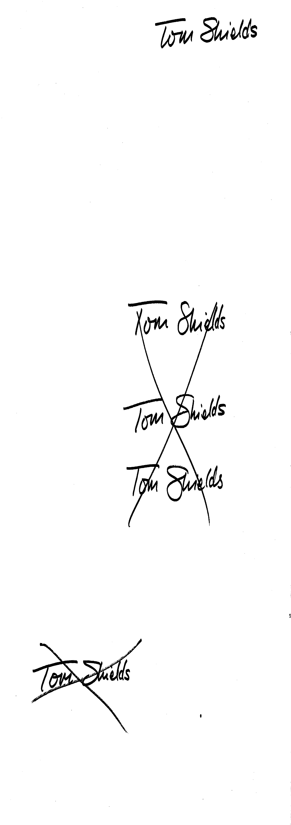
Development Control Manager

Contact:-

Mr Nicholas Williams
JS+P Architecture
31 Lower Brown Street
LEICESTER
LE1 5TH

This permission refers only to that required under the Town & Country Planning Acts and does not include any consent or approval under any other enactment, byelaw, order or regulations.

