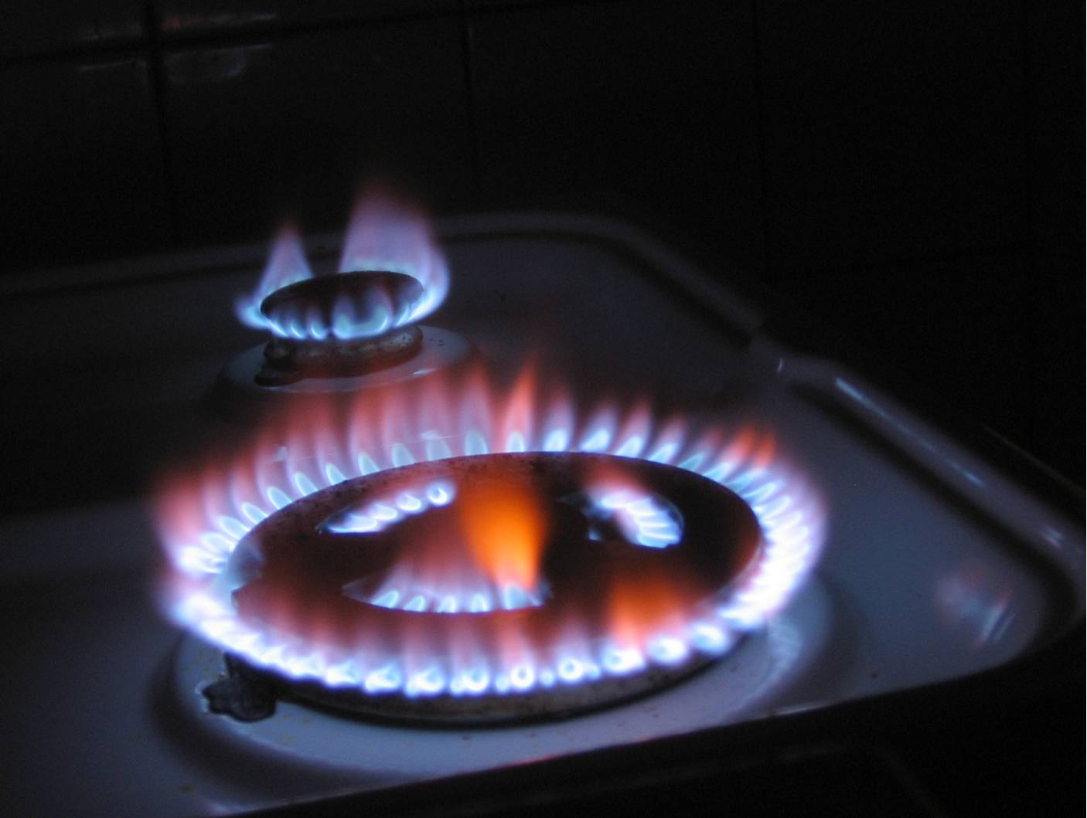
Keep Warm and Well
in Kettering

Contents
Introduction Page 3

Tackling Fuel Poverty Page 4

Details of Rural Fuel Poverty within Kettering Page 5

How we compare Page 7

Action Plan – Keep Warm and Well Page 9

Partners Page 15

The formal definition of fuel poverty is that it occurs when a household spends more than 10% of its income on domestic fuel use to provide adequate warmth to maintain a healthy indoor living environment (21c in living room and 18c in other occupied rooms).
Introduction

Fuel poverty is complex in nature and can be caused by a combination of physical factors relating to dwellings including:

- Poor home insulation
- Poor heating systems
- Low household incomes
- High fuel costs
- Under occupation

The consequence of fuel poverty can be:

- Cold damp homes leading to property disrepair
- Sub-standard housing
- Social exclusion
- Poor educational attainment
- Damage to health and quality of life
- And ultimately can result in excess winter deaths

There are some vulnerable groups that are affected more than others particularly:

- Elderly people
- Single parents
- Those with long term illness or certain disabilities
- Families with young children

Reducing fuel poverty within local communities can help achieve economic, social and physical regeneration, improve public services, reduce inequalities and deliver sustainable communities.

It is widely accepted that more people in the UK will fall into fuel poverty within the next few years. This is based on a number of factors relating the recent economic downturn, rising fuel bills and associated rise in unemployment. However this comes at time when the government and the energy industry developing a strategy for significant infrastructure investment both in renewable energies and nuclear power. This is to secure longer term fuel security based on an increasing and aging population requiring more energy. To date annual energy costs have run at the 2-3% mark. However, more recent industry projections suggest that over the next 10 years energy bills could rise between 14% and 25% as the industry pays for the £200bn cost of investment needed to overhaul the current market, though these projections are timed for later years of this decade. (Ofgem 2010)
Tackling Fuel Poverty

Fuel poverty has also more recently become a recognised problem within the private rental sector due to what some refer to as the ‘split incentive’. This is where landlords do not retro fit their properties with energy saving measures because it’s their tenants who recoup the savings through lower heating bills, not the landlord who has paid for the measures.

The Government are attempting to address this issue within the present Energy Bill whereby they are proposing to introduce a new Green Deal which would allow tenants to install energy saving measures themselves with the costs being repaid through a charge on their bills. It is expected that Local Authorities will become the first port of call for advice and guidance for the Green Deal so providing them with major opportunities in working towards their own Fuel Poverty strategies.

Further opportunities exist within other existing (and imminent) Government initiatives such as the present Feed in Tariff system for renewable electricity installations and the proposed Renewable Heart Incentive for space heating. These schemes have been developed to pump prime the UK’s renewable energy sector and work at domestic level by paying a tariff for relevant installations. Both schemes provide very useful opportunities for home owners to address their own fuel poverty and for Local Authorities to help them.

Kettering Borough Council is also undertaking its own wide ranging review of how its buildings use energy and what can be done reduce fuel use. The Council has identified a great many ‘mini projects’ such as installing insulation, heating controls and low energy lighting. However, as many of the Councils buildings are of a similar size to domestic properties, these mini projects will provide great examples and case studies of what other local people and landlords can do to retro-fit their properties.

To assist with the tackling of fuel poverty Kettering Borough Council is involved in a wide range of initiatives that have led to improvement of energy efficiency dwellings in Kettering, together with achieving affordable warmth.

We have worked in partnership with a wide range of agencies to achieve our objectives and key aims and we now need to look further and build on past success and embark on new challenges that reflect the economic downturn within society today. Some of the initiatives to date have been:

- Smart Meters
- Financial Awareness Training
- Keep Kettering Healthy
- Subsidised summer play activity
Map – based on presence or absence of gas meters in the home; “State of Countryside” - Calor Gas 2010
Details of Rural Poverty within Kettering
(Note purple, red and brown to see for Kettering)

(Yellow – 0.00 to 20.00 ;Amber 20.01 to 40.00; Brown – 40.01 to 60.00; Red – 60.01 to 80.00
Purple – 80.01- 100.00)
National - 28% of those households who are not on the mains gas network in villages and hamlets are in fuel poverty compared with the 13% who are on the mains gas network. The comparative figures for urban areas are 18% and 12%

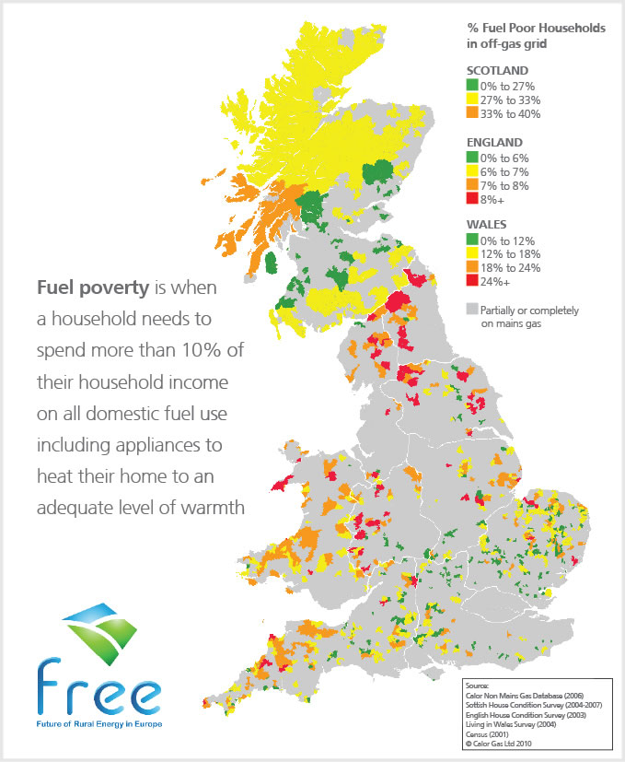
% Fuel Poor Households in off-gas grid

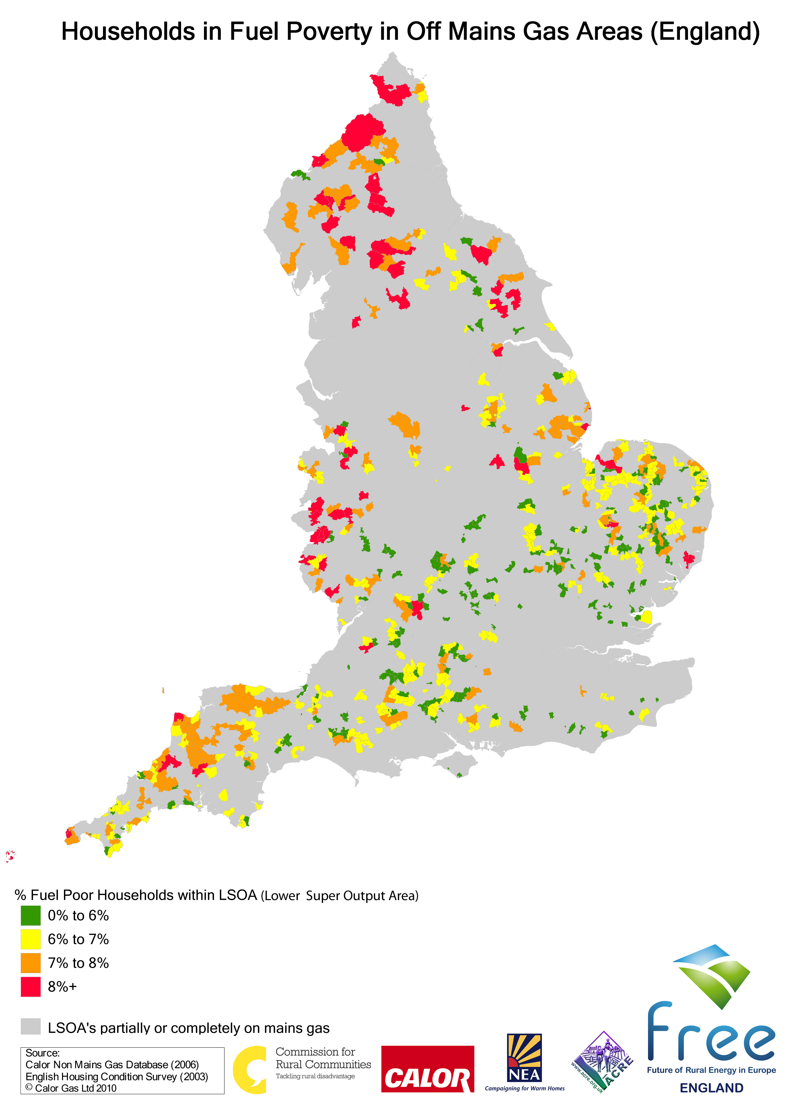
Details of Rural Poverty within Kettering

How we compare

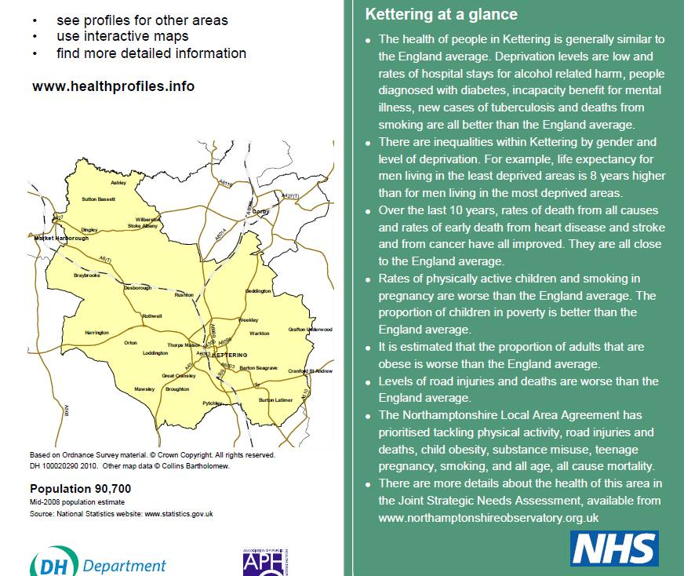

The aims and objectives of the action plan being produced are:

- Raise awareness of all help available to customers both economically and actively

- To identify and target assistance to the most vulnerable groups within the borough of Kettering Borough Council

♦ To encourage the maximum take up of benefits
♦ To encourage take up of energy efficiency grants

- To promote awareness and give advice on the benefits of energy efficiency.

♦ Help to provide local solutions to fuel poverty.
♦ To improve levels of knowledge of energy efficiency, fuel poverty and
maximisation of income by encouraging the maximum take up and targeting
of benefits and energy efficiency grants

- To alleviate the adverse effects on health of inefficiently heated or insulated homes.

- Contribute to the debate for national and regional solutions

- Raise awareness of all help available to customers both economically and actively

- To identify and target assistance to the most vulnerable groups within the borough of Kettering Borough Council

- To encourage the maximum take up of benefits
- To encourage take up of energy efficiency grants

- To promote awareness and give advice on the benefits of energy efficiency.

- Help to provide local solutions to fuel poverty.
- To improve levels of knowledge of energy efficiency, fuel poverty and maximisation of income by encouraging the maximum take up and targeting of benefits and energy efficiency grants

- To alleviate the adverse effects on health of inefficiently heated or insulated homes.

- Contribute to the debate for national and regional solutions

Action Plan – Keep Warm and Well

- Raise awareness of all help available to customers both economically and actively

- To identify and target assistance to the most vulnerable groups within the borough of Kettering Borough Council

♦ To encourage the maximum take up of benefits
♦ To encourage take up of energy efficiency grants

- To promote awareness and give advice on the benefits of energy efficiency.

♦ Help to provide local solutions to fuel poverty.
♦ To improve levels of knowledge of energy efficiency, fuel poverty and
maximisation of income by encouraging the maximum take up and targeting
of benefits and energy efficiency grants

- To alleviate the adverse effects on health of inefficiently heated or insulated homes.

- Contribute to the debate for national and regional solutions

No. | Objectives | Tasks | Lead | Partners | Target & Timescale | Resources
1 | 1, 2, 3, 4, | KBC Take Up / Social Inclusion officer to produce an annual work action plan using mosaic data of areas within the community where help and advice is needed in greater detail | KBC | Sure start  Mind  Parish Councils  Kettering hospital  Local employers  Ethnic communities | Review annually | KBC Staff  (Income and Debt)  All other organisation involved listed on annual action plan
2 | 1, 3, 4, | KBC Debt recovery team to offer financial awareness training to members of the community that are in large debts - initially with regards to Council Tax | KBC | CAB  Community Finance  Trading Standards  Water authorities | Six monthly ½ day sessions with 3 monthly review meetings | KBC Staff  (Income and Debt)  CAB  Community Finance  Trading Standards
3 | 2, 3, 4, 6, | To produce a plain English fuel poverty advice leaflet and distribute within the community of Kettering | KBC | CAB  County Council | December 2010 | KBC Staff  (Corporate Development)
4 | 2, 3, 4, 6, | To update the Council’s website to include data relating to fuel poverty and links to organisations giving help and advice | KBC | CAB  Community Finance  Trading Standards  Welfare Rights  Warm Front | March 2012 | KBC Staff (Customer Services)
No. | Objectives | Tasks | Lead | Partners | Target & Timescale | Resources
5 | 2, 3, 4, 5, 6, | To sign post customers to organisations such as warm front who may be able to assist customers with limited funds | KBC |  | December 2011 | KBC Staff (ALL)
6 | 2, 3, 4, | To organise two energy efficiency promotional events (under the Greening the Borough initiative) annually to raise awareness to customers of energy efficiencies available to them | KBC |  | October 2012 | KBC Staff  (Environmental Health) Work with Groundwork North Northants who lead on the Greening Borough
7 | 5, 6, | Burton Wold Wind Farm Community Fund – Produce project plan for funding for 10/11 to raise awareness of energy efficiency within Burton | KBC  Groundwork |  | June 2011 | KBC Staff  (Environmental Health) Greening the Borough Initiative
8 | 2, 5, 6, | To publicise HECA Government Funding to customers of Kettering by  advertising –website and paper based leaflet | KBC |  | March 2012 | KBC Staff  (Environmental Health)
No. | Objectives | Tasks | Lead | Partners | Target & Timescale | Resources
9 | 1, 2, 3, 5, 6 | Work with other local authorities and Health Service partners in the  provision of advice, education and assistance in improving public health outcomes and reducing health inequalities, as well as raising the profile on services provided by environmental health with the local community | KBC |  | March 2012 | KBC Staff (Environmental Health and community Services)
10 | 2, 3, 4 | To establish up to date data from GIS Mapping information | KBC | All groups | Ongoing | KBC Staff (Income and Debt & customer Services)
11 | 1, 3, 4, | Establish ways of communication i.e. direct mail, posters, telemarketing and face to face for each area. (GIS Mapping information) | KBC | All groups | Ongoing | KBC Staff (Income and Debt)
12 | 1, 2, 3, 4, | To specifically target Housing Associations and all KBC Sheltered Acc Schemes | KBC | Housing 21  KBC Tenants  Housing ass | Ongoing | KBC Staff (Income and Debt)
No. | Objectives | Tasks | Lead | Partners | Target & Timescale | Resources
13 | 1, 2, 3, 4 | To liaise with Tenancy Support Officer and Communication Officer within Housing to joint work re promotional material. | KBC | All groups | Ongoing | Staff (Income and Debt)
14 | 1, 2, 3, 4 | To target local/ethnic minority groups for advertising and to promote within all local Parish Councils | KBC | Hi Ho Group  Salvation Army  Sikh Temple  Muslim Ass  Parish Church groups | Ongoing | Staff (Income and Debt)
15 | 1, 2, 4 | To liaise with third party sectors and local employers. | KBC | Mind  Assertive Outreach Team  Sure Start Centres  Kettering General Hospital  Probation Service  Age Concern  Marlow House  Parent Advisers within local schools  Supermarkets Tresham  Doctor Surgeries  Vets  Dentist practices  Playschemes/groups | Ongoing | Staff (Income and Debt)
No. | Objectives | Tasks | Lead | Partners | Target & Timescale | Resources
16 | 4, 5 | Encourage Registered Providers to develop new units of affordable housing to a standard higher than the required level for affordable homes (currently Code Level 3 of the Code for Sustainable Homes)  In March 2011 eight units of affordable housing will be completed by Leicester Housing Association in Whiteford Drive, Kettering which will achieve Code Level 5. | KBC | Registered Providers | Ongoing | Housing Strategy Officer (Enabling)
17 | 4, 5 | Refurbish two Council properties in Top Dysons, Cranford to include energy efficient technologies such as photovoltaics, solar panels, biomass boilers, thermal breaks between walls, and positive pressure systems.  A Smart Meter will be fitted in the properties to monitor the outcomes of the new technologies on energy consumption and subsequent utility bills. | KBC |  | March 2011 | Housing Maintenance & Investment Manager
No. | Objectives | Tasks | Lead | Partners | Target & Timescale | Resources
18 | 1, 2, 3,4, 5 | Once the Energy Bill passes into law and establishes the Green Deal (expected 2012) we will set up scheme focussing on private sector rental housing to tackle the ‘split incentive’. | KBC | All SHA’s |  | Staff (HECA Officer)
19 | 3, 4, 5 | Research and undertake a feasibility study for establishing Green Deal and Renewable Heat Incentive council run schemes for all KBC tenanted properties | KBC |  | June 2012 | Staff (Housing Strategy Manager)
20 | 1,2,3,4. | Assess feasibility for KBC property services staff being trained and accredited as solar water heating and air source heat pump installers and for KBC to become an accredited installer under Green Deal scheme  Cost implications but could provide a council income stream and tackle fuel poverty amongst KBC tenants. | KBC |  | June 2012 | Staff (Housing Maintenance & Investment Manager)

Partners

Partner | Partner Involvement | Communication Link
Citizen Advice Bureau | Grant funded by KBC to deliver financial advice to customers | Regular review meetings  Joint training events
Groundwork North Northants | Groundwork have an SLA with KBC called the Green the Borough Initiative. This is based on developing a scheme to promote Eco living.  They are in a good place to do some good work to develop this strategy | Alison Phillips at Groundwork (see Dave Lane)
Salvation Army  Sikh Temple  Muslim Ass  Parish Church groups | Working with partners in relation to faith enables the Council to understand specific needs of customers whilst being respectful of customers specific cultures | KBC Staff
Play schemes/groups  Parent Advisers within local schools  Sure Start Centres  Hi Ho Group | Working with partners in relation to children enables the Council to understand the needs of potential vulnerable children and assist where we are able | KBC Staff
Partner | Partner Involvement | Communication Link
Mind  Assertive Outreach Team  Kettering General Hospital  Probation Service  Age Concern  Marlow House | Working with partners in relation to some of our most vulnerable customers enables the Council to assist customers who may not normally visit the Council offices for help and advice | KBC Staff
Supermarkets  Tresham  Doctor Surgeries  Vets  Dentist practices | Having a presence at partners premises allows the Council to communicate with customers on an adhoc basis, allowing customers access to information who may normally not attend the Council offices or website for assistance / advice | KBC Staff
Community Finance  Credit Union  Community Law Service | Working with partners to assist customers struggling to obtain affordable credit, and assisting customers embedded in illegal loans with high interest rates | KBC Staff

