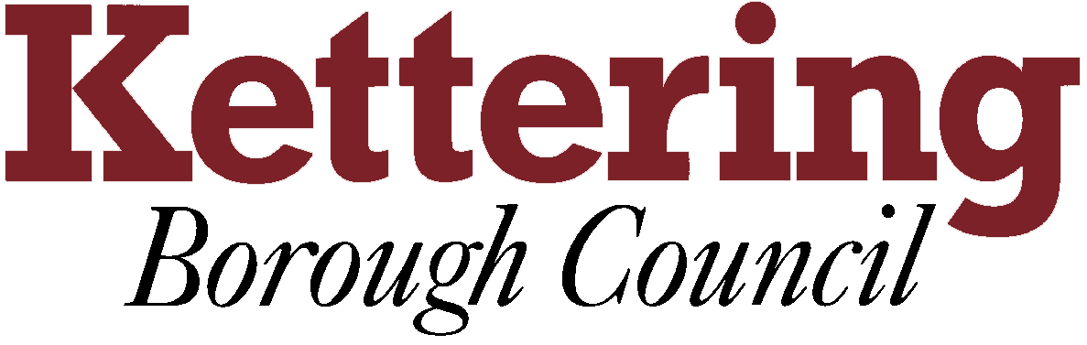

KETTERING BOROUGH TENANTS FORUM

14th July 2011

Feedback from the ARCH (Association of Retained Council Housing) conference
This report asks the Tenants Forum to note the feedback from the ARCH conference held on Thursday 19th May 2011 at Milton Keynes

This report is for Information

1 The Association of Retained Council Housing was set up for councils whose tenants have chosen the local authority as their landlord. ARCH brings councils who own and manage housing together to get the best service for their tenants.
1.1 The ARCH Tenants Group is a sub group of the main ARCH organisation and is made up of tenant representatives from 19 Local Authorities
2 The fifth ARCH Annual Tenants Conference was held on Thursday 19th May 2011 at Milton Keynes. 135 delegates attended the conference. KBC was represented by: Martyn Lund, Lynne Lund, Grahame Holman, Nigel Richards and Linda Nash.
3 The following key issues were raised in the morning sessions:
- Proposed changes to the Housing Revenue Account
- The Localism Bill and how it affects tenants
- Issues of security of tenure
- The future of housing regulation
- Freeing up family homes
- Scrutiny and more involvement from tenants
This session also saw the launch of their new publication ‘Home Truths’ Tenants’ tale of council housing
4 Four workshops were held in the afternoon session:
- Open discussion forum – none of us attended
- The role of scrutiny – Martyn & Linda. Covered the principles of scrutiny in various local authorities. Martyn gave a presentation on the work we are doing in Kettering, the key areas of his presentation were around partnership work, this was new to most authorities present and received a great deal of interest.
- “Opportunities and Bear Traps” – the Government’s plans for reforming Council Housing Finance – Lynne. This was looked at housing finance and where tenants money goes, the group worked in pairs to discuss what they considered to be the two most important questions. Unfortunately the workshop ran out of time. Lynne felt that she had already received the information that was discussed from our Forum. However, it was clear that not all tenants were as well informed.

- Home truths: Changing the face of Council housing – Grahame and Nigel This workshop explored changing the image of council housing:
  - The ARCH Tenants’ Group and Executive wanted to put tenants firmly at the heart of council housing
  - To challenge unhelpful myths associated with council housing
  - A booklet showing a more positive side of life in council homes
  - To be used for press, publicity and lobbying purpose
  - A starting point for building a better image of council housing
5 In summery, this was a very worthwhile conference to attend. Networking opportunities gave us the opportunity to discover that we at Kettering are very fortunate to be working in partnership with our council and that the ‘them and us’ culture still exists in a lot of other local authorities.

Nigel Richards & Linda Nash
On behalf of
Martyn Lund, Lynne Lund and Graham Holman

