To all Members | Direct Line: (01536) 534398  Email: anneireson@kettering.gov.uk  Our Ref: AI  Your Ref:  Date: 28th June 2011

Dear Councillor

You are summoned to a meeting of Kettering Borough Council to be held in the Council Chamber, Municipal Offices, Bowling Green Road, Kettering on Wednesday, 6th July 2011 at 7.00 pm.

Yours faithfully

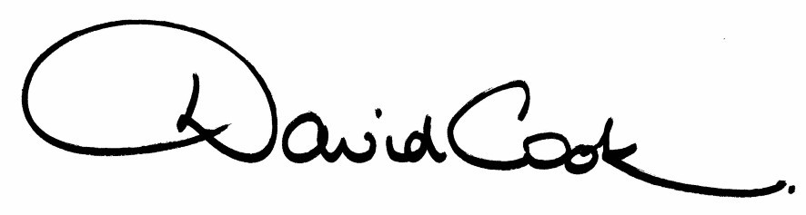

D Cook
Chief Executive

A G E N D A

1. Apologies.

2. Minutes of the annual meeting of the Council held on 18th May 2011 to be approved as a correct record and signed by the Mayor

3. Declarations of Interest:-

- Personal
- Prejudicial

4. To receive any announcements from the Mayor

5. To receive any announcements from the Leader of the Council

6. Report of the Chief Executive.

7. The Mayor to ask members of the public present if they want to speak on any item on the agenda.

8. To receive any deputations and petitions from members of the public.

Mr Greg Warden will present a petition containing 3,660 signatures on behalf of the Desborough Community Development Trust and Desborough Town Council:-

"We the undersigned call upon Kettering Borough Council to reverse their decision to demolish the Hawthorns Leisure Centre in the fast-growing town of Desborough (thus destroying without replacing the squash and the tennis courts, skateboard park, football pitches, community room and bar) and transfer it to us to manage as a community resource complementary of the phase-planned but long delayed and lesser facility at The Grange."

9. Dealing with Petitions : The Hawthorns Leisure Centre, Desborough (information report attached).

10. Appointment of Town and Parish Council representatives to the Kettering Borough Standards Committee (report attached).

11. Appointment of Members to Outside Bodies (list to follow).

12. North Northamptonshire Biodiversity Supplementary Planning Document (report attached)

13. Kettering Town Centre Area Action Plan (report attached)

14. To consider motions received in accordance with Council Procedure Rule 16 as follows:-

(i) To be proposed by Councillor Paul Corazzo and seconded by Councillor Jonathan West that:-

"This Council is disappointed that the Task and Finish Group on encouraging the use of and building of a sustainable public transport system in Kettering and its surrounding villages has been withdrawn from the Research and Development Committee. At a time of funding cuts to bus routes this Council pledges to open a dialogue with County Hall to ensure that routes affected by loss of subsidy are kept to a minimum for the population of Kettering Borough."

(ii) To be proposed by Councillor Linda Adams and seconded by Councillor David Bishop that:-

"This Council notes the success of the Blood Test Centre at the Municipal Offices. This Council will do all it can to ensure that NHS services are publicly run and discourages the 'competition' element of the Health and Social Care Bill."

15. To receive questions from members.

16. Any matters of urgency that the Mayor decides should be considered

28.6.11
Fire Alarm

All meetings shall be adjourned immediately on the sounding of the fire alarm. The alarm is a continuous two-tone siren. On hearing the alarm please leave the building by the nearest emergency exit. There are emergency exits at both ends of the corridor outside the meeting rooms. On leaving the building please cross the car park and assemble on the grassed area by the church. Do not attempt to drive out of the car park as this may impede the arrival of emergency vehicles. Please do not return to the building until you are told it is safe to do so by a Council employee.

Toilets

There are toilets in the corridor off the main entrance to the building you came through to get to the meeting room.

Facilities for Babies and Children

If you wish to use a private area to feed your baby please ask a member of staff. There are changing facilities in the corridor off the main entrance adjacent to the toilets.

.Access for Disabled People

There are allocated parking bays outside the main entrance to the Municipal Offices for disabled people. The meeting rooms are located on the ground floor and access is gained for wheelchair users via the main entrance. If you require assistance, please ask the attendant on duty in the reception area.

No Smoking

Smoking is not permitted in the Municipal Offices.

