BOROUGH OF KETTERING

Committee | Full Planning Committee - 21/06/2011 | Item No: 5.4
Report Originator | Mark Coleman  Assistant Development Officer | Application No:  KET/2011/0291
Wards Affected | Pipers Hill
Location | 260 Windmill Avenue, Kettering
Proposal | Full Application: Two storey side and single storey rear extensions.
Applicant | Mr T Medley

1. PURPOSE OF REPORT

  - To describe the above proposals
  - To identify and report on the issues arising from it
  - To state a recommendation on the application

2. RECOMMENDATION

THE DEVELOPMENT CONTROL MANAGER RECOMMENDS that this application be APPROVED subject to the following Condition(s):-

1. The development hereby permitted shall be begun before the expiration of 3 years from the date of this planning permission.
REASON: To comply with Section 91 of the Town and Country Planning Act 1990 (as amended) and to prevent an accumulation of unimplemented planning permissions.

2. The materials to be used in the construction of the external surfaces of the development hereby permitted shall match, in type, colour and texture those on the existing building.
REASON: In the interests of protecting visual amenity of the local area in accordance with policy 2 of the East Midlands Regional Plan and Policy 13 of the North Northamptonshire Core Spatial Strategy.

Notes (if any) :-
- The applicant is reminded of the provisions of the Party Wall etc Act 1996 which may require notification of the works hereby permitted to all affected neighbours. More detailed information regarding the provisions of 'The Act' should be obtained from an appropriately qualified professional with knowledge of party wall matters.

Justification for Granting Planning Permission

The proposal is in accordance with national and local policies as set out in Planning Policy Statements/Guidance Notes 1 and 3, Policies 2, 3 and 48 of The East Midlands Regional Plan, and Policies 1, 9 and 13 of the North Northamptonshire Core Spatial Strategy. The proposal is also in accordance with adopted Supplementary Planning Document Sustainable Design. There are no material considerations that indicate against the proposal.

Officers Report

3.0 | Information

Relevant Planning History
KET/2009/0774 - Timber shed for hobby and storage use to rear of dwelling (Approved)

Site Description
Officer's site inspection was carried out on 23rd May 2011 and 3rd June 2011. The site is located in Pipers Hill Ward of Kettering Town, and accessed directly off Windmill Avenue which serves as a main route into the town centre.

The site is occupied by a two storey, semi-detached dwelling, built circa 1950, which is set back from the highway providing parking to the front. The dwelling is designed with a strong symmetry with the adjoining property (both of which are largely unaltered to the front) and is therefore naturally read as a pair. It is noted that the application site benefits from a wider plot than its neighbour providing space for the existing flat roof garage located to the side (south) of the property. The existing garage is built on the southern boundary line.

The dwelling is designed with a hipped roof, covered in grey/brown interlocking concrete tiles. External elevations are finished with Canterbury spar pebble dash which has been painted cream/white on the rear elevation, and left bare to the front and exposed side. A single, flat roofed bay window is located on the front elevation, with vertically emphasised windows above providing visually balanced proportions.

The dwelling has been extended to the rear with a single storey, flat roofed extension and conservatory providing an enlarged dining and kitchen / lobby area. The rear garden extends approximately 20m to the west and is largely laid to lawn. A timber workshop (granted planning permission in January 2010) building sits along part of the south and west boundary of the site to the rear. Similar properties are located in close proximity to the north and south of the application site, with residential properties also located to the rear some.

Proposed Development
The proposed development involves demolishing the existing single storey garage and rear extensions, in order to construct a two storey side extension including integral garage, and a full width, single storey rear extension, using materials matching those used in construction of the existing dwellinghouse. The side extension will be set back from the southern boundary line by approximately 0.9m, providing side access.

Any Constraints Affecting The Site
Classified ‘A’ Road

4.0 | Consultation and Customer Impact

Neighbours
No comments received.

5.0 | Planning Policy

National Policies
Planning Policy Statement 1: Delivering Sustainable Development
Planning Policy Statement 3: Housing

Development Plan Policies

East Midlands Regional Plan
Policy 2: Promoting better design
Policy 3: Distribution of new development
Policy 48: Regional car parking standards

North Northamptonshire Core Spatial Strategy
Policy 1:Strengthening the network of settlements
Policy 9: Distribution and location of development
Policy 13: General Sustainable Development Principles

SPD
Sustainable Design SPD
6.0 | Financial/Resource Implications
 | None
7.0 | Planning Considerations
The key issues for consideration in this application are:-

- Principle of development
Policies within the North Northamptonshire Core Spatial Strategy provide for extensions to residential properties, subject to detailed criteria being satisfied. In particular; the proposed development must be of a high standard of design; it must respect and enhance the character of the surroundings; and it must not result in an unacceptable impact on the amenities of existing or future occupiers of neighbouring properties or the wider area by virtue of noise, vibration, smell, light or other pollutions, loss of light or overlooking. Policy 2 of the EMRP also seeks for the continuous improvement of design in relation to these issues, which will result in improving the quality of life of local people.

National policy in PPS1 promotes the sustainable use of existing land and buildings, focussing on the importance design and amenity play in this, whilst PPS3 reiterates this approach to design, and seeks to achieve a mix of housing which will strengthen communities.

The design of the proposed development meets these requirements and will increase variety of housing provision within the area. As the location of the proposed development is also within an existing settlement area, the proposal is supported by policies 1 and 9 of the North Northamptonshire Core Spatial Strategy and Policy 1 and 3 of the EMRP. As a result, subject to other material considerations being considered accepted, the proposed development is acceptable in principle.

- Impact on neighbouring amenity
The original proposal submitted to the Local Planning Authority included a standard mono-pitched roof design to the rear extension. This has been replaced with a hipped mono-pitched roof in order to minimise potential adverse impacts on the adjoining neighbours. With respect of the occupiers of no. 258 Windmill Avenue, applying a 45° the proposed rear extension is not considered to have an unacceptable impact on access to natural light or be overbearing. The rear extension is a sufficient distance away from other neighbours so as not to have any significant impacts in terms of neighbouring amenity.

The potential impact on neighbouring amenity resulting from the two storey side extension is only considered relevant to the occupiers of 262 Windmill Avenue, as other properties are located sufficient distance away so as not to be significantly affected. No. 262 Windmill Avenue sits south of the application site, with two windows located on its side elevation (north). These windows serve an understairs cupboard and stairs/landing area. As a result, they do not serve any habitable rooms and loss of access to natural light from these two windows resulting from the proposed side extension will not significantly harm neighbouring amenity. In addition, access to natural light from other windows in the neighbouring property and its outside areas is unobstructed by the proposed development from the south and west.

Although the submitted location plan shows that no.262 Windmill Avenue is stepped further east (approx 1m -2m) than the application site, the proposed side extension does not protrude significantly, and is sufficiently set back from the boundary line in order to ensure that overbearing impacts remain acceptable. The proposal does not give rise to any other considerations with respect of neighbouring amenity, and is therefore considered acceptable.

- Impact on visual amenity
Whilst the surrounding area is characterised by a range of building typologies, the prevailing character of development echoes a strong symmetry in building design whether they be semi-detached or detached dwellings.

The original proposal submitted to the Local Planning Authority included a front storm porch which stretched across the front elevation. This feature has subsequently been removed in order to minimise visual imbalance between the application site and the adjoining property, and enhances its overall appearance within the street scene.

There does however, remain a strong argument to require the side extension to be set back and set down in order to achieve a more subservient form of development which minimises its effects on the symmetry of the existing dwelling, and distinguishes the development from the original dwelling in order to communicate evolution of the property. However, this is a design consideration rather than a planning policy requirement.

In this instance the applicant has not sought to follow this approach, but instead sought to continue the front building line and ridge line of the existing dwelling. This creates a more visually weighted and bulky appearance to no. 260 Windmill Avenue. However, the development remains in scale with the existing dwelling, and in line with recent planning appeal decisions on the issue. As a result, it is not considered to provide sufficient reason for refusal.

In addition, due to the lack of side garden to no. 258 Windmill Avenue the proposed development goes some way to strengthen symmetry in terms of the spacing between neighbouring properties either side of the semi-detached properties, and goes some way to mitigate the resulting visual imbalance between the two properties. The applicant has also stated that due to the application site being set back from its neighbour at no. 262 Windmill Avenue the proposed side extension is less visible; this is particular evident when the site is approached from the south.

In weighing up all these considerations, the proposed development is considered to be in accordance with the relevant parts of the Development Plan with respect of visual amenity, and subject to condition requiring materials to match those used in the construction of the original dwelling, is considered to be acceptable.

- Impact on parking and highway safety
PPG13 encourages Local Planning Authority’s to set maximum parking standards in their Development Plans. Since the adoption of the North Northants Core Spatial Strategy there is no strong policy direction on the provision parking (maximum or minimum). Instead the policy focuses on the impact of the development on highway safety, which may have implications for the number of parking spaces, and space for vehicle manoeuvring provided. Proposals are therefore considered on a case by case basis.

In this instance, the proposed development provides for improved undercover parking provision within the site, resulting from an enlarged garage space. Whilst the width of the proposed garage does not comply with Northamptonshire County Council Highways Standing Advice, falling short by 40cms, it remains commensurate with the existing garage and in-excess of standard car park space requirements and therefore offers useable parking space for one vehicle. The majority of vehicle manoeuvring space to the front garden area will remain, providing a turning space of approximately 7m (d) x 9m (w) clear of the highway which is in excess of highway standing advice and will also offer further informal parking provision. As a result, the proposed development does not worsen the existing situation with regard to highway safety and is considered acceptable.

Conclusion

Section 38 (6) of the Planning and Compensation Act 2004 Act states: "If regard is to be had to the development plan for the purpose of any determination to be made under the Planning Acts the determination must be made in accordance with the plan unless material considerations indicate otherwise”. The proposed development is considered acceptable in principle, and in terms of its impact on neighbouring and visual amenity, parking and highway safety. Whilst the proposal does not seek a more subordinate form of development with respect of the side extension, it remains in scale with the existing dwelling, and is therefore considered to be acceptable. Subject to a condition requiring materials to match those used on the existing dwelling, the proposal is considered to be acceptable and in accordance with Development Plan Policies. It is therefore recommended for approval.

Background Papers |  | Previous Reports/Minutes
Title of Document: |  | Ref:
Date: |  | Date:
Contact Officer: | Mark Coleman, Assistant Development Officer on 01536 534316

SITE LOCATION PLAN

260 Windmill Avenue, Kettering
Application No.: KET/2011/0291

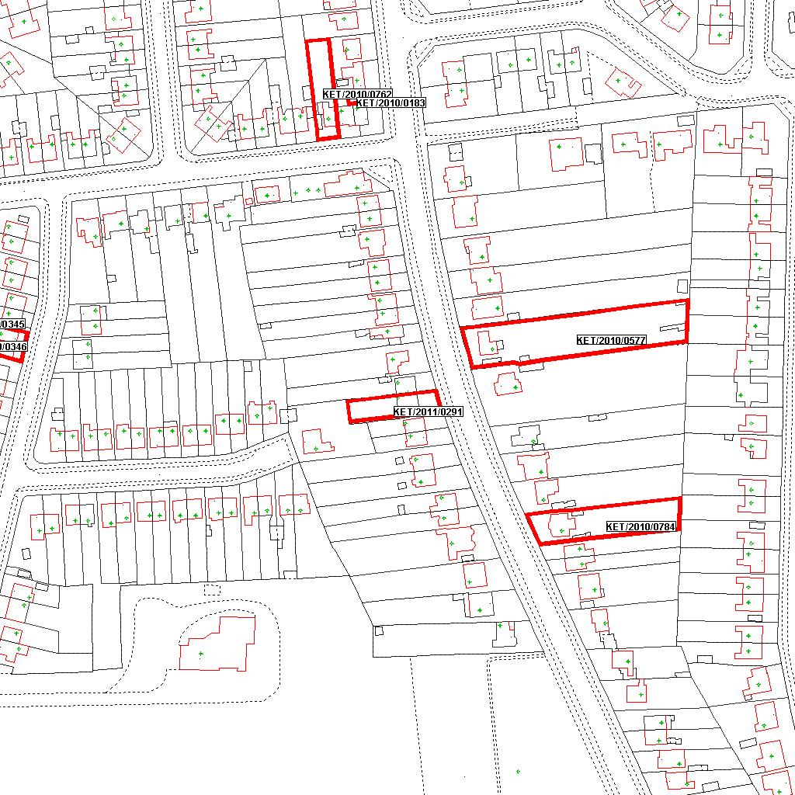

Reproduced from the Ordnance Survey mapping with the permission of the Controller of Her Majesty’s Stationery Office © Crown copyright. Unauthorised reproduction infringes Crown copyright and may lead to prosecution or civil proceedings.  LA078344 |  | N
Date: 17/05/2011 Do not scale from this map. For illustrative purposes only.

